Beyond the Vacancy: Tackling Workforce Shortages for a Resilient Hotel Industry

Name: Tony Ancuta
Student number: 2122379
Module code: BMIH6001
Module name: Contemporary Themes
Module lecturer: Natalie Brailsford

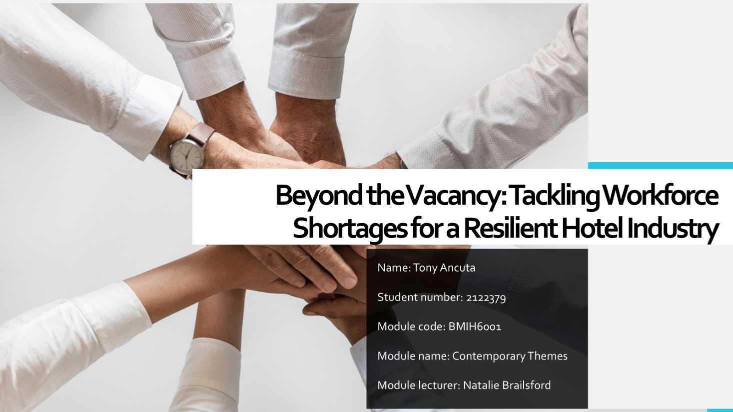
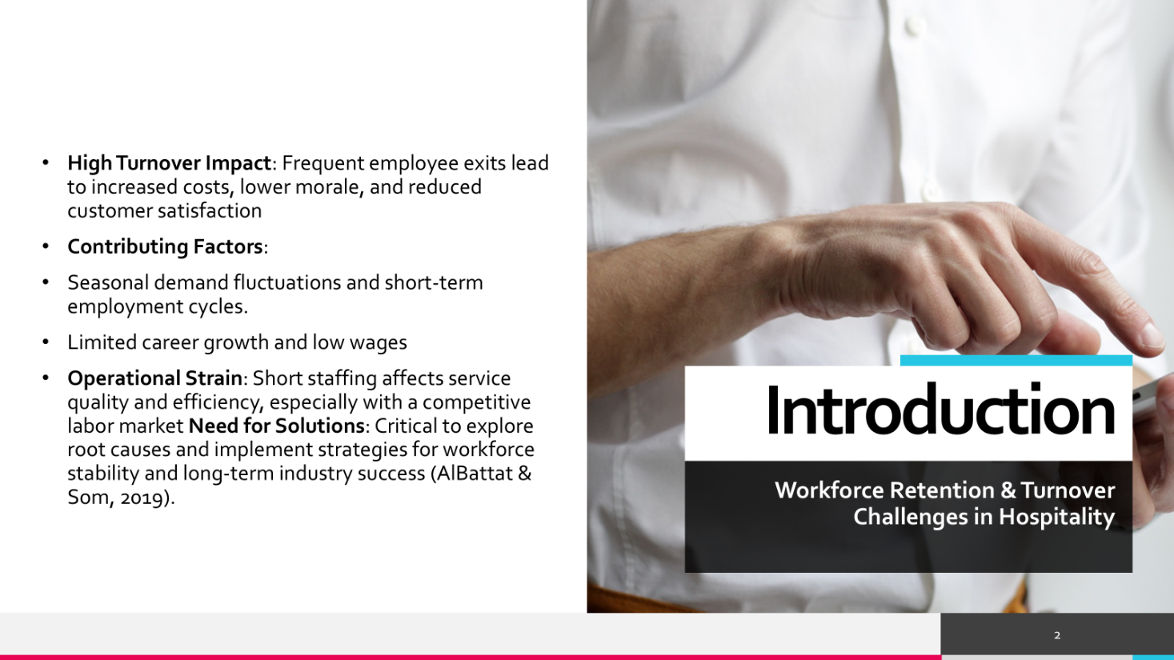


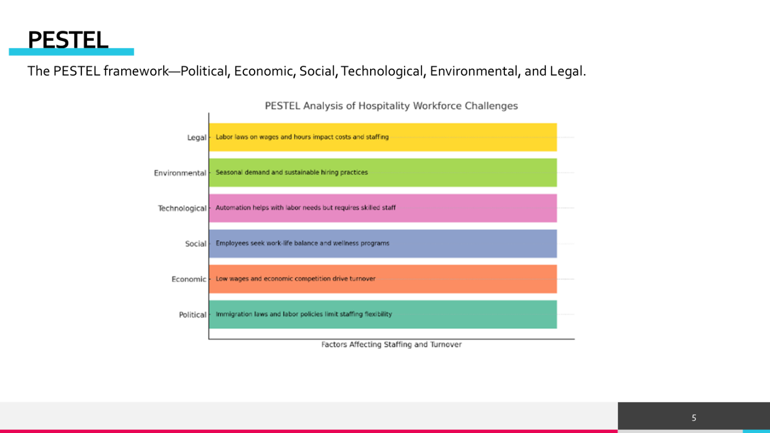

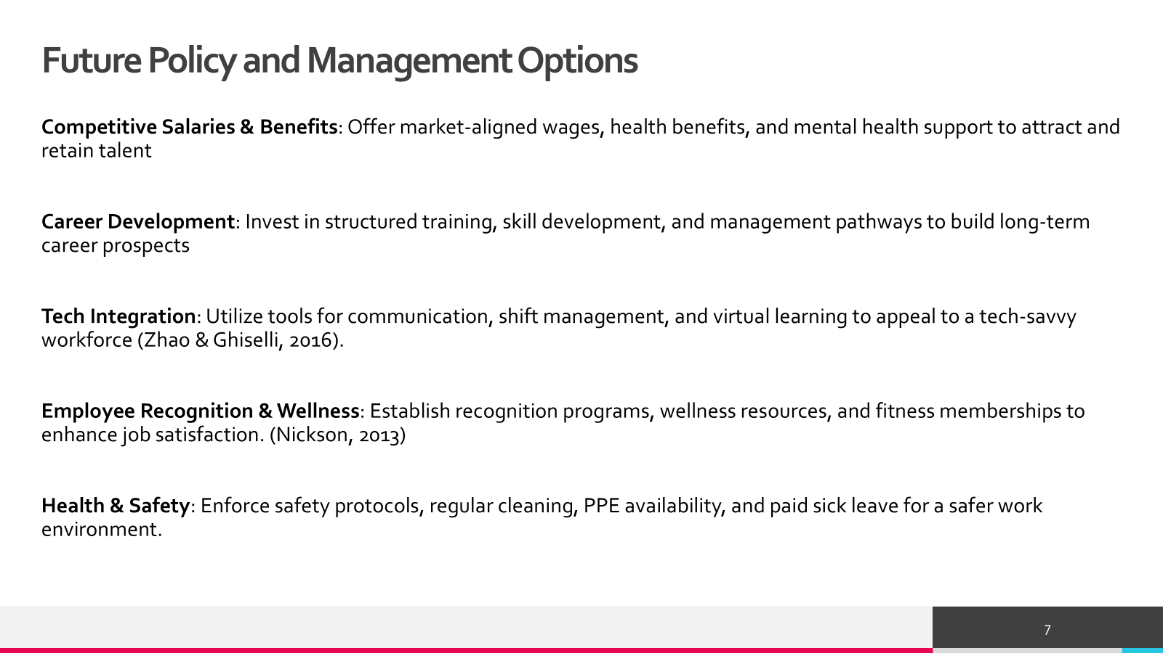
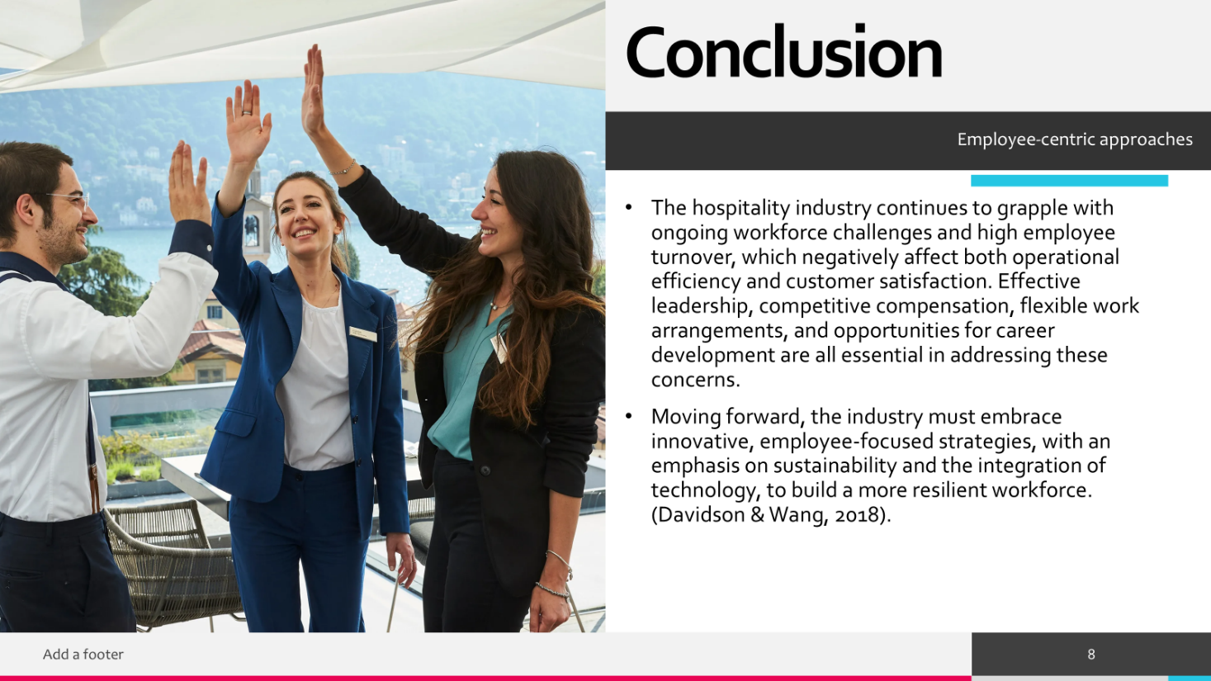
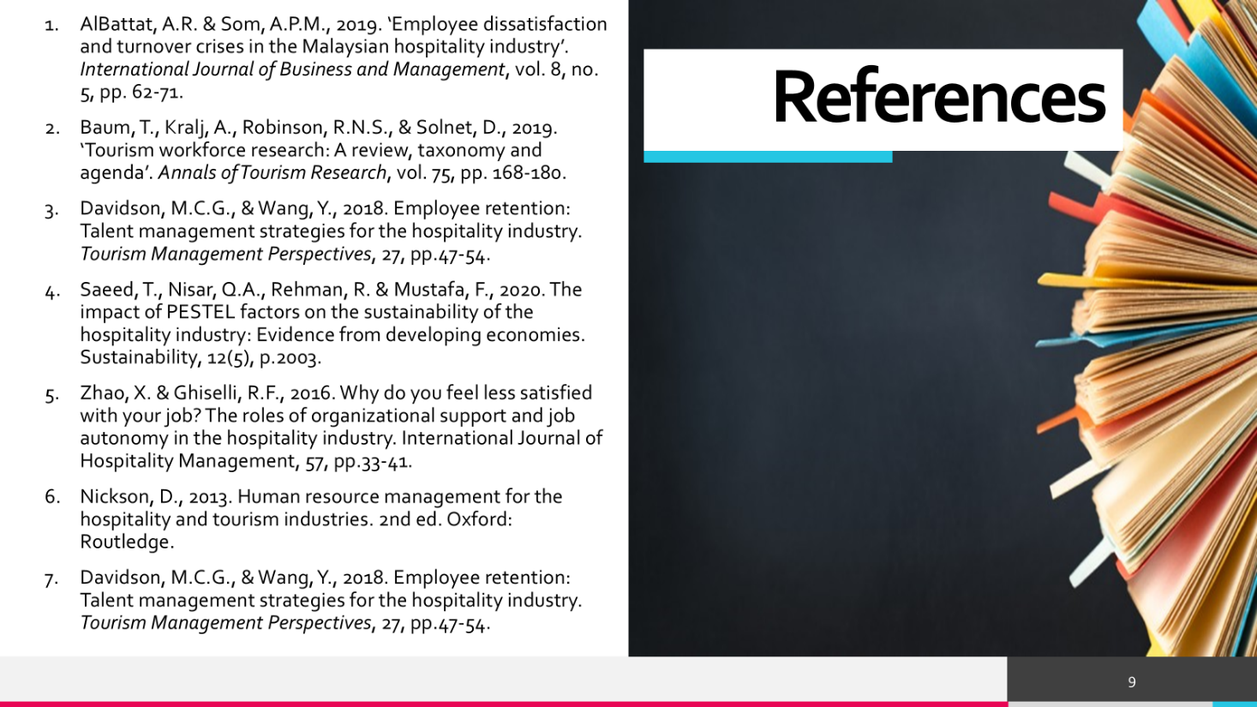

References:
- AlBattat, A.R. & Som, A.P.M., 2019. ‘Employee dissatisfaction and turnover crises in the Malaysian hospitality industry’. International Journal of Business and Management, vol. 8, no. 5, pp. 62-71.
- Baum, T., Kralj, A., Robinson, R.N.S., & Solnet, D., 2019. ‘Tourism workforce research: A review, taxonomy and agenda’. Annals of Tourism Research, vol. 75, pp. 168-180.
- Davidson, M.C.G., & Wang, Y., 2018. Employee retention: Talent management strategies for the hospitality industry. Tourism Management Perspectives, 27, pp.47-54.
- Saeed, T., Nisar, Q.A., Rehman, R. & Mustafa, F., 2020. The impact of PESTEL factors on the sustainability of the hospitality industry: Evidence from developing economies. Sustainability, 12(5), p.2003.
- Zhao, X. & Ghiselli, R.F., 2016. Why do you feel less satisfied with your job? The roles of organizational support and job autonomy in the hospitality industry. International Journal of Hospitality Management, 57, pp.33-41.
- Nickson, D., 2013. Human resource management for the hospitality and tourism industries. 2nd ed. Oxford: Routledge.
- Davidson, M.C.G., & Wang, Y., 2018. Employee retention: Talent management strategies for the hospitality industry. Tourism Management Perspectives, 27, pp.47-54.

