Task 1a
Academic Skills
Academic skills such as referencing, researching and task awareness are key academic skills that helps students engage with tasks and assignments in the most effective and successful ways they can. Gaining further knowledge and understanding prior to completing tasks. Finding out what is expected and how to reach their academic goals. This applies heavily when moving on to full-time employment when tasks have company wide implications. [1] In a digital driven world that requires digital skills, learners must become literate with digital information, data and collaboration to support their studies and keep up with the ever developing technical world. [2]
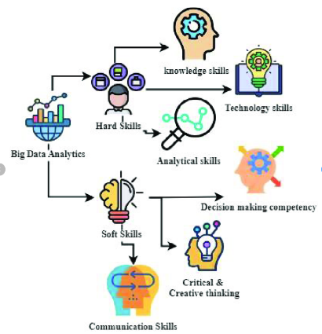
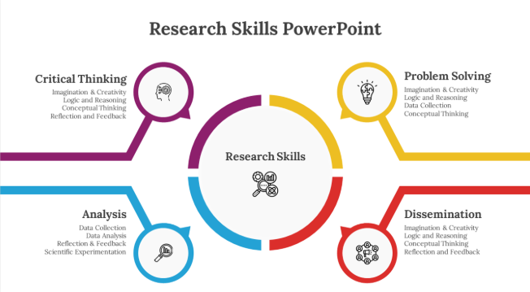
Figure 2: Employment Skills

Figure 1: Academic Skills

Employment Skills
In the world of cybersecurity, soft and hard skills are essential for career success and the ability to continuously progress within this ever-changing industry. Skills such as communication and collaboration help individuals bolster their competence when working alongside others to reach a common goal, be this to fix a vulnerability or to process new data. In a fast-paced environment such as cybersecurity, flexibility and integrity are essential to react quickly to new threats in a professional manner. [3] [4]

Throughout university and employment, I will develop acdemic and professional skills that directly prepare me for a career in cybersecurity. Academic skills such as research, referencing and task awareness will help me understand what is expected of me in my world of work as well as preparing me to analyse data and threats that coincide with my work. Digital literacy will ensure that I keep up to date in an ever evolving technical world. Alongside, clear communication and collaboration, these skills will allow me to work effectively in teams to resolve vulnerabilities, complete tasks and keep integrity while responding quickly and professionally to new threats. Together, these skills will enable me to progress confidently within the cybersecurity industry after graduation.

References

[1] | S. Cottrell, The study skills handbook, 6th edition ed., Bloomsbury Publishing Plc, 2024.
[2] | A. K. Giedrius Zilionis, “The importance of study skills in HE for learners to enhance and develop their studies further,” 9 March 2022. [Online]. Available: https://www.lsst.ac/blogs/the-importance-of-study-skills-in-he-for-learners-to-enhance-and-develop-their-studies-further/. [Accessed 28 September 2026].
[3] | OpenAI,ChatGPT 6, Generative AI. [Accessed 28 September 2026]
[4] | “NIST,” 16 May 2024. [Online]. Available: https://www.nist.gov/itl/applied-cybersecurity/nice/nice-framework-resource-center/resources/workplace-skills-and-nice?utm_source=chatgpt.com. [Accessed 28 September 2026].

