11/08/2026
Farhana Akhtar

Software Solutions for Business
ACCA4026



CertHE Computing Skills for Workplace
Module Name: Software Solution for Business
Module Code: ACCA4026
Student Name: Farhana Akhtar
Student ID: 2541761
Lecturer’s Name: Rajeev Nath
Submission date: 11/08/2026
University of Wales Trinity Saint David
Campus: London

Contents
Introduction 1
Task 1. e-Commerce Website builders/software solutions 1
1.1 Wix 1
1.2 Shopify 2
Task 2. Mind-map of contemporary software applications 3
2.1 Mind mapping and its benefits 3
2.2 Mind map of contemporary software applications 4
3.1 Four office software solutions 4
Ms Word 4
Ms Teams 6
Ms PowerPoint 10
Ms Access 11
VLOOKUP 15
IF Statement 18
Task 4. Communication and Collaboration applications 21
4.1 One contemporary Communication and one Online Collaboration 21
Gmail 21
Zoom 22
4.2 One feature of a Communication (1) and one feature of a Collaboration (1) application 24
Gmail 24
Zoom 27
Conclusion 30
References 31
Appendices 34
Appendix 1: Key Features of Wix. 34
Appendix 2: Average formula. 34
Appendix 3 : Auto sum formula. 35

Introduction
This assignment shows my understanding of various software applications and tools used in the workplace. Each task includes research and practical examples using simulated data instead of real or sensitive information. The assignment is supported by screenshots, credible sources and references, demonstrating the knowledge and skills I have developed throughout this module. This report follows GDPR guidelines, so no personal details or personal data have been included.

Task 1. e-Commerce Website builders/software solutions

Wix
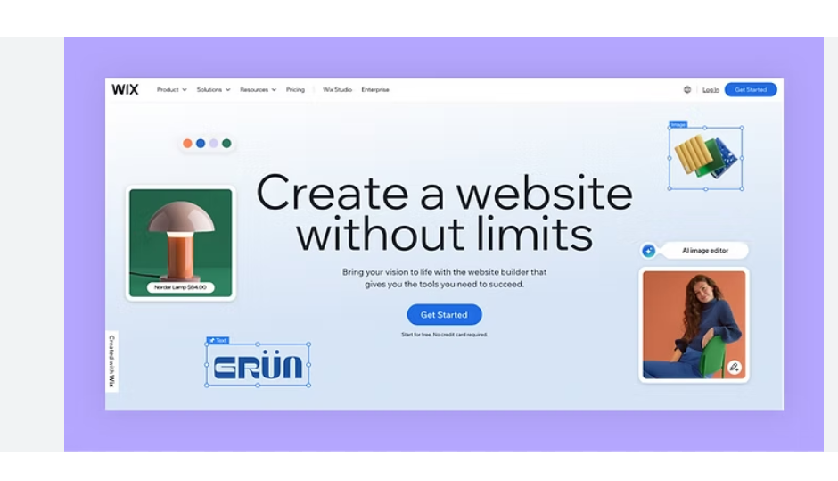
Figure 1: Wix official website [1].

Wix is a cloud based and all in one platform that offers individuals and business to create, manage and customize websites without advanced coding skills. It is a simple drag and drop website builder, customizable templates, web hosting, e-commerce capabilities and marketing tools. Inventory management, product listings, abandoned cart recovery and booking appointment handling are some of the main features [2], [3].
Wix Editor and Wix Studio are for professional designers and have 2700 plus templates. Customer can choose to use either AI powered features or traditional non-AI tools. Through Payment by Wix and Wix Pos business owners can accept payments for goods and services both online and offline [4].
It supports business to sell their product/service through multiple platforms such as Ebay, Amazon and TikTok many more. It offers AI website-building and design tools, affordable plans, mobile editing, and mobile and desktop previews. Wix has affordable subscriptions plans and editable from mobile application. Wix offers customers to change between mobile and desktop view of their website. There are 24 hours live chat, phone, email support, helpful guides and Wix’s official social media is available for customers. Wix domain is easy transferrable [4].
Once you have published a site on Wix you cannot switch to a different template. If you like to rebuild your site, unless you start from scratch which can negative impact on long term business. The platform has weak management which leads to inconsistencies in the designs and layout across different pages. Its capability for multi-currency and international selling is restricted. Wix is ideal for small to medium sized businesses. Advanced eCommerce features and marketing only available for paid plans [4].
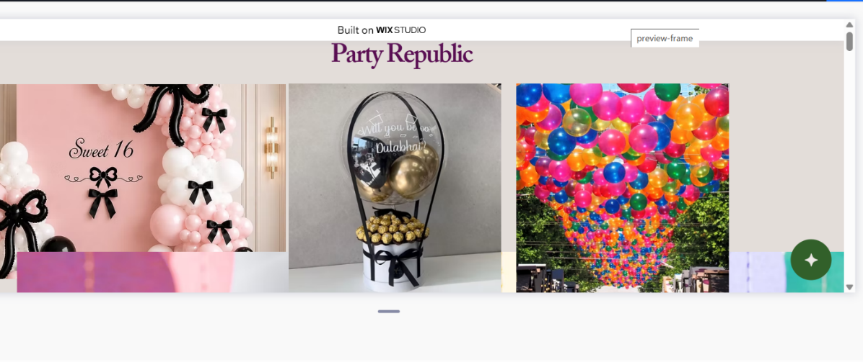
Figure 1: Created a website [5].

1.2 Shopify
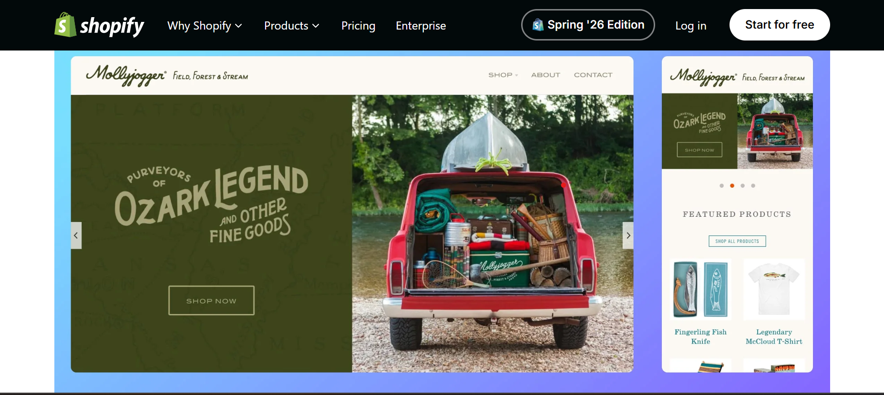
Picture 1: A website created using Shopify [6].
Shopify is a cloud and subscription based leading e-commerce platform that helps business to create, build and manage online store while supporting various functions such as marketing, sales, payment processing and logistics. Shopify offers template-based system with free and paid themes that can be customized using a visual editor [7].
Shopify is expensive compared to Wix but its primarily focuses on eCommerce and retail, providing the tools needed to manage large inventories and process high volumes of sales makes long-term investment impactful. It has range of customer such as Direct-to consumer, Business to Business, retail and international sale. Consumers have control over their business; it allows to edit website theme without rebuilding it. Customers have access to more detailed sales report and analytic dashboard, enable them monitor business growth [8].
Through Shopify you can sell wide range of products and services, including physical products, digital products, memberships, subscriptions, ticketed experiences and consulting services. However, some products/services prohibited to sell on the platform. Shopify has expanded such services as Shipping, Tax, Capital, Shopify Credits, POS, checkout, Chat and Email. This improved their customers engagement and contributed to increased success and long-term sustainability. Shopify has unlimited products unlike Wix Customer service is available 24/7 no matter which plan, blogs and help docs etc [8].

Task 2. Mind-map of contemporary software applications

2.1 Mind mapping and its benefits
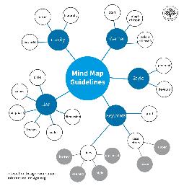
Figure 1: Example on a Mind Map [9].
A Mind Map is a visual thinking and brainstorming tool used to generate, organise and represent ideas freely without being restricted by a specific format. It makes information easier to review and recall. A Mind Map usually starts with a main topic in the centre of the page and extends into branches representing related subjects or categories. By showing relationships between concepts in a non-linear format, mind mapping can make information easier to understand, analyse and remember [9].
Mind mapping can help develop important academic and business skills, including decision-making, organisation, learning, collaboration, planning, problem-solving and goal setting. It can also help individuals and teams organise their ideas and present information clearly through a visual diagram. Mind maps have been adopted by organisations such as Boeing and British Petroleum, demonstrating their potential to support business activities and achieve cost reductions. They can also provide an inexpensive way to support learning by helping users process and recall information more efficiently and reduce the effects of forgetting. In addition, many online tools provide free options or trials for creating mind maps, making the technique accessible to a wide range of users [9].
Mind mapping can also support organisations when redesigning existing business models or developing new ones. It can help businesses explore different ideas, identify opportunities and consider possible outcomes. However, mind maps can sometimes be difficult for others to interpret because they reflect an individual's personal thoughts and associations. Different people may therefore create different mind maps for the same topic. Despite this limitation, mind mapping encourages creative and flexible thinking by allowing people to develop ideas without following a strict linear structure [10].

2.2 Mind map of contemporary software applications
I have created a mind map of contemporary software applications that are used to support day-to-today business operations.
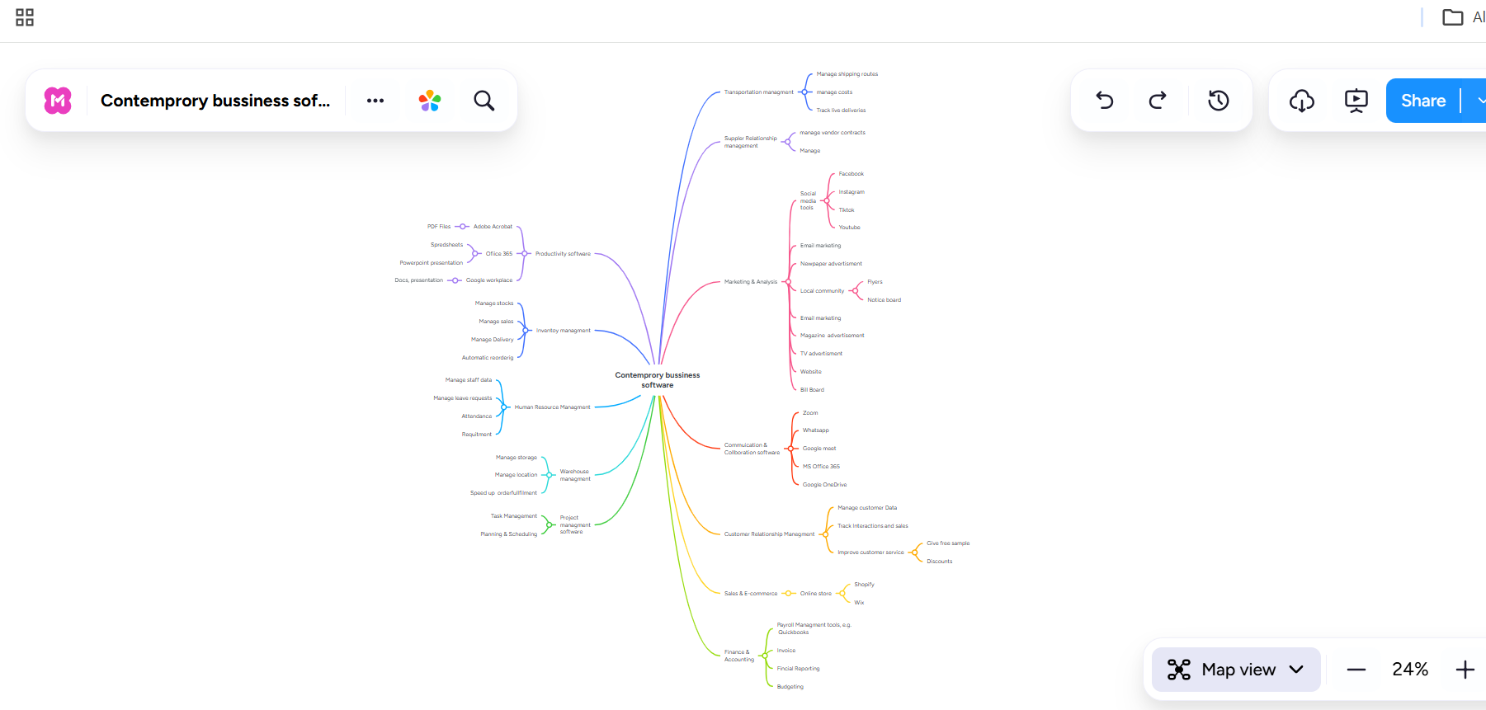

Figure 1. Mind Map on contemporary business solution using mind meister website.
Mind Map Link: https://www.mindmeister.com/4045816026/contemprory-bussiness-software

3.1 Four office software solutions

Ms Word

Figure 1. Ms Word logo [11].
Microsoft Word is a word processing program made by Microsoft and comes included in the Microsoft 365 package along with PowerPoint, Excel, Teams, and OneDrive for storing and sharing files online. Microsoft 365 subscription to unlock all its features. Word is used all around the world in schools, businesses, and organisations. It allows users to create, edit, format, save, and print documents like reports, CVs, letters, assignments, and newsletters. It also supports over 20 different languages; it works well for people who speak more than one language [12].
One of the best things about Word is how capable it is. Users can easily format your work, collaborate with others using comments and track changes, and even generate citations and bibliographies automatically. Users can also save and share work in widely used formats like DOCX and PDF, so anyone can open it [12].
It does have some downsides though. Word isn’t designed for handling complex data or doing calculations — that’s more what spreadsheets are for. There’s also a noticeable difference between the desktop version and the online version through OneDrive. The desktop app gives you every tool, including references, advanced page design, and the ability to work offline. But the OneDrive version is missing quite a few important features, such as mail merge, citations, and the option to create labels and envelopes. Users also need an active subscription to get the full experience, which is worth keeping in mind [12].
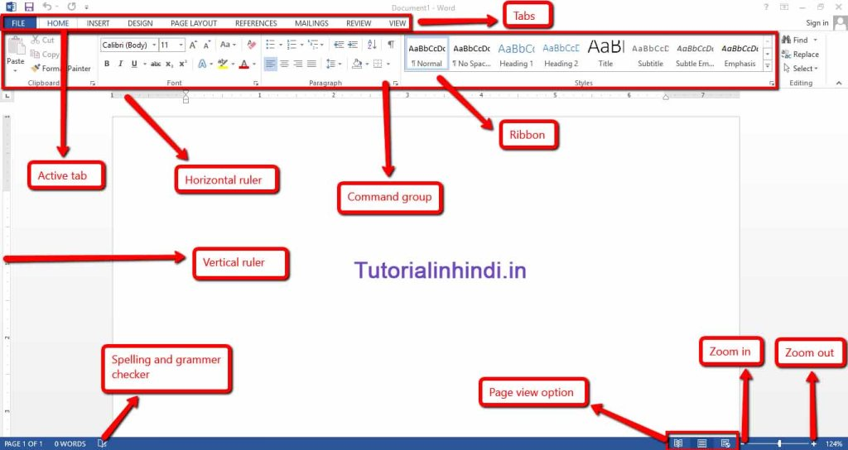
Screenshot 1: Features of MS Word [13].
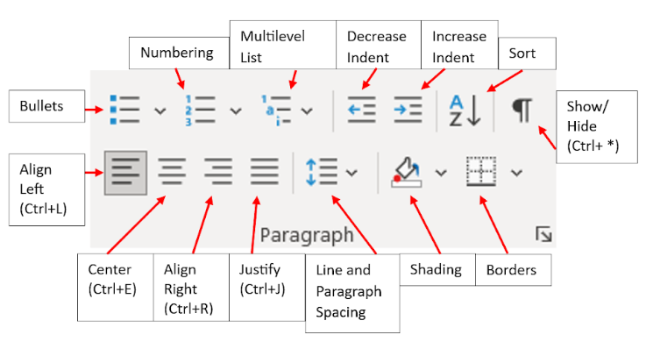
Figure 2: Features of formatting text [14].

Ms Teams
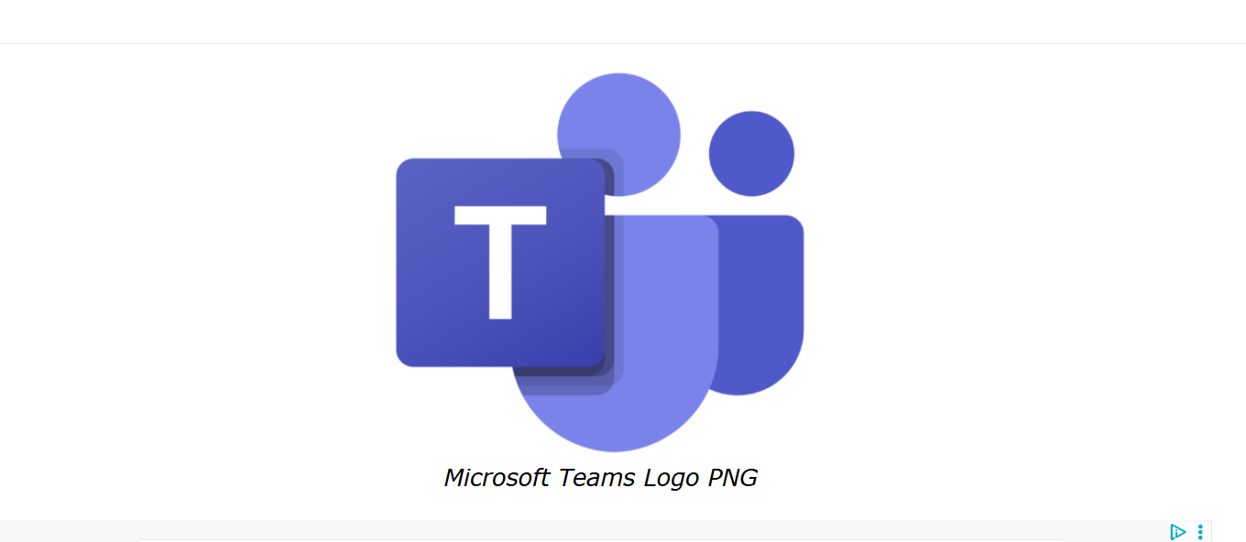
Screenshot 1: logo of Ms Teams (personal item) [15].
Microsoft Teams is a cloud-based collaboration and communication platform within Microsoft 365. It widely used by educational institution, government organization and business to communicate, collaborate on document, work together trough, chat, voice calls, video calls and file sharing. All in one and accessible to everyone. Ms Team has become a key platform for enabling teamwork, supporting remote work and facilitating online learning. It works alongside communication tools like email, Skype and file storage services such as OneDrive and Document Management Systems (DMS), making it easier for customers to communicate and share files.
Ms Team is free to download and use if customer paid monthly subscriptions. Customers need have Microsoft 365 account to access all features. Teams integrates with Ms Outlook, enables users to access emails and calendar in same platform. It provides security features that help users to protect information and data. It also works with Box, Zoom and YouTube which enhance collaboration by allowing users to access and share content in one platform. Teams can be organized into channels, and each channel is to reserve to a specific project like rooms in organizations. Channel can be restricted so information can be confidential. Some of the features on Teams for Web are limited such as avatars, video background effects in meetings, join on second device, advanced screen sharing features etc [16], [17].

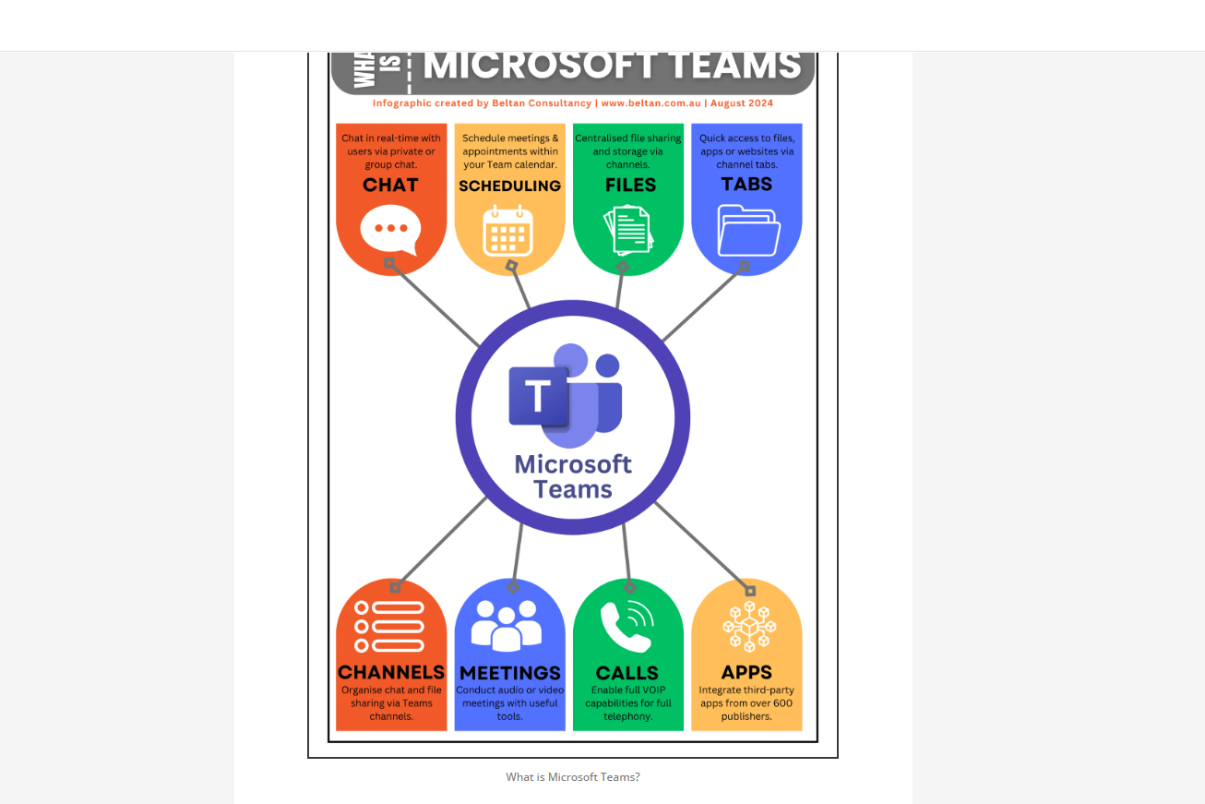
Figure 2: Major features of teams [17].
Teams administrators are responsible for configuring, managing and maintaining Ms Teams, including its users, features, security settings, and policies to ensure a secure, reliable and efficient teamwork environment. Ms Teams organizations support efficiency and work effectively on projects. However, organizations that require traditional telephone functionality. Teams has lack of a built-in phone system for users. Teams saves time by shorten meetings, save costs, improved teamwork and enable quicker decisions through real time communication and collaboration tools [16].
Ms Excel

Figure 1: Ms Excel logo [18].
Microsoft Excel is a spreadsheet program to use organize, calculate, study, and visualize data. It’s part of Microsoft 365 and mainly used by business, educational institutions and personal projects. Most common uses of Excel are preparing budgets, financial reports, managing employee/student record, creating invoices, timesheets many more. It helps businesses to managing data and generate reports. Microsoft Excel provides multiple major features store data, formulas, functions, chart, graphs, pivot tables etc. Data is stored in worksheets and multiple worksheets care contained in a workbook. It’s easy to organize, edit, analysis tool and autonomation etc. It’s difficult to manage large data and different types of functions can be problematic for non-IT users [19]. Copilot- AI chat in Excel can perform complex data analysis from start to finish, reducing the need to carry out each step manually [20].
OneDrive version does not need to install, runs on web page, ideal for basic spreadsheets task and collaboration. The desktop version provides advanced data analysis tools, supports complex formulas and functions and includes specialised features for working with large and complex datasets. Users can create as many worksheets as they need until the computer runs out of available memory [19].
One other limitation is large workbooks can take longer to open, save or update due to excessive formatting and large images. Users may feel compatibility issues when files are shared between different software versions. In addition, complex external link can reduce performance and make workbooks more difficult to manage [21].
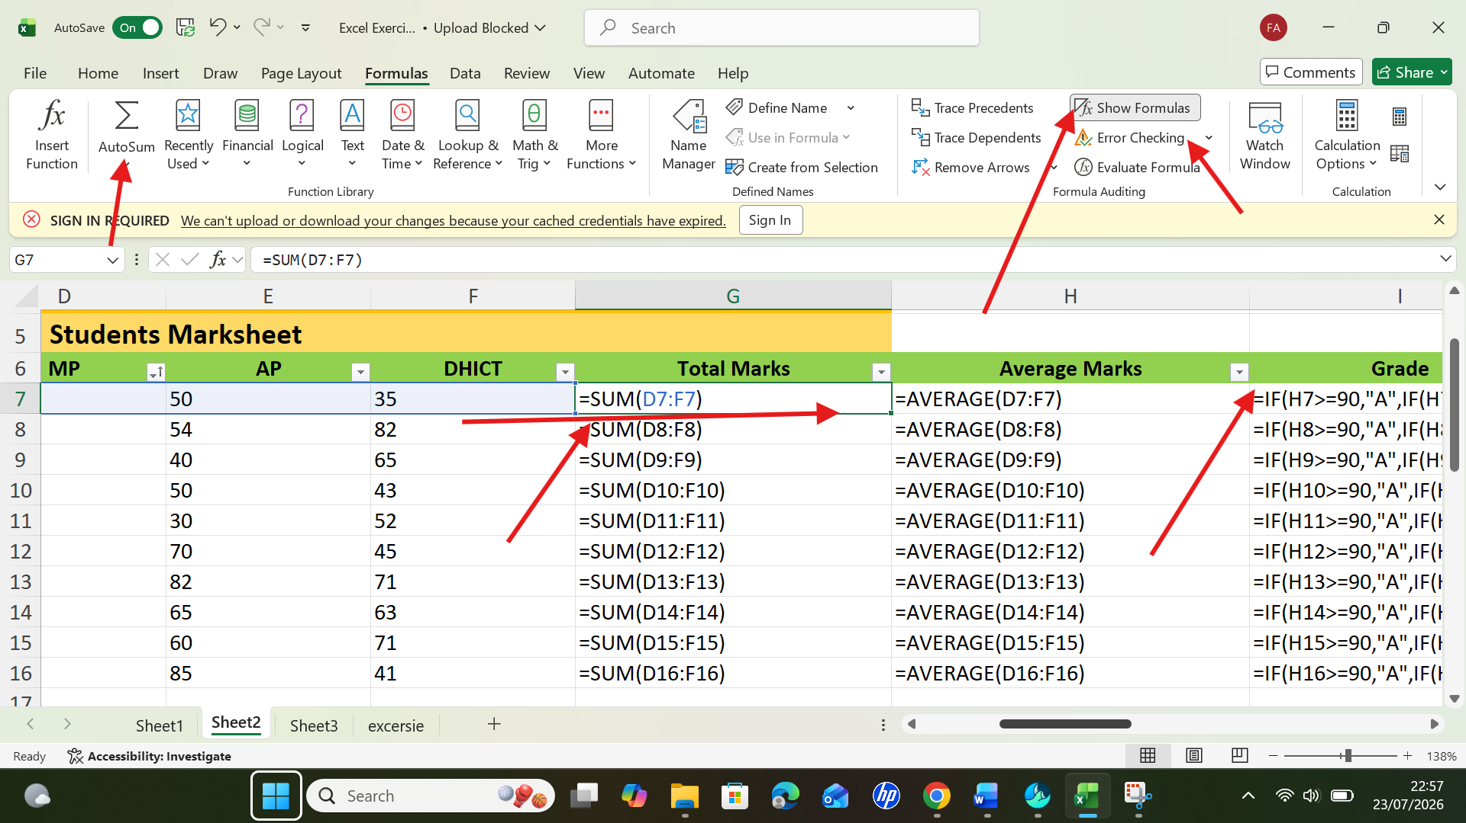
Figure 2: used IF function.

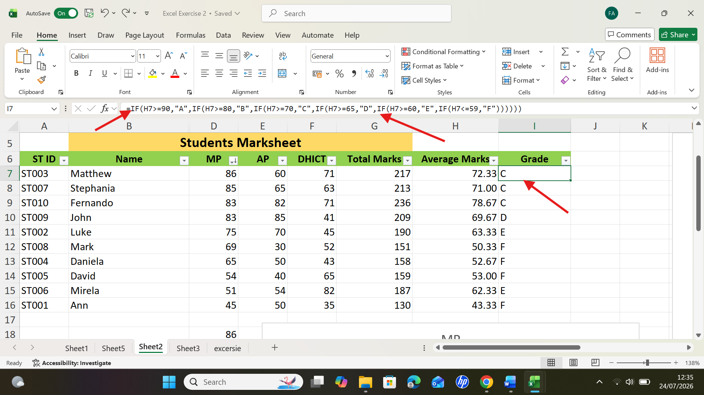
Figure 3: IF formula to find out the grades.

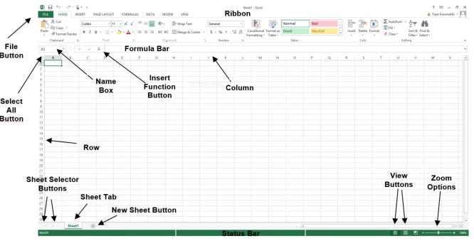
Figure 4: Overview of Ms Excel [22].

Ms PowerPoint

Figure 1: logo of Ms PowerPoint [23].

Microsoft PowerPoint is part of Microsoft 365 and it allows users to create presentation from beginning or by using templates. It can be used for personal, educational, business purpose. This software allows user add text, images, videos, animations, tables, chart etc. to make presentations look attractive. User can record it and save it OneDrive for access across various devices. It enables users to share with real time collaboration with others through such as Zoom. Users also able to rehearse with Speaker Coach and record to prepare in private to deliver effective presentations but only available in English language. Ms PowerPoint on OneDrive let users to create and share basic presentation but some features are limited such as adding, removing, changing slide animation, recording presentations and presenter view etc [24].
Microsoft PowerPoint offers many advantages that make it a popular presentation tool. It helps users keep information organised using slides and structured layouts, making presentation clear and easy to follow. The software is easy to learn and use for everyone. PowerPoint also makes complex data easier to understand by presenting it visually. Its professional templates save time while creating attractive presentations and the desktop version works offline without internet connection. These features make PowerPoint an effective tool for education, business, presentations and training sessions [24].
Despite its advantages, PowerPoint has some limitations such as slides with too much text can distract audience’s attention and make presentations less effective. Technical problems such internet connections or software failures may interrupt presentation. It is not suitable for small meetings and may lead to overdependent on slides which can impact personal communication and storytelling which is important for leadership in business [24].
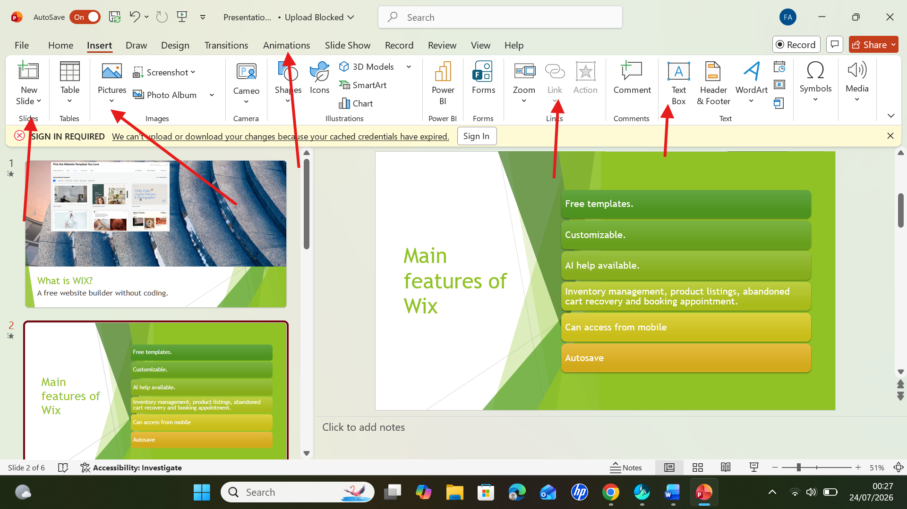
Figure 1: created a PowerPoint presentation.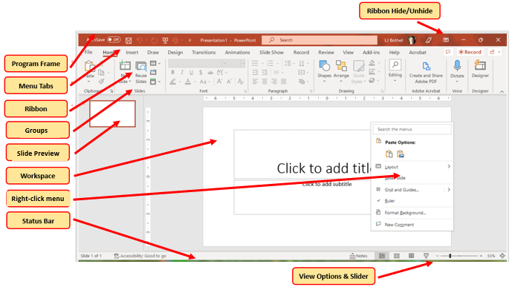
Figure 1: Overview of Ms PowerPoint [24].

Ms Access
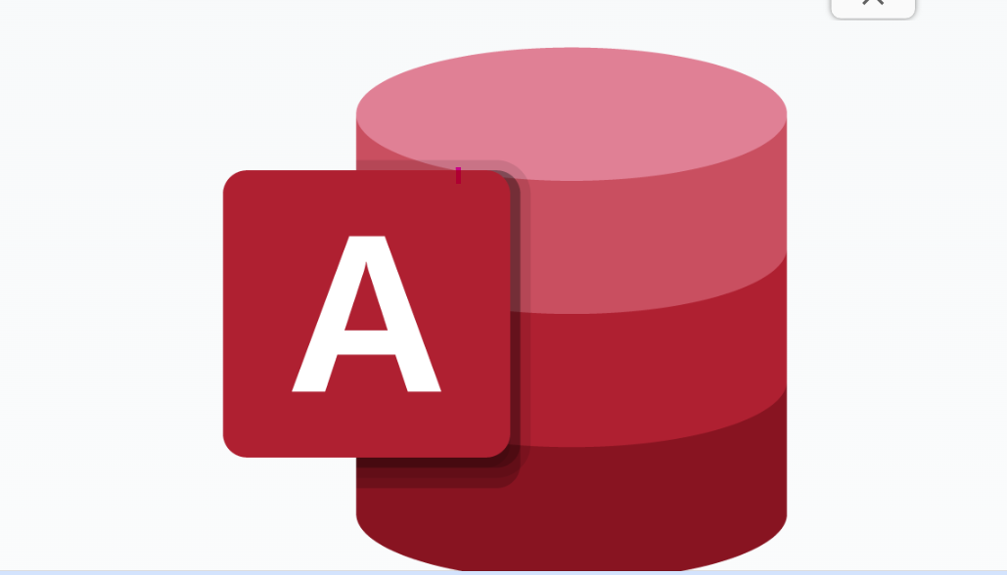
Figure 1: logo of Ms Access [25].
Microsoft Access is a database management system (DBMS) developed by Microsoft and available with subscription. It is designed to help users store, organise, manage, and retrieve information efficiently. Access allows users to create databases without coding knowledge. It used to store, organize, manage and related data. It has templates that support a faster way to build database and summarize data in grouped and summery reports. It cannot be accessed on Web, only on desktop. Microsoft Access can share data with other business applications using connectors. It also allows data to be stored in SQL Server or Microsoft Azure SQL, improving reliability, security, scalability, and long-term data management. It is also a low-cost solution for small and medium sized businesses.
One of the main benefits of Microsoft Access is that it provides a simple way to create database applications without requiring advanced programming knowledge. Its built-in tools and templates help users quickly design database structures and create features such as data entry forms and reports. Because of its ease of use, Access is commonly used by small businesses, students, and organisations that need a straightforward solution for managing smaller amounts of data.
However, Microsoft Access also has some limitations. It is not designed for handling very large databases or a high number of users at the same time. Compared with more advanced database systems, such as SQL Server, Access has fewer features for managing complex data environments and large-scale applications. As organisations grow and require more powerful database solutions, they may need to move to enterprise-level systems. All data is stored in a single file which can impact on speed as the database grows. Access also lacks advanced database features such as triggers and scheduled jobs which can cause compatibility problems when upgrading. It is mainly designed for desktop use and does not provide the same web-based database experience as some modern cloud database platforms [26].

Feature | Microsoft Access | Microsoft Excel
Software Type | Relational Database Management System (RDBMS) | Spreadsheet application
Primary | Store, manage, and retrieve large | Perform calculations, data
Data Storage | Uses multiple related tables with relationships | Stores data in worksheets (rows and columns)
Data Relationships | Supports relationships between multiple tables | Limited support for data relationships
Data Analysis | Uses queries to filter, search, and analyse data | Uses formulas, functions, PivotTables, and charts
Multi-user Support | Designed to allow multiple users to access and update data | Better suited for single-user or small-scale collaboration
Data Capacity | Better for large, structured datasets | Best for small to medium-sized datasets
Ease of Use | More complex; requires understanding of databases | Easier to learn and use for most users
Common Uses | Inventory management, customer records, employee databases, student information systems | Budgeting, financial analysis, reporting, calculations, and data visualization
Table 1: comparison between MS access and Ms Excel [27].

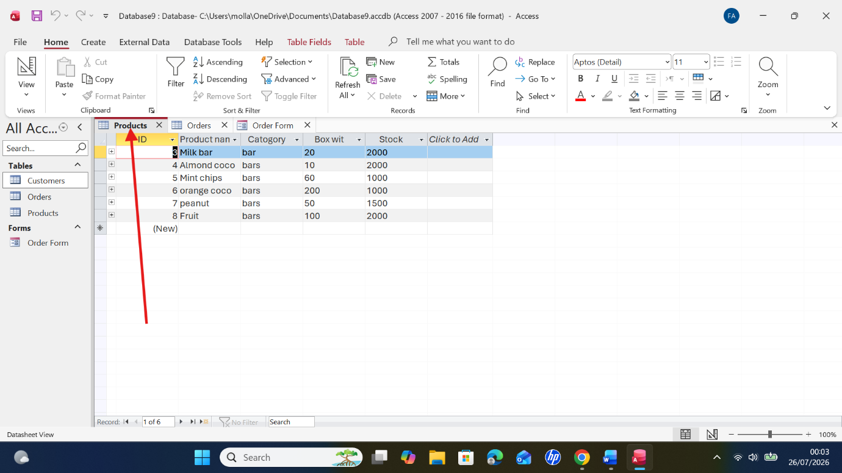
Figure 2: created table, adding data in Access & renamed it “products”.
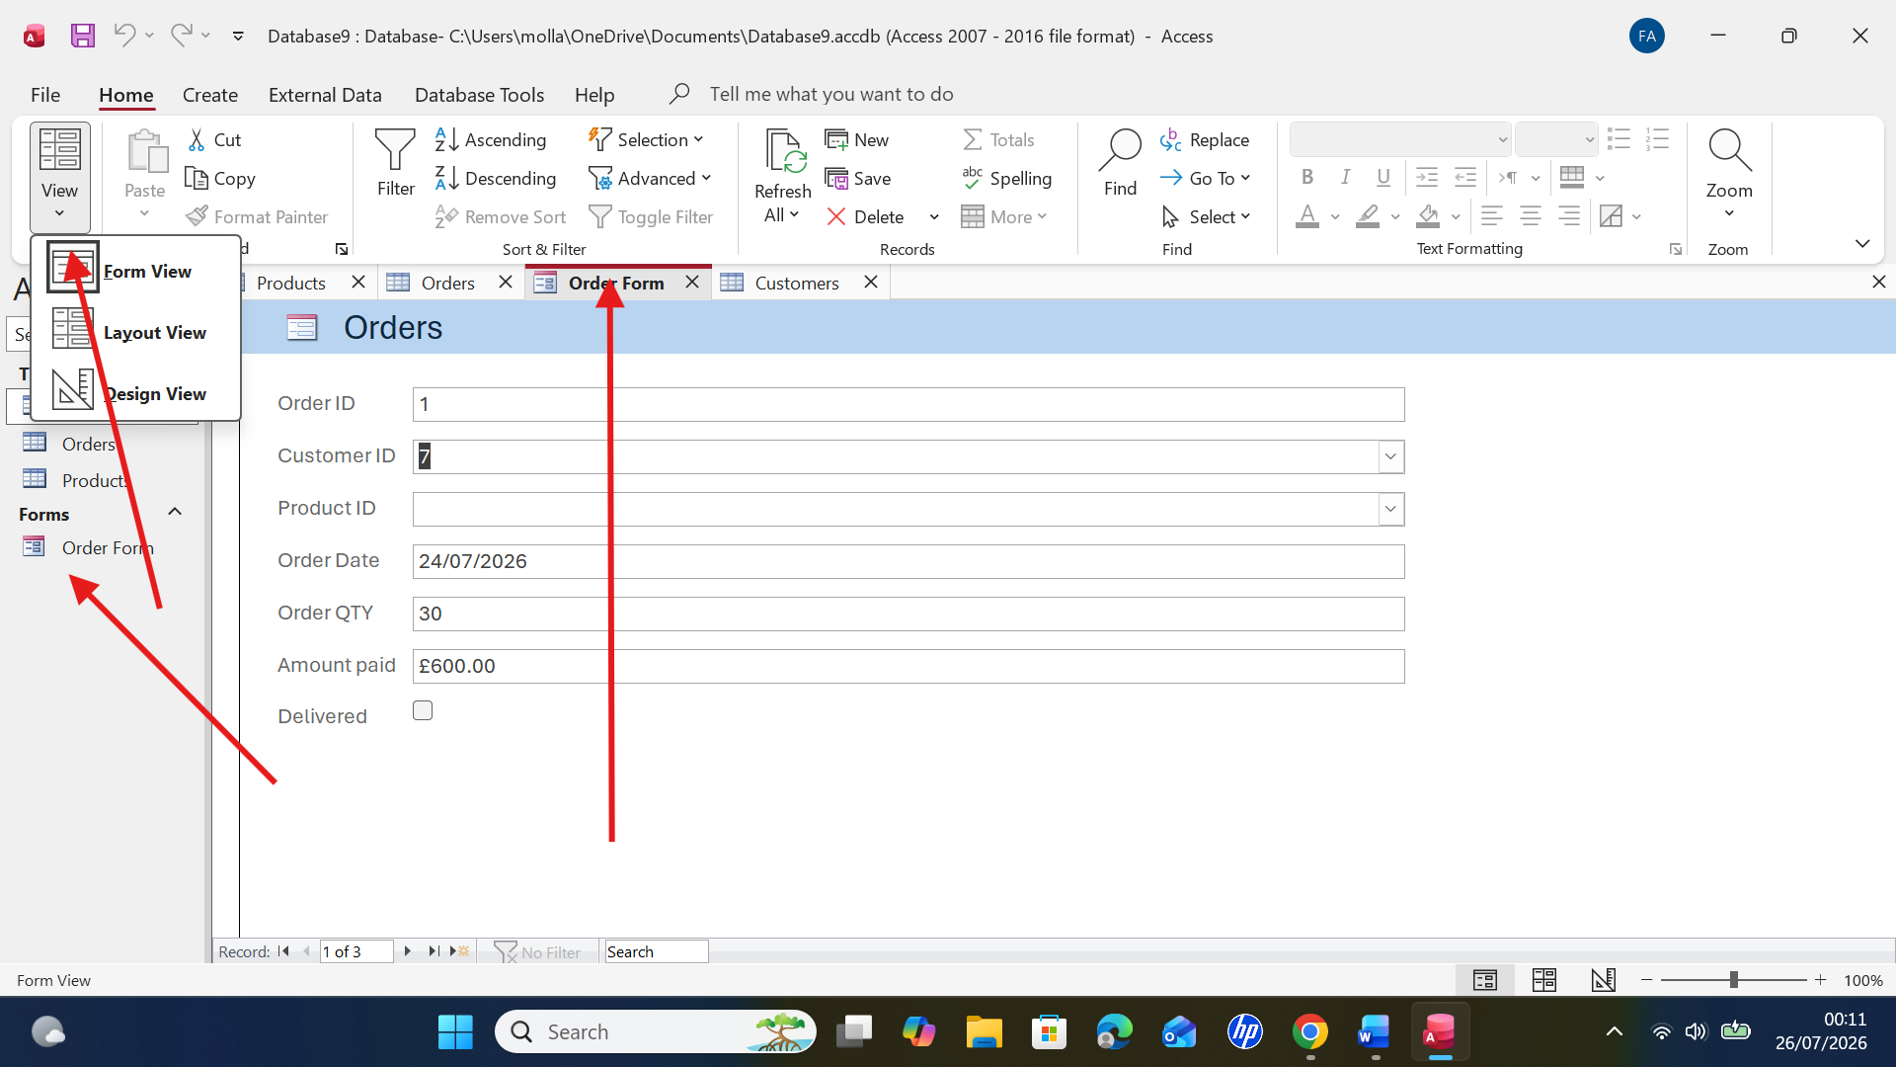
Figure 3: linking one table with another with relationships.
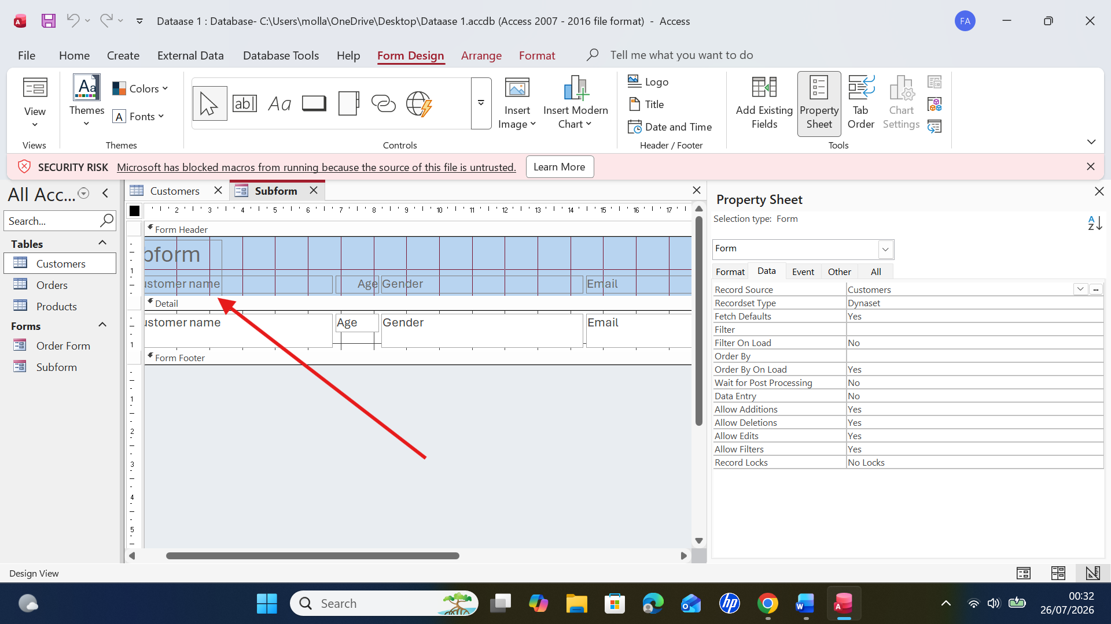
Figure 4: Form with a Subforum to Show Related Records in Microsoft Access.

3.2 Two features

VLOOKUP
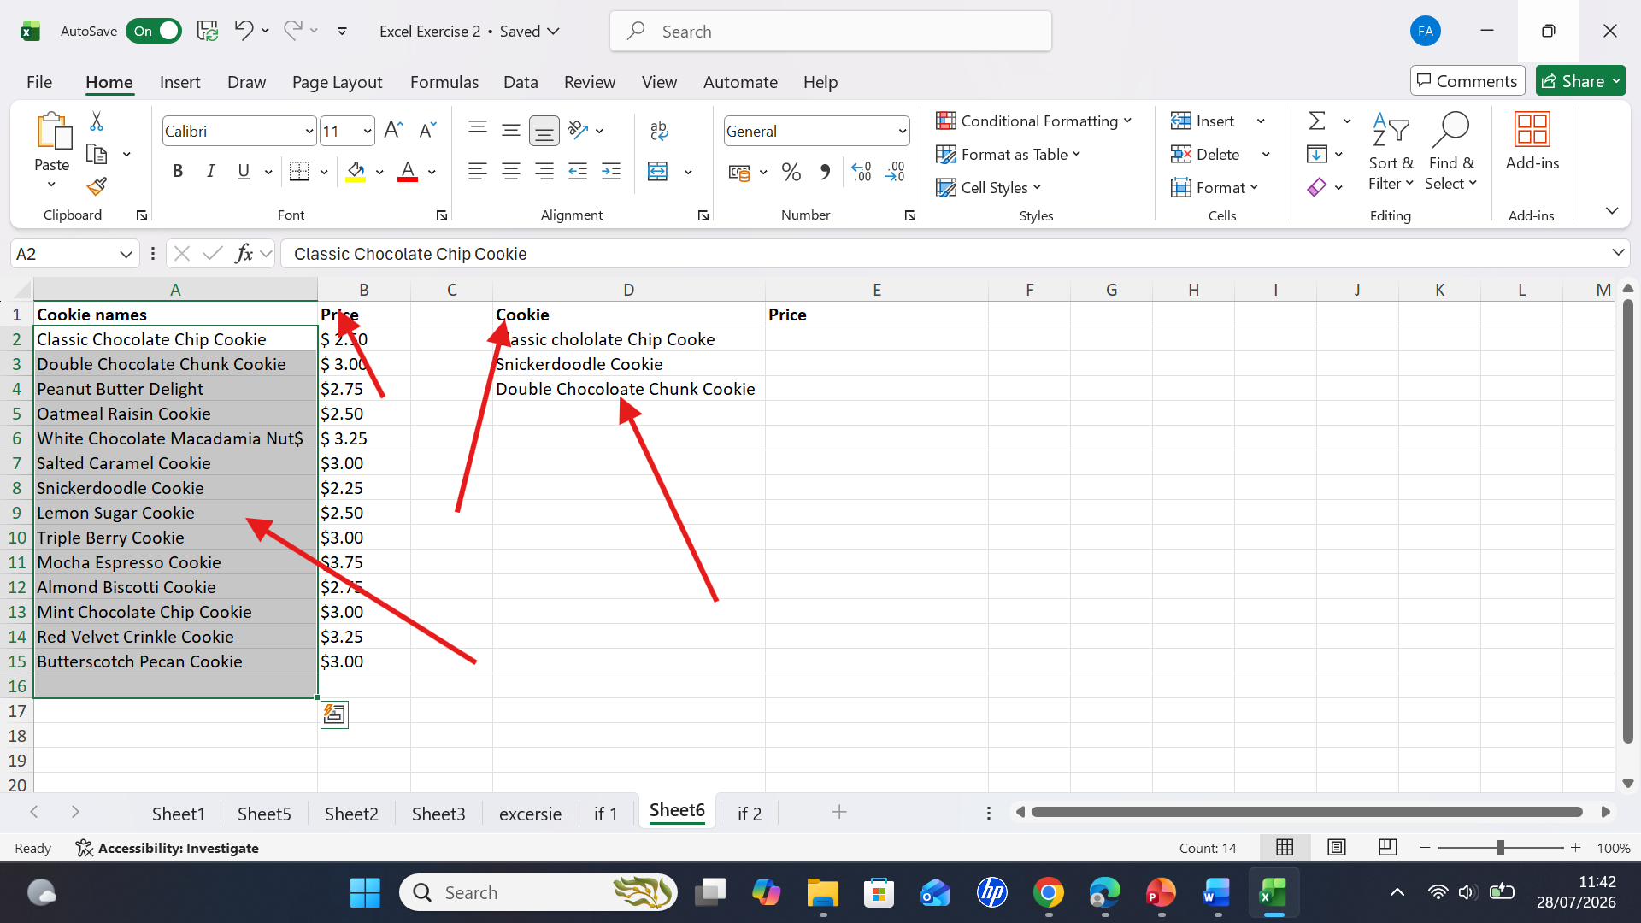Figure 1: Wrote headings and entered the data.
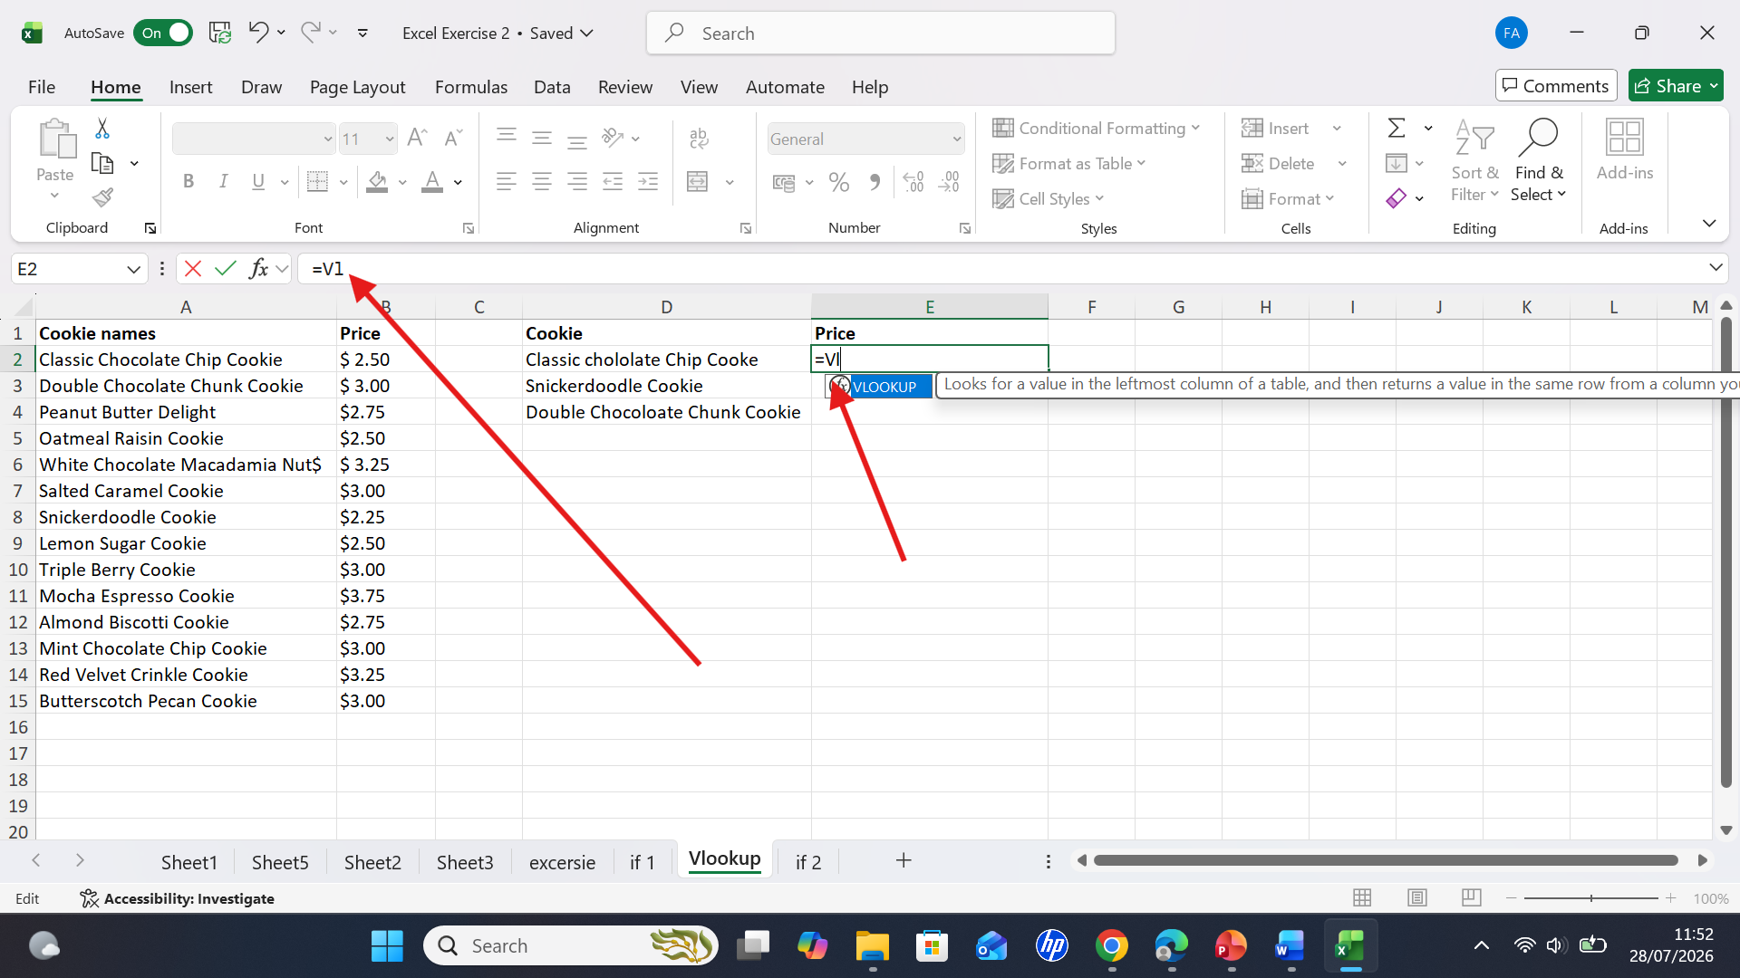
Figure 2: I typed =VLOOKUP in cell E.

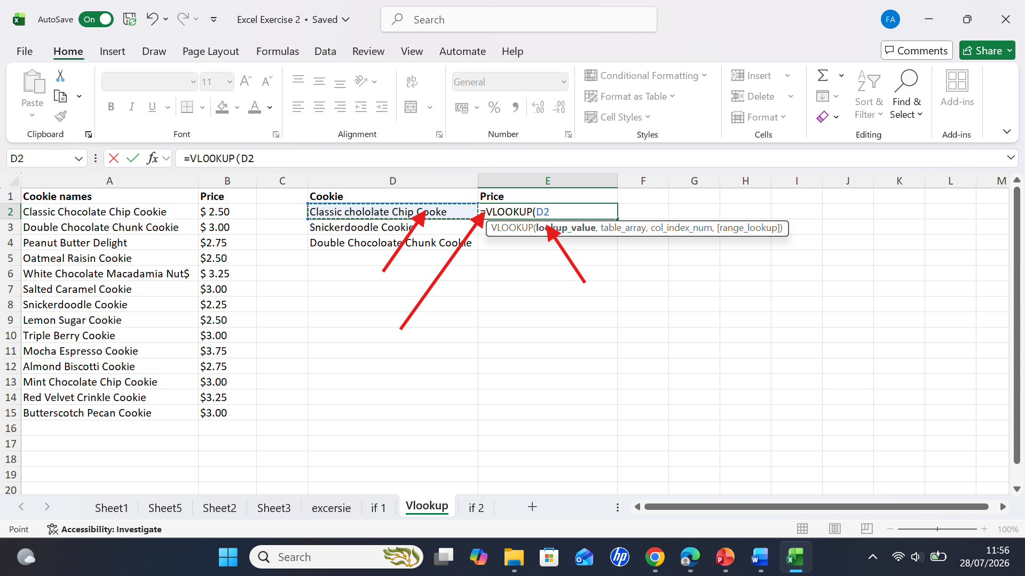
Screenshot 3: I selected D.

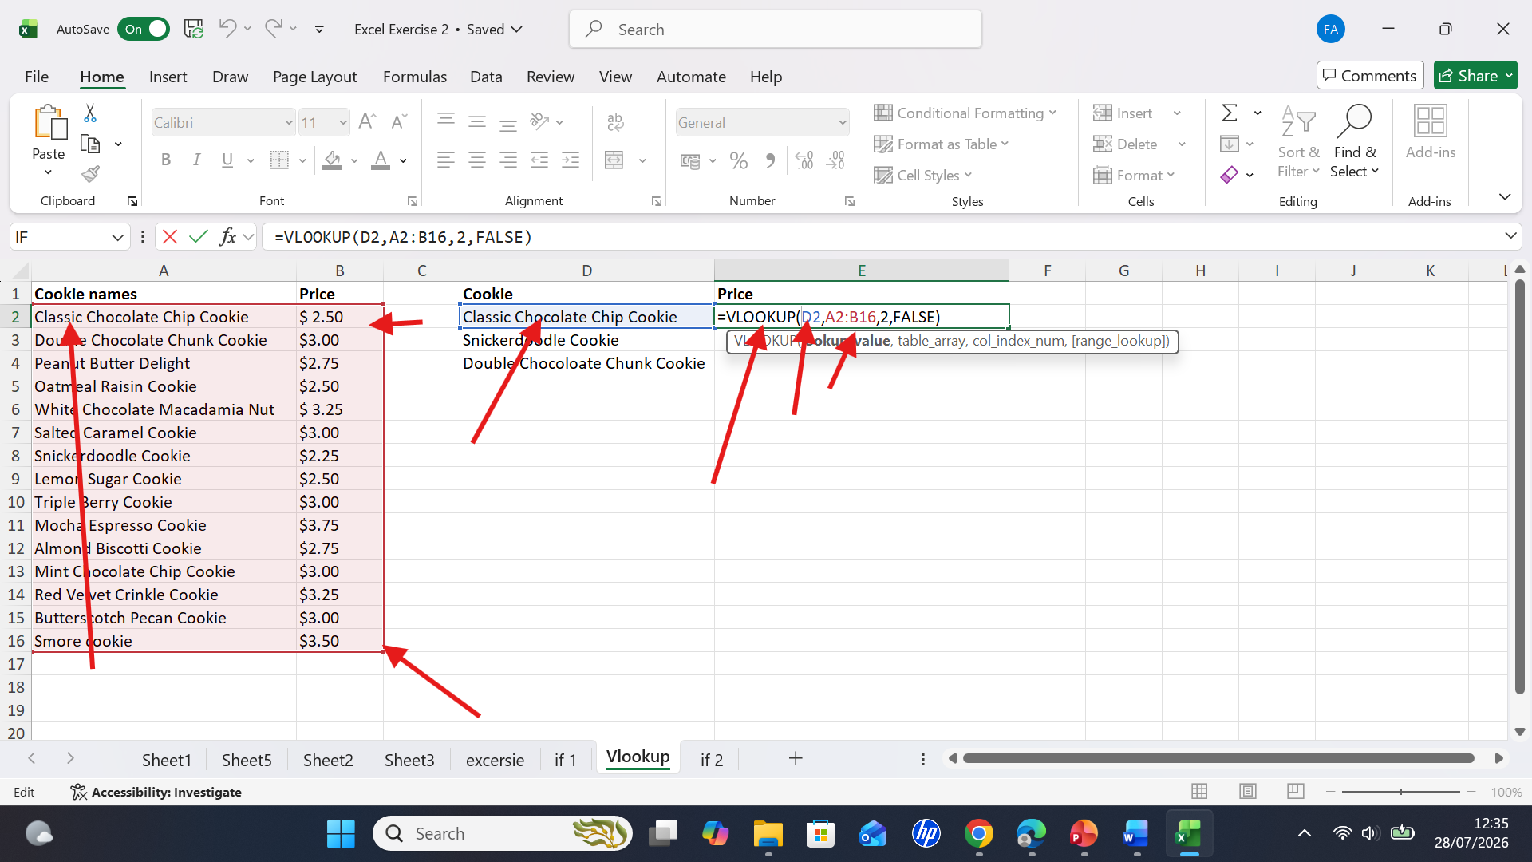
Figure 4: I typed coma (sign), selected column A2 till B16. Typed coma (sign) and False and closing the formula with a parenthesis. The formula will be =VLOOKUP(D2,A2:B12,2,FALSE).

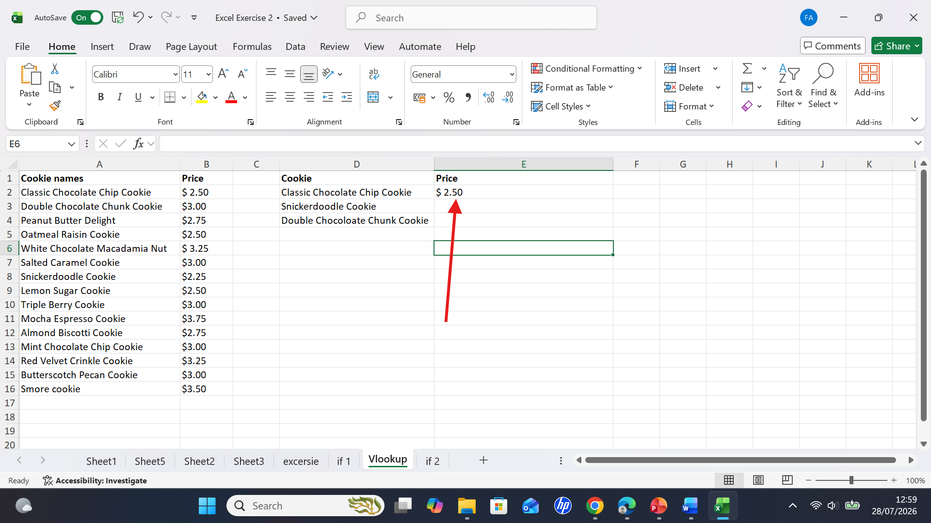
Screenshot 5: the price of the cookie has been appeared.

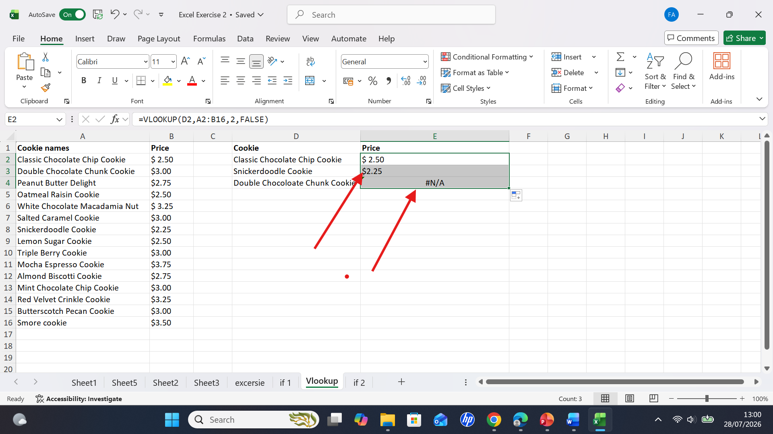
Screenshot 6: when I dragged the price double chocolate chunk is not mentioned how to lock the relative reference.

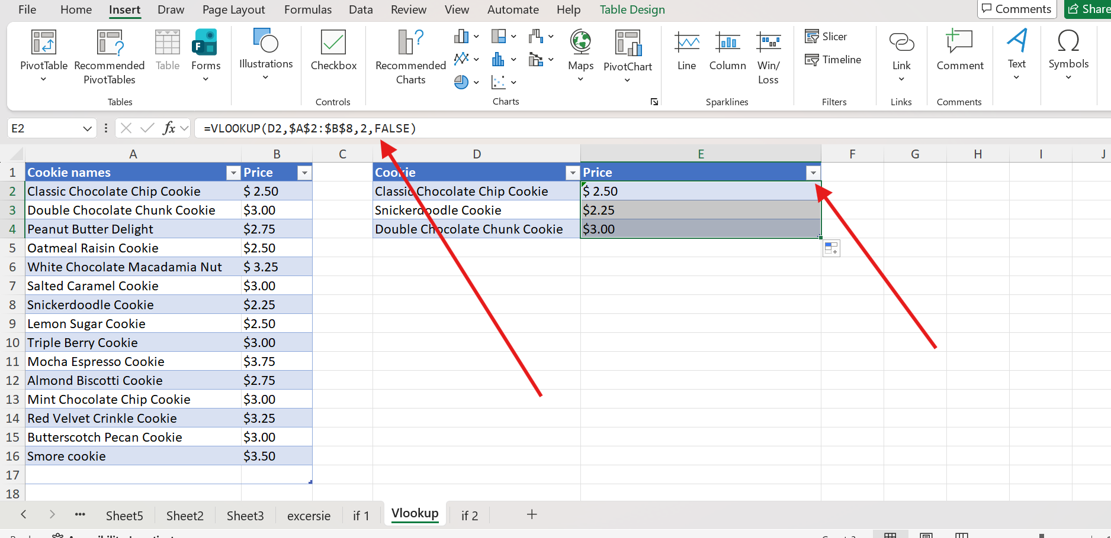
Screenshot 7: lock the formula using the dollar sign and enter. Select the price collum and drag it. Now price has appeared.

IF Statement
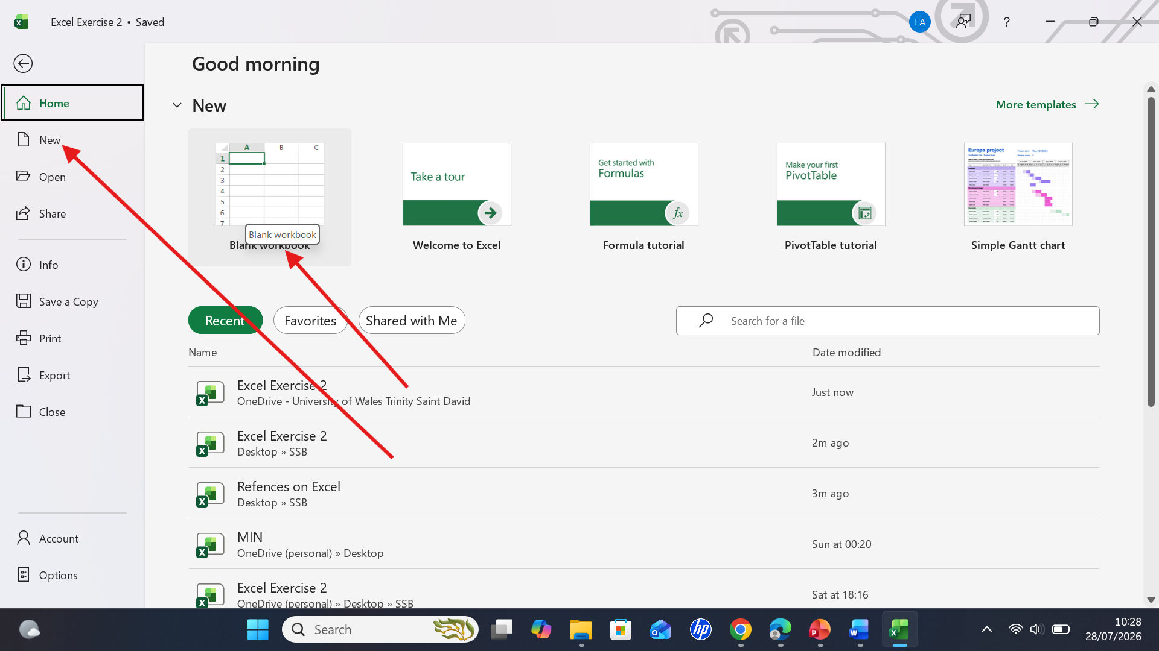
Figure 1: open Excel wordbook.

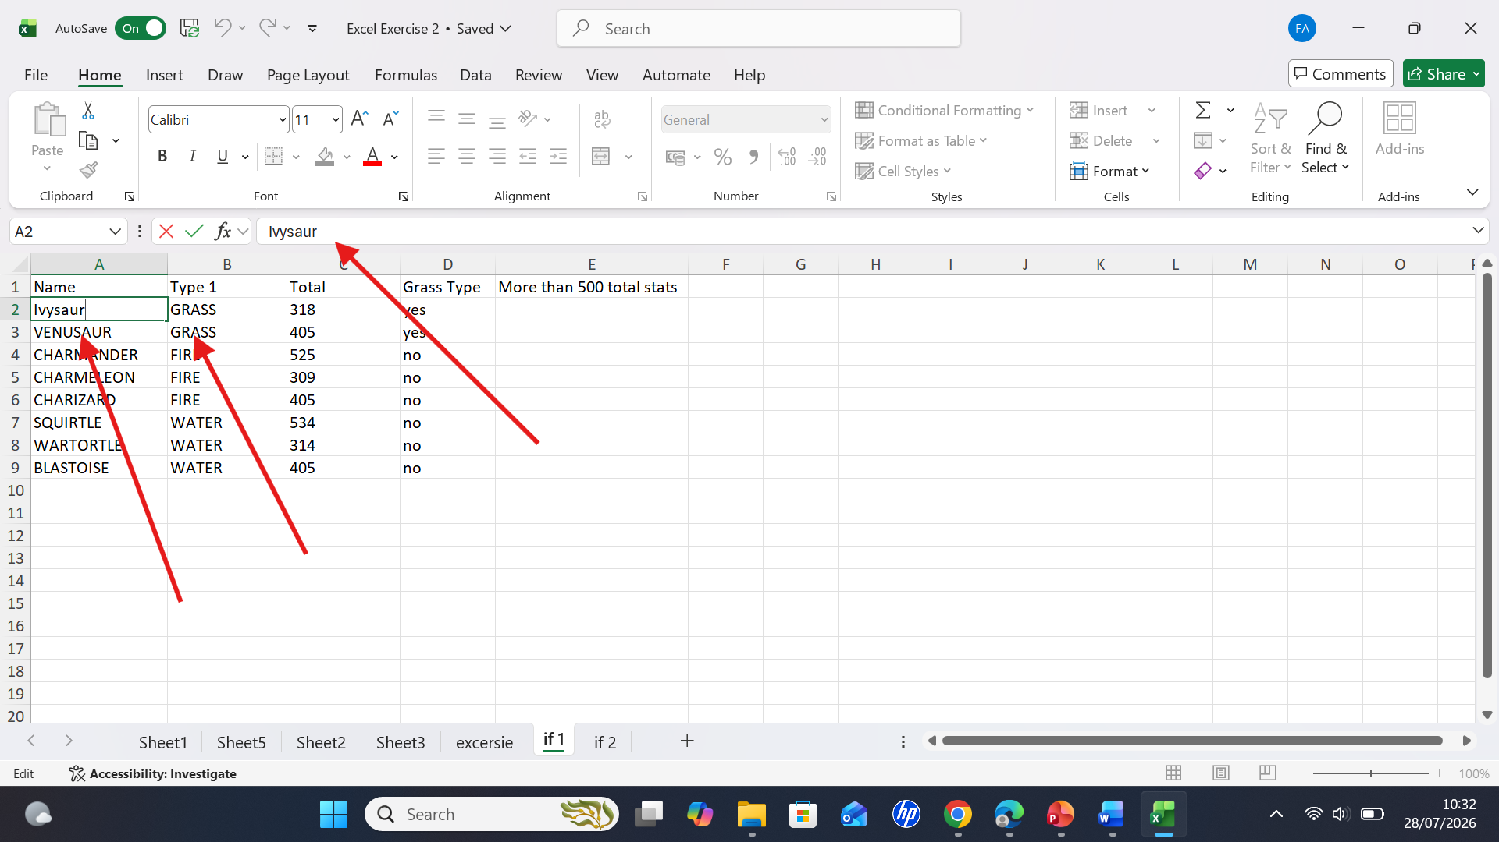
Figure 2: Entered data in the cell.
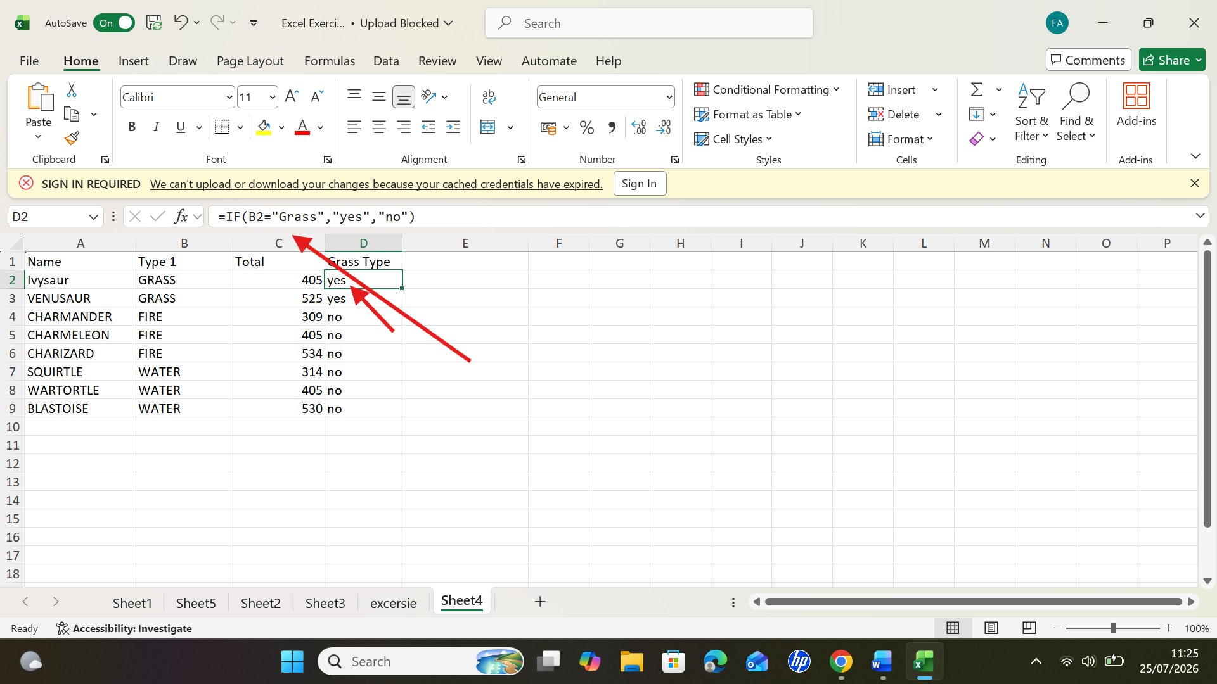
Figure 3: I wrote my data and used IF formula to find out which ones are Grass.

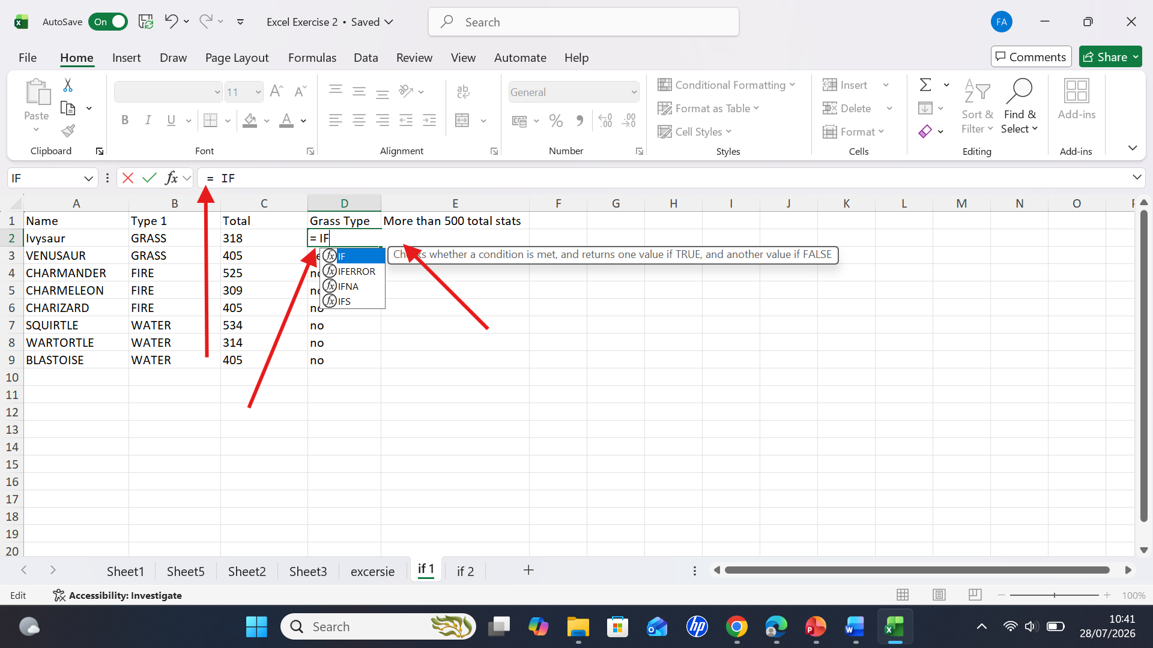
Figure 4: Select the cell D2 and type =IF. Double click IF command

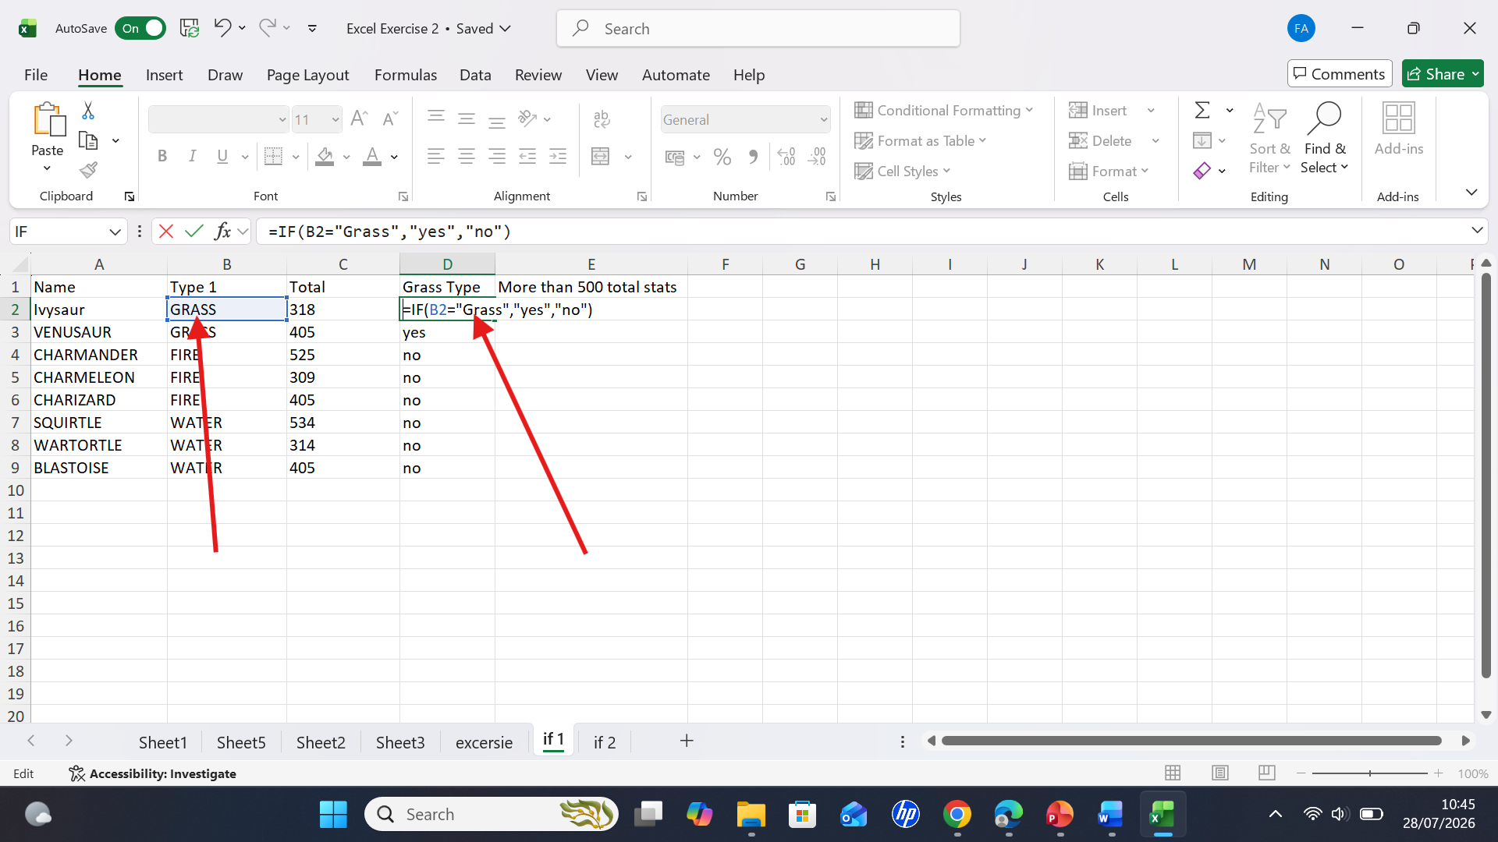Figure 5: Specify the condition B2= “Grass” and type koma (sign) specify the value “Yes”for when the condition is TRUE. Type koma (sign) Type “no” for when the condition is FALSE, 9. Hit enter.
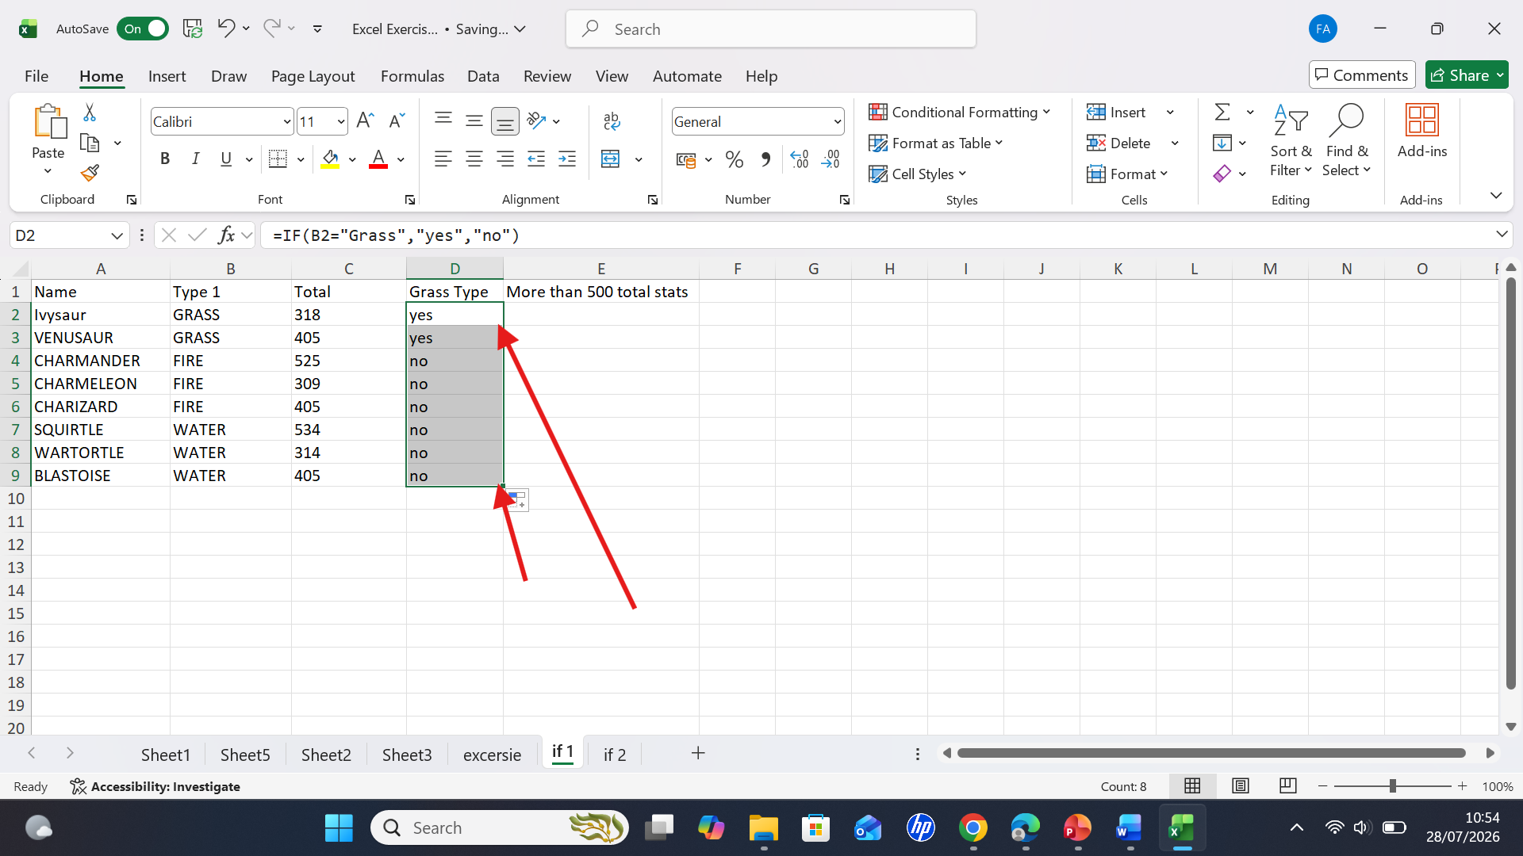
Figure 6: Select the first answer on D1 and drag it down then it all automatically find out how many grass I have on my data.

Task 4. Communication and Collaboration applications

4.1 One contemporary Communication and one Online Collaboration

Gmail

Figure 1. Logo of Gmail [28].
Gmail is a free web-based email service developed by Google that enables users to send, receive, and organise emails through a web browser or mobile application. Since its launch in 2004, Gmail has become one of the world's most popular email platforms because of its ease of use, reliability, and integration with other Google services. Unlike traditional desktop email programs, Gmail is a cloud-based service, which means that emails are stored securely on Google's servers instead of on a user's computer. This allows users to access their emails from any device with an internet connection, making communication more flexible and convenient.
One of Gmail's key features is its simple and user-friendly interface. Emails are automatically grouped into conversation threads, making it easier for users to follow discussions and keep related messages together. Gmail also uses labels and categories to help organise emails, allowing users to manage their inbox more efficiently. In addition, its advanced search function enables users to find emails quickly by searching for keywords, sender names, dates, or attachments. These features are especially useful for students and professionals who deal with large numbers of emails every day.
Another important advantage of Gmail is its integration with Google Workspace applications such as Google Drive, Google Calendar, Google Meet, and Google Contacts. Users can attach files directly from Google Drive, schedule meetings through Google Calendar, and join online meetings using Google Meet without leaving their inbox. This integration improves collaboration and productivity, making Gmail a valuable communication tool for educational institutions and businesses. Many organisations use Gmail because it supports teamwork and allows users to share information quickly and efficiently
Gmail also provides several security features to protect users’ personal information. It automatically filters spam emails and detects suspicious messages that may contain phishing attempts or harmful links. Google also offers two-factor authentication (2FA), which provides an additional layer of security by requiring users to verify their identity when signing in. Furthermore, Gmail encrypts emails while they are being transmitted, helping to protect sensitive information from unauthorised access. These security measures make Gmail a trusted platform for personal and professional communication [29].
Although Gmail is a popular and convenient email service, it has some limitations. The attachment size limit of 25 MB can make it difficult to share large files without using Google Drive. Gmail also raises privacy concerns because emails are processed by Google’s automated systems for security and smart features. The free 15 GB storage is shared across Google services, which can become insufficient for users with many emails and files. Additionally, Gmail depends on an internet connection and may not provide the advanced management features required by some large organisations [30].

Zoom

Screenshot 1: logo of Zoom [31].
Zoom is a cloud-based video communication platform that enables users to supervised online meetings, webinars, and virtual discussions through video, audio, and chat features. Developed by Zoom Video Communications and launched in 2011, it has become one of the most widely used platforms for online communication. Its popularity grew significantly with the increase in remote working and online education, as it allowed people to communicate and collaborate without being physically present in the same location. Zoom can be accessed through computers, tablets, and mobile devices, making it a flexible and convenient tool for individuals, educational institutions and businesses.
One of the key advantages of Zoom is its simple and user-friendly interface, which allows users to join meetings easily through a shared link without requiring advanced technical skills. The platform offers several features that support communication and teamwork, including screen sharing, meeting recordings, breakout rooms, virtual backgrounds, and instant messaging. Screen sharing is particularly useful for presentations, training sessions, and group projects because it enables participants to view and discuss documents or applications in real time. Breakout rooms also improve collaboration by allowing larger meetings to be separated into smaller groups for focused discussions. These features have made Zoom a valuable tool for online learning, workplace meetings, and remote teamwork.
Another important benefit of Zoom is its ability to support real-time communication between people in different locations. In education, it allows teachers and students to interact through virtual classrooms, share resources, and continue learning remotely. In professional environments, Zoom helps employees communicate, attend meetings, and collaborate on projects regardless of geographical distance. Zoom became an important platform for virtual meetings and e-learning by helping organisations and educational institutions maintain communication when face-to-face interaction was limited. Zoom also provides security features to help protect users and online meetings. Features such as meeting passwords, waiting rooms, and participant controls help prevent unauthorised access and improve privacy. These features are particularly important when Zoom is used for professional discussions, business meetings, or online education.
Zoom has its challenges such as the quality of video and audio depends heavily on internet connection speed, meaning users with weak or unstable connections may experience delays, poor-quality video, or interruptions. The free version of Zoom also has restrictions on meeting duration and participant numbers, which may not be suitable for larger organisations or longer sessions. Users need to manage meeting settings carefully because incorrectly shared links or security settings may create privacy risks.
In summary, Zoom serves as an effective platform for digital collaboration, supporting distance education, remote working, and group projects. Despite certain limitations, its accessibility, rich functionality, and capacity to connect people across locations have established it as a key tool in modern communication [32].

4.2 One feature of a Communication (1) and one feature of a Collaboration (1) application

Gmail
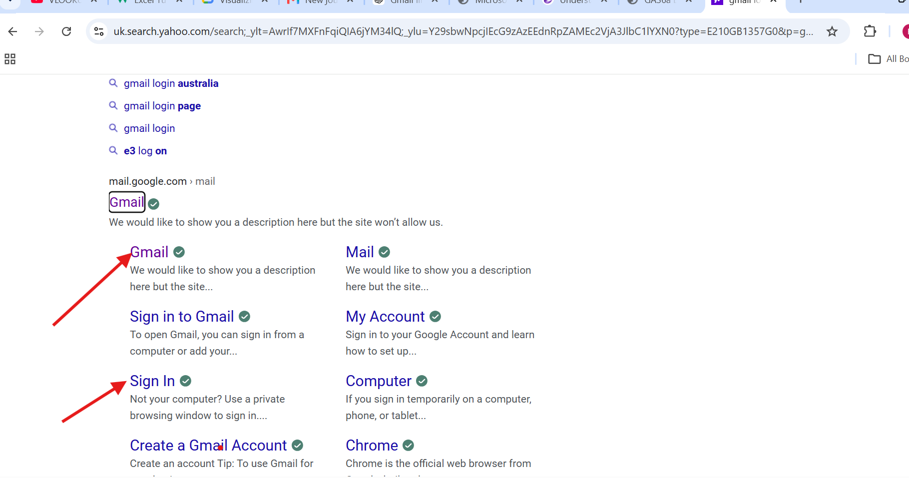
Figure 1: I have searched for Gmail on Google, signed into Gmail account.

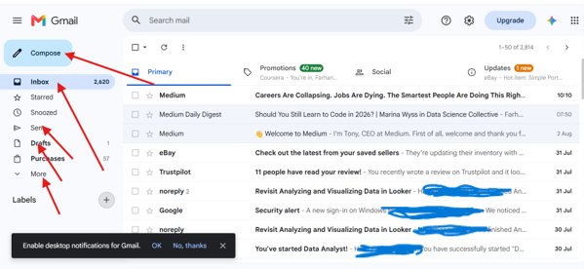
Figure 2: showing some features on Gmail.

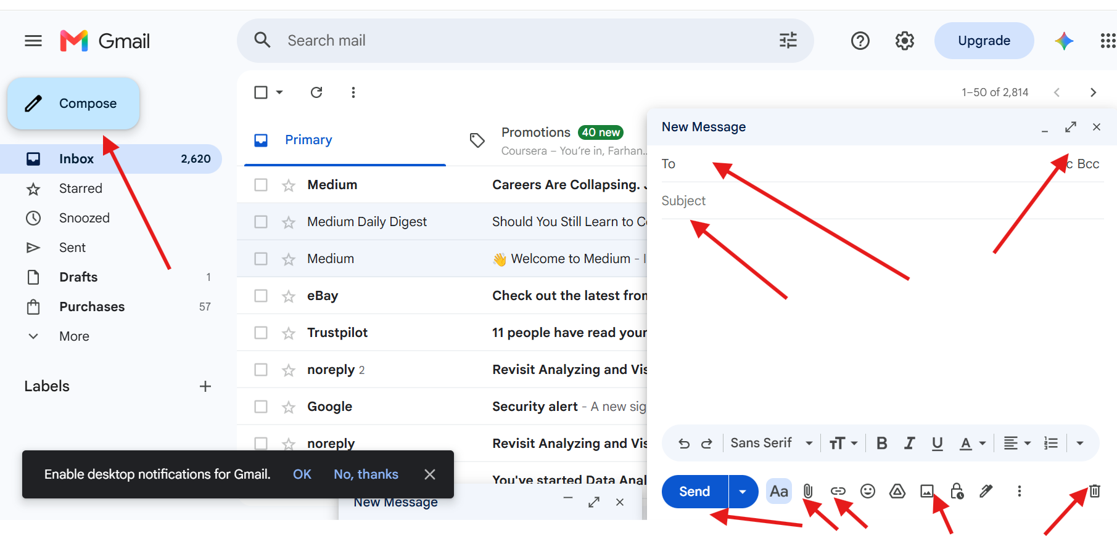
Figue 3 : I have chosen to compose an Email. I can attach a file, add other people on CC etc.

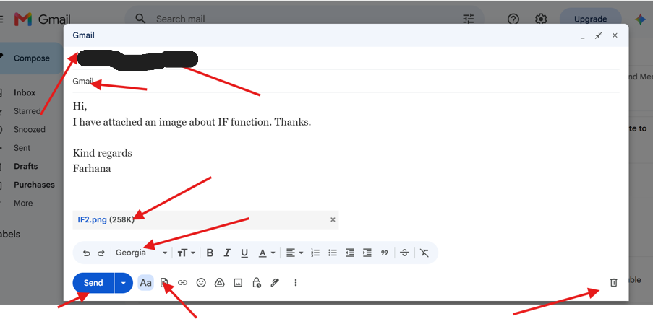
Figure 4: demonstrates how Gmail allows users to compose a professional email by entering recipients, adding a subject, writing a message, attaching files, formatting the text, & sending the email.
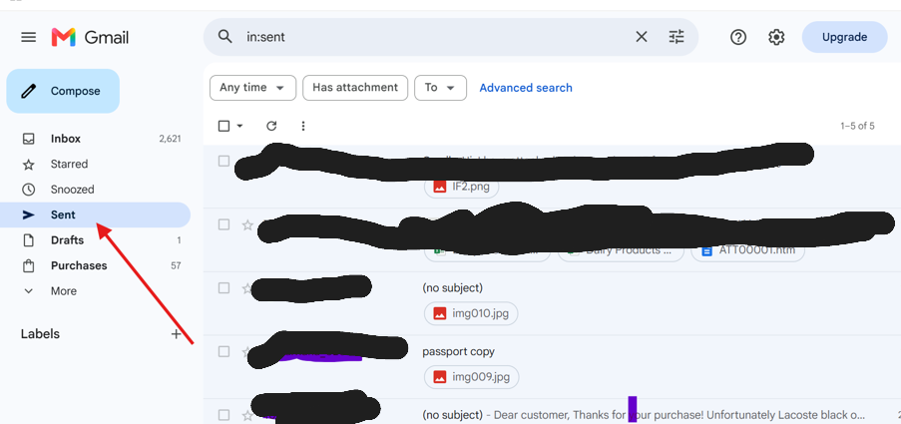
Figure 5: a confirmation that the email has been sent (Sent folder).

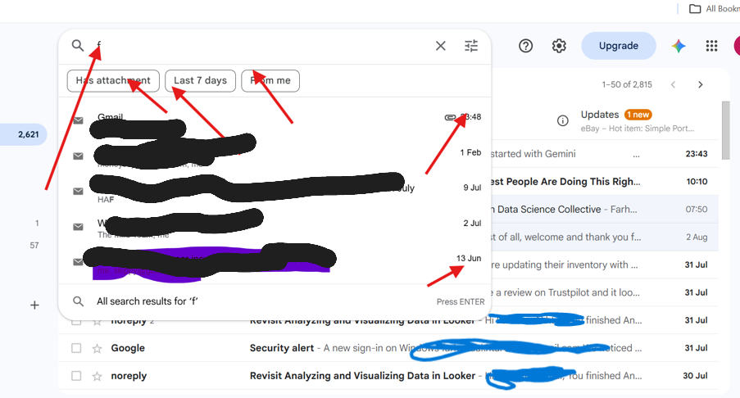
Figure 5: I have used the search bar at the top of Gmail to search for an email by keyword, sender, or subject.

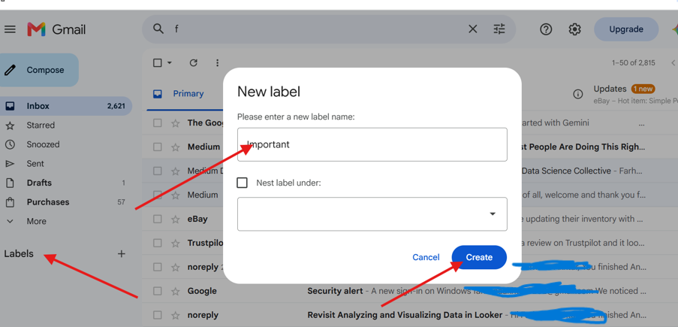
Figure 7: Shows how to create an email label & given the file name “important”. Then changed name to university.
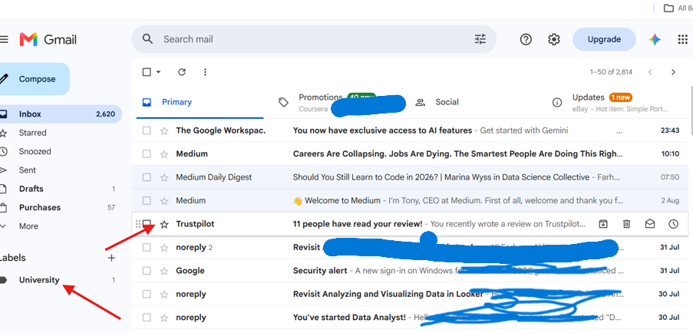
Figure 8: I have created the file and selected the email I wanted to move to the folder & drag it.
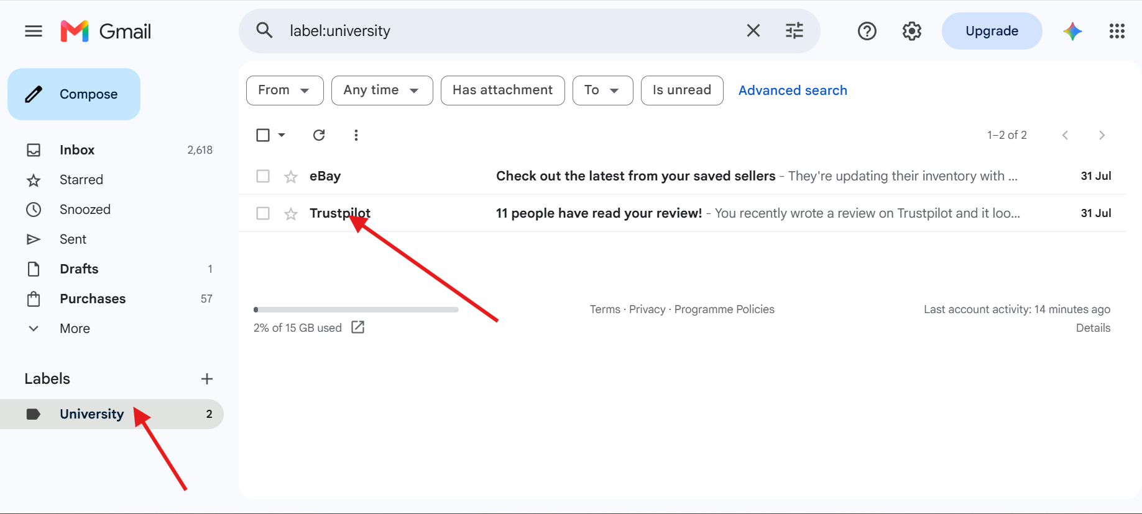
Figure 8: I can see the selected email has been now moved. Example on labelled and organised email.

Zoom
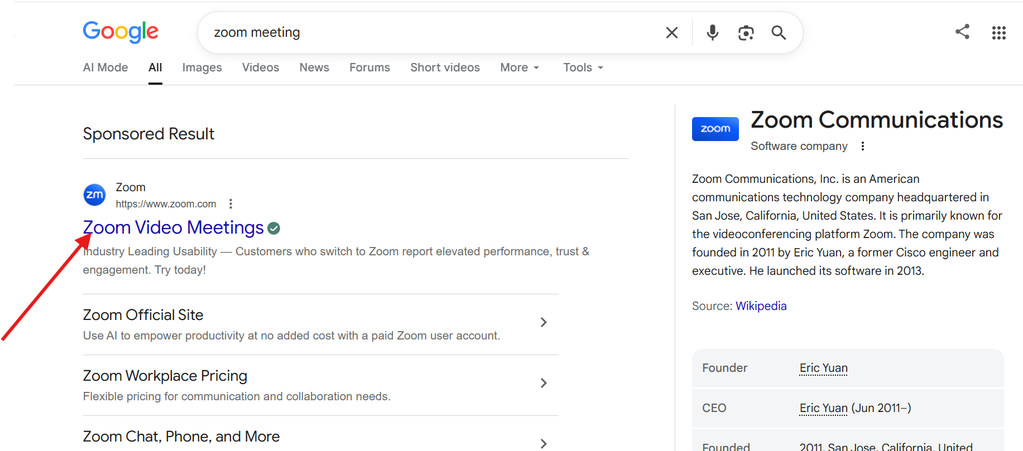
Figure 1: Searched zoom meeting on Google.
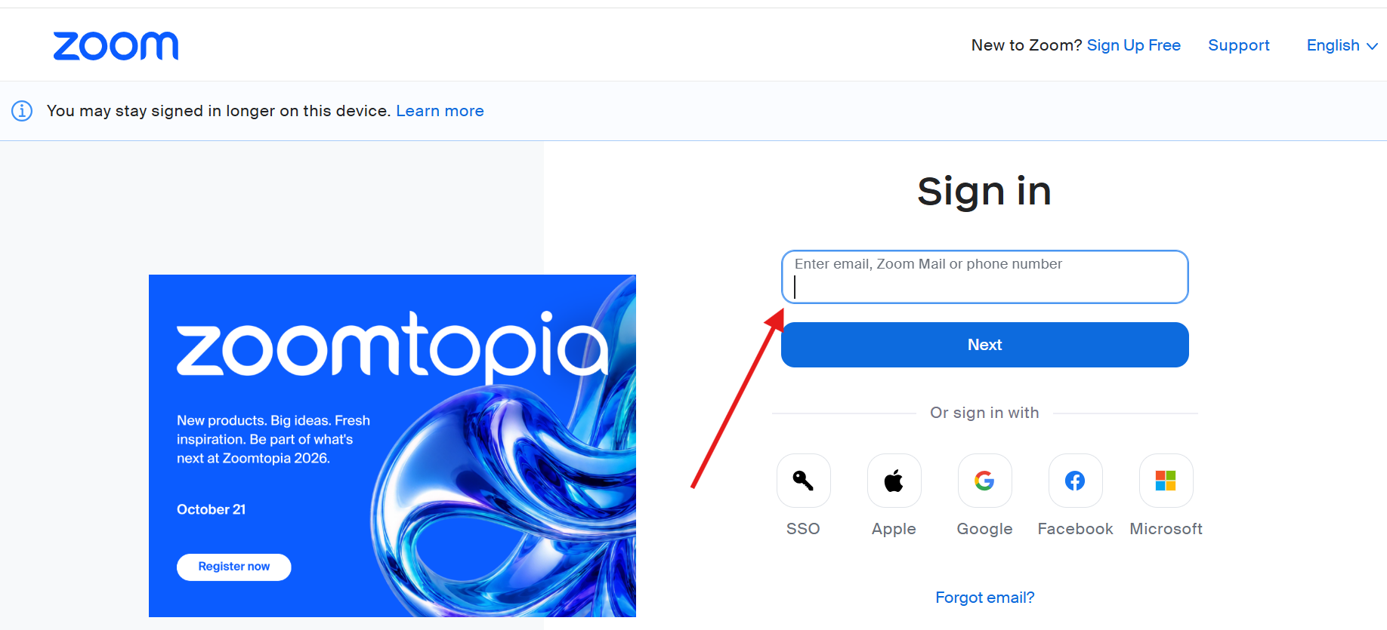
Figure 2: Signing with my email.
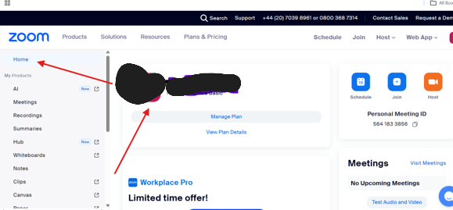
Figure 3: Homepage for Zoom.
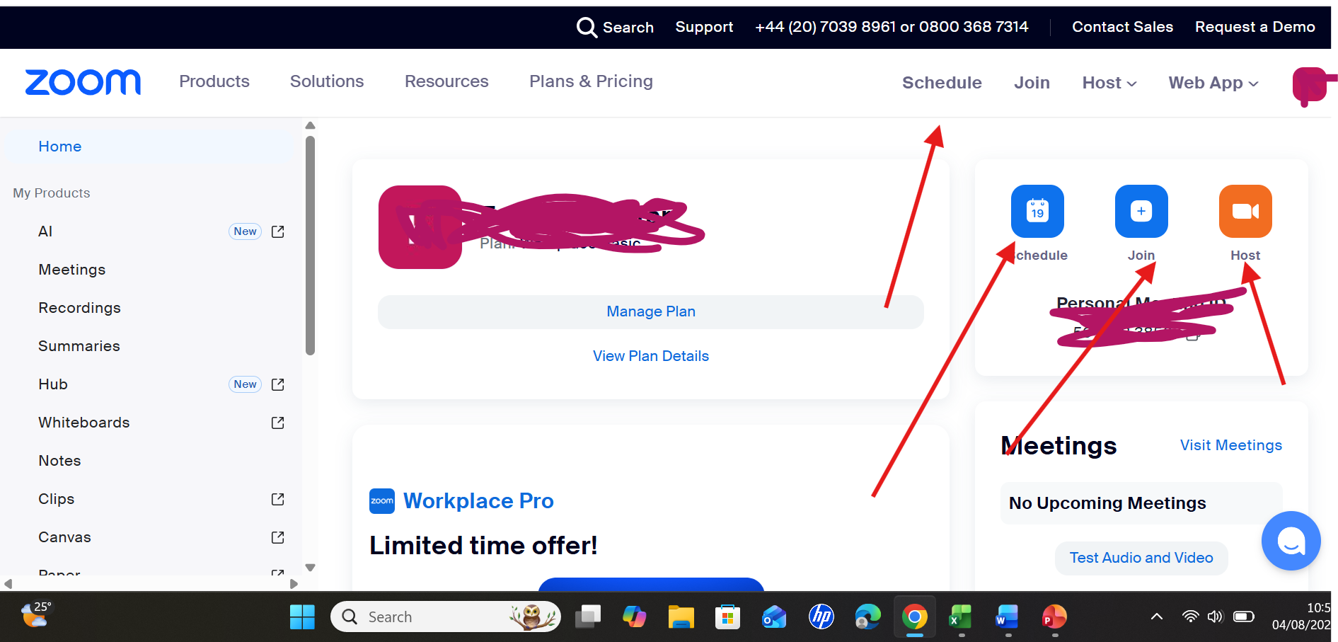
Figure 4: scheduling a meeting by clicking on schedule.
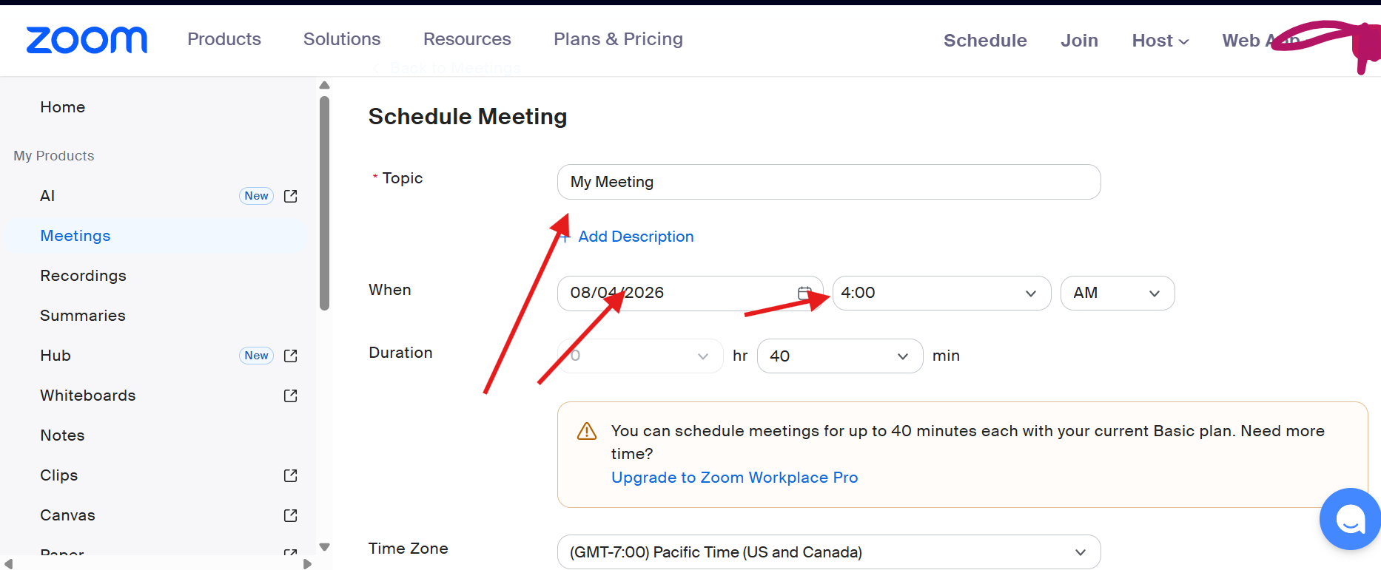
Figure 5: scheduled a meeting and created a link to share with other people out of contact list.
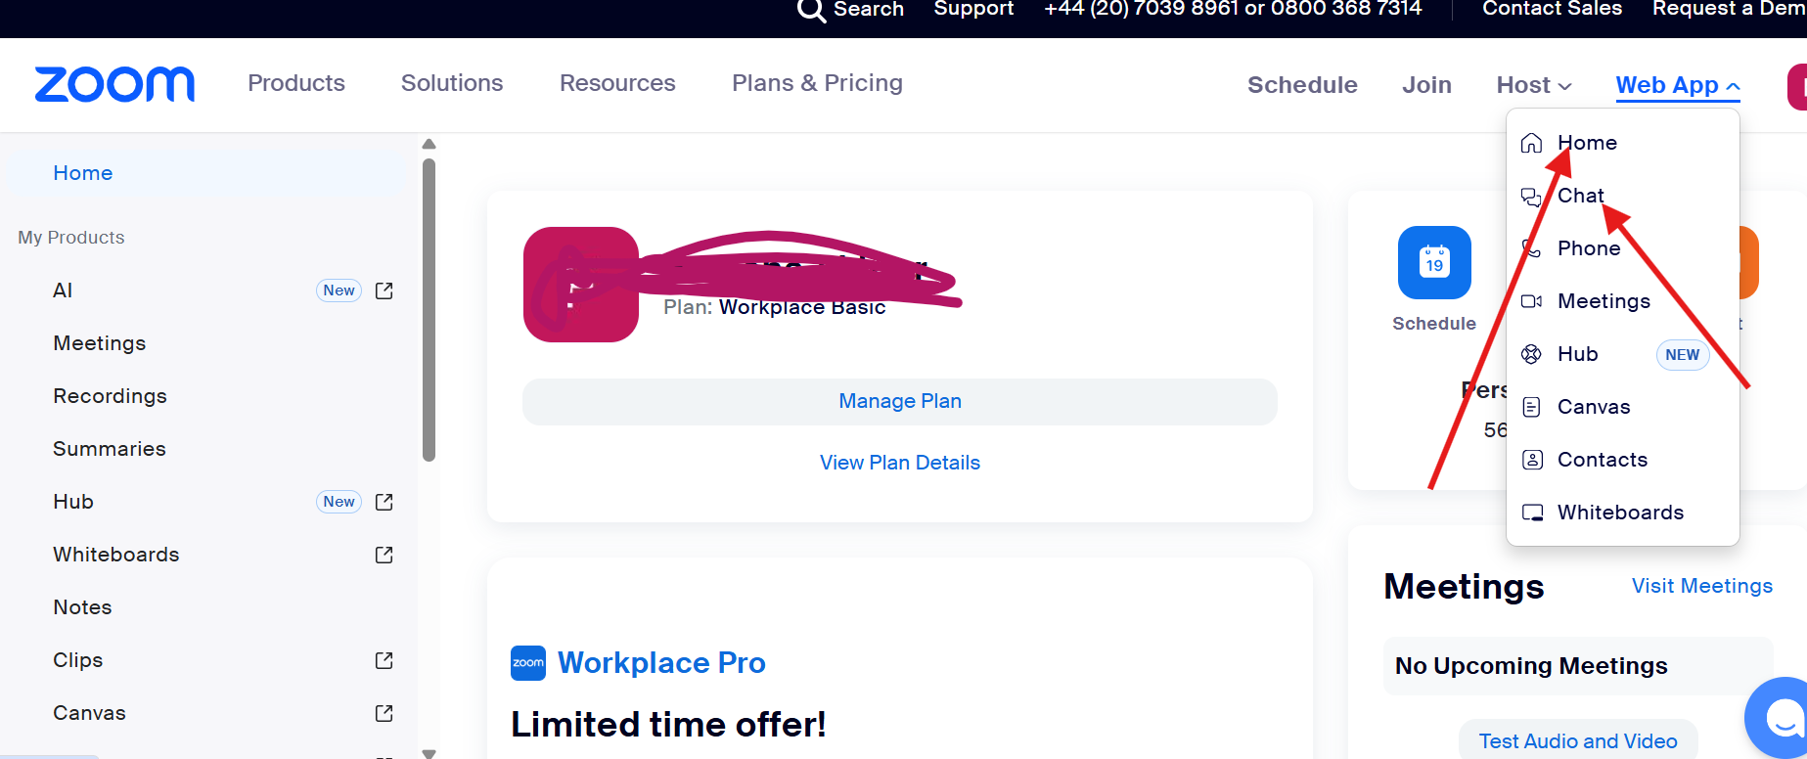
Figure 6: chat with my contact list.
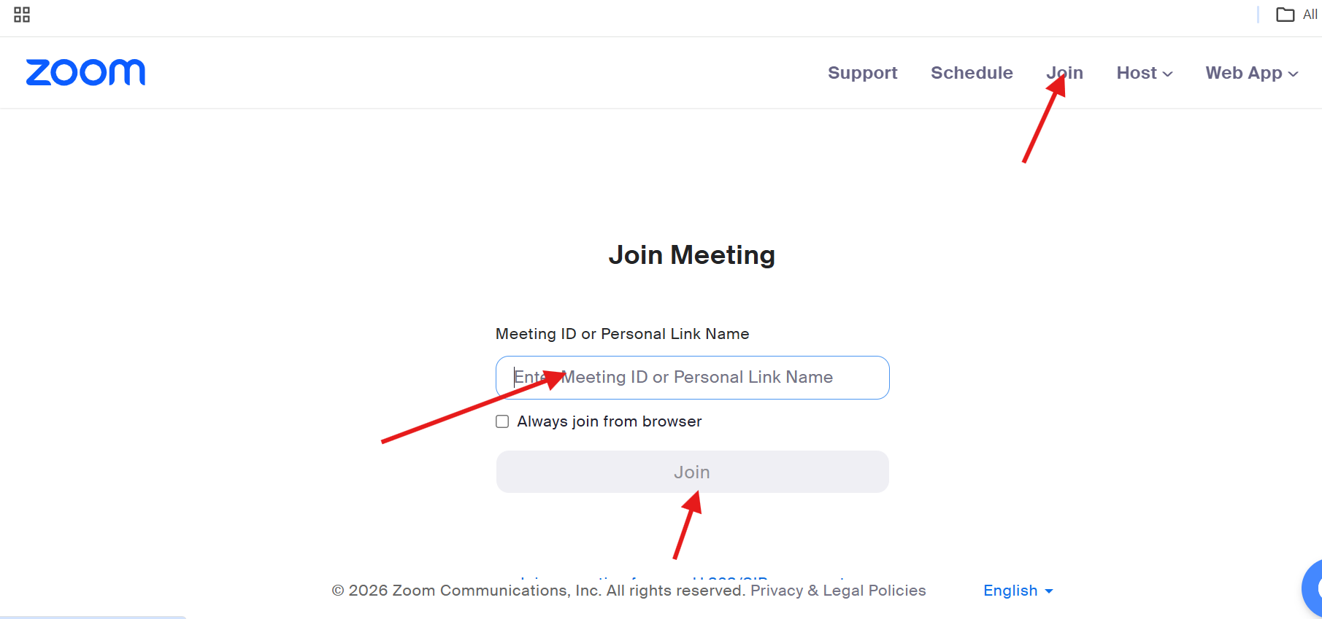
Figure 7: joined with a meeting ID or link.
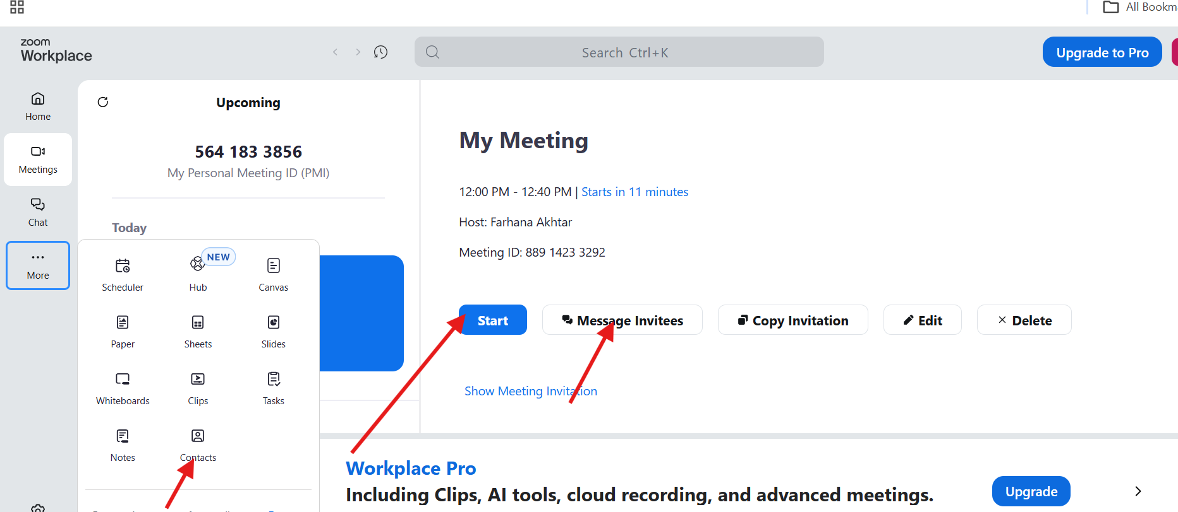
Figure 8: This screen lets you view, edit, share, or start a scheduled meeting. The most important button is Start — click it when you're ready to begin.
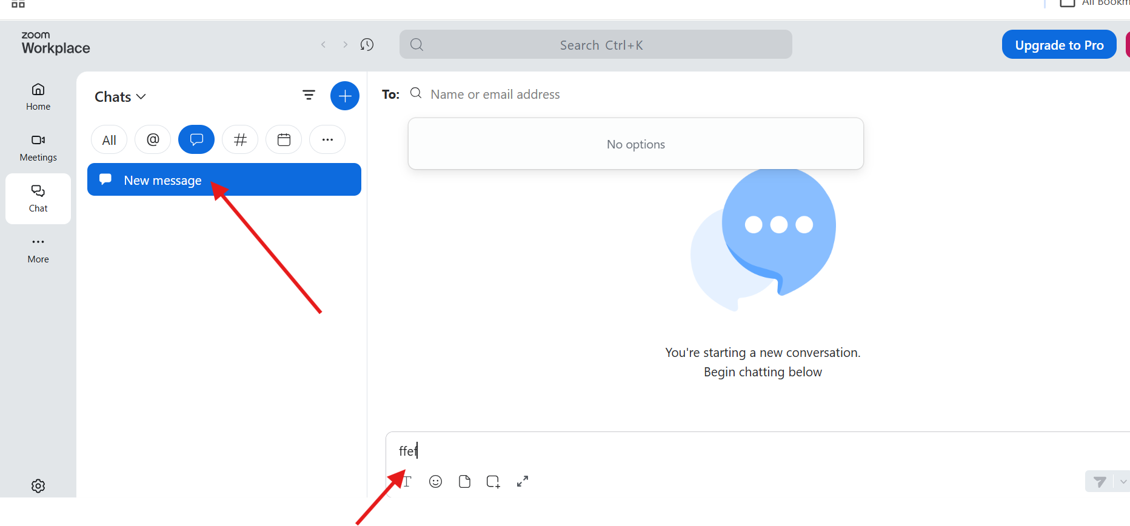
Figure 9: I can chat during meeting.

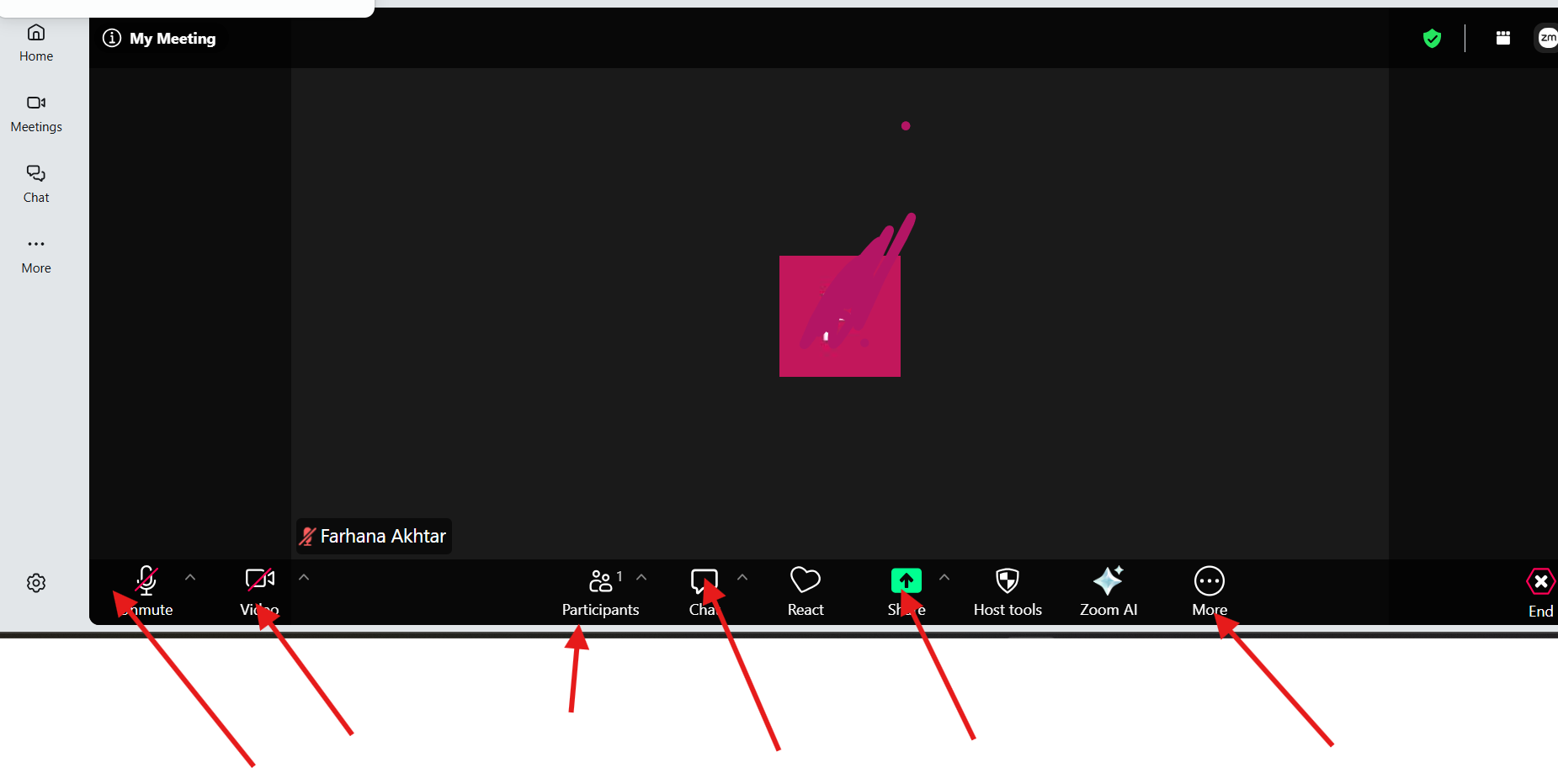
Figure 10: Zoom meeting screen where I can mute mic, turn off camera and share file, chat during the meeting.
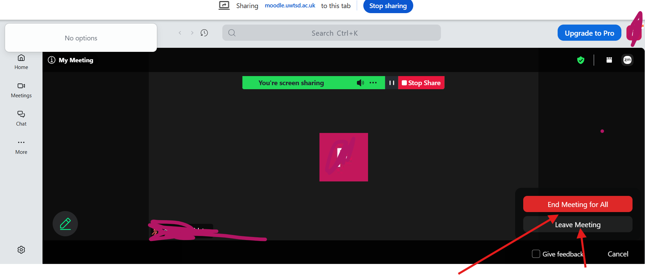
Figure 10: ending the meeting.

Conclusion
Overall, completing these four tasks helped me understand how different software applications are used in modern businesses. I learned about e-Commerce website builders, mind mapping, Microsoft Office applications, and communication and collaboration tools. I also had the opportunity to practise Excel features such as IF functions and VLOOKUP, which helped me become more confident when working with data. I realised that I still need to improve my Excel skills, especially when using more advanced functions and data-analysis tools.
One of the main difficulties I experienced was finding reliable sources about the advantages and disadvantages of the four Microsoft applications. There was plenty of information online, but not all of it was suitable for academic work. I also found it challenging to stay within the required word count and use IEEE referencing correctly. To improve in the future, I would start my research earlier and make greater use of academic sources. I would also practise Excel more regularly. Overall, these tasks have increased my confidence and helped me develop skills that will be useful in my future career as a Data Analyst.

References

[1] | E. Oduncu, “Website building tips: boost your Wix site’s performance and engagement,” WIX, 18 11 2025. [Online]. Available: https://www.wix.com/blog/website-building-tips. [Accessed 12 July 2026].
[2] | S. Analysis, “Stock Analysis,” [Online]. Available: https://website-builders.cybernews.com/wix-review/ . [Accessed 30 june 2026].
[3] | M. S. Iskandar and S. W. Adhayani, “Analysis of Utilizing Website in Designing Online Store Site,” in IOP Conference Series: Materials Science and Engineering, Bandung, Indonesia, 2018. [Accessed 18 June 2026].
[4] | Shopify. [Online]. Available: https://www.shopify.com/uk/blog/what-is-shopify#5. [Accessed 1 July 2026].
[5] | F. Akhtar, “Wix Studio,” Wix, [Online]. Available: https://farhanaakhtar0202.wixstudio.com/party-shop .
[6] | Shopify, “Shopify store examples,” Shopify, 20 June 2026. [Online]. Available: https://www.shopify.com/uk/examples. [Accessed 20 June 2026].
[7] | Shopify Theme Customization with Liquid: Design state-of-the-art, dynamic Shopify eCommerce websites using Liquid's powerful features, Birmingham: Packt, 2021.
[8] | Shopify, “Shopify,” [Online]. Available: https://www.shopify.com/uk/compare/shopify-vs-wix#content-2. [Accessed 01 July 2026]. [Accessed 15 June 2026].
[9] | T. B. Avgoustos A. Tsınakos, “A Comparative Survey On Mind Mapping Tools,” Turkish Online Journal of Distance Education (TOJDE), vol. 10, no. 3, pp. 55-67, 20 September 2009. [Accessed 20 June 2026].
[10] | T. Buzan and C. Griffiths, Mind Maps for Business: Using the Ultimate Thinking Tool to Revolutionise How You Work, 2 ed., Harlow: Pearson Education Limited, 2014. [Accessed 22 June 2026].
[11] | AllPNGFree, “Microsoft Word Logo PNG – MS Word Icon Transparent Image,” AllPNGFree, 2 June 2026. [Online]. Available: https://allpngfree.com/view?n=SZ80. [Accessed 2 July 2026].
[12] | Washington State Board for Community and Technical Colleges, “Chapter 7: Microsoft Word,” OpenWA, [Online]. Available: https://openwa.pressbooks.pub/bustechessentials/chapter/chapter-7-microsoft-word/. [Accessed 2 July 2026].
[13] | T. i. Hindi, “What is MS Word and Its Features?,” 25 09 2020. [Online]. Available: https://getcomputercourse.wordpress.com/2020/09/25/what-is-ms-word-and-its-features/. [Accessed 30 June 2026].
[14] | WTCS , “Formatting Text in Word,” Wisconsin Technical College System, [Online]. Available: https://wtcs.pressbooks.pub/digitalliteracy/chapter/formatting-text-in-word/. [Accessed 30 June 2026].
[15] | L. World, “Microsoft Teams Logo,” Logos-World, 13 09 2025. [Online]. Available: https://logos-world.net/microsoft-teams-logo/. [Accessed 5 July 2026].
[16] | B. A. Chaushi, “MS Teams for Virtual Collaboration — An Overview,” in 4th International Conference on Educational Technology and Online Learning (ICETOL 2024), 2024. [Accessed 5 July 2026].
[17] | B. Anderson, “How to Use Microsoft Teams,” Beltan Consultancy, 19 11 2025. [Online]. Available: https://www.beltan.com.au/how-to-use-microsoft-teams/ . [Accessed 5 July 2026].
[18] | W. Foundation, “Microsoft Office Excel (2025–present) logo file,” Wikimedia Foundation, 01 10 2025. [Online]. Available: https://en.wikipedia.org/wiki/File:Microsoft_Office_Excel_%282025%E2%80%93present%29.svg. [Accessed 7 July 2026].
[19] | C. M. Rebman Jr., Q. E. Booker, H. Wimmer, S. Levkoff, M. McMurtrey, and L. M. Powell, “An Industry Survey of Analytics Spreadsheet Tools Adoption: Microsoft Excel vs Google Sheets,” nformation Systems Education Journal (ISEDJ), vol. 21, no. 5, pp. 29-41, 2023. [Accessed 7 July 2026].
[20] | Microsoft, “Get Started with Copilot in Excel,” Microsoft, 2026. [Online]. Available: https://support.microsoft.com/en-us/excel/copilot/get-started-with-copilot-in-excel?culture=en-gb&country=gb. [Accessed 9 July 2026].
[21] | T. Singh, “Advantages & Disadvantages of MS Access,” ScaleUpAlly. [Online]. Available: https://scaleupally.io/blog/advantages-disadvantages-of-ms-access. [Accessed 9 July 2026].
[22] | Training NYC, “Excel User Interface,” Training NYC, 08 04 2021. [Online]. Available: https://training-nyc.com/learn/excel/user-interface. [Accessed 9 July 2026].
[23] | Microsoft (logo creator), “Microsoft Office PowerPoint (2025–present) logo,” Wikimedia Foundation, 2025. [Online]. Available: https://upload.wikimedia.org/wikipedia/commons/d/df/Microsoft_Office_PowerPoint_%282025%E2%80%93present%29.svg. [Accessed 11 07 2026].
[24] | L. Bothell, “Chapter 9: Microsoft PowerPoint,” in Business Technology Essentials, Olympia, OpenWA, 2023. [Accessed 12 July 2026].
[25] | Brandlogos.net, “Brandlogos.net,” 2025. [Online]. Available: https://brandlogos.net/microsoft-access-logo-vector-101066.html. [Accessed 15 July 2026].
[26] | P. Beynon-Davies, “Microsoft Access,” in Database Systems, Palgrave, 2004, p. 446–456. [Accessed 15 July 2026].
[27] | M. Schmalz, Integrating Excel and Access: Combining Applications to Solve Business Problems, California: O'Reilly Media, Inc., 2006. [Accessed 16 July 2026].
[28] | Dezeen, “Gmail logo gets new look as part of Google Workspace rebrand,” London, 2020. [Accessed 20 July 2026].
[29] | S. Schwartz, Google Gmail: Visual QuickStart Guide. Berkeley, California: Peachpit Press., 2004. [Accessed 20 July 2026].
[30] | S. Lemhandez, “Gmail limit 101: Common error messages and daily send limits,” Folk, 2026. [Accessed 20 July 2026].
[31] | S. Sande, “The Zoom Meeting Master Class: Better Picture, Sound, Screen Sharing & More,” OWC (Other World Computing), 2021. [Accessed 25 July 2026].
[32] | K. E. A. a. O. A. Abiodun, “Usage of Zoom Cloud Meeting for Virtual Meetings and E-Learning,” in Sustainable Development Goals Paradigm Shift: An Educational Approach, The Green Institute, 2018, pp. 1-13. [Accessed 29 July 2026].

Appendices

Appendix 1: Key Features of Wix.
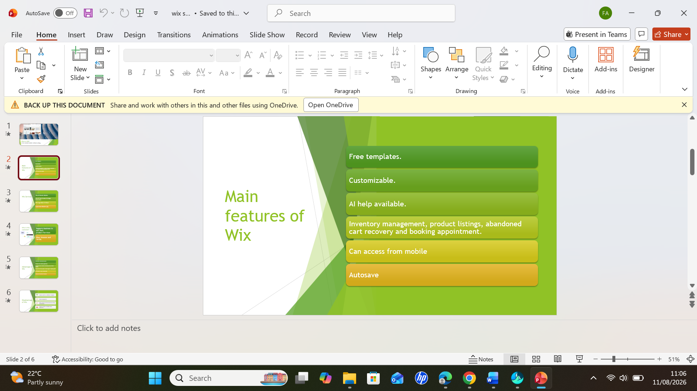

Appendix 2: Average formula.
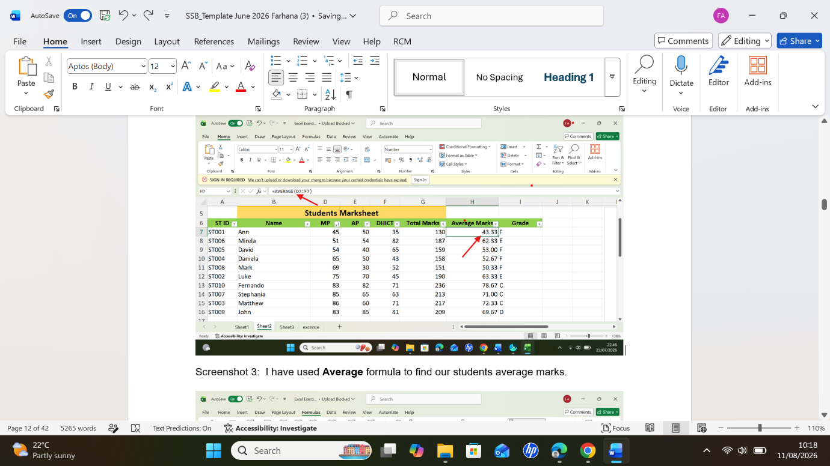

Appendix 3 : Auto sum formula.


