

Oliver Bowen.

P152150

HND Quantity Surveying (Year 1)

Procurement Method and Project Development

M5X01876

Dr N Tobin

Submission Date: 22/02/2019

Table of Contents
1. Introduction
2. Procurement Method
3. Structure of Project Team
4. The stages through which the project will progress up to Pre-Construction
5. Key Resources required at each stage and the involvement of personnel involved.
6. Bibliography

1.0 Introduction
The objective for this assignment is to undertake the role of a project manager for Rosko Pension Group. They specialise with pensions and investments. Rosko Pension Group are planning to construct a private hospital in order to sell it on after the building works are completed as a money-making exercise. The new development will be supported from members of Rosko Groups personal investment funds. There is a high demand for these types of facilities in recent times and it is seen as a good way to make a profit on an investment.
Throughout this assignment I will be acting as a project manager for Rosko Pension Group. It is my responsibility to incorporate a report for the type of procurement that would be best suited for this construction. I will also be suggesting the structure of the project team for the whole duration of this project. The report will also focus on the stage by stage advancement of the project up to pre-development stage and the key assets required at each phase of the venture's life.

2.0 Procurement Method
When choosing the type of procurement method, it is important to consider all potential methods. The chosen procurement method should follow a procedure which fits the project objectives of the client. Considerations such as the overall costs of the construction, the time and speed it will take for the construction to be built, also the quality in which the client may expect from the building and any potential risk the client is willing to commit to. These are some of the main aspects to consider when choosing a method of procurement.
Rosko Group intend to construct a new hospital on the investments of their members I am suggesting that the traditional method of procurement is carried out on this project, this method is also known as Design, Bid & Build. Rosko group will have distinct contracts for the design and construction stage. DBB procurement will require Rosko Group to obtain a select group of consultants. These consultants would typically be responsible for the design and procurement stage creating specifications, drawings and bills of quantities. The consultants will also be responsible for determining the potential budgets, location of the site and quality of build. These consultants are usually made up of Project Managers, Estimators, Quantity Surveyors and Architects

There are many advantages in the Design, Bid and Build method of procurement which I why it is seen as the most popular form of procurement. This method allows the client to take control of the design element of the planned construction prior to the tender stage,
“The design is completed fully before the tender process commences. It affords the Client a great deal of control over the quality, specification and cost” (APUC 2018)
This allows Rosko Group to obtain a better understanding of exactly what the hospital may look like. This will also give Rosko Group a greater understanding of overall cost budget and quality. A significant factor in choosing the DDB method is that Rosko Group will be funding this project through the investments of its members. Therefore, traditional method of procurement is most suitable as it offers the lowest amount of financial risk. Lump sum contracts are common with this type of contract as a result the greater finical risk would be with the contractor rather than the client.
“It is considered to be a low risk method of contracting for the client, as the contractor takes the financial risk for construction” (Design Building 2018)
This reassurance of the projected costs before construction phase, a better knowledge of the design and quality stages lead to a lower level of risk associated with the project. This would suit Rosko Group more than any other type of procurement.
However, this is not to say that Design, Bid and Build doesn’t have any disadvantages. The successful contractor will have little or no say in the design which can lead to problems whilst construction is ongoing. Traditional procurement is also a longer process to that of other methods.
“The disadvantages of this procurement method revolve largely around time” (Property Pro 2018)
A Design and Build contract could get rid of these problems as they offer a much quicker construction phase. However, I feel the issue of construction time is not the greatest risk to Rosko Group. The greatest risk would be the uncertainly of the final costs of the purposed construction. Therefore, a traditional procurement method of Design, Build and Bid would be best suited for the new hospital and the investment of Rosko Group’s members.

3.0 Structure of The Project Team.
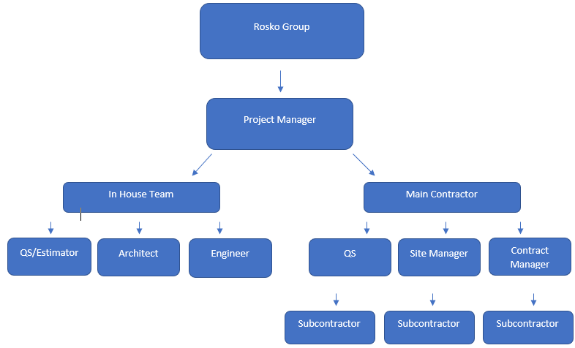
The structure of the project team is a vitality important factor in the construction running smoothly. The team must be correctly organised from the very beginning. The overall structure of the of the project team may change slightly throughout the construction process but the overall core of the team will remain the same as show in the diagram below.

Client
In more recent times the client has more of a hands-on approach with the project team liaising closely with the project manager. Rosko Group becoming more involved within the construction mainly to ensure they are getting value for money of their investors. Rosko Group will want reassurance that the quality of build is of a good standard and that the programme is running smoothly and on time.
Project Manager
As the project manager for this job it is my responsibility to oversee the whole project working closely with all parties to ensure a successful build of construction.
“A Project Manager is a key figure of any Service Team. They will be primarily responsible for the overall successfulness of delivering a project, reaching set targets both safely and correctly.” (Construction Chat 2016)

In House Team
The appointed architect and engineers make up the core of the design team. It is the architect’s responsibility to produce detailed design drawings as well as schedules and specifications. When designing these the appointed architect must take into consideration any special requirements the client has requested. The structural engineer’s role is also a vital one. Working closely with the architect to design machinal and electrical plans for the hospital as well as creating the skeleton design for the building.
Rosko Group will also approach a quantity surveyor to assist in the in-house team. A quantity surveyor has an important role to play as their expertise in cost construction will be vital in the early stages of the pre-construction process. The appointed QS will be responsible for putting together a cost plan for the hospital, as well as produce a bill of quantities making sure all dimensions are accurate, also he or she will advise on any cost changes that will occur due to any design changes. The quantity surveyor will assist in the preparation of contract documents with the design team. A quantity surveyor will also work closely with the main contractor, producing internal and external valuations.
Main Contractor and Sub-Contractor
The successful contractor will work as a representative for the client overseeing the whole project and managing all aspects of the build using the architects and engineers design as a blueprint for the construction. The main contractor will also appoint sub-contractors to carry out specialist works on site such as Electrical, Mechanical, Groundworks, Roofing & External Windows and Doors. The contractor must be confident that these subcontractors are capable of carrying out the packages successfully as a poor subcontractor could delay programme.

A well organise project team is critical for the construction running correctly and on time. Each team knowing their own tole and responsibilities aids in a helping the project reach each stage of the build minimising and problems that may occur.
“Without it, teams and clients are exposed to chaotic management, unclear objectives, a lack of resources, unrealistic planning, high risk, poor quality deliverables, projects going over budget and delivered late.” (DPM 2019)

4.0 The stages through which the project will progress up to Pre-Construction.
There are four main stages that the project will go through up to the Pre-Construction on site. These include inception, feasibility, strategy and Pre-construction. They will follow the Royal institute of British Architects (RIBA) stages very closely.
Inception Stage
RIBA Stage 0
Strategic Definition

Feasibility Stage
RIBA Stage 1
Preparation & Brief
Strategy Stage RIBA Stage 2 Concept Design

Pre Construction Stage
RIBA Stage 3 & 4
Developed & Technical Design

The inception stage allows the client to establish the key project objectives by recognising and purifying the requirements of the construction before the design team is involved. The shareholders may be involved in the Inception stage as this will allow them to see if the project is a sound investment or not as a detailed projected analysis will be reviewed at this stage. The inception stage follows closely to the RIBA Stage 0 – Strategic Definition which was introduced in 2013 and is primarily more suitable for refurbishment rather than the purposed development of a new hospital.
“This is particularly relevant in the context of sustainability, when a refurbishment or extension, or indeed a rationalised space plan, may be more appropriate than a new building” (RIBA Plan of Work 2013)
Even though this new stage in the RIBA is mainly for a refurbishment scheme I feel it is necessary for this project as this project is funded on the money of shareholders and this gives them a greater understanding of what they are paying for.
The next stage up to pre-construction is feasibility and RIBA Stage 1 which focuses on the preparation and brief. There are a number of important factors that must be completed correctly throughout this stage in order for the remaining stages to tun as smoothly as possible. These can be categorised in two aspects. Firstly, a project team must be appointed and roles and responsibilities will be set.
“The importance of properly establishing the project team cannot be underestimated” (RIBA Plan of Work 2013)

The second aspect is the initial project brief and overall feasibility of the project. The brief will include potential budgets, risks and highlight key objectives. The project brief will confirm drawings and specifications that will aid the next stage of concept design.

The next stage which is Strategy is mainly driven forward by the project manager. Now that the Preparation and Brief stage has been concluded we can now focus on the strategy and concept design of the project. As the project manager it is my role to prepare an outline strategy for the development. The below diagram shows the typical stages of strategy for a construction project.
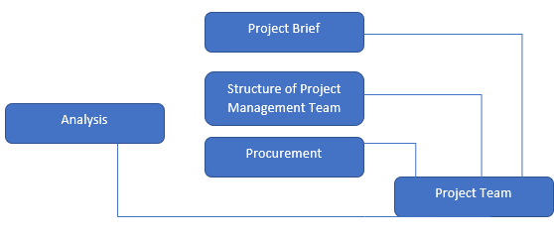
The project brief will be expanded on with the client and any changes that need to be made are done at this stage. The project team structure and roles will be highlighted to the client for clear reference of who is responsible for what work. The client team will also be assembled at this stage. A cost planning and budget strategy will be applied to determine overall all costs as well as the procurement strategy. Lastly contract duration and H&S files will also be implemented at this stage.
RIBA Stage 3 & 4 are the final stages up to Pre-Construction. The key factors of the design and develop stage are to further implement the key factors of the concept design stage. All engineering and architectural services should be final and all subcontractor and specialist packages need to be confirmed. This has been highlighted in several online publications.
“Prepare Developed Design, including coordinated and updated proposals for structural design, building services systems, outline specifications, Cost Information and Project Strategies in accordance with Design Programme” (Creative Architects 2019)
The preconstruction stage is used to finalise and agree tender documentation and design information with the client so the tender process can begin and a contractor to be appointed.
The ever-growing role of technology in construction is having a major influence on construction projects. The use of BIM allows for a visual of external and internal designs this can benefit all stages of the project life especially the concept design stage. BIM also offers the design team and client understand what is required as it aids in calculating room sizes, and the spaces within spaces such as the interior furniture. Seemingly the greatest influence BIM has is the ability to avoid human error and any changes that needed to be made whether design error or cost error can be done so easily. Previously this could be a very time consuming and costly processes. BIM certainly has the potential to rapidly improve every aspect of construction phase, the main problem is that not every company or organisation is fluent in BIM. Not understanding how BIM works fully has the potential to cause problems. “BIM offers a lot of clear benefits, although to some they are not instantly recognisable or apparent”. (Academy Class 2018)

5.0 Key Resources required at each stage and the involvement of personnel involved.
Inception stage is the very beginning of the project. At this stage the key resources are that of the client and the appointed project manager. They will discuss what exactly is needed for the project, the key objectives the project must meet and the strategic brief.
In the feasibility stage the client and the project manager are joined by specialist contractors. The client and the project manager will plan the strategic strategy. They will gain the information necessary from specialist contractors. The most common specialist contractors are architects, surveyors and engineers. These specialists are needed to supply estimates for costs, drawings from the design team as well as studies on potential risks. This information is key for the concept design stage of the project. The client may also be able to call on their own in-house specialists they already employ such as Quantity Surveyors or Lawyers.
The key outline for the strategy stage is finalising the project and procurement strategy. The project team will also be implemented at this stage by the client and project manager who are an ever-present key resource throughout these stages. Many of the specialist used in the feasibility stage are also used within the strategy stage. One specialist that will be utilised is that of an environmental consultant. Their report will be used to determine the potential environmental strategy and sustainability. The project manager will be using the information from specialist consultants to prepare for the next stage.
In the pre-construction stage the PM, Client & Specialist Contractors are joined by a CDM Co-ordinator. The project manager must appoint and laisse with a CDM Co-ordinator due to regulations.
“The CDM co-ordinator's role is to advise the client on matters relating to health and safety during the design process and during the planning phases of construction” (Design Buildings 2015)
Subcontractors also play a role as a key resource in pre-construction. Certain subcontractor packages will be classed as specialist items such as external cladding. The appointed cladding contractor will aid in costs, design, risk assessments and method statements. Due to the complexity of this package the project manager must appoint a subcontractor to avoid high costs and poor quality.

Project Stages | Key Resources
Inception  RIBA Stage 0 | Client Team  Project Manager
Feasibility  RIBA Stage 1 | Client Team  Project Manager  Specialist Contractors
Strategy  RIBA Stage 2 | Client Team  Project Manager  Specialist Contractors
Pre-Construction  RIBA Stage 3 & 4 | Client Team  Project Manager  Specialist Contractors  CDM Co-Ordinator

6.0 Conclusion
Traditional procurement has been chosen as the method of procurement of design and build for the may reason that the contract will be a lump sum. This gives the investors a fixed figure of how much the project will cost. As the project manager I will be working closely with my client, design team and specialist contractors to ensure that we hit all objectives required in the stages leading up to the Pre-Construction. There are many key resources required throughout the project and the Project Manager is the most important role as they have a say in all aspects of the build.

6.0 Bibliography - As per order of appearance
(2016). Construction Project Manager Roles & Responsibilities. Available: http://www.constructionchat.co.uk/articles/project-manager-roles-responsibilities/. Last accessed 01/02/2019.

(2019). Why is Project Management Important?. Available: https://thedigitalprojectmanager.com/why-is-project-management-important/. Last accessed 02/02/2019.

(2016). RIBA Plan of Work 2013 Overview . Available: https://www.architecture.com/-/media/gathercontent/riba-plan-of-work/additional-documents/ribaplanofwork2013overviewfinalpdf.pdf. Last accessed 15/02/2018.

(2018). Guide to Procuring Construction Projects . Available: http://www.apuc-scot.ac.uk/uploads/Docs/pdf/Guide%20to%20Procuring%20Construction%20Projects%2029-6-11.pdf. Last accessed 19/02/2019

(2018). Traditional Contract For Construction. Available: https://www.designingbuildings.co.uk/wiki/Traditional_contract_for_construction. Last accessed 19/02/2019.

(2018). Procurement Methods: Advantages and Disadvantages. Available: https://propertylikeapro.com/procurement-methods/. Last accessed 02/02/2019

(2016). RIBA Plan of Work 2013 Overview . Available: https://www.architecture.com/-/media/gathercontent/riba-plan-of-work/additional-documents/ribaplanofwork2013overviewfinalpdf.pdf. Last accessed 20/02/2018

(2019). Technical Design for Construction. Available: https://kreativarchitects.co.uk/riba-stage-4b-technical-design-for-construction/. Last accessed 20/02/2019

(2018). The significance of BIM in UK. Available: https://www.academyclass.com/architecture-engineeringproduct-design/bim-significance-to-the-construction-industry/. Last accessed 20/02/2019.

(2015). CDM Co-Ordinator . Available: https://www.designingbuildings.co.uk/wiki/CDM_co-ordinator. Last accessed 14/02/2019

