WHSmith
C/o Senior Management
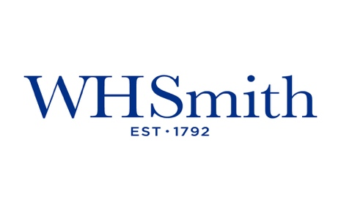

WHSmith Travel Plc:
Analysis of the Organisational Culture.

Amberlea Knowles
2116495
Word Count: 3601
Subject: Organisational Culture WHSmith Travel Plc.
Purpose: To Assess the culture and cultural climate at WHSmith Travel Plc through Schein’s ‘Pattern of Shared Basic Assumptions Model’ (Schein, 2004) and the impact on employee engagement, well-being, and organisational performance.
Recipients: Board and Senior Management team.
Recommendations/ Action: To note the content of the briefing and explore the implementation of the recommendations outlined for continued organisational success.

Subject: Organisational Culture WHSmith Travel Plc.
Purpose: To Assess the culture and cultural climate at WHSmith Travel Plc through Schein’s ‘Pattern of Shared Basic Assumptions Model’ (Schein, 2004) and the impact on employee engagement, well-being, and organisational performance.
Recipients: Board and Senior Management team.
Recommendations/ Action: To note the content of the briefing and explore the
1.0 Headline People statistics:
- Labour Turnover 65% for Store teams exc Management – 80% leave within first 3 months. (Fu, 2023)
- 50% LTO for Head off personnel (Fu, 2023)
- 10% internal progression FY21/22 (Scollen, 2023)
- 70% of employees have at least 2 absence occasions in six months (Fu, 2023)
- January – March 2023 – 34 grievances raised – (Scollen, 2023)
- 71% of store teams have completed mandatory training, and 2% have completed optional. (Fu, 2023)
1.1 Employee Engagement Survey headline results:
80% of Store Management reported feeling stressed and overwhelmed.
- 56% felt that they were not adequately supported by their line manager.
- 47% have or are considering leaving in the next year.
- 65% felt that they lacked autonomy and the ability to make decisions.
2.0 Securing future success:
Despite these insights, WHSmith Travel Plc delivered £73m profit in the last FY. (WHSmith, 2023). The External world is extremely volatile, and this has been exacerbated in recent times. The UK market has faced a pandemic, war, and economic crises in the last three years. (CIPD, 2023)
WHSmith Travel must continue to adapt and evolve to expand on the last decade's success. This review will outline the importance of promoting a good culture, how this can be linked with organisational success and, importantly, how this improves employee well-being and innovation.
High employee turnover, high grievance levels, low employee engagement scores and high levels of absence are key signs that there are issues with the organisation's culture; Instigation of investigation and the desire to change is critical. (Mayne,2023)

3.0 Contextual Overview of WHSmith Travel Plc (WHST):
WHSmith Group has been in operation for 230 years, founded in 1792. The Group has expanded exponentially during this time and has many arms of the business, including Highstreet, Travel, International and a vast range of online procurements such as Funky Pidgeon and Cult pens (WHSmith, 2023). WHSmith Travel was created as a separate business in 1997 and operates under a separate senior leadership team, although headed by the same CEO, Carl Cowling. (WHSmith, 2023) Operating more than 560 locations compromised of Airports, Railway stations, Hospitals and Motorway service stations, WHST is a complex business with various layers of intricacies not found in traditional Highstreet retailing, such as Airport and Railway security obligations and the importance of Landlord relationships to maintain operating tenders. In addition, WHST collaborates with other national brands such as Marks and Spencer, Costa Coffee, Well Pharmacy and The Post Office to diversify and capitalise on additional revenue. (WHSmith, 2022) WHST recorded operating profits above £73m in 2022 after challenging results in 2020/ 2021 when the business was adversely affected by the COVID-19 Pandemic. The overarching mission for WHST and the wider Group is to ensure shareholder value through an efficient business model with a profit focus.
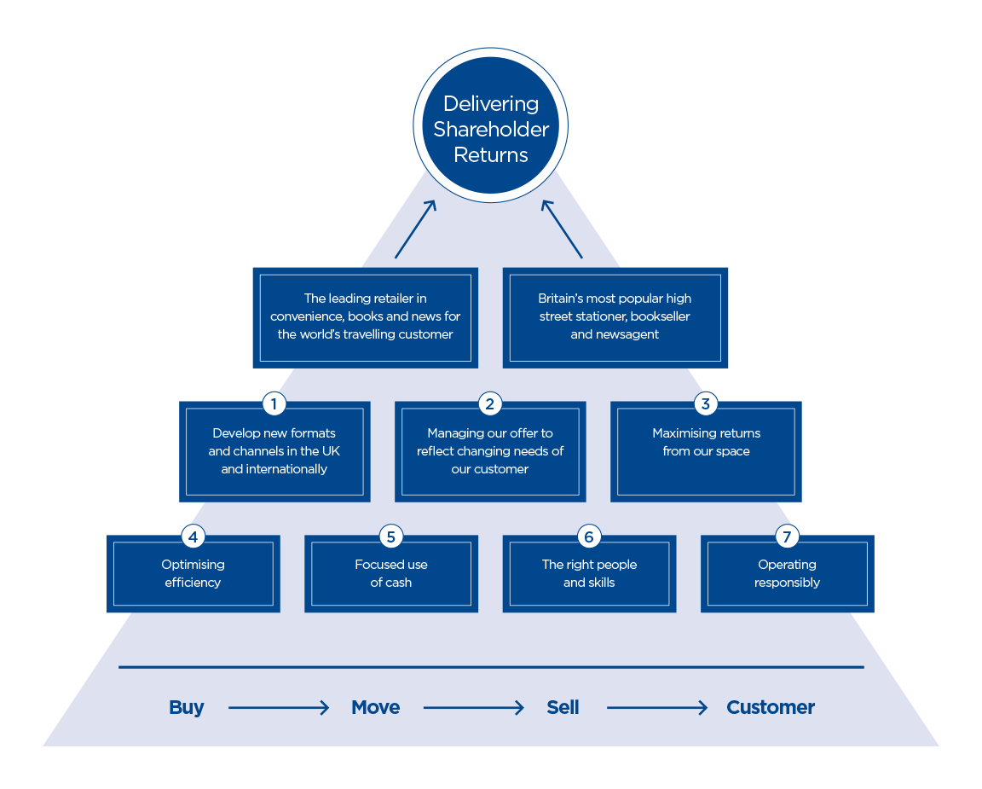
3.1 WHSmith Travel Strategy: (WHSmith, 2023).
4.0 Organisational Structure of WHSmith Travel:
As defined by Freedman (2023), the organisational structure is comprised of rules, relationships, roles, and responsibilities to meet overall objectives. The structure determines how information is gathered and shared and how the reporting relationships and approvals are formed. WHSmith Travel can be classified as a Centralised organisation (Hage &Aiken, 2014); decisions are made in a hierarchy, typically CEO/ director level. Employees at WHSmith do not influence business decisions that affect them. Friedman (2023) conceptualises that there are eight types of organisational structures due to the diversity of business practices. WHST is classed as a” Hierarchical structure” with Heads feeding information and collaborating in decision-making for their designated responsibility area. Disadvantages of this model, bureaucracy delays key decision-making and may cause employee dissatisfaction. Department heads will prioritise the growth of their responsibility and not the
Strategy:
Growing profit and constructing shareholder value. (WHSmith, 2023)

broader organisation resulting in stagnation. Reduces employee voice in decision-making and compromises innovation. (Wegner, 2020). Conclusions from a study into Organisational structure suggest that organisations may benefit from replacing hierarchical structures and greater flexibility in arrangements promoting flexibility and autonomy, thus improving innovation (Wegner, 2020).
5.0 Definition of Culture:
There are many definitions of Organisational Culture, and academics are yet to come to a universal definition due to the ambiguous nature of an abstract concept. (Tharp, 2019) A study in 1998 highlighted 54 definitions of Culture; an often cited and well-regarded purpose is that of Business Theorist,
5.1 Edward Schein (1985):
“a pattern of shared basic assumptions that the group learned as it solved its problems of external adaptation and internal integration, that has worked well enough to be considered valid and, therefore, to be taught to new members as the correct way to perceive, think, and feel about those problems”.

Dennison (1990) proposed a similar definition to Schein's, although it noted that the foundation for Culture is the organisation's management system for practices and behaviours reinforcing organisational principles.
There are many academic perspectives across all disciplines, such as sociology and psychology; however, there are some commonalities, “Shared meaning”, Culture as a social construct manipulated by the environment and behaviours. The final observation is that culture has many layers at all levels.
5.2 Cultural Climate:
Climate and culture are interchangeable (Glisson, 2015). Organisational culture, as outlined above, is, according to Glisson (2015), represented as behavioural norms and expectations. In contrast, Organisational climate can be defined as employees shared perceptions of the psychological impact of their working environment on their well-being. An example of a negative: The cultural climate is “Stressful” for the employee. Culture and Climate are closely interlinked and mutually influence each other (Young, 2020).

5.3 Subcultures: Regional, Department and store level:
DeLong and Fahey (2000); Trice and Beyer (1993) note that Subcultures consist of a set of values, norms and practices exhibited by specific groups or units within an organisation. Linking this theory to WHSmith, it is essential to note that many “subcultures” may exist. For example, the organisation of the hierarchy results in separate geographical areas assigned to different leadership teams. Differences in agendas and operational focusses may distort expectations of the organisation's objectives. This may also alter employee perceptions of the broader culture. Schein (2010) believes that identifying subcultures may be used to enact culture and change management and that radical cultural change can occur in specific subcultures and organisations (Trice and Beyer, 1993).

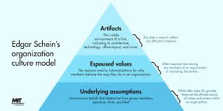
5.4 Schein’s Cultural Model Overview: [Fig 5.4.1]
Edward Schein's model of Organisational culture was theorised in the 1980s and is still relevant today (Cuofano, 2023). The Triangular framework, as depicted in Fig 5.41, comprises three layers; Artifacts, Physical or visible symbols of culture such as uniform, and organisational mission statements. (Millerd, 2022). The second layer, as depicted, Espoused Values, is often
how the organisation wants to be perceived and how it is introduced to external parties, such as in recruitment and selection (Millerd, 2022). According to Schein (1985), the final layer accurately reflects an organisation's culture and provides the most context: “Underlying Assumptions”. This is how employees understand how the organisation operates through unspoken rules and behaviours. (Schein, 1985).
5.5 Stages of Culture: (Schein, 2018)
Schein (2018) expanded on his research and analysed the “Stages of Culture” as depicted in [Fig 5.4.2]. For example, WHSmith Plc, founder of WHSmith Travel, has operated for 231 years (WHSmith, 2023);. However, many could argue that in the “maturity and Decline stage”, it is essential to note that the business was not separated until 1997 and has had several changes to organisational leadership.

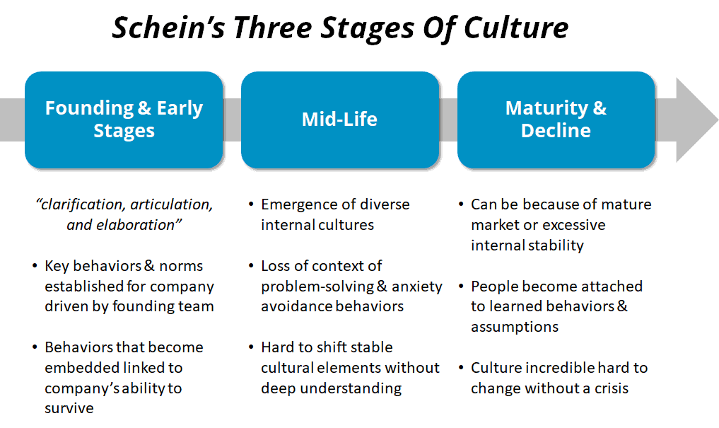
The current leadership has been in operation for seven years; for this reason, it could be theorised that WHSmith Travel, in its current form, is in the “mid-life” stage, although it could be argued that some underlying beliefs are in the latter stage. Schein (2018) expanded on his 1980s theory that changes in leadership shape and align culture, and culture is not adapted overnight, nor can it be changed overnight and is comprised of past work experiences. Schein, Quinn and Rohrnaugh (1983) believe there are three stages to organisational culture growth but note the formation of “subcultures” that exist alongside the macro culture. This can be evidenced at WHSmith, such as changes in behaviours and working practices in Head Office, regions, and stores.
Fig: 5.5.1
Fig 6.1
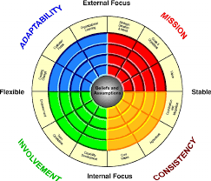
6.0 Critique Schein’s (1985) model vs Dennison's (1990):
Schein's cultural model and Denison's Organisational culture survey model help understand and manage organisational culture (Schein, 2010; Denison, 1990). While they share some similarities, they also have some key differences. Schein's cultural model focuses on the three levels of organisational culture: artefacts and behaviours, espoused values, and underlying assumptions (Schein, 2010). This model emphasises the importance of understanding the underlying assumptions and beliefs that guide employees' behaviour and decision-making. Schein's model also recognises that culture is often implicit, taken for granted, and adapts over time. Therefore, understanding and managing effectively requires a deep level of analysis. (Cuafano, 2023). An additional perceived limitation of Schein's model is that it does not provide a specific roadmap for changing culture or aligning it with an organisation's strategic goals; however, noting the assumptions resulting in the framework analysis can provide insights for change.
Denison's cultural model focuses on four critical cultures of organisations: adaptability, involvement, consistency, and mission (Denison, 1990). This model emphasises the importance of aligning an organisation's culture with its strategic goals and provides a more prescriptive approach to change management. Denison's model also highlights the role of leadership in shaping culture and provides a framework for assessing an organisation's cultural strengths and weaknesses. However, one potential limitation of Denison's model is that it may need to be more balanced with the complexity of organisational culture by focusing on only four traits. (Sudiro & Wahyuninsign, 2019)
Comparing Schein's and Denison's Models, Schein's model can be utilised to understand the underlying assumptions and beliefs that shape culture (Schein, 2010) and Denison's model to align the culture with the company's strategic goals (Denison, 1990). In addition, Dennison’s

The model provides insight into Internal and External factors influencing culture. Overall, both Schein's and Denison's models can help understand and manage organisational culture (Schein, 2010; Denison, 1990), and they can be used in conjunction to provide a more comprehensive approach.
It is important to remember that culture is complex and multifaceted, and no single model can capture its full complexity. (Hendry,1997)
WHSmith Travel Plc: Mission Statement [7.0]
“Keep the customer at the heart of all that we do. Our people are respected and valued in an honest, open environment. Tenacity for ambitious and competitive results – delivered with pace. Take personal responsibility and deliver what we say we will” (WHSmith, 2023)
Fig 8.0: SCHEIN (1985) : WHSMITH CULTURAL ANALYSIS  Artifacts & Creations:  “Visible but often not decipherable” | - Heritage - 231-year-old business  - Household name  - Uniform  - 1100 store locations in prominent locations.  - Job titles - Hierarchal structure.  - Policies and procedures  - Store layouts - challenging environments- railway stations can be excessively cold, hospitals emotional, airports extremely busy.  - Mission Statement: [Fig 6.1.01]
Espoused Values:  [Fig 6.1.1]  “Greater Level of Awareness”  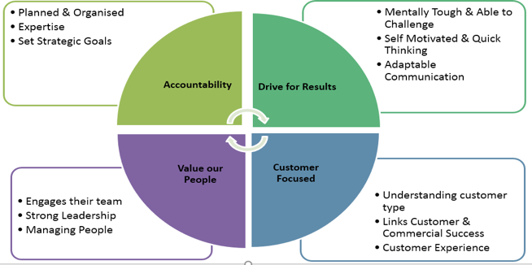 | - Successful and competitive and commercial  - People focussed encompassing mental health and D&I  - Results are a direct result of good behaviours.  - All directives can be delivered on time and are not complex or convoluted.  - Customer service is the most important element.  - Promotions are due to hard work and are not the easiest option.  - Pay and reward is fair and based on merit and hard work.  - Career-focused employer “sky is your limit”.  - Everyone is held accountable to the same standard.  - All employees encompass corporate values [Fig 6.1.01]
Underlying Assumptions:  “Taken for Granted invisible & pre-conscious.” | - Training is only important as a tick box exercise (mandatory)  - Work on goodwill due to an “efficient” operating model. Additional responsibilities are expected and not remunerated. Example- SGM role is similar to the Area manager role, with extra responsibility, and no pay as it is a “supporting role”  - Poor behaviour is unsanctioned or unfairly sanctioned based on personal perception, not fact.  - Unilateral communication, and upward feedback disregarded  - Compliance is highly regarded anything less will result in alienation. Deadlines are brought forward with expectations that everyone achieves in advance.  - Slow or disjointed systems accepted and not resolved. Store teams expected to find additional solutions and are held accountable regardless.  - Target driven environment, competitive environment.  - Personal Boundaries exploited due to operational trading times. (What’s app, phone calls out of working time)  - Cost saving as a reason for high workload low labour model.  - Managers are rewarded for financial performance regardless of people practices.  - Manipulative management behaviours to ensure employees agree to additional duties  - “Dysfunctional family”

8.1 Evaluation of factors affecting employee engagement:

As theorised by Schein (2010), Underlying assumptions of the cultural framework are the basis for assumptions employees make about the organisation. The above table reflects examples of behaviours and understanding of WHSmith Travel. There are explicit interlinked behaviours with the mission above statement, such as: “Tenacity for ambitious and competitive results – delivered with pace”. (WHSmith, 2023) For Example, about financial incentive rewards and the overview of the trading environment. The mission statement also reflects core values and behaviour expected by employees, “Drive for results”. It is noted in the assumptions that results are expected to be delivered in challenging circumstances; for example, in Low cost and efficient labour model, tasks delegated to sales assistants have a slight variation or overall importance. This can be linked to the Job Characteristics model, which identifies five core job dimensions that can enhance employee engagement and satisfaction, including skill variety, task identity, task significance, autonomy, and feedback (Hackman & Oldham, 1976). The Social Exchange Theory can also be linked as it offers insights into employee engagement. It suggests that employees are more likely to be engaged when they perceive their contributions are valued and receive fair rewards and recognition in return (Blau, 1964). Currently, employees below management are not rewarded or recognised by the organisation for good results. However, there has been an increasing awareness of the need to change this behaviour to improve organisational engagement.

8.2 Negative, Authoritarian Leadership and the Impact on Employee Engagement:

As articulated in the above Cultural evaluation, negative leadership behaviours can significantly affect employee motivation, satisfaction, and performance (Gooty, Connelly, Griffith, & Gupta, 2010). There are several types of negative leadership behaviours, including:
Abusive supervision: This involves the use of verbal or nonverbal aggression, belittling, or insulting behaviour by the leader towards their subordinates (Tepper, 2000).
Authoritarianism: This type of leadership is characterised by a high degree of control, where the leader makes decisions without consulting others and expecting compliance from their subordinates (Graen & Uhl-Bien, 1995).
Micromanagement occurs when the leader excessively monitors and controls the work of their subordinates, often resulting in a lack of autonomy and a decrease in motivation (Deci et al., 1989).
Active leadership: is a failure to act or provide direction, resulting in clarity and a lack of guidance for subordinates (Bass, 1985).
Negative leadership behaviours, as described above, can lead to reduced job satisfaction, lower levels of commitment, and increased turnover among employees (Tepper, 2000). Additionally, these behaviours can contribute to a toxic work environment, negatively impacting the overall culture and performance of the organisation.

8.3 Transformational Leadership Theory:

Transformational Leadership Theory (Bass (1985); Burns (1978) emphasise that organisational leaders inspiring and motivating followers to achieve greater levels of performance and development will improve overall employee engagement. According to this theory, influential leaders use their vision, charisma, and interpersonal skills to create a positive and motivational work environment where employees are encouraged to develop their full potential and contribute to achieving organisational goals (Bass & Riggio, 2006). Critics argue that transformational leadership theory is too idealistic and overlooks the importance of transactional leadership, which involves reward and punishment (Burns, 1978). In addition, there is limited empirical evidence supporting the effectiveness of transformational leadership theory in improving employee outcomes (Judge & Piccolo, 2004). Despite the lack of evidence, later studies have found links with a positive relationship between
transformational leadership and employee engagement, job satisfaction, and organisational commitment (Walumbwa et al., 2008; Wang et al., 2011). Transformational leadership has also positively influenced corporate culture, particularly regarding innovation and creativity (Shin & Zhou, 2007). With this in mind, there is a plausible application to WHSmith Travel Plc whereby transformational leadership could inspire and motivate employees to improve their performance and enhance the customer experience. By providing individualised consideration and intellectual stimulation, managers can enable employees to feel valued and empowered to suggest new ideas and take on more responsibility. The additional responsibilities should come with remuneration and be mutually agreed upon. The combination of the above could lead to a more innovative, positive, and customer-focused culture at WHSmith, encompassing the broader mission statement values.

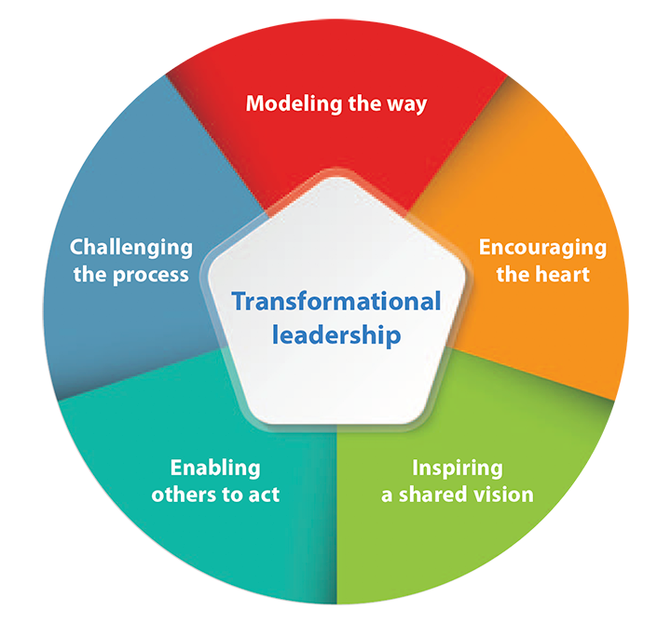

Fig 8.3.1

8.4 Engagement and Employee Well-being:
How employees feel can be linked to the Theory of human motivation, written by Maslow (1943): “Hierarchy of Needs”. Despite 80 years since this theory was written, it still has many practical applications in organisations, with many organisations adopting the framework. (Mind Tools, 2022)
Maslow’s (1948) Hierarchy of Needs:
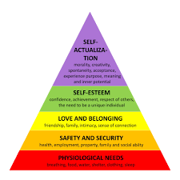
- Physiological needs: Ensuring personal boundaries are maintained, and employees are not expected to work excessive hours.

- Safety and security: Protect employees from excessive external temperature changes like those experienced in the Railway format. Safety measures are in place for defective equipment and aggressive customers.

- Love and Belonging: Ensuring Leadership is kind, empathetic, and distributed fairly and evenly. (Mindtools, 2022)

- Self-Esteem: Recognition and respect in addition to employee development and autonomy in their role to allow for innovation.

- Self-Actualisation: ensuring the needs of the employee are satisfied. Coaching, developing and nurturing them continually will promote motivation and a sense of belonging (Maslow, 1948)
FIG 8.4.1
8.5 Culture Linking with employee engagement:
A positive organisational culture can benefit both the employees and the organisation itself. Such a culture helps in creating an environment that values employees,
Promotes their well-being and improves job satisfaction (Schein, 2010). It can also increase employee engagement, improve retention rates, and create a cohesive and productive

team (Cameron & Quinn, 2011). As the statistics on page one presented, the requirement to reduce labour turnover rates and grievances in a cohesive environment should reduce these statistics.
A positive culture fosters a sense of belongingness, social support, and emotional safety among employees, which can significantly improve their mental and emotional well-being (Schein, 2010). In an uncertain world with many external factors, such as the cost-of-living crisis, prioritising employee welfare is important (Cheese,2023). In addition, it reduces the risk of stress, burnout, and other psychological problems commonly associated with a negative organisational culture (Grawitch, Munz, & Kramer, 2003). Positive cultures have also increased employee job performance, motivation, and commitment (Luthans & Youssef, 2007).
8.6 Organisational performance improvement:
Furthermore, a positive culture can also significantly impact the overall success of WHSmith Travel. It can improve customer satisfaction, increase profits, and enhance the organisation's reputation in the market (Cameron & Quinn, 2011). This is important as competitors emerge to protect the number-one retailer status in the Travel space. A positive culture creates an environment where employees feel empowered, valued, and motivated to contribute to the organisation's success (Schein, 2010). It is important to note that not all academics believe there is a causal link between culture and increased performance. However, Tan (2019) suggests as a result of his study that the non-causal link was due to research validity implications as opposed to a direct correlation between variables, Organisational performance vs Organisational culture.

9.0 Final Word:
This report has outlined the requirement and the importance of making changes to positively influence the Culture of WHSmith Travel. Despite growing profits and expansion, a people and cultural investment must be made in the short term for long-term viability.
Below are 3 top recommendations to implement in the short term. It is also recommended that a cultural assessment is carried out every two years (CIPD, 2022). Values and mission statements are updated as part of this review. It is important to note that Cultural change is an evolving, continuous process and is the responsibility of the senior leadership team (Young, 2022)

10.0 Recommendation One:
What: | Cost: | Timescale: | Accountability | Measured:
Transformational  Leadership training for all senior and mid-level management underpinned by organisational values. | £68,000 | All training to be delivered by 1/09/2023 | Board  HR Team  Senior Leadership  Operations management | Measured monthly through people stats.  Feedback reviews ad employee surveys

10.1 Recommendation Two:
What: | Cost: | Timescale: | Accountability | Measured:
Reward and Recognition at all levels.  Length of service pin badges  A weekly regional newsletter.  Financial rewards for achieving controllable targets. | Initial Costs:  £200,000  Ongoing costs per annum:  £120,000 | Implementation:  Regional Newsletter: 1/05/2023  Pin Badges:  1/09/2023 – New FY  Financial Reward/ Recognition:  1/09/2023 | Board  HR Team  Senior Leadership  Operations management | The impact is measured monthly through people stats.  Feedback reviews ad employee survey.

10.2 Recommendation Three
What: | Cost: | Timescale: | Accountability | Measured:
Career progression and fair remuneration for additional responsibilities | £565,000  Ongoing cost:  £300k per year | Career progression map: 1/09/2023  Renumeration policy and award:  1/06/2023 | Board  HR Team  Senior Leadership  Operations management  Finance  Payroll | The impact is measured monthly through people stats.  Feedback reviews ad employee surveys.  Measure internal fill monthly by region.

For further information and a breakdown of costs, see the additional communication link below:
https://1drv.ms/p/s!AmuJs91iMTL9iWvv3xK-0CZRQMqV
Questions or feedback are to be directed to: Amberlea.Mann@Whsmith.co.uk.

References:
- Bass, B. M. (1985). Leadership and performance beyond expectations. Free Press.
- Bass, B. M., & Riggio, R. E. (2006). Transformational leadership. Psychology Press.
- Burns, J. M. (1978). Leadership. Harper & Row.
- Blau, P. M. (1964). Exchange and power in social life. John Wiley & Sons.
- Cameron, K. S., & Quinn, R. E. (2011). Diagnosing and changing organisational culture: Based on the competing values framework. John Wiley & Sons.
- Cheese, P. (2023) Living in Interesting Times. Available Online: URL: https://community.cipd.co.uk/cipd-blogs/b/peter_cheese/posts/living-in-interesting-times (Accessed: 4th April 2023)
- Cuafano, G. (2023) What Is Schein’s Model of Organizational Culture? The Schein’s Model of Organizational Culture in A Nutshell. Available Online URL:
https://fourweekmba.com/scheins-model-of-organizational/ (Accessed: 8th April 2023)
- Deci, E. L., Connell, J. P., & Ryan, R. M. (1989). ‘Self-determination in a work organisation’. Journal of Applied Psychology, 74(4), 580–590. DOI: https://doi.org/10.1037/0021-9010.74.4.580
- De Long, D.W., Fahey, L.(2000) Diagnosing cultural barriers to knowledge management. Academy of Management Executive 14(4), 113–127. Available at DOI: http://dx.doi.org/10.5465/AME.2000.3979820 (Accessed 2nd April 2023)
- Denison, D. R. (1990). Corporate culture and organisational effectiveness. John Wiley & Sons.
- FU, N. (2023) Email to Amberlea Knowles 20th March 2023. [unpublished]
- Freedman, M. (2023) Types of organisational structures for business. Available Online: URL: https://www.businessnewsdaily.com/15798-types-of-organizational-structures.html (Date Accessed: 3rd April 2023)

- Glisson, C. (2015) ‘Human service Organisation’: Management Leadership Gov. 2015; 39(4): 245–250. doi:10.1080/23303131.2015.1087770. (Accessed: 3rd April 2023)

- Graen, G. B., & Uhl-Bien, M. (1995). ‘Relationship-based approach to leadership: Development of leader-member exchange (LMX) leadership theory over 25 years: Applying a multi-level multi-domain perspective’. Leadership Quarterly, 6(2), 219-247. DOI: https://doi.org/10.1016/1048-9843(95)90036-5 (Accessed: 3rd April 2023)
- Gooty, J., Connelly, S., Griffith, J., & Gupta, A. (2010). ‘Leadership, trust, and customer orientation: Implications for service quality’. Journal of Business Research, 63(12), 1260-1266. Available at DOI: https://doi.org/10.1016/j.jbusres.2009.11.014 (Accessed 3rd April 2023)

- Grawitch, M. J., Munz, D. C., & Kramer, T. L. (2003). ‘Effects of member mood and proactive behaviours: A longitudinal

Investigation’. Journal of Applied Psychology, 88(3), 411-419.
- Hackman, J. R., & Oldham, G. R. (1976). ‘Motivation through the design of work: Test of a theory’. Organisational Behaviour and Human Performance, 16(2), 250-279. Available at: DOI: https://doi.org/10.1016/0030-5073%2876%2990016-7 (Accessed: 7th April 2023)
- 18.. Hendry, J. (1997) Mintzberg’s Theory of Organisational Structure. Available online: URL
http://johnhendry.co.uk/wp/wp-content/uploads/2013/07/Mintzbergs-Theory-of-Organization-Structure.pdf (Accessed: 6th April 2023)
- Judge, T. A., & Piccolo, R. F. (2004). ‘Transformational and transactional leadership: A meta-analytic test of their relative validity’ Journal of Applied Psychology, 89(5), 755–768. Available at: DOI: https://doi.org/10.1037/0021-9010.89.5.755 (Accessed: 4th April 2023)
- Luthans, F., & Youssef, C. M. (2007). ‘Emerging positive organisational behaviour’. Journal

of Management, 33(3), 321-349. Available at: DOI: https://doi.org/10.1177/0149206307300814 (Accessed: 4th April 2023)

- Maslow, A. H. (1943) A Theory of Human Motivation, Psychological Review, Volume 50, Issue Review, 370–396. Available online: DOI: https://doi.org/10.1037/h0054346 (Accessed: 3rd April 2023)

- Mayne, M.(2023) Toxic Culture, Inadequate Management, Lack of Training – the HR lessons from the Casey review. Available online: URL:
https://www.peoplemanagement.co.uk/article/1817494/toxic-culture-inadequate-management-lack-training-–-hr-lessons-Casey-review (Accessed: 3rd April 2023)
- Mind Tools (2022) Maslow’s Hierarchy of Needs. Available online: URL:
https://www.mindtools.com/a4denhh/maslows-hierarchy-of-needs (Accessed: 4th April 2023)

- Millerd, P. (2022) Edgar Schein’s: Anxiety Assumptions: Powerful Ideas on Culture. Available online: URL: https://think-boundless.com/edgar-scheins- anxiety-assumptions-powerful-ideas-on-culture/ (Date Accessed: 3rd April 2023)
- Schein, E.H. (1985) Organisational Culture and Leadership. Available online: URL: http://www.untag-smd.ac.id/files/Perpustakaan_Digital_2/ORGANIZATIONAL%20CULTURE%20Organizational%20Culture%20and%20Leadership,%203rd%20Edition.pdf
(Date Accessed: 3rd April 2023)
- Schein, E. H. (2010). Organisational culture and leadership (Vol. 2). John Wiley & Sons. New York
- Schein, E. H (2018) Organisational Culture and Leadership. 5th Edn. John Wiley. New York.
- Scollen, V. (2023) Email to Amberlea Knowles 3rd March 2023 Unpublished.
- Scollen, V. (2023) Email to Amberlea Knowles. 14th March 2023. Unpublished

- Scollen, V. (2023) Email to Amberlea Knowles 2nd February 2023 Unpublished
- Scollen, V (2023) Email to Amberlea Knowles 20th March Unpublished
- Scollen, V (2023) Email to Amberlea Knowles 10th March 2023. Unpublished
- Shin, S. J., & Zhou, J. (2007). ‘Transformational leadership, conservation, and creativity: Evidence from Korea’. Academy of Management Journal, 50(1), 380-397. Available at DOI: https://doi.org/10.5465/amj.2007.24160888 (Accessed: 3rd April 2023)
- Tan, B.-S. (2019), ‘In search of the link between organisational culture and performance: A review from the conclusion validity perspective’. , Leadership and Organisation Development Journal Vol. 40 No. 3, pp. 356-368. Available at DOI: https://doi.org/10.1108/LODJ-06-2018-0238 (Accessed: 4th April 2023)
- Tepper, B. J. (2000). ‘Consequences of abusive supervision’. Academy of Management Journal, 43(2), 178-190. Available at DOI: https://doi.org/10.5465/1556342 (Accessed 8th April 2023)
- Trice, H., Beyer, J.M.(1993) The culture of work organisations. Prentice-Hall, Englewood Cliffs
- Vroom, V. H. (1964). Work and Motivation. John Wiley & Sons.

- Wahyuningsih, S. Achmad Sudiro, Troena, E. ,Irawanto, D. (2019). Analysis of organisational culture with Denison’s model approach for international business competitiveness. Problems and Perspectives in Management, 17(1), 142-151. Available at DOI:
http://dx.doi.org/10.21511/ppm.17(1). (Accessed 3rd April 2023)

- Wang, G., Oh, I.-S., Courtright, S. H., & Colbert, A. E. (2011). ‘Transformational leadership and performance across criteria and levels: A meta-analytic review of 25 years of research’. Group and Organization Management, 36(2), 223-270. Available at DOI: https://doi.org/10.1177/1059601111401017 (Accessed: 4th April 2023)

- Walumbwa, F. O., Avolio, B. J., Gardner, W. L., Wernsing, T. S., & Peterson, S. J. (2008). ‘Authentic leadership: Development and validation of a theory-based measure’. Journal of Management, 34(1), 89-126. Available at DOI: https://doi.org/10.1177/0149206307308913 (Accessed: 4th April 2023)
- WHSmith (2023) About us: Heritage. online: URL: https://www.whsmithplc.co.uk/about-us/history-heritage?page=1
(Date Accessed: 3rd April 2023)
- WHSmith (2022) Annual Reports and Accounts. Available online: URL
https://www.whsmithplc.co.uk/sites/whsmith-corp/files/whsmith-ar22.pdf
(Date Accessed: 3rd April 2023)
- WHSmith (2023) Our Strategy. Available online: URL: https://whsmithcareers.co.uk/about-us/ (Date Accessed: 3rd April 2023)
- WHSmith (2023) Careers. Available online: URL: https://whsmithcareers.co.uk (Date Accessed: 8th April 2023)

- Young, J. (2022) Organisational Culture. Available online: URL: https://www.cipd.co.uk/news-views/viewpoint/organisational-culture#gref. (Accessed: 5th April 2023)

