Rohan Dubrey (1905715)
Tutor: Dr David Jenkins
University of Wales Trinity Saint David
Financial Management for the hotel Industry
Module: M5X01922

Contents

Executive Summary-----------------------------------------------------------------2
Main Body------------------------------------------------------------------------------3
Table of Results----------------------------------------------------------------------3
Summary of Table-------------------------------------------------------------------3
Analysis---------------------------------------------------------------------------------4
Discussion of Ratio Families------------------------------------------------------4
Analysis of Each Family------------------------------------------------------------4
Profitability-----------------------------------------------------------------------------4
Figure 1.1------------------------------------------------------------------------------6
Liquidity---------------------------------------------------------------------------------7
Figure 1.2-------------------------------------------------------------------------------7
Efficiency-------------------------------------------------------------------------------8
Figure 1.3-------------------------------------------------------------------------------9
Capital Structure---------------------------------------------------------------------10
Figure 1.4------------------------------------------------------------------------------10
Round up of Analysis---------------------------------------------------------------11
Figure 1.5------------------------------------------------------------------------------11
Conclusion and Recommendation-----------------------------------------------11
References----------------------------------------------------------------------------12
Appendices----------------------------------------------------------------------------13

- Executive Summary

Analysis of the Gatsby Grange Boutique Hotel was conducted using four (4) families of ratios including profitability, efficiency, liquidity and capital structure. The analysis was done over a two year period (2019, 2018) and studied the sustainability and performance of the hotel. The efficiency of fixed asset turnover and inventory days were assessed and compared to the revenue generated, forecasting the year 2020. Liquidity position was examined to determine how quickly and efficiently the hotel could turn over assets with the ability to sustain its current liabilities.

The results showed that although no non-current assets were sold, the hotel was turning over nearly half of its inventory compared to the previous year, thus increasing revenue. Conversely, although revenue had increased, cost of sales (COS) had rocketed, resulting in the return on capital employed (ROCE) performance spiralling downwards, affecting the gross and net operating profits.

Cash owed to creditors was being retained for less time compared to the previous year, which can be an indication of poor cash flow management. The liquidity of the hotel needs to be looked at with caution as the acid test is much lower than the current ratio, indicating that the company is struggling to turn assets into cash to sustain its current liabilities. There is also a possibility that the company is heavily dependent on stocks, as an analysis of capital structure revealed the ability to leverage is not been utilised.

2. Main Body
(Ia). Table of Results
Ratios Table of Results | 2019 | 2018 | Absolute Difference | Relative Performance
Profitability ratios
ROCE | 70.8 | 71.9 | -1.1 | -1.1
Asset turnover | 1.04 | 0.99 | 0.06 | 5.7
Gross profit | 85.8 | 91.8 | -6.0 | -6.0
Net operating profit | 67.9 | 72.9 | -5.0 | -5.0
Efficiency
Non-current asset turnover | 1.29 | 1.22 | 0.1 | 5.6
Inventory turnover (days) | 386.5 | 648.9 | -262.4 | -40.4
Liquidity
Current ratio | 1.7 | 0.12 | -0.07 | -6.7
Acid test | 1.1 | 1.2 | -0.1 | -6.6
Creditor days | 373.6 | 648.9 | -275.3 | -42.4
Debtors days | 109.5 | 106.2 | 3.3 | 3.1
Capital Structure
Debt to equity (leverage) | 2.4 | 9.0 | -6.6 | -73.7
Debt to capital | 2.3 | 2.4 | -0.1 | -4.1

(Ib). Summary of Table

Table 1a shows the four groups of ratios used calculating the absolute difference (AD) and relative difference (RD), summarising the financial analysis for Gatsby Grange over a two (2) year period between 2018 and 2019.

(IIa). Analysis
(IIa). Discussion of Ratio Families
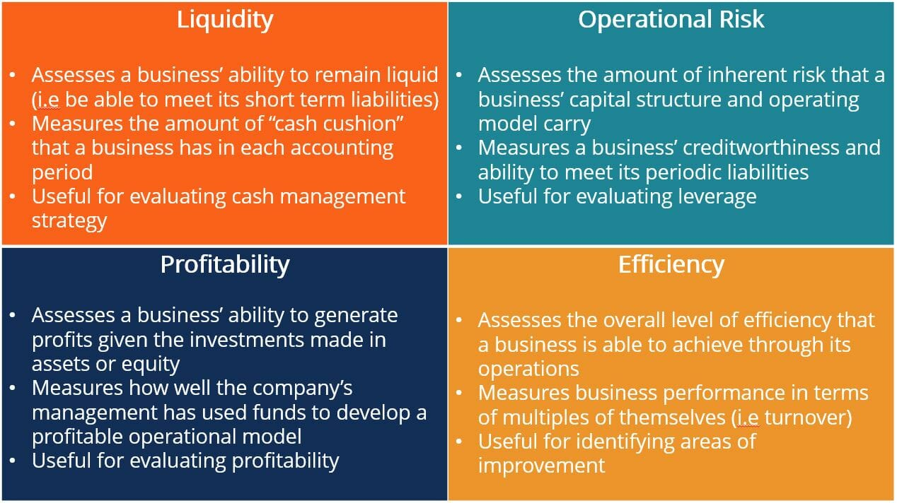
(Corporate Financial Institute, 2020)

(IIb). Analysis of Each Family
Profitability
Businesses invest with the sole purpose to gain an adequate return on capital (Atrill and McLaney, 2009). In ensuring profitability, ROCE ratio is used as part of the analysation. Using (AD) of 2019 and 2018, which is the first stage of the analysation, it has identified that ROCE has gone down by -1.1% with the RD doing the same.

In analysing the possible cause for the fall in ROCE, components of ROCE have been broken down into the following, calculating the relative difference.
- Operating Profits (OP)
- Capital Employed (CE) consists of total assets minus current liabilities.

Completing RD analysis calculations revealed an overall -1.1% fall in ROCE had contributed a combination of a 1.6% rise in the OP combined with a 3.2% rise in the CE. With the CE increasing more than the OP, the overall ROCE will be increased.

Another level analysis identified an increase in OP had been affected by the rise in the cost of sales (COS). Although revenue has gone up by £500 (9.1%), COS has risen by £400 (88.9%) resulting in a small overall increase, as OP improved by only 1.6% over the period.
With COS increasing more than revenue, this has slowed down the OP affecting the ROCE. Reducing COS could improve the ROCE performance amongst other strategies described below (Hayes and Miller, 2011).
Analysing the increase in COS by 88.9% and the increase in operating expenses (OE) by 3.4% reveals a clear indication that COS is causing a more significant problem.

With OE increasing by 3.4% the 88.9% increase in COS is responsible for the increase in sales, harming the overall profit margin.
The rise in CE by 3.2% is an indication that the company has acquired more assets, a second look revealed that is not the situation but instead a depreciation of non-current assets.

Additionally, the hotel could improve on the total asset by selling outdated non-current assets which have depreciated and seldomly use, having little significant value to the company. This would allow for more capital to be employed for the same amount of production, as depreciation is reflecting a 10% increase. Additionally, improving total assets could improve ROCE performance (Drury, 2018).

The management of inventory can also improve the ROCE, with inventory increased from the previous year. Managing borrowing can create lower interest rates by using suitable debentures, which is of value to ROCE. In 2018, the ROCE was 71.9pence for every pound [£] of capital employed followed by 2019 resulting in 70.8pence. The trend in ROCE has fallen from 2018-2019 with the increase in COS negatively affecting the increase in CE. However, expectations are CE will generate future sales.

Additionally, sales can also be increased and strategised, ensuring sales are transacted with appropriate pricing plans. Moreover, a rise in sales could still affect the ROCE if sales margins are low. More excellent efficiency plan could be introduced to reduce OE caused by light and heat. The hotel has an increase of 12.5% on debt capital with bank overdrafts up by 66.7%, which needs to be managed more effectively.

The Asset turnover is an indication of the number of times the total investment has resulted in sales; this measured the value of revenue showing an increase in monetary value from 2018-2019 (Holmes, Sugden and Gee, 2005). The AD reflects a 0.06pence increase with the performance difference, reflecting a 5.7% increase. This indicates the efficiency within which the hotel in using assets to generate sales as the capital employed has risen. The asset turnover reflects how much revenue the hotel is making from each £1.00 of sales in the asset.
The increase in asset turnover has resulted in the 9.1 pence rise in revenue and the 3.2% rise in the capital employed. Revenue has been affected by the -10% fall in loan interest over the period. The increase in asset turnover could be a trend with the increase in sales over the two years. Conversely, a five to ten-year financial statement would give more accurate information regarding the trends as figures do change (Hayes and Miller, 2011).

The gross profit margin (GPM) reflects the income generated from sales that is available after the cost of goods sold (COGS). The 2019 2018 period AD reflects a decline in the GPM by -6.0%. The RD also reflects a -6.0% decline. The decline in GPM was a combination of the 9.1% increase in sales and a 9.1% increase in gross profit with a 0.3% rise in operating cost.

The higher level of analysis reveals that the decline in gross profit can be a possibility of the rise in the operation cost. Net operating profit analysed reflected -5.0% fall in AD and an additional -5.0% fall in RD. The 1.6% rise in operating profit, combined with a 9.1% rise in revenue, has been affected by a 3.4% rise in the operating cost as shown in figure 1.1 below.

Figure I.I

Efficiency Ratios
Evaluating non-current asset turnover indicates how efficiently assets are performing. The AD indicates a 0.07pence increase and the RD reflected a 5.6% increase up from last year. The overall 5.6% increase was a combination of the 9.1% rise in revenue and the 3.3% rise in non-current assets. Probable cause for the assets performing well could be due to the increase in sales.

With non-current assets depreciating over time, selling unwanted assets can improve the revenue per pound (£). A high turnover shows that the company is efficiently utilising assets to generate sales. Conversely, a low asset turnover would indicate the company is failing to use assets to generate sales.

Inventory turnover interlinks with the efficiency of maintaining inventory and the liquidity it generates. This reflects the number of days the company is taking to turn over stock, resulting in sales. There has been a massive improvement between the two years with 2018 taking nearly two (2) years to turn over stock and 2019 turning over stock in just over a year. There has therefore been a significant improvement in the hotel’s performance in almost halving its inventory turnover as shown in figure 1.2 below.

Figure 1.2

Liquidity

The ability of the hotel paying its debt and the ability of the debtors paying the hotel is of extreme importance, which places the hotel in a liquid position (Holmes, Sugden and Gee, 2005). The current ratio reflects the working capital used to pay short term debts and manage the daily running of the hotel. With the AD slipping by -0.1times and the RD dropping by -6.7%, the third level of analysis looks at the possible cause.

Current assets have gone up by 12.6%, and current liabilities have gone up by 20.7%, giving the overall -6.7% in current ratio. Marr (2012) concludes that in measuring the hotel’s short term lability to liquidise assets, the hotel’s current liabilities have to be taken into account.

The -6.7 times drop in the current ratio as shown in table 1a, demonstrates that the cash position is weaker than the previous year. This indicates that there may be a cash problem, and there is the need to secure other financing. However, all aspects and ratios must be studied to get a clear picture and an in-depth view.

The acid test has been used as another liquidity ratio giving a more in-depth look into the hotel’s financing structure; it ignores inventory assets which might be difficult turning into cash. The first analysis indicates a fall in the AD by -0.08times with the RD showing a -6.6% fall, meaning that for every pound [£] owed 0.08pence is paid back. The 12.5% increase in stocks, 6.6% increase in total assets in addition to the 20.7% increase in current liability, is a combination of the overall -6.6% fall in the acid test (appendix 1).

However, if the accounts receivable [debtors] take longer than usual to settle, the acid test will not reflect an accurate result (Walsh, 2008). In addition, if the hotel’s accounts payable are due to be paid, but the accounts receivable are scheduled to be received later, this will negatively affect the acid test. Bank overdrafts which are placed in the current liabilities have a specific time, agreed to be paid, which is generally upheld by the bank (Holmes, Sugden and Gee 2005).

The acid test is indicating that the business should be cautious regarding its ability to satisfy its current liabilities. With the acid test much lower than the current ratio, an additional indication is that the hotel is heavily dependent on its stock (Marr, 2012). Woods and Sangster (2008) concluded that business, in spite of profitability, will fail if not adequately liquid.

The creditor days ratio reflects the amount of time the hotel takes to pay its creditors. Taking longer to pay, maximises the hotel’s cash flow, if it is done legally and morally. In the two (2) year period creditor days figure has nearly halved from the previous year as indicated in figure 1.3 below. The third level of analysis shows that creditor days are positive, which is a good position. Nevertheless, the position is that creditor days failed to improve. Improvements were showed in working capital, which was a result of creditors days falling and debtor days increasing.

 | 2019 (days) | 2018 (days) | AD (days) | RD (%) | Outcome
Creditor days | 373.6 | 648.9 | -275.3 | -42.4 | Adverse
Debtors | 109.5 | 106.2 | 3.3 | 3.1 | Favourable
Days holding money | 264.1 | 542.7 | -278.6 | -45.5 | Adverse
Figure 1.3

The debtor days ratio indicates how long money owing to the business is taking to be paid. Analysis indicates an AD of 3.3 days and an RD of 3.1%. With sales increasing by 9.1% and debtors 12.5% the overall 3.3 days for the payment to be made to the hotels is reflected as shown in figure 1.4 below.

Figure 1.4

Capital Structure

The hotel can sometimes finance assets with debts, which can be risky. Studying capital structure ratios highlights the hotel’s financing ability, showing the risk the hotel has taken on its assets (Walsh, 2008). The debt to equity [leverage] analysis indicated a -6.6% fall in the AD, with the RD indicating a -73.7% fall. With debt capital down by -3.3% and total equity indicating a 0.9% raise, the overall -73.7% is reflected. This could be a sign that the hotel is not utilising financial leveraging, which could increase total equity

Comparing the hotel’s total debt to the total capital, the debt to capital ratio analysis showed an AD of 0.1% in the first analysis and an indication of -4.1% fall in AD. The -0.6% fall in capital and 1.6% in operating profit is a combination of the -3.3% in debt capital accumulating to the overall -4.1% in debt capital. The hotel is not highly leveraged, which reduces the risk of insolvency, taking advantage of financial leverage could increase profitability.

Conversely, with bank overdrafts omitted from the gearing ratios and solely kept as current liabilities, it is imperative to use interest cover ratio to identify the hotel's ability in meeting its interest payments. The first level of the analysis identifies 25.9 times interest in the AD and 12.9% in RD.

The 1.6% rise in the OP and the -10.0% in the finance charge is a combination of the overall 12.9% in interest cover. This indicates that the hotel's financial health is being able to sustain its interest obligations from operating revenue. Conversely, this could again be an indication that the hotel is missing out or reluctant to take up leveraging opportunities that could potentially increase revenue.

Figure 1.5

(IIc). Round-Up of Analysis

The overall performance analysis indicated that the business has improved. The assets are turning over much quicker, generating revenue. The long-term liabilities have decreased, but the business has borrowed more in trade payables and increased its overdraft for the short term. The results of this analysis indicates the overall improvement forecast for the 2020 financial year, would be to consider more long term borrowing, and invest in assets as they are turning over. More time should also be negotiated with suppliers, allowing the hotel to retain creditors cash for prolonged periods, maximising cashflow. Although there is improvement in asset turnover, the gross profit margin is trending downwards, which can be an indication of increased competition within the hospitality industry. This suppreses profits margins, as does the huge increase in COS. An understanding of ratios and their fluctuations is essential for hotel management. Globalisation can affect credit-deposit ratios in relation to net-liabilities and the accessing of loans (Das and Das 2019). However, the limitations involved in the study of ratios is that they do not provide a cause to the situation affecting the business and would not be understood except by a financial expert.

3. Conclusion

In concluding, this analysis of the income and financial statements has identified areas of strengths and weaknesses. The appropriate ratio calculations made a high contrast in identifying areas in the report to demonstrated areas for caution and improvement. The appropriate use of ratios showed how they interlinked; one specific ratio is not a true reflection, as seen in the acid tests’ ratio calculations. It is important that management understands the importance and use of these ratios clearly. Additionally, it is clear that without the use of these ratios, the analysation reflecting the performance of the hotel would be compromised.

Recommendations
The hotel needs to source goods from other manufactures in bulk which can reduce the cost of goods sold. Non-current assets need to be sold for capital employed to be more effective. Areas within expenses should be addressed regarding the conservation and use of green energy (lighting and heating).

References
Atrill, P. and McLaney, E., 2009. Management Accounting for Decision Makers. 6th ed. Harlow: Pearson.
Corporate Financial Institute, 2020. [image] Available at: https://corporatefinanceinstitute.com/resources/knowledge/finance/corporate-finance-ratios [Accessed 7 July 2020].
Das, R.C. and Das, U., 2019. Analysis of fluctuations in Credit-Deposit Ratio of Indian States: From Pre-Globalization to Post-Financial Crisis Phase. In Handbook of Research on Managerial Thinking in Global Business Economics (pp. 229-245). IGI Global.

Drury, C., 2018. Management and Cost Accounting. 10th ed. London: Cengage.
Guilding, C., 2014. Accounting Essentials for Hospitality Managers. 3rd ed. New York: Routledge.
Hayes, D. and Miller, A., 2011. Revenue Management for The Hospitality Industry. Hoboken, N.J.: Wiley.
Holmes, G., Sugden, A. and Gee, P., 2005. Interpreting Company Reports and Accounts. 9th ed. Harlow: Financial Times Prentice Hall.
Horner, D., 2017. Accounting for Non-Accountants. 11th ed. London: Kogan Page Ltd.
Marr, B., 2012. Key Performance Indicators. The 75 Measures Every Manager Needs to Know. Harlow: Pearson.
Sangster, A. and Wood, F., 2008. Frank Wood's Business Accounting 1. 11th ed. Harlow: Prentice Hall.
Walsh, C., 2008. Key Management Ratios. The 100+ Ratios Every Manager Needs to Know. 4th ed. Harlow, England: Prentice Hall/Financial Times.

Appendices

