

Models of Communication

Modulo Name: Effective Team Work and Communication
Module Code: BMSW4002
Student Name: Luana Delaine Nunes Sequeira
Student ID: 2114278
Lecturer: Joy Botu

Table of Contents
Introduction 2
2. Models of Communication 3
2.1 Shannon and Weaver (1948-1948) 3
2.2 Schramm(1954) 4
2.3 Berlo (1954) 5
3. Communication Skills 7
3.1Types of communication 7
4conclusion 8
Reference 9

Introduction

Communication is the essence of social relationships, information disclosure, as well as political and commercial agreements, and for each field in which it is applied, a particular understanding is required, in such a way to carry it out correctly because, in the same way that is used in function of a healthy coexistence with the couple and family, reveal with clarity and transparency to society from the media about a momentous event, or manage to agree on the alignments of import / export rules for the countries of the region (for example, Europe or Latin America), can also trigger the failure of any of the examples mentioned. Therefore, it is not just a question of communicating, but also of how it is communicated, an error can imply an enmity, a job dismissal, economic losses, and social chaos, depending on the level of authority and responsibility of the person who makes it.
In principle, communication is the process by which a sender and a receiver establish a connection through a message that allows them to exchange or share ideas and information. In a deeper sense, communicating is sharing a bit of ourselves with others. It is well known that communication is the key to success in practically all aspects of life.
In many cases, the message is not received exactly the way the sender intends. Therefore, it is important that the communicator always looks for a way to verify that his message has been clearly understood, in other words to overcome these barriers that prevent an adequate flow of information.
There are many barriers, including: language and language ability, even when you do not communicate in the same language, the terminology used in a message can act as a barrier if not fully understood by the receiver; the physiological barrier can result from the physical state of the receptor. For example, a receiver with reduced audition may not capture the entirety of a spoken conversation especially if there is a background noise that is also one of the great barriers with which we find daily noise.

2. Models of Communication

2.1 Shannon and Weaver (1948-1948)
In this model, communication is understood as a process of information transfer, linear or unidirectional. It is a theory of information thought in function of cybernetics. Indicates 5 functions that must be fulfilled (source, transmitter, channel, receiver, recipient) and the noise factor.
According to this model, in the study of the case of Maria and Pedro, the cause of an ineffective conversation do not receive the message correctly, that is, it is distorted is by the medium since the noise.
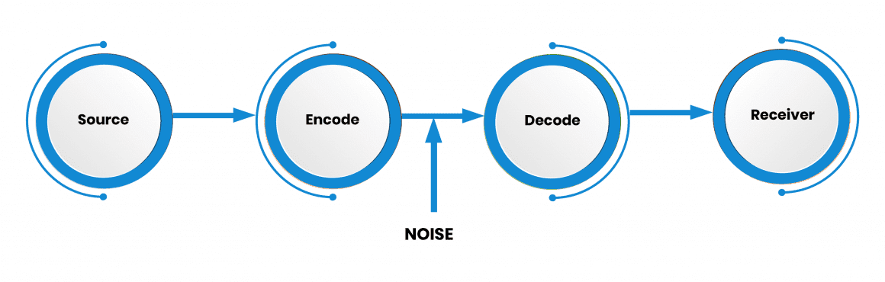

2.2 Schramm(1954)

Schramm expresses that communication cannot be understood as if it began in one place and ended in another, also is incomplete unless and until the sender receives feedback from the recipient. Communication is not a linear process as proposed by Shannon and Weaver's model but is fundamentally circular. On the other hand, it focuses attention on the behavior of the main actors in the communicative process, while Shannon's model that points to the channels that mediate between senders and receivers primarily. Schramm propose that the parts of the process are the same and perform identical functions. Each person is encoder and decoder.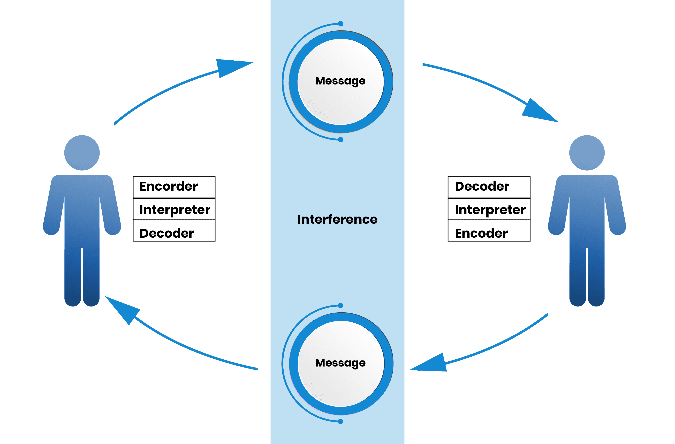

According to the study case of Maria and Pedro, if we analyze with this model (Schramm), We could say that the failure in the communication was due to lack of feedback. if Pedro had reaffirmed Maria’s message, she would have detected that the message was not the one he wanted to communicate.

2.3 Berlo (1954)
Berlo’s model is characterized by considering that communication has a purpose.
That is, the communication established by the source is intended to influence others. As the source knows its communication purpose better, it will be more effective and efficient.
On the other hand, for Berlo, another differentiating aspect of the communicative model is that it considers that the personal factors that affect the source and the receiver are very important.
People and their communication processes are influenced by their cultural environment and their position in the social system form which they come. In other words, the way we express ourselves comes from the culture we are from and place we occupy in society.
In addition to this, people’s communication skills will help make the communication process effective, if they are adequate.
If not, they will be communication problem known as “noises”, which will not allow the communication process to achieve its initial objective.
On the other hand, people’s ability to reflect and express themselves limits the message they share. That is, the idea they want to communicate are codified according to this set of communication skills that each person or source possesses.
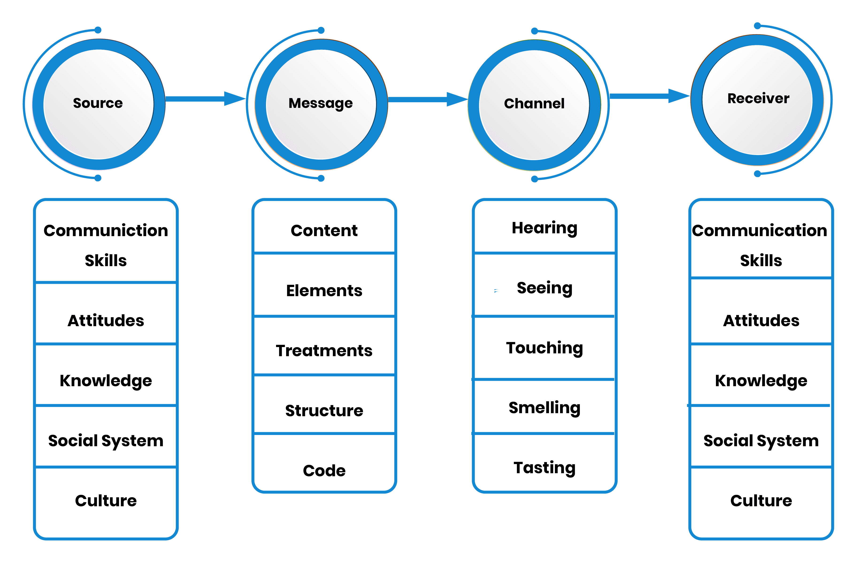

According to the case study “The Professor and the Village People”, here we find a man with a higher level of knowledge and culture than the village people . The professor in this case is the sender who goes to the village in search of help from village’s people who play the receiving role.
The professor screaming: “The edifice is being consumed by a great conflagration!” (message). Finally, he does not get help because the receivers were not able to decode the message due to factors such as the language barrier, which means that the established communication is not effective.
Numerous cases like this we come across daily. In my case, I had also suffered a similar situation in my workplace. When I start working in this country my English level was low, which caused communication difficulties. One day my manager asked me to call the boss who was in the office and I ha understood that he da asked me to take a box from the office, the confusion could have been avoided if there was feedback.

3. Communication Skills
Communication is the act by which an individual establishes with another a contact that allows him to transmit information.
Communication involves various elements that can facilitate or hinder the process.

Effective communication between two persons occurs when the receiver interprets the message in the sense intended by the sender.

3.1Types of communication
forms of human communication can be grouped into two broad categories: Verbal communication and non-verbal communication.

3.1.A Verbal communication refers to the words we use and the inflections of our voice
3.1B Non-verbal communication refers to a large space of channels between them we can cite as the most important eye contact facial gestures, arm and hand movements and posture and body distance.
In the case study -A Day with the Chief , in terms of non-verbal communication Mark shows more confidence and relaxes when speaking and that we can identify in his expressions when they tell us that he crosses his legs unbuttons the tie, etc. We can also say that the Mrs. Brown shows connection and empathy during the conversation, at times such as when they tell us to squint while looking at Mark.

4conclusion

No society in the world could be built without its members being able to communicate effectively. However, our reality today is much more complex than it was thousands of years ago. this requires a commitment to the development of communication skills
Communication models we can conclude that they are very necessary in everyday life. each has different elements but completes each other. none can be separated from another. are indispensable for effective communication.

Reference

- Ginn and Co(1951) The Mathematical Theory of Communication.
- Keyson, R, M, J,W, David(2016), The Six- Vertex modeland Schramm Loewen evalution.
- Stead, B.A(1972), Berlo’s Communication Process Model as Applied to the Behavioral theories of Maslow, Vol.15(3)
- Models of communication - Wikipedia

