

MODULE CODE: Digital Skills for Personal Development and Business Growth BMSW4008

ASSESSMENT COMPONENT: PORTFOLIO

STUDENT NAME: Michael Chambers

STUDENT NUMBER: 2233880

LECTURER: Philippa Fitzgerald

DATE: 16.03.2026
Contents
Task 1 3
Assessment of Digital Skills 3
References 3
Task 2 3
LinkedIn Learning Certificates for Office365 3
Task 3 4
Essay on Relevance of Excel in professional and personal life. 4
References 5
Task 4 5
7 Minute Reflective Presentation 5
References 6

AI STATEMENT

Task 1

Assessment of Digital Skills
Portfolio Example
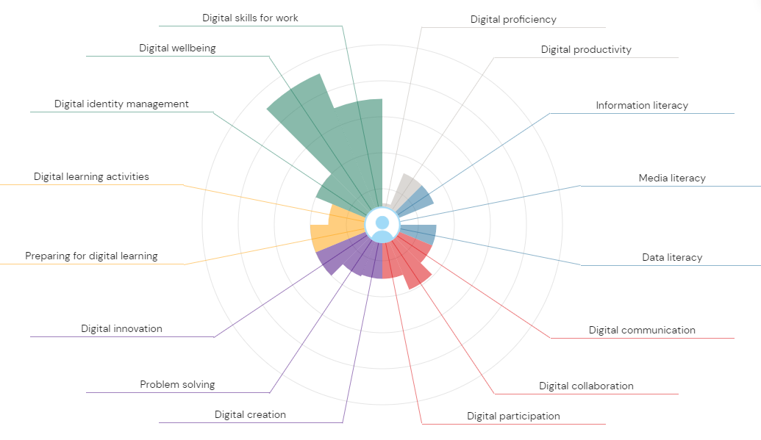
IMAGE 1. JISC REPORT

Assessment on Digital skills
Digital Skills for Work and Digital Well‑Being: Strengths.
In today’s digital world, individuals must possess a variety of digital competencies to perform effectively in the workplace and maintain healthy interactions with technology. Digital skills for work bound the ability to use digital tools such as productivity software, communication platforms, and data management systems. Digital well‑being refers to the balanced and mindful use of digital technologies in ways that support mental health, productivity, and life satisfaction. This evaluation describes an individual’s strengths and weaknesses in these areas and outlines a SMART action plan to address areas for development, particularly in digital proficiency and media literacy.
Strengths
This displays several strengths in relation to digital skills for work and digital well‑being:

- The individual demonstrates effective use of common workplace digital tools, such as email systems, cloud storage, and online collaboration platforms, which supports task completion and communication in professional contexts. Research shows that digital skills broadly enhance employability and workplace effectiveness because they enable individuals to engage with core technologies used by employers (Đorđević et al., 2025;).
- The individual shows strong digital well‑being awareness, managing screen time and avoiding distractions when working online. This awareness supports concentration and reduces the negative psychological impacts of digital overload, which is a growing concern in digital research (Uslu, 2025;).
- The individual can organise digital information and tasks efficiently, which contributes to productivity and work quality by reducing task duplication and supporting information retrieval.
- The individual exhibits responsible use of technology, showing respect for workplace norms of digital communication and demonstrating awareness of appropriate online behaviour.
- The individual shows basic adaptability to new digital environments, which enables them to begin using new digital tools with minimal supervision and engage with new systems when required for work.
These strengths indicate that the individual has a solid foundation in digital skills and recognises the importance of using technology in ways that support professional performance and personal well‑being.
Weaknesses
Despite these strengths, these areas that require improvement:
- Digital proficiency (weakness): The individual’s competency with advanced or specialised digital software remains limited. While basic tools are used effectively, the individual may struggle with more complex functions (e.g., advanced data analysis, automation tools, or adaptive problem‑solving across digital systems). This gap limits their ability to fully engage with digital tasks that require deeper technical competence.
- Media literacy (weakness): The individual sometimes has difficulty evaluating the credibility of digital information, especially online news or content encountered through browsing or social feeds. Media literacy — the ability to critically assess information sources and discern misinformation — is an essential skill for informed decision‑making, professional communication, and avoiding digital misinformation (Polizzi et al., 2025;).
These weaknesses matter because digital proficiency supports more efficient task execution and problem‑solving at work, while media literacy supports informed, critical engagement with information that affects professional decisions and reputation.
SMART Action Plan
To address the identified weaknesses, the individual will follow a SMART action plan. SMART goals ensure improvements are clearly defined, measurable, and time‑bound.
Goal 1: Improve Digital Proficiency
- Specific: The individual will improve digital proficiency by learning advanced features of workplace tools such as spreadsheets (e.g., formulas, pivot tables), project management software, and collaboration platforms.
- Measurable: Progress will be measured by completing two accredited digital training courses (e.g., Excel advanced, project management software) and demonstrating skills through work tasks that require more complex tool use.
- Achievable: The individual will allocate two hours per week to structured training modules and practice tasks.
- Relevant: Enhanced digital proficiency aligns with workplace needs and broader industry expectations, as advanced digital skills are linked to employability and performance (Đorđević et al., 2025;).
- Time‑bound: The individual will complete the training and demonstrate improved proficiency within three months.
Goal 2: Improve Media Literacy
- Specific: The individual will improve media literacy by learning how to critically assess online sources, identify misinformation, and evaluate credibility using structured criteria.
- Measurable: Progress will be measured by completing one online media evaluation course and implementing a checklist method (e.g., CRAAP: Currency, Relevance, Authority, Accuracy, Purpose) when researching or reviewing information.
- Achievable: The individual plans to practice media evaluation skills twice per week by reviewing online articles and applying critical assessment techniques.
- Relevant: Media literacy is essential for professional work, especially in roles that involve research, reporting, or client communication (Polizzi et al., 2025;).
- Time‑bound: The individual aims to establish effective media literacy habits and complete the training within two months.
Conclusion
Developing digital skills for work and maintaining digital well‑being are critical for success in today’s technology‑driven environment. The individual demonstrates strengths in responsible tool use and awareness of digital well‑being, but improvements are needed in digital proficiency and media literacy. By implementing a SMART action plan with clear training goals and time frames, the individual can enhance technical competence and critical thinking skills. These improvements will support stronger professional performance, more informed decision‑making, and greater resilience in the digital workplace.

References
Đorđević, B., Milanović Zbiljić, S. and Radosavljević, M. (2025) ‘Impact of the digital skills on employability’, Economies, 13(7), pp. 1–15.
Polizzi, G. (2025) ‘Digital literacy and strategic (dis)engagement: examining functional and critical digital literacy’, Information, Communication & Society, 28(14), pp. 2483–2502.
Uslu, O. (2025) ‘Understanding digital well‑being: impacts, strategies, and the digital environment’, Journal of Global Digital Studies.
Mahmutaj, L.R. and Jusufi, N. (2023) ‘The importance of digital skills in firms’ innovation’, Journal of Technology Management and Innovation, 18(3), pp. 90–102.
Van Laar, E., Van Deursen, A., Van Dijk, J. and De Haan, J. (2017) ‘The relation between 21st‑century skills and digital skills’, Computers in Human Behavior, 72, pp. 577–588.

Task 2

LinkedIn Learning Certificates for Office365

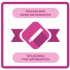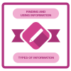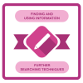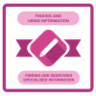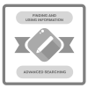

Task 3

Essay on Relevance of Excel in professional and personal life.

Microsoft Excel is widely recognised as one of the most essential digital tools used in both professional and personal contexts. Within the knowledge-based economy, organisations rely on technologies that help transform raw data into meaningful information and knowledge. Chapter 11.5 of the Knowledge Business discussion emphasises that knowledge is an organisational asset and can exist in explicit forms such as documents, databases, and digital tools. Tools like Excel help organise, analyse and share such knowledge effectively.

Excel therefore plays a critical role in enabling individuals and organisations to manage information, improve decision-making and enhance productivity.

Relevance of Excel in Professional Life
In professional environments, Excel is used as a powerful tool for data management, analysis and reporting. Businesses operate in information-rich environments where decision making depends heavily on analysing large quantities of data. Excel allows professionals to store, organise and analyse data using formulas, charts and analytical functions.
From a knowledge management perspective, digital tools support the transformation of data into useful knowledge for organisations. Knowledge is considered a valuable organisational asset that improves efficiency and competitive advantage when effectively managed and applied.
Excel is widely applied in many business functions such as finance, accounting, marketing and operations. For example, managers can use Excel to prepare budgets, forecast sales, monitor performance and evaluate business trends. By enabling the analysis of large datasets, Excel helps organisations identify patterns and make informed strategic decisions.
Furthermore, Excel facilitates collaboration and information sharing among employees. When data and analytical models are shared within teams, knowledge can be transferred more efficiently across the organisation, strengthening organisational learning and innovation. Knowledge sharing is a key aspect of knowledge management because the value of knowledge increases when it is disseminated and applied by multiple individuals.
Thus, Excel supports professionals by improving efficiency, enabling data-driven decisions and enhancing organisational knowledge.
Relevance of Excel in Personal Life
Beyond professional settings, Excel is also valuable in personal life. Individuals use Excel to organise information, track finances and manage everyday tasks. For example, Excel can be used to create personal budgets, monitor expenses, plan savings and manage household accounts.
Excel also helps individuals analyse personal data, such as tracking study schedules, recording health information or planning projects. By organising information into structured spreadsheets, individuals can better understand patterns and make informed decisions regarding their finances, education or lifestyle.
The importance of knowledge management is not limited to organisations; individuals also manage personal knowledge and information. Knowledge is created when individuals interpret data and apply it to solve problems or improve outcomes.
Through tools like Excel, individuals can convert personal data into meaningful insights, supporting better planning, organisation and decision-making in everyday life.

Conclusion
In conclusion, Microsoft Excel plays a vital role in both professional and personal life. In professional environments, Excel supports data analysis, reporting, decision-making and knowledge sharing, contributing to organisational efficiency and competitive advantage. In personal life, Excel assists individuals in managing finances, organising information and improving personal productivity.
Within the framework of the knowledge business, tools such as Excel enable the transformation of data into information and knowledge, which are critical resources in modern economies. As knowledge continues to become a key driver of economic and organisational success, the ability to effectively use tools like Excel remains an essential skill.

Income | Amount per month £££ | Expenditure | Amount per month £££
Wage 1 | £2,500.00 | Rent/Mortgage | £200
Wage 2 | £400 | Council tax | £100
Wage 3 | £500 | Electric | £40
 |  | Gas | £60
 |  | Phone bill | £30
 |  | Food | £300
 |  | Car insurance | £150
 |  | Car finance | £345
 |  | Birthday | £100
 |  | Child Maint. | £500

Embed Your excel here
References
Kramer, C. (2009) The Knowledge Business. Part 11.
Davenport, T.H. and Prusak, L. (1998) Working Knowledge: How Organizations Manage What They Know. Boston: Harvard Business School Press.
North, K. and Kumta, G. (2018) Knowledge Management: Value Creation Through Organizational Learning. Springer.
Mulla, N.A.I. (2009) ‘Knowledge Management: Implications on Business Education’, Communications of the IBIMA.
Turban, E., Sharda, R. and Delen, D. (2011) Decision Support and Business Intelligence Systems. Pearson.
Laudon, K.C. and Laudon, J.P. (2016) Management Information Systems: Managing the Digital Firm. Pearson.
Serrat, O. (2017) Knowledge Solutions: Tools, Methods and Approaches to Drive Organizational Performance. Springer.
Alavi, M. and Leidner, D. (2001) ‘Knowledge management and knowledge management systems’, MIS Quarterly, 25(1), pp.107-136.

Task 4

5 Minute Reflective Presentation
https://uowtsd-my.sharepoint.com/:p:/r/personal/2233880_student_uwtsd_ac_uk/Documents/PST%201.pptx?d=w0c641c0cd63c49a09f977a7c3579fe99&csf=1&web=1&e=mHkFsx

