[Date]
Samuel Kargbo (2423977)
[company name]
Assignment 1

Module name: creativity and value creation
module code: ACCA5033
student name: samuel momoh kargbo
student id: 2423977
lecturer: dr. fahad ahmad
uinversity of wales trinity saints david (london campus)
Contents
Introduction 1
Task 1 1
Mind Mapping 1
Task 2 2
Aims & Objectives and Research Areas 2
Research Philosophy 2
Research Strategies 4
Quantitative And Qualitative Analysis 5
References 6

Introduction
In today digital era, online banking has become an integral part of our daily life, enabling users to manage their finance effectively and conveniently. However, not all societal groups equally benefit from this technological advancement. Elderly individuals face considerable challenges when using online banking platforms due to limited digital literacy, accessibility barriers, and concerns regarding security and fraud.
This project aims to explore how innovation and creativity can enhance the online banking experience for elderly users. By identifying the primary challenges, they face and analyzing existing bank applications, the project seeks to develop solutions that are simple, accessible, and user-friendly. Employing user-centred design approach, the study ensures that the specific needs and capabilities of elderly are prioritized throughout the development process.
Additionally, this assignment will outline the projects, aims and objectives, examine an appropriate research philosophy, and discuss the research tools and strategies employed to gather pertinent data.

Task 1

Mind Mapping
Link: https://www.mindmeister.com/app/map/3956007402
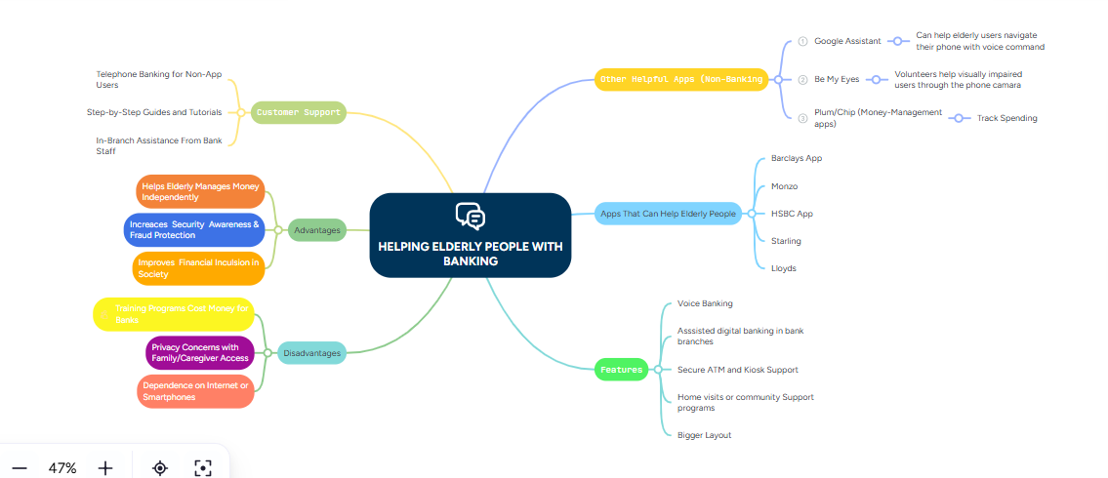

Task 2

Aims & Objectives and Research Areas

Accessibility
The project focuses on enhancing accessibility in online banking for elderly users by simplifying the design, improving readability, and incorporating supportive features. These improvements aim to enable older adults to manage their finances safely and independently, addressing common usability barriers faced by this demographic. [1]

Objectives
- To identify the main challenges faced by elderly users when using online banking systems, such as usability issues, lack of digital literacy, and security concerns [2]
- To examine existing online banking interfaces and evaluate their suitability for elderly users.
- To analyze common security risks (e.g., phishing, fraud) that disproportionately affect older adults.
- To propose design improvements or support solutions (e.g., simplified interfaces, tutorials, or assistive technologies) to enhance usability and security.
- To evaluate the effectiveness of the proposed solutions through user feedback or testing.

These objectives ensure a structured approach to understanding both the technical and human factors affecting elderly users, ultimately supporting the development of more inclusive banking systems.

Research Philosophy
The research philosophy for this project is User-Centred Design (UCD). This approach emphasizes understanding the needs, behaviours, and limitations of users in this case, elderly individuals when interacting with technology [3]
[4]User-Centred Design is particularly suitable because the projects aim to address a real-world problem by placing the user at the heart of the design process.
This philosophy encompasses observation, user feedback, and iterative design. By analyzing how elderly users engage with banking applications, the project can identify usability issues and develop solutions that simplify tasks like checking balances or making payments. [5]This approach aligns with the problem-solving methodology discussed in Unit 1, Topic 2, where a thorough understanding of the problem leads to more effective solutions.
In summary, User-Centred Design fosters innovation by promoting the creation of inclusive technologies that enhance both individual independence and societal well-being.

Search Tools and Strategies
To identify relevant research for my projects, I utilized a combination of general academic search engine and specialized research databases.

Google scholar
Website: https://scholar.google.com
- Use quotation marks for exact phrase searches (e.g., “elderly users online banking”) [6]
- Combine keywords using Boolean operators such as AND, OR.
- Sort results by relevance initially, then check publication dates to prioritize recent studies.
- Utilize the “Cited by” feature to identify influential and widely referenced papers.
- Prefer sources from journals, conferences, and academic institutions.
- Avoid non-academic or unverified sources, even if they rank highly.

IEEE Xplore
Website: https://ieeexplore.ieee.org
- Focus on topics related to cybersecurity, usability, and system design.
- Apply filters to include only peer-reviewed journals and conference papers.
- Limit results to publications from the last 5–7 years to ensure currency of technology.
- Use specific technical keywords such as “authentication systems” and “secure banking systems.”
- Review abstracts carefully before downloading full papers to confirm relevance.
- Prioritize highly cited IEEE papers to ensure reliability.

ScienceDirect
Website: https://www.sciencedirect.com
- Use advanced search options to combine multiple keywords effectively.
- Filter results to include research articles and exclude book chapters if unnecessary.
- Focus on research areas such as Human-Computer Interaction, Social Sciences, and Information Systems [7]
- Select recent publications (last 5–10 years) to ensure up-to-date findings.
- Read summaries and conclusions first to quickly assess relevance.
- Use articles published in reputable journals with strong academic credibility.

University Library Databases
Institutional tools to access subscription journals and eBooks
Allows filtering by peer-reviewed status, publication date, and subject area.

Search Strategy
To identify relevant research, I applied structured search techniques:

Keyword Searching
Identified key terms related to the project topic.
Example keywords include:
“(Main topic keyword)”
“(Technology or method used)”
“Application of (topic)”
“benefits of (topic) in (field)”

Research Strategies
Validity, Reliability, Generalisability, and Ethics
To ensure the quality of this research, several strategies will be implemented:
- Validity refers to the accuracy with which the research measures what it intends to measure. This will be enhanced by designing clear, relevant questions focused on elderly users’ experiences with online banking, ensuring that the collected data accurately reflects real issues such as usability and security concerns [8]
- Reliability will be ensured through consistent data collection methods, including structured questionnaires and standardized interview questions. This consistency allows the research to be replicated with similar results. Additionally, pilot testing (see Appendix) will help identify and correct any inconsistencies prior to full-scale data collection
- Generalisability pertains to the extent to which findings can be applied to a broader population. This will be improved by gathering data from a diverse group of elderly participants with varying levels of digital literacy. However, due to a limited sample size, generalisation may be somewhat restricted.
- Ethical considerations are paramount when working with elderly participants. Informed consent will be obtained before data collection, and participants will be assured of confidentiality and anonymity. Sensitive information, such as banking habits, will be handled securely. Participants will also have the right to withdraw from the study at any time

Q2. Research Strategies and Data Collection Methods
To collect relevant data for this project, a mixed-method research strategy will be employed, combining both quantitative and qualitative approaches. This approach facilitates a comprehensive understanding of the challenges elderly users face when using online banking.

Data Collection Methods:
Questionnaires
A structured questionnaire will be used to gather numerical data from elderly users. This method efficiently collects information from multiple participants and helps identify trends such as confidence levels, frequency of use, and common difficulties. Closed-ended questions (e.g., multiple choice, rating scales) will be included to facilitate straightforward analysis.
Semi-Structured
Interviews will be conducted to gain deeper insights into the experiences and perceptions of elderly users. This method allows participants to articulate their difficulties, security concerns, and suggestions for improvements in their own words.
Observation
Where feasible, observing elderly users interacting with online banking platforms can help identify usability issues that users may not explicitly report.

Pilot Data Collection Method
A pilot study was conducted to test the questionnaire before full data collection, involving a small sample of 3–5 elderly participants.
Purpose of the Pilot Study:
- To identify unclear or confusing questions.
- To test the structure and length of the questionnaire.
- To ensure questions are appropriate for elderly users.
Findings from the Pilot Study:
- Some participants found technical terms such as “authentication” difficult to understand.
- A few questions were considered too long or complex.
- Participants preferred simple language and clear answer options.
Improvements Made:
- Simplified wording of questions by replacing technical terms with everyday language.
- Reduced the number of questions to make the survey shorter and more user-friendly.
- Added examples to clarify certain questions.
These changes enhanced the clarity, accessibility, and overall effectiveness of the data collection tool.

Reference to Appendix
The final version of the pilot questionnaire is included in Appendix A. This appendix demonstrates how the research tool was designed and refined based on participant feedback.

Appendix A: Pilot Questionnaire (Final Version)
- How often do you use online banking?
  - Daily / Weekly / Rarely / Never
- How confident do you feel using online banking?
  - Very confident / Somewhat confident / Not confident
- What difficulties do you face when using online banking?
(e.g., remembering passwords, navigating the app, understanding instructions)
- Are you concerned about online security?
  - Yes / No
- What would make online banking easier for you?
(Open response)

Quantitative And Qualitative Analysis

Data Analysis in Research
Data Analysis is crucial for interpreting collected data and uncovering meaningful patterns or relationships. Research methods typically fall into two categories: quantitative analysis, which deals with numerical data, and qualitative analysis which examines non-numerical data such as words, opinions, and experiences. These approaches are combined in mixed-methods research to provide a comprehensive understanding of research problems. [9]

Quantitative Analysis
Quantitative analysis involves statistical techniques applied to numerical data to explore relationships, patterns, and trends. It is meanly used in surveys, experiments, and structured questionnaires where data can be quantified.

Regression Analysis: examines how one or more independent variables predict a dependent variable.

Descriptive Statistics: summarize data through measures like mean. Median, mode, standard deviation, and percentages.

Qualitative Analysis
Qualitative Analysis seeks to understand meaning, experiences, and perspectives, making it ideal for exploring complex social behaviours or deep insight into participants views.

Narrative Analysis: focus on personal stories to interpret participants experiences

Discourse Analysis examines language use within social or cultural context, exploring how meaning is constructed through communication.

Qualitative Analysis was selected for this project due to its emphasis on understanding the nuanced experiences, behaviors, and challenges encountered by elderly individuals when using online banking. Unlike quantitative methods that primarily focus on numerical data, this approach aims to delve into how users feel, the difficulties they face, and the underlying reasons behind these issues.
Elderly users often confront complex, personal challenges such as confusion with app interfaces, fear of online scams, and a lack of confidence in using digital technology. These aspects are inherently subjective and cannot be fully captured through quantitative measures alone. Qualitative methods, including interviews and open-ended surveys, enable participants to articulate their thoughts and experiences in depth, yielding richer and more detailed insights.
Moreover, qualitative analysis aligns with a user-centered design philosophy, which is crucial for developing accessible and straightforward online banking solutions. By collecting detailed user feedback, the project can identify specific usability problems and tailor more effective, inclusive designs that meet the unique needs of elderly users.
In summary, qualitative analysis is the most appropriate methodology for this project as it facilitates a comprehensive understanding of real user experiences, which is essential for creating innovative and user-friendly online banking solutions for elderly people.

References

[1] | A. Smith and J. Jones, “Designing for elderly user: Enhancing Online banking accessibility,,” Journal of Usability Studies, vol. 14, no. 2, pp. 45-58, 2022.
[2] | L. Chen and M.Chan, “Challenges of digital literacy among older adults in online financial servicees,” Computer in Human Behaviour , vol. 88, pp. 194-202, Jan 2019.
[3] | D. Norman, The Design of Everday Things, Revised and Expanded Edition Basic Books , 2013.
[4] | K. G. e. al, “Key Principles for user-centered systems design,” Behaviour & Information Technology , vol. 22, no. 6, pp. 397-409, 2003.
[5] | L. C. e. al, “Factors Predicting the use of technology: Findings from the center for Research and Education on Aging and Technology Enhancement (CREATE),” Psychology and Aging , vol. 21, no. 2, pp. 333-352, 2006.
[6] | E. Garcia, “Using Boolean operators to improve database searches,” Journal of Library Administration , vol. 50, no. 1, pp. 1-6, 2010.
[7] | P. Wright, “Human-Computer Interaction research trends,” Interacting with Computers , vol. 31, no. 6, pp. 557-569, 2019.
[8] | D. Bryman, “Social Research Methods 5th ed,” Oxfprd University Press , 2016.
[9] | J.W. Creswell and J.D. Creswell , Research Design: Qualitative, Quantitative, and Mixed Methods Approaches, Thousand Okaks CA USA: Sage: 5th Ed, 2018.

