Presentation on Workplace Culture and its impact on Organisational Efficiency
24 June 2019
Sabia Begum 1709485

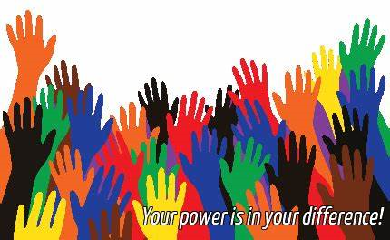

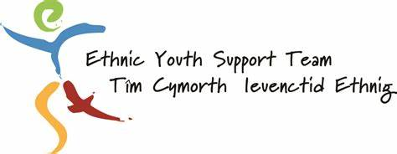

EYST culture has a sense of job satisfaction that they have might have helped someone facing issues or providing opportunities that some may not have experienced before (Participant 1,2019). They have an approachable, friendly like a family, diverse and helpful culture. Their culture made them successful and unique. Positive and negative feedback is part of the game but delivered in a constructive way.
Definitions
“Organisation culture describes those parts of human experience and performance that contribute to the differences and similarities in how people see and absorb with their world” (Martin and Fellenze. 2010, p.480).
“Organisation is prosperous human environments-environments which require of all employee’s and leader’s recognition, tolerance and, optimistically a celebration of individual and group differences” (Brooks,2009, p.4.).
According to these authors and articles on culture, the analysis of EYST culture is that their organisation has been recognised for its values and norms. They explored individual’s views and research through different perceptions and various perspectives. They focus on the attitudes, behaviour, how they communicate with others and be motivated and managed through working with different ethnic people. As we interviewed participant 2, (2019) said ‘money did not motivate me, it was the respect and friendship I had from the workplace by doing volunteering to becoming an employee’.
Furthermore, businesses these days are rapidly changing. So, regular check up on the workplace presents fantastic opportunities to highlight negative behaviours and their potential impact on the company offering direction and drive necessary change (HR, 2019).

After having conducted qualitative interviews with the CEO and employees of EYST, this is what we have found on the six elements of the cultural web (OPM,2019).

Stories
EYST awarded the largest funding (2011) from the Big Lottery People & Places Programme to deliver the My Space Project also they won the Welsh Assembly Government’s Outstanding Youth Centre Project Award in the Wales Youth Work Awards 2011 following the head to head with the Scouts and wins Public Telephone Vote in Big Lottery Fund’s People’s Millions Competition to win £49,000 to refurbish and create a new Youth Drop-in Centre (Eyst,2019).
Stories reinforce and drives the organisation forward into the future no matter how big the company is (Inc.com,2015). Stakeholders and staffs have a positive impact on the success of the company stories also for future employees who would want to work there (HBR,2019). In my knowledge company stories describe the inside culture of the organisation. Successful, hardworking and committed business wins awards which put the company’s reputation high and well known to the public. Not only company stories are positive but also negative too. When negative stories arise, the company could be described as irresponsible, false or looking out for their best interest (Azcentral,2018). Although it can be possible to gain a good name again, it will take time because of building trust again.

Ritual/routines
First, each of the interviewed employees agreed that they were part of that family-style organisation.
Employees are working on normal time schedules. The first thing they do is by signing in the board and add the location. Then make a cup of coffee or tea and discuss what has been scheduled for them. This is the same routine every day. Employees health and wellbeing is very important for every organisation. EYST monitoring their employee’s attendance and location shows that they have concern for their employee’s health and wellbeing. Cooper (2015) described a company’s safety culture is motivated by the executive leadership team that produces supports and sustains a company’s journey to excellence. Cipd (2019) critically reviewed that organisation that assesses the health and wellbeing of employees and more likely to report employee’s activities that has positive outcomes. Under UK law legislation, some organisation have a low level of hazard related to fire or health, etc so the manager should create a working environment that is reasonably practicable, safe and without risk to health. In case of fire, the manager can keep a track record of staffs, visitors by signing in and out on the reception on who’s inside the premises and who’s not (Gov.uk. 2016).
Team meeting is held monthly helps ensure that all staff members are informed of any important events, operational decisions and key changes. Decisions are made by the management board, but employees can give their suggestions and ideas. Wilkinson, et al (2010) commented that research has shown that employees’ participation such as sharing information with other employees are most likely to lead higher levels of performance. Employees feel they are valued and listened.

Symbols
The symbols are about recognisable expressions of the organisation, such as the logo. EYST logo has different colours. The colours are red, yellow, blue and green. Their logo represents their organisation culture as in love, harmony, trust, fun, responsibility and love (Think Design,2019).
In my research, I came upon few authors as Riggs (2019), Ornstein (1986) and Armstrong (2012) who resembles symbols as an organisation identity that addresses the culture and a source of information used by individuals in forming their impressions of the psychological environment.
However, as Armstrong (2012) has pointed out that symbols can be translated in different ways. Therefore, it can lead to widespread understanding of the organisation or mislead to serious communication problems. If this happens, then people can make a positive or negative impression of the organisation which can affect the organisation and people working there. As Pettinger (2012) mentioned, the greater the clarity of language, the greater the likelihood. Which means the clearer the understanding of the organisation sign or logo is, the clearer it reflects its organisation is about.

Organisational structure
The Organisation structure is hierarchical tall and formal. (Appendix 1)
In the analysis, EYST structure is flat. The flat structure has a tall hierarchy which means that there are not many people on the same level rank. Each person is in control of a small area which means not many people under each person. Looking at the structure; top level people are the management who are in control of the whole organisation. Decisions, planning, finances, marketing are made by managers. Then there are six teams with leaders. Each team has 3-6 members.
When the organisation grows and develops there are more ranks which makes the structure even taller.

Control systems
“Control system is a vital element of management. This process concerns planning, leading, systematising and monitoring the resources or team” (Martin and Fellenz, 2010, p.414).
Their control system is tight, it is controlled by the seniors as the council committee board because it is a funded organisation. Finance, marketing, human resources, IT are all controlled by them (Participant,2019). They are the third sector because it is in the charity sectors. The decisions making are down by board meetings. They do need to oblige by similar rules of the private sector.
There is no performance related reward not penalised for underperforming. CEO has monthly meetings.

Power structure
The power structure is hierarchical as to making decisions are managed by the management and council. If employees want to share ideas, then it will be collected by the CEO and then presented to the committee board. The employees feel they are empowered, and they can talk to the CEO whenever they have an issue. Employees want and need a feeling of intimacy when it comes to their leaders so that they can feel they can connect to them (HBR,2012). Employees champion are the executive.
Appendix 1

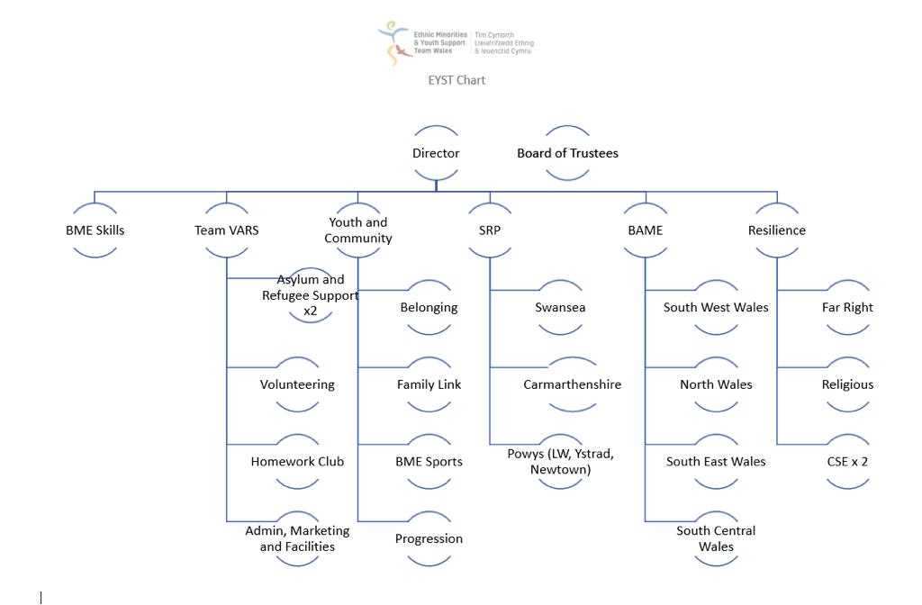

Reference
Armstrong, M. (2011) Armstrong’s Handbook of Strategic Human Resource Management.5th Ed. London: Kogan Page
Armstrong, M. (2012) Armstrong’s Handbook of Human Resource management Practice. 12th Ed. London: Kogan Page Limited.
AZcentral. (2018) The Disadvantages of Bad Publicity. [online] Available at: https://yourbusiness.azcentral.com/disadvantages-bad-publicity-3495.html (Accessed on 21.06.19)
Brooks, I, (2009) Organisational Behaviour: Individuals, Groups and Organisation. 4th Ed England: Pearson Education Limited.
Chron. (2019) What Are the Benefits of Stakeholder Communication?[online] Available at: https://smallbusiness.chron.com/benefits-stakeholder-communication-38875.html (Accessed on 14.06.19)
Cooper, D. (2015) Effective Safety Leadership Understanding Types & Styles That Improve Safety Performance. [online] Available at: http://www.behavioural-safety.com/articles/effective_leadership_cooper_0215.pdf (Accessed on 19.06.19)
Cipd. (2019) HEALTH AND WELL-BEING AT WORK. [online] Available at: https://www.cipd.co.uk/Images/health-and-well-being-at-work-2019_tcm18-55881.pdf (Accessed on 19.06.19)
EYST. (2019) Ethnic Minorities & Youth Support Team Wales. [online] Available at: http://eyst.org.uk/about.php [Accessed on 12.06.19].
Gov.uk. (2016) Office & General Workplace Safety. [online] Available at: https://assets.publishing.service.gov.uk/government/uploads/system/uploads/attachment_data/file/486694/20160101-375_2016_P2_Vol1_Chapter_02_V1-0_Workplace_Safety.pdf (Accessed on 19.06.19)
HBR. (2012) CEOs: Read this Before You Open Your Mouth. [online] Available at: https://hbr.org/2012/05/ceos-read-this-before-you-open (Accessed on 19.06.19)
HR. (2019) Company culture is critical to your success. [online] Available at: http://www.hrmagazine.co.uk/article-details/company-culture-is-critical-to-your-success ( Accessed on 12.06.19)
Inc.com. (2019). Using Stories and Symbols to Build a Powerful Culture. [online] Available at: https://www.inc.com/jim-schleckser/use-stories-and-symbols-to-build-a-powerful-culture.html [Accessed 13.06.19]
Martin, J. and Fellenze, M. (2010) Organisational Behaviour& Management. 4th Ed. London: South- Western Cengage Learning.
OPM. (2019) Understanding culture and change. [online] Available at: http://leadershipforchange.org.uk/wp-content/uploads/Cultural-Web-Questions.pdf (Accessed on 19.06.19)
Ornstein, S. (1986). Organizational symbols: A study of their meanings and influences on perceived psychological climate. Organizational Behaviour and Human Decision Processes, 38(2), pp.207-229. [online] available at: https://www.sciencedirect.com/science/article/pii/0749597886900178#! (Accessed on 13.06.19)
Participant, 1. (2019) ‘Interview with Participant 1’. Interviewed by Begum et al, (2019). ( 14.06.19)
Pettinger, R. (2012) Management: a concise introduction. London: Palgrave Macmillan.
Riggs, S. (2019). Organisational Symbolism: A Multi- dimensional Conceptualisation. [online] Available at: http://www.jgbm.org/page/22%20Sally%20Riggs%20Fuller.pdf [Accessed 13.06.19)
Think Design. (2019). Color Psychology in Logo Design | Meaning and Uses | Think Design. [online] Think Design | Spinning Design Ideas. Available at: https://blog.logodesignguru.com/meaning-and-uses-of-colors-in-logo-design/ [Accessed 14.06.19].
Wilkinson, A, Gollan, P J, Marchington, M and Lewin, D (2010) Conceptualising participation in organisations, in The Oxford Handbook of Participation in Organisations. Oxford: Oxford University Press.

