Reflective report
Elitsa Ivanova
Student ID: 2123375
Introduction to Modern Work Place

Introduction
In this report, I will analyse the group work assignment, which was a presentation on an UK organization, in this case TESCO using Gibbs Reflective Cycle. It was required to describe the organization, explore it’s relationship between the organizational structure and its performance, discuss what type of skills a manager would be to run the organisation, how the leadership theories could be applied on this organisation and lastly to discuss the factors which influences group and team behavior.

The Gibb’s Reflection Model was developed in the 1988 in order to give structure to learning from experiences. It’s a framework, which provides explaining for experiences and allows to learn and analyse if either things went well or not. This reflective model it’s helpful to use when reflecting on team work, encouraging individuals to express themselves and sharer how they felt and acted. (Gibbs, 1998)
It does cover 6 stages, which are:
- Description of the situation or the experience
- Feelings and what you thought about the experience
- Evaluation of the experience – positive or negative
- Analysis to critically and make sense of the situation
- Conclusion talk about what you learned and what would be done differently
- Action plan for how would be done if similar situation occurs.
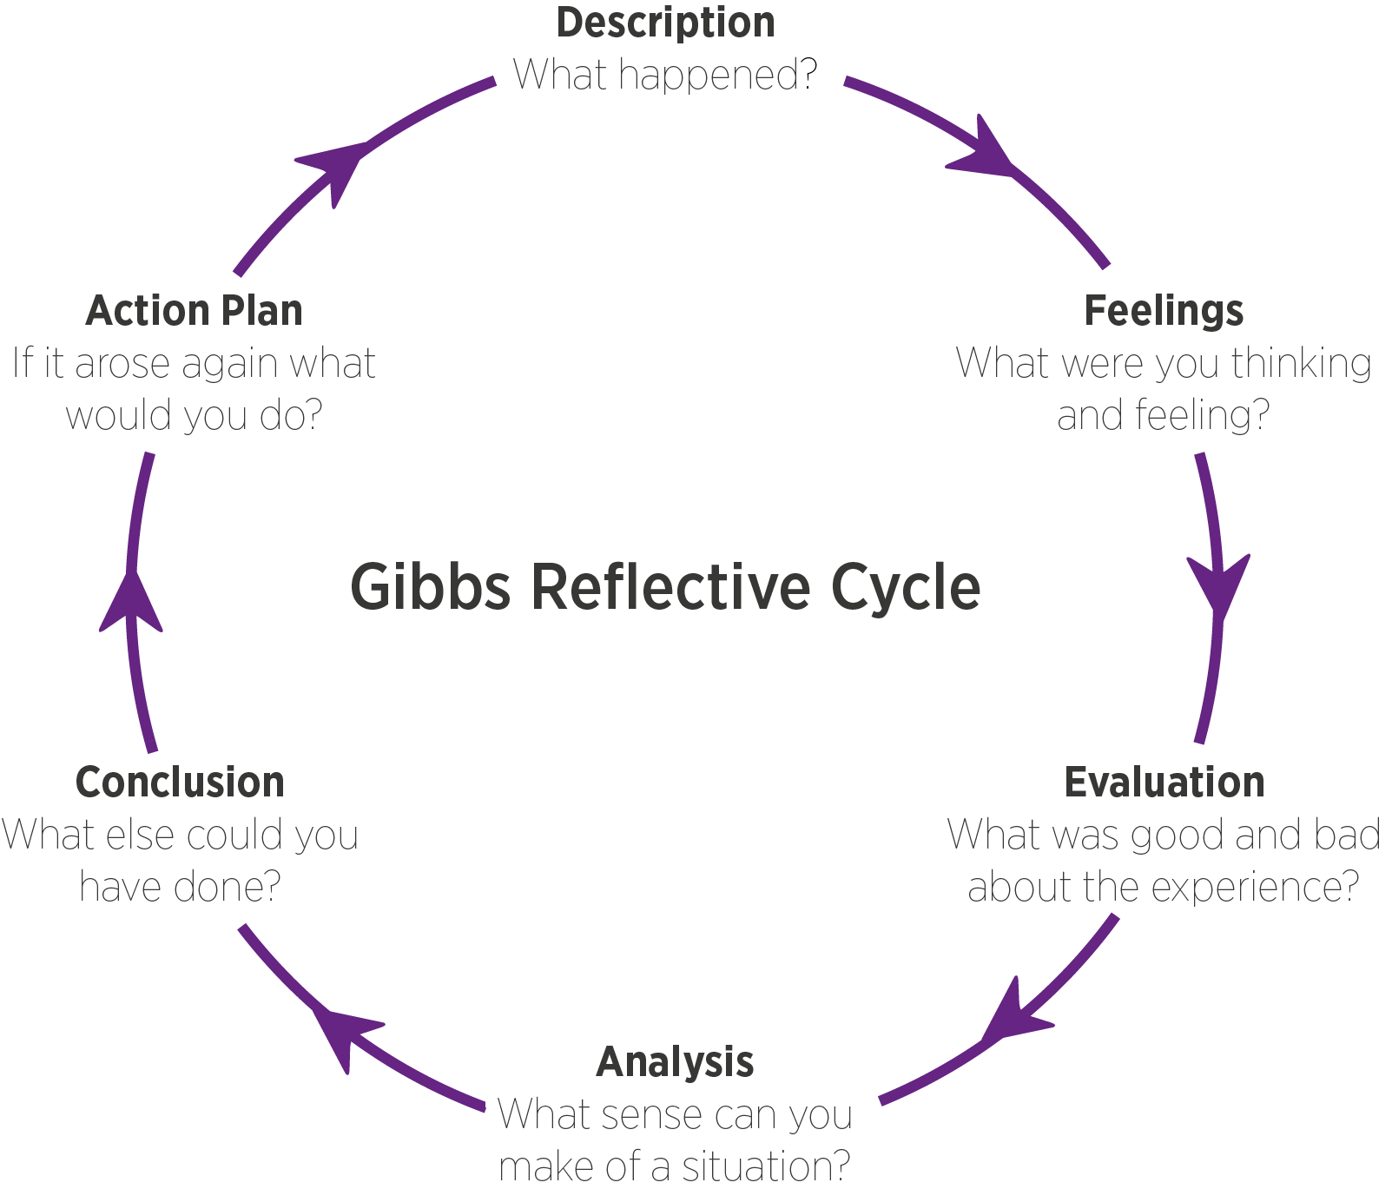

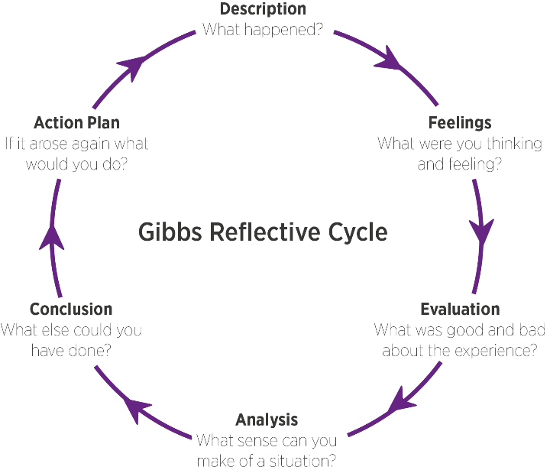
Description
For this group assignment, the group consists of 5 members, which was assigned a different task for our presentation. Each of us had a question, which we need to research and find relevant literature. After we were given the assignment, we sat down together and it was decided on the writing style, when the presentation would be put together and submitted and also what we should do if somebody is struggling with their section. In order for everything to run smoothly, we appointed a group leader who was in charge in making sure everything is okay with the designs, writing style and putting together and submitting the presentation before the deadline. A WhatsApp group was created where we were able to keep up to date.
Feelings
As it was my first time,I have worked together with so many people, it was exciting to hear everyone’s ideas and way of thinking. We knew it was going to be challenging but once everyone’s tasks and roles were established, we were able to communicate better. I was feeling a little bit nervous before presenting my part but my team encouraged me and ensure me that everything would be okay, even gave me few tips and tricks how to get over my scares. I need needed to work on my presentation skills so I did practice in front of one of my team members, which made me more secure in myself.

Evaluation
We had couple of weeks to complete the assignment and we all agreed on a timeline. It was quite easy to communicate and sharer thought with each other. We did need to ask for some help and clarification in regards to the assignment. We did face some challenges before submitting the assignment as some of the references were not done currently and some last-minute changes were required. It did put pressure on the team, it was very close to the deadline as the team was worried that we will miss the set deadline. However, our team leader did a very good job trying to motivate us during the whole process and frequently checked up on us. I think this was a positive contribution to the group work ethic.

Analysis
I am not required often to participate in group assignments and I need time to adjust to the group dynamic. I found it difficult to find literature and recent information regarding my tasks. It took me quite a while to find relevant studies with recently updated information. I did have to consult with other members on 2 separate occasions.
The biggest challenge we faced it was most of the people were very worried about the presentation and not so much about the content of the presentation. This had to be changed quickly and each of us did a script which guided us through the presentation.

Conclusion
Overall, it was very good opportunity for me, which help me develop my team working and communication skills. It made me realise the importance of getting to know every team member and ensure everyone is comfortable in sharing their perspective and ideas. Just few hours before submitting the group presentation, we had to make some last-minute changes which put pressure on some of the group members. What I learnt from this project is that it’s not effective and it does put a lot of stress into people when things have been done last minute.
Action plan
I have learned a lot working in a group setting for this assignment. Next time, when I am part of a group project, I would start with asking everyone to identify their strengths and weaknesses. I think it would be useful to understand what everyone is good in and also not so good at. If we are dividing the work again, could be better if people choose their topic instead of being assign to one without being asked. In additional, I will seek advice from somebody who has experience working on group presentations before. This will make me feel more confident when preparing the presentation. I will also aim to improve my communicate skills, so I can communicate better if I do not agree with decision made during the writing process. If I want to best possible results for the group and the outcome of the assignment, I do need to express myself freely even thought it might feel uncomfortable.
Assignment conclusion
Gibbs reflective cycle provided me with 6 specific stages, which effectively reflect on my experience working on a group assignment. It identified the key issues, as well as the positives. I realized what I need to work on in order to improve myself. I will continue developing my communication skills thought actively engaging and collaborating with my colleagues during our academic year.

Reference:
Gibbs, G. (1988) Learning by Doing: A guide to teaching and learning methods. Further Education Unit, Oxford Brookes University, Oxford.

