Kigali, Rwanda, Field Journal 2019
(SACCA)
Carrianne Ralph
Sunday 12/05/19
7:00 - Arrived at Kigali
8:30 - Rebecca and Joseph picked us up
9:30 - Arrived at the volunteer house and met Valentine Mukamuyenzi and Ester.
Valentine took us around the house, and we sat down over tea and fruit. Valentine left for the centre and we rested.
15:05 - Valentine came with her daughter and picked us up and took us to the centre in her car. The car had a sticker on the windshield saying, ‘Jesus is king’. We met the children and played games. I met Specious at the centre I think she is a social worker. Construction was taking place at the centre, builders (supported and trained by SACCA) were concreting the ground to protect it from rain.
18:30 - Valentine drove us back to the volunteer house and we wrote notes.
Monday 13/05/19
9:00 – Arrived at the centre, met Harriet (the accountant) and Joseph in the main office. We had a meeting with Valentine discussed what was expected of us, the history and aims of the centre.
11:00 – Went to the main hall and learned Kinyarwanda with the children. Met Juvenal Mujabere (a psychologist)
13:00 – Walked home from the centre for lunch
15:00 – Arrived at the centre and drew drawings, the children plated my hair and read to me in the main hall.
18:00 – Walked to the volunteer house from the centre.
Both Valentine and Juvenal spoke openly to us about the role of the genocide in influencing their careers, it was a shock for me to hear people speak so honestly about it, as we had been warned not to talk about it before we left.
Tuesday 14/05/19
9:00 – Arrived at the centre and waited to meet the Agronomist, Emmanuel.
9:30 – Met Emmanuel, He gave me wellies, football socks and rubber gloves for gardening. We walked to the gardens just behind the centre and planted cucumber seeds. (Everyone else was barefoot and without gloves, it made me wonder why I was having such special treatment).
The tools I brought proved useful, and I noted that I couldn’t see any others, (other than a razor blade, plastic piping, an empty sack and sticks). Interestingly, I was explaining the watering can to Emmanuel and he thought it was a seed dispenser, which it could be, so I’m hoping my definition of it doesn’t limit his use of it.
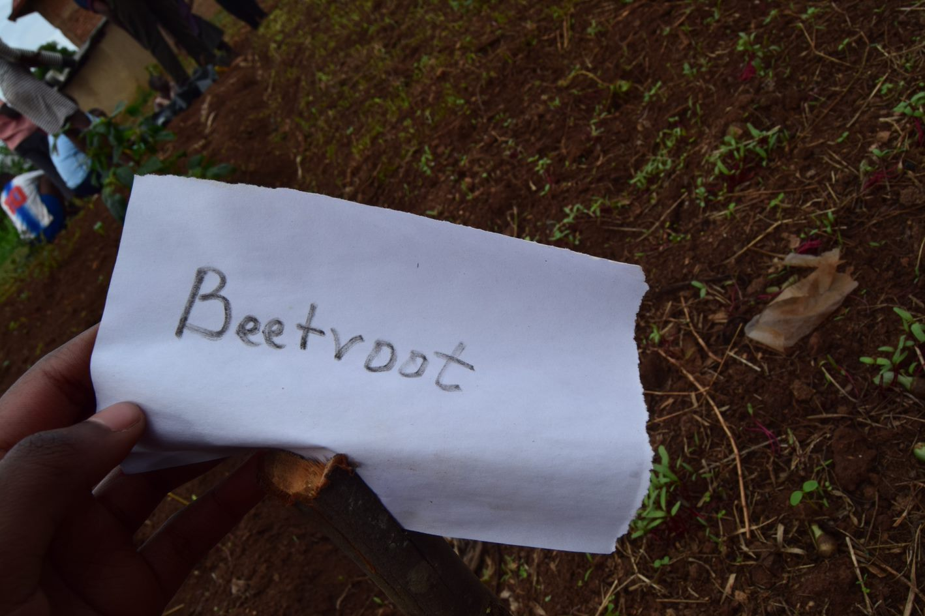
(Juvenal showing the crops he had planted, SACCA girls centre, Kayonza, Rwanda, 14/05/19)
11:30 – Finished gardening and so helped Carys teach English in the main hall.
12:00 – Juvenal walked us to the market in town.
13:00 – Arrived at the volunteer house for lunch.
15:00 – Arrived at the centre’s main office and Juvenal gave me case studies from 2004 – 2006 to read over. I was timetabled to write case studies with Charlotte, (social worker) but she was ill. My time could have been used more suitably. I did not feel as though my presence there was in any way productive that afternoon. Even if I had just been told to clean or order files, I feel as though I would have been more use to the centre.
17:45 – Harriet dismissed us, we walked to the internet café, emailed Ann.
18:25 – Walked to the volunteer house.

Wednesday 15/05/19
9:00 – Arrived at the office. Emmanuel was unavailable, so I was asked to wait for Christine so I could cut hedges. Valentine has told me that until the builders leave on Sunday I cannot continue with Emmanuel, planting flowers and vegetables in the centre.
9:30 – I helped Rebecca (teacher of culinary arts) and Christine unpack new kitchen utensils in the culinary arts teaching facilities.
10:30 – Helped Christine cut hedges.
12:00 – Walked to the Volunteer house for lunch
14:50 – Arrived in office preparing for dance this afternoon
16:00 – Helped Melany present discussion on sexual health, centring on puberty. Following this I played music and danced with the girls.
18:00 – Walked to the volunteer house.

Thursday 16/05/19
Day off from centre.
11:00 – Video meeting with Ann and Andy.
11:40 – Walked to centre to pick up Melany’s charger. Met a representative of World Jewish Relief, who was having a meeting with Valentine, and said that she was ‘[…] interested in hearing fresh perspectives […]’. And offered to go for coffee in the next couple of weeks to speak with us.
12:20 – Arrived at the volunteer house for lunch
13:20 – Walked into Kayonza to look around and buy small supplies. Whilst walking around we saw a school who’s sign read ‘Education for Sustainable Development’, intrigued by this, we pondered whether this was due to funding from NGOs? We also saw a building called ‘Kayonza Artizan Centre, Rural, small, microenterprises promotion project’. We will go back there after forming questions.
14:30 – Arrived home
15:00 – Writing up field work notes and preparing for dance session tomorrow afternoon.

Friday 17/05/19
8:30 – Left Volunteer house for centre
9:00 –left the centre with Charlotte (social worker), walked into town.
10:00 – Arrived at the first home of the day’s community visits. The name of the girl whom we were visiting was unavailable. The girl was trained by SACCA as a house girl, Charlotte explained that this is a good way for girls to gain independence, as it gives food and boarding, and a wage to save money.
10:30 – Went to a hotel in town to meet a girl who had been trained in hospitality. She was ill, and thus unavailable so we moved on, walking to the open day above town.
11:00 – Arrived at the SACCA stand at the Akarere Ka Kayonza 15-17/05/2019 open day. This open day was a three-day space where all the development projects in Kayonza could come together and be publicised. The vastness and multitude of development schemes was impressive. For example, ‘Women for Women International’, which is a social empowerment network which aims to help women affected by war to gain financial independence and sustainability through utilizing skills and resources available. The women at this stall were selling products they had made, from clothing to bags to sculptures and bowls. Whilst at the stand there was a farmer supported by SACCA (He spoke no English, so I couldn’t get his name), Emmanuel, Theogene Musoni (a social worker) Juvenal and two young people who were learning hairdressing through SACCA. One of these hairdressers asked to do my hair, the farmer didn’t believe it was real.
11:55 – Walked home from the open day with Theogene, and two young people who were training to be hairdressers through SACCA.
14:45 – Arrived at the girls’ centre, prepped in the office for dance at 4:00.
16:00 – Supported Melany teaching reproductive health (centring around the menstrual cycle and bodily hygiene). Following this I showed the girls some traditional folk dancing.
17:45 – Walked home.

Saturday 18/05/19
7:00 – Arrived at the girls centre ready for running.
8:40 – Got back from the run, arrived at the centre.
9:00 – Planted flower cuttings in the garden with Emmanuel and many of the girls. Interestingly, we used Aloe Vera cuttings as succulent for the cuttings in their potting.
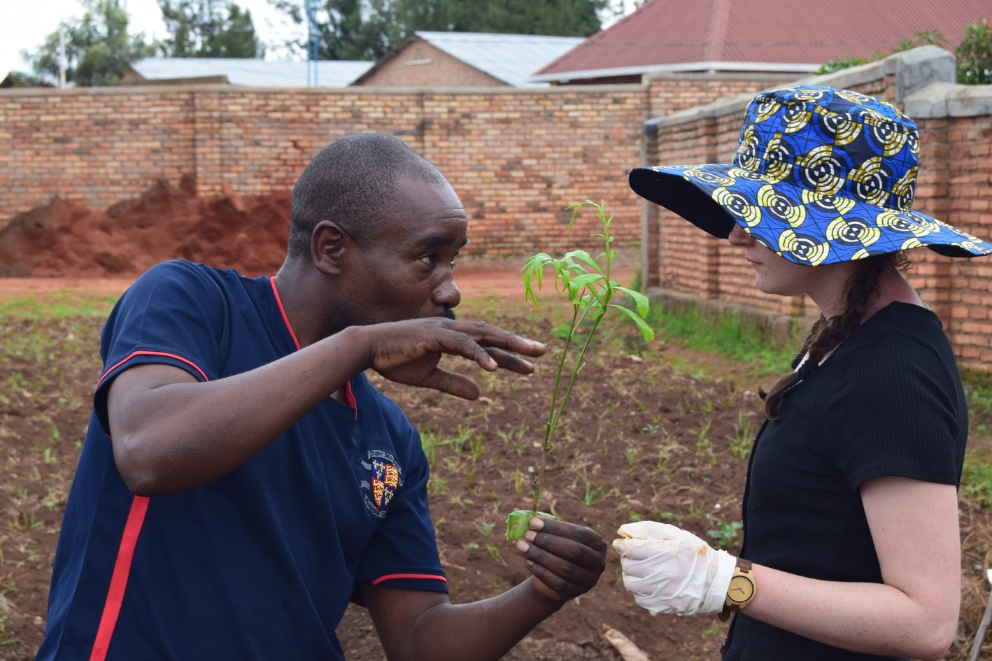
(Emmanuel and Carrianne, SACCA Girls centre, allotments, Kayonza, Rwanda, 18/05/19)
11:00 – Walked home from the centre.

Sunday 19/05/19
15:00 – Arrived at the centre, watched a Bollywood film with the girls, also managed to read some English language (GCSE) textbooks.
17:15 – Walked home from the centre.

Monday 20/05/19
8:50 – Arrived at the centre,
10:30 – Left the centre to go to Kigali hospital,
11:30 – Arrived at the hospital, was taken by a man named Benjamin, who led us to the dentistry/ paediatrician ward, and Carys was seen.
11:50 – Travelled to a second hospital in Kigali for a radiogram.
12:40 – Had lunch in Kigali
14:05 – Arrived at the first hospital with X-rays and Carys was seen again.
17:40 – Arrived home from Kigali.
It struck me how much these hospitals were like the ones at home, except in Rwanda you waited shorter times, and everything smelled better. But these seem like very small differences, considering we pay nothing for the ones back home.
Tuesday 21/05/19
8:50 – Arrived at the centre
9:30 – Helped Emmanuel plant flowers alongside the palm trees which he planted yesterday. Diane and Minyoni helped.
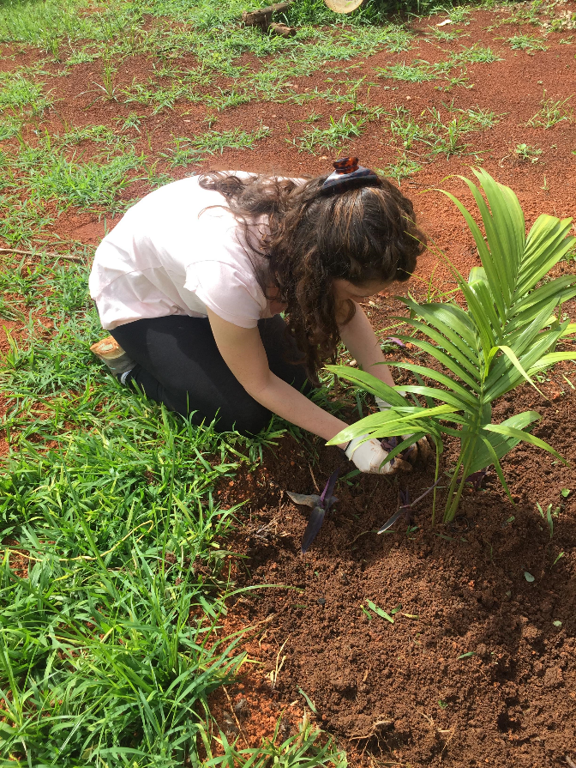
(Carrianne Ralph, SACCA girls centre, Kayonza, Rwanda, 21/05/19)
10:50 – Finished planting the flowers with Emmanuel.
- Had a meeting with Valentine and Melany discussing the change of circumstances regarding Carys, as we agreed that someone should stay home with Carys until she is better.
11:00 – Walked back to the volunteer house and had lunch. Stayed home for the afternoon with Carys.
- Wrote up notes from the week,
- Planned and structured games for tomorrow afternoon, as the dynamics will change, and it will be the first time I’m running an afternoon entirely alone.
- Started a blog for the SACCA website.
Also, today 15 new girls have attended the centre. Theogene introduced me to each of them, and I think this is demonstrative of SACCA’s confidence as a project.
Wednesday22/05/19
8:45 – Arrived at the centre
9:30 – Worked with Emmanuel, tidying the grounds for tomorrow’s visitors and planting grass.
Tomorrow’s visitors are funders of SACCA however, Emmanuel couldn’t tell me who they were. I will try to find out. We were preparing the grounds for them. I met Jesca Uwizeye today, she is lovely, she’s studying child development in Uganda, and although she has volunteered here three times, she is now on an internship. She hoped to study child advocacy after this degree. Jesca came and took some of the new girls from gardening so that she could write up their profiles.
11:30 – Finished working with Emmanuel. Worked in the office, preparing assignments.
12:30 – Left the centre.
14:50 – Arrived at the centre for afternoon activities.

Thursday 23/05/19
5:00 – Carys left this morning. It will be interesting to see how the dynamics of this placement change from her leaving.
8:30 – Melany was taken by Valentine to go to the salon in town. Interestingly, Melany said that she thinks Valentine (as a member of SACCA) has a lot of authority in the town. From further discussion, we think it may appear this way due to SACCA’s link with the salon; providing hairdressing courses in partnership with the salon.
10:30 – Joseph came to the house and took the peas and beans from the fridge. This showed the inter-connectedness of the SACCA centre with its other responsibilities and links. Ester had got and was keeping the vegetables for the girls at the centre.
18:00 – Had a meeting with Ann, discussed the experience so far. All is well both sides.

Friday 24/05/19
8:45 – Arrived at the centre, timetabled to go on community visits with Charlotte. However, this did not happen due to representatives from World Jewish Relief having a meeting and timetable with the centre (which was understandably more important to stick to).
9:30 – Met Alex, a representative for World Jewish Relief, who had not been to the centre before, but was working alongside Katrina.
13:00 – Left the centre for lunch. With my hair in plates, thinking about the role of hair in forming relationships, as I walked into town with Jesca, who has an internship at the centre, after three separate occasions of volunteering, (Jessica is studying child development, with two years left, and hopes to do a master’s degree in child advocacy). Following the children introducing themselves and playing games with Alex, Jesca asked to plate my hair, I said yes, and it got me thinking about the social role of hair in contexts like this. The way that groups of women work together, subbing one another in and out for hours all working for the same outcome – and as the third time that people had asked to do my hair in just two weeks. I began to think of hairdressing as more of a social experience, than a necessary outcome to having hair (due to this being a report, I think I will unpack this somewhere else).
15:00 – Arrived back at the centre. Although timetabled to do dancing, we did a range of activities. Ranging from dancing, to playing sticks to reading the books I had brought.
17:30 – Left centre. Jessica walked home with us, as she lives in town, and invited us to her house next Thursday – I hope she sticks to that promise!

Saturday 25/05/19
8:30 – Seth and Moses picked us up on their motorbikes and took us to Umuganda, which was just above town, past the grounds of the open day last week. Umuganda was spent weeding a rural road above Kayonza, using picks, shovels and slashers. There were over 50 people there in total. Whilst working we met a local pastor, who spoke fluent English, and had been to Canada, researching farming. He was wearing a top which said; ‘KOMERA, giving confidence, one girl at a time’. I recognised this from the open day last Friday, and it seems that he was a member of the Komera development programme, who’s slogan is; To give young women in Rwanda confidence to lead social change in their communities, through education, community and sports’. It is interesting to see the level of involvement of local people in all these development programmes in their day-to-day life in Kayonza.
10:00 – everyone congregated outside a home, and many people began speeches, thanking people for their service, and Melany was asked to speak, she spoke in Swahili, and Seth translated into Kinyarwanda.
11:00 – We were taken by Seth and Moses to Innocence’s (a local person) house, where we were given hot nuts and Fanta. We played cards, and it was a laid back atmosphere, it seemed like the first insight into the day-to-day life of local people since being in Rwanda – it was the first time that people were interacting with us from choice, not just because they were employed by SACCA.
13:30 – At this time the atmosphere changed, and many people came to the house, over 20 people were there in total, and we were given food by the host’s wife. In the afternoon all these people squeezed into the living room on laps and perched on the arms of chairs, began to speak more seriously, and those sat beside me on the Settee got big blue squared books out that said ‘East Africa’ on them. Then those reading from the books started to ask people for money (I could see from where I was sat that it was planned, and organised – the amount of money and from who) I noted that not everyone in the room gave money, and not everyone gave the same amount either. Melany said that it was like ‘Chama’ in Swahili, which is a small micro-finance group. The experience was quite overwhelming, so I’m hoping I can speak to Seth this week, now that I have understood all that’s happened.
16:00 – Seth and Moses took us back to the Volunteer house.

Sunday 26/05/19
Spent the morning writing assignments
15:15 – Arrived at the centre, sat with the girls in the dining room watching movies.
5:30 – Left the centre.

Monday 27/05/19
8:55 – Arrived at the centre, met Rebecca and Theogene in the office. Emmanuel picked me up from the office and we went to the Vegetable patch with six children, weeding the beetroots and onions. Afterwards we went to the front garden in the centre and took ‘sachets’ off of fruit plants that had been planted, so that they would grow. After washing all the tools using the water tanks Emmanuel said that we will be making a kitchen garden tomorrow.
10:45 – Finished working with Emmanuel, and so went back to the office. Walked back to the volunteer house to pick up my laptop so that I could do work in my spare time.
11:30 – Arrived back at the centre, and wrote up notes for assignments
12:30 – Left the centre for lunch
14:45 – Arrived at the centre and took photos of grounds and gardens that we did in the morning.
15:10 – Spent the afternoon colouring patterns with the girls on the grass in the centre. I was timetabled to do dance, but due to Presidia practicing for competitions, I didn’t want to interfere with any practice times she had. The children enjoyed colouring, and that is what is important.
17:30 – Left the centre for volunteer house.

Tuesday 28/05/19
8:50 – Arrived at the centre and waited for Emmanuel. We spent the morning filling rice bags with soil, then Emmanuel tied the bags together at the top with plastic wrap and placed them on their side in a circle. There was still a pile of soil in the middle when we had finished for the day.
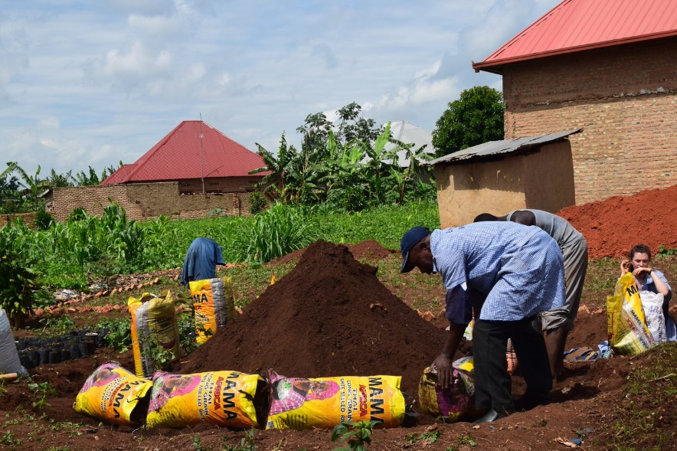
(Emmanuel, SACCA girls centre, Kayonza, Rwanda, 28/05/19)
11:10 – Finished working with Emmanuel. Worked in the office on my laptop.
12:30 – Went to the volunteer house for lunch
14:50 – Arrived at the centre. On the walk up, a woman game up to me and grabbed my arms demanding money because I’m a ‘Mozungu’. It was the second time that someone had grabbed/approached me in the street for this. Although I find it frustrating, I think it affected Melany more than me.
15:48 – I was timetabled to be in the office writing case studies, but there was no member of staff to support me, so I used the time to prepare for assignments. When we sit in the office, I often feel as though I’m in other people’s seats/ in the way.
17:30 – Before leaving I organised to have a meeting with Juvenal tomorrow after gardening, about the effect of student – volunteer relationships on children. Due to mine, Melany’s and Carys’ discussions around voluntourism. We left the office, and on our walk home we met Jessica, she took us to the market at the bus station, and bought us gum and popcorn, she walked us home then, and showed us some shortcuts through town. Oddly, it’s in this last week that I am beginning to feel comfortable here.

Wednesday 29/05/19
8:45 - Arrived at the centre ready for gardening. We spent the day finishing the kitchen garden that we started yesterday. Today we finished planting the kitchen garden as well as ploughing rows to plant and planting manga. The kitchen garden is very interesting. It’s a growing method which conserves water over the summer. It’s a three-tier system, comprised of sticks, rice bags, plastic sheets and soil. Firstly (yesterday) we start by filling rice bags with soil and laying them on the ground in a circle, planting sticks along the inside and placing a plastic sheet all along the inside of the sticks. The inner space is filled with soil and sticks are planted in a smaller circle in the centre of the structure. Again, this circle is covered on the inside with plastic wrap and filled with soil. A jerry can pierce with holes and filled with water; this jerry can is dug into the middle of this structure from the top. The principle is that water trickles down the structure, keeping the soil damp in the dry months, so crops will still grow. Lastly, the rice bags are cut into and planted in, serving as a bottom tier for the structure. We planted cucumbers in the top structure, then cucumbers and cabbages in the middle tier. I saw this style of agriculture everywhere at the open day in my first week, and so I tried to ask Emmanuel where he had learned it, wondering whether it was a new strategy, or a traditional one that is being reintroduced differently. However, the language barriers make it difficult, and so I never got a response.
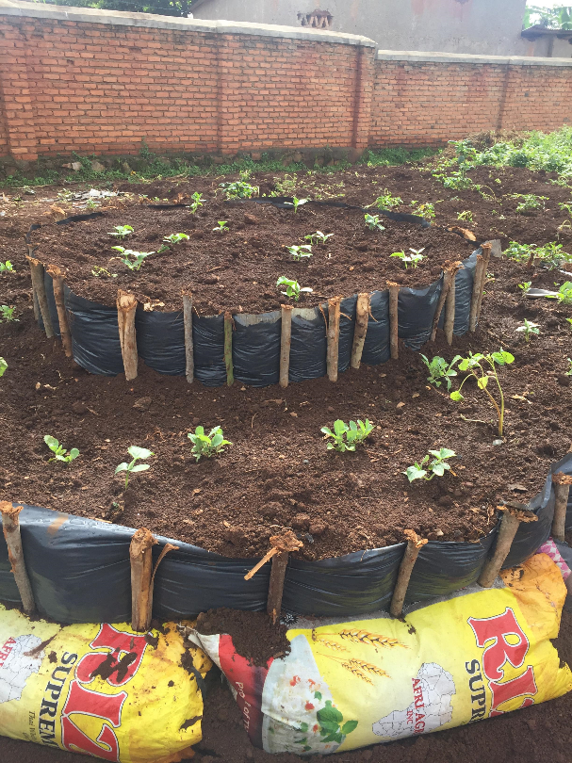
(Finished kitchen garden, SACCA Girls centre, Kayonza, Rwanda, 29/05/19)
11:30 – Finished gardening, went back to the office, Juvenal is not available because he has had to take two girls to the dentist in Kigali. I met Emmanuel (No.2), he is the chairman of the board for SACCA, and came to check on how everything was doing. He had just come out of a meeting with Valentine, and from what I could see, it was a surprise visit.
11:40 – Juvenal was back from the dentist, so we had a meeting in his office to discuss the effect of volunteer relationships with the children. Although the language barrier was very clear, we did manage to have a discussion on the topic.
Melany: Do you think it’s toxic to have volunteers?
Juvenal: yes, depends how you come.
Juvenal: Generally, children like to make good relationships with everyone.
From the conversation that we had with Juvenal, I understood that he personally believed that your intentions behind coming, and the way you treat the children whilst there is what is important. He explained that some children do cry when volunteers leave, but it seemed as though that was only a small product of volunteers, and it was more important that they made children happy when they were there.
Juvenal discussed how he was making personal charts to focus on the psychology of each girl, and he said that he was doing group chats on things such as sexual health/ personal hygiene, and he was getting good results from it because the children could understand themselves from the discussions, and so it was useful.
12:40 – Left for lunch
14:45 – Arrived back at the centre. Timetabled to do dance, but I had organised to do drawing games, Jessica translated, and we played in the dining hall.
17:30 – Left for volunteer house
18:40 – Valentine came to the house to have a meeting; she took us out for dinner at the Elegance hotel. She thanked us for our time here and invited us to come again and stay at her home. An interesting conversation that came up was when Valentine started discussing her time in Europe and seemed quite disheartened said that ‘Africa, will never catch up – Even in one hundred years’. I didn’t really push the conversation, because it seemed surprisingly raw. But it was interesting, I know Melany has a lot to say regarding it.
21:00 – We arrived back at the house.

Thursday 30/05/19
10:00 – Video Chat with Ann

Friday 31/05/19
8:45 – Arrived at the centre, walked to the allotments behind the buildings to take photos of the work we did yesterday, and to get one last glance at the allotment.
8:55 – Arrived in the office and printed off our boarding passes.
9:20 – Whilst in the office, it was clear that I was not doing community visits with Charlotte, so we walked down to the volunteer house to pick up laptops.
10:00 – Arrived back at the centre, writing up field journal.
12:00 – Left the centre for lunch
2:00 – Arrived back at the centre for a leaving ‘ceremony’. We danced and sang to say goodbye, exchanged gifts to say thank you and there was a lot of crying. I was surprised by how many meaningful relationships we had made in only three weeks.
5:00 – We left the centre.

As an anthropologist we are made aware that our presence in an environment inevitably changes the dynamics of said environment. The impact of my presence here is made consistently clear through stares and taunting from children and adults alike. It’s an interesting form of reminder.

