Engineering and Project Management Coursework
Joseph Samuel Roan
Student Number: 2411525

L5 Engineering & Project Management
ACDA5025A

Table of Contents
- Abstract……………………………………………………………………………………………………….…… 4
- Introduction……………………………………………………………………………….……………………. 4
- Aims and Objectives…………..…………………………………………………………………………….. 4
  - Aims………………………………………………………………………………………………………….… 4
  - Objectives…………………………………………………………………………………………………… 4
- Background Research……………………………………………………………………………………….. 5
  - Possible alterations and other uses for the aircraft………………………………….…. 5
- Project Design………………………………………………………………………………………………….. 6
  - Full Unit……………………………………………………………………………………………………… 6
  - Spotlight……………………………………………………………………………………………………… 7
  - Proximity Switch…………………………………………………………………………………………. 8
- Resources……………………………………………………………………………………….……………….. 9
  - Cost Breakdown………………………………………………………………………………….……… 9
- Planning…………………………………………………………………………………………………….…….. 11
  - Design & Manufacturing Stages…………………………………………………………..……… 11
    - Kick-off…………………………………………………………………….………………….….. 11
    - PDR………………………………………………………………………….………………….….. 11
    - CDR……………………………………………………………………….………………….…….. 11
    - Design Freeze………………………………………………………………….……..……….. 11
    - Drawing Release……………………………………………………….…………….………. 11
    - Production Start…………………………………………………….……………………….. 12
    - Production Finish & Testing………………………………..…………………..………. 12
  - Gantt Chart………………………………………………………………………………………….……… 13
  - Management Structure………………………………………………………………………………. 13
  - Roles of a Project Manager…………………………………………………………………….…… 14
    - Interpersonal Roles…………………………………………………………………………. 14
    - Informational Roles…………………………………………………………….…………… 14
    - Decisional Roles………………………………………………………………….…………… 14
- Expected Outcome / Deliverables…………………………………………………………..………... 16
- Risks………………………………………………………………………………………………………………….16
- Ethical Considerations ………………………………………………………………………................17
  - Regulations…………………………………………………………………………………………… 17
  - Compliance…………………………………........................................................... 17
  - Potential Impact …………………………………………………………………………………... 17
- Conclusion…………………………………………………………………………………………….…………. 18
- Appendices………………………………………………………………………………………………………. 19
  - Equality and Diversity Briefing Certificate………………………………………….….. 19
  - PREVENT Certificate………………………………………………………………………….…… 19
- References……………………………………………………………………………………………………..… 20

List of Figures

Figure 1 – Stowage Unit Assembly……………………………………………………………………………….. 6
Figure 2 – Stowage Unit Block Diagram………………………………………………………………………… 6
Figure 3 – Stowage Unit Wiring Diagram………………………………………..……………………………. 7
Figure 4 – Spotlight Assembly………………………………………………………………………………………. 7
Figure 5 – Proximity Switch………………………………………………………………………………………….. 8
Figure 6 – Multimeter………………………………………………………………………………………………….. 12

Table 1 – Approximate Design Costing ………………………………………………………………………… 9
Table 2 – Approximate Production Costing ……..………………………………………………………….. 10
Table 3 – Gantt Chart……………………………….………………………………………………………………….. 13
Table 4 – Action Tracker………………………………………………………………………………………………. 15
Table 5– Risks Register……………………………………………………………………………………………….. 16

- Abstract – Throughout this task the author has completed a product proposal document for the design and build of a Stowage Unit with a spotlight and proximity switch, that will be placed on aircrafts. This Also Includes the Aims and Objectives, background research, how the unit will work and the project planning.

- Introduction – On Aircrafts, stowage’s are very important, especially for airliners. Without them, airlines would lose money as their customers would have no storage for their items, the cabin crew (stewards and stewardesses) wouldn’t be able to store items that they need for their roles, for example food carts, galley (kitchen) equipment, own personal effects and more. Therefore, out potential clients are Airline companies, and aircraft interior companies that supply to airliners.

- Aims and Objectives

  - Aims – To design and manufacture a stowage unit fit for aircraft according to the clients choice of specification (Airbus or Boeing) additionally with the A/C (Aircraft) configurations which they will choose (What exact aircraft the Unit will be placed on). This Unit will consist of a proximity switch which will turn on automatically, illuminating light inside the unit when the door is open.

  - Objectives – To achieve the aim listed above in 3.1, the objectives that must be met in order to do this include are:

- Design a detailed Stowage Unit with a proximity switch according to the customers specification.

- Follow the Project timeline with project milestones, record the actual timeline for use in the future.

- Follow the drawings set by the design team to construct the Unit and its Electrical/Electronic Components.

- Background Research – Not all aircrafts have stowage’s, as a result many items that need to be stowed away, for example the cabin crews’ personal effects must be stored in the bins (overhead lockers) which means that the passengers have less space for their items and the airliners have less room to sell. A solution to this which is cost effective would be for further storage, hence our units.

  - Possible alterations and other uses for the unit – This is not the only use of the unit, as the units can be altered for each aircraft for different use, depending on the customers wants and needs. Making this a very versatile design with various applications.

- Project Design – The Design will consist of a Mechanical Aircraft Stowage Unit. On this unit will include a proximity Switch Aswell as a spotlight assembly. Additionally, some tests should occur. Further information on these can be found below.

  - Full Unit – The full unit will consist of the Mechanical Assembly, spotlight assembly, and proximity switch. When the door is opened this will send a signal to the spotlight assembly to turn the light on. When the door is closed the light will be turned off. This is to allow the cabin crew to affectively see throughout the unit when needed. Aswell as save on power as it will only be turned on when in use. And as it works automatically, it will not require any further actions by the cabin crew. An Isometric view of the full unit is shown below in Figure 1, a block diagram for the stowage unit is show below in Figure 2 and a Wiring Diagram is shown in Figure 3.

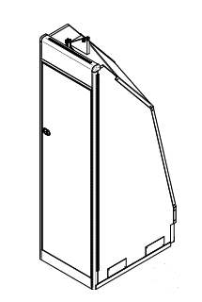

Figure 1 – Stowage Unit Assembly

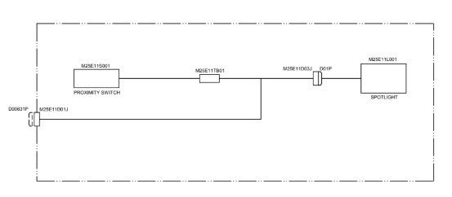
Figure 2 – Stowage Unit Block Diagram

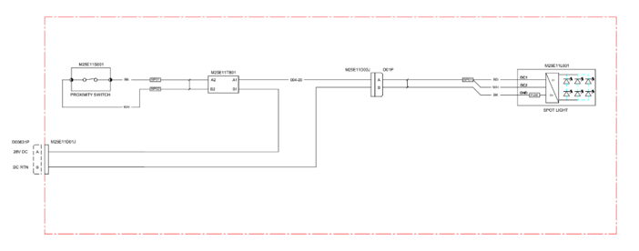

Figure 3 – Stowage Unit Wiring Diagram

  - Spotlight – The spotlight will work in conjunction with the proximity switch, as when the proximity switch is active the spotlight will be turned on. This will work using connectors. This will turn on and create a light that will luminate through the unit. This will allow for anyone who will use the unit to have the ability to see inside accurately. For an image of the Proximity Switch Refer to Figure 4 below. For Further information on the Proximity Switch, Refer below to 5.3.

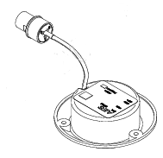

Figure 4 – Spotlight Assembly

  - Proximity Switch – The Proximity Switch will consist of two plates and 3 cables, (Shown below in figure 5) one will be fixed to the door and another fixed to the unit. They will be together when the door is shut, and when the door is open, they will be apart. When together they will have the light switch turned off. However, when they are apart it will send a signal to the spotlight to turn it on. To test if this works, refer to 7.1.7.

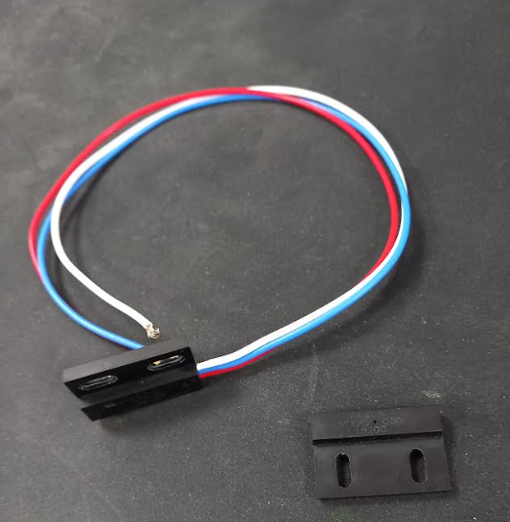

Figure 5 – Proximity Switch

- Resources – Throughout the Project several resources will be used, all of these will also come to a cost. We will be using various materials. On the mechanical structure, used will be honeycomb panels. Additionally, used will be some metalwork, these would be from Sheetmetal as well as blocks of metal. On the Electrical discipline, used will be metal and magnets for the proximity switch, as well as connectors.

  - Cost Breakdown – The cost for the whole unit design and production will be £34,000. This cost doesn’t include tolerances for if the project takes longer than expected or if unexpected costs occur, for example, staff being ill for periods of time, delays in information from clients, parts acquisition, additional employees or contactors needed, members of staff being on annual leave, and potential overtime needed. The breakdown of the approximate cost is shown below:

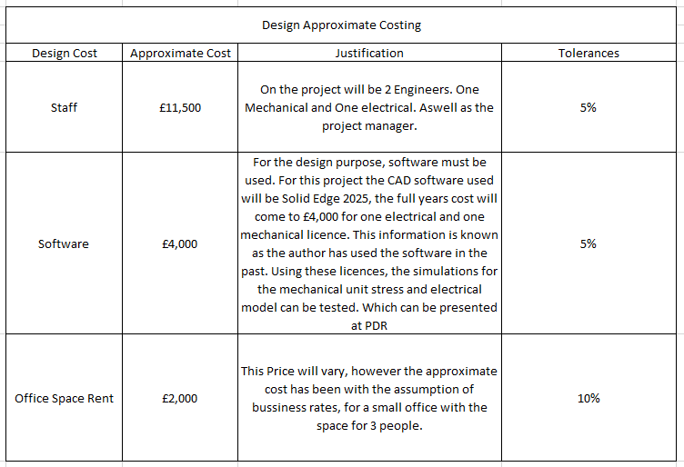
Table 1 – Approximate Design Costing

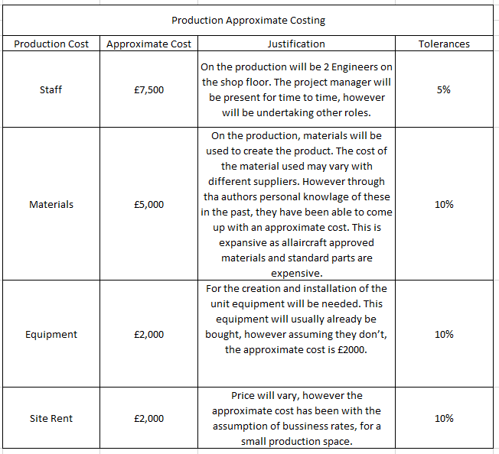
Table 2 – Approximate Production Costing

- Planning – For every project there should be a clear and concise plan to ensure that the project is carried out effectively.

  - Design & Manufacturing Stages – Throughout the Project there will be serval stages for the project. These are to ensure that a project is on track and delivered on time. For the Design Stages Refer to 7.1.1 – 7.1.5 For Manufacturing Stages Refer to 7.1.5 & 7.1.6

    - Kick-off – This is where the project has officially started. Before this point some research may have been done in preparation for the project, however at this point is where all the project members meet and discuss the project, what needs to be completed, and everyone’s roles within that. Parts of the discussion will be the project timeline, which will include the Design & Manufacturing Stages. All of whom that apply are shown below. Additionally, within this stage is where the engineers will investigate (mechanical and electrical) into the product. Also, the investigation will cover the research into the specifications that they will be adhering to in the design. As it is an aviation project, the two main specifications which they would be looking into is Boeing or Airbus. This will change depending on what aircraft the unit will be on.

    - PDR – This stands for Perimammary Design Review. This is a ‘Major Milestone’ within a projects design process, it’s when the initial design is captured and presented to clients / ’non-members of the project team’ [1]. In this case we will run some stress analysis for the mechanical unit and for the electrical discipline we will run simulations on an appropriate software, the costing for this is covered in Table 2.

    - CDR – CDR stands for Critical Design Review. This stage is when the main and Critical Design decisions have been made and incorporated to the design, this is presented to the clients, this must be completed before a design freeze and should share the fundamentals of PDR [2].

    - Design Freeze – Design Freeze is when the design modelling has ceased (frozen), all major changed should be completed by this point and any further changes will be documented and charged to the clients. The purpose of this is to lower the risk of having design changes, as they can be costly and take up time [3].

    - Drawing Release – This stage generally happens throughout the design stage. This happens gradually, because it allows for production to start work early, as if they received all the drawings in one time, production could take longer. For a drawing to be released it needs to be signed off and approved by the design authority and/or appointed persons.
    - Production Start – This is when the creation of the unit will commence. This can happen at any point during or after the design stage. During this stage, all required components and materials will be gathered for the production. Using drawings supplied by the design team the production team will produce the parts and assemblies for the project.

    - Production Finish & Testing– This is when the full production has been finished. At this point, Testing must be done for any units that will go on the aircraft. On the mechanical unit, static testing should be undertaken, this will include an up, down and side tests, for crash case scenarios. These can be done using a testing rig, with a wiffle tree. On the Electrical discipline the testing will include using a multimeter (shown below in Figure 6) to test that the proximity switch works. This test is completed by hooking onto the blue and white cables with the multimeter and then move the two plated together, when together they should emulate a beeping noise. If this doesn’t work, then there could be a system integration issue. If this fails, then reproduction of the proximity switch must commence immediately.

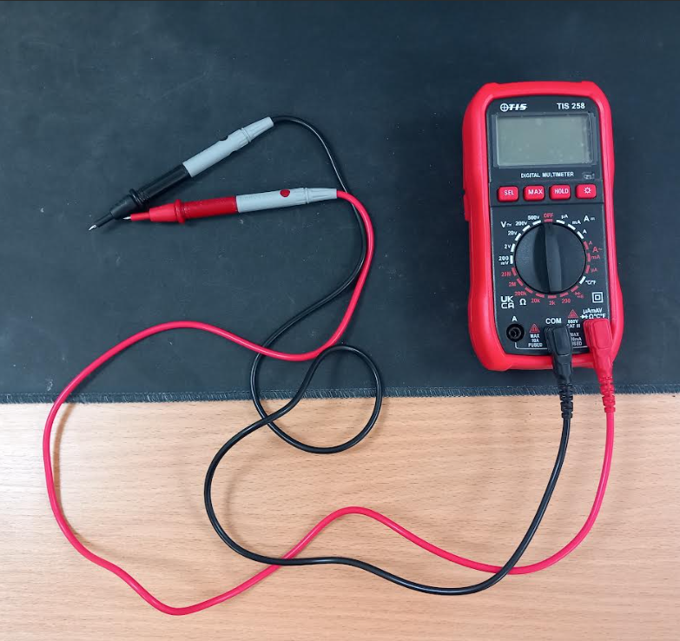

Figure 6 – Multimeter

  - Gantt Chart – Gantt Charts are a useful tool for Project Planning. This can also be used throughout the project plan to track progress and at the completion of a project can be useful for reflection on the project. This could tell the project manager if the project met its timelines and targets. Refer to Table 3 below for the Gantt chart for the stowage unit. It will show the approximate project duration and approximate duration of each team’s section. It’s been broken down to Mechanical Design, Electrical Design and Production.

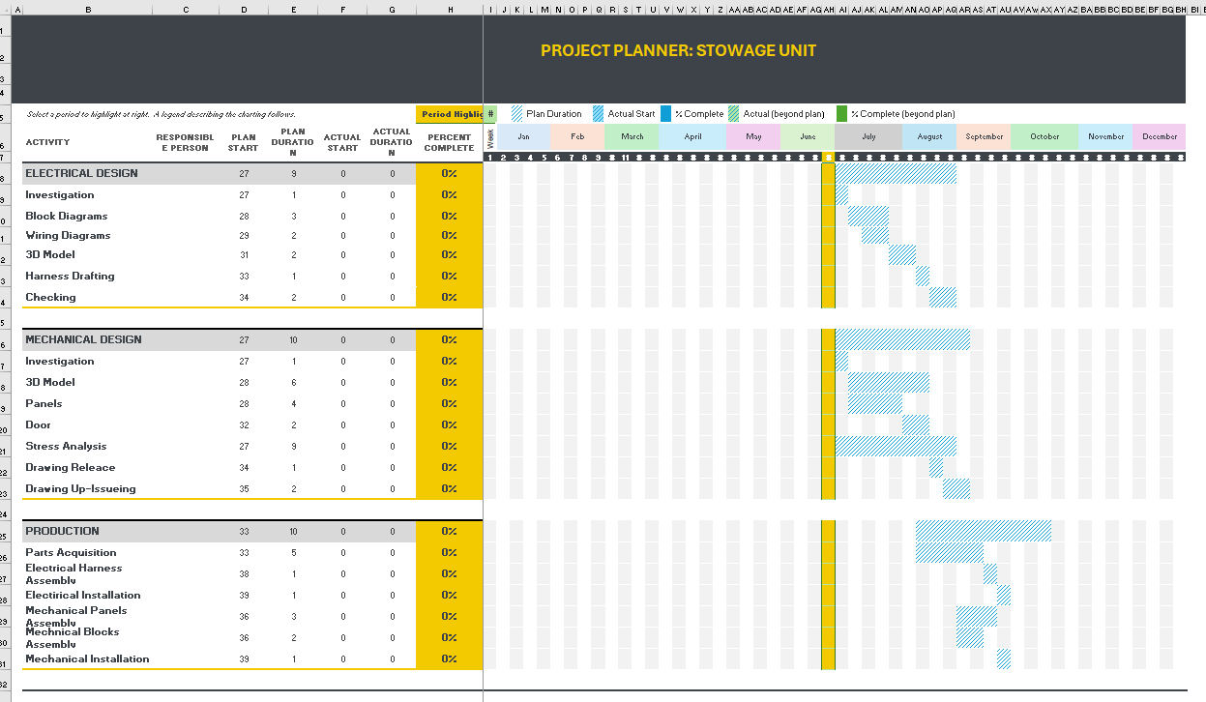
Table 3 – Gantt Chart

  - Management Structure – Effective Management Structure is key in the completion of any project. As the management structure will affect the way a project is undertaken in serval ways. This will determine who is responsible for certain aspects, as well as role and responsibilities everyone will have. The roles of a project manager is shown below in 7.4. In regards to companywide, a management structure will look different in every company. However, generally is split into Upper, Middle and Lower Management. With Upper being the top shot callers who will work more on a business management style. Middle management, is more about managing company aspects, delegated by the upper management. And lower management generally works directly with the employees in a supervisory role, an example of this would be a project manager.

  - Roles of a Project Manager – Project Managers are a vital part of any project, they are responsible for the management side of a project, with being responsible for several aspects of the project, as well as the delegation of tasks to complete the project. They will have several roles and responsibilities, Mintzberg, a world leading expert on management [4], stated that there were 10 roles for a manager, which fall under 3 sections, they are shown below with a brief role description [5]:

    - Interpersonal Roles:
- Figurehead – Formal Representative of the Company
- Liaison – The manager that interacts with personal outsider of the organisation
- Leader – The relationship between the Manager and the staff

    - Informational Roles:
- Monitor – Monitors and receives data about the organisations enterprise
- Disseminator – Responsible for information key given to the members of the organisation.
- Spokesperson – Shares company data externally, additionally being a representative to external stakeholders

    - Decisional Roles:
- Entrepreneur – Undertake changes, projects and ideas, additionally can delegate some of these roles.
- Disturbance Handler – Handles Risks, taking corrective action when necessary.
- Resource Allocator – The Manager that determines the resource (Money, staff, etc.) that will be allocated to every project/section.
- Negotiator – The manager that on the behalf of the organisation negotiates, depending on the level of management will depend on who with.

On this project, the Project manager will arrange weekly meetings with the team, to discuss the progress and actions which they will need to undertake. These can be recorded in an Action Tracker, this is shown below in Table 4. This will be present from the start to finish. This will help keep track of everything, and be a useful tool throughout the project.

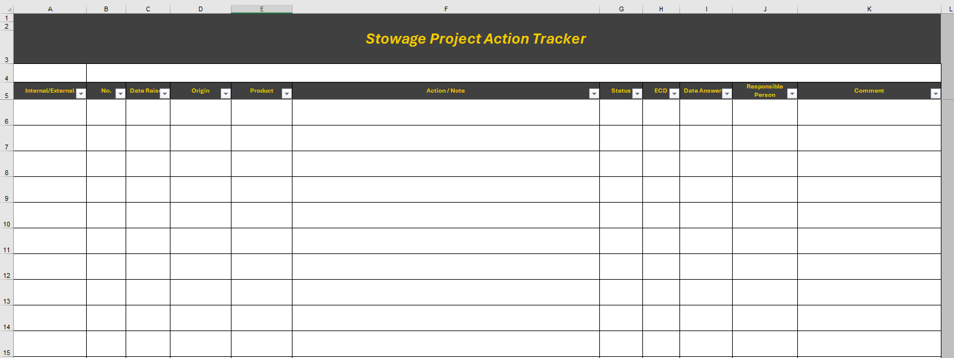
Table 4 – Action Tracker

- Expected outcome and Deliverables – On this project the expected outcome will be the delivery of a stowage unit, that can be installed on an aircraft depending on the aircrafts and customers specification. In order to have this, the design team will create 3D Models, from which they will produce drawings to construct the unit and its contents. This will be used by the production team to carry this out.

- Risks – Every project that is worth pursuing will have risks attributed to it, you will not be able to eliminate all risks [6], however a major role is how you manage the attributed risks. This is because without good risk management a project can fail or can cost the company large sums of money [7]. There are many ways you can manage and mitigate risks, refer to Table 5 below for the risk register attributed to the Stowage Project. This risk register describes the risks, their risk rating, how to mitigate them and who is responsible for them.

Table 5 – Risk Register
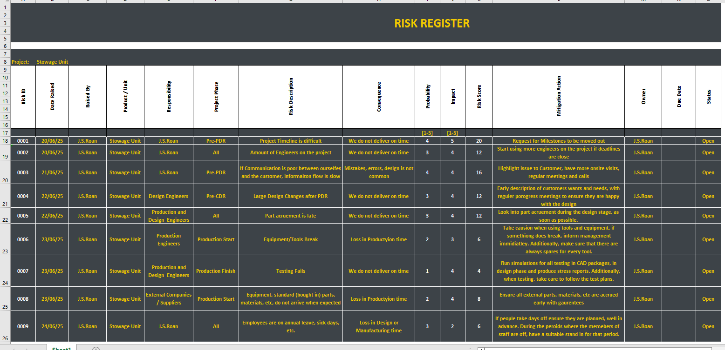

- Legal & Ethical Considerations – Legal and Ethical issues plague and overshadow everything, especially within projects and organisations. In regards to ethics, they stem down to having morality, which is how we treat each other, ‘Promoting’ being good over bad [8]. In the opinion of the author this just means that this is important to do the right thing and act with good morals. Regarding the legal considerations, this is covered below in 10.1 and 10.2. The potential impact of the unit is covered in 10.3.

  - Regulations – Regulations are important in any field of work, especially engineering. This is due to the potential dangerous nature of manufacturing and the situations that engineers may be placed into. Important regulations to follow include:

- Health and Safety at Work Act 1974 (HSAWA)

- Control of Substances Hazardous to Health (COSHH)

- Working at Height Regulations

- Manual Handling

Following these regulations are important, this is covered below in 10.2

  - Compliance – Similar to Regulations, Compliance is a key part of engineering. This mainly covers complying with regulations, see 10.1 for some examples of regulations that will need to be followed. In essence compliance is following the regulations set out by the government. This is important legally and ethically, as it’s an employers legal and moral responsibility to ensure that all workers are safe in their working environment. Legally the main overarching regulations that cover this is HASWA.

  - Potential Impact – This product can have several potential impacts. For instance its impact on the community/society, this is positive, as it makes the jobs of the cabin crew easier. Its environmental impact is also positive, as the unit will be made from honeycomb panels, which are ‘fully-recyclable’ [9]. However the methods in which they are made are not environmentally friendly. Additionally, as we cannot confirm how any bought-in parts are manufactured, we cannot determine if they are environmentally friendly.

- Conclusion – In conclusion, through the stowage project the client will receive a adaptable and useful stowage unit, that will be useful for their organisation. Through the project management and planning, this will be achieved to a high standard. There are risk attributed to this project, however have all been considered and mitigating actions will take place to combat this. This unit is innovative through the use of a proximity switch, making it a useful piece of equipment to have on a aircraft.

- Appendices

  - Equality and Diversity Briefing Certificate



  - PREVENT Certificate



- References

[1] | E. Menting, T. Britting and L. Pepermans, “Evaluation of Preliminary Design Review (PDR) formats in student space projects,” in 3rd Symposium on Space Educational Activities, Leicester, 2019.
[2] | K. R. Fowler and C. L. Silver, “Methods, Techniques, Tools, Processes, and Teamwork,” in Developing and Managing Embedded Systems and Products, Elsevier, 2015, pp. 535-557.
[3] | T. Eger, C. Eckert and P. J. Clarkson, “The role of design freeze in product development,” Melbourne, 2005.
[4] | P. G. Thomas, “Understanding management: Henry Mintzberg on the activities of managers.2004,” Canadian Public Administration, vol. 47, no. 2, 2004.
[5] | P. Kumar and K. Mahavidyalya, “An Analytical study on Mintzberg’s Framework:,” International Journal of Research in Management &, vol. 2, no. 3, p. 13, 2015.
[6] | C. Chapman and S. Ward, in Project Risk Management: Processes Techniques and Insights Second Edition, Southampton, John Wiley & Sons, Ltd, 2003, p. 8.
[7] | O. S. Fadun, “Risk Management and Risk Management Failure,” International Journal of Academic Research in Business and Social Sciences, vol. 3, no. 2, p. 1, 2013.
[8] | J. P. Thiroux and K. W. Krasemann, Ethics: Theory and practice, New Jersey: Pearson Education, 2009.
[9] | M. Z. Hassan, R. Umer, S. Balawi and W. J. Cantwell, “The impact response of environmental-friendly sandwich structures,” Journal of Composite Materials, vol. 48, no. 25, 2013.

