University of Wales Trinity Saint David

Ordnance Munitions & Explosives BEng Apprenticeship



Analysis of Electromagnetic wave propagation

Electromagnetic Radiation (ACDC5009)

Adam Mayo

2112088

04/2025

Lecturer: Stalin Jacob

Abstract
The report presents the design, theoretical analysis and simulation of rectangular waveguides and a dipole antenna using ANSYS HFSS. Waveguides were filled with both a vacuum and Teflon to investigate the influence of dielectric materials on electromagnetic behaviour. The cutoff frequencies for the dominant TE modes (TE₁₀, TE₂₀, TE₃₀) in the rectangular waveguides were theoretically determined and compared to simulation results, which demonstrated excellent agreement with a maximum error of 1.2%. When Teflon was introduced to the waveguide, a cutoff frequency occurred that was consistent with theory. Electric and magnetic field vector plots revealed improved intensity and confinement within the Teflon-filled waveguide, attributed to the lower phase velocity and reduced propagation losses. Additionally, a halfwave dipole antenna was simulated, operating at a frequency of 1.2962 GHz with an omnidirectional radiation pattern, and achieving a peak perpendicular to the antenna axis, which aligns with theoretical expectations. Overall, this report validates theoretical predictions through simulations and highlights the importance of dielectric materials in the design of efficient high-frequency waveguide and antenna applications.

AI Declaration
I acknowledge the use of Grammarly (https://www.grammarly.com/) on 24 April 2025 to check my work using the prompt(s):

- Please check the following text for readability, grammar and syntax.

I confirm that I have not presented any AI generated text as my own work. I confirm I have copies of my drafts, notes, and other resources I used before, and after the use of AI tools which I may be asked to provide in evidence.

Table of Contents
Abstract 2
AI Declaration 3
List of Figures 5
List of Tables 5
List of Equations 5
List of abbreviations 6
1.0 Introduction 7
1.1 Background 7
1.2 Aims & Objectives 10
2.0 Methodology 11
2.1 Task 1A 11
2.2 Task 1B 12
2.3 Task 2 13
3.0 Results 15
3.1 Port Field Display 16
3.2 Theoretical Calculations for the waveguides 18
3.3 Gamma Plots 19
3.4 Electric Field Magnitude and Vector 20
3.5 Magnetic Field Magnitude and Vector 24
3.6 S-Parameter Plot 28
3.7 Radiation Pattern 28
4.0 Discussion 30
4.1 Dominant modes 30
4.2 Cutoff frequencies 30
4.3 Vectors of the Magnetic and Electric Fields 31
4.4 Operating frequency 32
4.5 Radiation Pattern 33
5.0 Conclusion 34
6.0 References 36

List of Figures
Figure 1 – The first 12 modes in rectangular waveguide [8]. 8
Figure 2 - Rectangular waveguide design. 12
Figure 3 - Halfwave Dipole Antenna design. 14
Figure 4 - Task 1A Gamma plots. 19
Figure 5 - Task 1B Gamma plot. 19
Figure 6 - S parameter plot for dipole antenna. 28
Figure 7 – Dipole antenna radiation pattern. 28
Figure 8 – Incorrect simulation of dipole antenna 1. 29
Figure 9 - Incorrect simulation of dipole antenna 2. 29

List of Tables
Table 1 - Task 1A port field display. 16
Table 2 - Task 1B port field display. 17
Table 3 - Electric field magnitude and vector displays for task 1A. 20
Table 4 - Electric field magnitude and vector displays for task 1B. 22
Table 5 - Magnetic field magnitude and vector displays for task 1A. 24
Table 6 - Magnetic field magnitude and vector displays for task 1B. 26
Table 7 – Theoretical vs simulated cutoff frequencies. 30

List of Equations
Equation 1 – Phase velocity in a medium [7]. 7
Equation 2 – Length of halfwave dipole antenna [15]. 9
Equation 3 – Frequency of an electromagnetic wave [15]. 9
Equation 4 - Cutoff frequency for rectangular waveguides [16]. 11

List of abbreviations
μ_{r} – Relative permeability
ε_{r} - relative permittivity
GHz – Gigahertz
dB - Decibel

Introduction

1.1 Background
Electromagnetic waves are essential to modern communication systems, enabling transmission and reception of information across significant distances. This process relies on two primary components: antennas, which convert electrical signals into electromagnetic radiation and vice versa, and waveguides, which confine and guide electromagnetic waves to reduce propagation losses.

A waveguide is a structure that confines and directs electromagnetic energy between two locations with minimal attenuation [1] [2]. Waveguides are seen in applications ranging from micrometres in integrated photonics to hundreds of kilometres in optical fibre communications [3]. Based on shape and function, waveguides are commonly classified as rectangular, circular, or optical. Each type supports different modes and operates efficiently over specific frequency ranges.

In this report, part 1 focuses on rectangular waveguides, which are hollow metallic structures that confine energy within their Perfect Electric Conductor (PEC) boundaries [4]. These waveguides typically exhibit a width-to-height aspect ratio of 2:1. The dominant propagating mode is the Transverse Electric (TE) TE₁₀ mode, characterised by an electric field perpendicular to the propagation direction [5]. A key feature of a waveguide is the cutoff frequency, which is the minimum frequency required for wave propagation. Below this threshold, waves become evanescent. Traditionally, these waveguides are used for low-loss purposes such as low-power radio astronomy and high-power radar systems [6].

In this work, two rectangular waveguides were studied: the first filled with vacuum (ε_{r} = 1), and the second with Teflon (ε_{r} = 2.1). This reduces the phase velocity and cutoff frequency in the Teflon-filled waveguide. The phase velocity in Teflon is calculated below:

V = $\frac{1}{\sqrt{με}}$
Equation 1 – Phase velocity in a medium [7].

V = $\frac{1}{\sqrt{με}}= \frac{1}{\sqrt{\left(μ_{0} μ_{γ}\right) (ε_{o} ε_{γ})}}$ = $\frac{1}{\sqrt{(4π x {10}^{-7}x1)(8.854 x{10}^{-12}x2.1)}}$
μ = μ_{o} μ_{γ}
μ_{o} = 4π x 10⁻⁷ H/m
μ_{γ} = 1
ε = ε_{o} ε_{γ}
ε_{o} = 8.854 x10⁻¹² F/m
ε_{γ} = 2.1
= 2.06876444x10⁸ = 2.07x10⁸ ms⁻¹

Effective wave propagation occurs when the operating frequency exceeds the cutoff of the dominant mode, ensuring minimal attenuation.

Rectangular waveguide supports only TE and Transverse Magnetic (TM) modes, and not Transverse Electromagnetic (TEM) modes. In certain cases, degenerate modes arise when multiple modes share the same cutoff frequency, leading to implications such as mode coupling or mode competition, which may impact waveguide performance. Figure 1 illustrates the electric field distributions for the first 12 TE and TM modes.

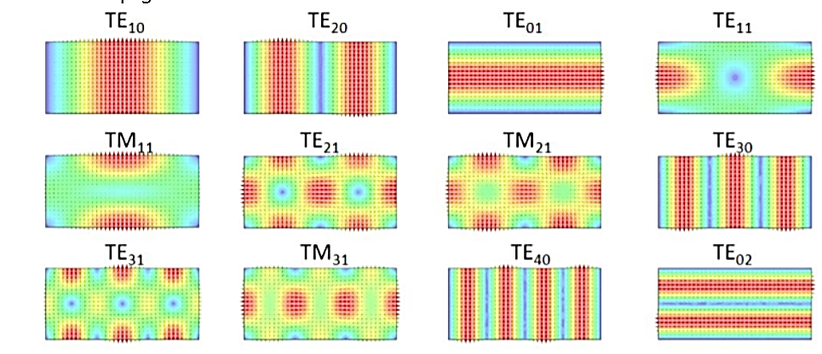
Figure 1 – The first 12 modes in rectangular waveguide [8].

Notably, TM_{mn} modes require both indices to be non-zero, which raises the cutoff frequency to be higher than the cutoff frequency for a TE_{mn} mode [9].

This report also examines antennas, which emit various radiation patterns based on their shape and functionality. Antennas are integral to numerous systems, including radar systems, radio and satellite communications. Common antenna types include:

- Dipole antennas consist of two conductive elements that are typically half the wavelength of the desired operating frequency [10].
- Yagi-Uda antenna is a directional antenna that is designed to enhance signal transmission and reception [11].
- Parabolic antennas utilise a parabolic reflector to focus radio waves, enabling high-gain and high-directivity transmissions and receptions of electromagnetic waves [12].

This report focuses on dipole antennas. Typically, each wire is a quarter of the wavelength of the operating frequency [13]. These antennas have a linear polarisation and a radiation pattern that resembles a ‘doughnut’ shape [14]. The limitation of having a limited power gain is attributed to their widespread coverage, as the antenna is not a directive antenna [14].

L = $\frac{λ}{2}$
Equation 2 – Length of halfwave dipole antenna [15].

$$f= \frac{c}{λ}$$
Equation 3 – Frequency of an electromagnetic wave [15].

The length of the antenna is governed by the wavelength at which the antenna is intended to work, as shown by Equation 2. Furthermore, Equation 3 allows the operating frequency to be determined.

1.2 Aims & Objectives
This report aims to design, simulate and analyse waveguide and antenna structures using ANSYS High Frequency Simulation Software (HFSS). By integrating computational and theoretical approaches, the study aims to develop a well-rounded understanding of the electromagnetic wave behaviour across different propagation mediums. Simulation results will evaluate the performance of the waveguide and antennas, providing critical insight into their operational characteristics and validating theoretical predictions. Additionally, the report facilitates the development of techniques used in electromagnetic simulations and analysis vital for understanding wave propagation phenomena in complex structures.

2.0 Methodology

2.1 Task 1A
The first part of this task involves the design of a vacuum-filled rectangular waveguide with Perfect Electrical Conductor (PEC) walls. Dimensions of the waveguide are a width (a) of 21mm along the x-axis, a height (b) of 6mm on the y-axis and a length of 50mm on the z-axis (Figure 2). With the following ε_{r}=1 and μ_{r} ​=1. The design incorporates two ports, which facilitate the simulation of the waveguide modes. A frequency sweep was applied over a range from 2.5 GHz to 7.5 GHz, enabling an investigation of the waveguide's performance across various frequencies. This frequency range was selected for a detailed examination of the waveguide’s modal behaviour. The simulation identifies the propagating modes within the waveguide based on the analysis of electric and magnetic field vectors.

$$f_{c}= \frac{c}{2}\sqrt{({\frac{m}{a})}^{2}+{(\frac{n}{b})}^{2}}$$
Equation 4 - Cutoff frequency for rectangular waveguides [16].

The theoretical cutoff frequencies for the first three modes were calculated using the formula for rectangular wave guides, as seen below in Equation 4.

The simulation included the following analytical steps:

- Identification of the dominant mode and other propagating modes.
- Recording of the port field display at Wave Port 1 and Wave Port 2.
- Extraction of the magnitude and vector representations of the magnetic and electric fields for the modes.

To analyse the cutoff frequencies of the modes, a rectangular plot was generated. These cutoff frequencies were recorded for further analysis within this report.
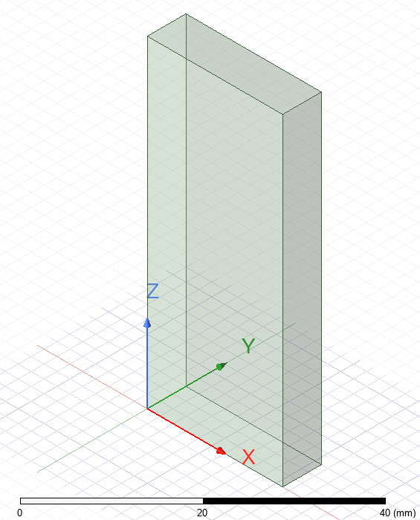
Figure 2 - Rectangular waveguide design.

2.2 Task 1B
Similarly to Task 1A, a waveguide was designed but with a Teflon filling, which has ε_{r}=1 and μ_{r} ​=2.1. The waveguide dimensions, boundary conditions, and port assignments remained unchanged with task A (Figure 2). The analytical steps from Task A were repeated for the Teflon-filled waveguide.

The cutoff frequencies of the Vacuum and Teflon waveguides were compared. The comparison provided insight into how the dielectric medium affects wave propagation in both the electric and magnetic fields. The cutoff frequencies were recorded and discussed later in subsequent sections of this report.

2.3 Task 2
Task 2 involved the design of a half-wave dipole antenna that had a radius of 1mm. The function of this antenna was to emit electromagnetic waves with a wavelength of 211 mm (Figure 3). An excitation was applied through a 50-ohm lumped port, and the antenna was constructed using a PEC material. A rectangular radiation surface enclosed the antenna in the model.

Based on knowing the wavelength of the antenna, the length was calculated to give the intended wavelength result below, using Equation 2.

λ = 211 mm
c = 3 x 10⁸ ms⁻¹
L = $\frac{λ}{2}$ = $\frac{211}{2}$ = 105.5 mm

Additionally, the operating frequency was determined using the intended wavelength below using Equation 3.

c = λf
f = $\frac{c}{λ}$ = $\frac{3 x {10}^{8}}{0.211}$ = 1421800948 Hz = 1.4218 GHz

Following the simulations, these computational analyses were performed:
- Generation of an S-parameter plot to capture the operating frequency of the antenna.
- Observation and recording of the antenna’s radiation pattern, to assess the directionality of the antenna's radiation.

These methodologies above ensure a systematic approach to designing and analysing waveguides and antennas, facilitating a comprehensive evaluation of electromagnetic wave propagation and antenna radiation characteristics.

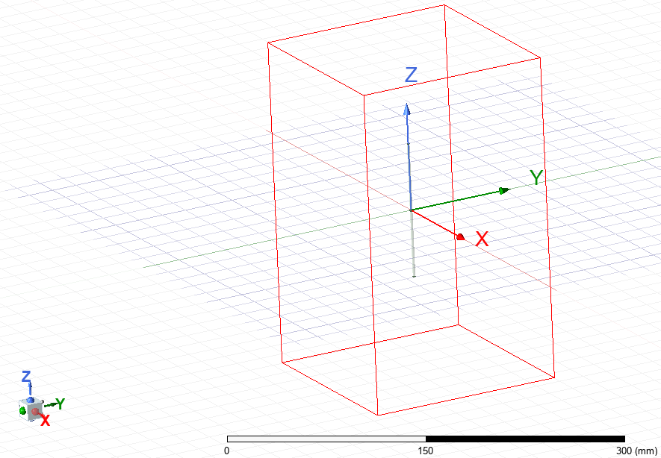
Figure 3 - Halfwave Dipole Antenna design.

3.0 Results

3.1 Port Field Display
Table 1 - Task 1A port field display.
Task 1A
 | Port 1 | Port 2
Mode 1 | 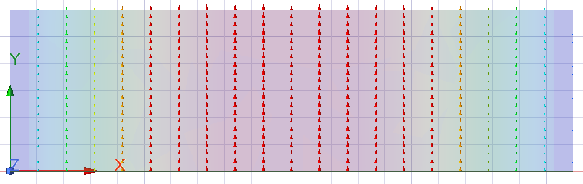 | 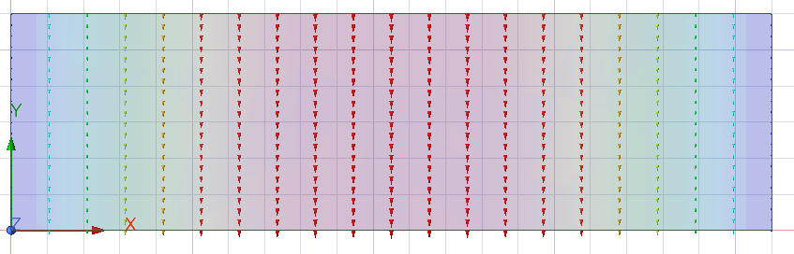
Mode 2 | 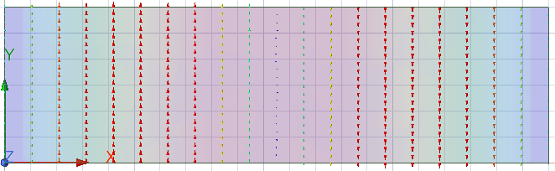 | 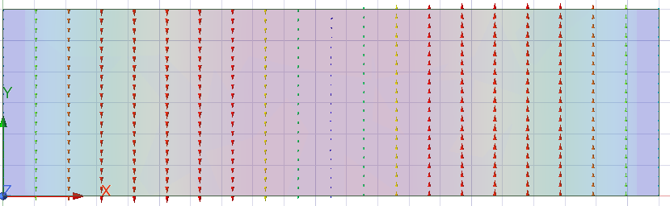
Mode 3 | 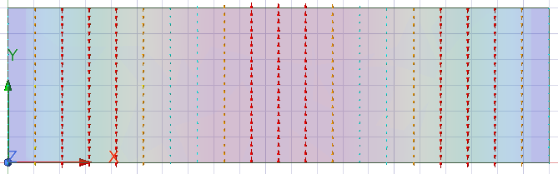 | 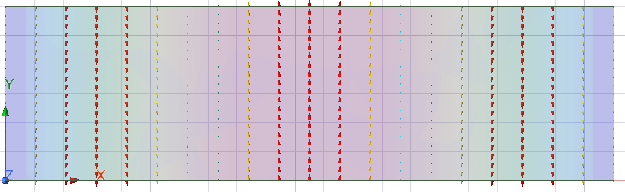

Table 2 - Task 1B port field display.
Task 1A
 | Port 1 | Port 2
Mode 1 | 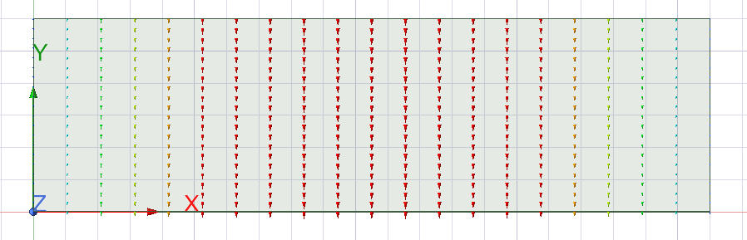 | 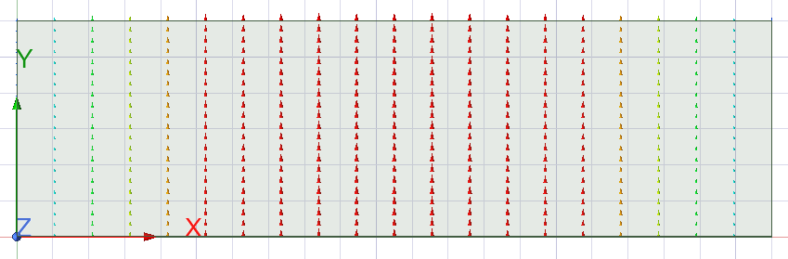
Mode 2 | 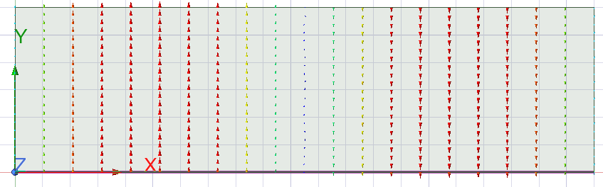 | 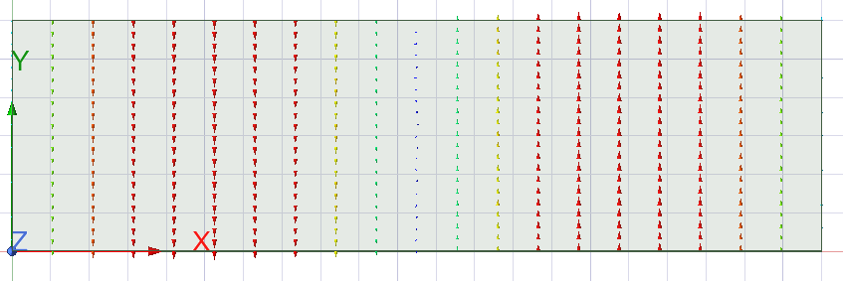
Mode 3 | 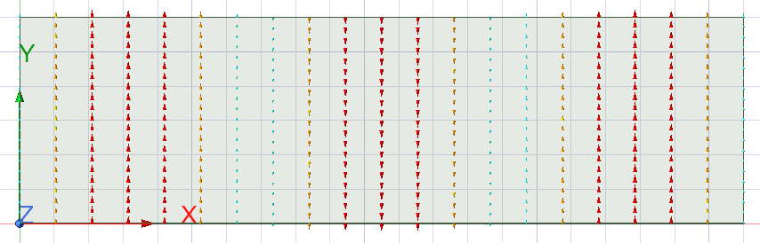 | 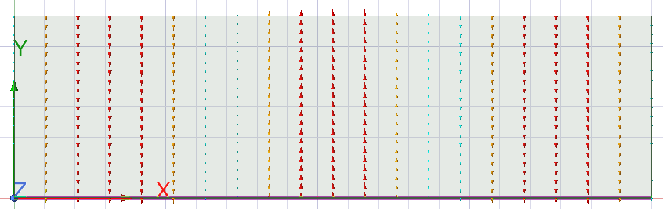

3.2 Theoretical Calculations for the waveguides
Using results obtained in section 3.1 to identify m and n, and using Equation 4 the following theoretical cutoff frequencies of each mode of the waveguide were obtained below for the two mediums of the waveguide:

Vacuum
Mode 1:
a = 21 mm
b = $\frac{12}{2}$ = 6 mm
c = 3 x10⁸ ms⁻¹
m₁ = 1
m₂ = 2
m₃ = 3
n₁ = 0
n₂ = 0
n₃ = 0
F₁ = $\frac{3 x{10}^{8}}{2} \sqrt{{(\frac{1}{0.021})}^{2}+{(\frac{0}{6})}^{2}}=7142857143=7.143 GHz$

Mode 2:
F₂ = $\frac{3 x{10}^{8}}{2} \sqrt{{(\frac{2}{0.021})}^{2}+{(\frac{0}{6})}^{2}}=1.428571429 x{10}^{10}=14.286 GHz$

Mode 3:
F₃ = $\frac{3 x{10}^{8}}{2} \sqrt{{(\frac{3}{0.021})}^{2}+{(\frac{0}{6})}^{2}}=2.142857143x{10}^{10}=21.429 GHz$

Teflon
Mode 1:
a = 21 mm
b = $\frac{12}{2}$ = 6 mm
c = 2.07 ms⁻¹
m₁ = 1
m₂ = 2
m₃ = 3
n₁ = 0
n₂ = 0
n₃ = 0
F₁ = $\frac{2.07x{10}^{8}}{2} \sqrt{{(\frac{1}{0.021})}^{2}+{(\frac{0}{6})}^{2}}=4928571429=4.929 GHz$

Mode 2:
F₂ = $\frac{2.07 x{10}^{8}}{2} \sqrt{{(\frac{2}{0.021})}^{2}+{(\frac{0}{6})}^{2}}=9857142857=9.857 GHz$

Mode 3:
F₃ = $\frac{2.07 x{10}^{8}}{2} \sqrt{{(\frac{3}{0.021})}^{2}+{(\frac{0}{6})}^{2}}=1.478571429x{10}^{10}=14.786 GHz$

3.3 Gamma Plots
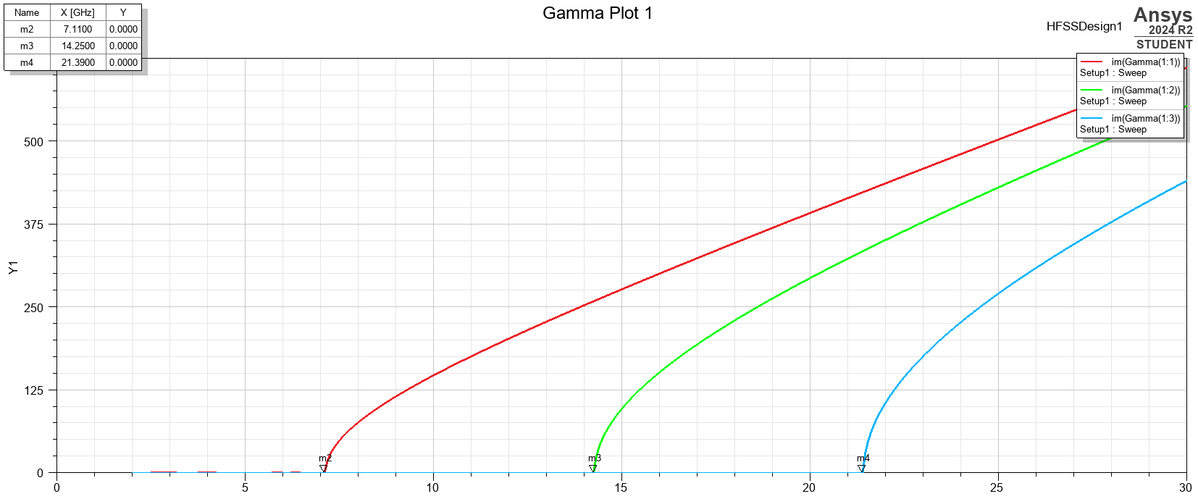
Figure 4 - Task 1A Gamma plots.

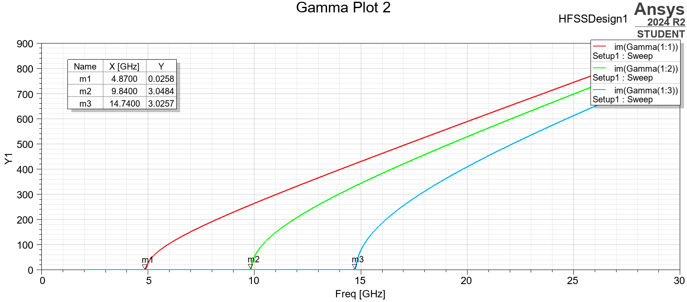
Figure 5 - Task 1B Gamma plot.

3.4 Electric Field Magnitude and Vector
Table 3 - Electric field magnitude and vector displays for task 1A.
Electric Field
Magnitude | Mode 1  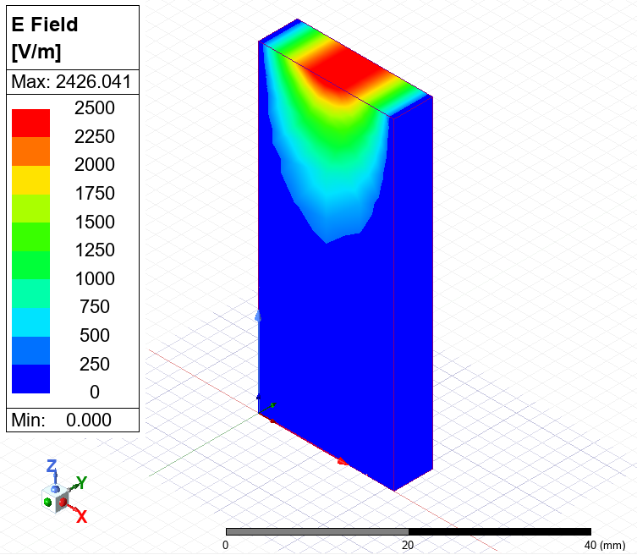 | Mode 2  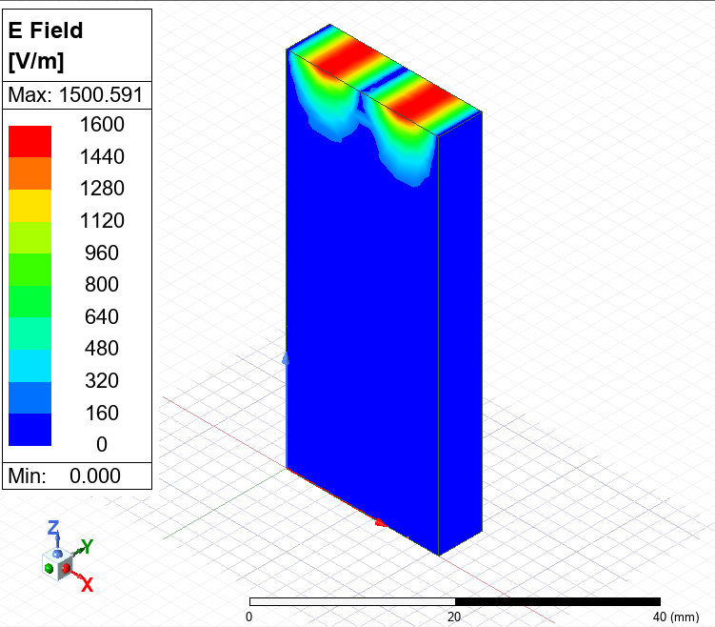 | Mode 3  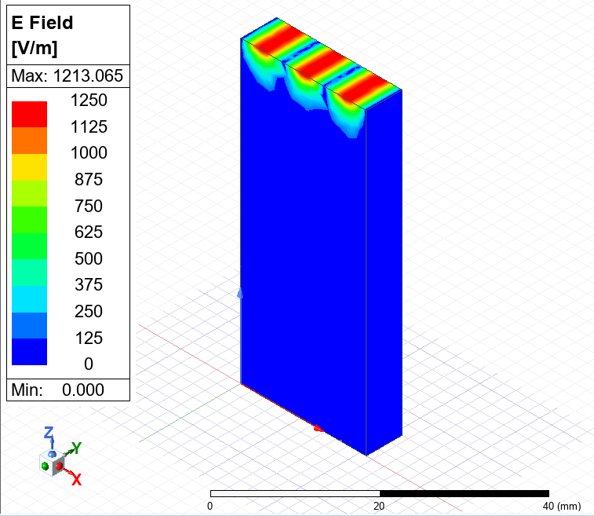
Vector | Mode 1  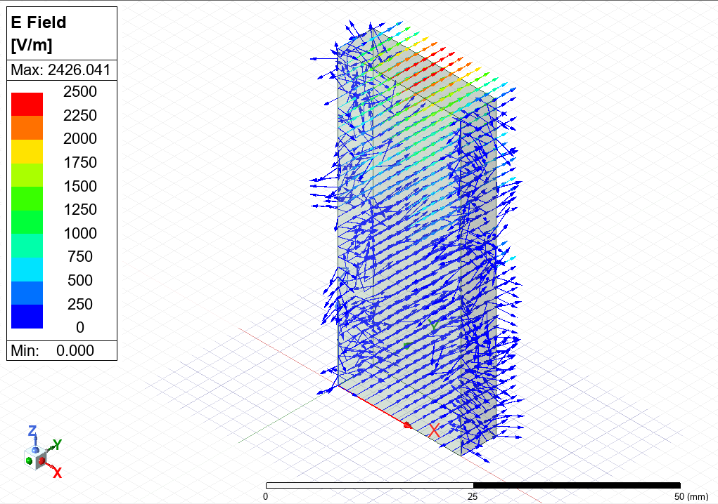  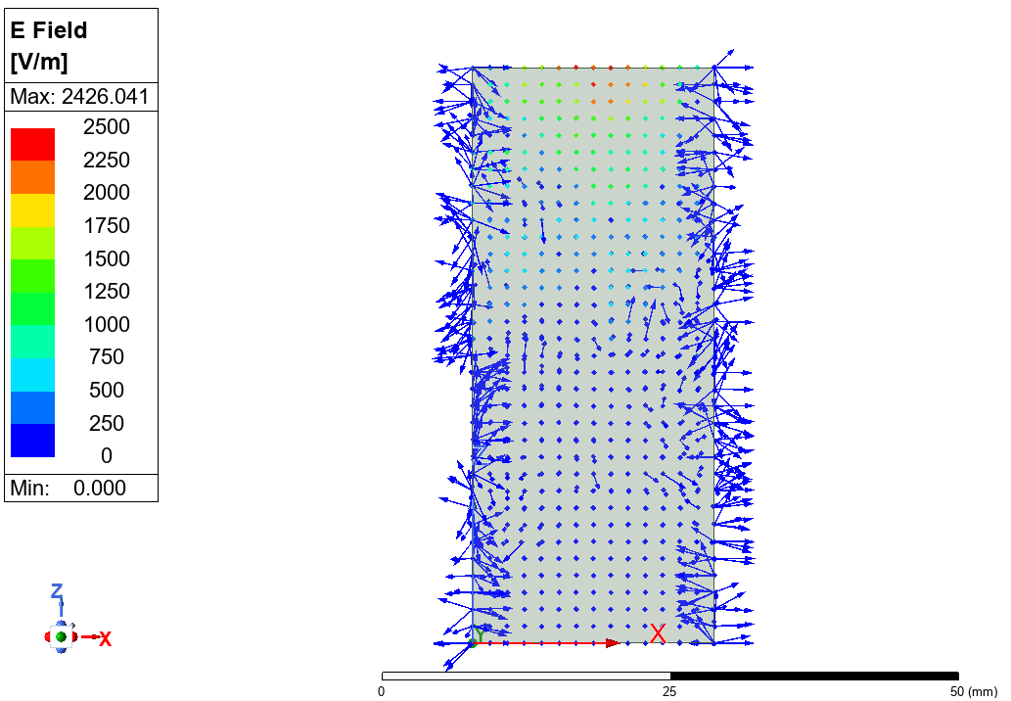 | Mode 2  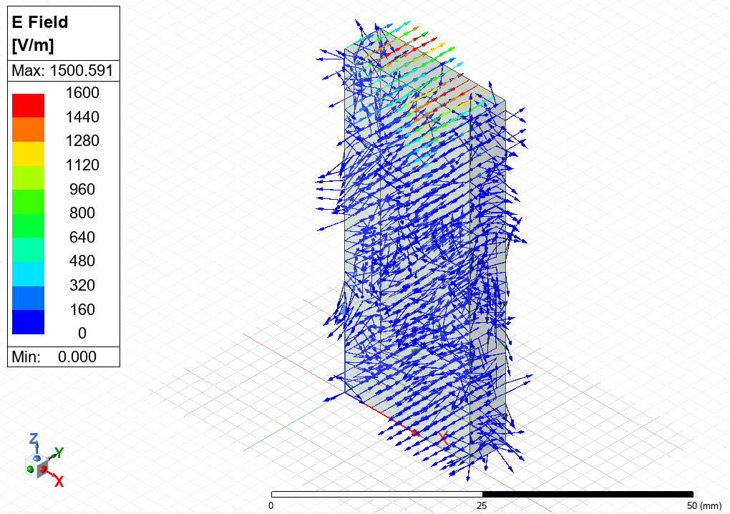  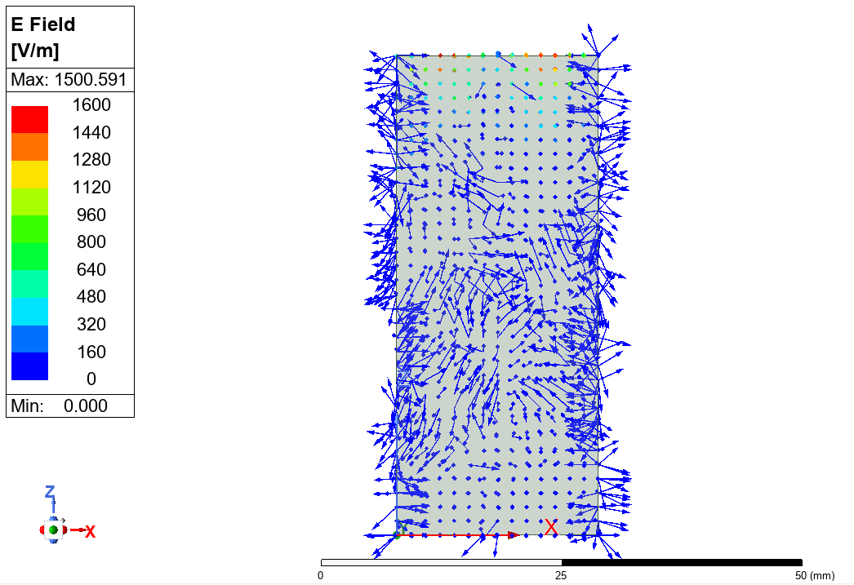 | Mode 3  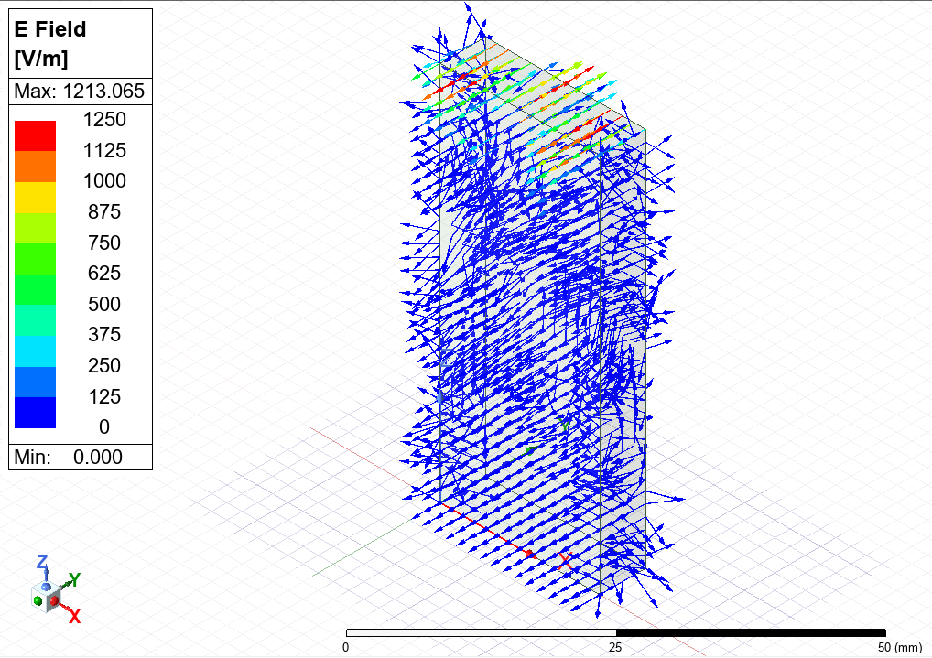  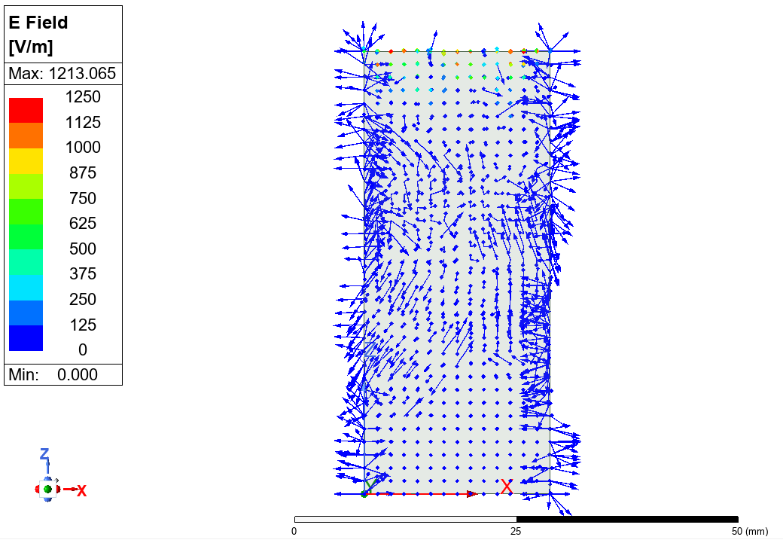

Table 4 - Electric field magnitude and vector displays for task 1B.
Electric Field
Magnitude | Mode 1  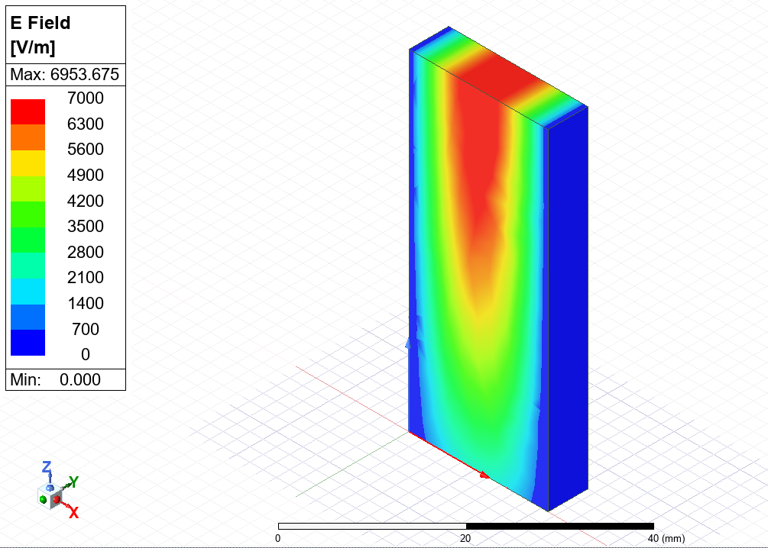 | Mode 2  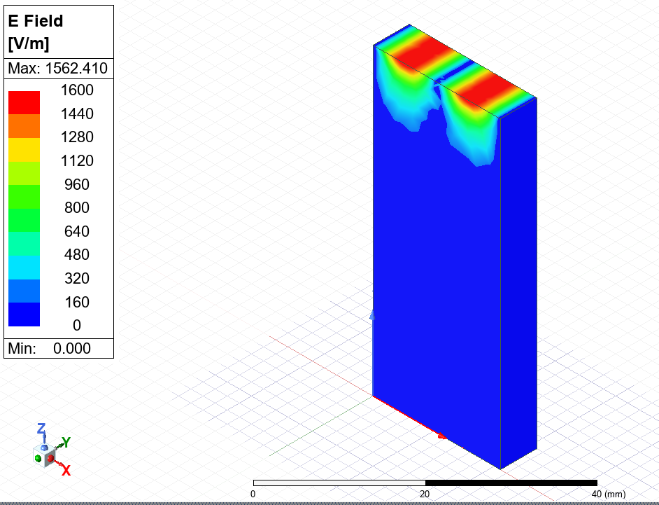 | Mode 3  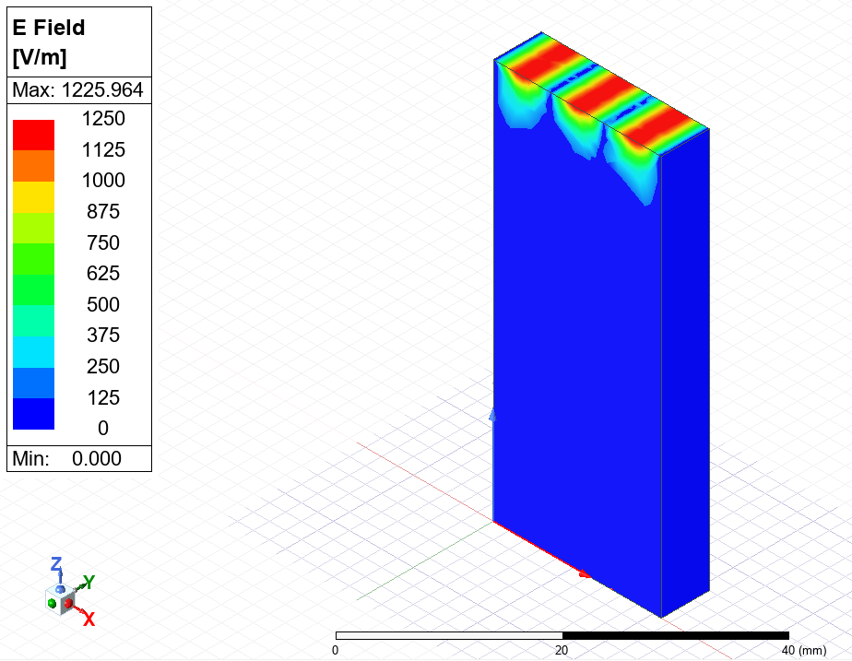
Vector | Mode 1  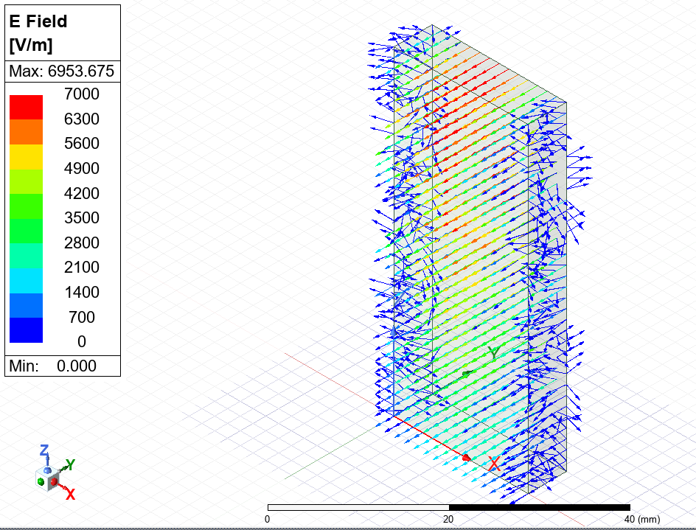  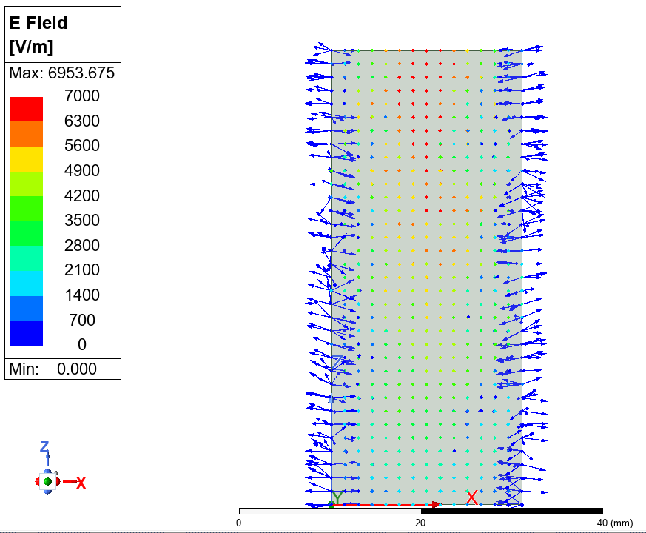 | Mode 2  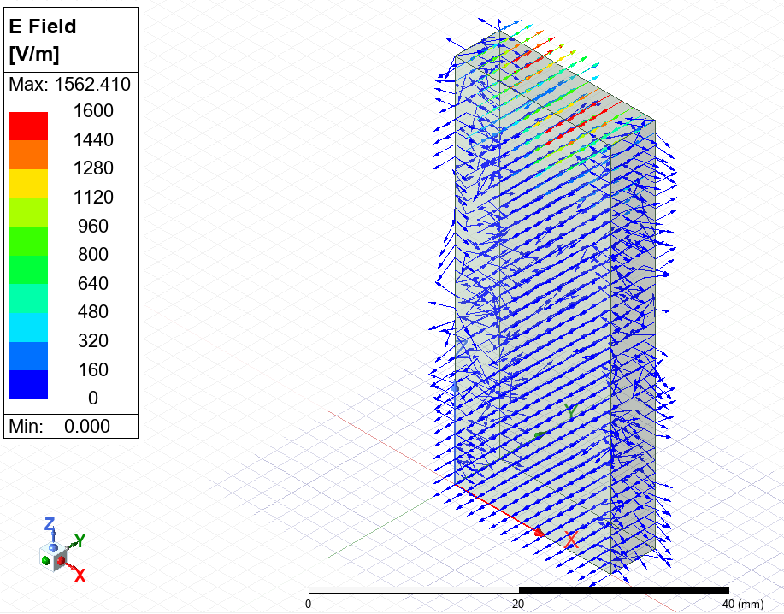  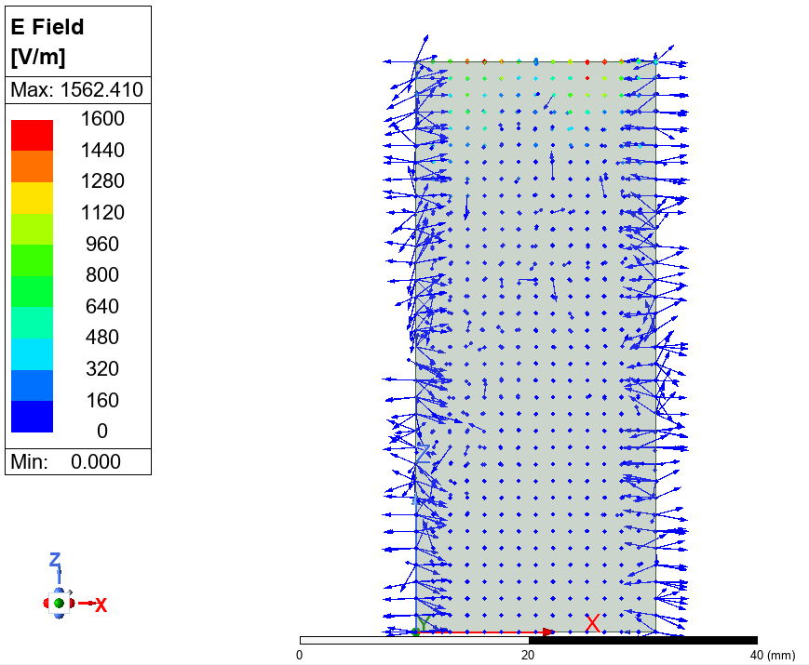 | Mode 3  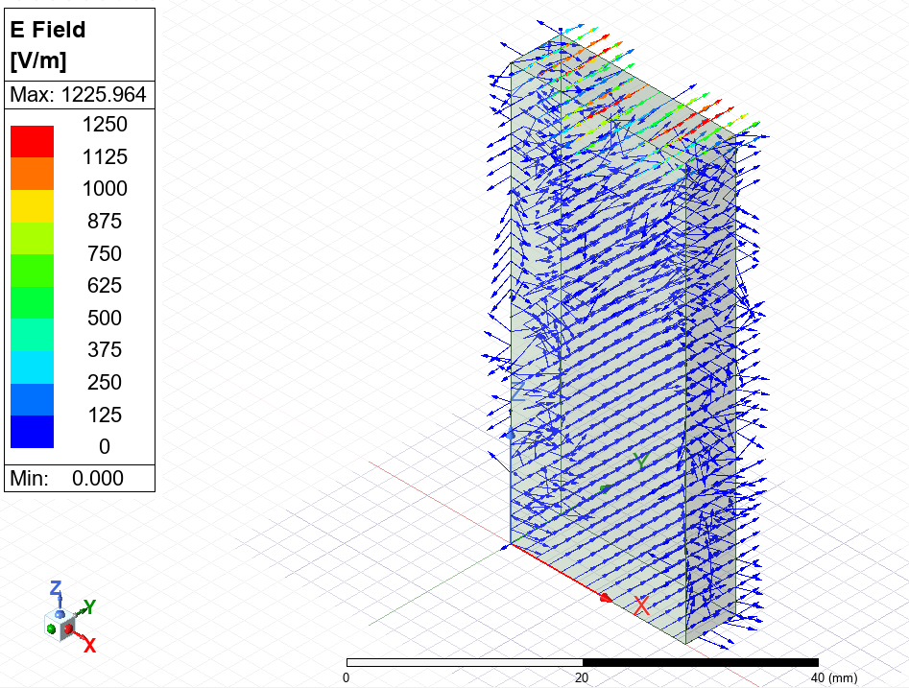  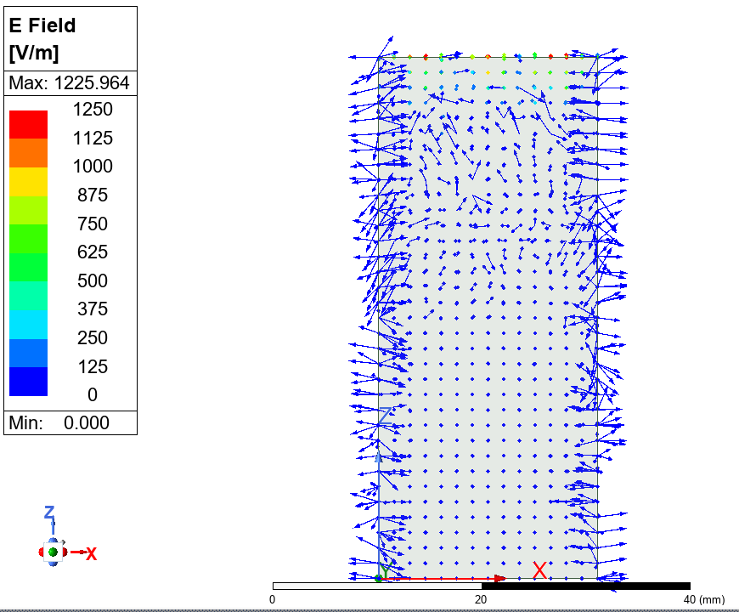

3.5 Magnetic Field Magnitude and Vector
Table 5 - Magnetic field magnitude and vector displays for task 1A.
Magnetic Field
Magnitude | Mode 1  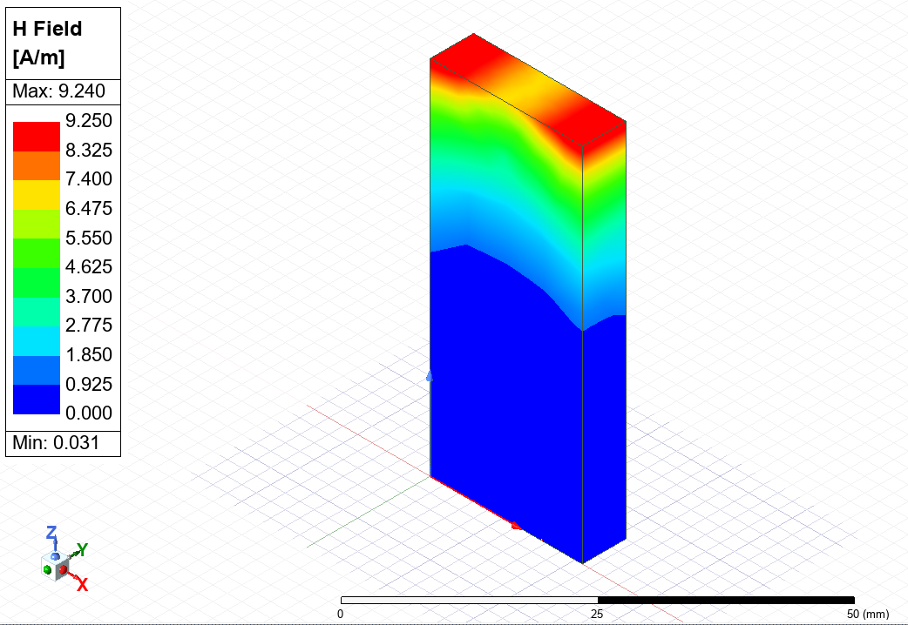 | Mode 2  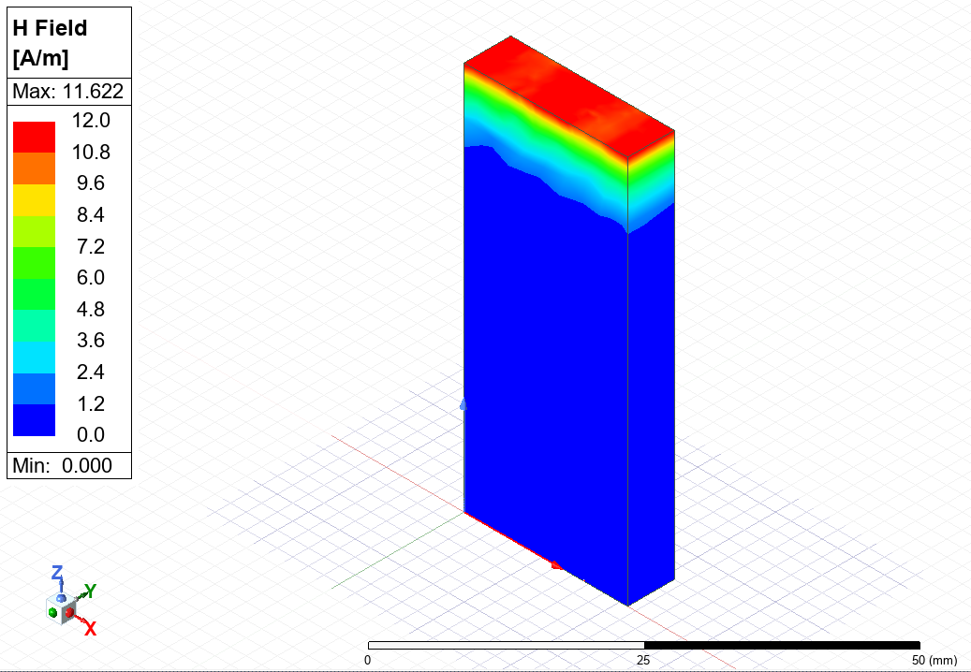 | Mode 3  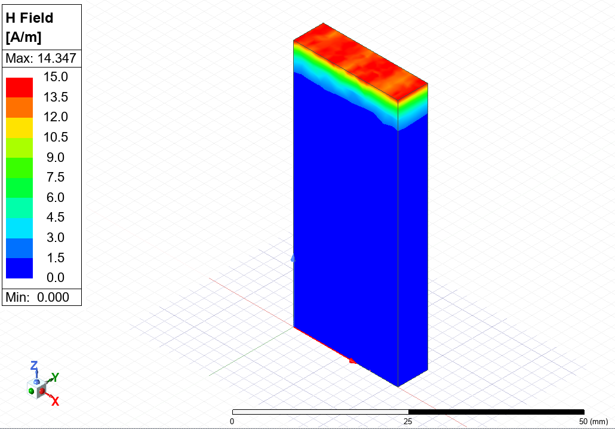
Vector | Mode 1  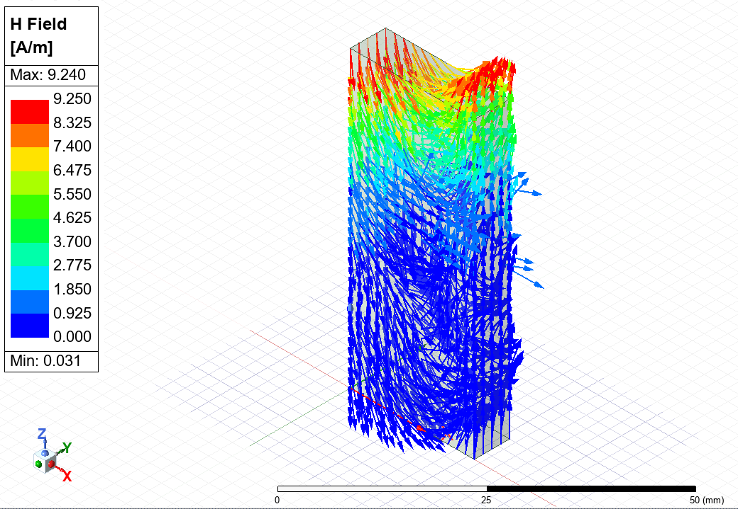  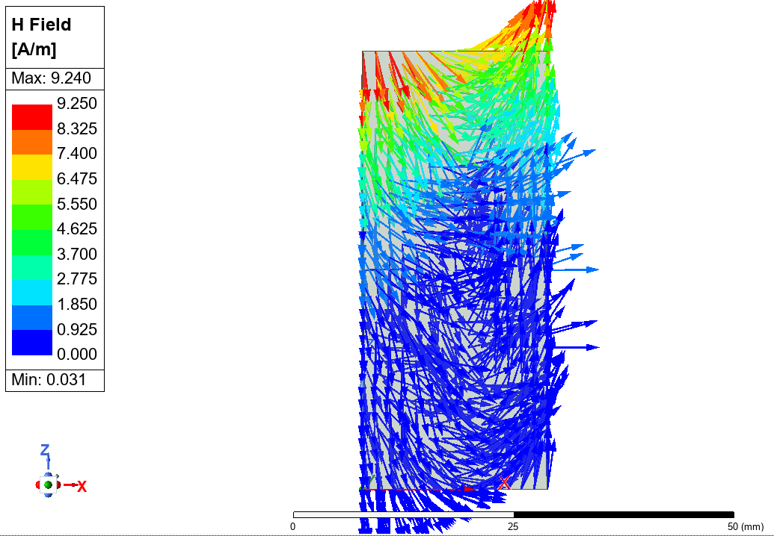 | Mode 2  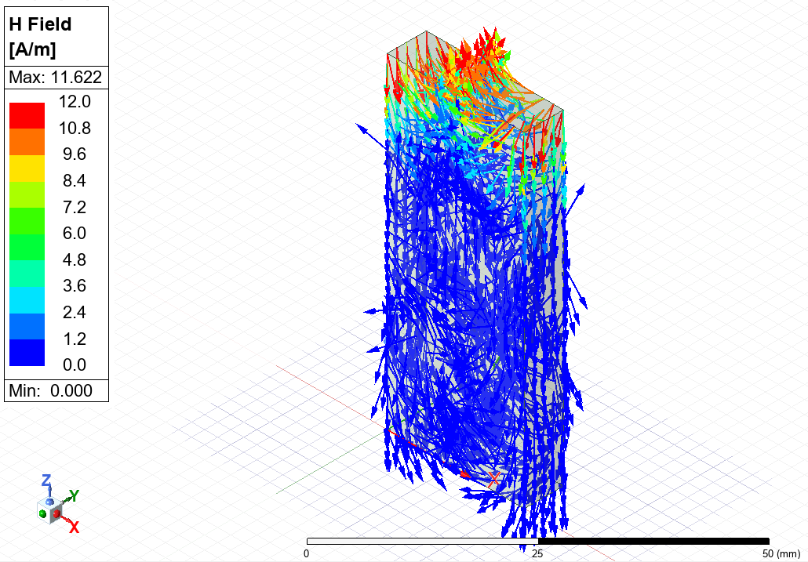  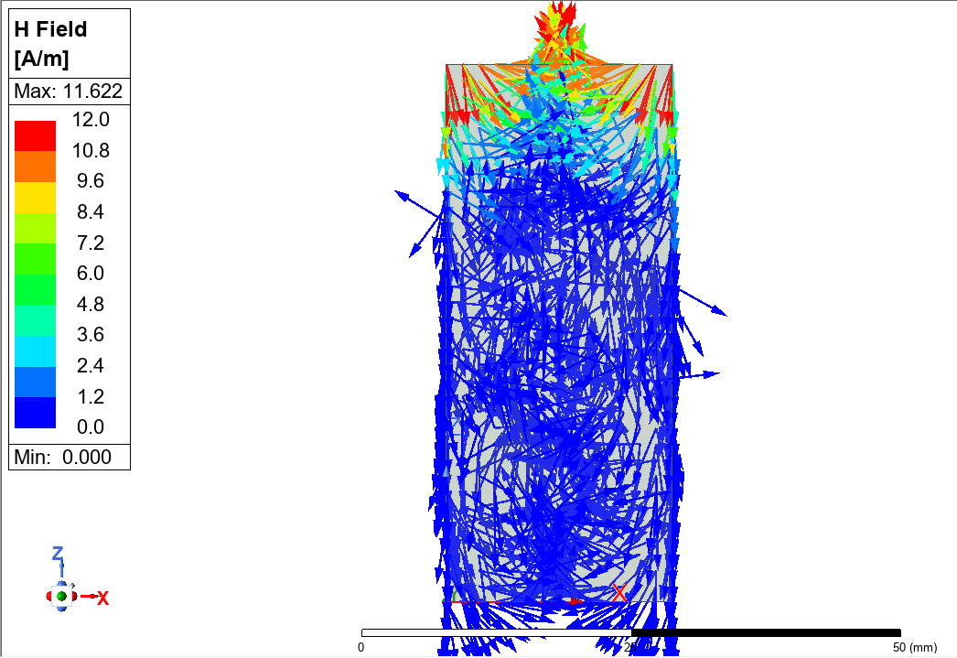 | Mode 3  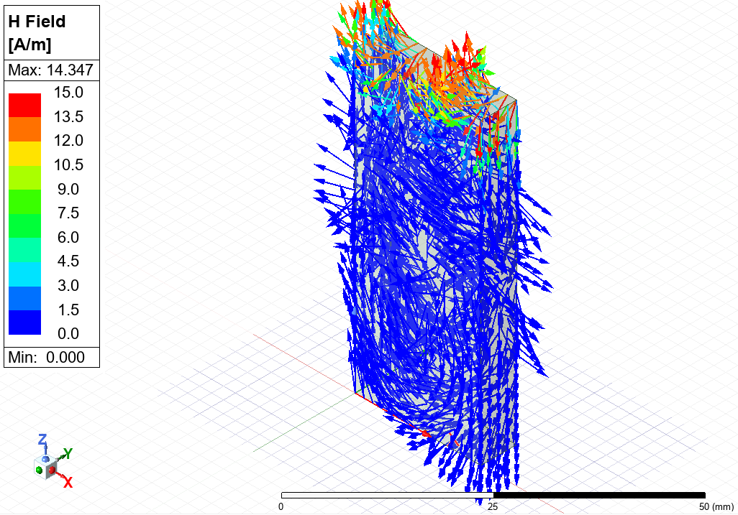  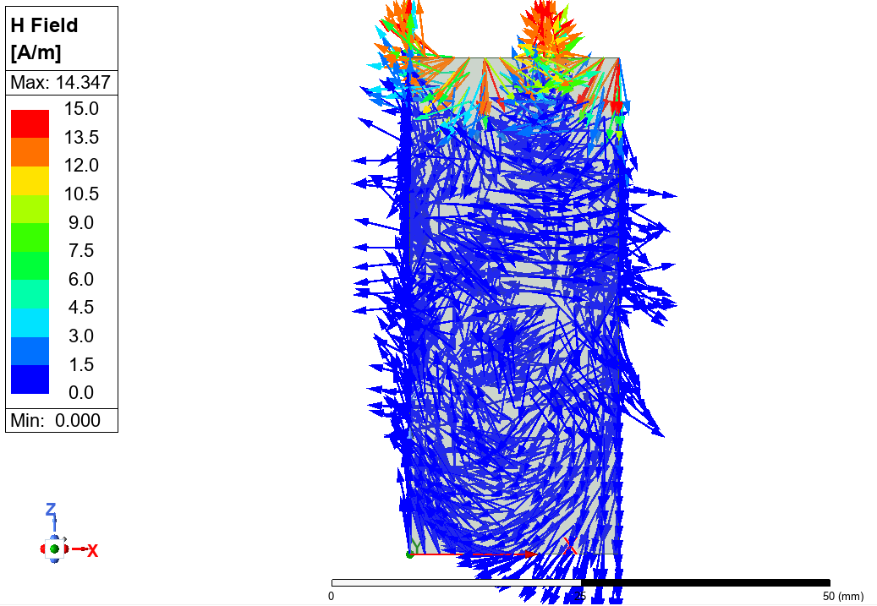

Table 6 - Magnetic field magnitude and vector displays for task 1B.
Magnetic Field
Magnitude | Mode 1  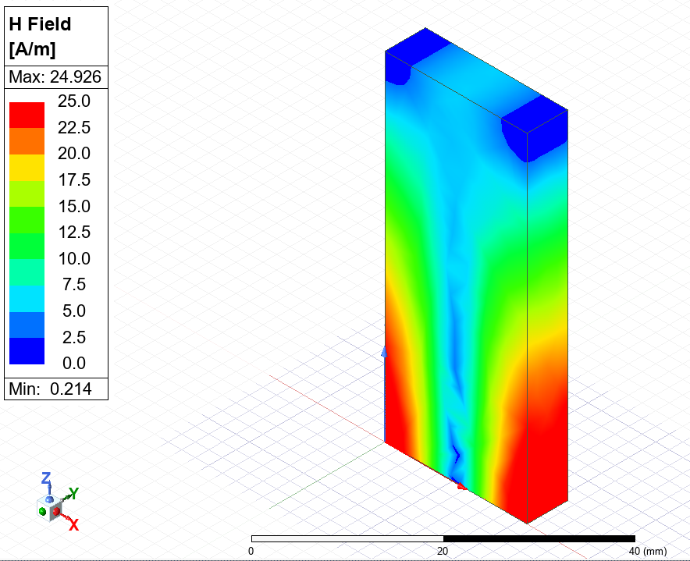 | Mode 2  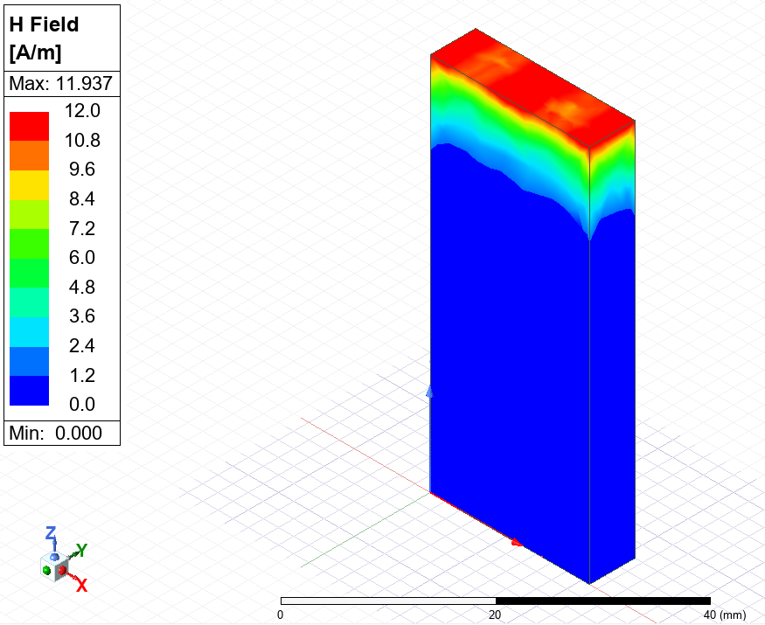 | Mode 3  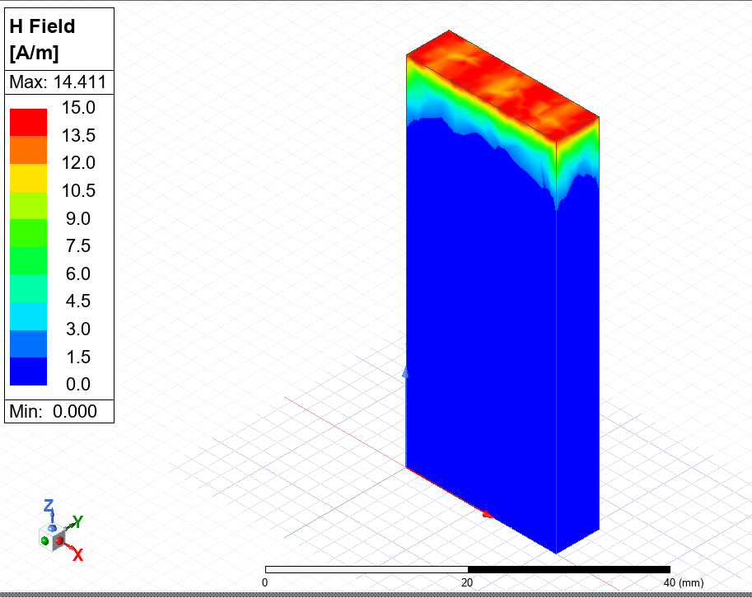
Vector | Mode 1  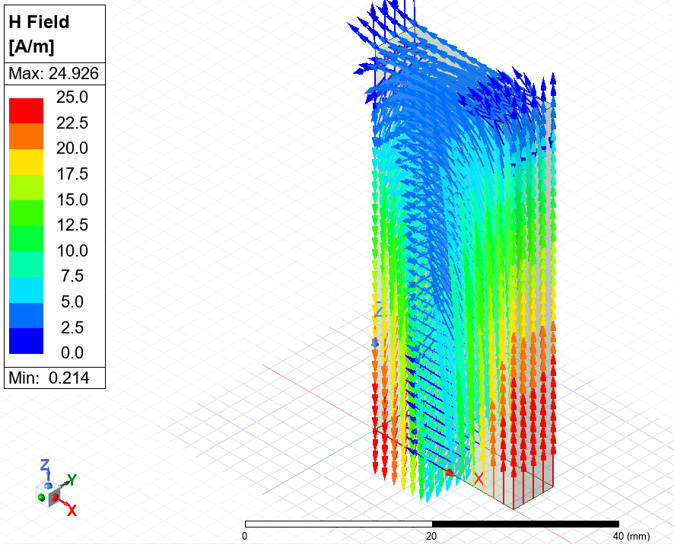  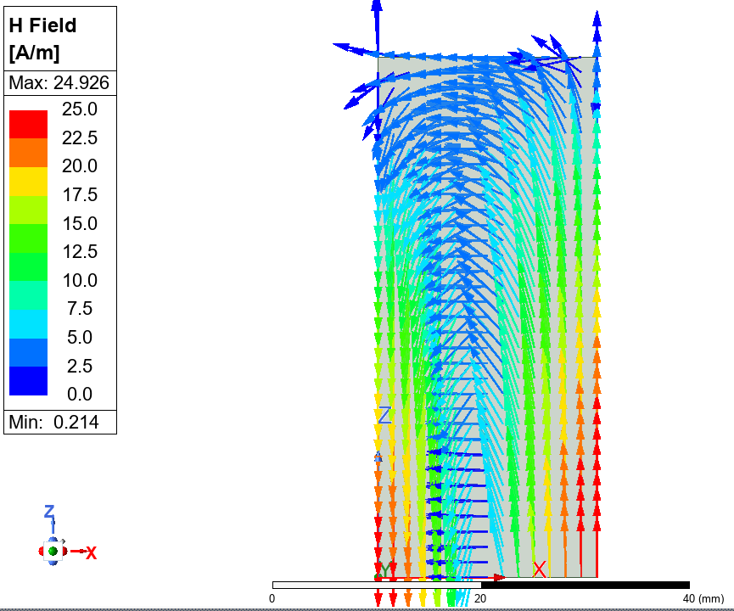 | Mode 2  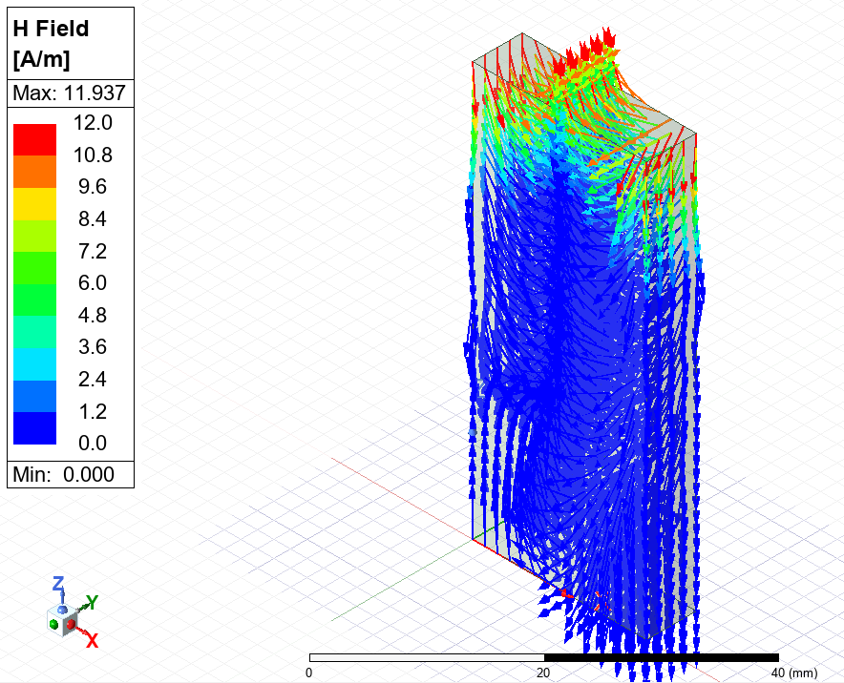  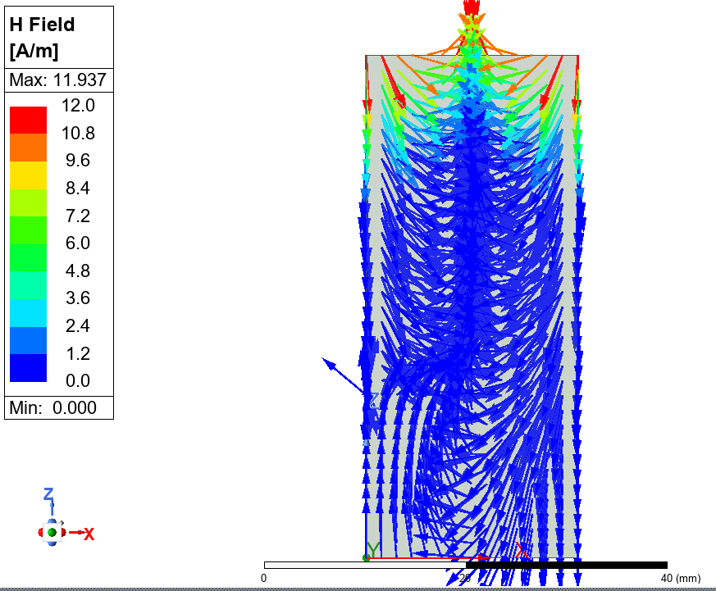 | Mode 3  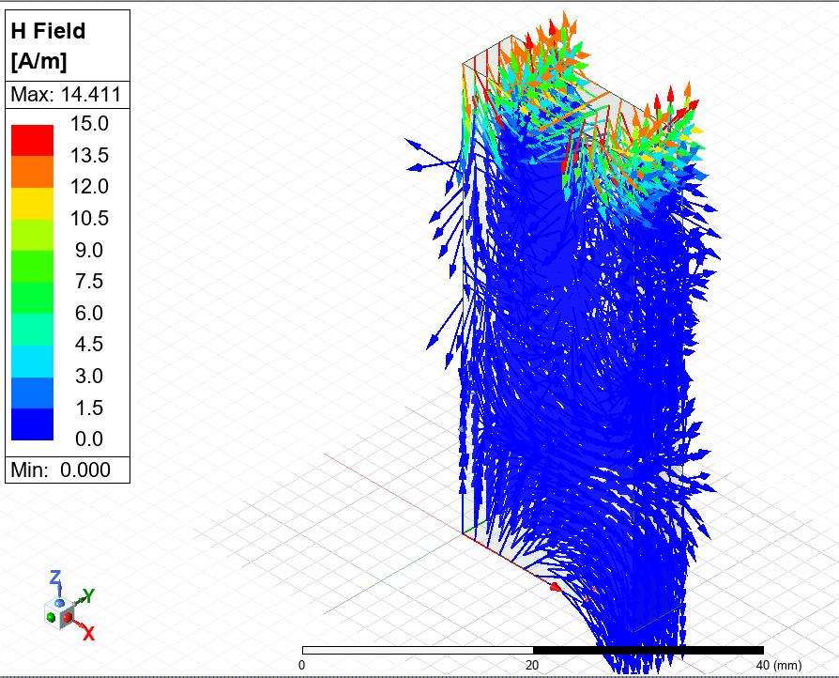  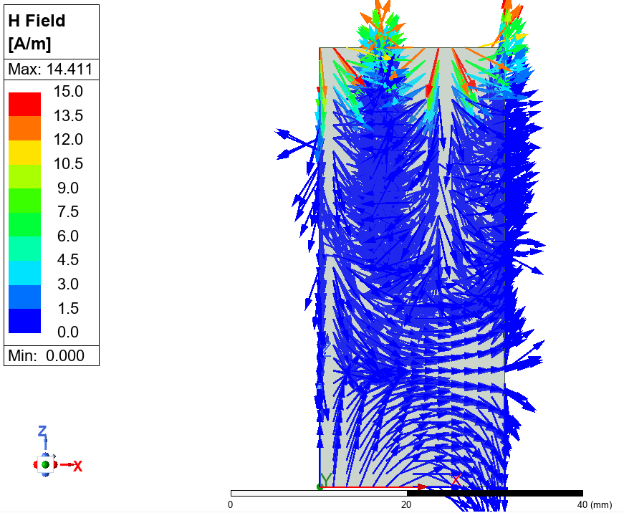

3.6 S-Parameter Plot
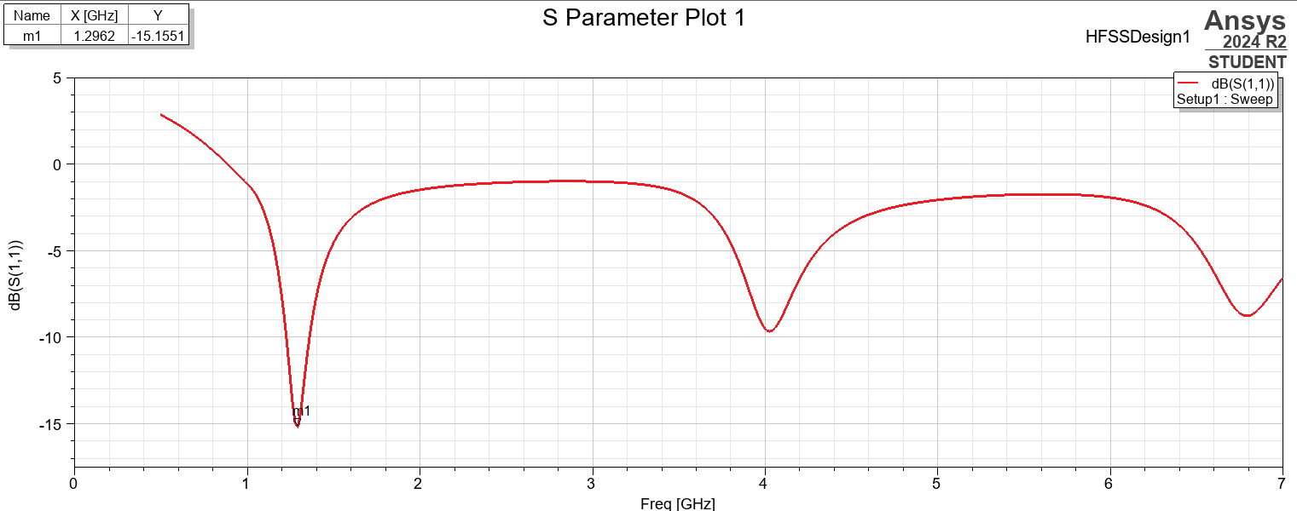
Figure 6 - S parameter plot for dipole antenna.

3.7 Radiation Pattern
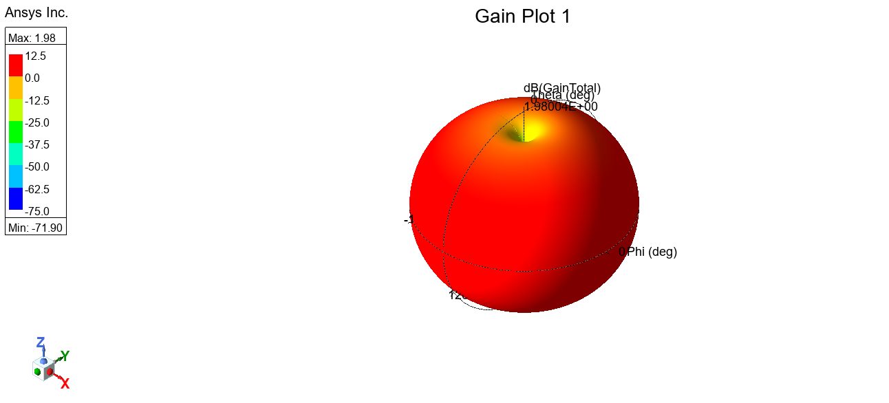
Figure 7 – Dipole antenna radiation pattern.
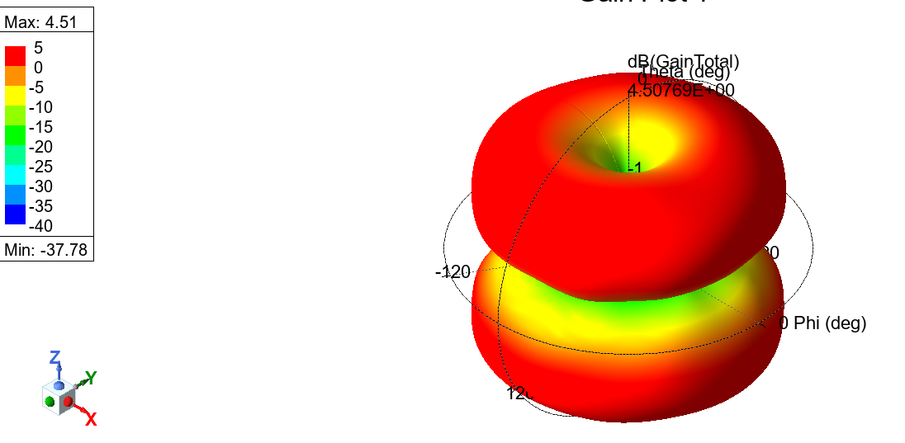
Figure 8 – Incorrect simulation of dipole antenna 1.

Figure 9 - Incorrect simulation of dipole antenna 2.

4.0 Discussion

4.1 Dominant modes
It can be seen from the port field displays in section 3.1 that both propagation mediums exhibit similar electromagnetic behaviour. For both configurations:

Mode 1 corresponds to the fundamental TE₁₀ mode, identified by a single half-wavelength across the width.
Mode 2 represents the TE₂₀ mode, displaying two half-wavelengths across the width of the waveguide.
Mode 3 indicates the TE₃₀ mode, with three distinct half-wavelengths spanning the waveguide width.

In all modes, no significant variation was observed in the vertical axis, consistent with the nature of TE modes in rectangular waveguides.

4.2 Cutoff frequencies
Table 7 – Theoretical vs simulated cutoff frequencies.
Filling | Mode | Theoretical (GHz) | Simulation (GHz) | % Error
Vacuum | TE₁₀ | 7.143 | 7.110 | 0.46%
Vacuum | TE₂₀ | 14.286 | 14.250 | 0.25%
Vacuum | TE₃₀ | 21.429 | 21.390 | 0.18%
Teflon | TE₁₀ | 4.929 | 4.870 | 1.20%
Teflon | TE₂₀ | 9.857 | 9.840 | 0.17%
Teflon | TE₃₀ | 14.786 | 14.740 | 0.31%

Table 7 presents theoretical cutoff frequencies, previously calculated in section 3.2, alongside simulated results from section 3.3. As expected, the presence of Teflon significantly reduced the cutoff frequencies due to the lower velocity of propagation of the waves through the waveguide. A detailed inspection reveals a strong correlation between theoretical and simulated values, with minor discrepancies being likely attributable to the following:
- Numerical artefacts or interpolation errors.
- Field ‘leakage’ near waveguide boundaries.
- Limited Mesh resolution.

4.3 Vectors of the Magnetic and Electric Fields
Table 3 shows the electric field distribution for the vacuum-filled waveguide Mode 1, showing a single peak at 2426 V/m near the top of the structure, consistent with the expected field maximum for the TE₁₀ mode. For Modes 2 and 3, the maximum electric field decreases to 1500 V/m and 1213 V/m, respectively. These modes have two and three peaks, indicating that higher-order modes introduce increased field complexity with multiple lobes across the waveguide. The associated vector plot confirms expected modal behaviour, with field vectors oriented perpendicular to the direction of propagation, which is characteristic of TE modes.

In contrast, the Teflon-filled waveguide significantly enhances electric field confinement and intensity across all three modes. In Mode 1, the electric field is centrally concentrated, whereas Modes 2 and 3 exhibit compressed lobes with sharper boundaries, in contrast to the broader nodes observed in the vacuum-filled waveguide. This enhancement is attributed to the higher dielectric constant of Teflon, resulting in stronger electric field reflections and tighter spatial control. The presence of Teflon lowers the phase velocity and cutoff frequency, allowing the waveguide to support more compact and intense electric field distributions.

Clear differences in magnetic field intensity and spatial variation were observed between the two propagation mediums, primarily due to the difference in relative permittivity, which influences the propagation and distribution of the magnetic field. Notably, mode 1 experiences a phase reversal in the Teflon-filled waveguide, stemming from the altered dielectric conditions.

Additionally, the node location in Mode 1 is found at the bottom of the waveguide, unlike Modes 2 and 3, where the nodes remain distributed across the top of the waveguide. This may result from the waveguide dimensions being less optimal for supporting mode 1 propagation. As the fundamental mode, Mode 1 supports only a single half-wavelength across the cross-section, whereas higher order modes accommodate multiple variations, allowing more extended field patterns. In addition, the Teflon waveguide reduces the amount of side losses.

The results of both electric and magnetic vectors and their magnitudes confirm that a Teflon-filled waveguide significantly improves magnetic field confinement, providing greater spatial precision and reduced propagation losses. These findings underscore the importance of the material selection in the design of waveguides for high-frequency systems.

4.4 Operating frequency
The study found that the dipole antenna in this report had an operating frequency of 1.2962 GHz, which is the lowest point of the plot in Figure 6 and transmission is the highest, and the reflection coefficient is the lowest. This correlates well with the theoretical calculations made in section 2.3 of 1.4218 GHz. The 9% difference could be explained by the simulation boundary conditions or the meshing and numerical accuracy of the simulation. If the diameter of the antenna were to increase, bandwidth would become wider, and loss resistance would decrease, improving efficiency, which would be advantageous when wider frequency coverage is required.

4.5 Radiation Pattern
The gain (dB) of the radiation pattern for the dipole antenna is shown in Figure 7. The radiation pattern suggests an omnidirectional radiation pattern, as the antenna radiates 12.5 dB equally in all directions within a specific plane. However, the radiation is the lowest along the axis of the antenna at 1.98004 dB. The ‘doughnut’ shape is the expected radiation pattern, supported by numerous academic studies. This type of radiation is useful in applications such as FM radio or broadcasting, where signals need to reach a wide audience in various directions.

As shown in Figures 7 and 8, the simulated radiation pattern of the dipole antenna deviates from the expected results. To correct this issue, the number of passes was adjusted from 99 to 10, and the frequency sweep from 1- 7.5 GHz to 0.5 – 7 GHz. These corrections improved simulation accuracy, yielding a pattern that aligned with theoretical predictions.

5.0 Conclusion
In this report, the aim was to design, simulate and analyse two waveguides with different propagation mediums as well as a dipole antenna using ANSYS HFSS, integrating both theoretical and computational approaches. Through analysis of port field displays, it was confirmed that the dominant modes in both vacuum and Teflon filled waveguides correspond to TE₁₀, TE₂₀, and TE₃₀, with field distributions aligning with theoretical expectations of TE modes.

The comparison of theoretical and simulated cutoff frequencies revealed excellent agreement, with insignificant percentage errors. The presence of Teflon significantly lowered the cutoff frequencies due to a reduced propagation velocity, which validates the inverse relationship with the square root of the relative permittivity. Minor deviations were likely attributed to the mesh resolution, boundary effects and numerical artifacts attributed to simulations.

The electric and magnetic field vector analysis proved that a Teflon-filled waveguide strengthened field confinement and reduced propagation losses. This was particularly confirmed by sharper lobe boundaries and increased field intensity. In conclusion, the dielectric material selection critically impacts modal behaviour and waveguide performance. Notably, a phase reversal and node migration in Mode 1 were observed in the Teflon waveguide, attributed to the new electromagnetic boundary conditions and structural dimensions of the waveguide.

Analysis of the dipole antenna showed an operating frequency of 1.2952 GHz that was 9% different when compared to theory and a maximum gain of 12.5 dB in the transverse plane. Despite initial difficulties in correctly simulating, corrective adjustments were made to the frequency sweep parameters, which improved results. The observed ‘doughnut’ pattern is aligned accurately with theoretical predictions and is well-suited for broad coverage applications.

The report was limited by only comparing two propagation mediums; a wider spread of mediums should have been analysed to make more certain conclusions. Notwithstanding these limitations, the study suggests that a Teflon-filled waveguide did enhance the performance of the waveguide in this report. Further studies need to be carried out to confirm the behaviour of waveguides with a range of dielectric materials.

6.0 References

[1] | J. S. Sobolewski, “Data Transmission Media,” in Encyclopedia of Physical Science and Technology , Third ed., Academic Press, 2003, pp. 277-303.
[2] | Z. Ahmad, M. K. Abdullah, M. Z. Ali and M. A. M. Zawawi, “Polymers in optoelectronic devices - 5.5 Optical waveguide,” in Polymers in Electronics, Elsevier, 2023, pp. 429-436.
[3] | Lawrence Berkeley National Laboratory, Lecture 4: Optical waveguides, California.
[4] | A. Moradi, “Electrostatic theory of rectangular waveguides filled with anisotropic media,” Sci Rep, 31 December 2021.
[5] | r. A. Meyers, “Microwave Communications - V.A Rectangular Waveguide,” in Encyclopedia of Physical Science and Technology, vol. 18, Elsevier, 2001.
[6] | S. Ppantonis, N. M. Ridler and S. Lucyszyn, “Rectangular Waveguide Enabling Technology Using Holey Surfaces and Wire Media Metamaterials,” Sensors and Actuators A: Physical, pp. 1-8, 1 March 2014.
[7] | D. M. Pozar, Microwave Engineering, 4 ed., Wiley, 2011, p. 113.
[8] | A. Ideas, “I need help trying to set up a rectangular waveguide in HFSS,,” 2022. [Online]. Available: https://electronics.stackexchange.com/questions/590314/i-need-help-trying-to-set-up-a-rectangular-waveguide-in-hfss. [Accessed 05 04 2025].
[9] | R. L. Eisenhart, A Collection of Thoughts, Tips and Techniques for Microwave Circuit Design - Section 4 Waveguides & Circuits, 2020.
[10] | S. Farahani, “Chapter 5 - RF Propagation, Antennas, and Regulatory Requirements,” in ZigBee Wireless Networks and Transceivers, 2008, pp. 171-206.
[11] | A. Ahmed, “Understanding and Desgin of Yagi-Uda Antenna,” p. 1, March 2022.
[12] | R. A. Meyers, “Microwave Communications - VI.A Parabolic Reflector Antenna,” in Encylopedia of Physical Science and Technology, Third ed., 2003.
[13] | S. Farahani, “Chapter 5 - RF Propagation, Antennas, and Regulatory Requirements,” in ZigBee Wireless Networks and Transceivers, 2008, pp. 171-206.
[14] | A. C. Caputo, “Wireless Networked Video,” in Digital Video Surveillance and Security, 2010, pp. 123-167.
[15] | K. Amelia, Design Dipole Antenna at 1 GHz using CST studio suite, 2021.
[16] | Cadence System Analysis, “The Rectangular Waveguide Cut-Off Frequency,” [Online]. Available: https://resources.system-analysis.cadence.com/blog/msa2021-the-rectangular-waveguide-cut-off-frequency. [Accessed 25 003 2025].

