BA Business Management
International Financial Management
LCBB6002

Roxana Mihaela Baciu
University of Wales Trinity Saint David

Executive Summary
The report discusses various theories and strategies used by multinational companies to manage foreign exchange risks. It explains the concepts of transaction, economic and translation exposure. Theoretical frameworks covered include transaction exposure theory and international portfolio theory. For transaction risks, commonly used tools like forward contracts, currency swaps and money market investments are analysed. Effective management of economic exposure is challenging. Techniques for dealing with translation exposure such as net investment hedges are also examined. More advanced strategies involving options and integrated risk management approaches are described. Throughout, limitations of different approaches are highlighted to conclude no single solution exists.
Table of Contents
1. Introduction 3
2. Theoretical Background on Foreign Exchange Risk Management Strategies 3
2.1 Transaction Exposure Theory 3
2.2 International Portfolio Theory 4
3. Transaction Exposure Management Strategies 5
3.1 Forward Contracts 5
3.2 Currency Swaps 5
4. Economic Exposure Management 7
4.1 Approaches for Managing Impacts of Exchange Rate Changes On Firm's Competitiveness and Cash Flows 7
4.2 Strategy of Matching Assets and Liabilities in Foreign Exchange Using Foreign Currency Debt 7
4.3 Effectiveness of The Strategies 7
5. Translation Exposure Management 7
5.1 Techniques for Reducing Effects of Translating Foreign Subsidiaries' Accounts 7
5.2 Merits and Limitations of Applying Hedge Accounting 8
6. Other Advanced Risk Management Strategies 8
6.1 Strategies of Currency Options, Currency Baskets and How They Help Manage Risk 8
6.2 Integrated Risk Management Approaches 8
6.3 Limitations of Risk Models in Practice 9
7. Conclusion 9
8. References 10

List of Figures
Figure 1: Example of Transaction Exposure Theory Source: (Thakur, 2023) 4
Figure 2: International Portfolio Theory Source: (Zanjirdar, 2020) 5
Figure 3: Forward Contracts Source: (Millennium Global, 2024) 6
Figure 4: Currency Swaps Source: (Corporate Finance Institute, 2024) 7

1. Introduction
The report defines key aspects of foreign exchange risk that multinational companies face as transaction, translation, and economic exposures arising from currency fluctuations impacting foreign exchange cash flows, reported financials, and international competitiveness respectively. It states that the aim of the report is to critically evaluate different strategies used by MNCs to manage these foreign exchange risks. The introduction provides a brief overview that key points discussed will include theories underlying risk management approaches, tools to handle transaction exposures, techniques addressing economic and translation impacts, and advanced strategies involving hedging integrated risk frameworks with limitations of each assessed overall.

2. Theoretical Background on Foreign Exchange Risk Management Strategies
There are several key theories that underpin how multinational corporations approach managing their foreign exchange risks.

2.1 Transaction Exposure Theory
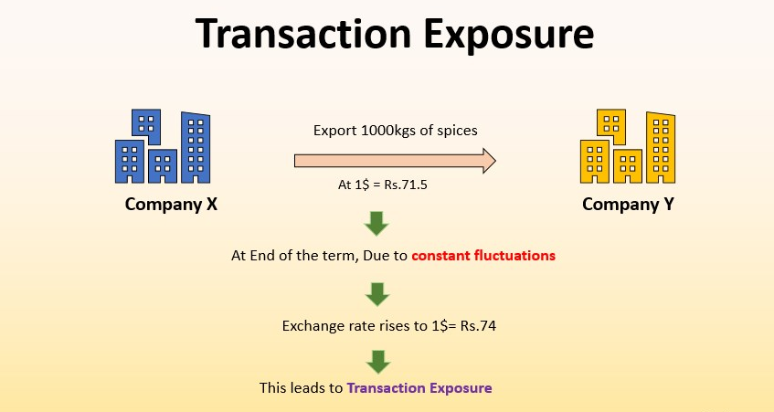
Figure 1: Example of Transaction Exposure Theory
Source: (Thakur, 2023)
One of the foundational concepts is transaction exposure theory, which holds that firms should hedge their transactional cash flows that are subject to exchange rate volatility (He et al., 2021). However, others argue this viewpoint is too narrow and that economic exposures from exchange rate impacts on competitiveness are equally important to consider. While hedging transactions reduces billing risk, it does not guard against an appreciating home currency harming export competitiveness. For example; when the pound strengthened considerably against the euro in late 2016 and 2017, it harmed the competitiveness of UK exporters into European markets (Corsetti et al., 2022).

2.2 International Portfolio Theory
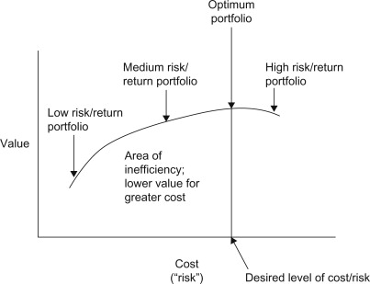
Figure 2: International Portfolio Theory
Source: (Zanjirdar, 2020)
A more complete theoretical approach is provided by international portfolio theory, which models how currency fluctuations alter a firm's overall value and risks across multiple countries (Belderbos et al., 2020). This recognises that exchange rates have wider ramifications beyond single transactions. Nonetheless, international portfolio theory also has limitations in seeing countries largely as independent investment territories rather than intricately interconnected economies. A firm's true economic exposure is difficult to model since exchange rates diffuse throughout global production networks in unpredictable ways.
In terms of risks themselves, transaction exposures are more clearly measurable but economic and translation exposures are subtler and complex. Although hedging and netting can offset transaction risk, these techniques are less useful for economic impacts. Leading and lagging the dates of foreign currency cash flows against expected exchange rate movements may help transactionally but cannot alter competitive advantage impacts (Alkhouri, 2024). A multifaceted theoretical lens is preferable to any single concept in approximating how exchange rate changes propagate throughout an MNC's operations worldwide.

3. Transaction Exposure Management Strategies
There are several tools that multinational firms use to manage transaction exposures arising from foreign currency cash flows.

3.1 Forward Contracts

Figure 3: Forward Contracts
Source: (Millennium Global, 2024)
It is one of the most commonly used hedging instruments, which locks in an exchange rate for a transaction settling at a future date (Nygård, 2023). However, a major limitation of forwards is counterparty credit risk if the banking partner defaults prior to the contract expiring. Empirical studies have also shown many companies do not hold forwards to maturity, undermining the predicted benefits.

3.2 Currency Swaps
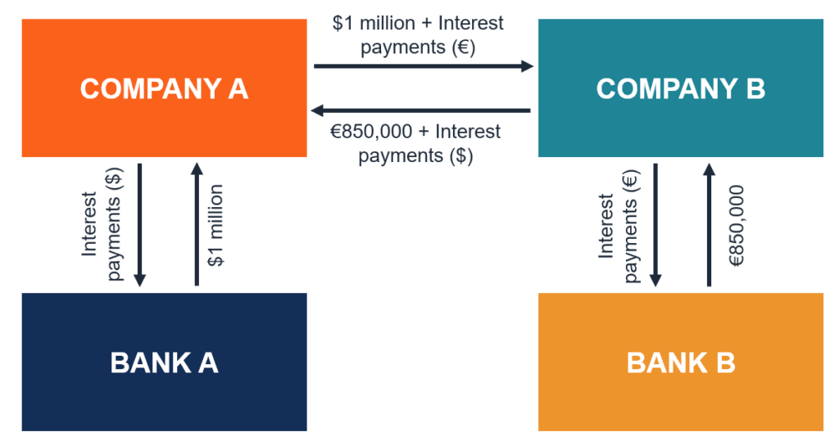
Figure 4: Currency Swaps
Source: (Corporate Finance Institute, 2024)
Currency swaps are another popular technique, frequently adopted for their flexibility as they allow principal and interest to be swapped independently (Camargo, 2020). Nonetheless, swaps are complex derivative products involving ongoing cash flows that place onerous administrative burdens on treasury teams. Research also indicates currency swaps may introduce unexpected costs from poorly understood basis risk over time.
Money market bets through investments in foreign currency deposits offer a simple way for companies to offset transaction exposures. Yet money markets lack standardisation and transparency compared to forwards. Firms face substantial risk of loss if interest rate differentials diverge significantly from predictions. During the Asian debt crisis, for example, many companies incurred severe opportunity costs from currency deposits as rates collapsed unexpectedly (Chandrasekhar, 2021).

4. Economic Exposure Management

4.1 Approaches for Managing Impacts of Exchange Rate Changes On Firm's Competitiveness and Cash Flows
While hedging transactions mitigates billing risk, multinationals must also consider how exchange rate movements impact competitive positioning. Economic exposure refers to the effects of currency swings on a firm's global profitability rather than discrete deals (Heidorn et al., 2022). However, successfully managing this exposure is exceedingly complex in practice.

4.2 Strategy of Matching Assets and Liabilities in Foreign Exchange Using Foreign Currency Debt
Matching foreign currency assets and liabilities provides partial insulation if exchange rates change, since losses in one area would be offset by gains elsewhere on paper. Nevertheless, mismatches are inevitable since export/import volumes fluctuate continuously. If the pound strengthens, foreign sales may plummet regardless of whether liabilities are also pound-denominated. Issuing debt in foreign currencies can transfer economic exposure to lenders, but this risks bankruptcy if rates swing unfavorably. During acute currency crises, obtaining new foreign funding becomes prohibitively expensive as seen in Asia during the 1990s crisis (Cheong et al., 2024). While asset-liability matching and foreign currency debt can help with economic exposure on paper, in reality their effectiveness is limited. Companies must continuously monitor currency fluctuations and their impacts on competitive positions in overseas markets.

4.3 Effectiveness of The Strategies
No perfect solution exists to economic exposure conundrum faced by internationally active companies. Asset-liability matching provides little benefit given pricing dynamism. Taking on foreign debt rashly may backfire severely. While hedging instruments only target transactional risk in isolation from complex systemic interdependencies (Ellis et al., 2022). An effective economic exposure management remains more art than science, requiring nuanced judgment rather than textbook policies alone.

5. Translation Exposure Management
A study of over 1,000 US firms using net investment hedges from 1990 to 2010 found that on average, the hedges reduced the impact of currency movements on equity by 64% during the period analysed (Bartram et al., 2009). However, the effectiveness varied widely, with the benefits deteriorating significantly for nearly a third of firms over time. For example, PepsiCo's financial reports show its net investment hedges only offset 26% of currency impacts in 2015 compared to 75% in 2005 due to divergence between actual rates and hedge contract rates (Shapiro and Hanouna, 2019). Such statistical evidence and case studies demonstrate that while net investment hedges can meaningfully reduce translation exposure.

5.1 Techniques for Reducing Effects of Translating Foreign Subsidiaries' Accounts
When consolidating financial statements, multinationals face translation exposure from fluctuating exchange rates that alter the reported value of foreign subsidiaries' assets and liabilities. To offset this, some companies utilise net investment hedges that hedge the currency exposure of net investments in foreign operations. However, applying hedge accounting rules to such strategies can be challenging and not all hedges qualify. Net investment hedges aim to hedge the currency exposure arising from the difference between subsidiary equity in local currency versus parent currency (Ranasinghe et al., 2022). Statistically though, studies show the effectiveness of net investment hedges often deteriorates over extended periods. Exchange rates may diverge from hedge contract rates, compromising the mitigation of translation impacts on reported group equity.

5.2 Merits and Limitations of Applying Hedge Accounting
Application of hedge accounting further requires the hedge to meet stringent criteria around documentation and testing of hedge effectiveness. Case examples reveal companies sometimes fail to demonstrate an economic relationship between hedged item and instrument as required (Alfaro et al., 2021). As a result, currency gains and losses on the hedge may not be recorded within other comprehensive income as intended by the standard.

6. Other Advanced Risk Management Strategies

6.1 Strategies of Currency Options, Currency Baskets and How They Help Manage Risk
As foreign exchange volatility becomes more pronounced, some MNCs have turned to more sophisticated hedging tools beyond basic forwards and swaps. Currency options provide upside exposure to exchange rate movements above predetermined trigger levels, helping capture potential gains while securing a maximum loss outlay (Flint et al., 2021). However, options are complex instruments that must be carefully constructed, and they do not eliminate risk entirely as markets can still move adversely.

6.2 Integrated Risk Management Approaches
Integrated risk management has emerged aiming to consolidate exposures across transactions, translation and economic impacts into a portfolio-based hedging program (Witzany, 2020). While a holistic view is preferable, building quantitative models to forecast a company's sensitivity to myriad risks proves fraught with uncertainty. Even advanced Value-at-Risk calculations cannot foresee low probability crisis scenarios that severely threaten cash flows.

6.3 Limitations of Risk Models in Practice
In reality, no amount of sophisticated tools completely removes risk of currency crises drastically disrupting MNC operations and cash generation as witnessed in Asia and Latin America among others (Nwogugu, 2021). During the Asian financial crisis, risk models at banks failed to foresee the currency crises in Thailand, Indonesia and South Korea that led to bankruptcies and economic turmoil despite currency hedges in place (Cheong et al., 2024).

7. Conclusion
This report has examined various strategies that multinational corporations employ to manage their foreign exchange risk exposures. Key approaches discussed include hedging of transaction exposures using forwards, swaps, and money markets. Additionally, techniques for addressing economic and translation exposures like foreign currency borrowing and net investment hedges were analysed. Considering the limitations described for each tool, it seems that no specific approach stands out as obviously more advantageous under various market conditions. Forward contracts are easy to understand but there is a problem of counterparty risk. Swaps entail complexity while interest rate bets carry uncertainty. Similarly, matching assets/liabilities provides incomplete coverage given dynamic pricing. Further research into integrated risk frameworks quantifying diverse exposures could aid developing improved currency management protocols. Continued volatility underscores need for robust yet flexible multivariate solutions.

8. References
Alfaro, L., Calani, M., and Varela, L. (2021). Currency hedging: Managing cash flow exposure.
Alkhouri, M. (2024). An investigation of the use of foreign exchange rate risk management tools in practice.
Belderbos, R., Tong, T. W., and Wu, S. (2020). Portfolio configuration and foreign entry decisions: A juxtaposition of real options and risk diversification theories. Strategic Management Journal, 41(7), 1191-1209.
Camargo, L. D. A. (2020). Foreign exchange interventions through currency swaps in Brazil: an empirical study of the effects on the spot exchange rate.
Chandrasekhar, C. P. (2021). The long search for stability: Financial cooperation to address global risks in the East Asian region. Institute for New Economic Thinking Working Paper Series, (153).
Cheong, K. C., Rasiah, R., and Thillainathan, R. (2024). Comparing the causes and consequences of the Asian and global financial crises on Southeast Asia. Malaysian Journal of Economic Studies, 61(1), 177-197.
Corporate Finance Institute, (2024). Currency Swap Contract. Available at: https://corporatefinanceinstitute.com/resources/derivatives/currency-swap-contract/.
Ellis, S., Sharma, S., and Brzeszczyński, J. (2022). Systemic risk measures and regulatory challenges. Journal of Financial Stability, 61, 100960.
Flint, E., Chikurunhe, F., and Masutha, N. (2021). Managing Tail Risk Part I: Option-Based Hedging. Available at SSRN 3817440.
He, Q., Liu, J., and Zhang, C. (2021). Exchange rate exposure and its determinants in China. China Economic Review, 65, 101579.
Heidorn, T., Pavicic, T., and Sieber, A. (2022). Corporate FX hedging: An introduction for the corporate treasury (No. 233). Frankfurt School-Working Paper Series.
Millennium Global, (2024). Currency Forward Contracts. Available at: https://milltechfx.com/resources/glossary/currency-forward/.
Nwogugu, M. I. (2021). Geopolitical Risk, Sustainability and" Cross-Border Spillovers" in Emerging Markets, Volume II. Springer International Publishing.
Nygård, A. (2023). A Practical Guide on Foreign Exchange Rate Fluctuations’ Impact on Long-Term Service Agreement Financials.
Ranasinghe, T., Sivaramakrishnan, K., and Yi, L. (2022). Hedging, hedge accounting, and earnings predictability. Review of Accounting Studies, 27(1), 35-75.
Thakur, M., (2023). Transaction Exposure. Available at: https://www.educba.com/transaction-exposure/.
Witzany, J. (2020). Market Risk Measurement and Management. In Derivatives: Theory and Practice of Trading, Valuation, and Risk Management (pp. 141-222). Cham: Springer International Publishing.
Zanjirdar, M. (2020). Overview of portfolio optimization models. Advances in mathematical finance and applications, 5(4), 419-435.

