Live Event Portfolio
Student: Savannah Kitching 2205032
Lecture: Deborah Jenkins

Tabel of context
- Introduction..........................................
- Date, Timings and event rota .............................................
- Aimes and objectives ...............................................
- Evidence of planning ...........................................
- Event marketing plan ...................................................
- Finances .........................................................
- Risk management and legal arrangements ......................................................
- References ................................................................
- Appendix .................................................................

Introduction
This live event will be an Indie rock live music features by three bans which be Coda, The False Idles and Stone Deaf. Have three of the bands play at the event was important as two off the bands were a following up before the Stone Deaf came on. This was the group unique selling point as it would engage with many customers to come and join the event on the night.
Date, Timings and event rota
The love music event is on 20th of March 2024. The timings of live music event were 6pm the doors open and then the first live bands started at 8pm and the last band would start at half past 9 which then will be ending at 11pm. The location of the event would be held at the Bunkhouse within Swansea as this was the perfect location for the live music event as the Bunkhouse has cater indie rock there before and they have the facilities there which makes the venue look and feel like you are within and indie rock live music event venue.
The rota of the band was:
- The False Idles – 20:00 to 20:30
- Coda – 20:45 to 21:15
- Stone Deaf – 21:30 until 22:15
Aims and Objectives of the event
An indie rock live music event organised and run by us can have a long-lasting effect on both organisers and attendees, while also having a positive impact on campus life, students' engagement, and the greater cultural environment.
The aims and objects are:
- Promote student lead events
- Create and entertainment and memories for students
- Create awareness on different areas that events can be held ( e.g. Bunkhouse)
- Support local music and scenes and venues
- Engages a wide swarm Ed of students and the community to go

Evidence of planning
When planning for the group live event it was important that we done as much research on live music before heading onto creating one ourselves. When searching more in-depth of indie rock I game across an article by Jax. J. (2022) and he states, “while it’s easy to think of indie rock as being a relic of the past, it’s actually more alive and well than ever”. Following on from this it gives information that indie rock is more popular now, so this fitted in well when organising and event which would be ran for students by students.

After completing the research on the indie rock music and how popular it is. It was important that we all had set roles for each other. By having set roles for each other it gives use job roles which needed to be completed and started at a date and had a set date to complete it by. As being a member of four people creating the event, one of my roles was to complete a Gantt chart. Having a Gantt chart will specify the objectives that need to be created, the daily and overall quantity, as well as the start and end dates for objectivise to be completed. (William, J.M. 2003).
Task names | Who was Involved | Start date | Final date to complete task | Completed?
Book a venue | Grace, Kirsty, Sav, Ben | 29/1/24 | 9/2/24 | Complete
Marketing | Sav and Grace | 12/2/24 | 26/02/24 | Complete
Planning for the event | Grace, Sav, Kirsty, Ben | 29/1/24 | 1/03/24 | Complete
Finances | ALL | 30/1/24 | 9/2/24 | Complete
Team Communications | Grace, Kirsty, Ben, Sav | 29/1/24 | 20/03/24 | Complete
Posting on social media | Kirsty and Grace | 29/1/24 | 20/3/24 | Complete
Follow up | Grace, Sav, Kirsty, Ben | 29/1/24 | 20/03/24 | Complete
Following on from the Gantt chart it shows that I completed each job roles and completed within the time frame that was set by the group. The job roles that were completed by me was to book and venue, marketing the event, planning on what will have within the event, finances, communications which were through emails and WhatsApp's as the Bunkhouse manager preferred WhatsApp over emails and having a follow up before the vent would take place.
Event Marketing Plan
Overseeing the marketing I was in charge of completing the marketing side the event it was important this I engaged with the Bunkhouse Manager which was Jordan to see which colours he was marketing our event on his page. I created numerous of marketing poster for the indie rock night to make sure that the group could pick from to make sure that everyone was happy. When completing the event I used the colours of purple, green and black as they were used in the colours of the Bunkhouse poster. Bunkhouse poster is displayed within the appendix.
After using the colours, I had to do a lot of research to know which platform was better for our group to post the event to engage numerous of students to event as it was run by students. When doing the research, the post popular place that game up to post Facebook. Robbins,R.(2023) states that “it’s an unparalleled giant with over 3.03 billion monthly actives user”. After reading this we all decide that we were posting the poster on Facebook, Instagram, TikTok and the billboards within university. Can see evidence of posting within the appendix.
Grace oversaw the creating of an eye catching video to go along side of the poster that was created to gain mire visitors for our event. By having a video to go alongside the poster it allowed customers to have an insight of what the bands were going there and listen to the type of music which would be played there. Transperfect.com (2022) states “87% of video marketers report that video gives them a positive return on investment.” Adding to this we knew that by having a visual to go alongside the poster would gain more visitors to come to the live event.
Here is an image of the poster that was advertise across Facebook, TikTok, Instagram and snapchat. See appendix for evidence of posting.
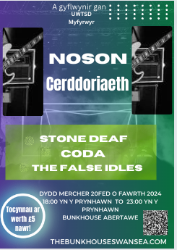
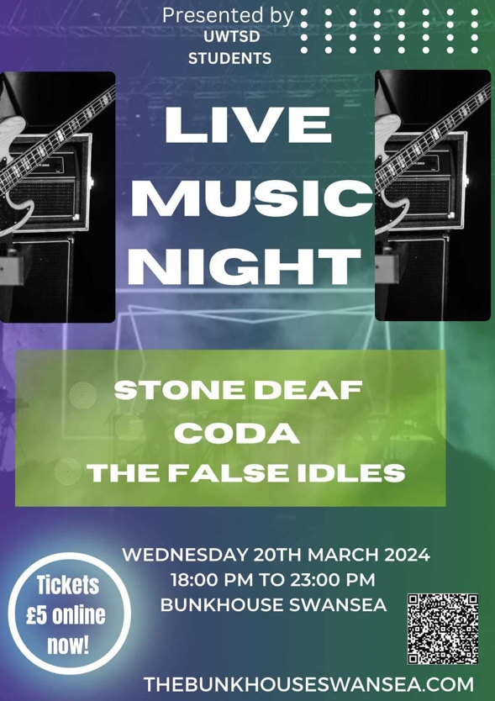
Another important part of the advertisement is that making sure that all advertisements was in Welsh and English. By having the posters in Welsh and English it allowed our group for Welsh and English speakers to read our posters. When doing the posters for the marketing of our events it was important that we followed the Welsh government guidelines. Gov.com(2022) states “we recommend bilingual advertising”. Adding onto this it shows by changing all the poster and video both into English and Welsh we followed the Welsh government guidelines.
Finances
Finances of this event was discussed with Jordan the manager of Bunkhouse and sent a copy of the agreement which is in the appendix. As a group we made the discussion of the ticket's sales money would go towards the bands which were playing. The money made from the tickets sales were £396. We had 54 sales on pre bookings and 21 sales bookings on the door. The price of the tickets online was £5 with 50p tax included and £6 on the door. As Coda and The False Idles were supporting acts we give them £100 each out of the money and the remaining £196 to Stone Deaf as they were the main acts and performed longer.
Risk Management and legal arrangements
Within the risk management and legal factors Ben was in charge of completing and risk assessment for our live music event. See in appendix for risk assessment. The legal factors which we needed to take into considerations is making sure that all the bar staff at the Bunkhouse had their alcohol licences to serve the customers with drinks they wanted. This will also come under the licensing act 2003 as this was put into place to make sure there was clear framework to sell and supply alcohol or provide certain types if regulated entertainment. (localgov.com, n.d.) Another legal factor which was taken into consideration was the live music time allowances. When doing a love music event, it was important to make sure that all music was turn off at 11 at night as the guile line shows live music's need to be stop at 11.

References
Gov.com.(n.d.) Welsh Language Standards: Communication and Marketing Guidelines. Available at: www.gov.wales/welsh-language-standards-communication-and-marketing-guidelines. [Accessed on: 29 March 2024]
Jax, J. (2022). Indie Rock Today vs 10 Years Ago. Available at: https://jacquelinejax.medium.com/indie-rock-today-vs-10-years-ago-ab1f9bf5ab0c [Accessed on: 15 Match 2024]
- Localgov.com. (n.d.) Licensing Act 2003 - Councillor’s Handbook. Available at: www.local.gov.uk/publications/licensing-act-2003-councillors-handbook-england-and-wales-0. [Access on 31st March 2024]
- Robbins, R. (2023). 5 Best Social Media Platforms for Marketing and Advertising. Available at: https://clictadigital.com/5-best-social-media-platforms-for-marketing-and-advertising/ {Accessed on: 29 March 2023]
- Transperfect.com. (2022). Why Video Is Vital for Attracting Audiences to an Event. Available at: www.transperfect.com/blog/why-video-vital-attracting-audiences-event. [Accessed on: 30 March 2024]
- Wilson, J. M. (2003). Gantt charts: A centenary appreciation. European Journal of Operational Research, 149(2), 430–437. https://doi.org/10.1016/S0377-2217(02)00769-5

Appendix
Engagement emails with Jordan
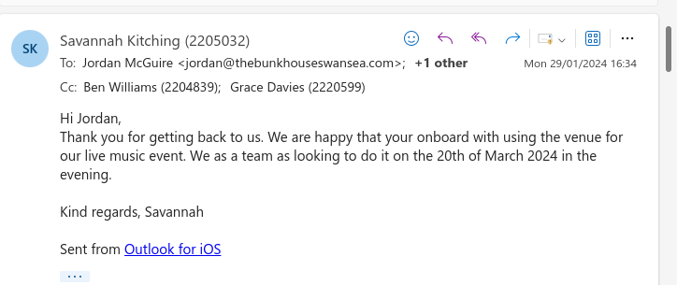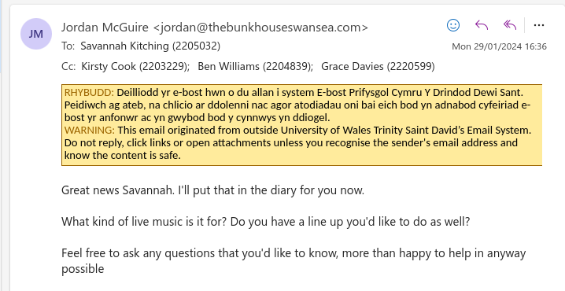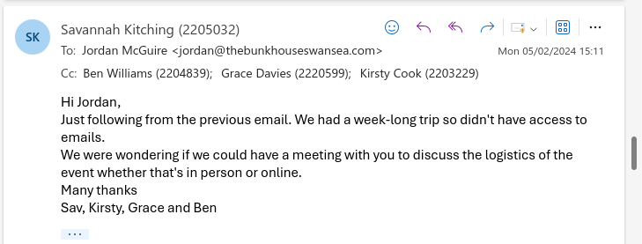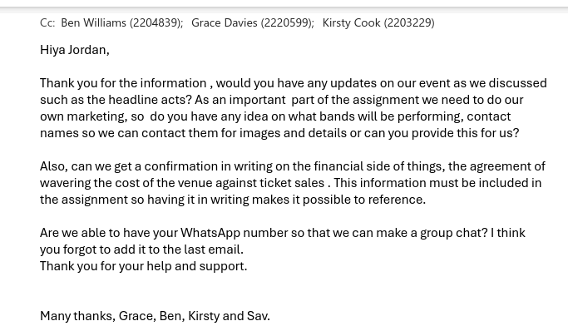

Finances – Agreement of the finances
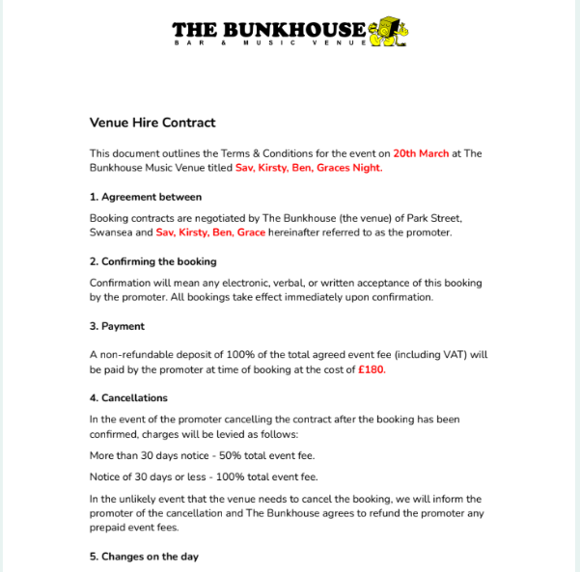

Image of Bunkhouse poster
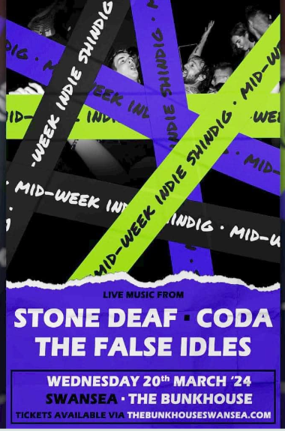
poster and video on social media
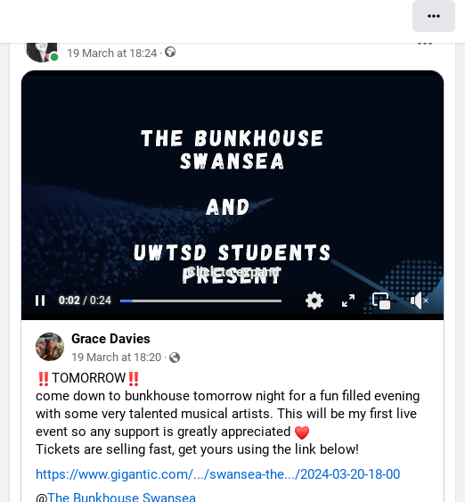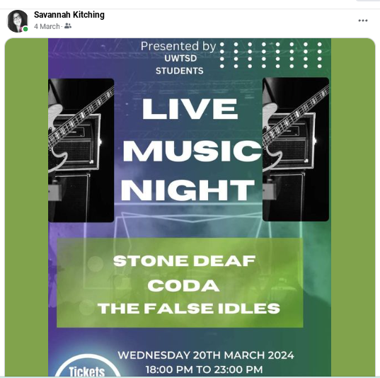

Risk assessment created by Ben for the event

Company name: UWTSD STUDENTS

Assessment carried out by: 27/02/24

Date of next review: 04/03/24

Risk assessment- Ben Williams

Event Name: | Live music event, STONE DEAF, CODA, THE FALSE IDLES |  |  | Date: |  | 20/03/24 |  | Venue: | Bunkhouse Swansea
(1)  Activity /  Area of Concern  ie: what is taking place as part of the event? |  | (2)  Hazards Identified  ie: what can cause harm? | (3)  Persons at Risk  ie: who could be harmed by the hazard? |  | (4)  Current Risk Factor  (high, medium or low)  ie: determine the level of risk |  | (5)  Actions to be Taken to Minimize each Risk  ie: what action can you take to lower the level of risk |  |  | (6)  New Risk Factor  (high, medium or low)  ie: risk factor after action taken to minimise the risk
Live music event in a small venue |  | Crowd Management | -Public  Venue staff (including security)  -Performers  Neighbouring residents and businesses |  | Crowd Management: Medium |  | -Implement and communicate venue capacity limits  -Ensure clear and unobstructed exit routes  -Regularly inspect and maintain flooring to prevent slips |  |  | Crowed management: Low
Emergency evacuation procedure |  | Fire;  Terrorist attack;  Storm | -Members of the public  -staff members |  | High |  | -Assembly point will be to evacuate into the street through the multiple fire exits.  -Information boards for public use such as fire exit signs and lighting  -Emergency services will be informed in case of an incident by a member of staff on duty |  |  | Emergency evacuation procedure:  Medium
First Aid |  | -Minor injuries  -Heat stroke,  -general accidents  -Major incidents | -Public  Venue staff (including security)  -Performers  Neighbouring residents and businesses |  | Medium |  | -Provide adequate First Aid cover.  Number of qualified First Aiders to be present for the event=2 |  |  | First aid:  Low
Electrical Equipment |  | Electrocution  -Death  -Shock and Burns | -Attendees (patrons)  -Venue staff  Performers  Neighbouring residents and businesses |  | Electrical Equipment: Medium |  | -Regularly inspect and maintain all electrical systems  -Provide staff training on identifying and reporting electrical issues |  |  | Electrical Equipment: Low
Toilet Provision |  | Not enough toilets | Members of the public |  | Low |  | -Ensure enough toilets present at site for numbers attending  -Use public toilets on site. |  |  | Not enough toilets:  Low
Noice Levels |  | Annoyance to locals in the area | -Attendees (patrons)  Venue staff  -Performers  Neighbouring residents and businesses |  | Noise Levels: Medium |  | - Implement noise level monitoring and control measures  -Install soundproofing measures within the venue  -Finish live music at 11pm following guidelines. |  |  | Noise level-Low
Risk of fire |  | Burn or smoke injuries | -Members of the public especially people with disabilities  -Staff  Event participants  Contractors |  | Medium |  | - Fire Detection and Suppression:  - Emergency Preparedness:  - Smoking Policies:  - Lighting and Visibility:  - Communication and Contacts  - Regular Procedure Review: |  |  | Risk of fire: Low
Security |  | -Alcohol  -18 years plus  -tickets are mandatory | -Attendees (patrons)  - Venue staff (including security)  -Performers  -Neighbouring residents and businesses |  | Medium |  | -Employ trained security personnel  - Implement a comprehensive security plan  - Monitor and control alcohol consumption to reduce the likelihood of altercations  -Security cameras in place |  |  | Security levels: Low
Alcohol Service |  | -Glass bottles  -Unresponsible use of alcohol  -Licensing of products  -Security measures  -Capacity levels | -Attendees (patrons)  -Venue staff (including bartenders) -Neighbouring residents and businesses |  | Alcohol Service: Medium |  | - Enforce responsible alcohol service policies  - Train staff to identify and manage intoxicated patrons  - Implement ID checks and limit the sale of alcohol to appropriate hours |  |  | Alcohol service: Low
Litter |  | Litter or other debris generated by event | (Complaints from) Members of the public  Parks Division staff |  | Medium |  | -Ensure that a litter pick is pre-arranged and undertaken by the venue  -Clean the venue during the event to keep a good level of hygiene |  |  | Litter levels: Low
Crowd management |  | Pinch points;  Over-crowding;  Potential conflict re-entry to event | -Members of the public  -Senior citizens  -disabled people |  | High |  | -PA system in place.  -Appropriate number of identifiable staff on site, with radio system. Staff to be fully briefed prior to event.  -Limit to ticket sales |  |  | Medium
Cash collectors |  | Risk of theft / injury to cash collectors | Competitors / members of the public |  | Medium |  | -All cash collection points are well known by security in case of a theft or incident  -Members of staff will report an issue to the police immediately  -Security cameras are in place  -Staff are fully trained |  |  | Low

I hereby confirm that I will fully comply with this Event Risk Assessment and agree to obtain all the necessary permission and licences required.
Name of person completing Risk Assessment (printed)
Ben Williams, Kirsty Cook, Grace Davies, Savannah Kitching
Organisation: University of Wales Trinity Saint Davids.
Signature: Ben WIlliams, Kirsty Cook, Grace Davies, Savannah Kitching
Date: 04/03/2024
- Fire Detection and Suppression:
  - Install and maintain smoke detectors, alarms, and fire extinguishers.
  - Consider automatic sprinkler systems for enhanced fire suppression.
- Emergency Preparedness:
  - Clearly mark and maintain accessible emergency exits.
  - Conduct regular fire drills and provide staff training on evacuation procedures.

Smoking Policies:
Implement strict no-smoking policies near potential fire risks.
Designate smoking areas away from flammable materials.
Lighting and Visibility:
Maintain well-lit exit routes and emergency exits.
Regularly replace and maintain lighting fixtures.
Communication and Contacts:
Install effective emergency communication systems.
Keep a list of emergency contacts easily accessible.
-Regular Procedure Review:
Periodically review and update fire safety procedures based on changes in operations or regulations.

