Project Management

MODULE CODE/ COD Y MODIWL: LCBB5005

Lecture name: Dr Nandish Patel
Student name: Denitsa Echeva
Student number: 1813734
Assessment 1

Executive summary
The report will initiate with the description and importance of Project management and the importance of project management in the development of a skill development portal by Softwire Corporation. The project will provide insights on the goals and objectives of the development, and then it will dive into discussion of the scope of the development and then will identify any risk associated with the development. Once all these are defined, the project will elaborate the assumptions made for the project and define the work breakdown structure. Then the project will discuss the control mechanisms and develop a robust communication plan. The report will further discuss the involvement of the stakeholders and decide on the milestones of the project. Finally the report will devise a budget plan in the concluding note.

Table of contents
Introduction 3
Goals, Objectives and critical success factors 3
Project scope 3
Identifying Risk and constraints affecting the project 4
Assumptions 5
Project Organisation Structure and Roles and Responsibilities 5
Project Work Breakdown Structure 7
Project Control Mechanisms 7
Reporting Framework 8
Stakeholders involvement 10
Project planning with milestones 11
Budget Assumptions 12
Table 3: Budget Planning 13
Conclusion 13
References 14

Introduction
Project management is essential for any organisation to develop and execute a project in a coherent manner. Having a proper project management plan will help in aligning the project with the organisations and clients goals. It helps in defining goals and objectives of the project clearly and makes a realistic plan with specific, measurable and achievable milestones (Fioravanti et al., 2018). It also takes into consideration the project risks and helps create an orderly process. In this report a project management plan will be developed for creating a product line of a well knowing software development company named Softwire. The report will define the objectives of the project and then assess the risks and constraints related to the project and assumptions made for the development. The report will further describe the Project ownership structure and the responsibilities assigned to each and every member of the team, discuss the control mechanisms used for seamless execution of the project.

Goals, Objectives and critical success factors
The goal of this report is to develop a successful plan for a new product line for the Softwire solutions, an organisation based out of the UK dealing with different kinds of software development. The report will focus on building a product in the existing product line of the company. The report will identify the need of the development and then will ensure the development has the following criteria, the product being developed should possess the functionality it proposed to develop, it is usable in the regular environment and has sufficient security measures in place for ensuring it cannot be hacked to manipulate the data it is working on and it provides the simplicity of use in the real-life environment (Axinte et al., 2017). The project here has a limited timeframe and a limited budget. Thus for the critical success of the project should be considered while the project has introduced the usability it promised and it met the timeline and the cost projected for the project. For the success of a project it is absolutely necessary that the project is documented properly and then control measures are taken into consideration. The developed build needs to be stable and it has to produce reliable results in terms of execution post-delivery.

Project scope
The project will deliver insights about the development plan for building an app for tracking the skills development of any user in the real time. The scope of the app is to identify the learners in the schools who are missing out on opportunities of harnessing the self-potentials in the classroom environment due to any socio cultural differences they might face and provide them with a one-to-one guidance to develop the teachers and care practitioners to keep a track of the progress of the students using the app and for the students, it will provide an infrastructure to keep a track of their own progress and the skills they are learning through the process and also provide the feedback about the specific developments and pointing out the areas of improvement for the students using the same. In order to do so, the project will encounter many hurdles and will develop strategies to manage those hurdles and gain success in the development of the new product development project (Ali et al., 2019).

Identifying Risk and constraints affecting the project
Risk is a coherent factor while executing any new project. If identified and managed properly it can help in proper development of any project in real, but if neglected and not accounted for it will create hindrances which will result in improper development and failure to address the real issue. Also, there will be consequences which will be reflected upon the time restrictions and costing of the project (Robbins et al., 2018). There are three categories of risk in this project namely, Risk related to the Scope, Risk related to the resource and Risk related to the technology. Poorly specified scope statements will not provide a clear idea about the work that needs to be done and will result in execution or addition of relevant features to the project. Scope Creep is referred to as the unexpected changes and uncontrolled growth in the scope of the project and can result in failure to meet the time allocation of the project and may incur additional costs to the initial budget of the project. Additional features can also be added to the scope of the project which were not initially identified and this will require to deploy additional resources, cost and time to the project. The previously mentioned risks can be categorised as risks related to scope of work. While a project has to be worked on a collaborative environment with different teams being involved in the process, it will be difficult for the project to continue and execute when the teams involved in the project does not have the required cohesion and inner conflicts are visible (Esteki et al., 2020).The stakeholders play an important role in the development of any project, a classic risk is not to engage the stakeholders and thereby generating a lack of commitment in the team as a whole. The previously mentioned risks are related to the resources and manpower requirement of the project. Software is made for the scalability of the application for coping with the increasing load on the application, if the build is not scalable or easily installed as a duplicate on another system the performance of the software might face difficulties. For any software the build needs to be stable and bug free in order to run smoothly and bring satisfaction to the user and the owner. The previously mentioned risks are related to the technicalities of the project.

Assumptions
Assumptions are the act of taking something to be granted or more lucidly it can be said that assumptions are beliefs of something to be true without having any real proof of the validity of the statement (El Yamami et al., 2020). The assumptions of a project can be known factors as well as unknown factors. The assumptions for the current project are;
Completion of development in 6 months from start to finish and there would be no extensions required in the development. The project budget is set to be 50,000 pounds and a safety factor is considered as 10% of the overall project budget. The stakeholders will be actively involved with the project of development. The developers of Softwire will use uniform coding methods and flow to ensure there is proper flow available in the process. The users vide, the students and the teachers taking care of the development process will be honest while taking the assessments and there would not be any falsified data to be entered in the system. While utilising the data it is assumed that the data needs to be cleaned and properly formatted before the analysis. It is also assumed that the users of this application will also be wide, using a wide range of data to be analysed. In the development scenario, it is also assumed that the work will be broken down according to modules and each of the modules will be completed within a stipulated time and budget. There will not be any overages in the process.

Project Organisation Structure and Roles and Responsibilities
A project organization structure is needed to complete any project successfully.

Figure 1: Organisation Structure for Softwire Corporation’s project team
(Source: Prepared by the Researcher)
Roles and Responsibilities
Development Manager
The Development Manager serves as a “point of contact” for the consumers and upper management. The Development Manager would “scope out” the project (Javed et al., 2018).
Software Architect
The Software Architect would develop the app by making high-level choices of design and enforces “software coding standards”, platforms and tools.
Designers
The Designers would make the app and would keep into consideration that it would become user-friendly.
Developers
The Developers would develop the app by maintaining the app design and specifications.
Quality Assurance
The Quality Assurance Team would see that the app would satisfy the customer expectations according to the demand of the market.
Business Analyst
The Business Analyst would manage the documents and systems. He would assess the right model for business and how the model can be integrated with technology.

Project Work Breakdown Structure
The work breakdown structure shows the workflow and the involvement of the specific people in their role to complete the project (Strojny, 2016). The work breakdown structure for the development of skill upgrading web app is as follows;
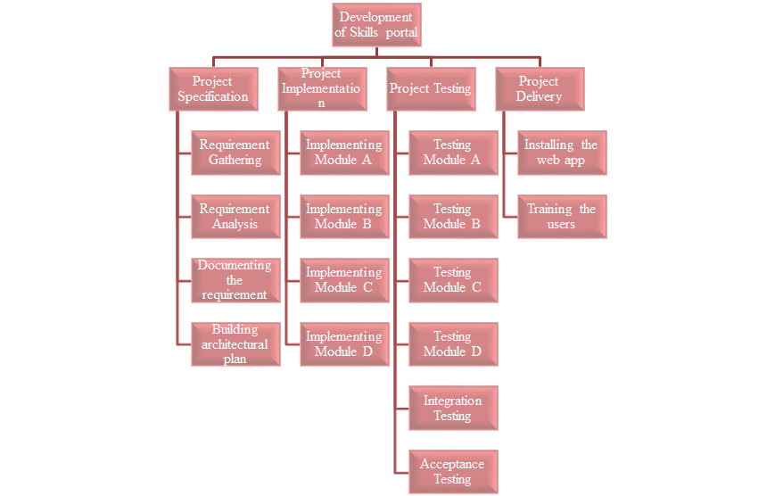
Figure 2: Work Breakdown Structure
(Source: Prepared by the researcher)

Project Control Mechanisms
The control mechanisms are present in the project to gather relevant data, and analyse them to predict the outcomes and constructively influence the project to meet the constraints of the time and cost of the project (Moe et al., 2018). It involves the decisions influenced by the stakeholders for identifying the bottlenecks of the project and mitigating them. The control mechanisms also help in keeping up with the quality parameters of the project goals. For the development of the skills portal Softwire must ensure they have implemented proper control mechanisms in each phase of the project lifecycle. Three mechanisms would be present in the controlling of the project. Cybernetic control focuses on the requirements getting done on time and ensuring there is no deviation in the completion of each module. The Project manager and the managers of each of the team must be involved in the decision making of the project. Go or No-Go controls are linked with the actual plans and take into account the dependencies of each module.. The Business analysts and the managers of each vertical related to the project are involved in such types of control mechanisms. The other mechanism is the post control mechanism, in this mechanism the project is developed and made ready to deploy, but before the release there is a thorough testing takes place to measure the performance of the development and the good and bad practices are recorded to assist the future projects (Van der Ryst and Pretorius, 2019). For the development of the skill development web app, Softwire has a dedicated team and manager for testing, this particular team is involved in measuring the performance of the developed product. They need to ensure that there are no loopholes or development gaps in place before handing over the product to the client. Using different software packages like Trello, Zoho Projects, Jira, Asana etc. the control mechanisms can be implemented and monitored.

Reporting Framework
According to the PRINCE2 methodology, there are different roles involved and responsible for a development project. The roles are the customer who is spying for the overall development. The SME provides the required knowledge to complete the project from initiation to completion. The Project Manager who is responsible for the overall development, allocation of resources and making sure the project is moving as per the planned guidelines (Hughes et al., 2017). The Project team consists of different managers as well as executioners working under the guidance of the manager. An administrator oversees the requirements of the project and manages logistics. Often the Project manager takes up this role as well. For efficient reporting and planning of the project, it is necessary to develop a proper reporting structure for the project to be executed properly, the development in Softwire needs to understand the requirement clearly and have a clear communication path to describe any problems that are being faced during the development (Hughes et al., 2017). The involvement of different stakeholders and the reporting structure for the development of the skill development portal by Softwire is as follows. Project management software’s like Trello, Jira, Zoho Projects, helps in implementing the project reporting framework.

Description | Frequency | Method | Audience | Owner
Kick off meeting | day 1 of the project | Face to face | Project sponsor, Project Management, Stakeholders | Project Manager
Project team meeting | Weekly | Face to Face | Project Team, Project Management | Project Manager
Stakeholder communication | Monthly | Conference and face to face | PMO, Stakeholders | Project Manager
Board Meeting | Every two weeks | Conference and face to face | Project board | Project Manager
Project status meet | Monthly | Face to face presentation | PMO | Project Manager
Reports discussion | Weekly | Face to face, conference and Email | PMO, Project supervisor, Stakeholders, customers | Project Manager

Table 1: Communication plan
(Source: Made by the researcher)

Stakeholders involvement
The stakeholders can be external as well as internal members of the team. For the development of the skills portal by Softwire, the stakeholders are as follows (Siegelaub, 2017).
 | High Interest | Low-interest
High-power | - The Project Team  - Clients  - Suppliers  - Needs to be managed closely | - Software regulatory authority  - Have to be satisfied by complying to data protection rules
Low-power | - Small scale vendors not selected for the tender  - They need to be informed when any need arises | - Competitors  - Have to be monitored

Table 2: Stakeholder Mapping
(Source: Prepared by the Researcher)

Project planning with milestones
In the PRINCE2 methodology, there are 7 stages of the project lifecycle, namely,
Project starting involves the request of a new project by a customer through a document called mandate.
Directing involves the review of the proposal with the involvement of stakeholders and getting approvals, generating the requirements and the roles and responsibilities are delegated along with the gathering of the required resources.
Initiating the project requires base line documentation approved by the stakeholders and focused on time, quality, cost, scope, risk and benefits of the project. This also provides an executable project plan to initiate the development (Siegelaub, 2017).
Controlling is undertaken when the whole chunk of work is broken down into small chunks and assigned to different team managers to complete the tasks. With the team members coordinating the tasks assigned to them with the managers.
Delivery Management phase deals with the inspection of the project and ensuring whether the work meets the quality parameters mentioned in the PRINCE2 methodology. The project board evaluates the work packages and either passes or proposes revisions to them (Siegelaub, 2017).
Managing Boundaries helps the project to stay on trajectory through rigorous reviews of each stage and decides whether to continue with the next stage or not, this stage also records any lessons learned to improve the execution of the next stage (Siegelaub, 2017).
Closing stage completes the loose ends of the projects and delivers the finished product to the customer.

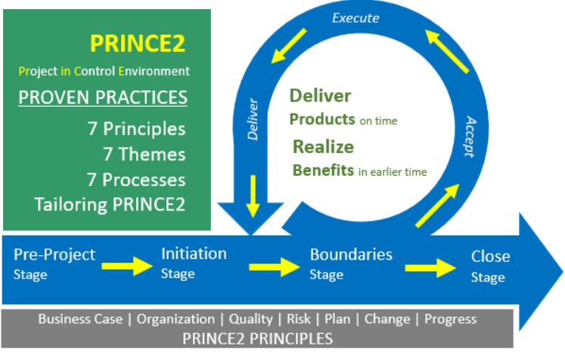
Figure 3: Diagramatic representation of PRINCE2
(Source: Siegelaub, 2017)

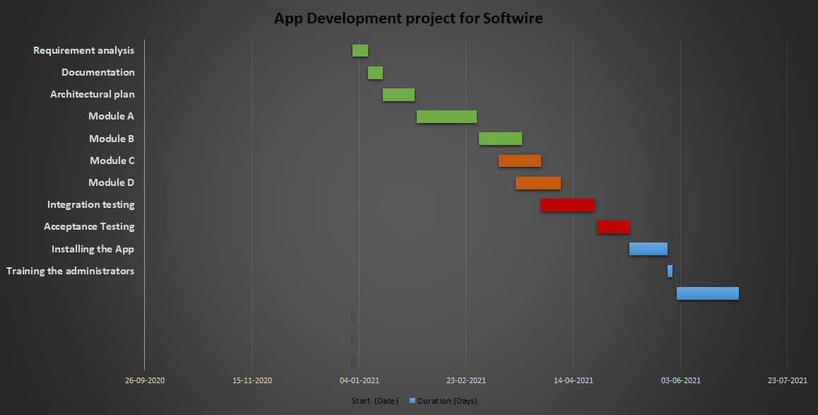
Figure 4: Gantt Chart for project scheduling
(Source: Made by the researcher)

Budget Assumptions
Sl no | Item | Rate | Hours | Total
1 | Requirement gathering | 20 | 80 | 1600
2 | Requirement analysis | 20 | 40 | 800
3 | Documentation | 17 | 30 | 510
4 | Architecture | 40 | 60 | 2400
5 | Module A | 30 | 224 | 6720
6 | Module B | 30 | 220 | 6600
7 | Module C | 30 | 120 | 3600
8 | Module D | 30 | 260 | 7800
9 | Testing | 20 | 160 | 3200
10 | Integration | 28 | 170 | 4760
11 | Acceptance | 15 | 50 | 750
12 | Installing | 18 | 30 | 540
13 | Training | 40 | 240 | 9600
Total |  |  | 1684 | 48880

Table 3: Budget Planning
(Source: Prepared by the Researcher)

Conclusion
The project provides insights about the development of a skill development portal carried out by Softwire Corporation using the PRINCE2 methodology and discusses the aspects of development in detail with identification of scope, risks associated with the development. It finds out the WBS and control mechanisms and gives an idea about the reporting framework. It discusses the involvement of the particular stakeholders and chalks out the milestones with the help of Gantt chart on the concluding note it puts out the budget assumptions identifying that the project will be completed within the stipulated timeline and the budget.

References
Ali, Z., Yaseen, M. and Ahmed, S., 2019. Effective communication as critical success factor during requirement elicitation in global software development. vol, 8, pp.108-115.
Axinte, S.D., Petrică, G. and Barbu, I.D., 2017, June. Managing a software development project complying with prince2 standard. In 2017 9th International Conference on Electronics, Computers and Artificial Intelligence (ECAI) (pp. 1-6). IEEE.
Bishop, W.A., 2018. A project management framework for small-and medium-sized entities: Accounting software implementation. Journal of Economic and Financial Sciences, 11(1), pp.1-11.
El Yamami, A., Ahriz, S., Mansouri, K., Qbadou, M. and Illoussamen, E., 2017. Representing IT projects risk management best practices as a metamodel. Engineering, Technology & Applied Science Research, 7(5), pp.2062-2067.
Esteki, M., Gandomani, T.J. and Farsani, H.K., 2020. A risk management framework for distributed scrum using PRINCE2 methodology. Bulletin of Electrical Engineering and Informatics, 9(3), pp.1299-1310.
Fioravanti, M.L., Sena, B., Paschoal, L.N., Silva, L.R., Allian, A.P., Nakagawa, E.Y., Souza, S.R., Isotani, S. and Barbosa, E.F., 2018, February. Integrating project based learning and project management for software engineering teaching: An experience report. In Proceedings of the 49th ACM Technical Symposium on Computer Science Education (pp. 806-811).
Gaziyev, M., 2019. Integrating Sustainability into Project Stakeholder Management.
Hasibović, A.Ć. and Tanović, A., 2019, May. PRINCE2 vs Scrum in digital business transformation. In 2019 42nd International Convention on Information and Communication Technology, Electronics and Microelectronics (MIPRO) (pp. 1514-1518). IEEE.
Hughes, D.L., Dwivedi, Y.K. and Rana, N.P., 2017. Mapping IS failure factors on PRINCE2® stages: An application of interpretive ranking process (IRP). Production Planning & Control, 28(9), pp.776-790.
Javed, S.A., Syed, A.M. and Javed, S., 2018. Perceived organizational performance and trust in project manager and top management in project-based organizations. Grey Systems: Theory and Application.
Mikhieieva, O. and Waidmann, M., 2017. Communication management tools for managing projects in an intercultural environment. PM World Journal, 6(8), pp.1-15.
Moe, N.B., Dingsøyr, T. and Rolland, K., 2018. To schedule or not to schedule? An investigation of meetings as an inter-team coordination mechanism in large-scale agile software development.
Mousaei, M. and Javdani, T., 2018. A new project risk management model based on scrum framework and Prince2 methodology. International Journal of Advanced Computer Science and Applications, 9.
Naik, N. and Jenkins, P., 2019, October. A Web Based Method for Managing PRINCE2® Projects Using Trello®. In 2019 International Symposium on Systems Engineering (ISSE) (pp. 1-3). IEEE.
Robbins, C., Korkmaz, G., Calderón, J.B.S., Kelling, C., Shipp, S.S. and Keller, S., 2018. The scope and impact of open source software: a framework for analysis and preliminary cost estimates. In 35th international association for research on income and wealth (IARIW) general conference. IARIW.
Siegelaub, J.M., 2017. How PRINCE2® Can Complement the PMBOK® Guide and Your PMP®. APMG International.
Strojny, J., 2016. Project Orientation in Institutions of the Public Sector: Key Methodological Assumptions. In Entrepreneurship, Business and Economics-Vol. 2 (pp. 385-398). Springer, Cham.
Van der Ryst, G.J. and Pretorius, J.H.C., 2019. Management Strategies and Organisational Structures for Project Management (Doctoral dissertation, University of Johannesburg).

