The University of Wales Trinity Saint David
Wales Institute of Science and Art


Introduction to automotive engineering
Technical report writing

Nevin Jyothis
2205181
23/04/2023
Contents
1 Introduction 1
2 Impact of the topics 2
2.1 Aerodynamics 2
2.2 Materials 3
2.3 Innovation 4
2.4 Computer-aided Design (CAD) 5
2.5 Crash testing 6
2.6 Data Analysis 7
3 Current state of the industry 8
4 Conclusion 9
5 References 10

Introduction
This technical report provides an in-depth investigation of the McLaren P1 which is a high-performance hybrid supercar that combines a twin-turbocharged V8 engine with an electric motor to deliver impressive power and acceleration.
The McLaren P1 is a production hybrid supercar that was launched in 2013 as the successor to the iconic McLaren F1. With a price tag of over £1 million and a production run of just only 375 units which makes it extremely sought after by collectors and enthusiasts which drives up its value of it even more; the P1 is an exceedingly exclusive and demanded vehicle that showcases McLaren's pioneering, manufacturing and design capabilities.
This report examines key features that contribute to its outstanding performance on both the track and the road

(Figure 1)

Impact of the topics

Aerodynamics
The McLaren P1 was designed with a number of aerodynamic features in mind, one of them being the large rear wing which can be adjusted to different angles depending on the speed and driving conditions which helps it reduce drag and increase downforce; the wing can also be used as an air brake helping the car slow down, much more efficiently during high-speed manoeuvres.
Another key feature of the P1's aerodynamics is the use of active aerodynamics. The car features several flaps and vents that can be opened or closed electronically to direct airflow around the car. This helps to reduce drag and increase downforce, improving the car's handling and performance.
The P1 also has a flat underbody, which helps it decrease drag and improve stability at high speeds; the car's body is also built to direct airflow around the car, with smooth curves and sharp edges that help to reduce turbulence and improve aerodynamic efficiency.
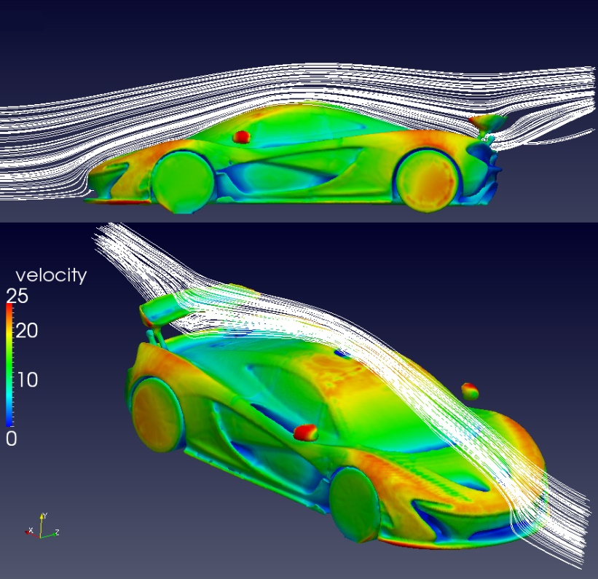
(Figure 2)

Materials
The materials used in the construction of the P1 include:
Aluminium: The suspension system of the McLaren P1 is made of aluminium, a lightweight and strong metal that is commonly used in high-performance sports cars. The use of aluminium helps to reduce the car's weight while providing a high level of structural rigidness and handling performance (McLaren Automotive, n.d.).
Carbon fibre: The P1’s monocoque chassis, body panels, and many other components are made up of carbon fibre which is a strong durable material that can not only withstand high temperatures but is also extremely light making it useful when designing high-performance vehicles.
Titanium: The exhaust system in the McLaren P1 is made of titanium, which is a lightweight and corrosion-resistant metal. The use of titanium in the exhaust system helps to reduce the car's weight while improving its performance and durability
Glass: The windows of the McLaren P1 are made of lightweight and durable glass, which helps to reduce the car's weight while providing a high level of visibility and safety for the driver and passengers. (Top gear series 21)

Innovation
The McLaren P1 is an innovative hypercar that introduced several new features and technologies to the automotive and racing industry.
One being the hybrid power train as the P1 was one of the first hypercars that featured a hybrid powertrain which consisted of a twin-turbo v8 with an electric motor providing 176 horsepower and all together the car is putting out 903 horsepower and 723 Ib-ft of torque
The McLaren p1 also features advanced active aerodynamics, including a rear wing and front splitter that can adjust its angle to increase downforce or reduce drag depending on the driving conditions improving the cars handling and stability at high speeds making it one of the most track-focused street car at its time.
Thirdly, the P1 also featured a lightweight carbon fibre monocoque chassis that was incredibly stiff and strong, allowing for a low curb weight of just 3,075 pounds which combined with the influential hybrid powertrain, this allowed the car to accelerate from 0 to 60 mph in just 2.6 seconds and reach a top speed of 217 mph.
Finally, the P1 was designed with several progressive technologies such as the active suspension system, carbon ceramic brakes, and a Formula 1-inspired Drag Reduction System that reduced drag and increased straight-line speed and overall handling; These features have helped to make the P1 one of the most advanced and track-focused hypercar of its time.
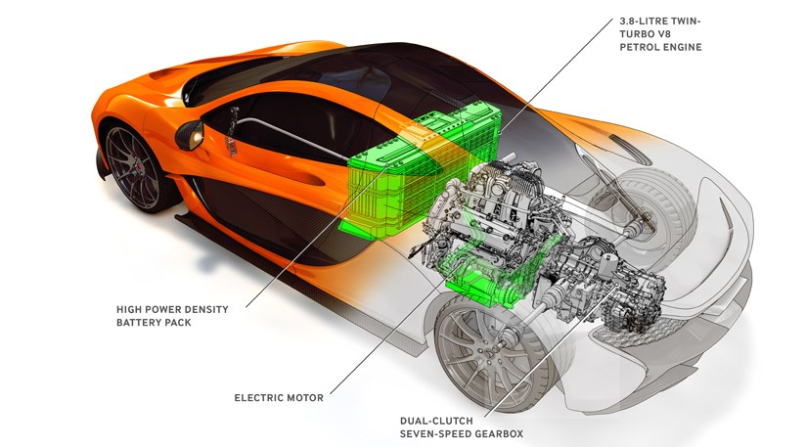
(Figure 3)

Computer-aided design (CAD)
CAD software allows designers and engineers to create a detailed 3D model of the car's exterior and interior as well as individual components and subsystems. This enables them to refine the design and adjust the aerodynamics of the vehicle and to test out various different configurations and materials before building any physical prototypes.
One of the key features of the P1 is its hybrid powertrain where CAD was used extensively in the development of this system, allowing the engineers to simulate the performance of different components and to optimize their parts for as much maximum efficiency as possible.
Another area where CAD played a vital role in the P1's development was in the design of its lightweight carbon fibre chassis. By using CAD, the engineers were able to create a precise model of the chassis, which can then be used to manufacture the final component.

Crash testing
The McLaren P1 underwent various different types of crash testing to ensure its safety and compliance with other international regulations. The car underwent both physical and virtual crash testing during its development process to make sure it was perfect.
In physical crash testing, the McLaren P1 underwent several tests, including frontal impact tests, side impact tests, and rear impact tests. These tests simulated various collision scenarios to evaluate the car's crashworthiness and occupant protection. The car was also subjected to roll-over testing to ensure that it could withstand a roll-over collision.
In addition to physical testing, the McLaren P1 also underwent virtual crash testing using computer simulations. These simulations allowed engineers to evaluate the car's structural integrity and performance in various crash scenarios before any physical testing took place. The virtual crash testing also enabled the engineers to optimize the car's design to improve its crashworthiness and driver protection.

Data analysis
For data analysis, McLaren has used advanced computational fluid dynamics (CFD) ‘‘Harris, lawther and Alderson (2016)’’ simulations to optimize the car's aerodynamics and reduce drag. They have also used data from track testing to tune the car's suspension and handling ability. McLaren has also used extensive track testing to gather data on the vehicles handling and performance. Furthermore, McLaren has used a simulation software to optimize the cars hybrid powertrain for peak performance and efficiency ‘’Ricardo (2014)’’

Current state of the industry
The shift towards electric vehicles poses a significant challenge for the automotive industry. EVs are expected to reach an equivalence in price with gasoline-powered vehicles by 2025. However, the transition to EVs requires a significant amount of time and research, infrastructure development, and manufacturing capacity, which not all car manufacturers are prepared to make. ‘Bloom BergNEF (2020)’
Another challenge for the industry is the increasing demand for connected cars and autonomous driving technology. The market for autonomous cars is expected to grow significantly, with the projected to reach £225 billion by 2025.
The automotive industry must also address sustainability concerns, which is a growing concern for consumers. The automotive industry is responsible for around 8% of global greenhouse gas emissions. Automakers must work to reduce carbon emissions, promote the use of sustainable materials, and invest in renewable energy sources.
At the time of the creation of the McLaren p1 the automotive industry was focused on improving fuel efficiency and reducing emissions to meet increasingly severe environmental regulations; the P1 was designed to address these concerns by incorporating hybrid technology that has allowed for improved fuel efficiency and reduced emissions whilst also being exuberant and thrillful towards the consumer.

Conclusion
In conclusion, the McLaren P1 is a remarkable accomplishment of engineering and design, showcasing the pinnacle of automotive innovation. With its advanced hybrid powertrain, carbon fibre construction, and active aerodynamics; the P1 is a true masterpiece that pushes the boundaries of what's possible in the world of high-performance supercars.
Not only is the P1 incredibly fast and agile on the road, but it also represents a significant step forward in terms of sustainable performance. The hybrid system enables it to achieve impressive fuel efficiency for a car of its class, while also being of lightweight construction and aerodynamic features this further reduces its environmental impact.
Overall, the McLaren P1 is an amazing example of how technology and innovation can be joined to create truly exceptional vehicles that are both thrilling and sustainable for the environment.

References
BloombergNEF. (2020). Electric Vehicle Outlook 2020. https://about.bnef.com/electric-vehicle-outlook/– (Date accessed: 20/04/2023)-
IEA. (2021). Global EV Outlook 2021. https://www.iea.org/reports/global-ev-outlook-2021– (Date accessed: 21/04/2023)
McKinsey & Company. (2021). Automotive & Assembly. https://www.mckinsey.com/industries/automotive-and-assembly/our-insights– (Date accessed: 21/04/2023 )
World Economic Forum. (2020). Driving Sustainability in the Automotive Industry. https://www.weforum.org/reports/driving-sustainability-in-the-automotive-industry – (Date accessed: 21/04/2023)
Top gear series 21 https://www.youtube.com/watch?v=OL_eIZjiLUk – (Date accessed: 20/04/2023)
Harris, M., Lawther, R., & Alderson, R. (2016). The Aerodynamic Development of the McLaren P1™. Journal of Automobile Engineering, 1229-1245 – (Date accessed: 21/04/2023)
McLaren press release (2019 )https://www.ricardo.com/media/yhnbrq5b/ricardo-and-mclaren-renew-engine-supply-agreement.pdf - (Date accessed: 19/04/2023
(Figure 1) https://www.google.com/url?sa=i&url=https%3A%2F%2Fwww.topgear.com%2Fcar-reviews%2Fmclaren%2Fp1&psig=AOvVaw37YOVcd_HyJbBALiiCf0yg&ust=1682356882902000&source=images&cd=vfe&ved=0CBAQjRxqFwoTCOiAwvTBwP4CFQAAAAAdAAAAABAE - (Date accessed: 23/04/2023)
(Figure 3) https://www.google.com/url?sa=i&url=https%3A%2F%2Fwww.carmagazine.co.uk%2Fcar-news%2Ffirst-official-pictures%2Fmclaren%2Fmclaren-p1-2013-powertrain-revealed-with-903bhp-and-electric-driving%2F&psig=AOvVaw0mUsXBfV9m_X67d-47mYoS&ust=1682357476255000&source=images&cd=vfe&ved=0CBAQjRxqFwoTCPj7zY_EwP4CFQAAAAAdAAAAABAE - (Date accessed: 23/04/2023)

(Figure 2) https://www.google.com/url?sa=i&url=https%3A%2F%2Ftwitter.com%2Fgarcfd%2Fstatus%2F543339665483657216&psig=AOvVaw1b5ufx8RFcCIfbKYQzdLU9&ust=1682358152135000&source=images&cd=vfe&ved=0CBAQjRxqFwoTCODL2NHGwP4CFQAAAAAdAAAAABAE - (Date accessed: 23/04/2023)

