
Cloud Engineering Principles and Practice
ACCA7027

11 May 2026
kelly casey
2106451

Contents
1. Introduction 2
2. Principles of Virtualisation. 3
3. Principles and Benefits of Containerisation. 3
4. Images and Publishing Images. 5
5. Container Volumes. 6
6. Container Networking. 7
7. Cloud Computing Concepts. 10
7.1 Load Balancing. 10
7.2 Scalability. 11
7.3 Application Gateways. 12
7.4 Relationship Between Load Balancing and Scalability. 13
7.5 Integration of Load Balancing, Scalability and Application Gateways. 13
8. Serverless Functions and the Expansion of Cloud Computing. 14
8.1 Driving Forces Behind Cloud Computing. 14
8.2 Serverless Functions. 15
8.3 Comparison Between Serverless Functions and Containerisation. 16
9. Conclusion. 17
Appendix 18
Bibliography 18

Introduction
Cloud computing has become a major part of modern computing and is now widely used by organisations to deliver applications and services over the internet instead of relying only on local hardware. Cloud platforms provide access to resources such as storage, networking, servers, and applications, making it easier for businesses to scale systems when needed and reduce infrastructure costs [1].
One of the main technologies that supports cloud computing is containerisation. Containerisation allows applications and all their required files and dependencies to be packaged together into lightweight units called containers. Unlike traditional virtual machines, containers share the host operating system while remaining separate from each other, making them more efficient in terms of performance and resource usage [2]. Docker is one of the most used container platforms and has become a crucial tool for deploying applications in cloud environments.
This report explores the main principles of virtualisation, containerisation, Docker images, container networking, and container volumes within cloud computing. It also looks at wider cloud concepts such as load balancing, scalability, application gateways, and serverless computing. Practical examples completed during lab activities are included throughout the report to show how these technologies work in practice.
As part of the practical work, a multi container Docker application was created using a Harry Potter themed website. The project included a main Hogwarts library page linked to separate house pages running in different Docker containers. This example shows how applications can be split into smaller independent services, like the way many modern cloud computing systems are designed.

Principles of Virtualisation.
Virtualisation is a key technology within cloud computing that allows multiple operating systems and applications to run on the same physical hardware [1]. Instead of using one physical machine for a single operating system, virtualisation uses software called a hypervisor to create multiple virtual machines. Each virtual machine runs independently with its own operating system, applications, and allocated resources [4].
Virtualisation helps organisations make better use of physical hardware by allowing computing resources to be shared across multiple systems. This improves efficiency and reduces the need for large numbers of physical servers. As a result, businesses can lower infrastructure costs while also improving flexibility and scalability within cloud environments.
Figure 1 shows how virtualisation allows multiple virtual machines to run independently while sharing the same physical hardware through a hypervisor layer.
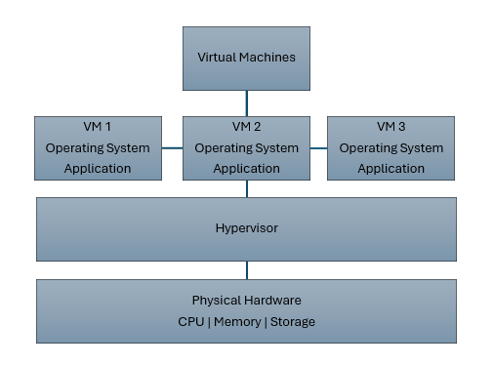
Figure 1. Virtualisation of shared hardware using multiple virtual machines and a hypervisor.

Principles and Benefits of Containerisation.
Containerisation is a lightweight form of virtualisation that allows applications and their dependencies to be packaged together into isolated environments called containers [2]. Unlike traditional virtual machines, containers do not need a full guest operating system because they share the host operating system kernel. This makes containers much more lightweight and efficient, which is one of the reasons they are widely used in cloud computing environments [3].
Docker is one of the most used containerisation platforms and provides tools for building, deploying, and managing containers. Docker containers allow applications to run consistently across different systems because all the required files, dependencies, and configurations are included within the container image.
One of the main advantages of containerisation is portability. Containers can run across different devices and cloud platforms without needing major configuration changes. This makes software deployment more reliable and simplifies development and testing. Containerisation also supports scalability, as additional containers can be created quickly when demand increases.
Another important advantage is isolation. Each container runs independently from other containers on the same host system. This improves reliability and security because issues in one container are less likely to affect other services running on the same infrastructure.
As part of the practical work, Docker was used to create a multi container Hogwarts themed web application. A Dockerfile was created to define the application environment and build a reusable Docker image. Figure 2 shows the Dockerfile used within the project.
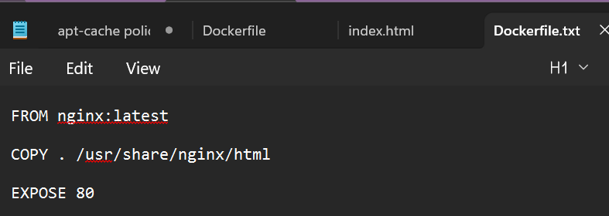
Figure 2. Dockerfile used to build the Hogwarts web application image.
The Dockerfile used the Nginx web server image as the base image and copied the application files into the container directory. Port 80 was then exposed so the application could be accessed through a web browser.
After the Dockerfile was created, the Docker image was built using the docker build command shown in Figure 3.
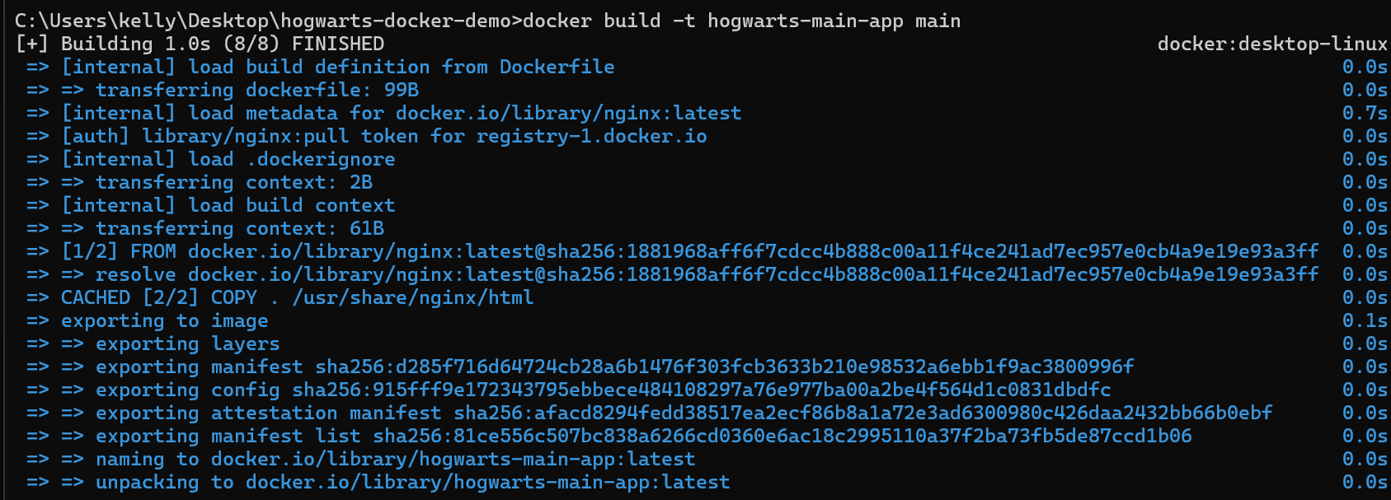
Figure 3. Building a Docker image using the docker build command.

Images and Publishing Images.
Docker images are reusable templates that contain all the files, dependencies, libraries, and configurations needed to run an application consistently across different systems [3]. They are an important part of containerisation because they provide a reliable and standardised way of deploying applications within cloud environments. Once an image has been created, multiple containers can be started from the same image without needing to configure the application again each time.
Docker images are usually created using a Dockerfile, which contains a set of instructions that define the application environment. These instructions can include selecting a base image, copying application files, installing dependencies, and exposing the ports needed for the application to run correctly.
As part of the practical implementation, several Docker images were created for the Hogwarts multi container web application. Separate images were developed for the main application and the individual Hogwarts house pages, allowing each service to operate independently while remaining connected as part of the same overall system. Figure 4 shows the Docker images created during the development process.
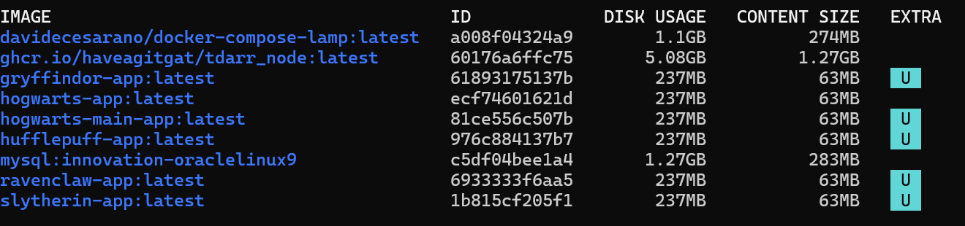
Figure 4. Docker images created for the Hogwarts multi-container application.
Creating multiple Docker images provides several advantages within cloud computing environments. Images can be reused many times, deployed quickly, and scaled more easily when demand increases. Because each image already contains the required application files and configurations, deployment becomes more reliable and reduces compatibility problems between different systems.
Docker images can also be shared through container registries such as Docker Hub. Docker Hub is a cloud-based repository service that allows developers to store, manage, and share container images online [5]. Publishing images to Docker Hub improves portability because applications can be downloaded and deployed onto other systems using a simple docker pull command.
As part of this project, the completed Hogwarts application image was tagged and successfully published to Docker Hub using the docker push command. Figure 5 shows the successful publication of the Docker image to the online registry.
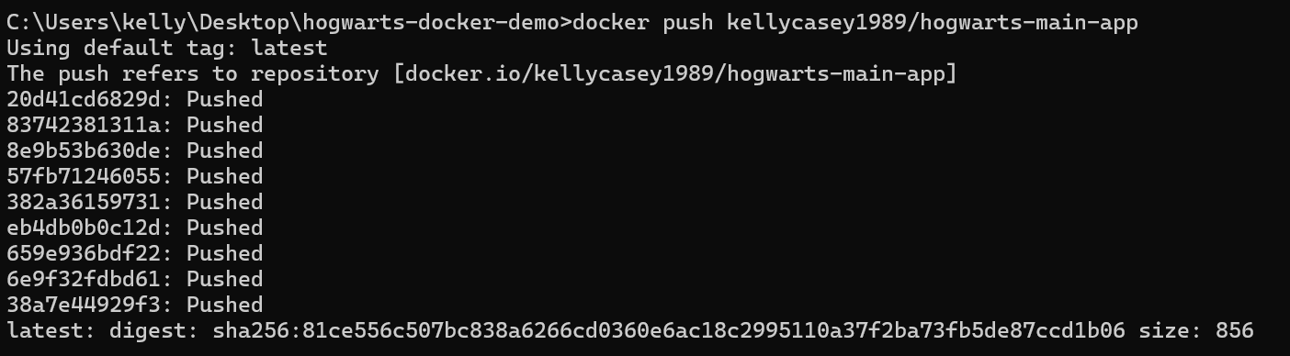
Figure 5. Docker image successfully published to Docker Hub.
Publishing images to Docker Hub demonstrates an important cloud computing principle because applications can be distributed globally without transferring source files manually. This supports scalability, portability, and simplified deployment across different environments. It also enables development teams to collaborate more effectively by sharing standardised application images through a centralised platform.

Container Volumes.
Container volumes provide persistent storage for Docker containers, allowing data to remain available even when containers are stopped, removed, or recreated [6]. Normally, data stored directly inside a container can be lost if the container is deleted. Volumes help solve this issue by storing the data outside of the container itself while still making it accessible when needed.
Volumes are important in cloud computing because many applications need permanent access to data such as databases, configuration files, uploaded files, and other application information. Using volumes improves reliability and helps prevent important data from being lost during updates, failures, or redeployment.
Docker volumes are managed by the Docker engine and can also be shared between multiple containers if required. This makes data management easier and supports scalability within cloud-based environments.
As part of the practical work, a Docker volume called Hogwarts-volume was created using the docker volume create command. Figure 6 shows the Docker volumes created during the project.
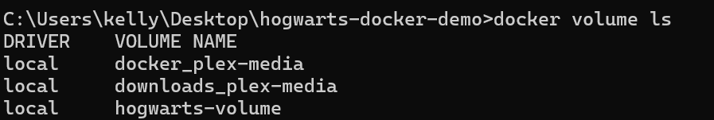
Figure 6. Docker volumes created for persistent container storage.
The created volume was connected to the Hogwarts web application container using the -v option within the docker run command. This allowed the application files and data to remain available independently from the running container itself.
Container volumes provide several important advantages within cloud environments. They improve data persistence, make backups easier to manage, support migration between systems, and provide greater flexibility when scaling applications across multiple containers or servers.

Container Networking.
Container networking allows Docker containers to communicate with each other and with external systems while remaining isolated from the host environment [7]. Networking is an important part of cloud computing because modern applications are often split into smaller independent services that need to exchange information across networks.
Docker includes built in networking features that allow containers to connect through virtual networks. Containers connected to the same network can communicate securely while remaining separated from unrelated services. This supports the development of distributed and microservice based cloud applications.
Container networking also makes it possible to separate applications into smaller services that can run independently. This improves scalability, fault isolation, and overall system management because individual services can be updated or restarted without affecting the entire application.
As part of the practical implementation, a multi container Hogwarts web application was developed using separate Docker containers for the main application and each Hogwarts house page. Each service was assigned its own network port, including:
- Main application: Port 8080
- Gryffindor service: Port 8081
- Slytherin service: Port 8082
- Ravenclaw service: Port 8083
- Hufflepuff service: Port 8084
Figure 7 demonstrates the multiple Docker containers running simultaneously within the Docker environment.
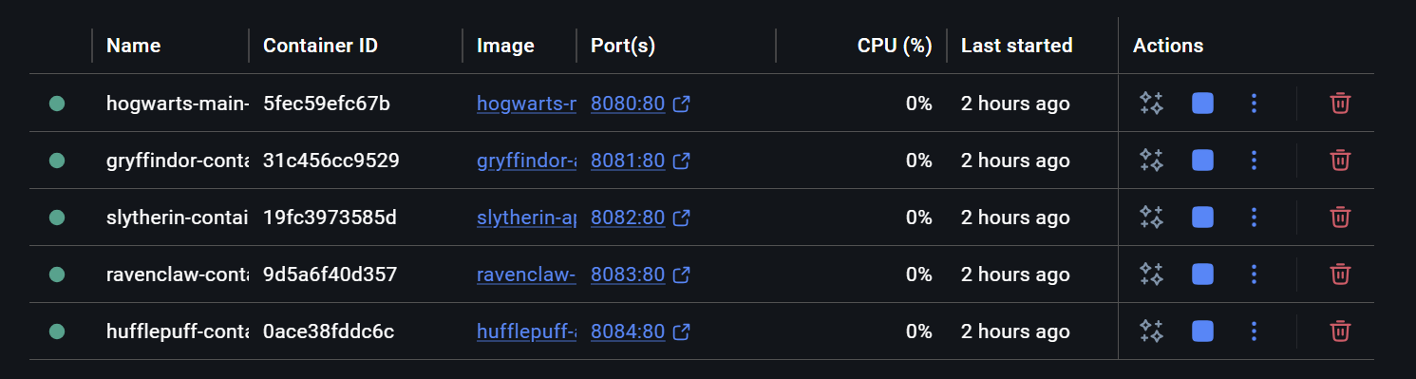
Figure 7. Multiple Docker containers running simultaneously within the Hogwarts application.
The main application page included hyperlinks that allowed users to move between the separate Hogwarts house services. Although each page was running inside its own independent container, the overall application still worked as a single connected system through Docker networking and port mapping.
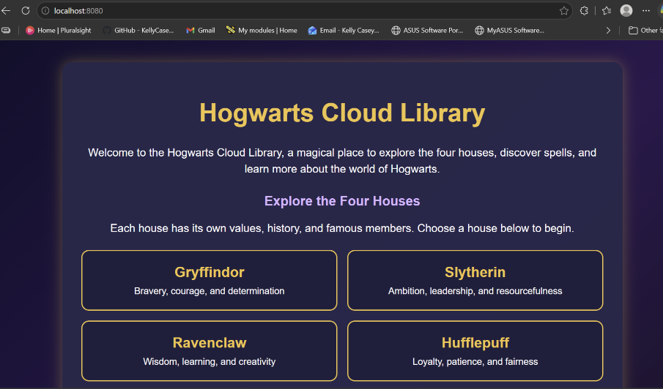
Figure 8(a). Main Hogwarts Cloud Library page.
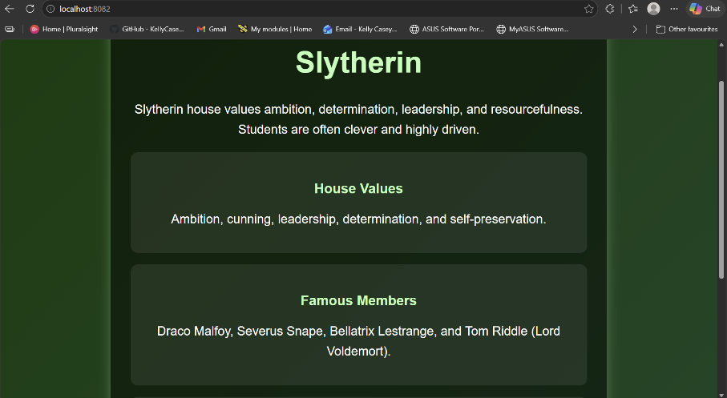
Figure 8(b). Slytherin container service.


Figure 8(c). Gryffindor container service.

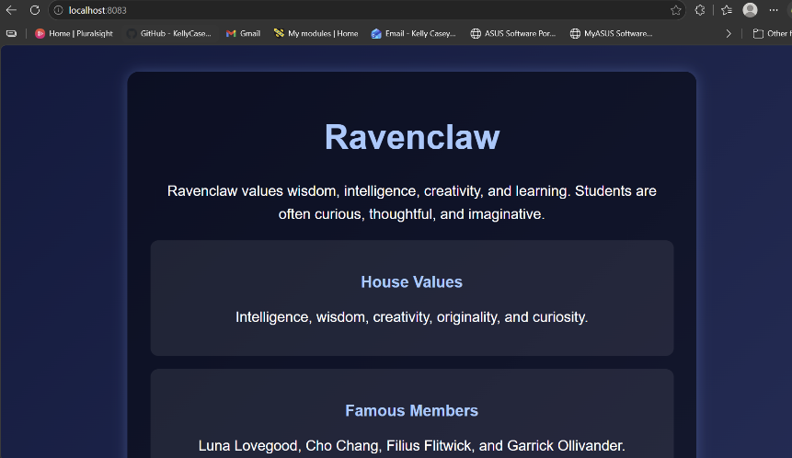
Figure 8(d). Ravenclaw container service.


Figure 8(e). Hufflepuff container service.

Figure 8 (a)–8(e) shows the navigation between multiple independently running Hogwarts container services.

This practical implementation demonstrates principles like the microservice architectures commonly used in cloud computing environments. By separating services into independent containers, applications become easier to scale, maintain, and manage. If one service fails or needs updating, the other services can continue running without interruption.
Container networking provides several important advantages within cloud systems, including improved scalability, simpler deployment, better fault isolation, and more efficient resource management. These features make container networking well suited to modern cloud native applications.

Cloud Computing Concepts.
Load balancing, scalability, and application gateways are widely used within cloud computing to help applications remain reliable, secure, and responsive when handling different levels of user demand [8],[9],[10]. Modern cloud providers such as AWS and Azure commonly combine these technologies to help applications remain reliable and available during periods of high demand.

Load Balancing.
Load balancing is the process of distributing incoming network traffic across multiple servers or application instances [8]. This helps stop one server from becoming overwhelmed while also improving performance and reducing the risk of downtime. If one server becomes unavailable, traffic can be automatically redirected to other working servers, helping to reduce downtime and improve fault tolerance.
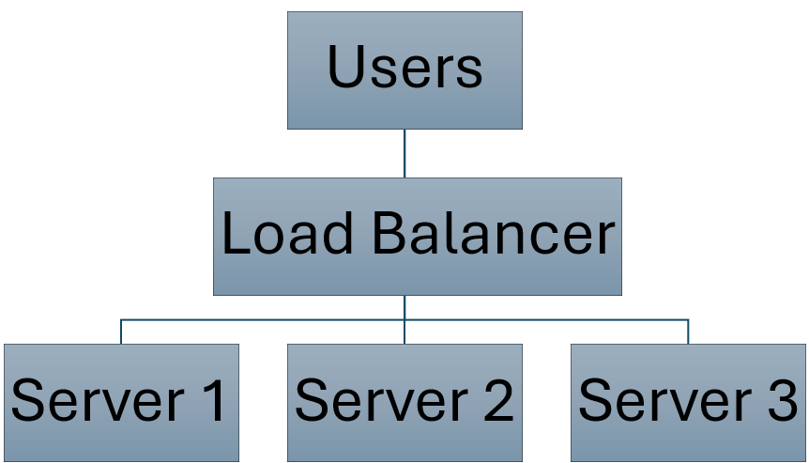
Figure 9. Load balancing distributes traffic across multiple servers.

Cloud providers such as Amazon Web Services use services like Elastic Load Balancing to distribute incoming traffic across multiple servers automatically. This helps prevent a single server from becoming overloaded and improves the overall performance and reliability of cloud applications. In Amazon Web Services, traffic is often distributed across multiple Amazon EC2 instances. EC2 instances are virtual servers hosted in the cloud that organisations can use to run applications and services without needing their own physical hardware [8].
Microsoft Azure offers similar functionality through Azure Load Balancer, which distributes traffic across virtual machines and cloud services. This helps applications remain available and responsive, even when large numbers of users are accessing them at the same time [8].
Load balancing is especially important for cloud-based web applications because it helps maintain stable performance during periods of high demand. By spreading traffic across multiple systems, applications are less likely to slow down or fail if one server experiences issues. As a result, applications are more stable and users are less likely to experience slow loading times or service interruptions.

Scalability.
Scalability refers to the ability of a cloud system to increase or reduce computing resources depending on demand [9]. In cloud computing, applications can be scaled by adding more servers, virtual machines, or containers when workloads increase, and reducing resources again when demand becomes lower. This allows organisations to keep applications running smoothly without paying for unnecessary resources all the time.
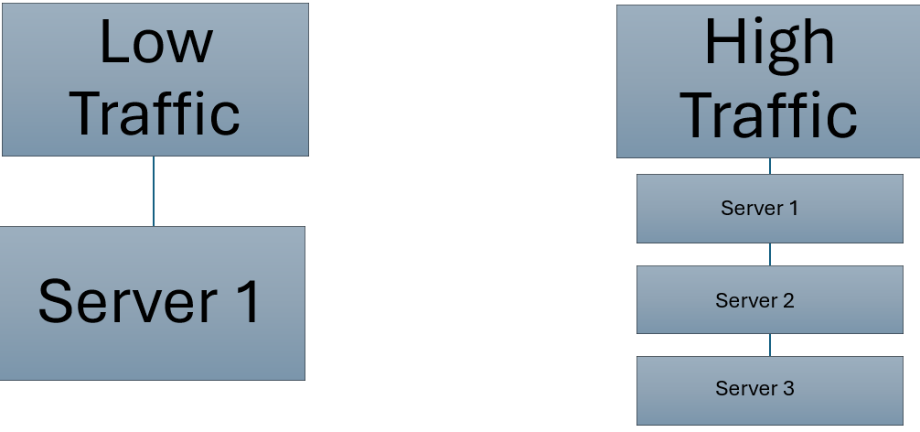
Figure 10. Horizontal scalability increases resources during periods of high demand.
There are two main forms of scalability, vertical scaling, and horizontal scaling. Vertical scaling increases the resources available to a single server, such as memory or processing power. Horizontal scaling increases the number of servers or application instances used to handle workloads. In cloud computing, horizontal scaling is often preferred because it improves both performance and reliability by distributing traffic across multiple systems.
Cloud providers such as Amazon Web Services use services like AWS Auto Scaling to automatically increase or reduce resources depending on application demand. Microsoft Azure provides similar functionality through Virtual Machine Scale Sets, which can automatically adjust the number of virtual machines being used [9].
One of the biggest advantages of cloud computing is that resources can quickly be increased during busy periods and reduced again when demand becomes lower. This improves flexibility while helping organisations avoid unnecessary infrastructure costs.

Application Gateways.
Application gateways sit between users and cloud services, helping control incoming traffic while also improving security and routing requests to the correct backend services [10]. They operate at the application layer of the OSI model and are commonly used to inspect, filter, and direct HTTP and HTTPS traffic within cloud computing environments.
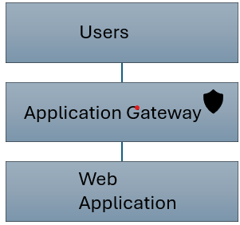
Figure 11. Application gateways manage and secure traffic between users and cloud services.
Application gateways provide several key features, including SSL termination, intelligent traffic routing, session management, and Web Application Firewall protection. SSL termination helps manage encrypted traffic more efficiently, while traffic routing ensures requests are directed to the correct backend services. Web Application Firewall protection helps block malicious traffic and common web attacks before they reach the application itself.
Cloud providers such as Microsoft Azure offer services like Azure Application Gateway, which allows organisations to securely manage and route incoming traffic to backend cloud services. Amazon Web Services provides similar functionality through Application Load Balancer and Amazon Web Services Web Application Firewall [10].
Application gateways play a significant role in cloud security because they help filter harmful requests before they reach backend systems. They also improve traffic management by directing requests to the appropriate backend services based on application requirements. Because of this, application gateways are now commonly used within modern cloud environments.

Relationship Between Load Balancing and Scalability.
Load balancing and scalability are closely linked because they work together to improve the performance, reliability, and availability of cloud applications [8], [9]. Scalability allows cloud systems to increase or reduce resources depending on workload demand, while load balancing ensures incoming traffic is spread evenly across those resources.
If additional servers are added without load balancing, too much traffic could still be directed to a single server while others are underused. On the other hand, load balancing alone cannot improve performance if there are not enough servers or resources available to handle increased demand. When combined, these technologies help cloud systems deal with changing workloads more effectively while keeping performance stable for users.
Cloud providers such as Amazon Web Services and Microsoft Azure commonly combine auto scaling services with load balancing technologies to create systems that are more reliable and fault tolerant. This helps improve resource usage, reduce downtime, and provide users with more consistent online services.

Integration of Load Balancing, Scalability and Application Gateways.
Combining load balancing, scalability, and application gateways helps create cloud environments that are more reliable, secure, and efficient [8],[9],[10]. Each technology has a different role, but together they help maintain stable performance, improve security, and manage resources more effectively.
Load balancing spreads incoming traffic across multiple servers, scalability adjusts resources based on demand, and application gateways securely manage traffic between users and backend services. When combined, these technologies help reduce downtime and improve fault tolerance during periods of high traffic or server failure.
For example, an e commerce website hosted in the cloud could use an application gateway to filter harmful traffic, a load balancer to distribute users across multiple servers, and auto scaling services to increase resources during busy shopping periods. Using these technologies together improves performance, reliability, and the overall user experience.
Cloud providers such as Amazon Web Services and Microsoft Azure widely use these technologies because they support cloud native systems that can handle large workloads efficiently.

Serverless Functions and the Expansion of Cloud Computing.
Cloud computing has expanded rapidly as organisations look for more flexible and cost-effective ways to run applications and store data [11]. Many businesses now rely on cloud technologies to reduce infrastructure costs, improve accessibility, and support changing workloads more efficiently. Modern cloud platforms now offer a wide range of services that make it easier to deploy and manage applications without relying heavily on physical hardware.
The practical implementation completed during this project demonstrated several of these cloud computing benefits using Docker containerisation and cloud-based image hosting. Publishing the Hogwarts application image to Docker Hub showed how cloud technologies support portable and reusable application deployment across different systems and environments.
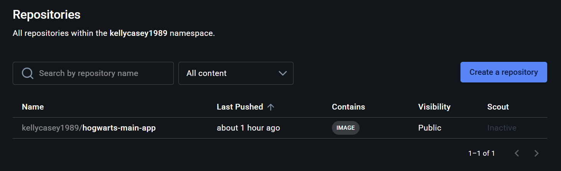
Figure 12. Docker image hosted within the Docker Hub cloud registry.

Driving Forces Behind Cloud Computing.
Several factors have contributed to the rapid growth of cloud computing, including reduced costs, flexibility, scalability, accessibility, and improved resource management [11]. Traditional computing infrastructures often require organisations to purchase and maintain expensive physical hardware, which can lead to high operational and maintenance costs. Cloud computing helps reduce these costs by allowing organisations to use computing resources only when they are needed.
One of the biggest advantages of cloud computing is flexibility. Cloud platforms allow organisations to deploy applications quickly, adjust resources depending on demand, and support access from different locations. This makes it easier for businesses to respond to changing workloads and customer needs without making major infrastructure changes.
Scalability is another important benefit. Cloud providers allow resources to be increased or reduced depending on workload demand, helping improve both performance and cost efficiency [9]. This means organisations do not need to permanently maintain expensive infrastructure that may only be needed during busy periods.
Cloud computing also improves accessibility and collaboration because applications and services can be accessed through the internet from different devices and locations. This has become especially important with the increase in remote working and globally distributed services.
The practical implementation completed during this project demonstrated several of these cloud computing benefits using Docker containerisation, reusable images, and multi container deployment. The ability to quickly deploy and manage multiple independent services showed the flexibility and scalability provided by modern cloud technologies.

Serverless Functions.
Serverless computing, also known as Functions as a Service, is a cloud computing model where the cloud provider automatically manages the infrastructure needed to run application code [12]. Instead of managing physical servers or virtual machines themselves, developers can deploy small functions that only run when triggered by specific events or requests.
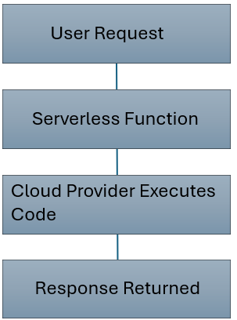
Figure 13. Basic workflow of serverless function execution within cloud computing.

Serverless platforms automatically provide computing resources when functions are triggered and release those resources once execution has finished. This means developers can spend more time working on the application itself instead of managing infrastructure and server maintenance.
Cloud providers such as Amazon Web Services offer AWS Lambda, while Microsoft Azure provides Azure Functions. These services allow developers to build event driven applications that can automatically respond to actions such as API requests, database updates, or file uploads.
One of the main advantages of serverless computing is cost efficiency because organisations only pay for the time the function is running, rather than paying for servers that run continuously. Serverless computing also improves scalability because the cloud provider can automatically scale functions depending on workload demand.
However, there are some limitations. Serverless functions may have execution time limits, delays when functions start running, and less control over the underlying infrastructure. Even with these limitations, serverless computing has become very popular for lightweight cloud applications and event-driven services.

Comparison Between Serverless Functions and Containerisation.
Serverless computing and containerisation are both modern approaches used in cloud computing to improve flexibility, scalability, and deployment efficiency, although they are designed for different purposes [11], [12]. Both reduce the need for organisations to manage large physical infrastructures and make it easier to deliver scalable cloud-based services.
Containerisation technologies such as Docker package applications and their dependencies into isolated containers that can run consistently across different systems and cloud environments. Containers give developers more control over the application environment and are commonly used for long running services, custom configurations, and microservice based applications.
Serverless computing takes a different approach. Instead of managing servers or containers, developers deploy small functions that only run when triggered by events or requests. The cloud provider automatically handles the infrastructure, scaling, and resource management, allowing developers to focus more on the application itself.
Both approaches support scalability and allow cloud applications to respond to changing demand more efficiently. Containerised applications and serverless functions can both scale automatically depending on workload demand. They also improve flexibility and resource efficiency compared to traditional on premises systems.
Even though they share some similarities, they are designed for different types of workloads and application requirements. Containerisation provides more control because developers manage the container environment directly, while serverless computing removes most infrastructure management completely. Containers are usually more suitable for larger or continuously running applications, whereas serverless functions are better suited to smaller event driven tasks.
The practical implementation completed during this project demonstrated several advantages of containerisation using Docker images, multi container deployment, Docker networking, and Docker Hub image publishing. The project showed how containerisation supports portability, modular application design, and scalable cloud native architectures.
Overall, both technologies now play a key role within modern cloud computing because they improve flexibility, deployment speed, and resource efficiency.

Conclusion.
This report explored the importance of virtualisation, containerisation, and cloud infrastructure technologies within modern cloud computing environments. It showed how technologies such as Docker support portable, scalable, and efficient application deployment using containers, images, volumes, and networking.
The Hogwarts Docker project helped demonstrate these concepts through the development of a multi-container web application using separate services and containers. Separate Docker containers were used to host independent services, while Docker networking, volume management, and Docker Hub image publishing demonstrated important cloud computing principles in practice.
The report also examined the role of load balancing, scalability, application gateways, and serverless computing within cloud environments. These technologies improve performance, reliability, security, flexibility, and resource management within modern cloud native systems.
Overall, cloud computing continues to expand because organisations need systems that are flexible, scalable, and easier to manage. The practical work completed during this project demonstrated how technologies such as Docker containerisation can be used to create scalable and modular applications suitable for modern cloud environments.

Appendix
Video Demonstration Link
https://www.youtube.com/watch?v=JdgHneQ3zzg

Bibliography
[1] M. Armbrust et al., “A view of cloud computing,” Communications of the ACM, vol. 53, no. 4, pp. 50–58, 2010. doi: 10.1145/1721654.1721672.
[2] Docker, “What is a container?,” Docker Resources. Accessed: May 10, 2026. [Online]. Available: https://www.docker.com/resources/what-container/
[3] Docker Docs, “Docker overview,” Docker Documentation. Accessed: May 10, 2026. [Online]. Available: https://docs.docker.com/get-started/docker-overview/
[4] VMware, “Server virtualization,” VMware Topics. Accessed: May 10, 2026. [Online]. Available: https://www.vmware.com/topics/server-virtualization
[5] Docker Hub, “Docker Hub repositories,” Docker Hub. Accessed: May 10, 2026. [Online]. Available: https://hub.docker.com/
[6] Docker Docs, “Persisting container data,” Docker Documentation. Accessed: May 10, 2026. [Online]. Available: https://docs.docker.com/get-started/docker-concepts/running-containers/persisting-container-data/
[7] Docker Docs, “Docker Engine networking,” Docker Documentation. Accessed: May 10, 2026. [Online]. Available: https://docs.docker.com/engine/network/
[8] Amazon Web Services (AWS), “What is load balancing?,” AWS. Accessed: May 10, 2026. [Online]. Available: https://aws.amazon.com/what-is/load-balancing/
[9] Microsoft Learn, “Autoscale overview in Azure Monitor,” Microsoft Learn. Accessed: May 10, 2026. [Online]. Available: https://learn.microsoft.com/en-us/azure/azure-monitor/autoscale/autoscale-overview
[10] Microsoft Learn, “What is Azure Application Gateway?,” Microsoft Learn. Accessed: May 10, 2026. [Online]. Available: https://learn.microsoft.com/en-us/azure/application-gateway/overview
[11] Amazon Web Services (AWS), “What is cloud computing?,” AWS. Accessed: May 10, 2026. [Online]. Available: https://aws.amazon.com/what-is-cloud-computing/
[12] Amazon Web Services (AWS), “Serverless computing on AWS,” AWS. Accessed: May 10, 2026. [Online]. Available: https://aws.amazon.com/serverless/

