The Guardian
Chloe Fowler
Thu 8 Dec 2022
Love through the ages is the best phrase that describes UWTSD’s production of LovePlay written by the playwright Moira Buffini. Third year acting students performed this production on
Wednesday 30th November 2022 and it was an interesting take on a
play that was first published in 2001. The play was about love
and sex and how it has developed through time. Some mature scenes took place but were very well balanced with moments of comedy.
A perfect blend of light and shade.
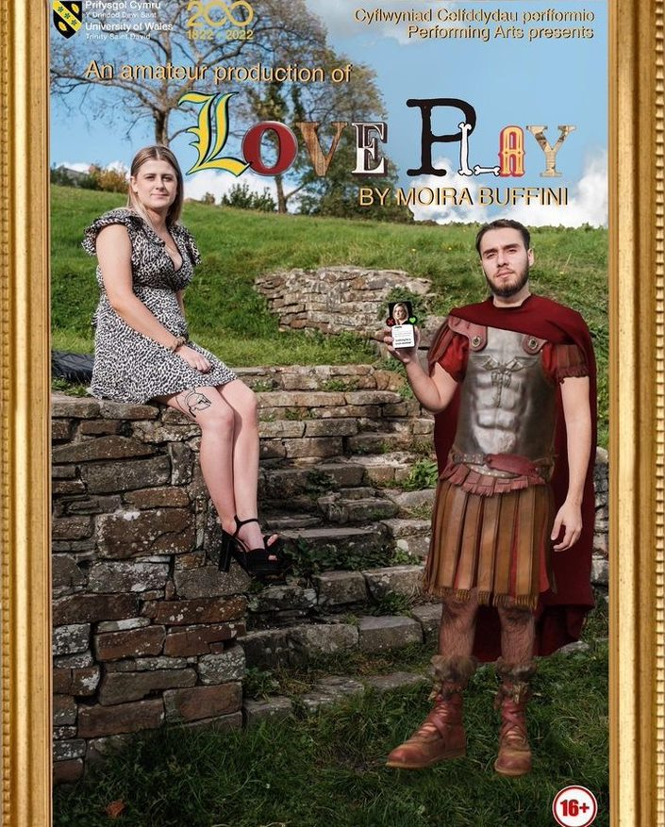
Themes of the play included love, time, relationships and the
link between sex, love and consent. The play was detailed and ridden with the theme of hierarchy and religion. The comedy elements of
this piece was tremendously timed and did not overshadow the other more delicate themes which implies that the company
worked hard on each element of the play and how they took care of the script and the plot lines included. However, I did
find that when watching those comedic moments some
of the actors were more confident and comfortable than
others which did affect the company feel of the performance at times as some performers were weaker, and it was visible.

The stage was set up in a thrust style with one main structure at its centre which had steps leading to the floor which was an open space for scenes and transitions to take place. This structure was the focal point of the whole production and was so cleverly used as it was very adaptable. Throughout the scenes it was transformed into an office, a bedroom, a temple and even a construction site for a Roman toilet. The space was flexible for all the time periods that were included, and it gave every scene a link to the one before. I think this was a brave choice of repetition, but it worked. Each change of scene had its own transition where every single member of the cast was involved. There was music and a prominent use of phones to mimic the action of swiping right on a dating app, the phone’s screen was displayed on two small projection screens that had photos of men and women for that time period. The mix of modern technology and history was not only a genius idea from the playwright, but the production and execution of the idea was fantastic.

A scene that stood out from the rest was a scene where there was a character playing a minister and he was visiting an old school friend and was trying to seek help and guidance but wouldn’t verbally ask. This scene was unique because the tension that was built between the two actors was remarkable to watch and was engaging. The set for that scene was simplistic so all the focus was on the actors which was beautiful to see. The relationships between cast members throughout was impressive in scenes with two characters or the whole company. Actor, (Charla Marie Grace) said that the company felt “United and adaptable” which was the exact impression it gave off to the audience.
In addition, throughout this play there were some serious, difficult scenes as one actor described it as “A rigorous process but we handled it with maturity.” (Romario Buzi.) Overall, this play was a delight to watch.

Bibliography
- Pavis, P. (1985) “Theatre Analysis: Some Questions and a Questionnaire,” New Theatre Quarterly. Cambridge University Press. Available at: Theatre Analysis: Some Questions and a Questionnaire (uwtsd.ac.uk) )Assessed at: 8/12/2022)

- Croggon, Alison. "How to Think Like a Theatre Critic." Theatre Criticism: Changing Landscapes. By Duška Radosavljevi. London: Bloomsbury Methuen Drama, 2016. 309–311. Bloomsbury Collections. Available at: 31631.indb (uwtsd.ac.uk) (Assessed at: 8/12/2022)

- Photo taken from UWTSD LovePlay Instagram https://instagram.com/uwtsdloveplay?igshid=YmMyMTA2M2Y=

