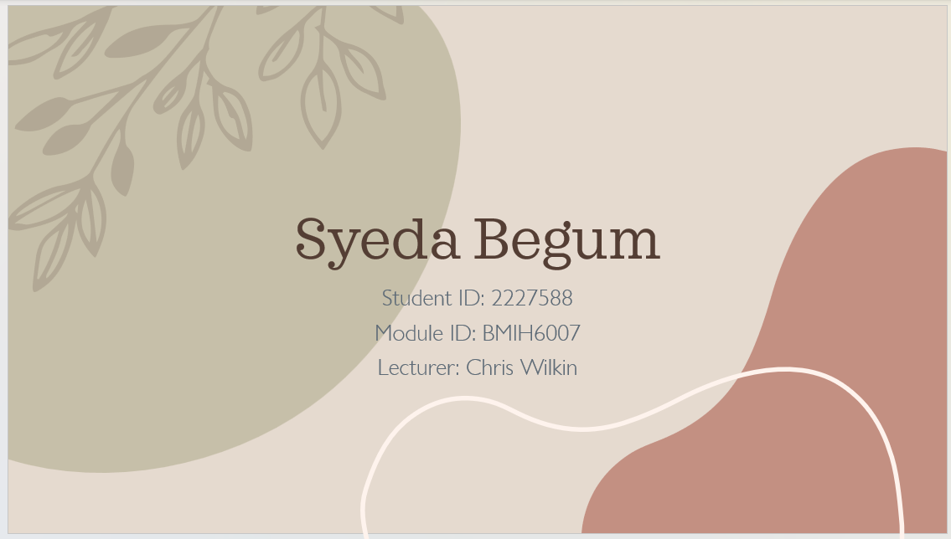

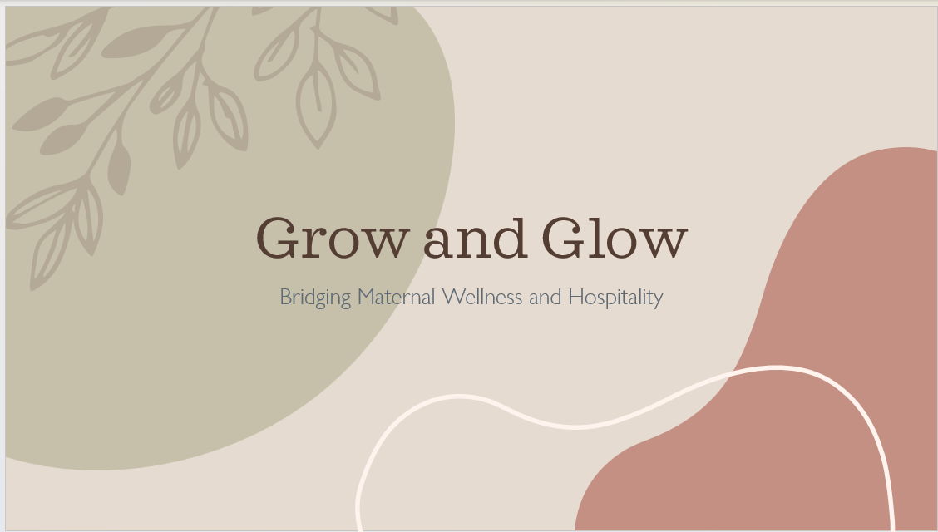

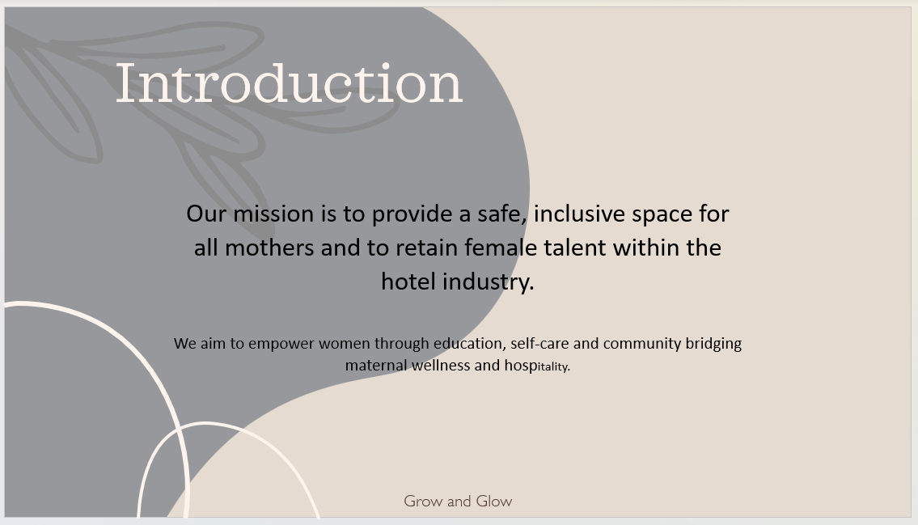

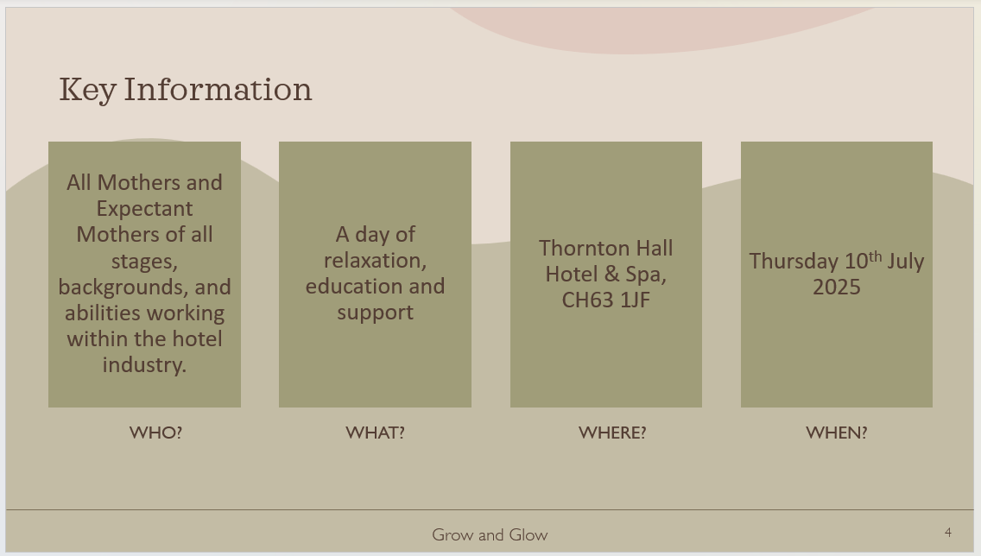

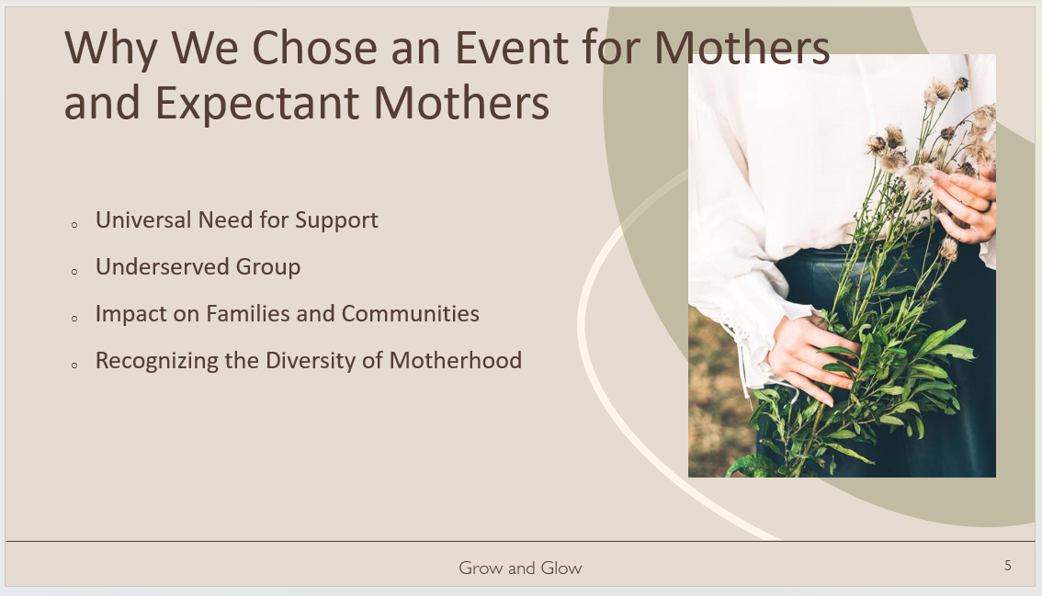

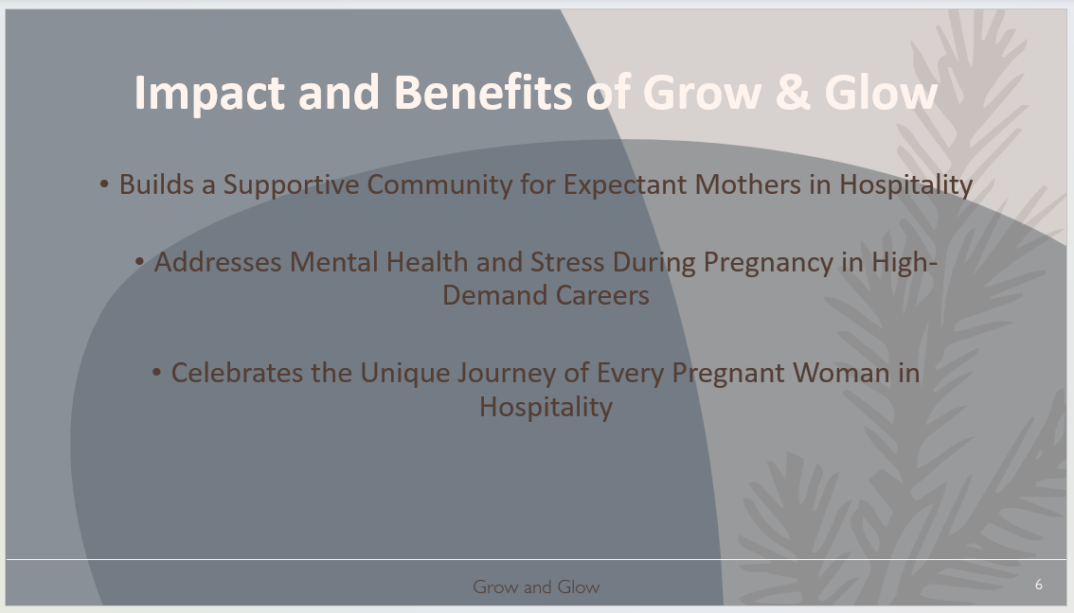

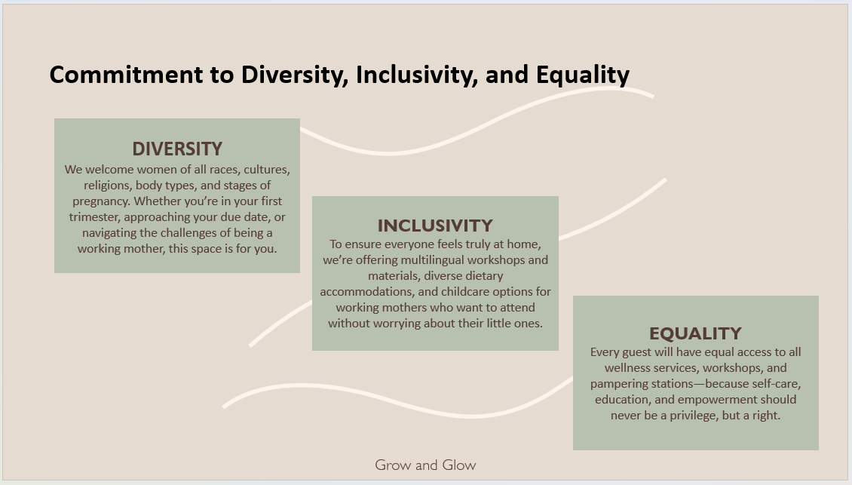

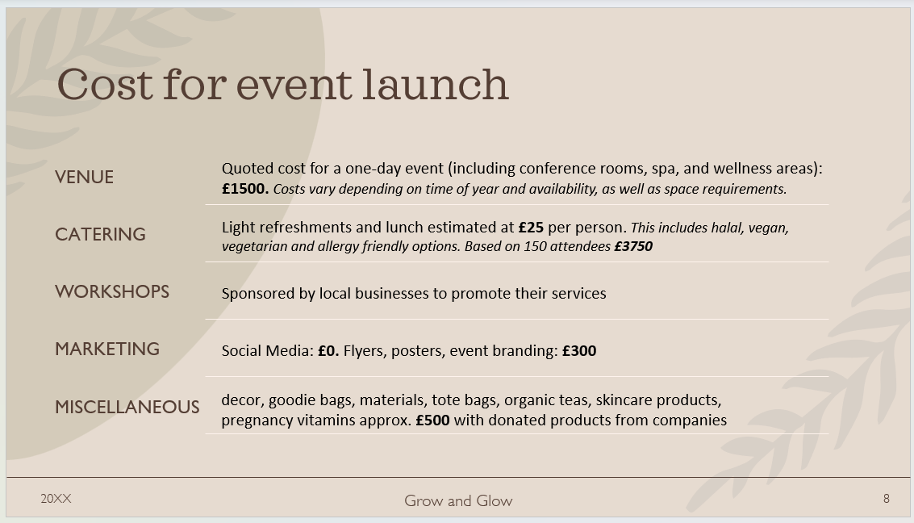

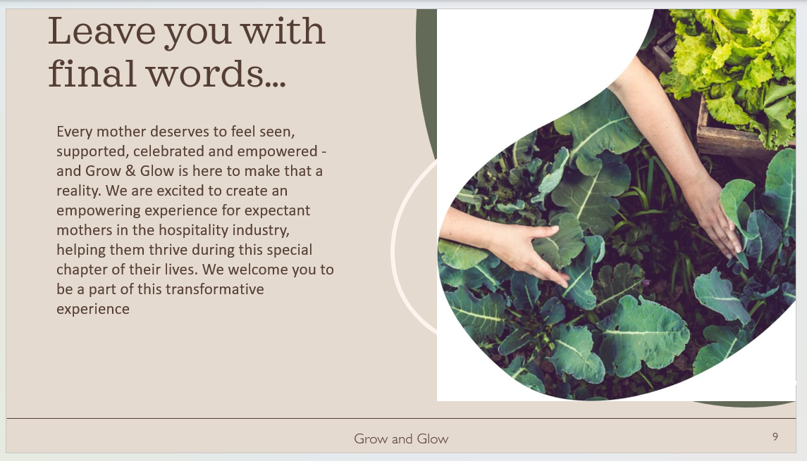

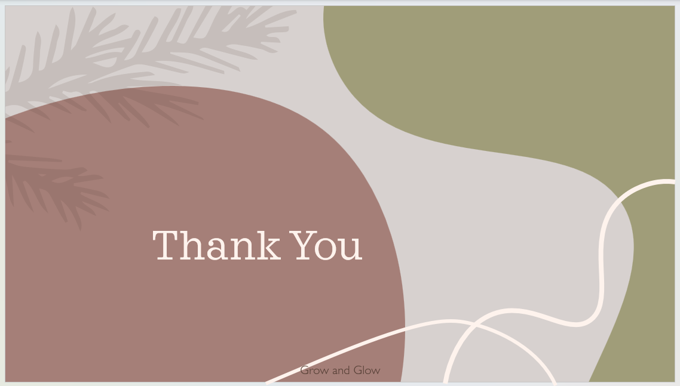

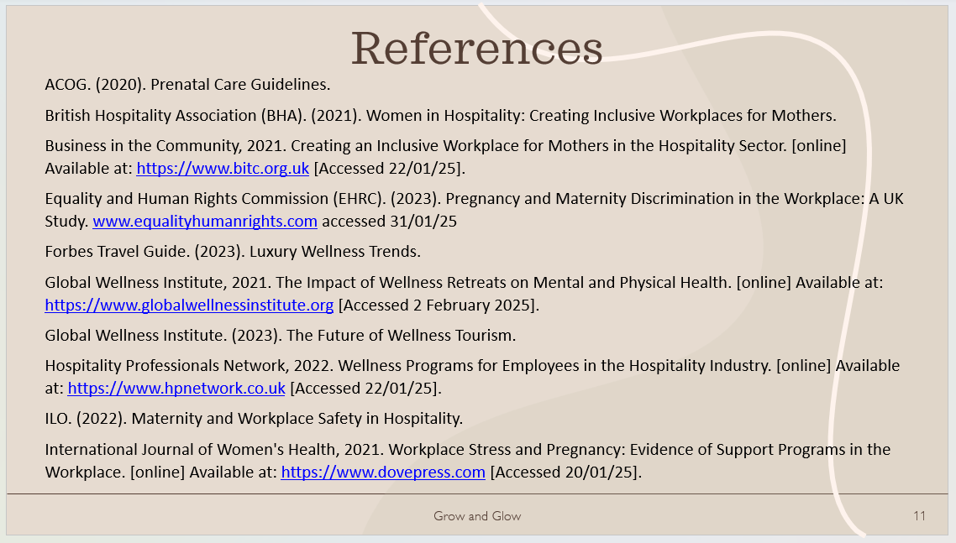

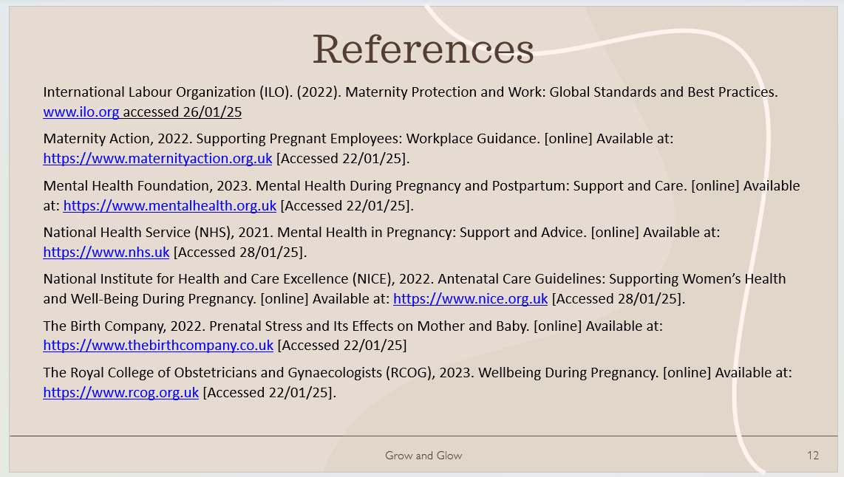

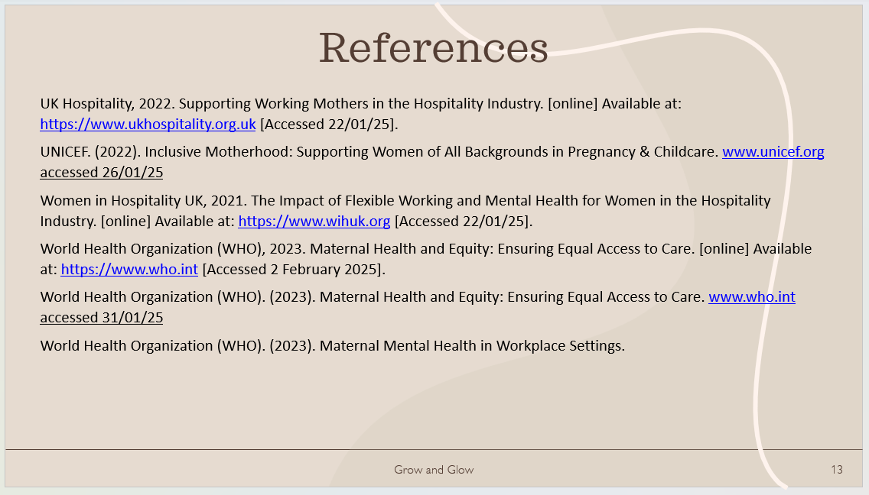

References
ACOG. (2020). Prenatal Care Guidelines.
British Hospitality Association (BHA). (2021). Women in Hospitality: Creating Inclusive Workplaces for Mothers.
Business in the Community, 2021. Creating an Inclusive Workplace for Mothers in the Hospitality Sector. [online] Available at: https://www.bitc.org.uk [Accessed 22/01/25].
Equality and Human Rights Commission (EHRC). (2023). Pregnancy and Maternity Discrimination in the Workplace: A UK Study. www.equalityhumanrights.com accessed 31/01/25
Forbes Travel Guide. (2023). Luxury Wellness Trends.
Global Wellness Institute, 2021. The Impact of Wellness Retreats on Mental and Physical Health. [online] Available at: https://www.globalwellnessinstitute.org [Accessed 2 February 2025].
Global Wellness Institute. (2023). The Future of Wellness Tourism.
Hospitality Professionals Network, 2022. Wellness Programs for Employees in the Hospitality Industry. [online] Available at: https://www.hpnetwork.co.uk [Accessed 22/01/25].
ILO. (2022). Maternity and Workplace Safety in Hospitality.
International Journal of Women's Health, 2021. Workplace Stress and Pregnancy: Evidence of Support Programs in the Workplace. [online] Available at: https://www.dovepress.com [Accessed 20/01/25].
International Labour Organization (ILO). (2022). Maternity Protection and Work: Global Standards and Best Practices. www.ilo.org accessed 26/01/25
Maternity Action, 2022. Supporting Pregnant Employees: Workplace Guidance. [online] Available at: https://www.maternityaction.org.uk [Accessed 22/01/25].
Mental Health Foundation, 2023. Mental Health During Pregnancy and Postpartum: Support and Care. [online] Available at: https://www.mentalhealth.org.uk [Accessed 22/01/25].
National Health Service (NHS), 2021. Mental Health in Pregnancy: Support and Advice. [online] Available at: https://www.nhs.uk [Accessed 28/01/25].
National Institute for Health and Care Excellence (NICE), 2022. Antenatal Care Guidelines: Supporting Women’s Health and Well-Being During Pregnancy. [online] Available at: https://www.nice.org.uk [Accessed 28/01/25].
The Birth Company, 2022. Prenatal Stress and Its Effects on Mother and Baby. [online] Available at: https://www.thebirthcompany.co.uk [Accessed 22/01/25]
The Royal College of Obstetricians and Gynaecologists (RCOG), 2023. Wellbeing During Pregnancy. [online] Available at: https://www.rcog.org.uk [Accessed 22/01/25].
UK Hospitality, 2022. Supporting Working Mothers in the Hospitality Industry. [online] Available at: https://www.ukhospitality.org.uk [Accessed 22/01/25].
UNICEF. (2022). Inclusive Motherhood: Supporting Women of All Backgrounds in Pregnancy & Childcare. www.unicef.org accessed 26/01/25
Women in Hospitality UK, 2021. The Impact of Flexible Working and Mental Health for Women in the Hospitality Industry. [online] Available at: https://www.wihuk.org [Accessed 22/01/25].
World Health Organization (WHO), 2023. Maternal Health and Equity: Ensuring Equal Access to Care. [online] Available at: https://www.who.int [Accessed 2 February 2025].
World Health Organization (WHO). (2023). Maternal Health and Equity: Ensuring Equal Access to Care. www.who.int accessed 31/01/25
World Health Organization (WHO). (2023). Maternal Mental Health in Workplace Settings.

