DECLARATION

This work has not previously been accepted in substance for any degree and is not being concurrently submitted in candidature for any degree

Signed……………………………………………

Date………………………………………………

STATEMENT 1
This dissertation is being submitted in partial fulfilment of the requirements for the degree of BA.

Signed…………………………………………….

Date………………………………………………

STATEMENT 2
This dissertation is the result of my own independent work/investigation, except where otherwise stated.

Other sources are acknowledged by footnotes giving explicit references. A bibliography is appended.

Signed……………………………………………

Date………………………………………………

STATEMENT 3
I hereby give consent for my dissertation, if accepted, to be available for photocopying and for interlibrary loan, and for the title and summary to be made available to outside organisations.

Signed………………………………………………

Date…………………………………………………

STATEMENT 4

I hereby give consent for my dissertation, if accepted, to be available on the university’s IT system to those who have consent to use the system.

Signed………………………………………………

Date…………………………………………………

Is the system failing our farmers; Suicide and Mental health in United Kingdom Agriculture with reference to other countries?

Catrin Boulton

1602533

Acknowledgements

I would like to show gratitude to my Fiancé Dafydd and my two wonderful daughters Caitlyn and Naomi and include my extended family in the support they have given me throughout my journey at UWTSD.
I would like to thank Fran for being #1 TP and being my rock.
Thankyou for the support from my lecturers, and Ben my supervisor.

Abstract

This dissertation focuses on the high rate of suicide within farming and the associated rural/ agricultural sector. Farmers in England and Wales statistically have one of the highest rates of suicide in any occupational group, although it is unclear if this due to poor mental health or the inability of help-seeking or support provision. Analysis of the data will be undertaken to ascertain the key factors in both mental health and associated rates of suicide and the causal links examined. To fully understand the reasons for the statistical peak in male suicides within agriculture and farming, a broad understanding of a range of factors will first be considered. The key questions to be addressed within this Dissertation will be; Is there a higher rate of poor mental health occurrence within this occupational sector ; Are there issues in the underreporting of psychological problems ; If not, what are the factors driving the continued high rate of male suicide. The research approach chosen to assist in answering the research question will be based around an extensive literature search and review. This review has been defined and structured in conjunction with a thematic analysis which ultimately will seek to refine and answer the research question. Focuses on the four core themes deemed most relevant and appropriate to assist in answering and informing the research question. Furthermore, whilst the four themes can be analysed and discussed individually the links between them will also be examined. The research is clear that the high suicide rate in farmers is of concern and more importantly, appears to show little reduction over the timeline addressed in this dissertation. The fact that there is a downward trend in overall suicide within the UK, yet that is not mirrored within agriculture is concerning. The research clearly shows that a major issue is that of help-seeking by the male agricultural. The results show no discernable link between high suicide rates and rate of psychiatric morbidity. Recommendations are made based on the conclusions.

Contents
Acknowledgements 4
Abstract 5
Chapter One 7
1.Introduction 7
1.1 Context 7
1.2 Background 8
1.2.1 Suicide 8
1.2.2 Mental Health 9
1.3 Justification 10
1.4 Aim and Objectives 12
Chapter Two 13
2.1 Methods 13
2.2 Literature search 13
2.3 Keywords 14
2.4 Thematic Analysis and Systematic Review 16
2.5 Research Themes 17
2.6 Ethics 17
Chapter Three 19
3.Literature review 19
3.1 External factors as stressors in Farming and farmers 19
3.2 Suicide within farming and agriculture 20
3.3 The link between mental health and suicide (again within the farming/ agricultural context) 23
3.4 Help-Seeking and Stigma with reference to generational differences 24
Chapter Four 26
4. Discussion, Conclusions and Recommendations 26
4.1 Discussion 26
4.2 Help initiatives and support networks 29
4.3 Conclusion 31
4.4 Recommendations 32
References 33
Bibliography 37
Appendix I 39
Appendix II 41
Appendix III 47

Chapter One

1.Introduction

1.1 Context

This dissertation focuses on the high rate of suicide within farming and the associated rural/ agricultural sector as one in three of the population live in rural areas in Wales agree Mental Health Foundation (2016) and National Health Service Wales (NHS) (2018). Farmers in England and Wales statistically have one of the highest rates of suicide in any occupational group, although it is unclear if this due to poor mental health or the inability of help-seeking or support provision. Analysis of the data will be undertaken to ascertain the key factors, in both mental health and associated rates of suicide and the causal links examined.
The high rate of suicide of farmers within the United Kingdom (UK) is echoed in many other first world countries (such as, Australia, New Zealand, USA). The reasons that cause the statistical peak appear at first glance unclear. This alone makes a case to justify the study of suicide in male farmers and the associated causes and effects investigated, nevertheless it is not the only factor in the choice of this subject. The author of this dissertation is from a farming family and has grown up on a small dairy farm in Pembrokeshire, West Wales. The author has first-hand experience and knowledge of the unique nature of farming and the factors that directly affect the farming community.
During the scoping phase of this dissertation and working forward from the point of the high rate of suicide, a range of other issues helped in formulating the research question. The issues that will be discussed relate not only to suicide within the farming and rural context; they will include mental well-being, mental health, help-seeking and an investigation into the pressures and circumstances of farming.
To allow informed analysis and a detailed understanding of this area of study, the methodology utilised in this dissertation will aim to gather and evaluate the most relevant and where possible current research of the subject. This information will inform the discussion and hopefully allow further insight into this complex and emotive subject.

1.2 Background

1.2.1 Suicide

Suicide is the act of intentionally causing one’s own death, according to the World Health Organisation (WHO) (2017), suicide is a serious public health problem and they state for responses to be effective a comprehensive understanding of the causes is needed before a prevention strategy can evolve.
In 2018 over 5800 people committed suicide within the UK; three-quarters of them were male. Bachmann (2018); Campbell (2018); and Van Sabben and Paulsen-Becejac (2018) all state that suicide in the UK is the largest killer of males under 45, with Scotland being the highest rate overall. Pitts-Tucker (2012) coupled with Campbell (2018), affirm that stigma affects men greatly in discussing their feelings surrounding suicide.
According to Van Sabben and Paulsen-Becejac (2018), 70% of suicidal deaths are men making them at far higher risk than women. Farm Safety Foundation (2018) report that in the UK 84 men per week commit suicide. Schwartz-Lifshitz et al (2012), state that prevention of suicide is an international task, which extends far outside mental health services. The Office for National statistics (ONS) (2017), report that ever since 1990 men compared to women have always been three times more susceptible to suicide. Samaritans research advocates that complex reasons such as decrease of male dominated trades; men living alone due to amplified family failures and social expectations about masculinity are the reasons for greater risk of suicide (Samaritans, 2019).
The World Health Organisation (WHO) (WHO, 2019), have estimated that almost 20% of worldwide suicides are linked to pesticide self-poisoning, majority of that happen are in rural agriculture regions, including low and middle-income nations. According to Goffin (2014), farmers compared to non-farming population globally over numerous countries are at an elevated risk of committing suicide. Gregoire (2002), conveys that social isolation and geographical isolation are the leading risk factors for affecting psychological health of farmers. This is a major contributor as Gregoire (2002) also affirms that the UK is 90% rural land, with 20% of the population living in the countryside. Agreeing with Gregoire (2002), Hounsome et al (2012) notes rural areas are at a higher risk of suicide.
The farming community the literature shows many factors that could be the cause of suicide. According to Thomas et al (2003), factors affecting farmers psychological morbidity were often family difficulties rather than finances. Parry et al (2005) list stress, depression, mental health and the unique nature of farm and rural issues as contributing factors. Behere and Bhise (2009), and Thomson (2016) agree with WHO (2019), that firearms followed closely by hanging were the main methods of suicide within farming in the UK.

1.2.2 Mental Health

The World Health Organisation (WHO) (2019) cited WHO (2014) defining Mental Health as,
“A state of well-being in which every individual realises his or her own potential, can cope with the normal stresses of life, can work productively and fruitfully, and is able to make a contribution to her or his community”.
Mental health issues are prevalent across all ages with specific diagnosis affecting the young, all the way to older age (NHS, 2017). According to Gregoire (2002), Mental illness impacts on both genders; however male mental health is in certain sectors at crisis point due to a range of factors.
Mental Health has the potential to become a significant health crisis and is becoming key component and driver in future health care planning; this is not just nationally but on a global scale, especially in more developed countries (Lake and Turner, 2017). In the UK it is an area that is currently receiving enhanced scrutiny from the NHS and planning and funding is being discussed at both Central and Local Government level (NHS, 2017). The poor provision of services and the lack of funding is high on the list of these discussions and analysis. The issues of care and provision are paramount in dealing with the problem, the subject of Mental health, suicide and their associated stigmas is not always addressed (WHO, 2014).
Mental health is a significant factor to the overall well-being and health of all people, this however can be affected by a range of factors, not only physical health but issues as diverse as loneliness, substance abuse, bereavement and social exclusion. In fact, all possible scenarios in people’s modern lives can adversely affect psychological morbidity according to the ICD 11 (WHO, 1992). These factors are of relevance to farmers, many of whom are sole workers and potentially spend extended time with little or no social contact. Male mental health and general mental well-being is subject to a range of unique conditions and stimuli, that in many cases are not factors in female health diagnosis (Parry et al, 2005). Perceived masculine expectations of strength, resilience and ability to cope, are often self-defeating in maintaining good male mental health (Roy et al, 2014).
Pollard (2016), discusses stress as an umbrella term indicating external issues for an individual; the type of burdens that could amplify possible mental health issues. Furthermore, Pollard (2016), relays that discussing stress with men could be a possible gateway to develop a conversation. Thus, for this to be achieved Pollard (2016), affirms that men must be allowed to feel as if they are in complete control of the conversation.
In the UK, the Office for National Statistics (ONS) (2018), has for many years compiled and disseminated statistics relating to mental health and suicide rates on an annual basis. There appear to be a range of occupational sectors that continually show noticeable high rates of suicide, specifically in the male population (Hounsome et al, 2012). It is shown by Office for National Statistics (ONS) (2018), that occupations such as medicine, nursing, police and farming show highly elevated risk compared to the other employed sectors in Wales.

1.3 Justification

The UK has a significant agricultural industry, in land use alone 72% of available rural areas is laid to agriculture according to Department for Environment, Food and Rural Areas (DEFRA) (2018). The workforce in all aspects of agriculture is in excess of 450, 000, with farmers making up 290,000 of these (DEFRA, 2018). The industry is crucial to the UK food chain supplying both animal product, cereals, fruit and vegetables (DEFRA, 2018). Income generated by UK farming amounts to over £5.7 billion a year, with small farms making a substantial contribution to this figure according to DEFRA, (2018).
The UK is not just made up of the urbanised high population cities, significant areas of the UK are classed as rural, and the associated population is serviced by small county towns and rural villages DEFRA, 2018). Whilst there is no universally agreed definition of what is classed as rural (Gregoire and Thornicroft, 1998), it is generally loosely defined by things such as; population density, social and physical environmental and land use (industrial or agricultural). The access to health and support services is vastly decreased and limited by distance, transport links and the centralisation of specialist services in large urban areas (British Medical Association, (BMA), 2012). This centralisation of services and the removal of the traditional rural Doctors’ surgery may play a part in the help-seeking culture of farmers.
To fully understand the reasons for the statistical peak in male suicides within agriculture and farming, a broad understanding of a range of factors must first be considered. The key questions to be addressed within this Dissertation,
- Is there a higher rate of poor mental health occurrence within this occupational sector?
- Are there issues in the underreporting of psychological problems?
- If not, what are the factors driving the continued high rate of male suicide?
The high rates of suicides in agriculture internationally coupled with the fact that whilst in the UK suicide rates are broadly declining but remain at the same levels within farming would indicate that this is a long term and yet not a fully understood problem. Not only does suicide and poor mental health affect those in the farming community at an emotional level there are impacts on community cohesion. Furthermore, it is unclear what the impact is on Health and Social Care services and even the productivity and efficiency of farming systems.
It is inevitable that post Brexit agriculture and farming within the UK is about to undergo a once in a generation change in operating, financing and future planning (National Farming Union (NFU), 2019). At current time of writing the potential challenges of the UK’s exit from the European Union are still uncertain, this uncertainty continues to cause worry within the industry. This change feasibly could have a further detrimental effect on the psychological morbidity of males within the industry. Considering these potential changes, a clearer understanding of the factors relating to mental health and suicide within this sector is even more critical to understand and research.

The rationale for undertaking research in suicide, mental health and help-seeking within agriculture communities are:
- Difficult community to access, farmers can be insular and mistrusting of outsiders and strangers. Is “Help seeking” an issue?
- Has the rationalisation and centralisation of health services and provision been a contributing factor?
- Is there a higher rate of poor mental health or is it a lower rate of care seeking/ support?

1.4 Aim and Objectives

The aim of this study is to investigate the high rate of male suicide in farming and to understand if there are factors relating to a help-seeking or mental health crisis in agricultural and rural communities. In order to do this the aim of the study sets out to meet the following objectives.

- Research literature relating to a set of defined key words
- Identify and critique the literature
- Conduct a thematic analysis of the literature
- Identify and extrapolate core themes relating to the research question
- Discuss findings thematically
- Produce a set of conclusions and recommendations

A clear and defined project plan was constructed with defined timelines to allow focus of research (See appendix I). The discussion will also focus on both public and private sector initiatives currently being used to tackle the key issues of mental health and suicide.

Chapter Two

Somekh and Lewin (2005) define methodology as it being a collection of rules by which research is undertaken. The methodology of this research thesis is mixed in nature, the study aims to investigate all aspects, issues and factors that are critical for an understanding of this complex area of research.
The research approach chosen to assist in answering the research question will be based around an extensive literature search and review. This review has been defined and structured in conjunction with a thematic analysis which ultimately will seek to refine and answer the research question. Aveyard (2014), notes that this method not only helps in answering a research question but also can lead to the development of new insights.

2.1 Methods

The starting point for this research dissertation was the formulation of a research question. The question has gone through a set of revisions from the original concept and now reflects the core point of interest that of Suicide in Male Farmers, mental health and help-seeking. The methodology and method used to undertake this desk-based study allowed for the various elements to be investigated. The area of study potentially is large in relation to suicide, mental health, population and outcomes so a rigorous and proven systematic method was applied to refine the information and produce trusted and focused results. Aveyard (2014) notes that to understand the full picture of any subject within the Health and Social Care field, the use of a comprehensive literature review allows the researcher to see the full picture. The literature review carried out in a systematic way forms the research methodology for this dissertation. The inclusion and exclusion criteria used within the thematic analysis of the literature has according to Aveyard (2014), helped validate the literature search.

2.2 Literature search

The core focus of this study has been to understand a range of issues and where possible assess the nature and success of current initiatives addressing rural Suicide rates, Mental Health and help seeking. The overall study has produced a body of work that gives a comprehensive snapshot of Mental Health/ Suicide in the farming/ rural setting. Due however to the large and complex nature of the chosen subject the problem of the study being too broad in scope has been constantly monitored. Important throughout the process has been the continued reference to the research question, this coupled with a concentration of study relating to a local scale has provided enough constraints to keep the study focused.
To fully understand the background of the research question, a detailed and comprehensive literature search was undertaken. By concentrating and using the academic library catalogue available, through the University of Wales Trinity St David (UWTSD), access was available to a large reservoir of on-line resources, these included ProQuest Central, Cambridge Core and Wales Higher Education Library Forum (WHELF) (UWTSD, 2019). This resource acted as a portal to several important databases including Social Care on line; PsycLit; British Nursing Index; Social Services Abstracts. These online databases are trusted and rigorously well managed (Aveyard, 2014). The decision was made in the first instance to target e-journals, peer-reviewed industry periodicals and all available dissertations and theses. The use of books and non-peer reviewed material was kept to a minimum, and only used where appropriate for formal definitions and illustration of salient incidence or articles in press. A range of professional manuals and books however, were consulted to inform on study skills, presentation and research educational information including Aveyard (2014); Moule, 2015); Cottrell, (2013).
Whilst the core research will be looking at previous scientific and social enquiry into the research question, a significant section of this study will understand what current initiatives are being undertaken, considering the nature of the data, and recommendations made by previous study. These initiatives with their associated organisations are not in the realm of peer-reviewed research, and a separate more general web search, with face to face enquiry has been made to gather this information. The authors contacts within the farming and agricultural community, were used to gather information regarding organisations involved in the delivery of support and suicide prevention services, within the rural and farming context. The author also continues to work as a volunteer from an organisation that supports and encourages dialogue in relation to male mental health and suicide preventions locally, within farming.

2.3 Keywords

The use of keywords whilst searching for data and studies have been core when defining the parameters and scope of the study area.
Initially a core list of key words was decided upon, the results of the primary search allowed for further refinement, and an improved approach to searching and retrieving the information. The term suicide clearly would have returned large quantities of research, much being general in nature, and lacking the context required for this study. Moreover, the examination of search returns targeting mental health would produce similar unfocused results. The use of farming, farmers and agriculture as operators in conjunction with suicide and mental health, allowed a controlled return of peer reviewed papers, journal articles and relevant studies. The key words were constantly refined with every more focused search, and as Aveyard (2014) noted new key words were identified as results were initially processed.
Keywords used;
Suicide | Mental Health | Help-Seeking
Farmers | Agriculture | Farming
Rural community | Stress | Depression
Psychological Morbidity | Suicidal thoughts | Masculinity
Health and Safety | Work-related stress | Foot and Mouth
BSE | Common agriculture policy | Rural networks
Rural mental health services | Initiatives | Stigma
Suicide statistics | TB | Farming community

Background research with a thorough and detailed understanding of the pertinent background climate was essential. A systematic review of all literature relevant to mental health/ depression has been undertaken, encompassing where relevant studies comparing both rural and urban sectors. The geographic scope of the review has primarily focus at a local (Wales) level however, has also related to a broader resolution encompassing work undertaken both globally and nationally.
Where appropriate all relevant statistics have been collected from trusted sources (ONS; NHS; peer reviewed studies). These data have been presented in the format primarily collected however, data has been re-analysed both visually and statistically with a full explanation of methods applied. The statistical analysis used has been appropriate and benefits further understanding of the topic being studied and the relevance to the research question. As with all statistical analysis, possible sample sizes, margins of error and other possible data anomalies have been indicated and discussed. The primary purpose of this literature review has been to provide a comprehensive background of current knowledge relating to the subject area. It is hoped that the results of the above have reinforced the validity of the research question and assisted in better defining the question.
All previous studies identified as being pertinent to this work were then graded on a simple numerical scale as to their perceived importance to the research question under consideration (all graded papers range from 1 least important to 5 most important) see appendix 1. Furthermore, from the above work five key themes emerged from the most salient and valid studies and papers.

2.4 Thematic Analysis and Systematic Review

By applying the Critical Analysis Skills Programme (CASP) (2018), thematic framework (see appendix II), key papers were analysed and sifted to gain relevance and suitability, in informing and delivering knowledge and data in relation to the study question. This enabled the selection of a set of key papers that formed the basis of the themes this study goes on to analyse in more detail.
The CASP system allows for a structured analysis of the literature by using a simple but effective set of checklists to make decisions in relation to relevance and quality. This form of critical appraisal in a structured manner is important to help determine the strength and limitations of any material. Aveyard (2014) notes that no author or paper should be cited without this analysis being undertaken to validate or gauge the contribution of the work. The validation of each paper or research report require justification of their inclusion in this study, therefore using the CASP (2018) questionnaire justified their purpose. This structured approach has facilitated a common process to review and assess quality and validity of the literature.
The CASP checklists have allowed the quality of the research found to be monitored and further aided in screening out less relevant and lower quality (Singh, 2013). The systematic approach has always been followed whilst undertaking the review. Sources have been accessed and reviewed using a predefined set of key words and Boolean operators. Sources have been prioritised and concentrate on peer reviewed journals and studies (both primary source and secondary source), however some relevant literature looking at conceptual, theoretical and opinion pieces have also been reviewed and assessed.
The CASP process has allowed a core selection of relevant and informative papers and studies to be identified. This literature has allowed for the creation and identification of several research themes pertaining to the research question.

2.5 Research Themes

Primary studies published in peer reviewed journals were appraised against quality assessment criteria using CASP methodological assessment tools. A total of 61 studies were retained for further thematic examination. Key findings were abstracted, and a themes matrix was generated to identify key papers and studies that reflected the theme of the research question. 20 papers emerged and were scrutinised for suitability and relevance. The most pertinent were then subjected to a final review, where a personal summary was written where key topics, themes, methods and important key words were recorded (See appendix III for examples). The use of key words, phrases and similar frameworks of research were used to link and identify the themes for this study.
The five themes that were chosen in the light of the above process form the basis of the study.
- Theme 1 – External stressors in Farming and farmers
- Theme 2 – Suicide within farming and agriculture
- Theme 3 – The link between mental health and suicide (again within the farming/agricultural context)
- Theme 4 – Help-seeking, with reference to generational differences

2.6 Ethics

As with all scientific research proposals and projects any study, data collection undertaken must adhere to the Universities and any other relevant bodies (NHS) standard of ethics. Whilst the proposed study is not clinical or patient centred, the basic outline of research ethics as set out by NHS Health research authority (2018) will be applied appropriately. These will include the following guidelines which are deemed most appropriate to the nature of this study. Transparency integrity and quality will be ensured throughout this research in the design, the research phase and how it is managed throughout. The research proposal has been created and the design and any procedure required to be undertaken will also be in line with NHS Health research ethics (2018). While not applicable in this case the study may be subject to research ethics committee or relevant body approval.
All research ethics are critical in demonstrating the use of clear transparent and effective procedures, the adherence to them allow all involved in the research to be accountable and responsible. The Economic and Social Research Council (2018) state that these lines of responsibility and accountability should be clearly defined.

Chapter Three

3.Literature review

The following review focuses on the four core themes deemed most relevant and appropriate to assist in answering and informing the research question. Furthermore, whilst the four themes can be analysed and discussed individually the links between them will also be examined.

3.1 External factors as stressors in Farming and farmers

The literature search focused and returned studies that were centred on farming, farms and farmers. The deliberate omission of larger industrialised or corporately run or owned farms is deliberate as many such institutions have occupational health programmes in place (Parry et al, 2005).
Roy et al (2014), note the challenging and unpredictable nature of the farming industry as being the primary factor, in the vulnerability of both issues of farmers physical and mental health. This vulnerability is analysed in more detail by Parry et al (2005), who highlights that those running smaller farms demonstrate a greater risk of occupational based harm. The factors that influence and place farmers at risk are covered in multiple studies (Gregoire, 2002; Hounsome et al, 2012; Peck, 2005; Gregoire and Thornicroft, 1998), all of which dispel the romanticised idyll of the rural farming life. Gregoire and Thornicroft (1998), identify particularly that the uncertain financial rewards of a small farm can prove to be particularly stressful to the farmer. The issues surrounding weather, life-stock husbandry, fluctuation in prices are illustrated by Parry et al (2005), whom define small scaled farming as unstable and volatile industry. Parry et al (2005), undertook a qualitative case study approach and interviews were conducted with (n=60) members of the farming community, across England and Wales. This study insured all participants were members of the farming community, and actively worked or owned small to medium sized farms. In addition, as part of the study Parry et al (2005), also included farmers wives as they play an intrinsic and vital role in the traditional farm environment. Parry et al (2005) noted that all those participants interviewed referred to the unpredictability of the farming life, with some respondents indicating that this unpredictability had a detrimental effect on their mental well-being.
The vulnerability of farming in the UK was especially highlighted during the Foot and Mouth outbreak in 2001 (Peck, 2005). The Foot and Mouth outbreak in the UK, affected significant numbers of people within the farming community according to Peck (2005). Furthermore, the financial costs to the industry were widely reported, and central government moved swiftly in the aftermath to reimburse the losses sustained agree Peck (2005) and Parry et al (2005). The cost to the mental health of those involved was less publicised. The extensive social consequences of the outbreak are addressed by Peck (2005), as postal questionnaire survey made comparison with farmers (n=118) in Cumbria (Foot and mouth area) with farmers (n=80) in the Scottish Highlands (no outbreak) where he compares farmers from infected and non-infected areas. There is a demonstratable increase in psychological issues in farmers from affected areas, with the study showing high morbidity of 73% in Cumbria and 33% in the Scottish Highlands (Peck et al, 2005), with many showing post-traumatic stress disorder (PTSD) type symptoms. Parry et al (2005) also note that the nature of movement controls during Foot and Mouth further isolated people within the farming community, with what support may have been available during this difficult time being restricted. Peck et al (2005), also notes that at the time of his paper that only three systematic studies on the affects of the outbreak on the mental health of farmers had been conducted. Both Peck et al (2002), and Hannay and Jones (2002), found high rates of psychological morbidity within farmers and agricultural workers in infected areas. All the studies concluded (Hannay and Jones, 2002; Peck et al, 2002; Peck et al, 2005) that the external stresses of Foot and Mouth contributed to higher reporting of psychological morbidity.
Hounsome et al (2012), states that the uncertain and fluctuating prospects of farming coupled with the ‘self-reliant’ culture, are key factors in the mental well-being of farmers. Hounsome et al (2012), undertook a questionnaire study and identified (n=287) as farmers or members of farmers families, because the study was based on a predefined questionnaire, respondents were limited to their choice of answers. In that respect, Parry et al (2005) would seem to provide a more detailed over-view of the multiple factors relating to the prospects, and culture of farming by using an interview approach of that study.

3.2 Suicide within farming and agriculture

The Office for National Statistics (ONS) (ONS, 2018) has recorded suicide data over the full time series 1981 / present. This has shown a consistently high level of suicide within the agricultural sector when compared to other occupations, such as skilled trades; management roles and professionals such as; Doctors and Solicitors (ONS, 2017). According to the ONS (2018) suicide within England Wales is not as prevalent as it used to be and has been broadly declining since records began in most occupations. Nevertheless, suicide rates in the occupational group of farmers and farm workers whilst differing year to year show no trend in declining and remain statistically high according to ONS, (2018).
Farmers and agricultural workers within the United Kingdom (UK), present as having one of the highest number of suicides in any single occupational sector (Gregoire, 2002). This trend is also mirrored in other countries where analysis has been undertaken, these include Australia; Canada; India; Japan and Norway (Hounsome et al, 2012). Thompson (2016), further expands on Hounsome et al (2012), noting that within those countries the suicide rate was between 1.5% and 2.5% times higher than non-farmers, between 1993 and 2008. Suicide is also a fundamental factor in relation to numerous studies observing everything from causal links; chemical exposure; social isolation; overt masculinity and a range of other possible linked factors (Stocks et al, 2010; Thompson.;2016., Hounsome et al, 2002; Goffin, 2014; HSE, 2017).
The prevalence of suicide in farmers and the possible link with mental illness is subject to a range of studies such as Gregoire, 1998; Eisner et al, 1999; Thomas, 2003. Whilst research was focused mainly on the UK, this review also highlighted similar research themes within European countries and elsewhere. Thomas et al (2003), looks at the mental health of British farmers and tries to estimate the prevalence of psychological symptoms, and to test a hypothesis if British farmers have a higher occurrence of depression and, associated suicidal thoughts in relation to non-farming households. This work was further to the research carried out by Simkin et al (1998), and a similar study by Eisner et al (1999). The study by Eisner et al (1999), looked at the effect of the 1996 BSE crisis on the mental health of farmers in North-Yorkshire (n=106) farmers participated in the study with (n=93) participants from a control group with no relationship with the agricultural sector. A significant difference in anxiety and depression was found between the farmers and the controls, however it was unclear that this was solely linked to the BSE crisis. The investigation of potential sources of stress for farmers in England and Wales Simkin et al (1998), is based on the results of 500 questionnaires received back from National Farming Union (NFU) members. Simkin et al (1998) is interested in the factors that lead to stress vulnerability and potentially suicide within the farming sample. High percentages of replies >50%, reported stressors such as paperwork, financial problems and legislation. The survey concludes that farmers are experiencing considerable stress from various causes. Based on these findings Simkin et al (1998), highlights concern regarding mental health consequences and proposes practical measures to address and alleviate rural stress. A core recommendation of Simkin et al (1998), was the creation of help lines, the collation and publication of best practice resources, and a recommendation that Ministry of Agriculture Fisheries and Food (MAFF) staff be briefed and be aware of distress in farmers, and to provide a sympathetic approach to those having difficulty in the completion of paperwork and forms.
Thomas et al (2003), sampled farmers (n=425) with a comparison population of (n=9830) private households. After statistical analysis their conclusions were that farmers have a lower occurrence of psychiatric morbidity than the general population however, are more likely to report suicidal thoughts. Thomas et al (2003), concludes that this is due to farmers having a more fatalistic attitude towards their own life. It is also noted that access to lethal methods (such as firearms and chemicals) may contribute to the high suicide rate in farmers. The issue surrounding methods used for suicide by farmers is investigated early on by Hawton et al (1998). Of the 719 deaths relating to suicide or open-verdict deaths in farmers, between 1981-1993, it was found firearms were involved in 40%; death by hanging 29.6%; and carbon monoxide poisoning at 16.4%. Hawton et al (1998) note that the high proportion of death by firearm is reflected in the high rate of firearm ownership within the farming community, however it is also noted that during the study period there was a reduction in firearm death, most notably post 1989, where legislation was tightened on ownership, registration and storage of firearms. Hawton et al (1998), note that this reduction in firearm deaths was directly related to the restriction and ready availability of firearms, and note that farmers whom commit suicide use methods to which they have easy access.
Stark et al (2006), further reinforces these findings whilst studying suicide in farmers in Scotland. The study looks at death of men aged between 15-74 from suicide and identifies farmers and farm workers using ONS occupational codes. Stark et al (2006), reports that deaths using firearms were greatly overrepresented in the farming community with 29% of male farmers using this form of suicide, compared to only 3.6% in the general male population. Whilst both these studies (Stark et al, 2006., and Hawton et al, 1998) agree that deaths were substantially more likely to involve the use of firearms within the farming population, neither paper fully addresses the core question of the high rate of farming suicide. Arguably, this would suggest the difficulty in truly understanding the causal links of male suicide in agriculture remains elusive and the nature of the suicide is merely dictated by availability of method.

3.3 The link between mental health and suicide (again within the farming/ agricultural context)

The mental well-being of farmers is critically to the associated high rate of suicide however, the statistical evidence is not readily obvious, and studies have highlighted contrasting opinions and results.
Hounsome et al (2012), suggest that based on the high rate of suicide amongst UK farmers, that they may suffer greater mental health problems than the general population. Like Thomas et al (2003), and Hounsome et al (2012) sought to sample farmers and their partners/spouses and compare the results for the non-farming population. Unlike Thomas et al (2003) however, they used a more simplified general health questionnaire as opposed to the formers clinical interview technique. The conclusions noted (whilst admitting limitations) demonstrated a higher psychological morbidity of farmers compared to the non-population of farmers. Whilst results are contradictory with those of Thomas et al (2003), both studies report that there is a case for more detailed and further research.
Letnes et al (2016), expanded on the theme of linking depression and mortality in farmers. In their Norwegian cohort study (cross section of a particular population, in this case farmers), they applied statistical analysis investigating symptoms of depression and all-cause mortality in farmers. Overall the results produced an estimated mortality risk that was considerably lower than all other non-farming occupations. Whilst depression in farmers increased mortality that risk was still the lowest of all sampled occupations. On the other-hand however, suicide was still presenting at a high rate within this group, whilst not alluded to by Letnes et al (2016), other studies (Parry et al, 2005; Hounsome et al, 2012; and Gregoire, 2002) do mark out farmers for having a high rate of under reporting mental health illness. This under reporting is discussed by Parry et al (2005) and is highlighted as being a significant factor in the high rate of suicide within the farming community.
In three similar statistical studies reviewed implemented a different sample methodology and associated statistical analysis the results do not correlate. All the studies however, recommend further research with Thomas et al (2006), suggesting a much larger sample utilising using both qualitative and quantitative method. Whilst Hounsome et al (2012), proposing a long-term time linked data collection methodology. Letnes et al (2016), recommends statistical analysis of the data to allow it to be related to the social costs and estimated public health burden.

3.4 Help-Seeking and Stigma with reference to generational differences

Farmers and the farming community according to Parry et al (2005), like to emphasis their occupational identity and resilience. The lifestyle and male dominated nature of farming within the UK according to Parry et al (2005), demonstrates a self-reliant and self-involved culture. Stigma of poor mental is often seen as a weakness coupled with the self-reliant nature of the community leads to a poor record in help-seeking and asking for support.
All literature reviewed in this study further reinforces that farmers and agricultural workers are a vulnerable group, that experience high rates of suicide and as Parry et al (2005) state in interview with farmers many report a low use of health provision. The stigma of help-seeking appears to be a significant issue in the farming community, with high levels of perceived masculinity being prevalent. According to Clement et al (2014), mental health related stigma on help-seeking provides a significant barrier to dealing with well-being. A key finding from this study which looked across both genders, all age limits and undefined socio-economic groups, shows a significant level of stigma associated with seeking mental health care.
Roy et al (2014) undertook a range of in-depth interviews with Canadian farmers (n=32). The study builds upon previous work looking at suicide within men in rural populations (Fraser et al, 2005; Allston, 2012; Jbilou, and Robertson, 2013), further reinforced the data in these studies, that of high suicide and lower use of support services within men. During Roy et al (2014) interviews certain common themes emerged that of traditional masculine values including strength, resilience and independence that play an important role in the farming community. Depression and poor mental health emerged as an area regarded as an outward weakness with the interviewees. Where the participants indicated that they would seek help, however the most common response was from family members and their close personal network. Formal use of health services was not flagged as a general path for help. Roy et al (2014), on the other hand makes a noticeable differentiation between younger and older participants, with the latter more likely to access professional services.
Reed et al (2012), in their study look at farm elders and their ability to work. The report was based on completed surveys sampling farmers (n=1288) over 50 years of age. The respondents all broadly agreed that they identify good health (both mental and physical) as the ability to work, whilst some even described “work as therapy”. This study repeats the findings Roy et al (2014), with older men seeking help and support from within the community, choosing not to use external health services unless necessary.
The generational differences when accessing help and support for stress, depression or other mental health issues is further discussed by Parry et al (2005). In this report it addresses a range of issues in work-related stress specifically in farmers and farm-workers. The report notes that those of a younger generation are more likely to access help and support. Parry et al (2005), also note that the access and use of technology is a key driver, allowing for anonymity and flexibility when help-seeking. It is also noted by Parry et al (2005), that older farmers even when they are prepared to seek external help, are likely to seek help from local based groups, or persons deemed appropriate (Veterinarians and Professional colleagues). Furthermore, Parry et al (2005) illustrates that an anomaly in family run farms, is that adult children often mirror the help-seeking behaviours of their parents.
The issue with stigma and the way it affects those within the farming community readily seeking help for their mental well-being, has become a key driver in the creation of a range of specialist charities and non-governmental organisations, targeting their resources at the farming community (Naik, 2016). According to Naik (2016), there has been significant change and reduction in stigma and associated increase in help-seeking in areas where the farming community has actively engaged with agricultural welfare charities and other specialist groups. For example, Naik (2016) pays specific attention to the success of young farmers clubs (YFC) and the farming community network, rolling out training on mental health awareness to the members. This initiative Naik (2016) notes is mirrored in New Zealand with the “Good Yarn project” and in Australia’s “Farm Link” programmes. Considerable steps have been taken in creating local support networks Peck (2006), made this a core recommendation when analysing and understanding the mental health effects post Foot and Mouth. Peck (2006), went further and suggested that mental health specialists should also adopt an educational consultative programme, to raise awareness amongst farming organisations, community groups and specialist such as veterinary surgeons.
The insular nature of the farming community (Parry et al, 2005), coupled with a strong social masculinity appears to be a fundamental factor in farmers seeking-help or support for their mental well-being. This traditional mind set appears to be more prevalent in those of an older generation. Any support targeted at the farming community must reference the key issues highlighted above.

Chapter Four

4. Discussion, Conclusions and Recommendations

4.1 Discussion

The research question asked; Are we supporting our farmers? In relation to suicide, mental health and help-seeking. When reviewing the literature and range of studies relating to the broader subject area of mental health, mental well-being and suicide within this community, further questions arose. The assumption that a high rate of suicide would be directly linked to a higher rate of poor mental health occurrence, does not appear to be conclusively proven positively or negatively (Hounsome et al, 2012; Thomas et al, 2003). The literature would seem to point strongly in the direction of under-reporting of issues relating to mental well-being, and places help-seeking by the farming community as central to this issue as Parry et al (2005) show. The difficulty in accessing the rural and farming community highlights specific central themes that exacerbate the issues in both receiving and providing support (Clement et al, 2014). It has been shown that farmers can be insular and mistrusting of outsiders and strangers, this coupled with the overtly masculine attitude of male farmers, only supports the overall lower-rates of help-seeking and good mental well-being (Parry et al, 2005). There is nevertheless evidence of change within the community with younger generations being more aware of good mental health, and unlike previous generations seem able to accept the reality of stress and depression as key factors of the farming life (Reed et al, 2012).
To many mental health implies words associated with ill-health, yet mental health in relation to farmers is more specifically regarding mental well-being. This term mental well-being is the key focus of groups such as Daniel Picton-Jones Foundation (DPJ) (2019) as it allows them to focus on support and not burdens them with trying to initially source medical qualified support. The key to good mental health is the ability to cope with and manage change, stress and uncertainty. This study in no way has tried to look at the concept and issues of “mental illness” or “mental disorders” these terms require professionals to make clinical diagnosis and where required deliver the appropriate levels of care.
The literature studied highlights stress and depression as key contributors to the mental well-being of farmers, and in some instances makes valid arguments that these effects on mental well-being, could be directly related to suicide statistics (Parry et al, 2005). Farming and the rural way of life has been shown to provide a unique set of circumstances that mean farmers, farm workers and their families are exposed to a wide number of stressors. Amongst the most common would be feelings of isolation, the effect of many external influences of which they have little or no control, financial burdens and the erosion of many aspects of traditional rural life.
Previous studies are inconclusive into finding a direct link between male suicide figures and high-levels of poor mental health in farmers (Hounsome et al, 2012; Thomas et al, 2003). It is a reasonable and informed assumption to point towards the insular nature of the farming and rural community, and as has been reported the issue of farmers seeking help may well lie at the heart of this anomaly. This disconnect between suicide rate and reported levels of poor mental health is a key aspect of this study. The issue was deemed worthy of analysis and has been subjected to a range of differing studies, periodically over the past decades (Hounsome et al, 2012; Thomas et al, 2003). Tellingly the issue of poor mental well-being, high suicide rate and the factors at work within the farming community, present themselves in all leading industrialised nations (Parry et al, 2005).
The reviewed literature is often in agreement when discussing cause and effect of male farmers’ psychological morbidity (Parry et al, 2005; Clement et al, 2014; Letnes et al, 2015). Numerous studies discuss the unique set of circumstances that cause stress, anxiety and depression amongst this community (Parry et al, 2005; Hounsome et al, 2012; Peck, 2005). Whilst it has been stated that the current statistical trend for male suicide within the UK is downwards, it is telling that there appears to be little change in the associated statistic for male farmers within the UK (ONS, 2017). This would allow us to reasonably conclude that despite recommendations little progress is being made to address the issue, or there is still a lack of a full understanding to inform key policy makers within the appropriate health and social care organisations or agencies. Especially within the UK, this lack of progress is surprising considering key analysis was undertaken post BSE, post Foot and Mouth and regularly after extreme weather events. All government backed reports and academic research projects (Parry et al, 2005; Mental Health Wales, 2016; Thomson, 2016), have recommended a range of procedures and best practice to help support the rural and farming community, in the aftermath of such incidence these include the creation of helplines and the training of government farmer facing employees (Simkin et al, 1998; Parry et al, 2005). It is reasonable that there may be a time lag between policy change, support structures and monitoring regimes being implemented as there does not appear to be a significant or measurable change in suicide rate. Despite compelling evidence of poor mental health, and the lack of sick leave reporting, coupled with the occupational stigma of talking about depression and stress there is no clear understanding and link to the subject of suicide. A long-term study ideally using the same farmers and control groups was recommended by Eisner et al (1999) to produce more meaningful data.
The above studies in relation to suicide, mental health and help-seeking demonstrate a similar set of results. This could be regarded as significant as the methods and methodology used in many of the studies differed substantially. The face to face interview technique used by Parry et al (2005), provided a wide selection of the farming population spread over a wide geographic area of the UK. Other studies took a postal questionnaire style approach Hounsome et al (2012) and produced similar conclusions from a larger population and less geographically diverse. The work of Letnes et al (2006) compared a whole country study (Norway) and again produced results in keeping with the other work reviewed.
In the UK mental health support and provision has traditionally been only provided at a government/local authority level, with the NHS and associated government funded initiatives taking the lead. In recent years to mirror the increasing mental health need and in some cases crisis, there has been an emergence of community and charity led support groups and health initiatives.
Mental health in agriculture as has been discussed demonstrates a unique set of issues regarding sufferers seeking help and support such as; stigma; masculinity. Therefore, in order to tackle these rising problems, there has been an increase in the appearance of support groups and initiatives, focused on the specific objectives of support within the agricultural sector. The NHS is struggling to deliver mental health services at a required level (NHS Providers, 2017) and the lack of mental health services are limited with excessive waiting times to seek professional support. Nevertheless, the third-party sectors such as charities and volunteers have created numerous organisations to combat the growing issue. The increase in these organisations however, does not negate the need for a more comprehensive and focused approach by the NHS to the perceived crisis in mental health care within the UK.
Whilst the motivations for the creation of many of these organisations are very different some common themes do appear within their desired outcomes. All of the above organisations have a strong link with the agricultural and wider agricultural community. By providing support, awareness raising and acting as advocates for this community, they have not only started the conversation about this kind of support within rural areas but, have also started to break down barriers and the stigma of suicide within agriculture (Daniel Picton-Jones Foundation (DPJ), 2017).
Money for mental health initiatives is needed as the population grows so does the need for the support in wider areas such as rural and smaller cities/ towns (Parry et al, 2005). These initiatives have the same common theme which is tragedy; trying to raise awareness of suicide, getting rid of the stigma that has been around for years and enhancing support.
Trying to change older generations mentality towards mental health reporting difficult project but with vital education, awareness and talking about mental health this can be achieved. This is what all these initiatives have in common, and they proactively not only help sufferers but also aim to change the mind-set of those who stigmatise and dismiss fragile mental health within the agricultural community.
The need and in recent years the increased development of such support organisations does vividly highlight the huge gap in centrally funded governmental support. It could be argued that many services that they provide should be part of the NHS provision. To better understand this service, a deeper analysis of NHS rural services and future NHS provision planning needs to be discussed.

4.2 Help initiatives and support networks

Whilst the academic literature reviewed and studied covers much of the salient points of the research question, they do not provide a current or practical snapshot of work being undertaken by specialist groups and organisations. To fully conclude the issues surrounding mental well-being and suicide within the farming community, a review and broad understanding of these initiatives has been completed.
There are numerous organisations supporting people with mental health issues, in the UK some key organisations are; Mind (2013); SANE (2019); Mental Health UK (2019), within Wales there are Mind Wales (2019); Gofal (2019); Hafal (2019) and the Mental Health Foundation (2019), these organisations provide ongoing help to people whom require support, sign posting or referral on a range of mental health issues. In West Wales there are currently a limited amount of mental health organisations, however Tir Dewi (2017), and Daniel Picton-Jones Foundation (DPJ) (2019) are working with mental health issues in farming communities. Many of the organisations have links to one another and the ability to sign-post towards available NHS services.
The National Farming Union (NFU) (2019), is a nationwide organisation that provides information and support to the members. In 2014 NFU Mutual created the Farm Safety Foundation which runs campaigns in farm safety, “Yellow Wellies”, “Who would fill your boots?” and “Mind your head”, to confront stigma surrounding risk taking on the farm. This form of industry led corporate responsibility can be effective in the ability to target the specific intrust group (NFU, 2018). Yellow wellies are an organisation that was set up by NFU mutual in 2014 (Farm Safety Foundation, 2019) the organisation wanted to support young farmers and change harmful behaviours, whilst altering attitudes towards farm safety. The core purpose of the organisation is to decrease harmful and unnecessarily unsafe behaviour on farms. In order to accomplish the target, the organisation works diligently with other players within the sector, enabling them to raise awareness of farm safety and educate. Farm safety foundation are tackling stigma surrounding risk-taking on farms, thus, enabling smart strategies and skills to be used by the next generation of farmers. The organisation receives funding from NFU Mutual and have been receiving it since the formation of the organisation, and of late have approved funding for an additional three years. Further proceeds are increased through donations and funding events. Colleges all over the UK are receiving training highlighting risks for farmers. Progress has been made since 2014 such as the evolution of an awareness raising session called Rural+, with Young Farmers Clubs (YFC) trainers, rural support groups and The Farming Community Network working together to provide support and guidance.
DPJ (2019) was founded after the suicide of Daniel, his wife Emma started the charity to raise awareness of the ever-growing mental health issues in the agriculture sector in Pembrokeshire. The foundation has grown with 18 volunteers successively manning a 24hour call-line for people who need some support in the farming community. In 2018, 84 calls were received by DPJ (2019) in Pembrokeshire. The work of DPJ (2019) has been recognised and is quickly becoming a template for best practice in delivering volunteer led mental health support within agriculture. The DPJ foundation is gradually extending their work and creating branches in Ceredigion and Carmarthenshire (DPJ, 2019). In 2018, the DPJ foundation (2019) was widely recognised and received several nominations and awards for the innovative work in tackling mental well-being and suicide within the agricultural community.
A new initiative founded in 2017, “Give the boys a lift” in Pembrokeshire and neighbouring rural areas. It is a charity that is set up to enhance mental health in rural communities and support young people, enabling suicide lines to remain open and delivering counselling for communities of farming. The work they carry out is fundamental in enabling them to make a difference and break the stigma and work alongside other initiatives such as DPJ and Yellow Wellies.
As technology has advanced so has the power of social media. This has given people new tools enabling them to blog and share experiences, whilst creating new opportunities for positive conversations about previously taboo subjects like suicide. The above community groups and charitable organisations have all embraced this technology, and anecdotal evidence suggests that the ease of use coupled with the ability to control anonymity, are key to the success. Nevertheless, as Parry et al (2005) note it is key not to disenfranchise the older less technically proficient generation.

4.3 Conclusion

So, is the system failing our farmers in relation to suicide, mental health and help-seeking in agriculture? The research is clear that the high suicide rate in farmers is of concern and more importantly, appears to show little reduction over the timeline addressed in this dissertation. The fact that there is a downward trend in overall suicide within the UK, yet that is not mirrored within agriculture is concerning. The research clearly shows that a major issue is that of help-seeking by the male agricultural community, it would be simple to suggest that the problem rests with that community to seek help, however this is a simplistic conclusion. The basis of any social, health and support system are not only to treat those who seek help, however to also educate and offer help if sections of society, are either unable or unwilling to ask for it.
The studies reviewed show no direct link between high rates of poor mental health and suicide within the farming community, however the low rates of help-seeking coupled with the demonstratable levels and measured instances of external stressors, could feasibly be linked.
The emergence of a range of charitable agriculturally focused community help and support groups is a progressive and important shift, towards helping and supporting those farmers in need. That said, the emergence of such groups should in no way nullify and remove the responsibility for care, and support that those in the urban community expect from the NHS and local authorities. The need for support and urgency for action to be taken by the appropriate authorities, has never been more critical considering the potential for a paradigm change within UK farming, due to the challenges of our future outside the European union.

4.4 Recommendations

Based upon the above study in conjunction with current literature and data, a series of recommendations can be made;

- Further research and practical data are required to help develop the evidence base on farmers mental health in the UK. This will allow a more detailed picture of the extent and nature of the problem, as well as informing actions to address the issues and where best to target resources.
- To reflect the unique nature of the farming community, leading industry organisations should aim to play a more active role, in raising awareness and delivering and accessing funding for tailored support services.
- The creation of education initiatives specifically designed for and targeted towards farmers and farm workers. These should be focused on promoting positive behaviours and equipping those at risk, with practical skills to build and maintain mental well-being. By enabling the culture of self-help, it would allow farmers and the rural community to have the skills and support needed, whilst maintaining the structure of their unique communities.
- The ability to provide the correct and appropriate support for farmers is critical however, it must be delivered in such a way as to respect and understand the unique factors and culture of the farming community. The organisations that are best placed to assist with this level of education support and behavioural change, are those that have themselves been founded within the rural and agricultural sector. The successes that the organisations are having must be studied and used as a template for best practice. It is recommended that if possible, the ability to gauge and measure effectiveness of these organisations is developed. This measurement of success would become a key driver in future policy and funding decision.

References

Anonymous. (2017) Mental Health Promotion, Prevention, and Intervention in Occupational Therapy Practice. The American Journal of Occupational Therapy, 71, p.p. 1-19.
Aveyard, H., (2014). Doing a Literature Review in Health and Social Care. (3rd edn.). Maidenhead: Open University Press.
Bachmann, S., (2018) Epidemiology of Suicide and the Psychiatric Perspective. International Journal of Environmental Research and Public Health, 15(7), p.p. 1425.
Behere, P. and Bhise, M., (2009) Farmers' suicide: Across culture. Indian Journal of Psychiatry, 51(4), p.p. 242-243.
Bourne, J., (2002) The 2001 Outbreak of Foot and Mouth Disease. National Audit Office (NAO)
British Medical Association (BMA) (2012) Healthy transport=Healthy lives. BMA, 2012.
Campbell, S., (2018) On the Edge. Community Practitioner, 91(9), p.p. 38-43.
Champion, J., (2016) Research Briefing Psychological Therapies in Wales. National Assembly for Wales
Clement, S,. Schauman, O., Graham, T., Maggioni, F., Evans-Lacko, S,. Bezborodovs, N., Morgan, C., Rüsch, N., Brown, J, S., and Thornicroft, G. (2014) What is the impact of mental health-related stigma on help-seeking? A systematic review of quantitative and qualitative studies. Psychological Medicine 45 (10) p.p. 11-27.
Common Agriculture Policy (CAP) (2018) The common agricultural policy at a glance. Available from: https://ec.europa.eu/info/food-farming-fisheries/key-policies/common-agricultural-policy/cap-glance_en. (Accessed 4th February 2019).
Cottrell, S., (2013). The Study Skills Handbook. (4th edn.). Basingstoke: Palgrave MacMillan.
Department for Environment, Food and Rural Affairs (DEFRA) (2018) Agriculture in the United Kingdom 2017. Crown copyright.
Economic and Social Research Council (ESRC) (2018) Our core principles-Ethics. Available from: www. Esrc.ukri.org/ethics. Accessed 2nd April 2019.
Eisner, C., Neal, R., and Scaife, B., (1999) The effect of the 1996 “Beef crisis” on depression and anxiety in farmers and non-farming controls. The Journal of the Royal College of General Practitioners.
Farm Safety Foundation (2019) Fit for Farming. Available from: https://www.yellowwellies.org/. (Accessed 10th February 2019).
Get the boys a lift (2019) Available from: http://get-the-boys-a-lift.mybigcommerce.com/about-us/. (Accessed 10th February 2019).
Gofal (2019) Thinking differently about mental health and wellbeing. Available from: http://www.gofal.org.uk/. (Accessed 21st February 2019).
Goffin, A. (2014) Farmers’ mental health: A review of the literature. Accident Compensation Corporation. USA.
Goodyear, V.A., and Armour, K.M., (2018). Young People’s Perspectives on and Experiences of Health-Related Social Media, Apps, and Wearable Health Devices. Social Sciences, 7(8)
Grant, W., (2016) The Challenges Facing UK Farmers from Brexit. On behalf of Agricultural Economics society and the European Association of Agricultural Economists. 15(2). P.p. 11-16. Wiley.
Gregoire, A., (2002) The Mental Health of Farmers. Society of Occupational Medicine. UK.
Gregoire, A., and Thornicroft, G., (1998) Rural mental health. Journal of Continuing Professional Development. 22, p. p 273-277.
Hafal (2019) Welcome to Hafal. Available from: http://www.hafal.org/. (Accessed 21st February 2019).
Hannay, D., and Jones, R., (2002) The effects of foot and mouth on the health on those involved in farming and tourism in Dumfries and Galloway. European journal of general practice. 8. P.p.-83-89.
Hawton, K., Fagg, J., Simkin, S., Harriss, L., and Malmberg, A., (1998) Methods used for suicide by farmers in England and Wales. The contribution of availability and its relevance to prevention. British Journal Psychiatry.173 p.p 320-4.
Health and Safety Executive (HSE) (2017) Managing work-related stress as part of a prevention culture. HSE, 2017.
Hounsome, B., Edwards, R, T., Hounsome, N., and Edwards-Jones, G., (2012) Psychological Morbidity of Farmers and Non-farming Population: Results from a UK Survey. Community Mental Health Journal. 48(4) p.p.503-510.
House of Lords European Union Committee 20th Report of Session 2016–17 HL Paper 169 Brexit: agriculture. Available from: https://publications.parliament.uk/pa/ld201617/ldselect/ldeucom/169/169.pdf. (Accessed 28th March 2019).
Jensen, A. and Lo, B., (2018) The use of arts interventions for mental health and wellbeing in health settings. Perspectives in Public Health, 138(4), p.p. 209-214.
John, A., Dennis, M., Kosnes, L., Gunnell, D., Scourfield, J., Ford, D.V. and Lloyd, K., (2014) Suicide Information Database-Cymru: a protocol for a population-based, routinely collected data linkage study to explore risks and patterns of healthcare contact prior to suicide to identify opportunities for intervention. BMJ Open, 4(11).
Lake, J., and Turner, M. S. (2017) Urgent Need for Improved Mental Health Care and a More Collaborative Model of Care. The Permanente journal, (21) p.p. 17-024.
Letnes, J, M., Torske, M, O., Hilt, B., and Bjorngaard, S., (2015) Symptoms of depression and all-cause mortality in farmers, a cohort study: the HUNT study, Norway. British Medical Journal.
Mental Health Act 1983. (2019) Available from: https://www.legislation.gov.uk/ukpga/1983/20/contents. (Accessed on February 1st 2019).
Mental Health Foundation. (2016) Mental Health in Wales: Fundamental Facts 2016. Mentalhealth.org.uk. Available from: https://www.mentalhealth.org.uk/publications. (Accessed 19th October 2018).
Mental Health Foundation. (2019) Wales. Available from: https://www.mentalhealth.org.uk/wales. (Accessed 21st February 2019).
Mental Health UK. (2019) Poor mental health affects more people every year than cancer or heart disease – every year, one in four of us in the UK is affected by a mental health problem. Available from: https://www.mentalhealth-uk.org/. (Accessed 21st February 2019).
Mind (2013) Mind for better mental health. Available from: https://www.mind.org.uk. (Accessed 21st February 2019).
Mind (2013) Mind for better mental health. Available from: https://www.mind.org.uk/. (Accessed February 18th2019).
Mind Wales (2019) Mind For better mental health. Available from: https://www.mind.org.uk/about-us/mind-cymru/. (Accessed 21st February 2019).
Moule, P., (2015). Making Sense of Research in Nursing, Health and Social Care. (5th edn.). London: Sage.
Naik, A., (2016) Supporting farmer well-being: addressing mental health in agriculture and horticulture. Nuffield farming Trust. 2016.
National Farming Union (NFU) (2019) NFU unveils detailed plans for a future domestic agricultural policy. Available from: https://www.nfuonline.com/news/brexit-news/eu-referendum-must-read/nfu-unveils-detailed-plans-for-a-future-domestic-a/. (Accessed 28th March 2019).
National Health Service (NHS) (2017) NEXT STEPS ON THE NHS FIVE YEAR FORWARD VIEW. NHS, 2017.
National Health Service Providers (2017) Foundation Trust Network; The state of the NHS provider sector. London
Office for National Statistics (ONS) (2017) Who is most at risk of suicide? ONS 2017.
Office for National Statistics (ONS) (2017) Who is at most risk of suicide. Available from: www.ONS.gov.uk/whoisatmostriskofsuicide. Accessed 2nd April 2019.
Office for National Statistics, Statistical bulletin (ONS) (2018) Suicides in the UK. Registered deaths in the UK from suicide, analysed by sex, age area of usual residence of the diseased and suicide method. ONS 2018.
Parry, J., Barnes, H., Lindsey, R., and Taylor, R., (2005) Farmers, Farm Workers and Work-Related Stress. Health and Safety Executive, London.
Peck, D, F., (2005) Foot and mouth outbreak: lessons for mental health services. Advances in Psychiatric Treatment, 11, p.p. 270–276
Peck, D, F., Grant, S., and McArthur, W., (2002) Psychological impact of Foot and Mouth disease on farmers. Journal of mental health.11 p.p-523-531
Pitts-Tucker, T., (2012) Pressure to keep up macho image might be behind rise in suicides among men. British Medical Journal, 345.
Pollard, J., (2016) Early and effective intervention in male mental health. Perspectives in Public Health, 136(6), p.p. 337-338.
Reed, D, B., Rayens, M, K., Conley, C, K., Westneat, S., and Adkins, S, M. (2012) Farm elders define health as the ability to work. Workplace Health & Safety. 60(8) p.p. 345-51.
Roy, P., Tremblay, G., and Robertson, S. (2014) Help‐seeking among Male Farmers: Connecting Masculinities and Mental Health. Social Rurales, 54 p.p. 460-476.
Samaritans (2019) Samaritans Cymru. Available from: https://www.samaritans.org/your-community/samaritans-ireland-scotland-and-wales/samaritans-work-wales. (Accessed February 2nd, 2019).
SANE (2019) Together we can #StopStigma And change mental health for good. Available from: http://www.sane.org.uk/. (Accessed 21st February 2019).
Schwartz-Lifshitz, M., Zalsman, G., Giner, L., and Oquendo, M, A., (2012) Can we really prevent suicide? Current Psychiatry Report. 14(6) p.p 624–633.
Simkin, S., Hawton, K., Fagg, J., and Malmberg, A. (1998) Stress in farmers: a survey of farmers in England and Wales. Occupational and environmental medicine, 55(11), p.p.729-34.
Singh, J., (2013) Critical appraisal skills programme. Pharmacol Pharmacother 4p.p. 76-7.
Slade, M., (2010) Mental illness and well-being: the central importance of positive psychology and recovery approaches. BMC Health Services Research, 10, p.p. 26.
Solli, H.P., Rolvsjord, R., and Borg, M., (2013) Toward Understanding Music Therapy as a Recovery-Oriented Practice within Mental Health Care: A Meta-Synthesis of Service Users' Experiences. Journal of music therapy, 50(4), p.p. 244-73.
Somekh, B., and Lewin, C. (2005) Research methods in social sciences. P.p. 346 London: Sage.
Stark, C., Gibbs, D., Hopkins, P., Belbin, A., Hay, A., and Selvaraj, S., (2006) Suicide n farmers in Scotland. Rural Remote Health. 6, (1).
Stocks, S, J., Turner, S., Carder, M., Hussey, L., McNamee, R., and Agius, R, M., (2010) Medically reported work-related ill-health in the UK agricultural sector, Occupational Medicine. 60, (5). p.p 340–347.
The Mental Health Foundation (2019) About the Health Foundation. Available from: https://www.health.org.uk/about-the-health-foundation. (Accessed 21st February 2019).
Thomas, H, V., Lewis, G., Thomas, D, Rh., Salmon, R, L., Chalmers, R, M., Coleman, T, j., Kench, S, M., Morgan-Capner, P., Meadows, D., Sillis, M., and Softley, P., (2003) Mental health of British farmers. Occup Environ Med. 60.p.p 181-186.
Thomson, K., (2016) Health and Safety in EU Agriculture. University of Aberdeen and James Hutton Institute, 2016.
TirDewi. (2017) TirDewi. Available from: http://www.tirdewi.co.uk/en/homepage-1/. (Accessed 21 February 2019).
Van Sabben, E. and Paulsen-Becejac, L., (2018) An enquiry into young men at risk of suicide in the UK. Nursing Children and Young People 30(4).
Welsh Government (2018) Foot and Mouth Disease. Welsh Government.
Welsh National Health Service (NHS) (2018) Rural Health and Care Services in Wales. NHS Wales.
World Health Organisation (WHO) (2014) Mental health: a state of well-being. World Health Organisation
World Health Organisation (WHO) (2017) suicide fact sheet. Available from: www.who.international.int. Accessed 1st April 2019.
World Health Organisation (WHO) (2019) Suicide. Available from: https://www.who.int/news-room/fact-sheets/detail/suicide. (Accessed 14th March 2019).
World Health Organisation (WHO) (2019) World health report Available from: https://www.who.int/whr/2001/media_centre/press_release/en/. (Accessed February 13th 2019).
World Health Organisation. (1992) The ICD-10 Classification of Mental and Behavioural Disorders: Clinical Descriptions and Diagnostic Guidelines. (1) WHO Publications.
University of Wales Trinity St David UWTSD) (2019) Resources. Available from: www.uwtsd.ac.uk/library. Accessed 2 April 2019.

Bibliography

Allen, J., Balfour, R., Bell, R., and Marmot, M. (2014). Social Detriments of Mental Health. World Health Organisation.
Critical Appraisal Skills Programme (2018). CASP Qualitative Checklist. [Online] Available at: https://casp-uk.net/wp-content/uploads/2018/01/CASP-Qualitative-Checklist-2018.pdf. Accessed 06 November 2018.
Mackenzie, N., and Knipe, S. (2006). Research dilemmas: Paradigms, methods and methodology. Issues in Educational Research, 16(2), pp.193-205. Available from: http://www.iier.org.au/iier16/mackenzie.html. Accessed: 01 November 2018.
National Health Services (NHS) NHS Health Research Authority (2018). UK policy framework for health and social care research, Available from: https://www.hra.nhs.uk/planning-and-improving-research/policies-standards-legislation/uk-policy-framework-health-social-care-research/. Accessed:25 October 2018.
Office for National Statistics (ONS) (2018). Available from: https://www.ons.gov.uk/. Accessed on 12 October 2018.

Appendix I

Appendix II
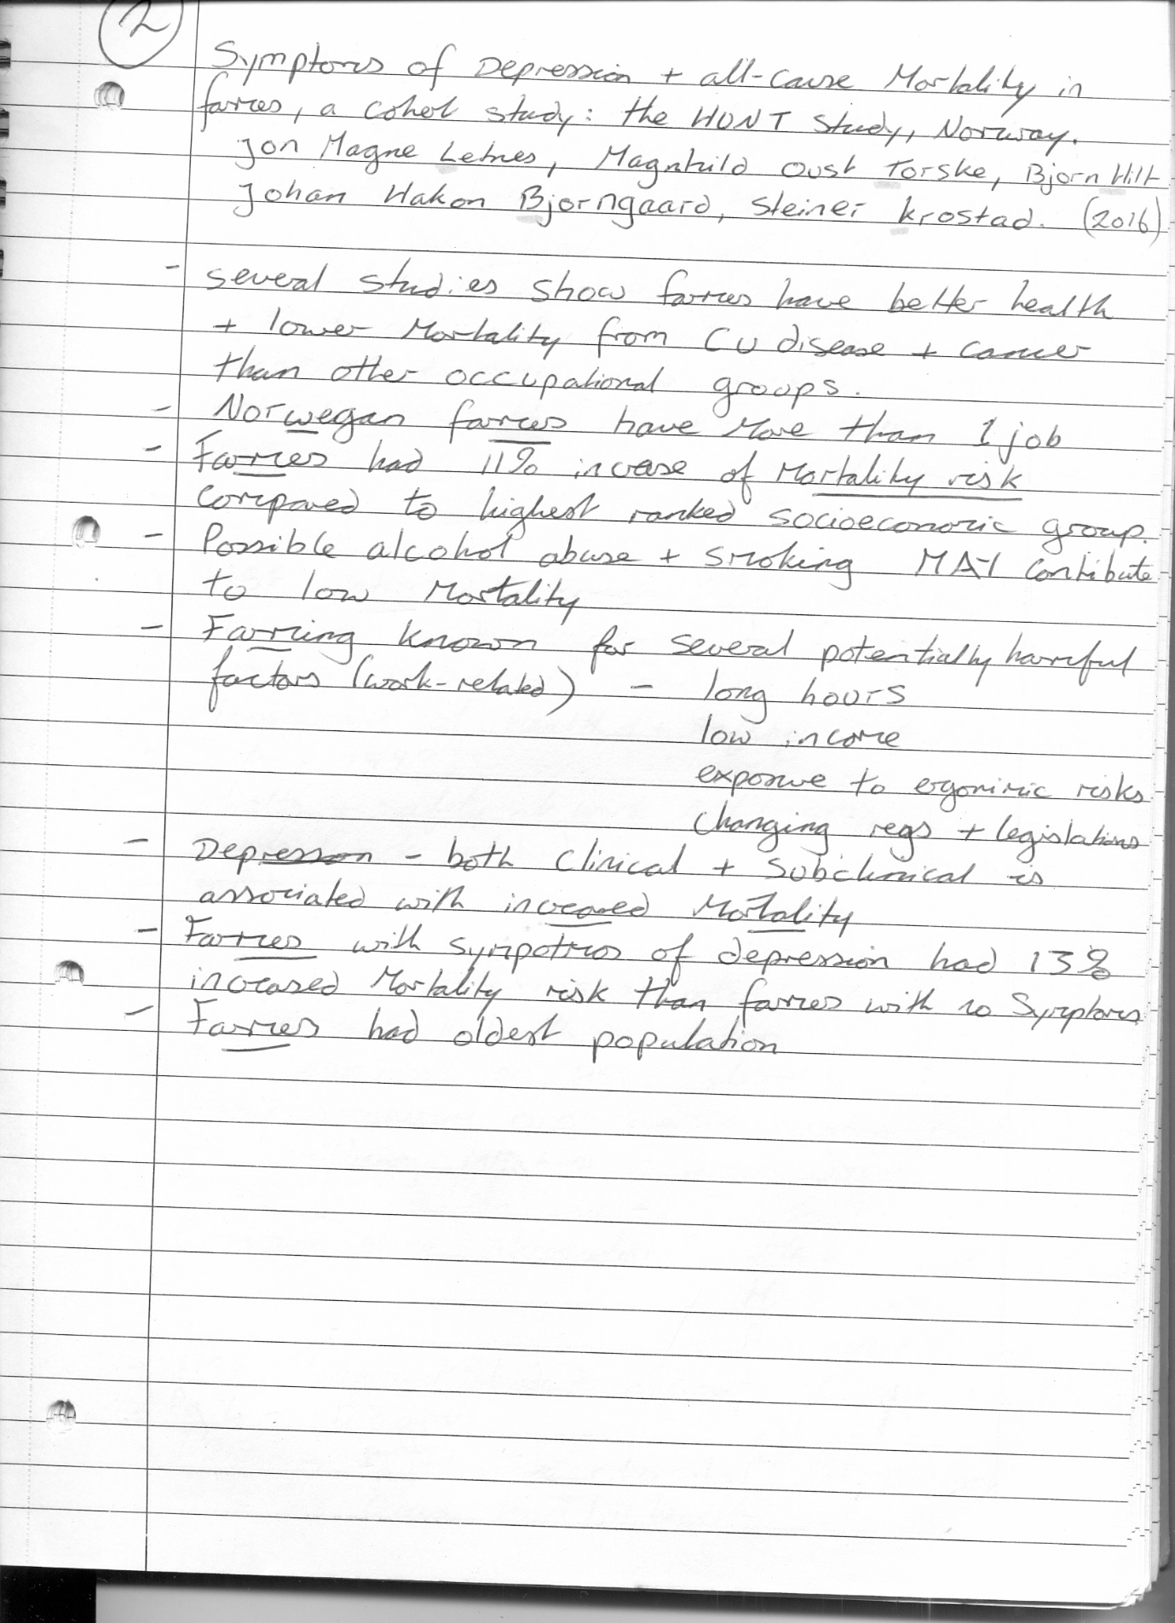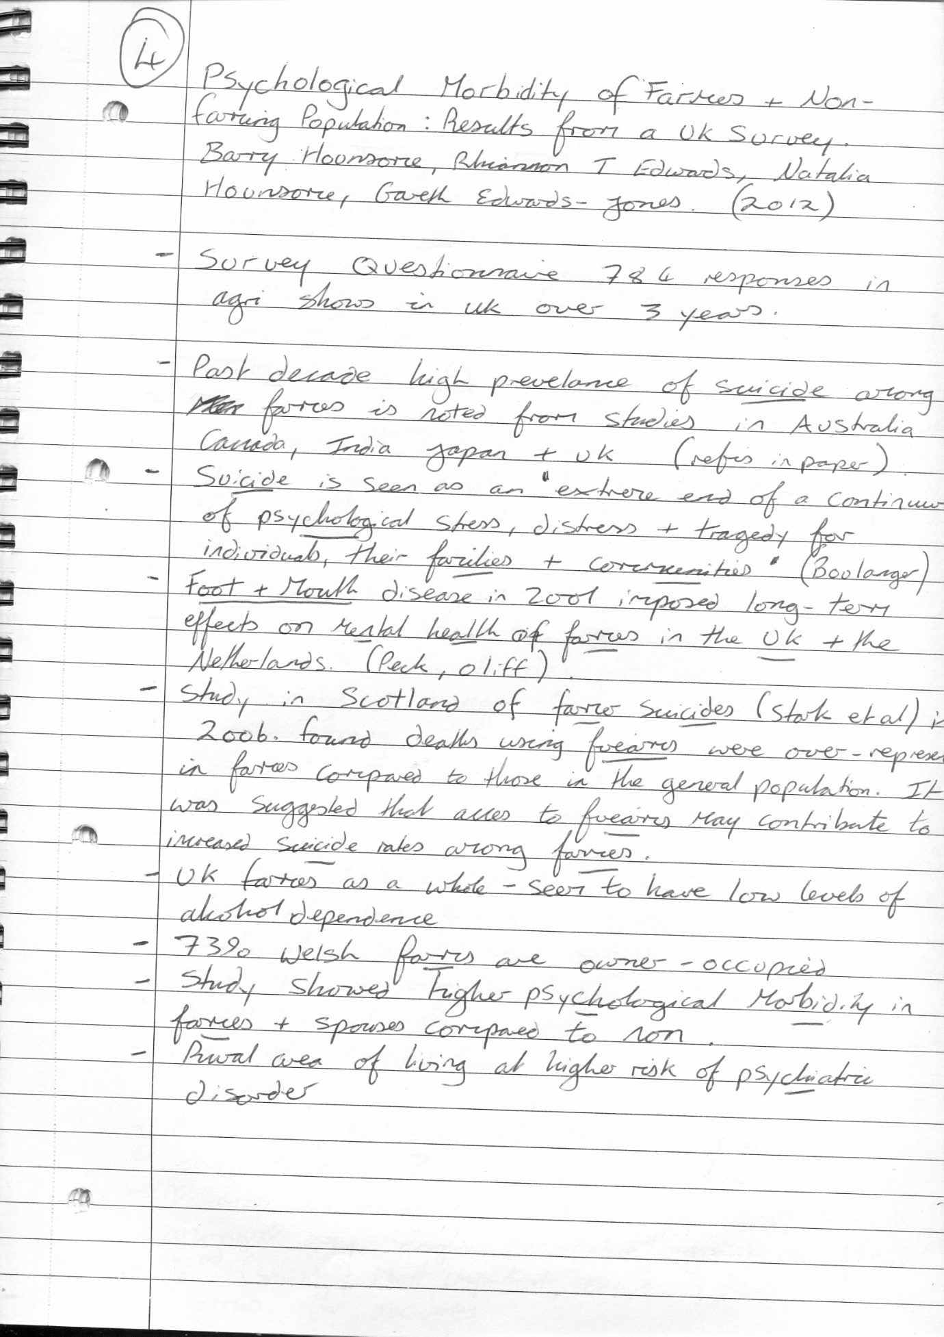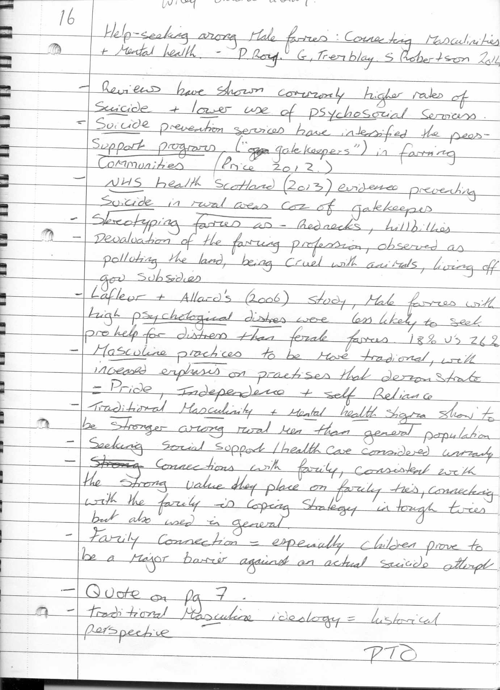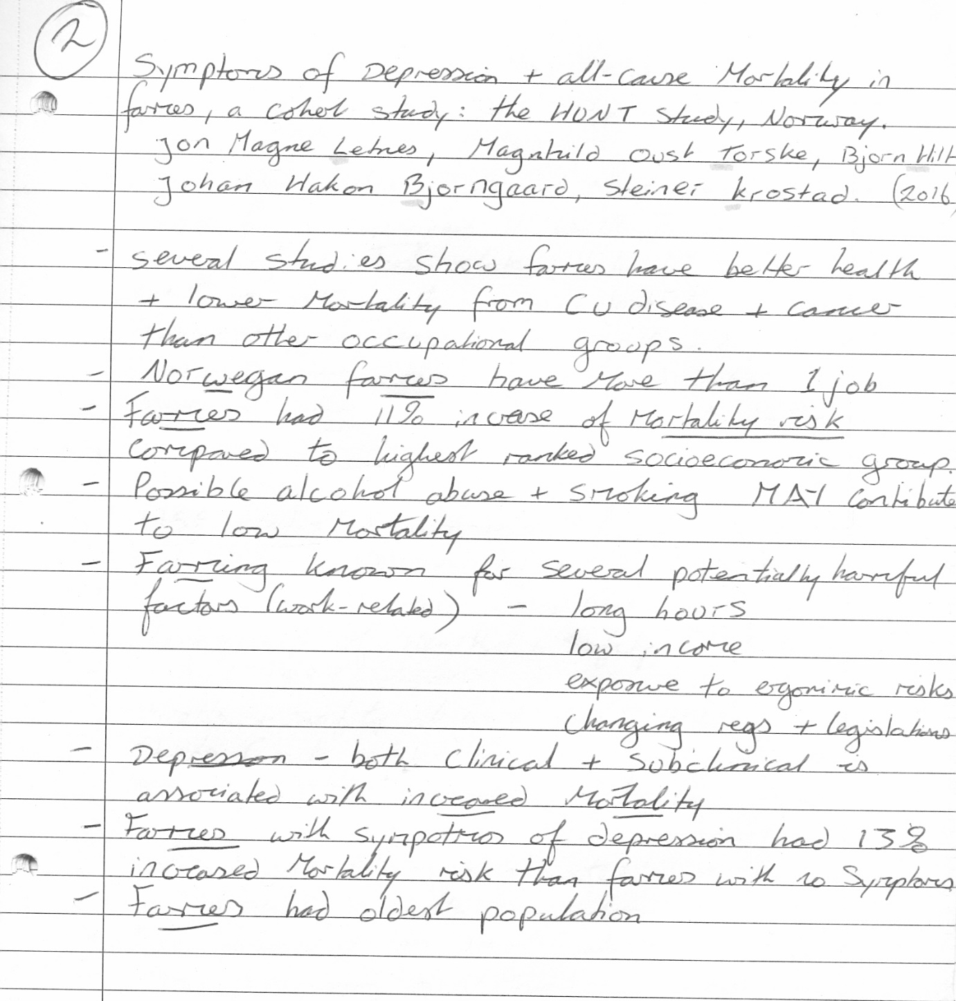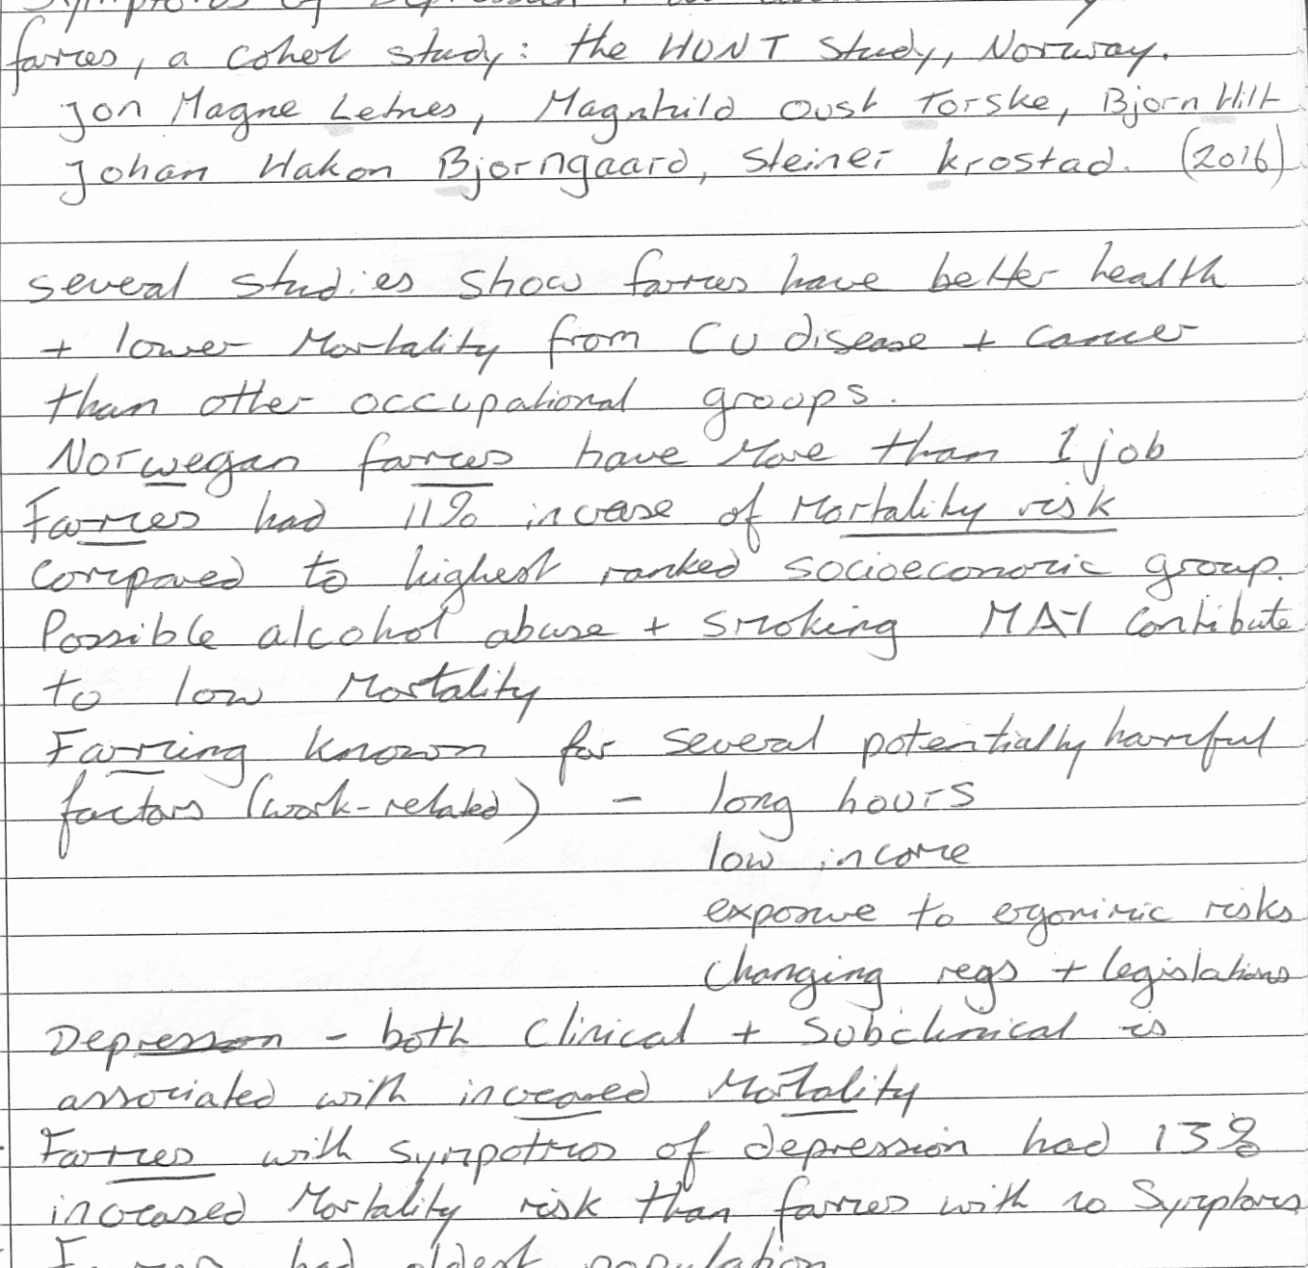

Appendix III


