Session one – THE WEIRD AND WONDERFUL IN INDIA

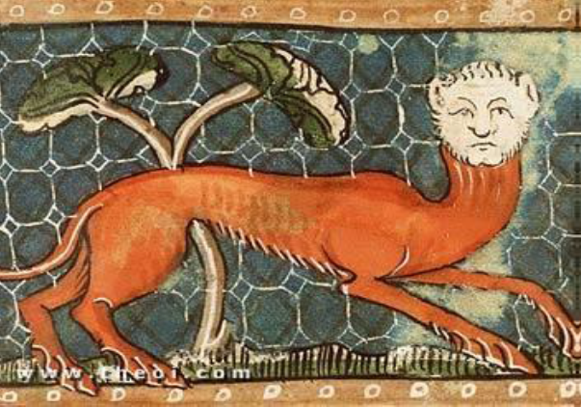
Manticore, Der Naturen Bloeme manuscript c. 1350, National Library of the Netherlands

In this session we will look at what Greek authors “pre-Alexander” (i.e. before Alexander brings his Graeco-Macedonian army to Central Asia and Northwest India) have to say about Indian and the Far East. Particular focus is given to the surviving fragments of Ctesias’ Indika, but extracts from Herodotus’ Histories are considered as well. We will reflect on whether the information they provided can simply be dismissed as “tall tales” or if any grains of truth exists in these reports. A number of extracts from Nichols translation of the fragments of Ctesias’ Indika have been made available on Moodle, and some extracts from Herodotus’ descriptions of India have been given below.

Questions:
1) What are your impressions of Herodotus’ and Ctesias’ descriptions about the land of India?

2) To what extent is our understanding of Ctesias’ writing skewed by the choices made by later writers in excerpting his work?

3) Might Herodotus and Ctesias have had access to genuine sources of information on India? If so can we know what they were?

4) What impact may Herodotus’ and Ctesias’ writings have had on later Classical authors?

Extracts from Herodotus
From the Loeb translation of A. D. Godley (1920)

“I hold it then in every way proved that Cambyses was quite insane; or he would never have set himself to deride religion and custom. For if it were proposed to all nations to choose which seemed best of all customs, each, after examination, would place its own first; so well is each convinced that its own are by far the best. It is not therefore to be supposed that anyone, except a madman, would turn such things to ridicule. I will give this one proof among many from which it may be inferred that all men hold this belief about their customs. When Darius was king, he summoned the Greeks who were with him and asked them for what price they would eat their fathers' dead bodies. They answered that there was no price for which they would do it. Then Darius summoned those Indians who are called Callatiae, who eat their parents, and asked them (the Greeks being present and understanding through interpreters what was said) what would make them willing to burn their fathers at death. The Indians cried aloud, that he should not speak of so horrid an act. So firmly rooted are these beliefs; and it is, I think, rightly said in Pindar's poem that custom is lord of all.” (3.38)

“The Indians, who are more numerous than any other nation we know, paid a tribute beyond that of every other people, namely 360 talents of gold-dust.” (3.94.2a)

“As for those on whom no tribute was laid, but who rendered gifts instead, they were, firstly, the Ethiopians nearest to Egypt, whom Cambyses conquered in his march towards the long-lived Ethiopians; and also those who dwell about the holy Nysa, where Dionysus is the god of their festivals. These Ethiopians and their neighbors use the same seed as the Indian Callantiae, and they live underground…
All this abundance of gold, from which the Indians send the aforementioned gold-dust to the king, they obtain in the following way. To the east of the Indian country is sand. Of all the people of Asia whom we know - even those about whom something is said with precision - the Indians dwell nearest to the dawn and the rising sun; for on the eastern side of India all is desolate because of the sand.
There are many Indian nations, none speaking the same language; some of them are nomads, some not; some dwell in the river marshes and live on raw fish, which they catch from reed boats. Each boat is made of one joint of reed. These Indians wear clothes of bullrushes; they mow and cut these from the river, then weave them crosswise like a mat, and wear them like a breastplate. Other Indians, to the east of these, are nomads and eat raw flesh; they are called Padaei. It is said to be their custom that when anyone of their fellows, whether man or woman, is sick, a man's closest friends kill him, saying that if wasted by disease he will be lost to them as meat; though he denies that he is sick, they will not believe him, but kill and eat him. When a woman is sick, she is put to death like the men by the women who are her close acquaintances. As for one that has come to old age, they sacrifice him and feast on his flesh; but not many reach this reckoning, for before that everyone who falls ill they kill.
There are other Indians, again, who kill no living creature, nor plant anything, nor are accustomed to have houses; they eat grass, and they have a grain growing naturally from the earth in its husk, about the size of a millet-seed, which they gather with the husk and boil and eat. When any one of them falls sick, he goes into the desert and lies there, and no one notices whether he is sick or dies.
These Indians whom I have described have intercourse openly like cattle; they are all black-skinned, like the Ethiopians. Their semen too, which they ejaculate into the women, is not white like other men's, but black like their skin, and resembles in this respect that of the Ethiopians. These Indians dwell far away from the Persians southwards, and were not subjects of King Darius.
Other Indians dwell near the town of Caspatyrus and the Pactyic country [Northeast Afghanistan], north of the rest of India; these live like the Bactrians; they are of all Indians the most warlike, and it is they who are sent for the gold; for in these parts all is desolate because of the sand. In this sandy desert are ants, not as big as dogs but bigger than foxes; the Persian king has some of these, which have been caught there. These ants live underground, digging out the sand in the same way as the ants in Greece, to which they are very similar in shape, and the sand which they carry from the holes is full of gold. It is for this sand that the Indians set forth into the desert. They harness three camels apiece, males on either side sharing the drawing, and a female in the middle: the man himself rides on the female, that when harnessed has been taken away from as young an offspring as may be. Their camels are as swift as horses, and much better able to bear burdens besides.
I do not describe the camel's appearance to Greeks, for they know it; but I shall tell them something that they do not know concerning it: the hindlegs of the camel have four thighbones and four knee-joints; its genitals are turned towards the tail between the hindlegs.
Thus and with teams so harnessed the Indians ride after the gold, being careful to be engaged in taking it when the heat is greatest; for the ants are then out of sight underground. Now in these parts the sun is hottest in the morning, not at midday as elsewhere, but from sunrise to the hour of market-closing. Through these hours it is much hotter than in Hellas at noon, so that men are said to sprinkle themselves with water at this time. At midday the sun's heat is nearly the same in India as elsewhere. As it goes to afternoon, the sun of India has the power of the morning sun in other lands; as day declines it becomes ever cooler, until at sunset it is exceedingly cold.
So when the Indians come to the place with their sacks, they fill these with the sand and drive back as fast as possible; for the ants at once scent them out, the Persians say, and give chase. They say nothing is equal to them for speed, so that unless the Indians have a headstart while the ants were gathering, not one of them would get away. They cut loose the male trace-camels, which are slower than the females, as they begin to lag, one at a time; the mares never tire, for they remember the young that they have left. Such is the tale. Most of the gold (say the Persians) is got in this way by the Indians; they dig some from mines in their country, too, but it is less abundant.
The most outlying nations of the world have somehow drawn the finest things as their lot, exactly as Greece has drawn the possession of far the best seasons. As I have lately said, India lies at the world's most distant eastern limit; and in India all living creatures four-footed and flying are much bigger than those of other lands, except the horses, which are smaller than the Median horses called Nesaean; moreover, the gold there, whether dug from the earth or brought down by rivers or got as I have described, is very abundant. There, too, wool more beautiful and excellent than the wool of sheep grows on wild trees; these trees supply the Indians with clothing.” (3.97.2, 3.98-106)

“Darius, desiring to know where this Indus empties into the sea, sent ships manned by Scylax, a man of Caryanda… these set out from the city of Caspatyrus and the Pactyic country [northeast Afghanistan], and sailed down the river toward the east and the sunrise until they came to the sea; and voyaging over the sea west, they came in the thirtieth month to that place from which the Egyptian king sent the above-mentioned Phoenicians to sail around Libya. After this circumnavigation, Darius subjugated the Indians and made use of this sea. Thus it was discovered that Asia, except the parts toward the rising sun, was in other respects like Libya.” (4.44.1-3)

“The Indians wore clothes made from trees [cotton?] and carried reed bows and iron-tipped reed arrows. Such was their equipment; they were appointed to march under the command of Pharnazathres son of Artabates.” (7.65)

Appendix I: Key Locations and Place Names

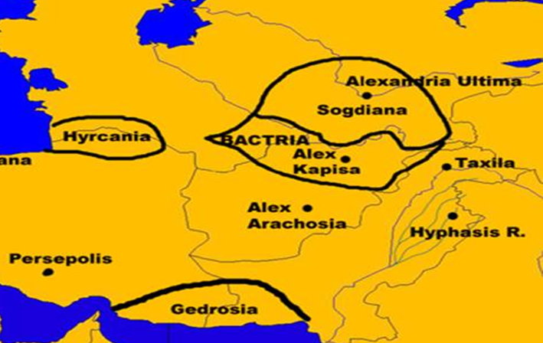
Bactria and Sogdiana
Ancient Bactria comprises roughly the mountainous north-eastern area of what is now modern Afghanistan. Strabo comments on the fertility of the land noting that it produces everything but the olive and reports that the people were semi-nomadic, although still reasonably “civilised”, but with some of their more unsavoury customs being stamped out by Alexander (Geog. 11.11.1). Indeed, this territory was a satrapy of the Persian Empire until being taken over by Alexander, and by the last decade of the fourth century becoming a province of the Seleucid Empire. During the course of the latter third century BC become the centre of an independent Graeco-Bactrian kingdom.
Strabo (Geog. 11.11.2) notes that ancient Sogdia or Sogdiana lay north of the Oxus River (the modern Amu Darya) and south of the Jaxartes River (Modern Syr Darya). The territory most probably covered an area that roughly equates with present-day eastern Uzbekistan, much of Tajikistan, western Kyrgyzstan and a small part of southern Kazakhstan. It is a mountainous area with many desert parts, but which contained many ancient oases, and was also quite a rich territory. However, it was more exposed to the depredations of nomadic steppe peoples and proved a difficult area to control.

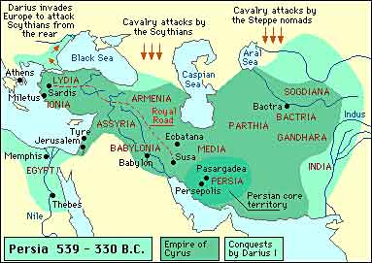

Indus Valley Region
Much of the Indus River runs through what is now modern Pakistan, with several other major rivers feeding into it. It formed the eastern boundary of the Persian Empire, at least during the reign of Darius the Great who is reported to have conquered the Indians in this region (Herodotus 4.44.1-3; a claim also made in a Persian inscription at Persepolis). When Alexander campaigned in India (largely in the area of modern Pakistan) during the 320s BC he was faced with a series of small kingdoms and independent Republics / City-States. He would established part of this Indus Valley region into provinces/vassals of his Empire. After his death these proved fairly short-lived, with their annexation by the Mauryan Emperor Chandragupta Maurya (called Sandrokottos in Greek texts). By the early decades of the second century BC Graeco-Macedonian rulers/warlords from Bactria encroached into this region taking advantage of the disintegration of the Mauryan Empire.

Appendix II: Key Dates

c. 519-513 BC: Scylax of Caryanda is commissioned by Darius to explore the sea-route down the Indus and sail along the coastal areas of the north-western Indian Ocean until reaching the Suez. Around this period Darius the Great conquers up to the Indus Valley region.
c. early-fifth century BC: Hecataeus of Miletus writes the Periodos Ges (Circuit of the Earth) which gives a description of Europe, Asia and Africa in two books.
c. 440s to 430s BC: Herodotus writes his enquiry into the cause of the war with the Persians. In part of the work, especially book 3, he provides snippets of detail relating to Greek conceptions of India.
c. End of the fifth to beginning of the fourth century BC: Ctesias of Cnidus is taken as a prisoner of war and ends up serving as a court physician to the family of Artaxerxes II Memnon (405/4-359/8 BC), one of the kings of Persia. It is here that he claims to hear various reports about India and to see “Indian things”. Some of the details are quite fantastical.

