Community Engagement
Structure and Culture
Name: Gheorghe Laurentiu Stanescu
Student’s ID:2124714
Lecture: Nadeem Mirza
Table of Contents
1.0 Introduction 3
2.0 Organisational Structure Culture and Organisational Performance 3
2.1 Introduction 3
2.2 Organisational Structure and Organisational Performance 4
2.3 Culture and Organisational Performance 10
2.4 Conclusion 12
3.0 Employee Motivation 12
4.0 Conclusion 15
References 16

1.0 Introduction
Organisational behaviour is a crucial concept when analysing the behaviours and attitudes of a person working in a particular company (Arieli and Roccas, 2020). This helps the leaders to give their members responsibilities and roles more effectively. Hence studying organisational behaviour is important when analysing the culture of a company and also the structure of a company and how it impacts its performance. This report has focused on CAPCO, a company that offers services in IT consultations and financial consulting services. The company has 28 offices through continents such as Europe, North America South America and parts of Asia (Zippia, 2022). This company was initially founded in 1988 having its headquarters in London UK. However, its main services are offering financial services such as bank services, capital markets and payments (Zippia, 2022). CAPCO has further employed 6500 people that offer consulting services (Adeniji, 2021). Through this project, the analysis of how the organisational culture and structure impact the performance of CAPCO will be done. Furthermore, through this report, various frameworks have been applied. Finally, the motivation of employees has been analysed, with various frameworks, and an analysis of how CAPCO motivates its employees has been done.

2.0 Organisational Structure Culture and Organisational Performance

2.1 Introduction
Organisational Structure: This is an outline of how operational are being managed to achieve the goals of the company
Organisational Culture: These are the values and beliefs that have been established within a company that is used in shaping the employees' behaviours and understanding while dealing with clients (Lam and Tran, 2021).
Motivation: These are the desires that encourage people to behave in a certain way. In business are the motives that push the employees to achieve the goals of the company (Basalamah and As’ad, 2021).
CAPCO is a company that offers services in technology and financial solutions for the management industry. CAPCO is located at 77-79 Great Eastern Street, London. The company’s revenue per staff is $9127 (Zippia, 2023). Considering the statistics at the Johannesburg Stock Exchange, the company has a stock of 31.49 ZAR (Frith, 2022). The company recorded up to $59.3M in annual revenue, which was per the records declared in 2022 (Zippia, 2022). However this company does not only operate in the UK, with the help of globalisation, the company has diversified to India and US.

2.2 Organisational Structure and Organisational Performance
The organisational structure of CAPO has been based to be more group-driven having numerous layers of leaders. The company has considered a hierarchical form of structure, which has leaders from top to bottom which shows that communication issues have been reduced in this company.

Staff
Staff
Staff
Staff
Junior Managers
Junior Managers
Junior Managers
Senior Management
Middle Management
Middle Management

Figure 1: CAPCO Organisational Structure

The CAPCO organisational structure has been adopted as it is the most suitable for an innovative and entrepreneurship culture. Through the flat structure practised, a matrix structure is adopted, as employees work on one project for a particular time and after they finish it is when they will begin another project. With this structure, the employees are motivated to get advice from each other on promotion ream work. With the hierarchy, CAPCO makes its employees feel like this is their firm too. With this, they come up with various ideas that they think would help. However in the hierarchy, the top management has all the power over the policies, in the next levels, the Middle managers report to the top managers. In the next levels, we have the junior managers who report to the middle management and the staff reports to them.
Relationships between organisational structure and CAPCO Performance
The organisational structure of CAPCO has different layers. With these layers, communication issues have been reduced. According to statistics, up to 86% of employees and leaders claim that, with reduced collaboration and communication in workplaces, high failures are experienced (Pumble (2023). Furthermore in another research, companies that have implemented effective communication strategies increase their productivity by 25% (Flynn, 2023). However, it is too unfortunate that up to 60% of companies have not implemented long-term strategies to enhance effective communication (Signage, 2022). However with the structure of CAPCO, effective communication has been attained that increases productivity, this can also be based on the facts by (Gibson, 2023) when he carried out an interview and reported that 71% of employees admitted that they perform more effectively when they feel more connected to each other.
Furthermore, with effective communication, engagement in the workplace is increased. According to statistics by (Pendell, 2023) employees who are not engaged to their workplaces, cost the world $7.8 trillion as a result of lost productivity. With this, it is the same that companies will experience losses too. Furthermore, with high engagement levels employee turnover is reduced by 60% which makes it easy for the organisation to maintain top talents (Mancini, 2021). All this is based on the fact that with a structure that is with more clear communication, efficiency and engagement within the company are increased as projects will be completed within the required timeline and all the instructions will be followed. Below is a figure showing an interaction with an employee who proves that the structure results in management being useful and enhancing collaboration that result in high outputs
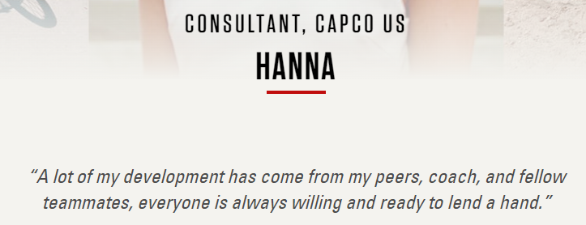
Figure 2: Evidence of practising organisational structure (Source: Capco (2023)
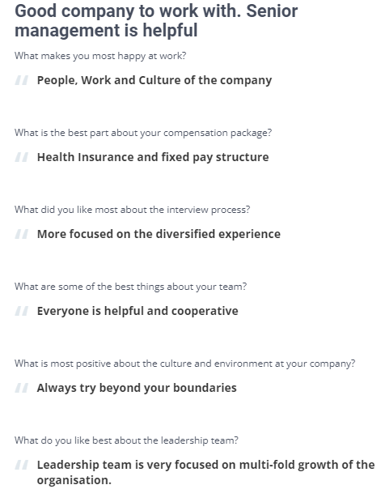
Figure 3: Evidence of practising organisational structure
Source: comparably (2023)
Furthermore, this shows that getting access to senior managers is not hard, which increases transparency within the company. This structure is important to the company’s success as it enhances innovation. With the high collaboration as per Figure 3 above, people interact and develop various perspectives that are turned into ideas that generate more sales for the company. Furthermore, with creativity and an environment that encourages risks taking, the employees feel that the company acknowledges their presence. This impacts their performance. This can be based on the statistics by (Wellable, 2022) that reports that employees with higher employee engagement recorded an increase in productivity by 21%. Considering that several aspects within a specific time are emphasised, it becomes less of a probability that the employees will make mistakes. With this, improved efficiency is experienced. An authoritative structure shows a working way of a firm and how the chain of command within the company is considered which makes it easy to know responsibilities and improve accountability.

2.3 Culture and Organisational Performance
The culture of a company shows the method and the relationship that the company has. Furthermore, it impacts work efficiency in terms of manpower. In the company, the superiors are well familiar with the staffs which make it easy for the staff to comfortably listen to the guidelines when given by their bosses. With the culture of legitimate correspondence, the superiors get it easy to control the company. In CAPCO, the company has considered various principles that make up of its culture: Respect, Excellence, Commitment and Knowledge (Capco (2023b).
With these values, the company has been able to develop a good working environment that harbours good working conditions. With good working conditions, employees are subjected to maximising their efforts. This can be supported by a study by (Basalamah and As’ad, 2021) up to 84% of their participants who were employees from different companies, acknowledge that the environment especially the people surrounding them had an impact on their performance.
Through the culture of CAPCO, they encourage the employees to be themselves and be authentic when carrying out their duties. With this culture, employees have a higher chance of being creative and going the extra mile to help the company without being limited. By being such, the company then receives unique services that make them gain a competitive advantage. In this competitive market where industries are faced with threats of being replaced by new entrants offering the same services but with more accessibility and creativity, being replaced in the market is easy. However, in an environment where the stakeholders have been given the will of being more innovative, ideas could be developed that could take the company to other levels.
According to the company leaders, the company testifies that letting their workers be their selves has resulted in high creativity in the company

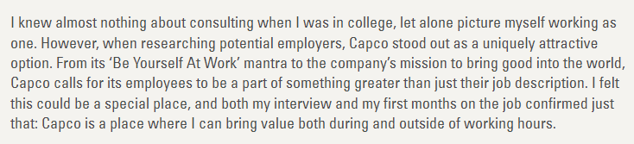
Figure 4: Comment from one of the employees (Source Capco, 2023)
Furthermore, the company has a culture where the diversity power of innovation has been highly appreciated. In its employees profile it is clear that it has diversified as various cultures are seen.

Figure 5: Diversification of employees
The company values that people coming from different locations have different mindsets that can bring an impact on the company. Yes, this is true, despite that many companies have not considered diversification, and they are missing out on a lot of ideas. Having people from various backgrounds, with different ideas promote unique idea generation. An individual can come up with ideas that have not been introduced in a particular society that they practise in their society which has proved effective. In this case, if the company had not considered diversification, this could have not been attained. With such ideas, high rates of uniqueness and differentiation among its competitors are achieved. Furthermore, this helps the company to have increased revenue generation and an extra market audience. With these cultural strategies, the company has been able to achieve high customer satisfaction which has seen those getting loyal clients. This was seen during the pandemic when all companies were shutting down, the company continued to make profits.

2.4 Conclusion
In conclusion, culture and structure have proven to be major participants in the success of the company. The culture of a company is the core values that guide the activities that the employees and leaders practise in the workplace. Structure on the other side is the leadership and the hierarchy that the activities at work are controlled. In this analysis, it is clear that the structure and Culture of the CAPCO have impacted its performance at large.

Employee Motivation
Managers at CAPCO have realised that the motivation of employees is important as it contributes to efficiency. Through its motivation schemes, it has considered:
Building strong communication at work: Managers at CAPCO realised that when employees feel less motivated they are not willing to communicate. Hence the managers must ensure that they have a strong communication chain where they can express their grievances. With this, the managers have been able to get some of the things that do not motivate the employees. By ensuring that the things raised have been rectified, the employees are motivated that the company cares about their morale too.
Career Growth: The Company has considered training programs for its employees that make them motivated. When an employee knows that a company will sponsor their training, they will be more motivated to stay in the company and work effectively to reward the company.
Proper training and Development: The Company has taken the role to do research and locate the needs and requirements that rises as the business world is changing. The company then offers them training, which ensures that the employees have all the necessary skills to carry out all the duties as per the requirements, with such, many of the employees are motivated
Compensation: the company has offered adequate salaries and also provided bonuses that come upon outstanding work. When an employee works exceptionally they stand a chance of being promoted and their salaries being increased. With this, many of the employees get to work hard for recognition. They are motivated to compete and ensure that they work exceptionally.
Identification of the gap
The company identifies the gaps and barriers that make it hard for the employees to complete the tasks. They then help them address the issues. With this, the employees are motivated and they know that the company will help them through all the difficulties.
Theoretical Approach
Herzberg's motivational Hygiene theory
This theory is also known as two-factor theory. In this theory, employees are only motivated to work more once their hygiene factors have been met.
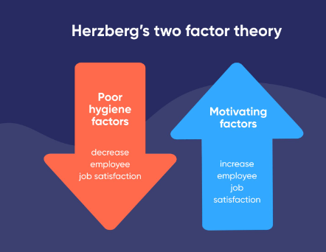
Figure 5: Herzberg's motivational Hygiene theory

They include salary and policies within a company that related to the benefits that the people will get supervision, acknowledgement and working conditions. This theory bases that the different variables result in disappointments or fulfilment in a workplace. This hypothesis emphasises more on how the different variables impact the employees. With this, the managers can apply the variables to ensure that motivation at the workplace has been achieved. However, this theory states that with motivation, employees can gain the high maximisation of their skills hence increasing efficiency. This theory is widely used in many companies which also can be used to explain the motivation at CAPCO.

4.0 Conclusion
In conclusion, the report has analysed how structure and culture impact the performance of the business. In this case, CAPCO was used which results prove that culture and structure have contributed highly to its success. Furthermore, the report analysed the motivation at CAPCO, where it is seen that the company values the motivation of its employees highly.

References
Arieli, S., Sagiv, L. and Roccas, S., 2020. Values at work: The impact of personal values in organisations. Applied Psychology, 69(2), pp.230-275.
Basalamah, M.S.A. and As’ad, A., 2021. The Role of Work Motivation and Work Environment in Improving Job Satisfaction. Golden Ratio of Human Resource Management, 1(2), pp.94-103.
Basalamah, M.S.A. and As’ad, A., 2021. The Role of Work Motivation and Work Environment in Improving Job Satisfaction. Golden Ratio of Human Resource Management, 1(2), pp.94-103.
Capco (2023) Capco career stories: Hanna, Capco us, Capco Career Stories: Hanna, Capco US. Available at: https://www.capco.com/Careers/Meet-Our-People/Hanna (Accessed: 03 May 2023).
Capco (2023b) Our culture and values, Capco. Available at: https://www.capco.com/About-Us/Our-Culture-and-Values (Accessed: 03 May 2023).
Comparably (2023) Capco employee reviews | comparably, Comparably. Available at: https://www.comparably.com/companies/capco/reviews (Accessed: 03 May 2023).
Flynn, J. (2023) 25+ critical communication in the workplace statistics [2023]: How effective is good communication?, Zippia. Available at: https://www.zippia.com/advice/communication-in-the-workplace-statistics/#:~:text=Teams%20with%20effective%20communication%20see,open%2C%20and%20timely%20at%20work. (Accessed: 03 May 2023).
Frith, N. (2022) Capital & Counties Properties Plc (JSE: CCO): Share price, AskTraders.com. Available at: https://www.asktraders.com/za/learn-to-trade/stock-trading/capital-counties-properties-plc/#:~:text=The%20current%20price%20for%20Capital,closing%20price%20of%2032.36%20ZAR. (Accessed: 03 May 2023).
Gibson, E. (2023) How to collaborate effectively with peers, DocFlite Powered by QuoteOnSite. Available at: https://docflite.com/how-to-collaborate-effectively-with-peers#:~:text=The%20study%20found%20that%20a,connected%20culture%20feel%20more%20productive. (Accessed: 03 May 2023).
Lam, L., Nguyen, P., Le, N. and Tran, K., 2021. The relation among organizational culture, knowledge management, and innovation capability: Its implication for open innovation. Journal of Open Innovation: Technology, Market, and Complexity, 7(1), p.66.
Mancini, S. (2021) How to reduce employee turnover by 60 per cent, Effectory. Available at: https://www.effectory.com/knowledge/how-to-reduce-employee-turnover-by-60-percent/ (Accessed: 03 May 2023).
Pendell, R. (2023) The world’s $7.8 Trillion workplace problem, Gallup.com. Available at: https://www.gallup.com/workplace/393497/world-trillion-workplace-problem.aspx (Accessed: 03 May 2023).
Pumble (2023) Communication statistics in the workplace 2022 - bumble, Knowledge hub. Available at: https://pumble.com/learn/communication/communication-statistics/ (Accessed: 03 May 2023).
Signage, M.D. (2022) 50 Statistics about Employee Communications, LinkedIn. Available at: https://www.linkedin.com/pulse/50-statistics-employee-communications-mvix-usa-?trk=pulse-article_more-articles_related-content-card (Accessed: 03 May 2023).
Wellable (2022) 9 employee engagement statistics you should know for 2023, Wellable. Available at: https://www.wellable.co/blog/employee-engagement-statistics-you-should-know/#:~:text=Companies%20with%20a%20highly%20engaged,have%20higher%20customer%20retention%20rates. (Accessed: 03 May 2023).
Zippia (2022) Capco history: Founding, timeline, and milestones, Zippia. Available at: https://www.zippia.com/capco-careers-98223/history/ (Accessed: 03 May 2023).
Zippia (2023) Capco revenue: Annual, Quarterly, and Historic, Zippia. Available at: https://www.zippia.com/capco-careers-98223/revenue/ (Accessed: 03 May 2023).

