University of Wales Trinity Saint David

Wales Institute of Science & Art

Automotive Materials & Sustainability
Materials Testing and Sustainability of Composites for Motorsport & Automotive Industries
(ACHA6012)

Jacob Ling
220427
February 2026
Contents
1 Introduction 3
1.1 Background to Composite Materials 3
1.2 Importance in Motorsport and Automotive Engineering 3
1.3 Sustainability Challenges 3
1.4 Aim and Objectives of the Report 3
2 Literature Review 4
2.1 Overview of Composite Materials 4
2.2 Types of Composites Used in Motorsport 4
2.3 Manufacturing Processes 4
2.4 Applications in Motorsport and Automotive 4
2.5 Summary 5
3 Sustainability Analysis 6
3.1 Environmental Impact of Composite Materials 6
3.2 Recycling and End-of-Life Challenges 6
3.3 Sustainability in Motorsport and Automotive 6
3.4 Future Sustainable Materials 6
3.5 Legislation and Industry Policy 7
4 Experimental Testing 8
4.1 Materials Tested 8
4.2 Testing Methodology 8
4.3 Experimental Results 10
5 Discussion 15
5.1 Sustainability Trade-offs 15
5.2 Limitations of Testing 15
5.3 Validation with Literature Data 16
5.4 Validation with Literature Data 17
6 Recommendations 19
7 Conclusion 20
8 References 21
9 Appendix 22
9.1 Aluminium 22
9.2 Carbon non-Woven Bio 26
9.3 Carbon Woven Bio 31
9.4 Carbon Woven Epoxy 35
9.5 Flax non-woven bio 40
9.6 Flax woven bio 44
9.7 Kevlar Woven Bio 49

Introduction

Background to Composite Materials
Composite materials consist of a reinforcing fibre phase embedded within a polymer matrix, combining the strength of the fibre with the formability of the matrix to produce materials with high strength-to-weight ratios and improved fatigue resistance compared to conventional metals.

Importance in Motorsport and Automotive Engineering
Mass reduction is a primary driver of composite adoption in both automotive and motorsport engineering. CFRP and GFRP are widely used in vehicle structures, body panels, and aerodynamic components, with CFRP the dominant structural material in Formula One monocoque chassis construction.

Sustainability Challenges
Composite materials present notable sustainability challenges: thermoset matrices are difficult to recycle, and carbon fibre production is highly energy intensive. Growing environmental regulation is driving both industries toward bio-based and recyclable composite alternatives.

Aim and Objectives of the Report
This report evaluates the performance and sustainability of composite materials for motorsport and automotive applications through a literature review, experimental testing of seven composite samples, and a sustainability analysis, concluding with recommendations for future material selection.

Literature Review

Overview of Composite Materials
Composite materials consist of a reinforcing fibre phase within a continuous polymer matrix, producing materials with exceptional strength-to-weight ratios. A 10% reduction in vehicle mass delivers a 6 to 8% improvement in fuel economy, driving rapid growth in composite adoption across the automotive and motorsport sectors (Sarfraz et al., 2021). Composites are classified by matrix type — thermoset or thermoplastic — and by fibre type, with matrix selection having significant implications for both structural performance and recyclability (Yan & Xu, 2025).

Types of Composites Used in Motorsport
CFRP offers mass reduction of 40 to 70% compared to steel and is the primary structural material in Formula One monocoque chassis construction (Sarfraz et al., 2021). GFRP accounts for approximately 95% of composite volume in automotive manufacturing, used extensively for body panels and structural components where cost is a primary consideration (Choi et al., 2023). Aramid fibres (Kevlar) offer superior impact resistance and are deployed in hybrid laminates for crash protection structures (Mengesha Aznaw, 2025)
Natural fibre reinforced polymer composites (NFRPCs) are increasingly adopted for interior and semi-structural automotive components, offering low density, renewability, and better end-of-life recyclability than synthetic fibre thermosets (Choi et al., 2023). Hybridising natural fibres with synthetic fibres overcomes their strength limitations whilst retaining cost advantages, with carbon/glass and natural/carbon systems widely applied in automotive components (Ravishankar et al., 2019).

Manufacturing Processes
Prepreg layup and autoclave curing is the dominant method for motorsport components, achieving the highest mechanical properties, though high costs restrict it to low-volume applications (Sarfraz et al., 2021). For volume automotive production, resin transfer moulding (RTM) variants are preferred, with compression RTM achieving cycle times below 5 minutes at significantly lower cost than high-pressure RTM. Compression moulding of SMC and LFT materials, with cycle times of 1 to 3 minutes, is the most widely used automotive process (Sarfraz et al., 2021).

Applications in Motorsport and Automotive
Road transport contributes approximately 25% of global CO₂ emissions, and EU legislation targeting a 45% reduction in greenhouse gas emissions by 2030 is a primary driver of composite adoption as a lightweighting strategy (Choi et al., 2023). Life cycle assessment demonstrates that use-phase fuel savings from mass reduction outweigh the higher manufacturing energy cost of composites compared to steel over a typical vehicle lifetime, though the end-of-life recyclability of thermoset composites remains a significant challenge (Shamsi et al., 2022). Thermoset composites cannot be re-melted: mechanical recycling degrades fibre length, pyrolysis recovers carbon fibre with 72 to 98% retained tensile strength but renders glass fibre unusable, and solvolysis offers high-quality fibre recovery but is not yet economically viable at industrial scale (Choi et al., 2023). Natural fibre and thermoplastic matrix composites offer substantially better end-of-life profiles, and the FIA’s target of carbon neutrality across motorsport by 2030 is accelerating the development and validation of these materials in a demanding performance environment (Choi et al., 2023).

Summary
CFRP dominates structural motorsport applications, GFRP serves high-volume automotive production, and natural fibre composites are established in interior roles. The primary challenge facing the industry is the recyclability of thermoset composites, with thermoplastic matrix systems and bio-based hybrid composites representing the most promising pathway toward meeting tightening environmental regulation.

Sustainability Analysis

Environmental Impact of Composite Materials
Carbon fibre production requires approximately 183 to 286 MJ/kg — far higher than aluminium at 35 MJ/kg — meaning the carbon woven epoxy, carbon woven bio, and carbon non-woven bio samples carry a substantially greater embodied energy than the aluminium baseline (Vohra et al., 2022). The bio-based matrices used in the carbon woven bio, flax woven bio, flax non-woven bio, and Kevlar woven bio samples reduce this burden compared to conventional epoxy, and natural flax fibre sequesters CO₂ during growth, offering a near-carbon-neutral reinforcement. Despite high production energy costs, life cycle assessment studies consistently show that use-phase fuel savings from mass reduction outweigh manufacturing burdens over a vehicle’s lifetime: a 10% mass reduction delivers a 6 to 8% improvement in fuel economy, and road transport accounts for approximately 25% of global CO₂ emissions, making composite lightweighting one of the most effective systemic strategies for reducing fleet emissions (Sarfraz et al., 2021; Choi et al., 2023).

Recycling and End-of-Life Challenges
Because thermoset matrices cure irreversibly, the carbon woven epoxy sample cannot be re-melted or reformed at end of life. Mechanical recycling degrades fibre length and yields a recyclate with only 79 to 91% of virgin tensile strength (Choi et al., 2023). Pyrolysis — the most widely used industrial recovery route — recovers carbon fibre with 72 to 98% retained strength but renders glass fibre unusable due to thermal damage. Chemical solvolysis achieves higher fibre quality recovery but remains economically unviable at scale. The bio-based matrix samples — carbon woven bio, flax woven bio, flax non-woven bio, and Kevlar woven bio — offer a potentially better end-of-life profile, and thermoplastic composites are the most circular option as they can be granulated and reprocessed with minimal property loss (Vohra et al., 2022).

Sustainability in Motorsport and Automotive
Formula One has set a net-zero carbon target by 2030, and the FIA’s sustainability framework encourages bio-based materials and sustainable fuels across all sanctioned series. In the automotive sector, BMW has incorporated natural fibre composites in the M4 GT4 race car, Toyota has developed bio-composite radiator end tanks, and Ford uses kenaf and castor fibre composites in production vehicles — demonstrating that sustainability-driven material substitution is increasingly viable at industrial scale (Choi et al., 2023).

Future Sustainable Materials
The flax woven bio and flax non-woven bio samples represent the most sustainable direction tested in this study: natural flax fibre sequesters carbon during growth and natural fibre composites can be recycled four to six times with minimal property degradation, far outperforming thermoset systems (Skosana et al., 2025). The Kevlar woven bio sample illustrates how bio-based matrices can be extended to high-performance fibres. Bio-derived polymer matrices such as PLA and bio-based polyamides are the frontier of this development, though thermomechanical performance improvements are still needed for structural applications (Yan and Xu, 2025).

Legislation and Industry Policy
The EU End-of-Life Vehicle Directive mandates that at least 95% of vehicle mass be recoverable and 85% be recyclable or reusable, directly incentivising thermoplastic and natural fibre composite development over conventional thermoset systems (Vohra et al., 2022). EU targets to cut greenhouse gas emissions 45% by 2030, California’s zero-emission commercial vehicle mandate by 2035, and the FIA’s carbon neutrality target by 2030 collectively require the automotive and motorsport industries to fundamentally reassess their materials supply chains from fibre production through to end-of-life (Choi et al., 2023).

Experimental Testing

Materials Tested
Seven samples were tested in this study: aluminium (the metallic baseline), carbon non-woven bio, carbon woven bio, carbon woven epoxy, flax non-woven bio, flax woven bio, and Kevlar woven bio. The composite samples use either a conventional epoxy matrix or a bio-derived matrix, allowing direct comparison of mechanical performance and sustainability profile across synthetic, natural fibre, and hybrid material systems.

Testing Methodology
Tensile testing was conducted using the Denison Tensile/Compression test machine in the Science Lab (IQ007), with testing overseen by the laboratory technician. All samples were measured prior to testing to calculate cross-sectional area, enabling stress and strain to be derived from the recorded load-time data. Each material was tested twice per group, producing a total of approximately 20 tests per material across all groups, providing a statistically meaningful dataset for analysis. Load-time data was exported as a CSV file and processed in Excel. All composite samples were manufactured using a resin infusion process with mesh end-tabs to enable machine gripping. Twill materials consisted of 3 layers of 200g fabric oriented at 45 degrees to each other, whilst non-woven materials consisted of a single 300g layer. Carbon fibre composites were assumed to have a 50:50 fibre-to-epoxy volume fraction; for all other materials, volume fraction data was taken from the manufacturer’s datasheets (Easy Composites).
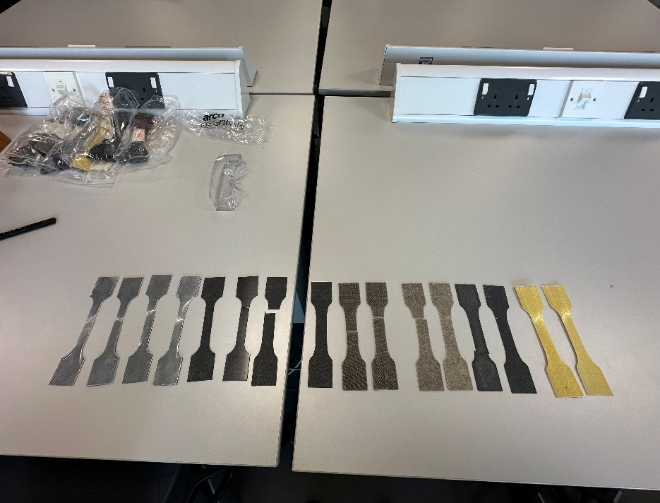
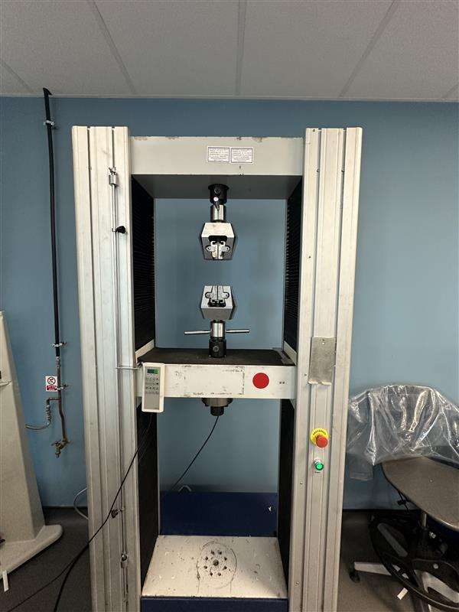
Figure 1
Figure 2

Experimental Results
All data highlighted in Orange was excluded from graphs as they show inconsistencies in the data.
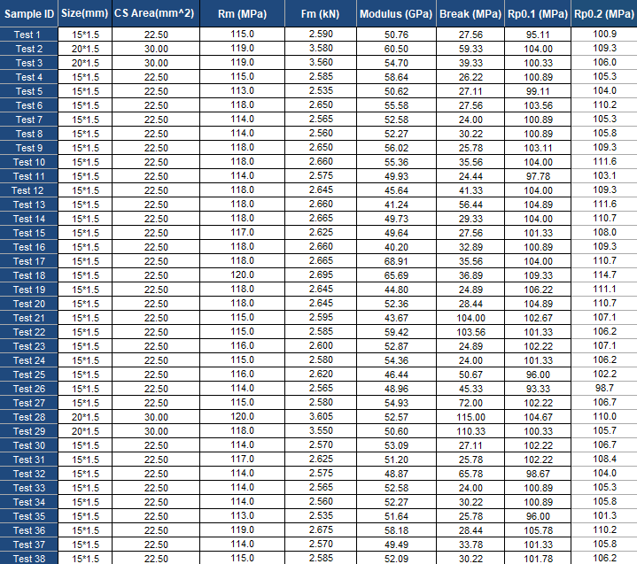
Table 1 - Aluminium samples

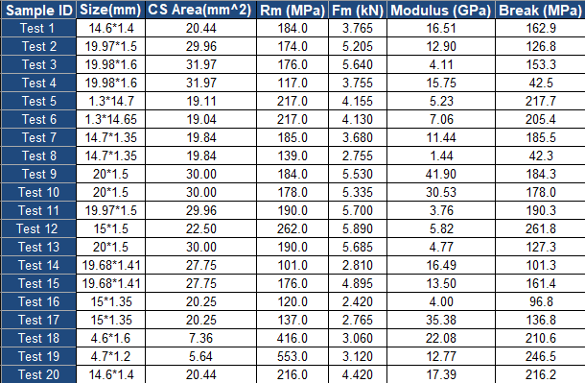
Table 2 - Carbon Non-Woven Bio samples

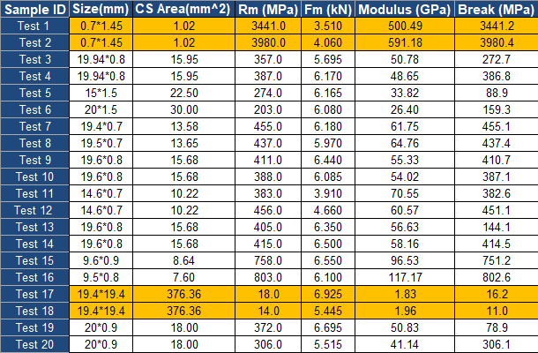
Table 3 - Carbon Woven Bio Resin

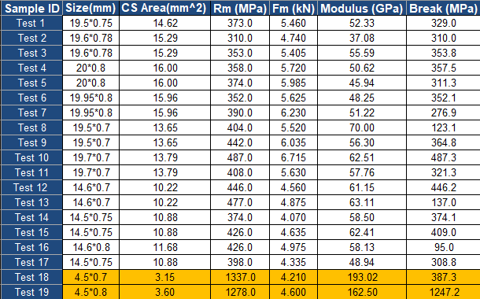
Table 4 - Carbon Woven Epoxy Resin

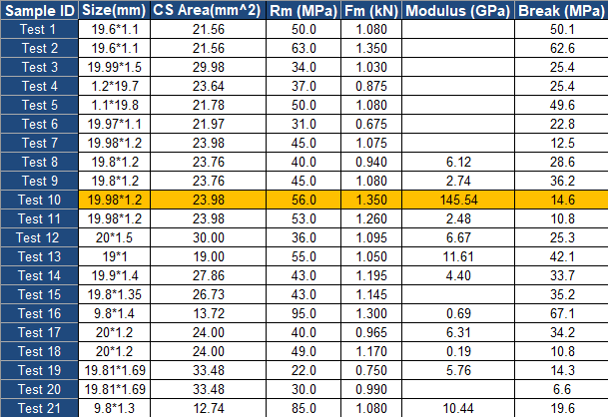
Table 5 - Flax Non-Woven Bio

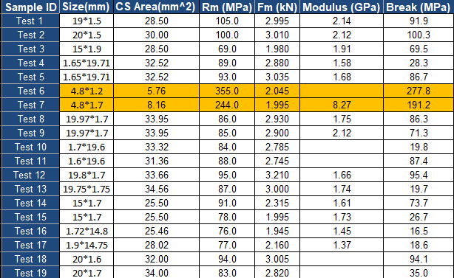
Table 6 - Flax Woven Bio samples

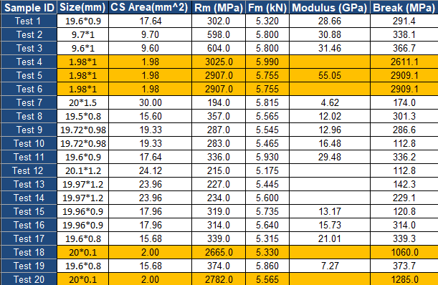
Table 7 - Kevlar Woven Bio samples

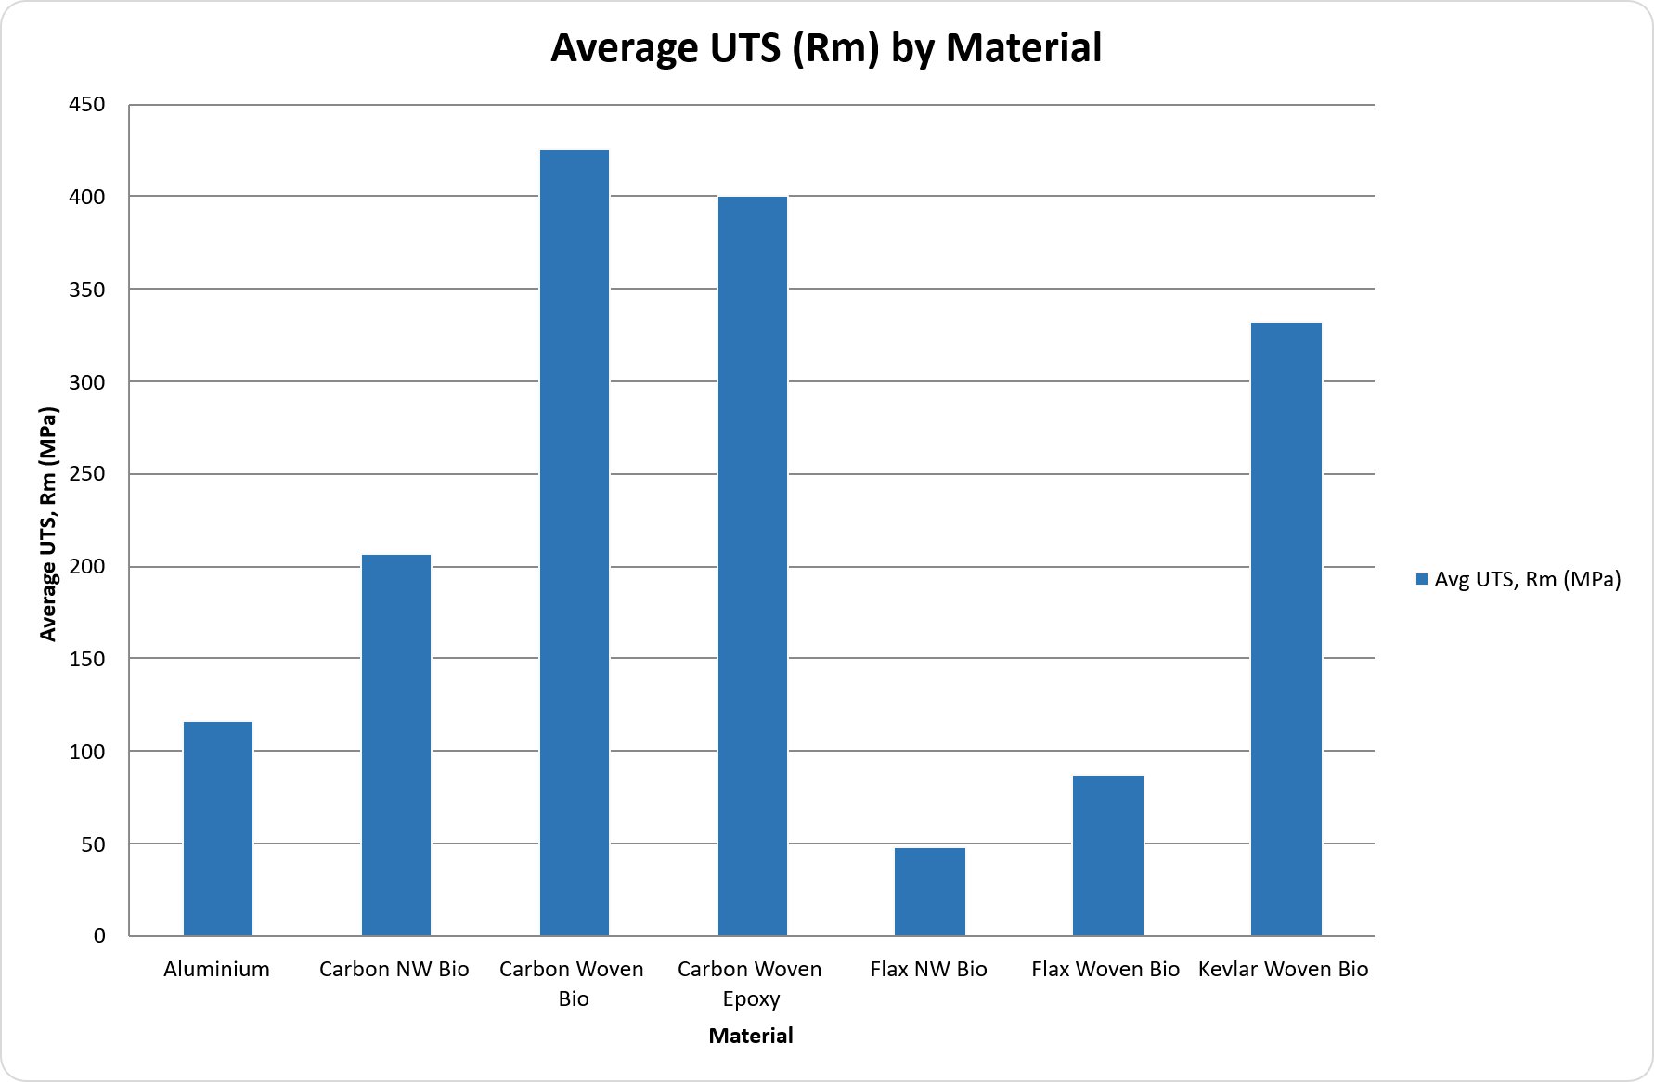
Figure 3 – Average UTS comparison of all tested materials

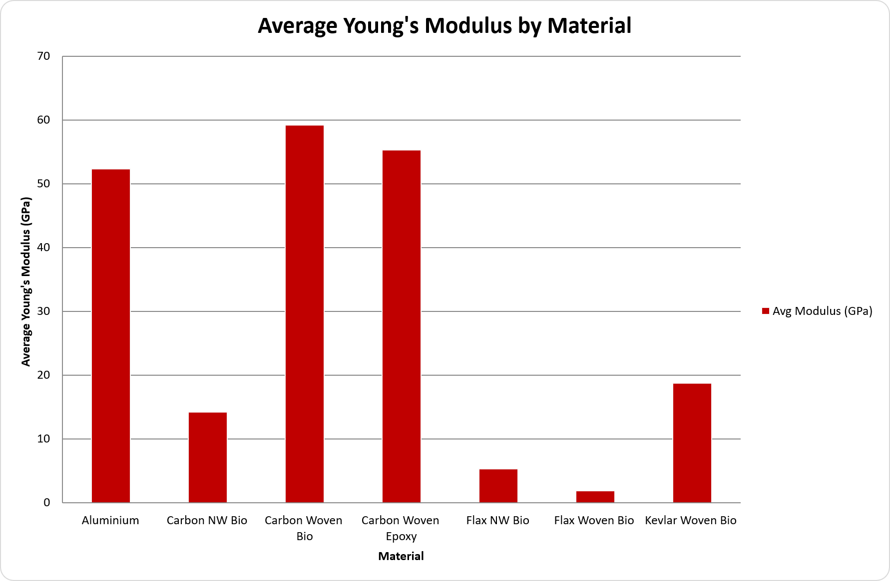
Figure 4 – Average Youngs Modulus comparison of all tested materials

Discussion

Performance Comparison
The experimental results establish a clear hierarchy in mechanical performance, with carbon fibre reinforced composites significantly outperforming both aluminium and natural fibre systems. Carbon woven bio achieved the highest mean ultimate tensile strength (UTS) of 425.6 MPa, marginally exceeding carbon woven epoxy (399.9 MPa), indicating that substitution of conventional epoxy with a bio-derived matrix does not compromise tensile performance. This finding is particularly significant given the conventional assumption that bio-based resins exhibit inferior mechanical properties.
In terms of stiffness, carbon woven bio (59.19 GPa) and carbon woven epoxy (55.28 GPa) both demonstrated comparable performance to aluminium (52.33 GPa), reinforcing the suitability of carbon composites for structural applications where rigidity is critical. However, the relatively low modulus recorded for aluminium compared to expected values suggests potential experimental limitations, such as machine compliance or gauge length effects, which must be considered when interpreting comparative performance.
Kevlar woven bio (332.2 MPa, 18.64 GPa) provides a distinct performance profile, characterised by moderate strength but significantly lower stiffness. This reflects the inherent properties of aramid fibres, which prioritise energy absorption and impact resistance over stiffness. In contrast, flax composites exhibited substantially lower tensile strength and modulus, confirming that natural fibre systems remain unsuitable for primary load-bearing structures despite their sustainability advantages.
A key structural insight from the results is the influence of fibre architecture. Woven composites consistently outperformed non-woven equivalents, with carbon woven bio demonstrating more than double the tensile strength and over four times the stiffness of carbon non-woven bio. This can be attributed to improved fibre continuity, alignment, and load transfer efficiency in the multi-layer twill configuration. However, it should be noted that the 45° inter-ply orientation introduces off-axis loading conditions, meaning the measured properties do not represent maximum fibre-direction performance.

Sustainability Trade-offs
While carbon woven bio demonstrates superior mechanical performance, its sustainability advantages must be critically evaluated in the context of the entire material lifecycle. Although the bio-based matrix reduces reliance on petrochemical feedstocks, the dominant environmental burden remains the production of carbon fibre itself, which is highly energy intensive. As such, the overall sustainability improvement relative to conventional carbon fibre composites is incremental rather than transformative.
Flax-based composites represent the most environmentally favourable materials tested, due to their renewable origin, carbon sequestration during growth, and improved recyclability. However, the significant reduction in mechanical performance limits their application to non-structural or semi-structural components. This highlights a fundamental trade-off: materials that offer the greatest environmental benefits often fail to meet the mechanical demands of high-performance applications.
Kevlar woven bio presents an intermediate solution, balancing mechanical performance with partial sustainability improvements through the use of a bio-derived matrix. However, like carbon fibre, aramid fibres are energy intensive to produce and present recycling challenges, limiting their long-term sustainability potential.
From an industrial perspective, the feasibility of adopting sustainable composites is constrained not only by material properties but also by economic and manufacturing considerations. High-performance composites such as CFRP remain expensive and are typically restricted to low-volume applications such as motorsport. Conversely, natural fibre composites offer cost advantages but require further development to meet structural performance requirements. Therefore, a hybrid material strategy is likely to represent the most practical pathway, combining high-performance composites for structural components with natural fibre systems for interior and secondary applications.

Limitations of Testing
Several limitations within the experimental methodology must be considered when interpreting the results. Firstly, testing was restricted to uniaxial tensile loading, which does not fully represent the complex loading conditions experienced in real-world automotive and motorsport applications. Properties such as impact resistance, fatigue behaviour, and compressive strength are critical for material selection but were not evaluated in this study.
Secondly, variability in sample preparation, including potential inconsistencies in resin infusion, fibre alignment, and void content, introduces uncertainty into the dataset. While a relatively large number of samples were tested, the exclusion of anomalous data points highlights the presence of variability that may affect the reliability of the mean values.
Additionally, the use of a 45° inter-ply orientation for woven composites means that the measured properties reflect off-axis behaviour rather than optimal fibre-direction performance. This limits the direct comparability of results with manufacturer datasheets, which are typically based on unidirectional or optimised lay-ups.
Finally, differences between experimental results and datasheet values, particularly for carbon non-woven composites, indicate that manufacturing method plays a critical role in determining material performance. Vacuum infusion, while practical for laboratory testing, does not achieve the same fibre volume fraction or consolidation quality as industrial processes such as compression moulding.

Validation with Literature Data
Material | Experimental UTS (MPa) | Reference UTS (MPa) | Experimental Young's Modulus (GPa) | Reference Young's Modulus (GPa) | Source
Aluminium | 116.3 | ≤90% of 150 max | 52.3 | 69 | (aalco, 2026)
Carbon NW Bio | 206.6 | 290–330 | 14.1 | 25–35 | (Rahmani et al., 2014)
Carbon Woven Bio | 425.6 | 530–856 | 59.2 | 38–41 | (Canaroli et al., 2025)
Carbon Woven Epoxy | 399.9 | 530–856 | 55.3 | 38–41 | (Canaroli et al., 2025)
Flax NW Bio | 47.7 | 37–44 | 5.22 | 5 | EcoTechnilin (2023)
Flax Woven Bio | 87.1 | 58–61 | 1.76 | 6–7 | EcoTechnilin (2023)
Kevlar Woven Bio | 332.2 | 200–303 | 18.6 | 13.9–16.3 | (Oliwa, 2020)
Table 8 - Comparison of experimental results against manufacturer datasheet values.
Comparison with manufacturer datasheets and literature provides validation of the experimental results while highlighting discrepancies arising from differences in processing, fibre architecture, and testing conditions.
Aluminium shows good agreement in tensile strength, with a UTS of 116.3 MPa within the expected range for 6000-series alloys. However, the measured modulus of 52.3 GPa is approximately 25–30% lower than the expected 69 GPa, likely due to experimental factors such as machine compliance or strain measurement inaccuracies rather than material behaviour.
Carbon non-woven bio exhibits reduced performance relative to reference values, with UTS approximately 30–35% lower and modulus 40–50% below expected ranges. This can be attributed to poor fibre alignment, reduced fibre length from recycled content, and the limitations of vacuum infusion, which typically produces lower fibre volume fraction and higher void content than industrial processes.
Carbon woven composites show lower tensile strength than reference values but higher modulus. This reflects the influence of laminate configuration, as the 45° inter-ply orientation reduces tensile strength in the loading direction while increasing apparent stiffness through shear-dominated behaviour. This highlights the strong dependence of composite properties on fibre orientation.
Flax non-woven bio aligns closely with datasheet values, indicating that the manufacturing process achieved representative material performance. In contrast, flax woven bio demonstrates higher tensile strength but significantly reduced modulus, reflecting the combined effects of multi-layer construction and off-axis fibre orientation.
Kevlar woven bio shows higher strength and slightly increased stiffness compared to reference values, likely due to differences in fibre volume fraction and laminate configuration, as well as inherent variability in aramid composites.
Overall, while general trends align with literature, discrepancies are primarily driven by manufacturing method, fibre architecture, and testing conditions. This reinforces that datasheet values represent optimised conditions and may not be directly comparable to experimental results.

Recommendations
Based on the combined analysis of mechanical performance and sustainability considerations, carbon woven bio is identified as the most suitable material for high-performance structural applications within motorsport and low-volume automotive engineering. Its ability to match or exceed the performance of conventional carbon woven epoxy, while incorporating a bio-derived matrix, demonstrates that incremental sustainability improvements can be achieved without compromising structural integrity. However, its adoption should be considered within the context of its continued reliance on energy-intensive carbon fibre production.
For applications where impact resistance and energy absorption are critical, such as crash structures and safety components, Kevlar woven bio is recommended as either a standalone material or as part of a hybrid laminate system. Its mechanical properties, while lower in stiffness, provide advantages in durability and failure behaviour that are not captured by tensile testing alone.
Flax-based composites are recommended for non-structural and interior applications, where their sustainability benefits can be maximised without compromising safety or performance requirements. Their low density, renewable origin, and recyclability align strongly with current legislative pressures, particularly the EU End-of-Life Vehicle Directive. However, their use should be limited to applications where mechanical demands are relatively low.
A hybrid material approach is therefore recommended, combining carbon woven bio for primary load-bearing structures with flax-based composites for secondary components. This strategy enables optimisation of both performance and environmental impact, reflecting current industry trends toward material diversification.
Future research should prioritise multi-axial mechanical testing, including fatigue, impact, and compressive behaviour, to provide a more comprehensive understanding of material performance. Additionally, further investigation into scalable recycling technologies, such as solvolysis and thermoplastic composite systems, is essential to address the end-of-life limitations of fibre-reinforced polymers. The development of cost-effective and industrially viable recycling infrastructure will be critical in determining the long-term sustainability of composite materials in both automotive and motorsport sectors.

Conclusion
This study has demonstrated that carbon fibre reinforced composites remain the dominant materials for high-performance applications due to their superior strength-to-weight ratio and stiffness. Carbon woven bio, in particular, achieved the highest tensile strength and modulus of all materials tested, confirming that bio-based resin systems can be implemented without compromising mechanical performance. This represents a meaningful step toward improving the sustainability profile of high-performance composites, although the environmental impact associated with carbon fibre production remains a significant limitation.
Flax-based composites offer clear sustainability advantages, including renewability and improved end-of-life recyclability, but their substantially lower mechanical properties restrict their application to non-structural components. Kevlar woven bio provides a balance between performance and functionality, particularly in applications requiring impact resistance, but does not significantly reduce environmental impact compared to carbon-based systems.
The findings highlight a fundamental challenge within the automotive and motorsport industries: achieving a balance between mechanical performance and environmental sustainability. No single material currently satisfies both requirements fully, and as a result, a hybrid material strategy is the most practical approach. By integrating high-performance composites with more sustainable alternatives, it is possible to optimise both structural efficiency and environmental impact.
Ultimately, the transition toward sustainable composite materials will depend not only on material innovation but also on advances in manufacturing processes, recycling technologies, and supporting infrastructure. Continued research and development in these areas will be essential to enable the widespread adoption of sustainable composites in high-performance engineering applications.

References
aalco. (2026). Aluminium Alloy - Commercial Alloy - 1050A H14 Sheet. https://www.aalco.co.uk/datasheets/Aluminium-Alloy-1050A-H14-Sheet_57.ashx
Canaroli, L., Baldi, N., Del Pero, F., La Battaglia, V., Arcidiacono, G., & Citti, P. (2025). Mechanical characterization of carbon fiber composite materials with different reinforcement and thickness cured in autoclave. Hybrid Advances, 11. https://doi.org/10.1016/j.hybadv.2025.100550
Choi, J. Y., Jeon, J. H., Lyu, J. H., Park, J., Kim, G. Y., Chey, S. Y., Quan, Y. J., Bhandari, B., Prusty, B. G., & Ahn, S. H. (2023). Current Applications and Development of Composite Manufacturing Processes for Future Mobility. In International Journal of Precision Engineering and Manufacturing - Green Technology (Vol. 10, Number 1, pp. 269–291). Korean Society for Precision Engineeing. https://doi.org/10.1007/s40684-022-00483-3
Mengesha Aznaw, G. (2025). Advances in Composite Structures: A Systematic Review of Design, Performance, and Sustainability Trends. https://doi.org/10.11648/j.cm.20250901.11
Oliwa, R. (2020). The mechanical properties of kevlar fabric/epoxy composites containing aluminosilicates modified with quaternary ammonium and phosphonium salts. Materials, 13(17). https://doi.org/10.3390/MA13173726
Rahmani, H., Najafi, S. H. M., & Ashori, A. (2014). Mechanical performance of epoxy/carbon fiber laminated composites. Journal of Reinforced Plastics and Composites, 33(8), 733–740. https://doi.org/10.1177/0731684413518255
Ravishankar, B., Nayak, S. K., & Kader, M. A. (2019). Hybrid composites for automotive applications – A review. Journal of Reinforced Plastics and Composites, 38(18), 835–845. https://doi.org/10.1177/0731684419849708
Sarfraz, M. S., Hong, H., & Kim, S. S. (2021). Recent developments in the manufacturing technologies of composite components and their cost-effectiveness in the automotive industry: A review study. In Composite Structures (Vol. 266). Elsevier Ltd. https://doi.org/10.1016/j.compstruct.2021.113864
Shamsi, N. A., Vohra, P., Dagar, P., & Sharma, P. (2022). Review of Sustainable Materials for Automotive Applications. International Journal of Scientific Research in Engineering and Management, 06(10), 1–9. https://doi.org/10.55041/IJSREM16704
Skosana, S. J., Khoathane, C., & Malwela, T. (2025). Driving towards sustainability: A review of natural fiber reinforced polymer composites for eco-friendly automotive light-weighting. In Journal of Thermoplastic Composite Materials (Vol. 38, Number 2, pp. 754–780). SAGE Publications Ltd. https://doi.org/10.1177/08927057241254324
Yan, L., & Xu, H. (2025). Lightweight composite materials in automotive engineering: State-of-the-art and future trends. Alexandria Engineering Journal, 118, 1–10. https://doi.org/10.1016/j.aej.2024.12.002

Appendix

Aluminium
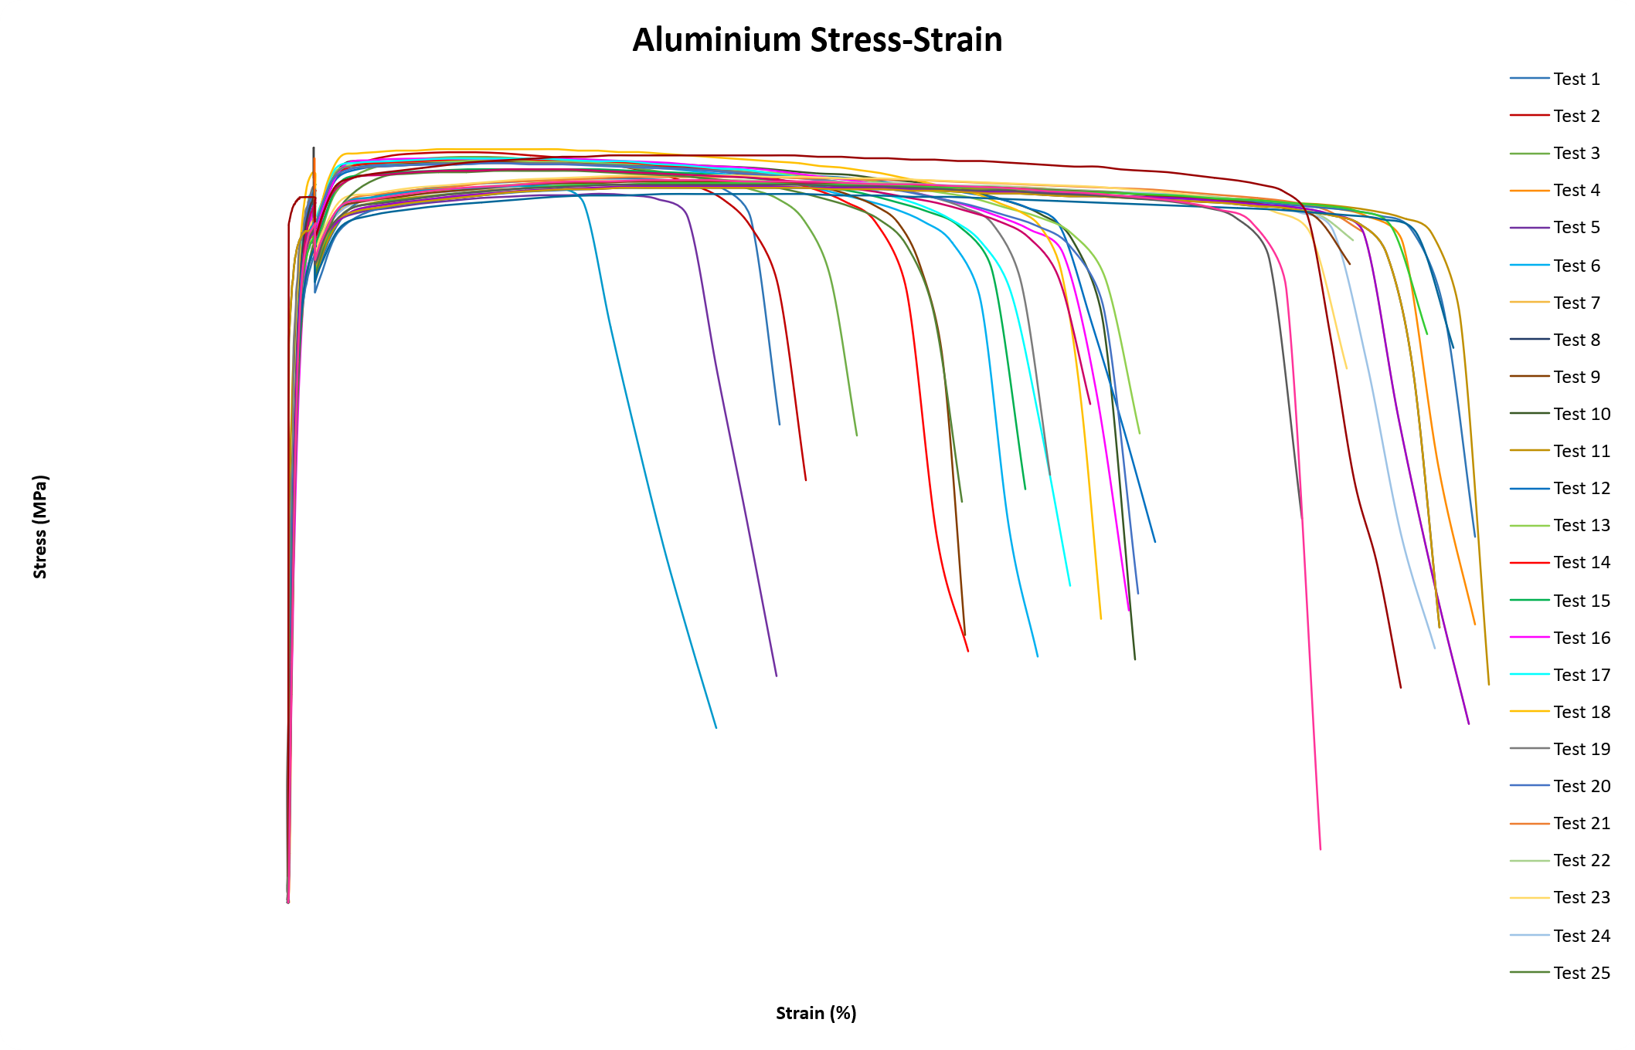
Figure 5 – Aluminium tests Stress-strain curves

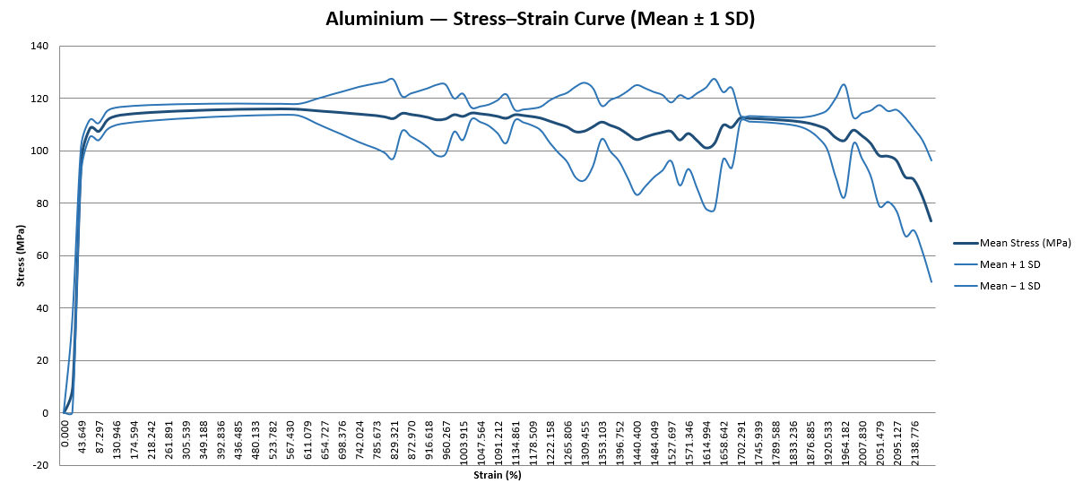
Figure 6 - Stress–Strain Curve (Mean ± 1 SD)

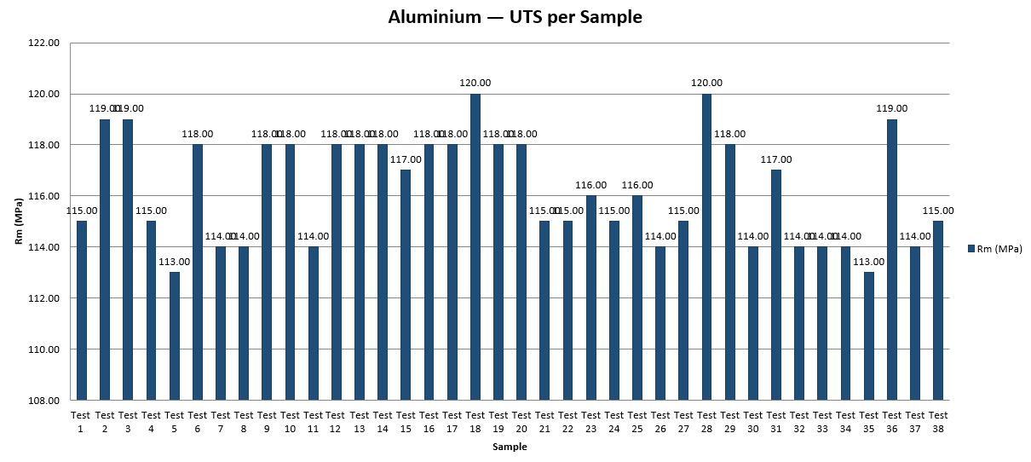
Figure 7 - Ultimate Tensile Strength (Rm) per Sample

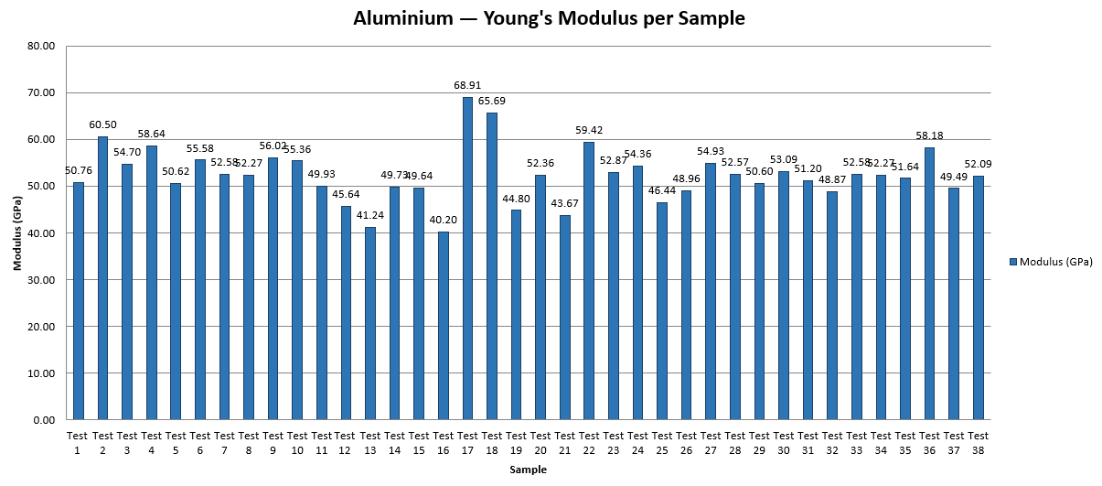
Figure 8 - Young's Modulus per Sample

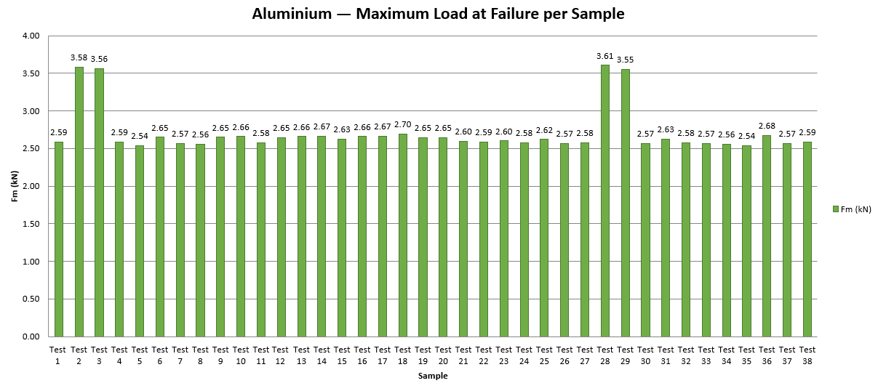
Figure 9 - Maximum Load at Failure (Fm) per Sample

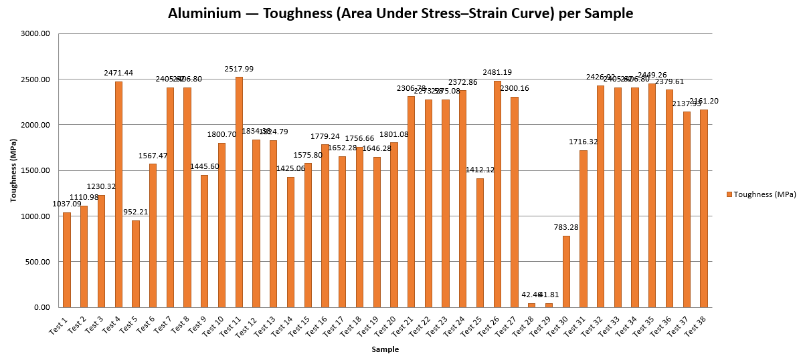
Figure 10 - Energy Absorption / Toughness per Sample

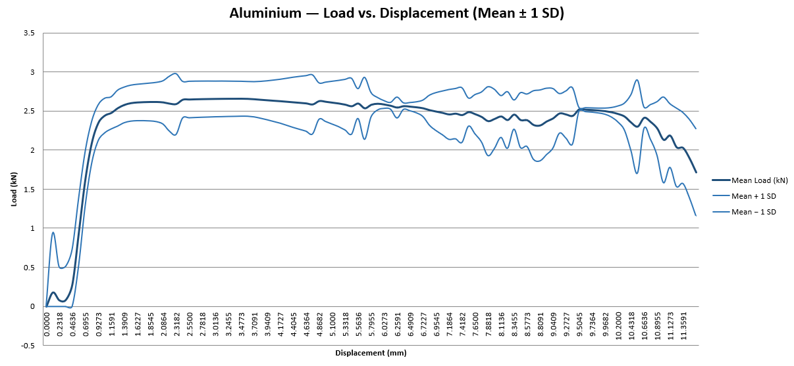
Figure 11 - Load–Displacement Curve (Mean ± 1 SD)

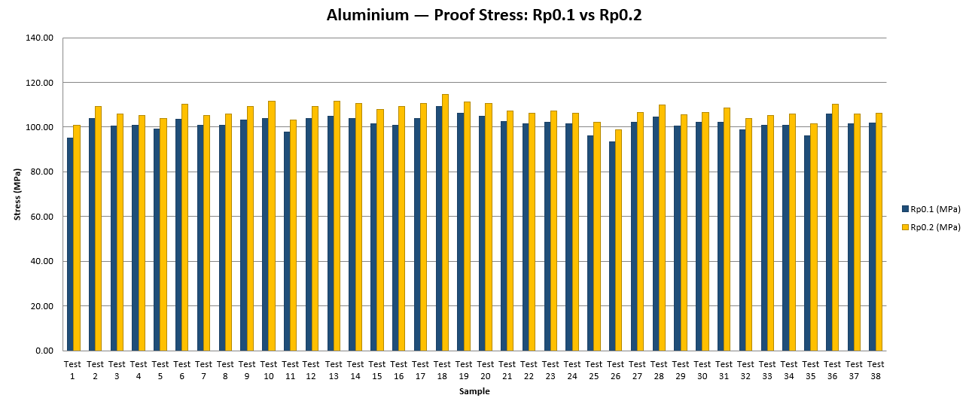
Figure 12 - Proof Stress Comparison (Rp0.1 vs Rp0.2)

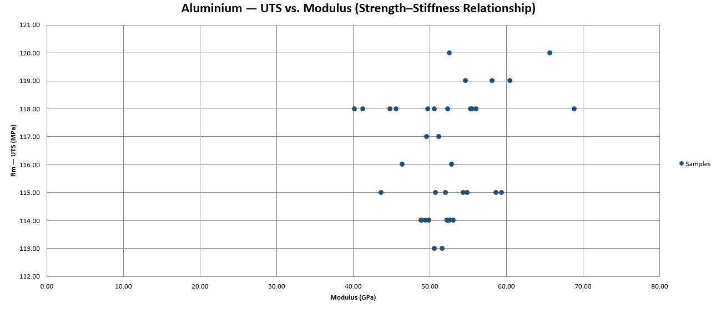
Figure 13 - UTS vs. Modulus Scatter Plot

Carbon non-Woven Bio
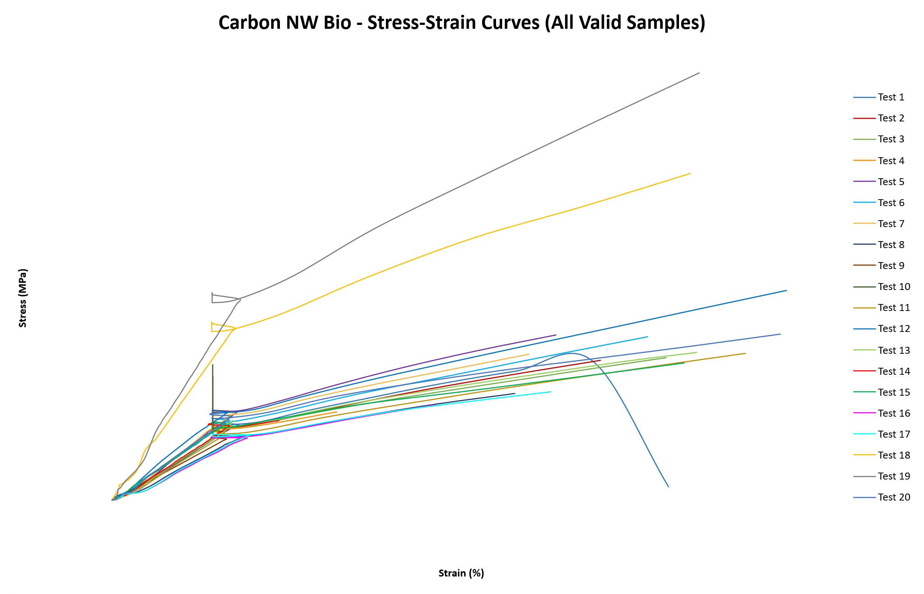
Figure 14 – Carbon Non Woven Bio tests Stress-strain curves

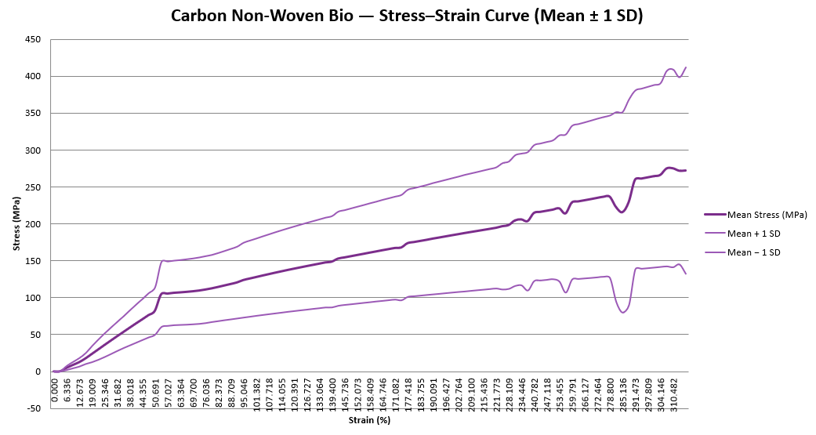
Figure 15 - Stress–Strain Curve (Mean ± 1 SD)

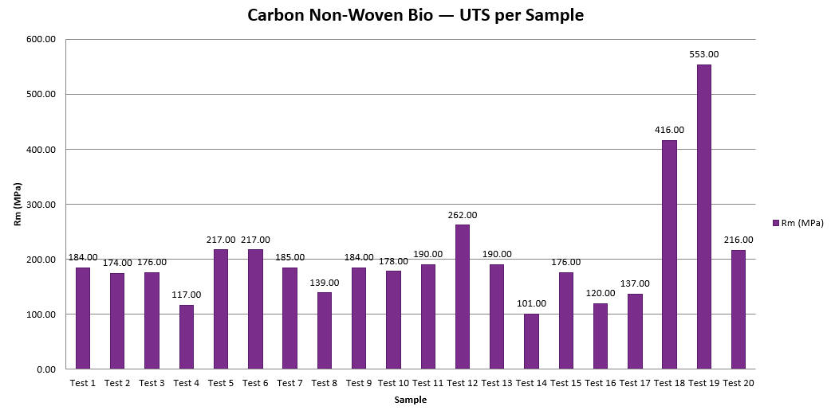
Figure 16 - Ultimate Tensile Strength (Rm) per Sample

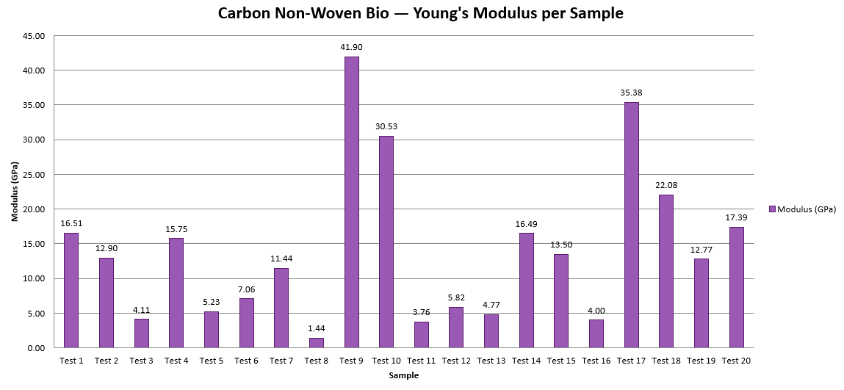
Figure 17 - Young's Modulus per Sample

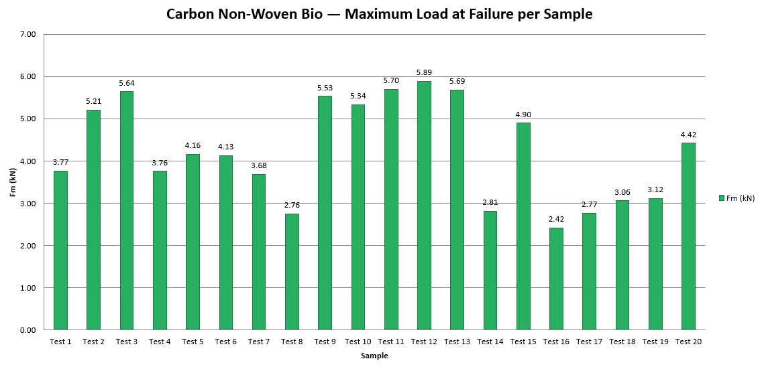
Figure 18 - Maximum Load at Failure (Fm) per Sample

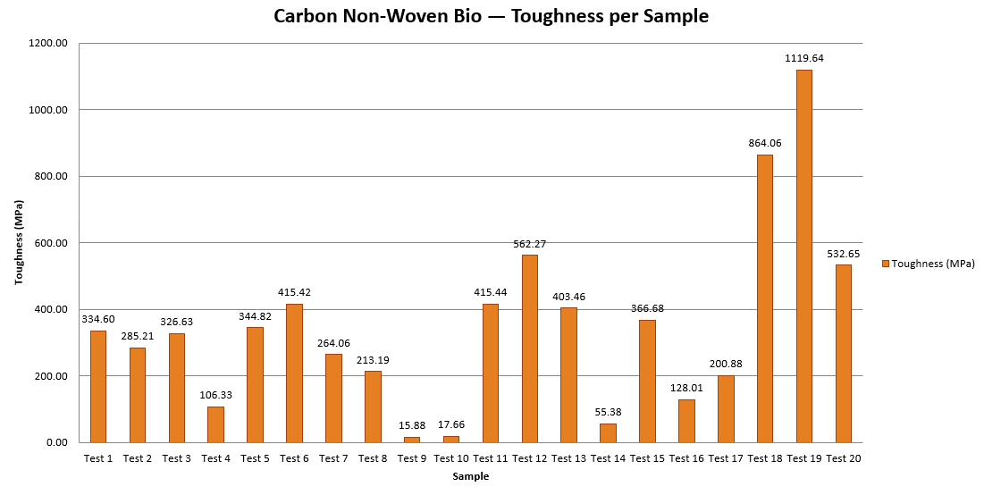
Figure 19 - Energy Absorption / Toughness per Sample

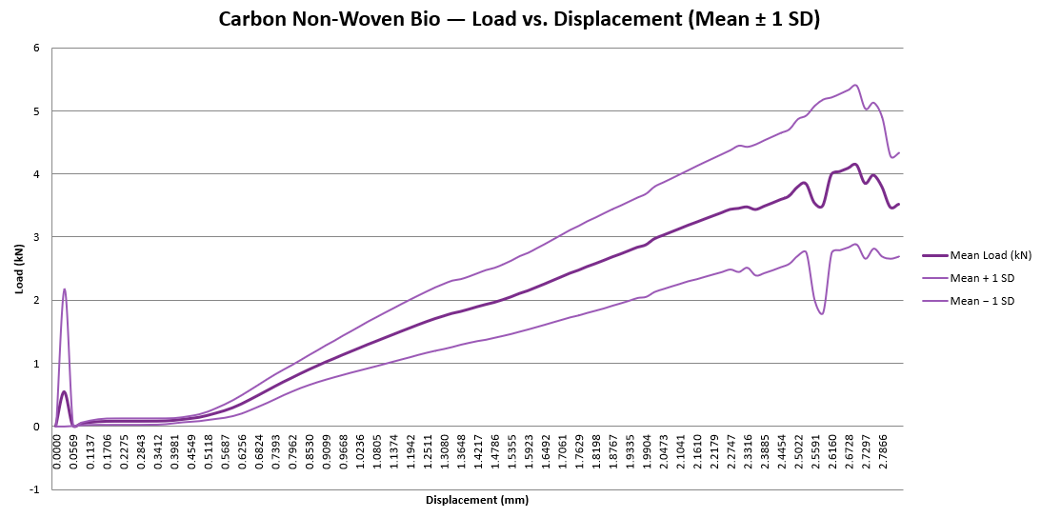
Figure 20 - Load–Displacement Curve (Mean ± 1 SD)

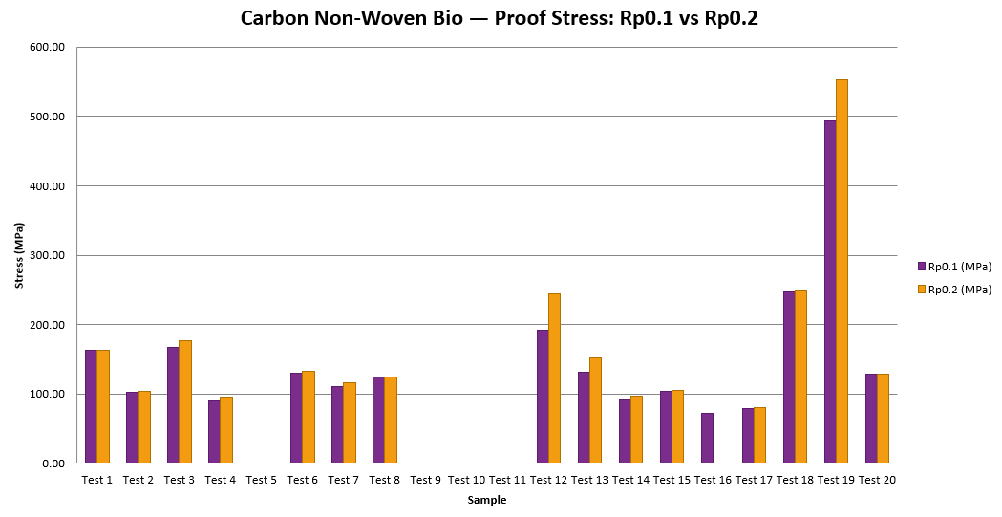
Figure 21 - Proof Stress Comparison (Rp0.1 vs Rp0.2)

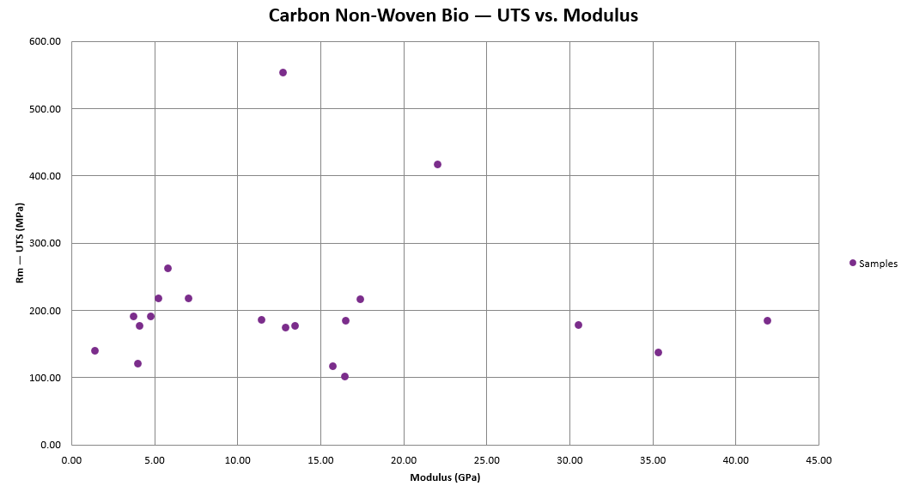
Figure 22 - UTS vs. Modulus Scatter Plot

Carbon Woven Bio
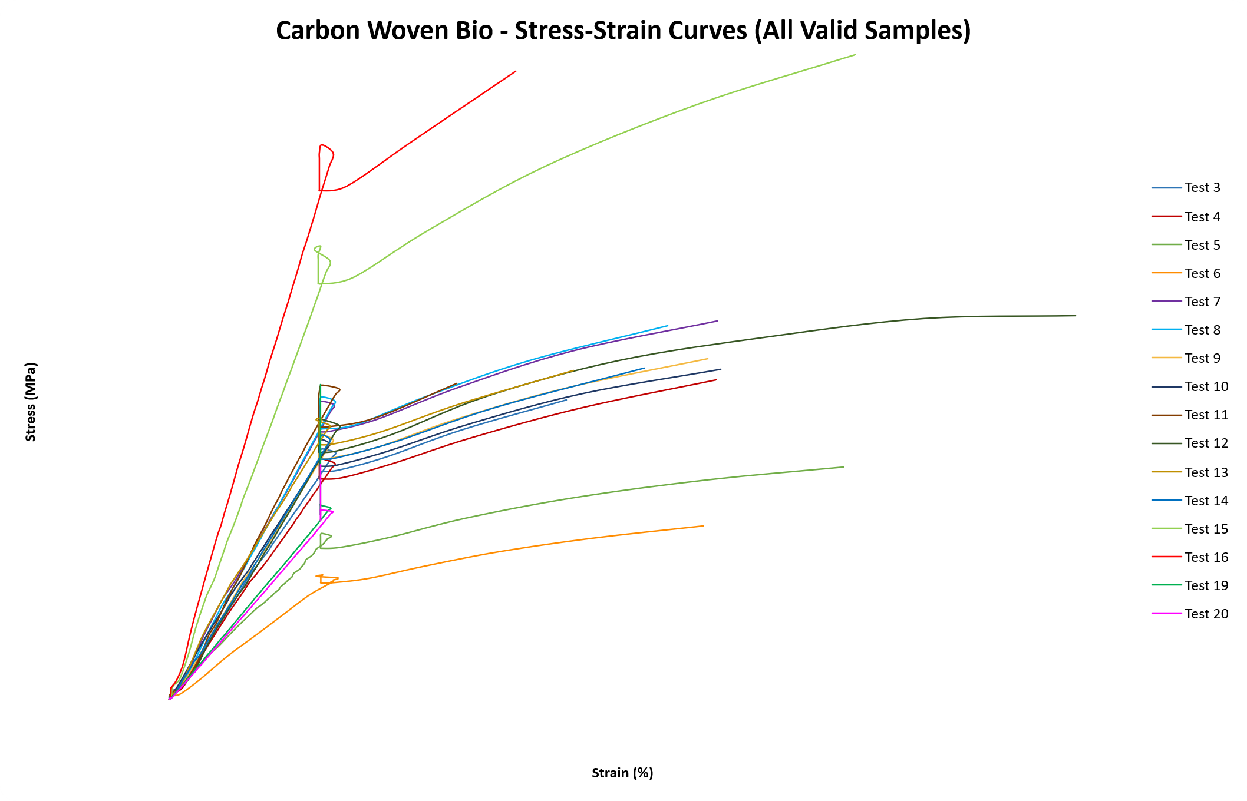
Figure 23 – Carbon Woven Bio tests Stress-strain curves

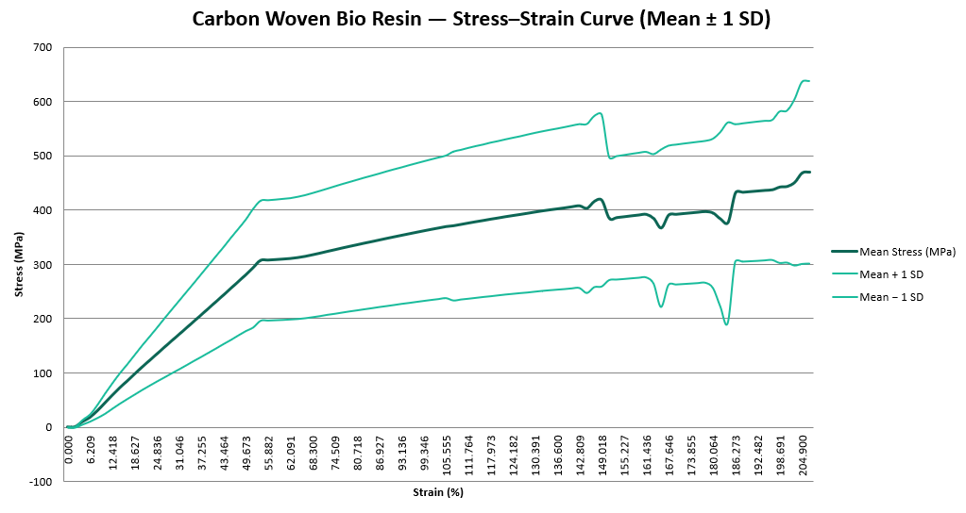
Figure 24 - Stress–Strain Curve (Mean ± 1 SD) [16 valid samples]

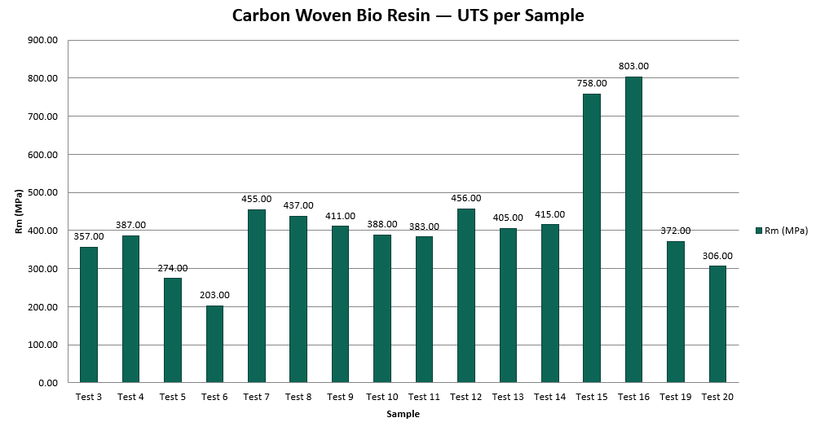
Figure 25 - Ultimate Tensile Strength (Rm) per Sample

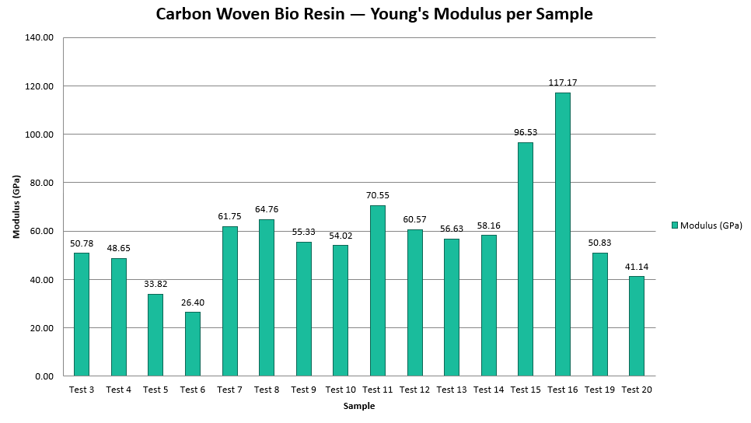
Figure 26 - Young's Modulus per Sample

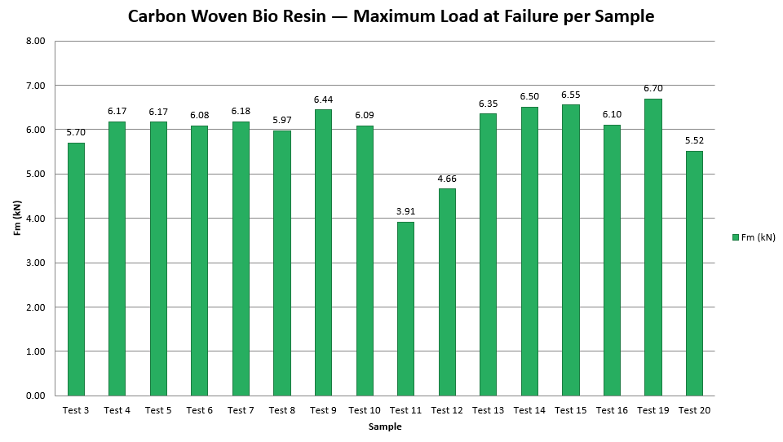
Figure 27 - Maximum Load at Failure (Fm) per Sample

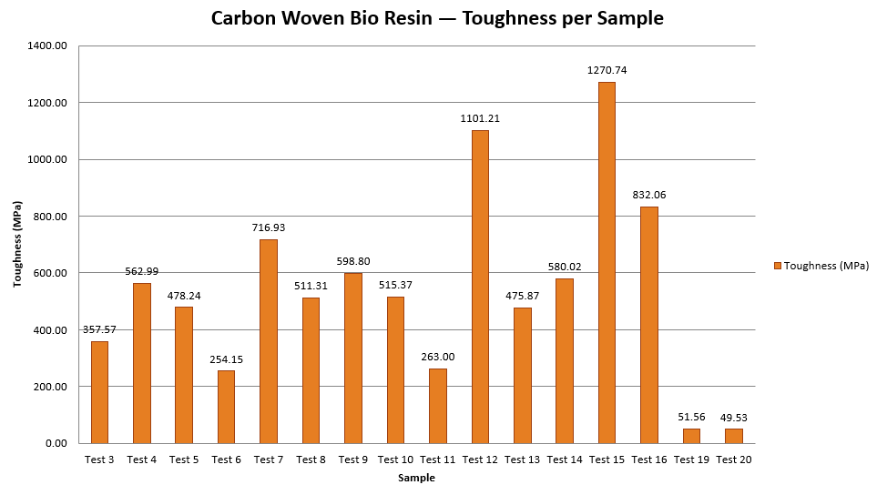
Figure 28 - Energy Absorption / Toughness per Sample

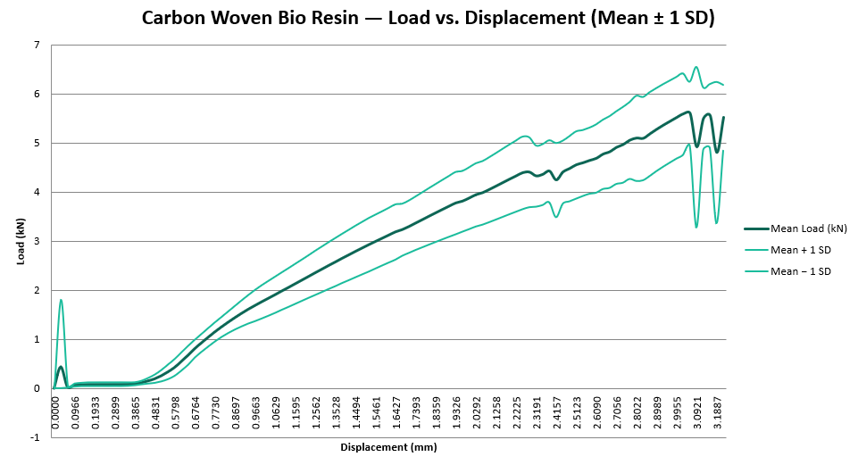
Figure 29 - Load–Displacement Curve (Mean ± 1 SD)

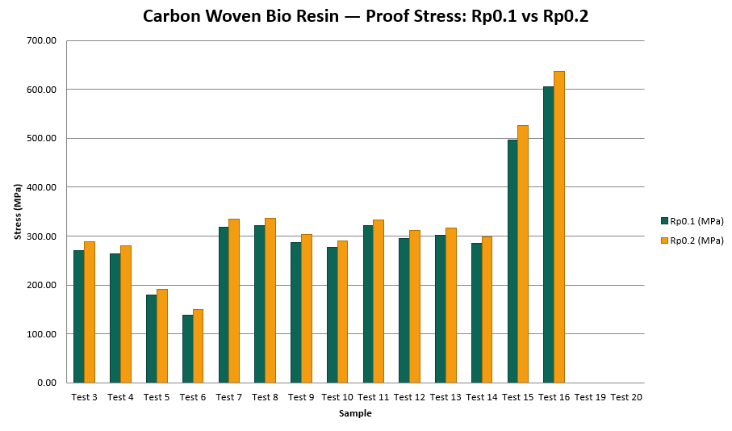
Figure 30 - Proof Stress Comparison (Rp0.1 vs Rp0.2)

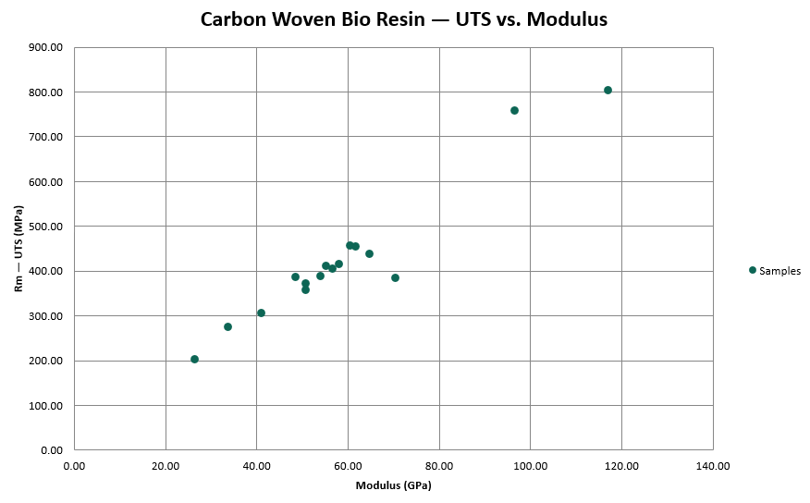
Figure 31 - UTS vs. Modulus Scatter Plot

Carbon Woven Epoxy
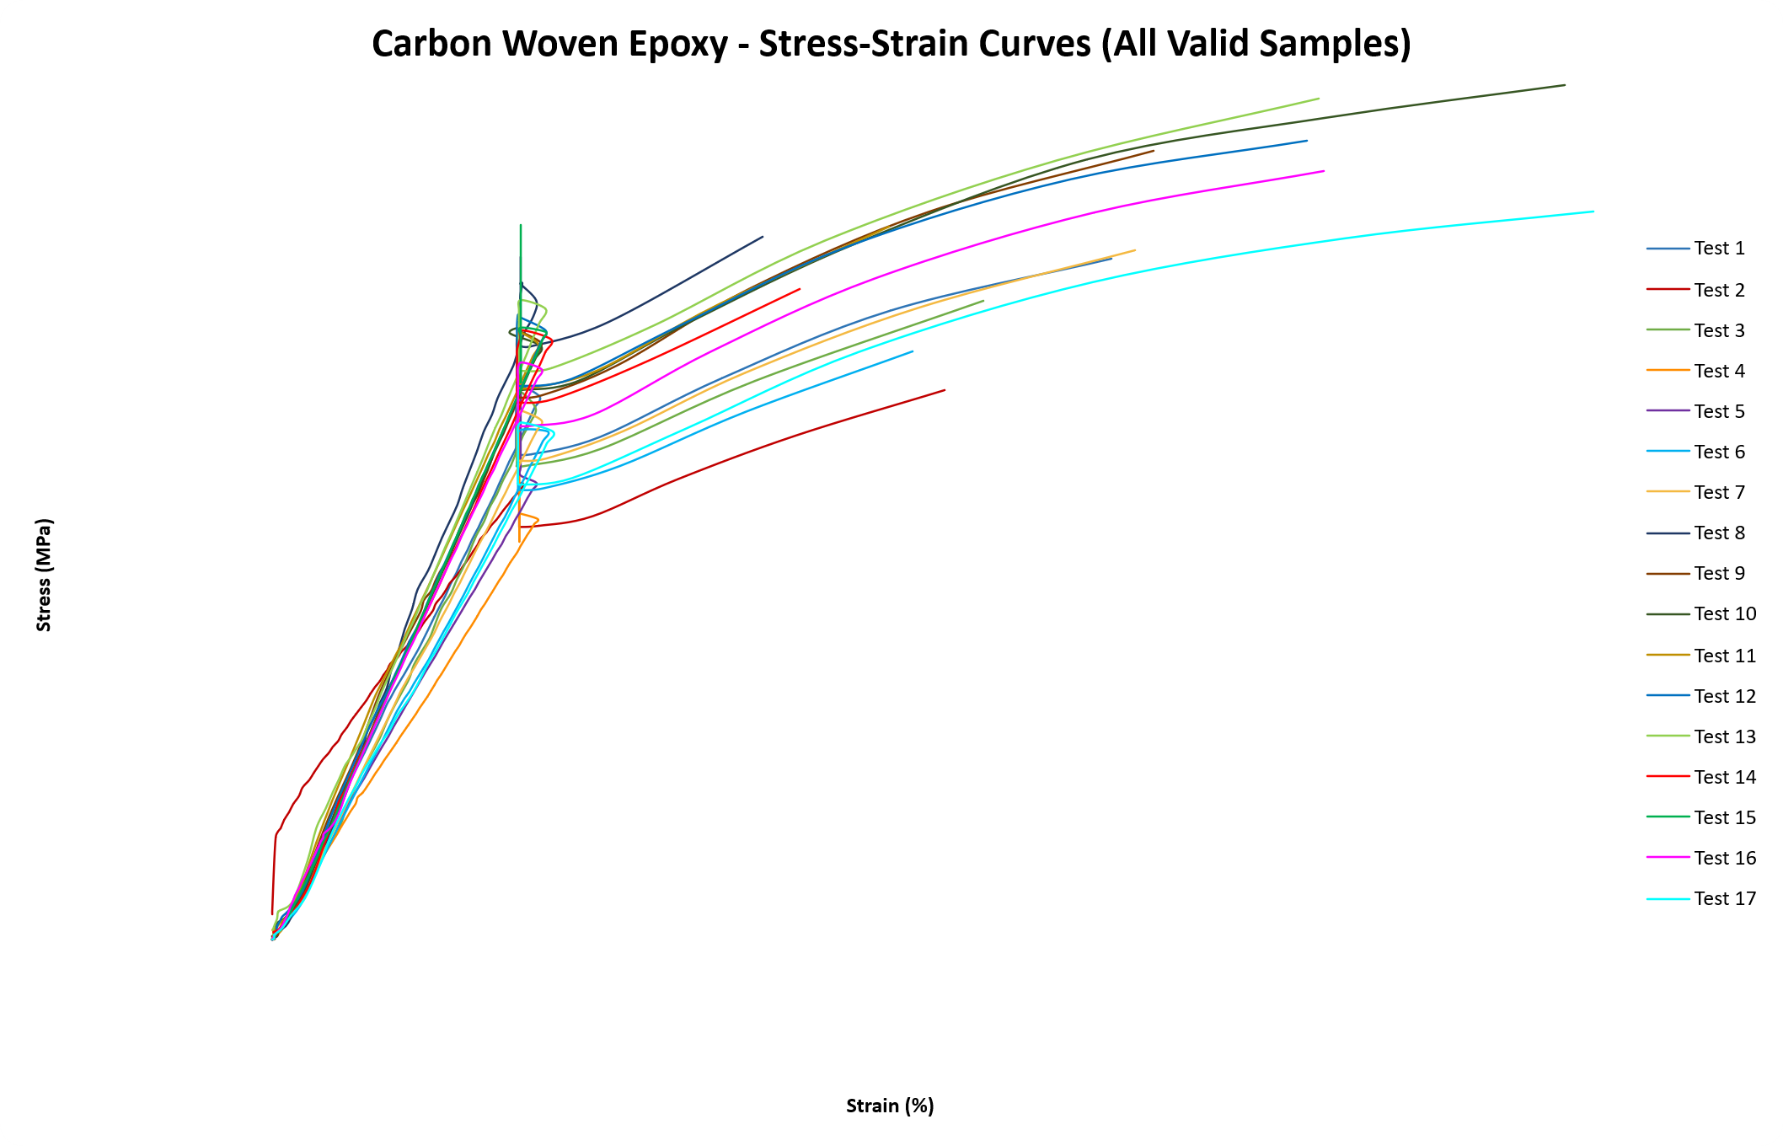
Figure 32 - Carbon Woven Epoxy tests Stress-strain curves

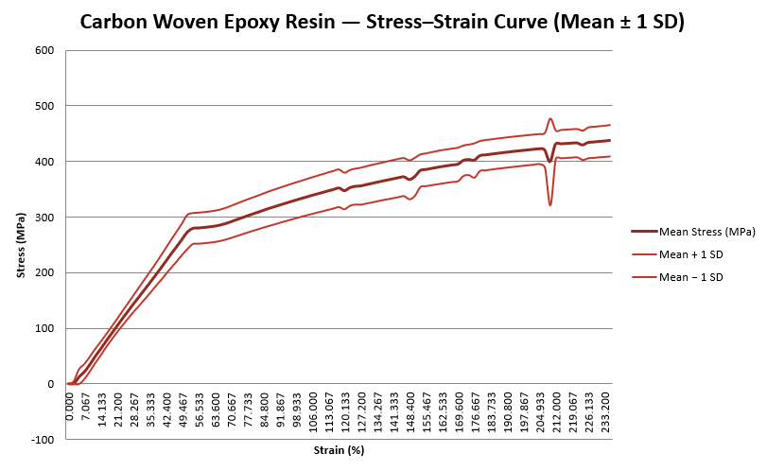
Figure 33 - Stress–Strain Curve (Mean ± 1 SD) [17 valid samples]

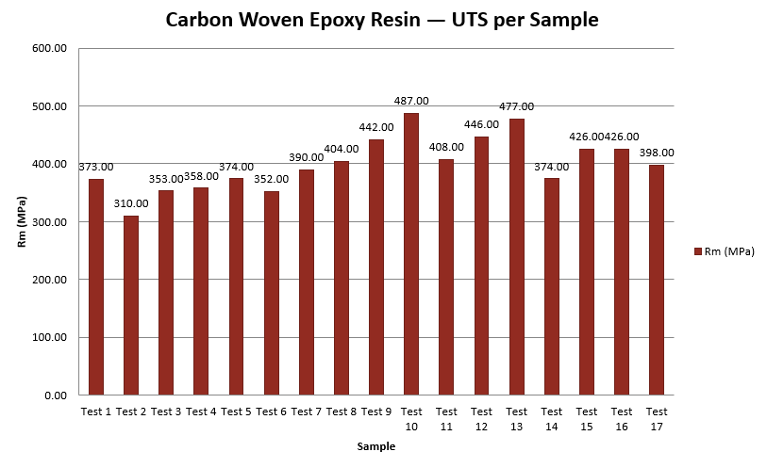
Figure 34 - Ultimate Tensile Strength (Rm) per Sample

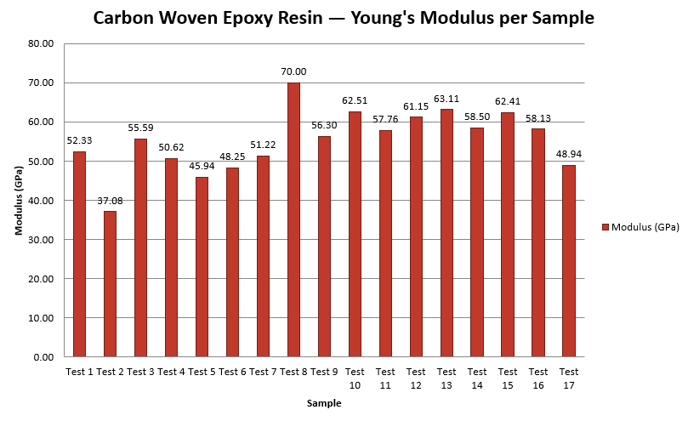
Figure 35 - Young's Modulus per Sample

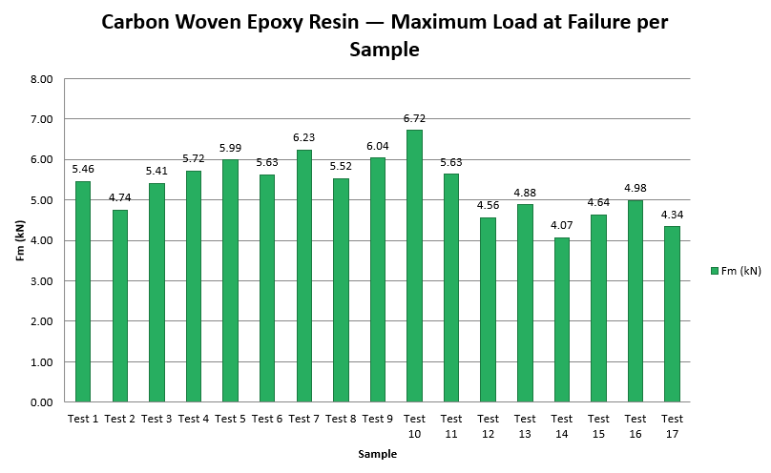
Figure 36 - Maximum Load at Failure (Fm) per Sample

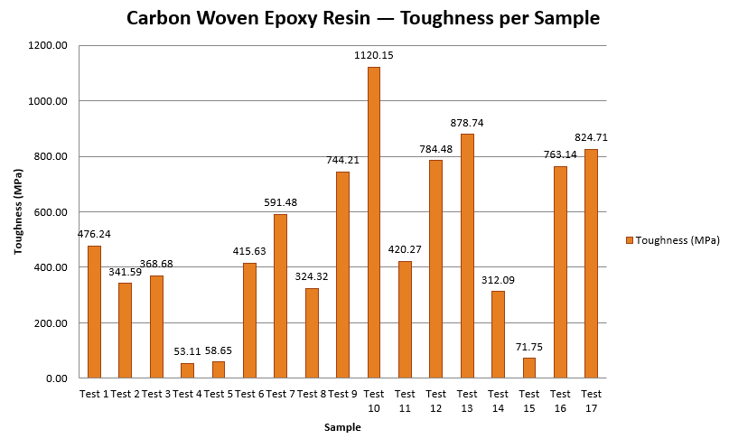
Figure 37 - Energy Absorption / Toughness per Sample

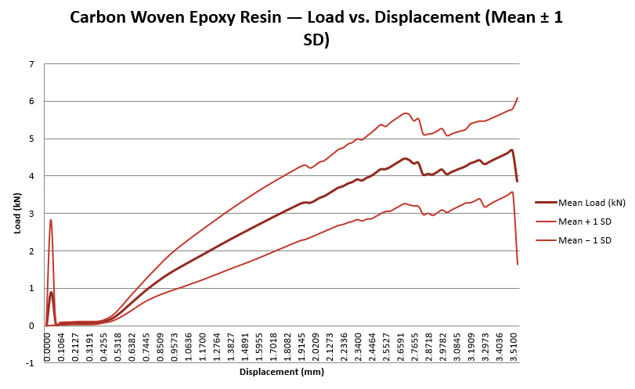
Figure 38 - Load–Displacement Curve (Mean ± 1 SD)

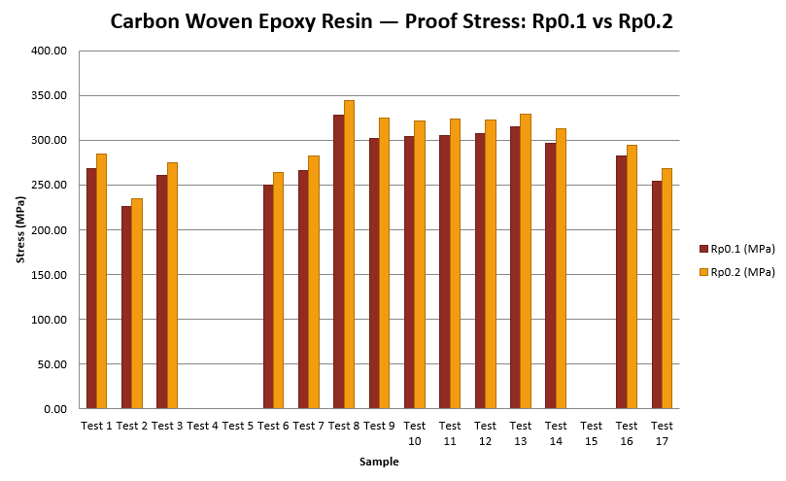
Figure 39 - Proof Stress Comparison (Rp0.1 vs Rp0.2)

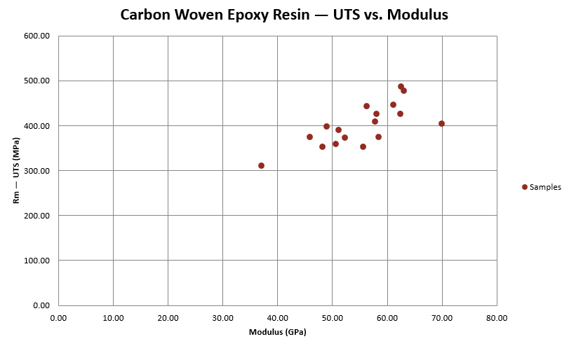
Figure 40 - UTS vs. Modulus Scatter Plot

Flax non-woven bio
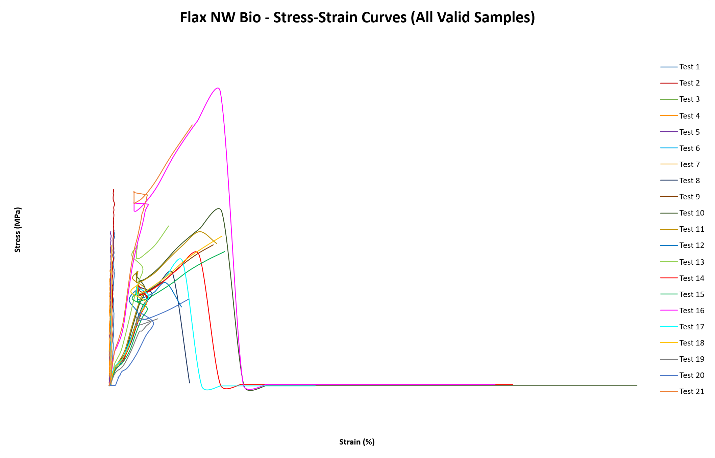
Figure 41 – Flax Non Woven Bio tests Stress-strain curves
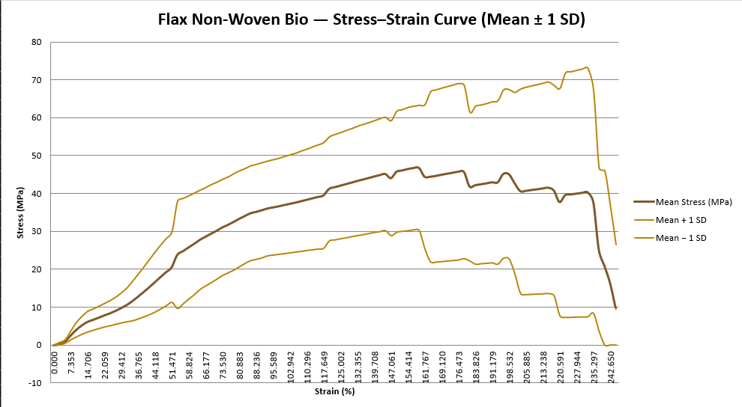
Figure 42 - Stress–Strain Curve (Mean ± 1 SD) [21 samples]
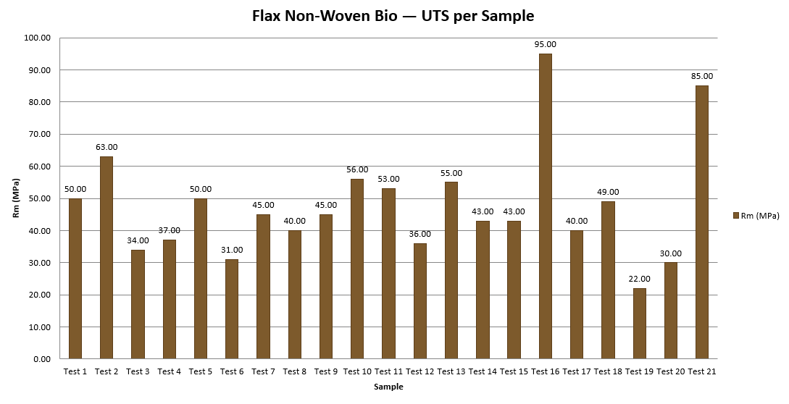
Figure 43 - Ultimate Tensile Strength (Rm) per Sample

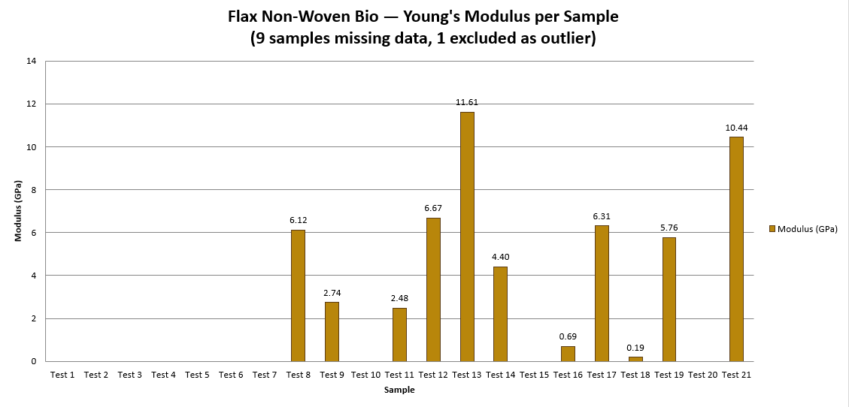
Figure 44 - Young's Modulus per Sample (12 samples with valid data)

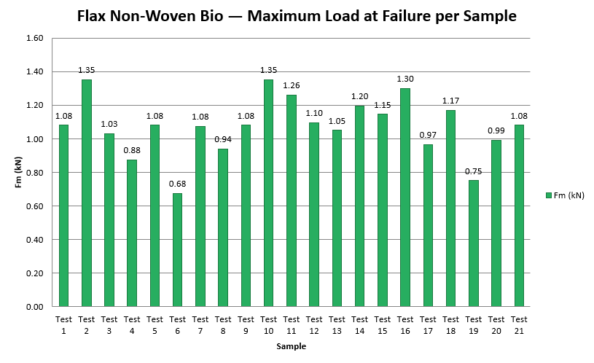
Figure 45 - Maximum Load at Failure (Fm) per Sample

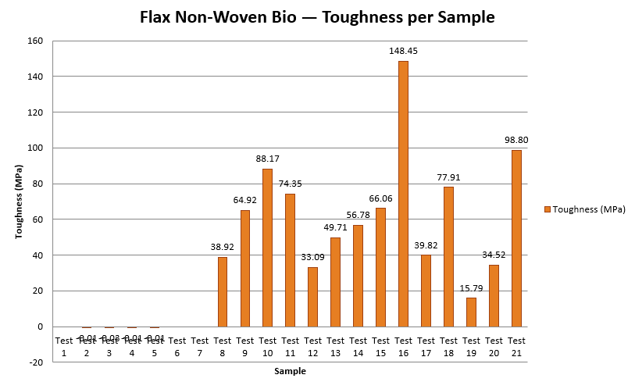
Figure 46 - Energy Absorption / Toughness per Sample

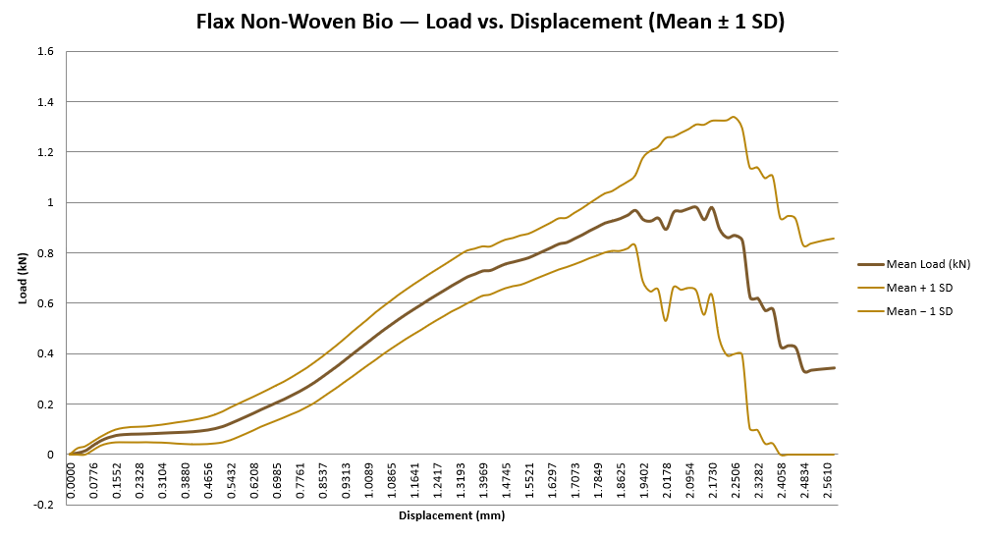
Figure 47 - Load–Displacement Curve (Mean ± 1 SD)

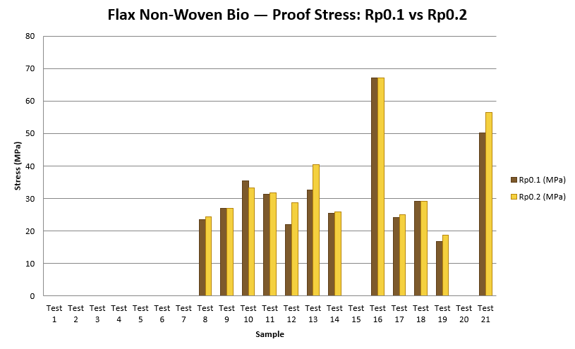
Figure 48 - Proof Stress Comparison (Rp0.1 vs Rp0.2)

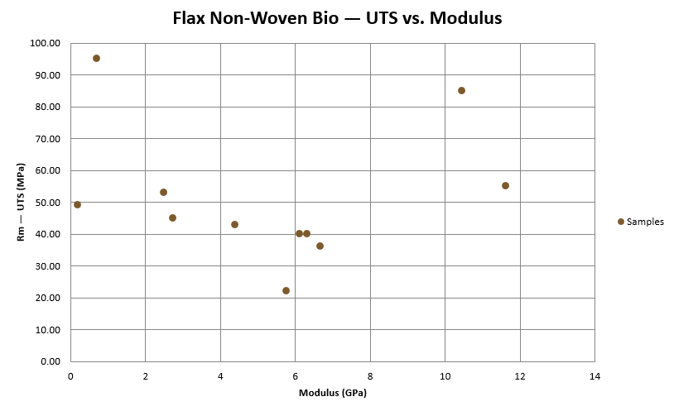
Figure 49 - UTS vs. Modulus Scatter Plot (samples with valid modulus only)

Flax woven bio
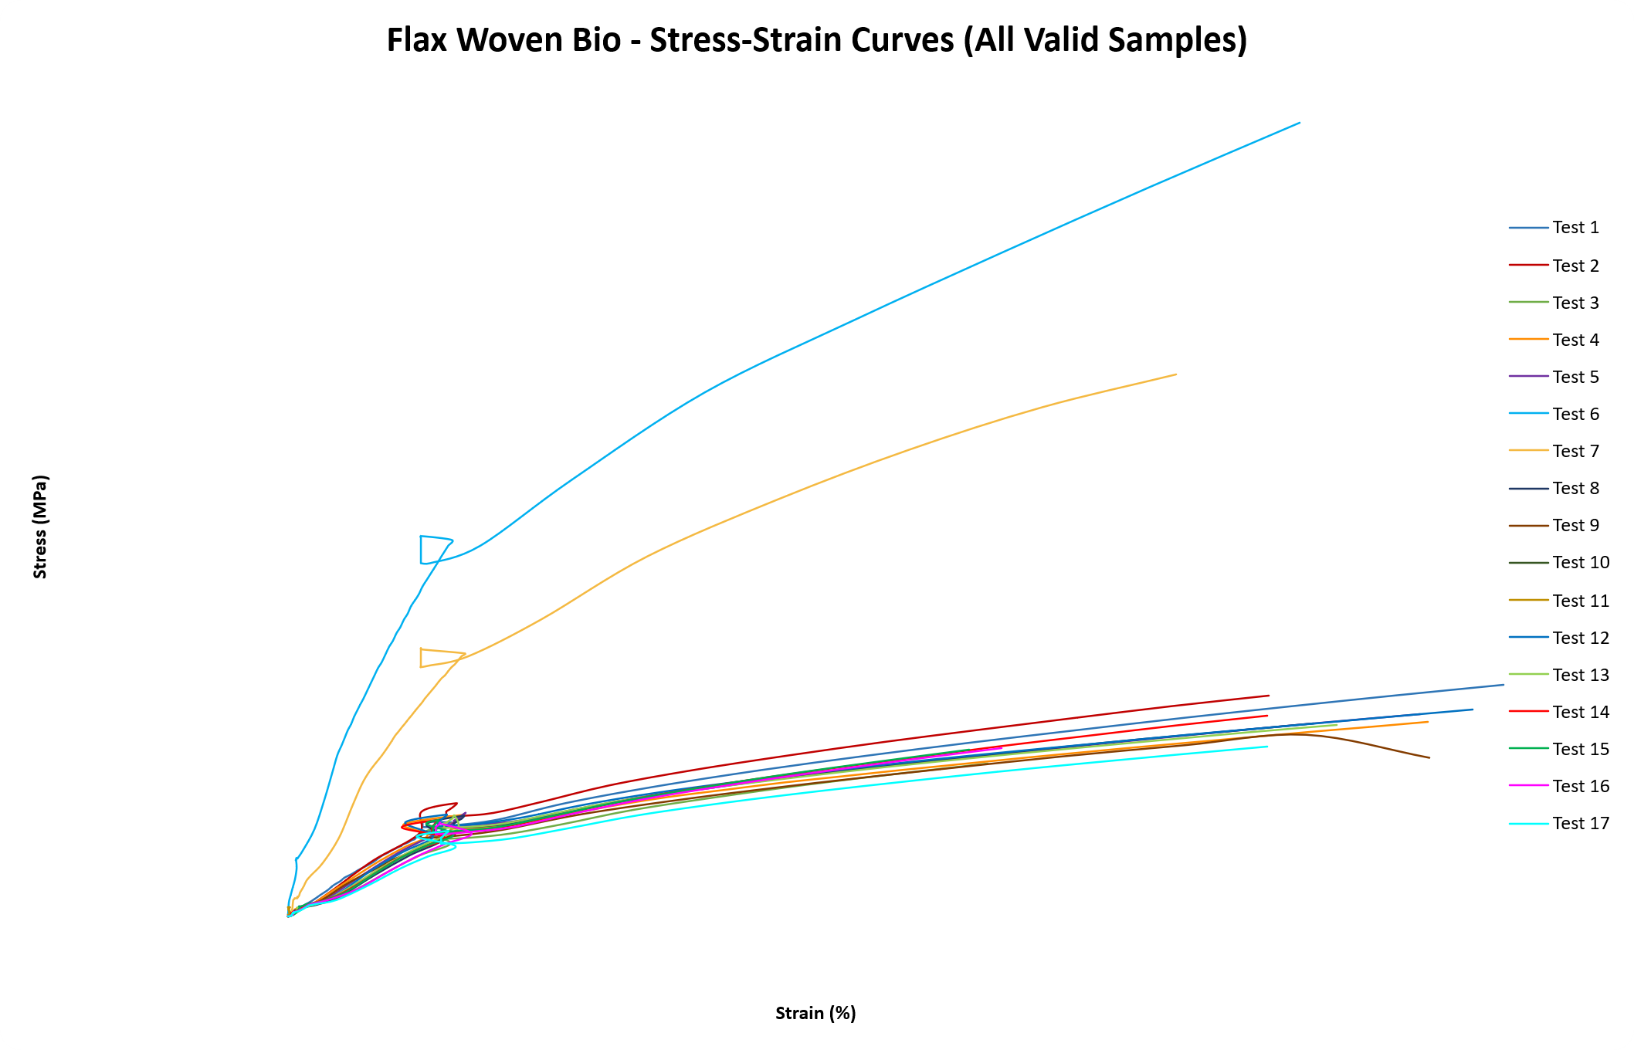
Figure 50 – Flax Woven Bio tests Stress-strain curves

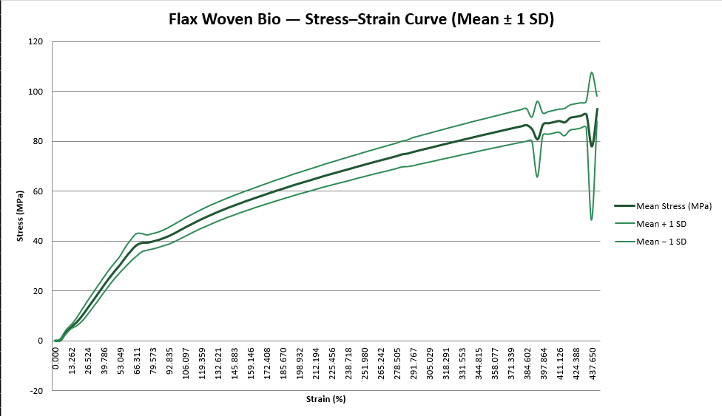
Figure 51 - Stress–Strain Curve (Mean ± 1 SD) [17 valid samples]

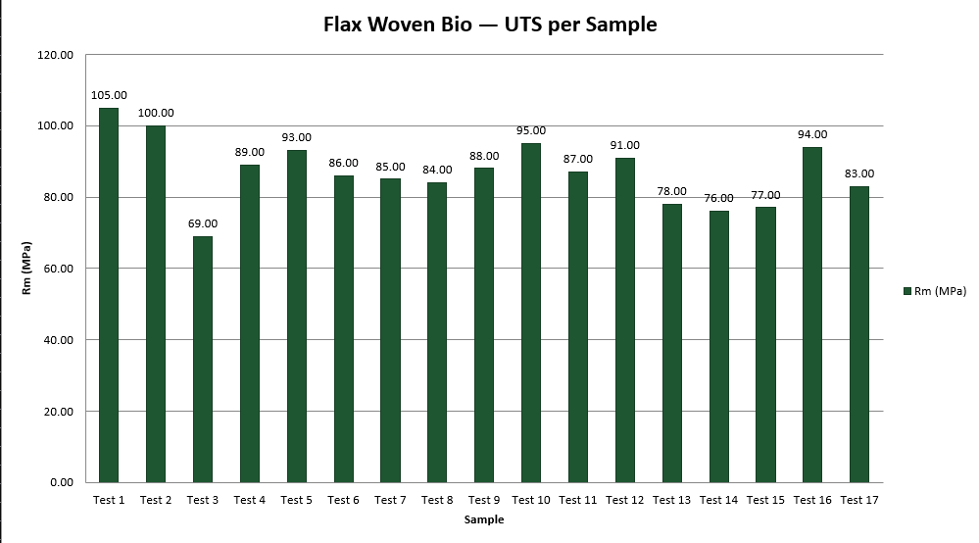
Figure 52 - Ultimate Tensile Strength (Rm) per Sample

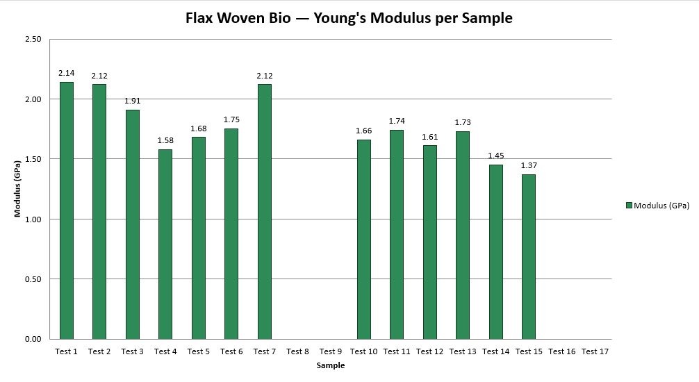
Figure 53 - Young's Modulus per Sample (13 valid, 2 suspect, 2 missing)

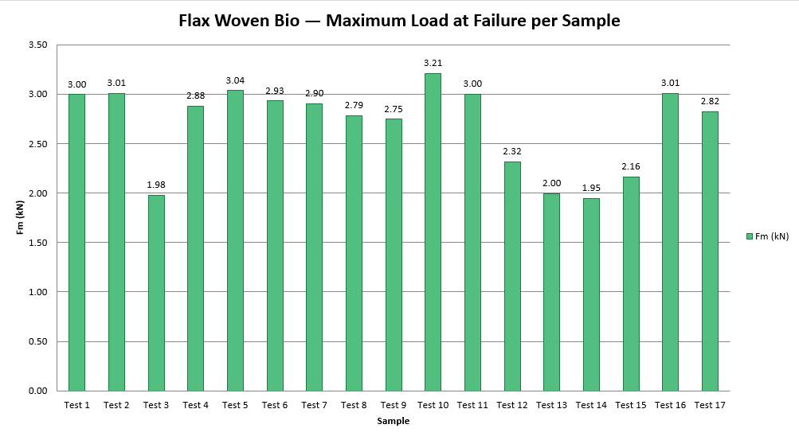
Figure 54 - Maximum Load at Failure (Fm) per Sample

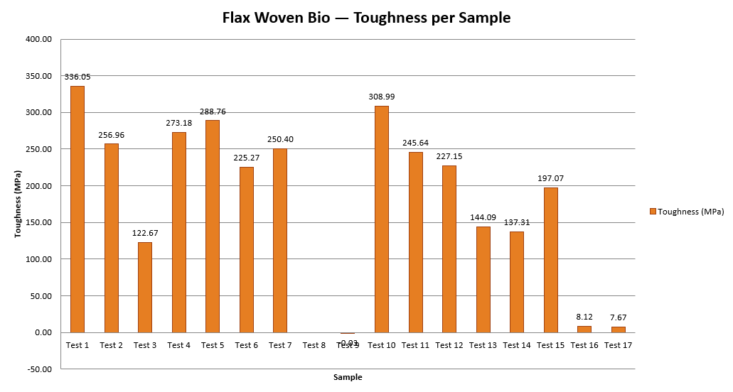
Figure 55 - Energy Absorption / Toughness per Sample

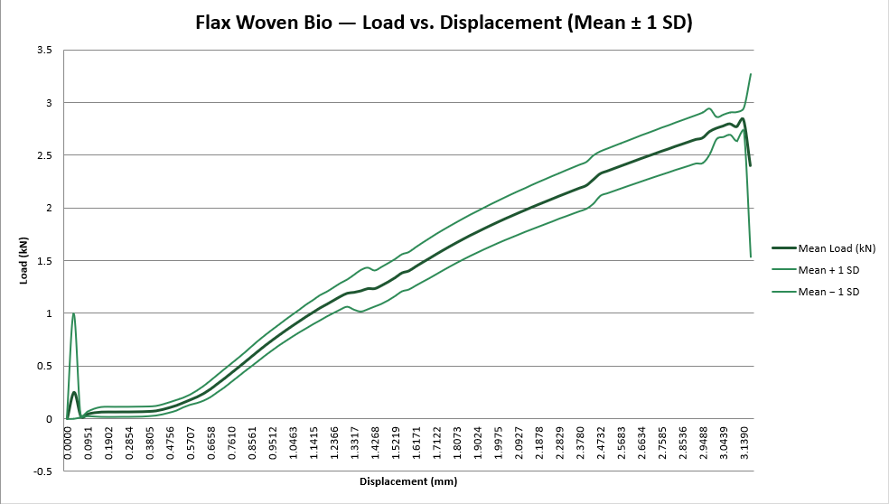
Figure 56 - Load–Displacement Curve (Mean ± 1 SD)

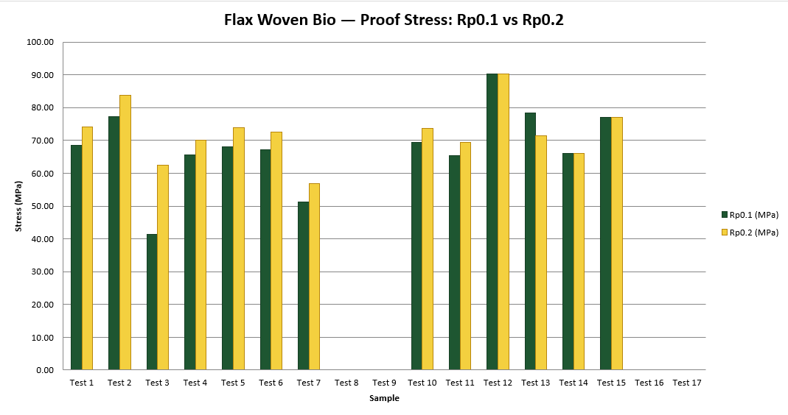
Figure 57 - Proof Stress Comparison (Rp0.1 vs Rp0.2)

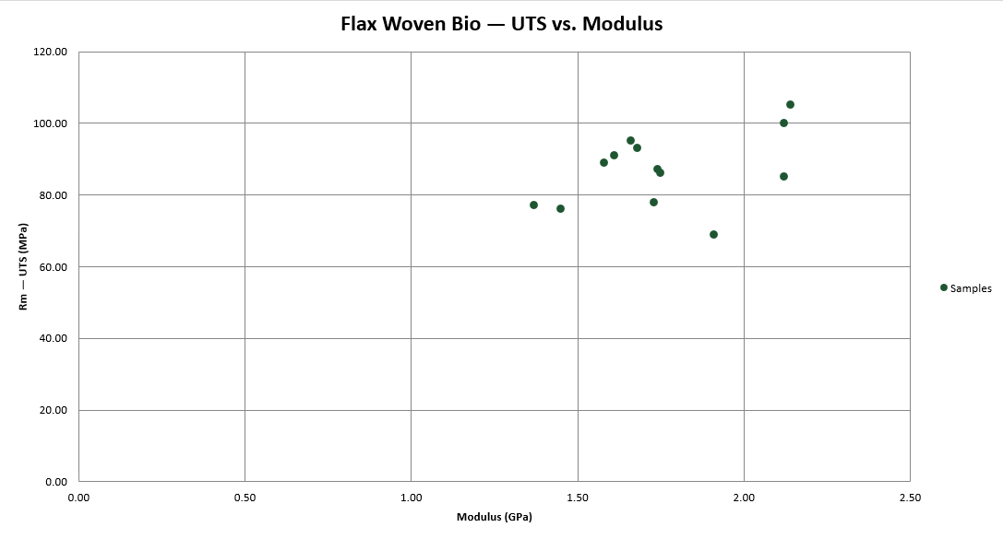
Figure 58 - UTS vs. Modulus Scatter Plot (valid modulus only)

Kevlar Woven Bio
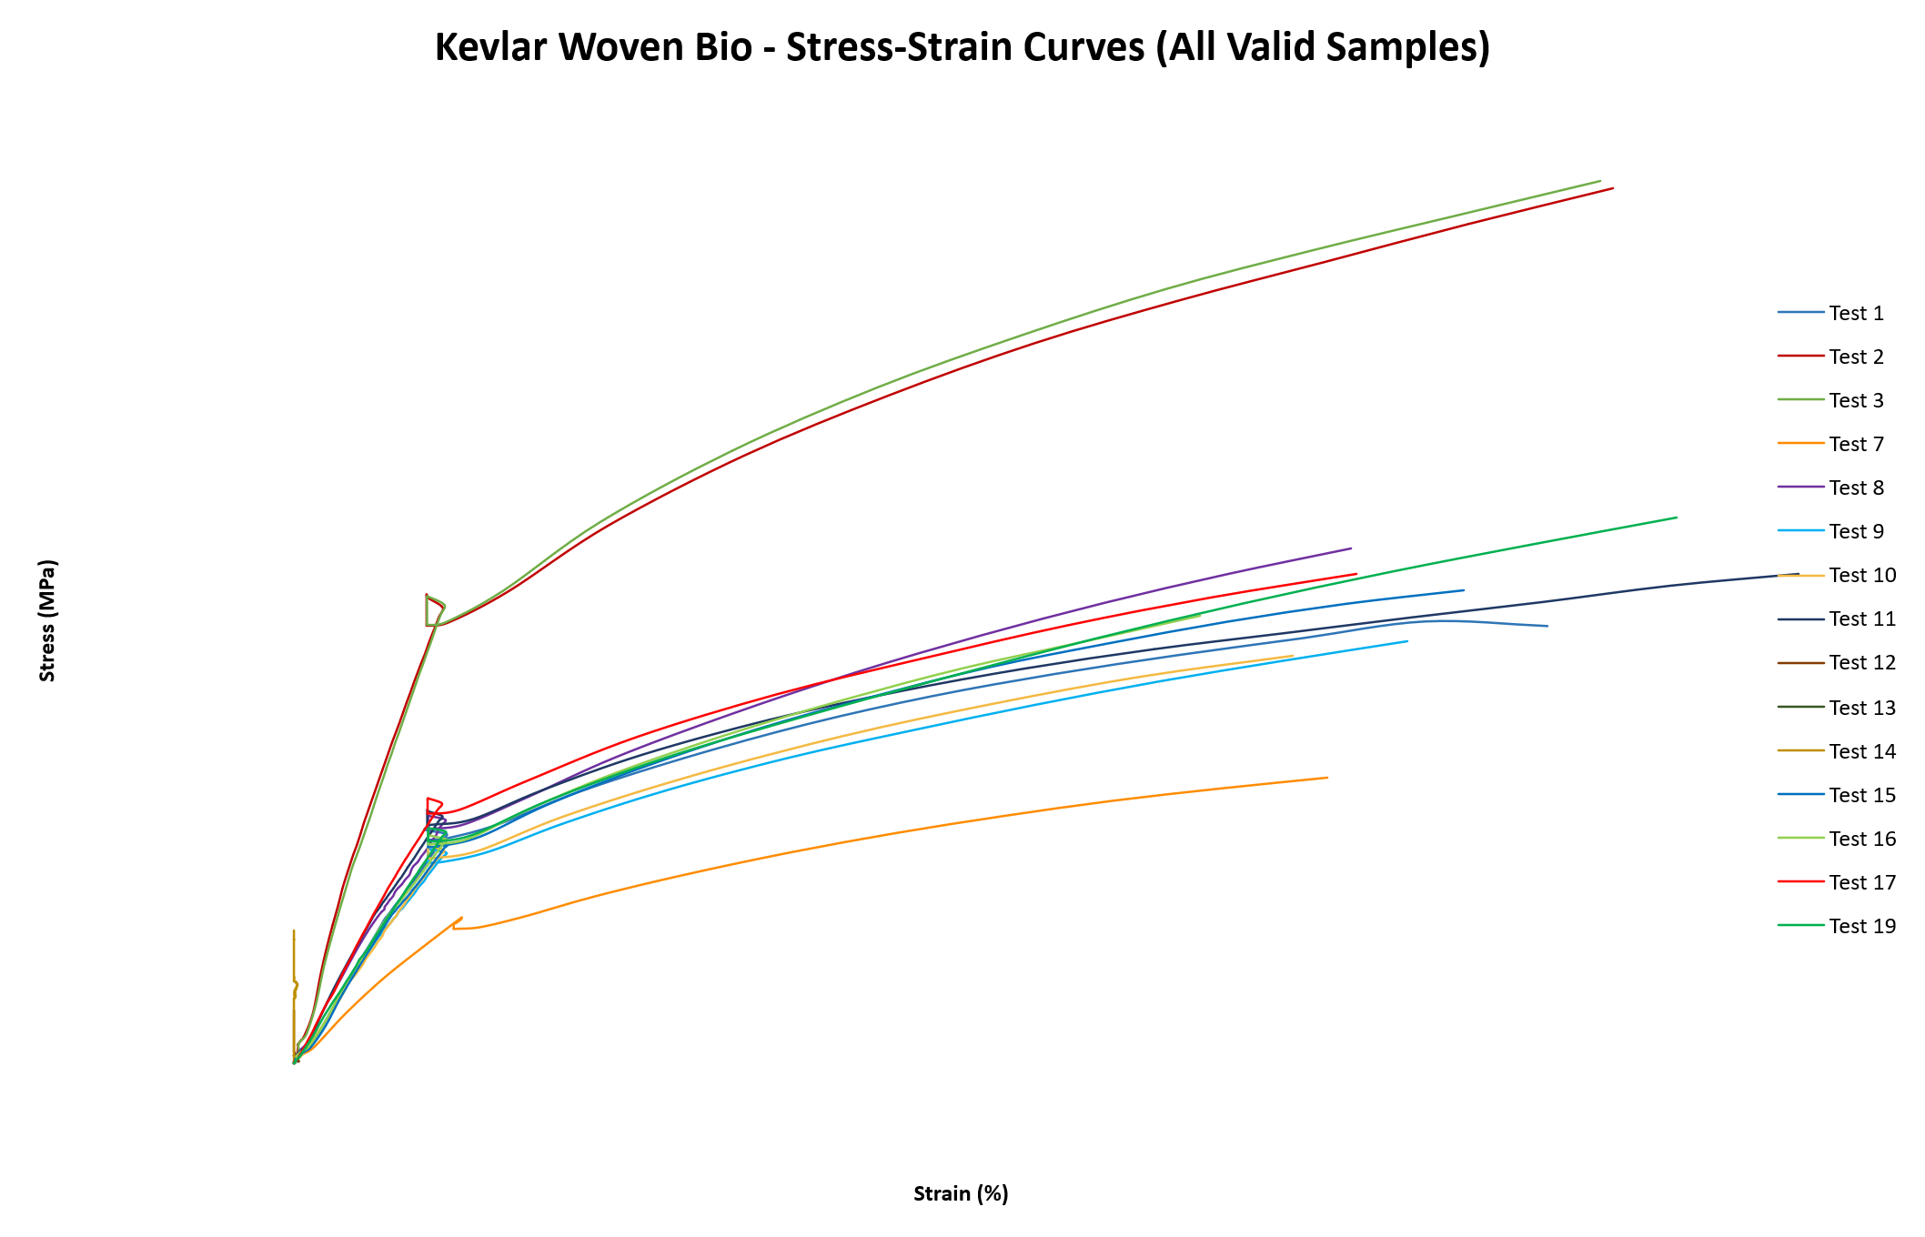
Figure 59 - Kevlar Woven Bio tests Stress-strain curves
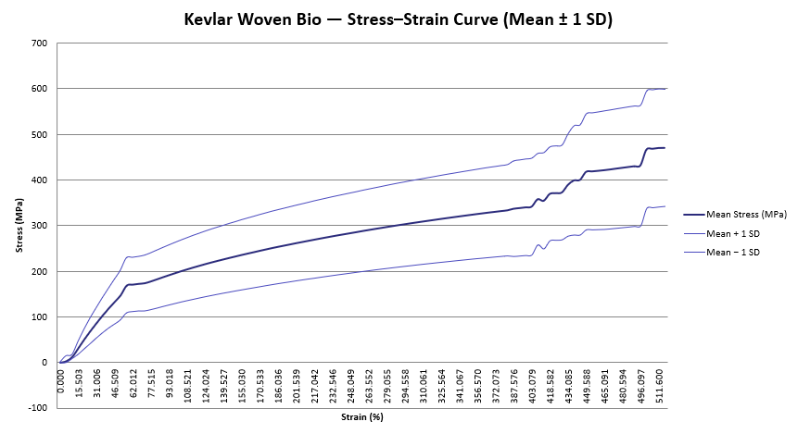
Figure 60 - Stress–Strain Curve (Mean ± 1 SD) [15 valid samples]

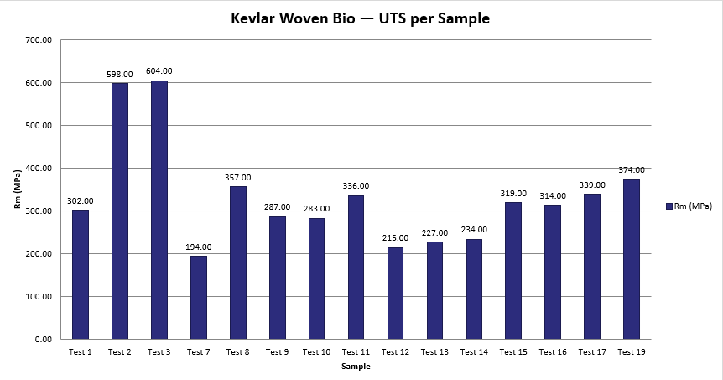
Figure 61 - Ultimate Tensile Strength (Rm) per Sample

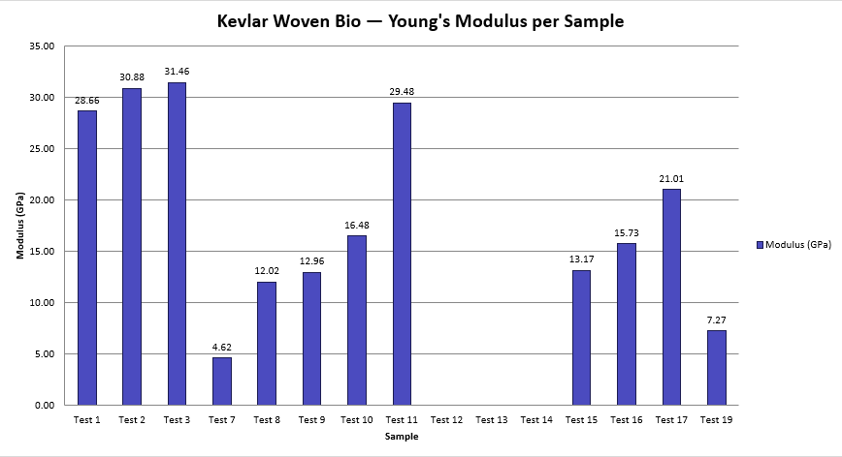
Figure 62 - Young's Modulus per Sample (12 valid, 1 suspect, 2 missing)

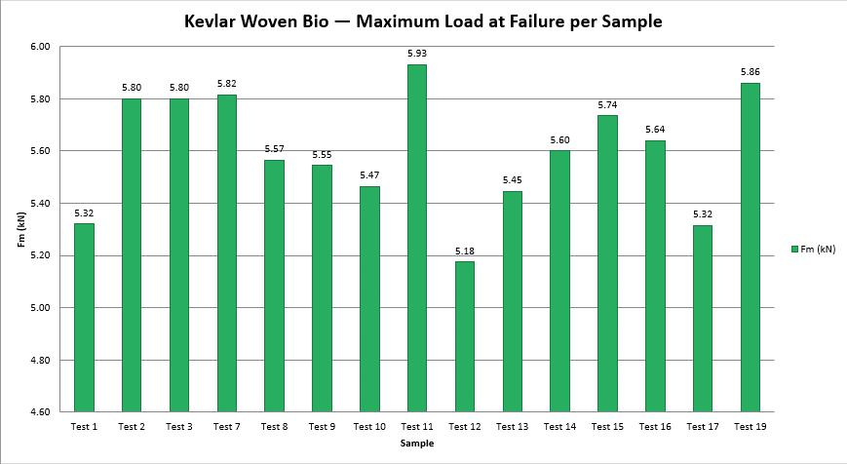
Figure 63 - Maximum Load at Failure (Fm) per Sample

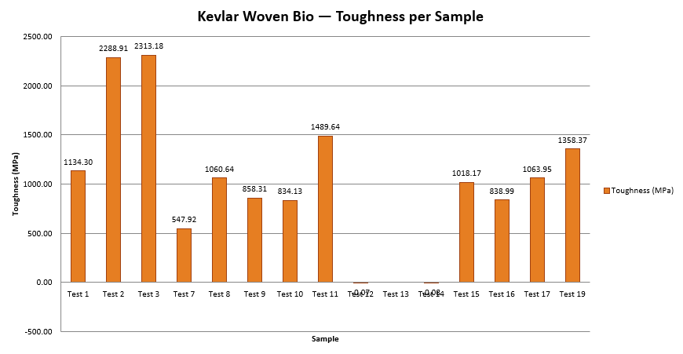
Figure 64 - Energy Absorption / Toughness per Sample

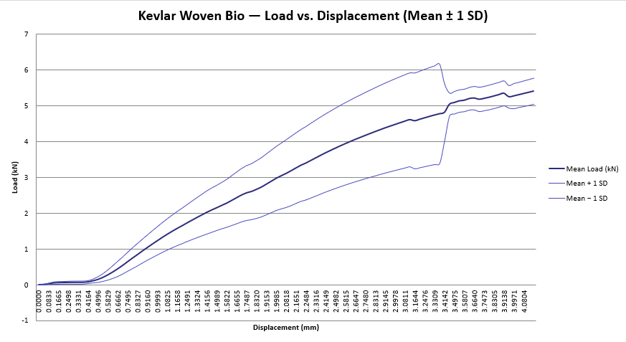
Figure 65 - Load–Displacement Curve (Mean ± 1 SD)
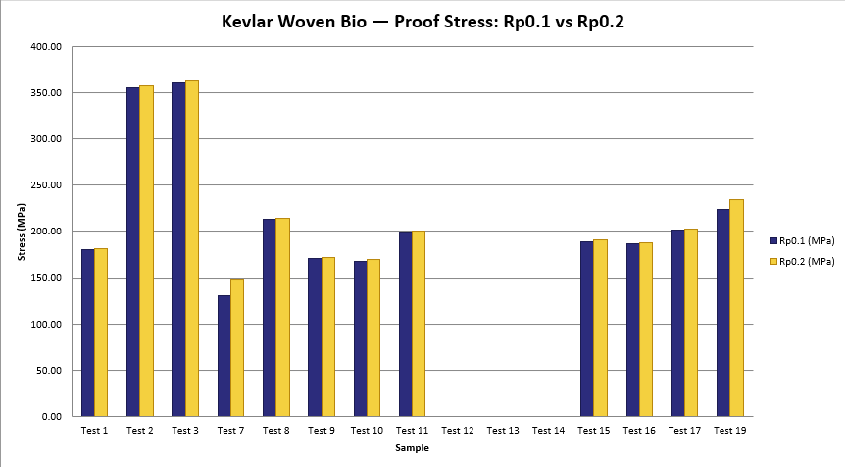
Figure 66 - Proof Stress Comparison (Rp0.1 vs Rp0.2)

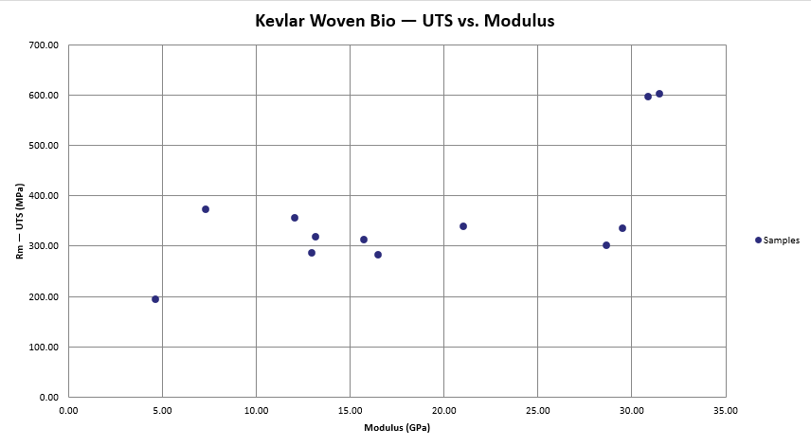
Figure 67 - UTS vs. Modulus Scatter Plot (valid modulus only)

