Name Of the Student: Shahedabibi Shaikh
Student ID : 2223092
Module Name : Human Resource Management
Title : Jeff Bezos’s leadership and amazon revolution


Table Of Content
Chapter 1: Introduction ......................................................................................................... 04
  - Background and Context .................................................................................................04
1.2 Purpose of the Study ....................................................................................................... 06
1.3 Statement of the Problem ................................................................................................ 07
1.4 Research Gap................................................................................................................... 08
1.5 Research Objectives and Aims ....................................................................................... 08
Aim :...................................................................................................................................... 08
Objectives.............................................................................................................................. 09
  - Research Questions ......................................................................................................... 10
  - Project Structure ............................................................................................................. 10
Chapter 2: Literature Review ............................................................................................... 11
2.1 Introduction..................................................................................................................... 11
2.2 Character Traits of Bezos ............................................................................................... 11
2.3 Jeff Bezos Leadership Style ............................................................................................ 13
2.3.1 Contingency of Bezos................................................................................................... 13
2.4 Amazon’s People Management ...................................................................................... 13
2.4.1 Recruitment and selection............................................................................................. 13
2.4.2 Performance and Reward Management........................................................................ 15
2.5 Ingredients of Amazon’s retail dominance ..................................................................... 16
2.5.1 Simplicity of purchase ................................................................................................. 17
2.5.2 Reasonably priced ....................................................................................................... 17
2.5.3 Delivery that is both quick and free ............................................................................. 17
2.5.4 Success Prioritising Growth Above Profit ................................................................... 17
2.6 Contingency Management Theory ................................................................................. 17
2.7 Unchanging Strategy....................................................................................................... 18
2.8 Summary.......................................................................................................................... 18
Chapter 3: Research methodologies .................................................................................... 19
3.1 Introduction..................................................................................................................... 19
3.2 Research Philosophy ...................................................................................................... 19
3.3 Research Approach......................................................................................................... 20
3.4 Research Strategy ........................................................................................................... 22
3.5 Research types................................................................................................................. 22
3.6 Sampling ........................................................................................................................ 22
3.7 Construction of questionnaire ........................................................................................ 23
3.8 Research Design ............................................................................................................. 23
3.9 Data Collection................................................................................................................ 23
3.9.1 Research process ......................................................................................................... 24
3.9.2 Elimination of Biases .................................................................................................. 24
3.9.3 Validity and Reliability ............................................................................................... 24
3.10 Ethical Considerations ................................................................................................. 24
Chapter 4: Finding and Results............................................................................................. 26
4.1 Introduction..................................................................................................................... 26
4.2 Key Results / Findings..................................................................................................... 26
4.2.1 Results from the questionnaire .................................................................................... 26
4.2.2 Results concluded from research ................................................................................. 35
4.3 Discussion ....................................................................................................................... 38
4.3.1 Bezos Leadership Theoretical Perspective .................................................................. 38
4.3.2 leadership Attributes in the Work of Bezos ................................................................. 39
4.3.3 Achievement of Bezos in Organisational Performance and the
Transformation of Amazon ..........................................................................................40
4.4 Summary ........................................................................................................................ 40
Chapter 5: Conclusions and Recommendations ................................................................... 41
5.1 Introduction .................................................................................................................... 41
5.2 Conclusion from Literature Review ............................................................................... 41
5.3 Conclusion from Primary Research ............................................................................... 42
5.4 Conclusion from Case Study ......................................................................................... 42
5.5 Recommendations .......................................................................................................... 44
5.6 Main Contributions ......................................................................................................... 45
5.7 Limitations and Suggestions for Future Studies ............................................................ 45
References.............................................................................................................................. 46
Appendix .............................................................................................................................. 48
Appendix – 1......................................................................................................................... 48
Declaration form .................................................................................................................. 50

Chapter 1: Introduction
1.1 Background and Context
Since its establishment in 1995 by Jeff Bezos to operate an internet-based bookstore, Amazon has seen rapid expansion and now operates as a colossal e-commerce entity, employing a workforce of 224,000 people worldwide. Perhaps during 2018, Amazon's market capitalization was over $900 billion, positioning it as the second-largest corporation globally. The corporation's outstanding success is closely linked to its unique business strategy along with efficient human resource management. Conversely, the managerial approach of the company has received substantial criticism. Daily, the firm sells millions of things via its website or app; it is among the most prosperous e-commerce enterprises globally; and no other company comes close to matching the company's user base or income (AmazonJobs, 2019). The corporation has branched into several areas over the years, making a fortune in cloud computing via Amazon Web Services and manufacturing its products like the Amazon Kindle and Firefly Phone. In 2019, the business earned an astounding 280.5 billion US dollars. Among the few businesses that managed to weather the COVID-19 storm, Amazon shocked investors with first- to third-quarter sales estimates of $80 to $95 billion. Across its worldwide offices and warehouses, the corporation employs more than ten million people, making it one of the biggest employers in the world.
Jeff Bezos founded Amazon in 1995 as an e-commerce platform specialising in the sale of books over the Internet. Subsequently, it has evolved into a colossal multinational enterprise, employing 224,000 individuals throughout the globe. During 2018, Amazon's revenues reached $900 billion, second only to Walmart. One of Amazon's main goals is the efficient administration of its employees and the company's unique business strategy. However, the company has also been given the responsibility of overseeing employees (Schein, 2017). A poll conducted by Kansas University found that compared to other online workers, Amazon employees reported lower levels of job satisfaction. By "human resource management," we mean a system of checks and balances. This work is grounded on pertinent ideas, theories, as well as facts which discuss human resource management (HRM) methods and their potential in the future. This research delves into Amazon's people management strategy, looking at how the company hires, evaluates and makes suggestions for employees. Leadership is influencing others in such a manner that they accomplish set objectives via fostering an environment that welcomes and embraces change, innovation, and progress. Strong leadership is essential for achieving current levels of performance, but unfortunately, none of the organisations have it. To increase their chances of survival in the face of fierce competition in global markets, companies throughout the globe are working hard to refine their leadership styles. This is due to their realisation of how crucial the kind of management structure is. This is typical of how Jeff Bezos, CEO of Amazon, grew the firm from its humble beginnings into the multimillion-dollar behemoth that it is today (J., Goldfinch and Chinta, 2018).
Amazon is the first name that comes to mind when you think of a wild retail giant and industry leader. Once a powerhouse in book sales, the company today has a presence in almost every sector conceivable. Amazon is a world-renowned e-commerce powerhouse that provides customers with information, ideas, and inspiration about products and services from a diverse array of companies. The firm has gained a foothold in various prominent nations, such as Germany, the United States of America, Canada, Japan, as well as France. The capacity to operate remotely expands the range of opportunities for the organisation, potentially including ventures such as book along music publications. Popular consumer products sold by Amazon include apparel, footwear, purses, jewellery, accessories, gadgets, toys, and home furnishings, among many more (Bloomberg, 2019a). The company's website allows customers to sell their items. Accurate title and subject information about products must be provided by customers. After this Amazon company's human resource management department analyses the subject information, they publishes the findings based on the information's popularity and use. Also included are the results and how they pertain to the subject at hand.
Ignoring the technological progress of the modern world is wrong. Embracing the power of technology across all sectors and enabling people to achieve their full potential is Amazon's aim. Amazon, a worldwide B2B marketplace, has already reaped the benefits of Bezos and his team's recent successes. To preserve life and boost the human brain, the business delivers artificial intelligence via computers and efficient software. Every every day, the Internet's power increases at an exponential rate (Schein, 2017). In the next years, progress's trajectory is anybody's guess. Instead of worrying about the future and attempting to predict our impact or power, Bezos advises us to live in the now. If people are capable of accepting anything, they shouldn't hide the results. He puts his faith in Bezos's assurance. Since he adheres to procedures, he has built relationships with trustworthy people and works well with them. He sticks to his word and does his best to make sure the company achieves its goals. Despite the occasional difficulty, I always enjoy the process of learning new things and sharing what I've learned with others.

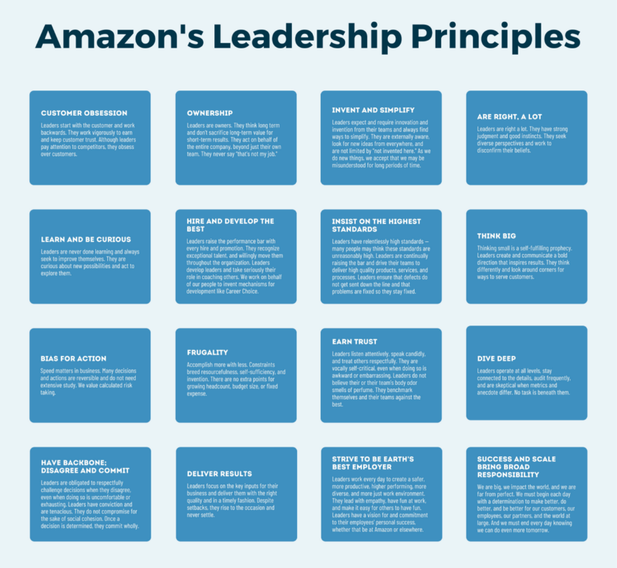
Figure 01: Leadership principles of Amazon (Schein, 2017)
Being the one to launch the Amazon Revolution, Bezos has gained widespread fame. Amazon dominates China's business-to-business (B2B) sector, making life tough for many customer-facing enterprises and organisations. What makes Amazon tick is its dedicated customer base, brilliant employees, and top-notch support system. At each level, the team working under Bezos's direction faces a different challenge. His charisma and ability to bring people together for a shared purpose enable him to bridge generations and continents in his coordination of activities.
A variety of ideas, principles, and methods may be employed to develop and enhance leadership skills. In a society that demands leaders to exhibit their utmost virtues, there are prospects to collaborate with individuals from diverse backgrounds, adjust to unfamiliar circumstances, surmount obstacles, devise innovative resolutions, and generate novel concepts. That is why many people continue to appreciate transformative leadership. Communicating our plans and objectives inspires others. No leader deserving of the title should ever use bullying or pressure to get what they want (J., Goldfinch and Chinta, 2018). A transformative leader can divine the necessary tasks, adapt to change, and take the appropriate action in every given situation. A leader such as Bezos, someone who's willing to actively engage in tasks, take calculated risks, and attract new members, would serve as a source of motivation for individuals in need of a catalyst for change. His projects, which include transcriptions and technical advancement, are something he is happy to talk about and provide details on. Those fortunate enough to work with Bezos describe him as an interesting and charismatic boss. The public at large ought to support Bezos's ambitions to channel his wealth into various projects that would further the digital revolution.
Both of the STO as well as two-pizza team setups have significant disadvantages. Consequently, Amazon consistently assesses organisational models as well as the influence of team dynamics on creativity and efficiency. Organisational network analysis (ONA) is used to investigate and audit the team hierarchies of Amazon Products. This firm produces a diverse range of goods for Amazon, such as Alexa, FireTV, Amazon Kindle, and several more. Organisational Network Analysis (ONA) is a methodology used to examine the flow of decisions, details, and connections inside an organisation by analysing the informal connections among employees. Collaboration enables ONA to identify its areas of expertise and opportunities for expansion. Amazon used the Organisational Network Analysis (ONA) method to uncover obstacles in the decision-making process, undue reliance on others, and untapped knowledge resources (AmazonJobs, 2019). This resulted in enhanced cooperation and faster decision-making. As part of their evaluation process for innovative collaborations, Amazon used ONA to identify development ties. To make big ideas a reality as designs, concepts, or alternatives, local development linkages enhance them first.

1.2 Purpose of the Study
Kansas University revealed that employees at Amazon tend to be less delighted with their jobs compared to their counterparts at other digital corporations (like Apple and Google). The HRM practices used by the company are not devoid of imperfections. This study analyses Amazon's approach to managing its workforce and provides recommendations for enhancing its human resource management procedures throughout the future, using relevant concepts, theories, and empirical evidence. In particular, this article provides a description of, analysis of, and evaluation of Amazon's performance as well as reward management, recruiting and selection processes, and then concludes with recommendations for the business.

1.3 Statement of the Problem
Each worker at Amazon is expected to adhere to the fourteen management principles: obsession with customers, ownership, innovation and simplification, being right, continuous learning and curiosity, recruiting and developing top talent, demanding the highest standards, thinking big, taking decisive action, practising frugality, earning trust, conducting a thorough analysis, demonstrating resilience, and ultimately achieving tangible outcomes (Amazon Global). These values demonstrate the company's dedication to providing excellent service to its clients, which is said to be more important than staff engagement or contentment. Despite the organization's strict adherence to secrecy agreements, rumours persist concerning staff breakdowns and disputes. According to a 2013 poll conducted by PayScale, Amazon maintains one of the poorest % of employee retention compared to other firms in the Fortune 500. The interviews conducted by reporters Jordan Kantor as well as David Streitfeld from The NY Times uncover that one contributing factor is the organization's feedback environment. According to the report, employees are encouraged to provide rigorous critiques of their colleagues' ideas and are given guidance on how to confidentially share comments with one other's supervisors. Furthermore, there are assertions that the feedback system is too susceptible to exploitation, often used to undermine the efforts of others. The feedback mechanism at Amazon, created by the company itself, is intended to challenge and motivate employees to meet the ambitious goals set by Mr. Bezos, according to several Amazon employees. What sets Amazon apart is its capacity to measure and evaluate every facet of its operations (Schein, 2017).
Amazon also applies performance management via weekly or monthly company reviews, during which each employee is held responsible for a variety of criteria. Kantor and Streitfeld assert that workers are provided with this data in a printed format consisting of 50 to 60 pages. During these evaluations, workers are often assessed on their proficiency in certain criteria. These meetings are lengthy and draining since a significant portion of work hours is dedicated to preparing for and discussing the metrics. Currently, Amazon utilises an internal application to facilitate the sharing of feedback among its workers. The Anytime Feedback Tool allows employees to provide immediate feedback, whether it is positive or negative, about their peers (Soper, 2016). The criticism is sent immediately to the management of the individual getting the input, with the name of the feedback source being disclosed only to the manager. Amazon allegedly utilises comments from co-workers to compile a yearly list of underperforming employees, which serves as the foundation for termination. Annually, Amazon conducts Organisation Level Reviews, during which the most and lowest achievers are shown to the entire hierarchy of management. Dubbed "deliberate Darwinism" by a previous Amazon human resources director, the technique is essentially a disguised version of the old 'rank and yank' procedure. According to managers' reports to The Times, the process of preparing for these assessments is akin to the preparation required for a court case. Frequently, managers must possess substantiated evidence to protect their staff from unjust allegations. In some instances, managers may choose to select a scapegoat to retain the most vital components of the team. The most justifiable and pertinent critique of Amazon's performance management is in its organisational framework. The method advocated by Bezos promotes meritocracy, when ideas are subjected to competitive evaluation, and only the most exceptional ones emerge victorious.
This kind of competitiveness establishes the foundation for a detrimental working atmosphere in which individuals must surpass others. The feedback culture at Amazon is characterised by its severity, setting it apart from the feedback cultures at other creative businesses like Facebook, Google, or Adobe. The organisation's performance management strategy excessively emphasises the connection between workers' performance and the overall success of the company right from the beginning. Employees have a sense of being overwhelmed when they are burdened with excessive responsibilities due to a misunderstanding of the ownership culture. Given the alleged usage of antagonistic language throughout these feedback meetings, it is quite probable that staff morale at Amazon is now low. An inherent drawback of the feedback process at Amazon is its lack of provision for workers to directly access and review comments. Instead, they are solely reliant on receiving feedback from their supervisors. Nevertheless, this contradicts the fundamental objective of performance management, which is to facilitate the professional development of your staff.
The company's performance management concept exerts an excessive amount of pressure. Bezos has implemented a rigorous procedure for recruiting skilled individuals and evaluating prospects, known as the Bar Raiser. Amazon places great emphasis on Person-Organization fit (P-O fit) since several research indicate that interviews are not a reliable means of properly assessing P-O fit. Amazon's performance and incentive management system is contentious due to the company's use of transparent peer evaluation, which places significant stress on its employees.

1.4 Research Gap
Amazon has consistently been hailed as being one of the world's most prominent and well-known internet service providers on a worldwide scale throughout the past few years. The interests and necessities of contemporary individuals are closely linked to Amazon's aims and principles. The combination of this strategy with the importance of listening to clients has made the firm a frontrunner in its industry. Analytics as well as researchers are interested in its global site development and many customer service centres. The ability to quickly collect various products and ideas and sell them is the company's key accomplishment. The initiatives that the Amazon staff have come up with are not very noteworthy. Jeff Bezos, Amazon's CEO, is still widely thought of as the company's driving force (Hanley and Hubbard, 2020). Among the most illuminating figures in the history of e-commerce, this one stands out as a transformative leader. Currently, Bezos has shown a plethora of future possibilities and demonstrated that, with careful planning and development, his technique may be of use to people.
The unique thing about Bezos is his desire to work with individuals of all ages, not only to purchase things but also to generate new ideas and develop them until they achieve the necessary level of success and profit (AmazonJobs, 2019). Several years earlier, Jeff Bezos demonstrated that certain leadership qualities affected the success of organisations and enabled millions of individuals to achieve both their private and professional objectives. He did this by promoting the Amazon Revolution.

1.5 Research Objectives and Aims
Aim:
Amazon's administration of human resources techniques aligns with its leadership philosophy. Amazon conforms to the SHRM philosophy, which states that all human resource choices should be in line with the fundamental strategy of the firm. Their approach is using skilled people resources to achieve sustainable advantages. Therefore, Amazon's primary goal is to cultivate competent leaders by providing training and promoting the necessary abilities and attributes. These executives are expected to enhance the corporation's competitiveness within the market.
Regarding team collaboration, Amazon has distinct regulations for both full-time and part-time staff members, seeing them as independent entities. Part-time workers experience less stress and achieve a better work-life balance, dividing their time between the workplace and their family. The company's administrators assert that the segregation of full-time and part-time staff members enhances Amazon's adaptability and augments the efficiency of their teams (Stewart and Long, 2021). Their exceptional performance is also contingent upon a feedback mechanism that enables workers to provide constructive criticism and commendation to one another.
Although the firm has implemented several efforts and programmes to enhance collaboration with its workers, the management continues to encounter significant unresolved challenges. They include all aspects of Amazon's operations, ranging from the skills and abilities of its employees to the adherence to health and safety protocols. Given that managing employees was a significant weakness for the organisation during its initial stages, it is vital to monitor the advancements in this domain and rectify any deficiencies to enhance productivity. To provide recommendations on enhancing Amazon's existing policies and processes about personnel management.
Objectives:
Amazon excels at prioritising customer interest and stands out as a market leader rather than a rival. The rules, methods, and structures employed by the e-commerce behemoth unequivocally demonstrate the firm's goal and purpose, that it wants to position the company as the most customer-centric organisation worldwide. Through the use of internet access and other technological means, the company aims to transform the consumer experience by facilitating online shopping, providing information about novel items, and enabling individuals to disseminate their findings globally (Amazon, 2020).
Amazon adopts the defined triple bottom line strategy since it is dedicated to investing in the development and welfare of its people, customers, as well as the environment, alongside its financial prosperity. Amazon is backing many sustainability projects, such as the economy of circularity, closed-loop infrastructural funds, and measures to reduce the company's carbon emissions (Amazon, 2020). Despite being seldom addressed in academic literature, there is a noticeable dearth of research on the potential influence of Amazon on project management along with the overall team dynamics within a business.
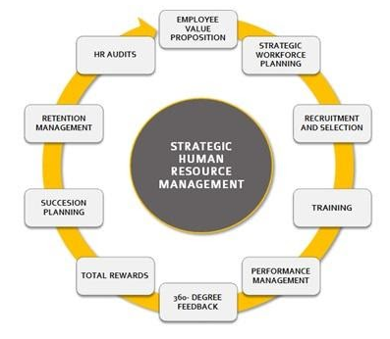

Figure 02: Strategic Human Resources Management (Claus, 2019)
1.6. Research Questions
The objective is to examine Jeff Bezos's approach to management and assess how it has influenced the profitability of Amazon.com, Inc.
The objective is to analyse how Amazon's unwavering emphasis on performance has led to a very high rate of employee turnover, which has subsequently damaged the company's reputation and raised the toll on its workforce. The aim is to identify measures to avoid a recurrence of this issue.
Does the two-pizza staff at Amazon have strong skills in personnel management?

1.7. Project Structure
The undertaking's six chapters are structured as follows. The first chapter provides an overview and some necessary context. In chapter two of the dissertation, the methods used by Jeff Bezos to lead Amazon and manage its employees are examined in depth. In it, the existing body of information is evaluated, gaps in understanding are highlighted, and the study's distinctive contributions are emphasised. The third chapter provides a contextual framework that is essential for understanding Amazon's tactics. Thirty authentic customer surveys are gathered and assessed using a 5-point Likert scale; the emphasis is on Amazon and Jeff Bezos. The study methodology, including the research design, setting, data-collecting techniques, and ethical issues, is described in the following chapter. In chapter five, we go into qualitative analysis, highlighting the most salient aspects of the data we gathered and exploring what it means for academics, policymakers, and industry experts. The study's limits, findings, and recommendations for further research are detailed in chapter six.

Chapter 2: Literature Review
2.1. Introduction
Amazon is a very prosperous multinational corporation. Bezos has undeniably been an important leader. Amazon's leadership philosophies, corporate structures, and atmosphere of excellence have established it as a renowned breeding ground for CEOs. Simultaneously, Amazon has encountered several prominent concerns over its corporate culture and the well-being of its workforce. There are several insights to be gained from comprehending both the triumphs and shortcomings of Amazon. We will analyse the efficacy of Bezos's management and leadership skills, as well as identify the obstacles and places for development (Stewart and Long, 2021).
Amazon's HRM policies are evident in their approach to cultivating autonomous leaders who can effectively oversee their tasks and facilitate the growth of others by fostering the acquisition of essential job-related skills. Therefore, to effectively execute their policies, it is necessary to cultivate a distinct philosophy that will serve as a foundation for future achievement.
2.2. Character Traits of Bezos
Started as a garage operation and has now grown into a well-recognised internet shopping portal. Amazon, which Bezos founded with his wife Eliza, helped him reach the pinnacle of success and established him as the undisputed ruler of the Internet. He became the richest man in the world when his net worth reached $157.7 billion. Some have speculated that Jeff Bezos is a risk-taker and a merciless boss who will not tolerate mediocrity. On the other hand, Bezos may be an overly sentimental person. Here are a few things about Bezos's persona that contribute to his success (AmazonJobs, 2019).
Extremely Competitive: Bezos's ability to be someone competitive is one of his most prominent attributes. Amazon had previously targeted a character person trade with infant products; they significantly reduced prices to avoid competing inside and outside, and ultimately, the company failed. Typical of him, Jeff came out on top. As far back as anybody can remember, Jeff Bezos has consistently been at the forefront of innovation. From developing a comprehensive plan to protect his neighbourhood from bothersome relatives to building the well-known e-retailing site, Bezos's passion for innovation has only grown over the years. Because it expanded over time, his ability to create something luminous has. Delivering products to customers was the original plan. Thanks to his innovative skills, the internet department now offers anything and everything a person may want. To take on Apple's iPad, Bezos unveiled the Kindle, a widely acclaimed e-book reader.
Dedicated Realist: Jeff possesses a crucial personality trait that is essential for every successful business venture. The individual thinks about and mulls over every possible outcome and likelihood; he may be a radical. While launching Amazon into the worldwide market recently, Jeff admitted that the venture may fail and that money could run out. He has a problem with focusing on the negative aspects and making decisions based on his evaluation alone (Hanley and Hubbard, 2020).
The Regret Minimization Theory postulates that Bezos's well-known "R M F" could be an assumption he loves to boast about nearly. Given his role as a businessperson, Jeff will probably need to make audacious and sweeping choices for the foreseeable future of his company and its workforce. How does he effectively manage the obligations of a well-acknowledged international institution? Bezos wants an answer that's more straightforward than what most people think. Going to his "R M F," as Jeff calls it, maybe a geeky way for him to reflect on his past and compare it to his future self, highlighting the actions that Jeff would regret the most. Jeff Bezos asserts that his nerdy idea was the deciding factor in his decision to step down as senior vice president of launching an online advertising endeavour.


Figure 03: People management of Amazon (Stewart and Long, 2021)
Unwavering Pioneer: As said before, Jeff Bezos is a firm believer in adapting products to meet the needs of the moment. In addition to his normal internet meandering, he often experiments with new ideas. The CEO of Amazon has an intense passion for listening to and fulfilling customer needs. Since its inception in 1994, Jeff Bezos has assumed the position of investigator at Amazon. Amazon's transformation from an online bookshop to the world's biggest online marketplace may be attributed to the CEO's passion for travel (Tuytens, M. and Devos, 2012).
A guy who has a family and secure employment isn't a commercial type if he lacks the willingness to take risks, but this isn't always an excuse to not take risks. Jeff Bezos had already decided to launch his claim trade. Because they were financial specialists, he had been looked after when he ran out of money. He was relentless in the face of the danger, even though he was aware that there was a 70% chance of disappointment (Stewart and Long, 2021). Even though he is now one of the world's richest individuals, his penchant for reckless risk-taking is as strong as ever. An example of Bezos's courageous character may be the comparison of the Kindle to the iPod.
Space layout for the office door: Bezos, in an unusual but very genuine move, opened up shop in his garage at the very beginning of his firm. There was no annual incentive advantage for Bezos as he sold out during the year. This is when his penchant for frugality first emerged. For his first office, Jeff had transformed a wooden entrance into a workspace. The floor plans of Jeff's offices still resemble an entrance to this day.

2.3. Jeff Bezos Leadership style
One of Bezos's qualities is that of a transformational leader, someone who can persuade others through the power of their words. He is a successful and charismatic CEO who builds dedicated relationships with his followers. If a leader can inspire their people to think and act in radically different ways, the results will be remarkable. This kind of leadership is known as transformational leadership. Given Jeff Bezos's track record of inspiring his staff, it's easy to understand how this has contributed to Amazon's meteoric rise from an online bookstore to its current prominence. Jeff sparked interest and dedication in achieving the company's long-term goal by drawing a connection between it and the workers' own beliefs. Even though financial experts and rivals did not believe in his vision and its potential to generate great financial results, Bezos was able to imagine, improve, and inspire the representatives nevertheless, and as a result, Amazon has grown tremendously under his leadership (J, Goldfinch and Chinta, 2018).
Employees are empowered to go outside the box, find novel solutions, and plan for the future under transformational leadership. Thanks to this sort of leadership, Amazon has maintained its position as the leading e-commerce trader by ensuring that customers get value for money and that deliveries are made almost the same day. Rather than concentrating on his position within Amazon's administration, Bezos has been able to put the needs of others first. This dissertation will observe that Bezos's leadership is unique if we examine his approach. He oversees everything personally, which is an autocratic leadership style. As a leader, he also has a crucial role to play in which he shares the unique strategies that power his company. It seems that Jeff Bezos has the group leadership approach. Helped along in this manner, he may chart a roadmap for his trade's future and establish its rationale. In addition, his leadership style is characterised by both charisma as well as vision.
2.3.1. Contingency of Bezos
Simply put, the total of a frontrunner's achievements in light of the current situation is the contingency notion. The guiding concept is to understand how different situations call for different approaches to leadership. The most well-known theories of contingencies involve the Path-purpose theory, situational management, as well as Fiedler's Contingency Model. There are three parts to Fiedler's principle: the structure of the endeavour, the authority of the functions, and the interactions between the head and the members (Tung and Berkowitz, 2020). There is a perception that Amazon CEO Jeff Bezos has a more efficiency-focused, venture-oriented leadership style. When a leader inspires their followers to do great things, they are engaging in inspirational motivation. Both the leader and his followers may achieve the lofty yet attainable objectives that this leader sets. By working together towards the same vision, they inspire loyalty and dedication from their employees. Leaders who can articulate their aspirations clearly and who employ inspiring motivation inspire their followers in an outward and natural way.
2.4. Amazon’s People management
2.4.1. Recruitment and selection
To find and hire the best people, Bezos has instituted stringent procedures. Bar Raiser is a part of Amazon's streamlined and consistent recruiting process. When hiring new employees, the firm looks for two things: performance and qualification. Employees' capacity to provide value to the organisation in the long run is also highly valued. Bar Raisers are responsible for conducting thorough applicant evaluations at Amazon, taking into account the company's culture and leadership principles. To make sure that applicants can raise the bar for talent standards across the board, barristers collaborate with other interviewers throughout the final selection process and have veto power. For Bezos, hiring creatives from all walks of life is essential to Amazon's continued success and innovation, thus he actively seeks out candidates from all walks of life. So, you'll find professional skaters, literary scholars, artists, rock singers, and more on Amazon's crew. Amazon uses online applications and screening rather than conventional written tests to keep recruiting costs down (Schein, 2017).
Two of the most important HR policies in any contemporary company are recruitment and selection. As is customary, the steps include assessing the requirements of the company or workforce, writing the position's description and personal specifications, advertising the position, reviewing applications, selecting candidates, scheduling interviews, and finally, introducing the applicant to the company and their position. Recruiting is defined by Barber (1998) as actions used to find and entice possible new workers. The kind and quantity of applicants, their level of interest in the position, and whether or not they decide to withdraw from the recruiting process are all significantly affected by Amazon's recruitment techniques and activities (J., Goldfinch and Chinta, 2018). Because a lack of applications might result in a shortage of skills and that ineffective recruiting can result in additional training expenses, recruitment is a top priority for Amazon and other organisations. Amazon has built a reputation as a top employer. "We are creating history" and "We are establishing an everlasting enterprise" are perennial themes at Amazon, used to entice creative thinkers who share the company's vision. When filling open positions, managers use a procedure called selection to narrow down the pool of applicants. Organisations should utilise person-organization (P-O) fit when hiring new employees, according to Kantor, Weise and Ashford (2021). This method helps businesses get an edge in the market, find and keep talented individuals who can help them grow, and cut down on employee turnover. Amazon places a premium on P-O fit. For instance, according to Rossman (2016), Amazon only hires people who have a solid grasp of its Fourteen leadership principles and who have faith in the company's potential.
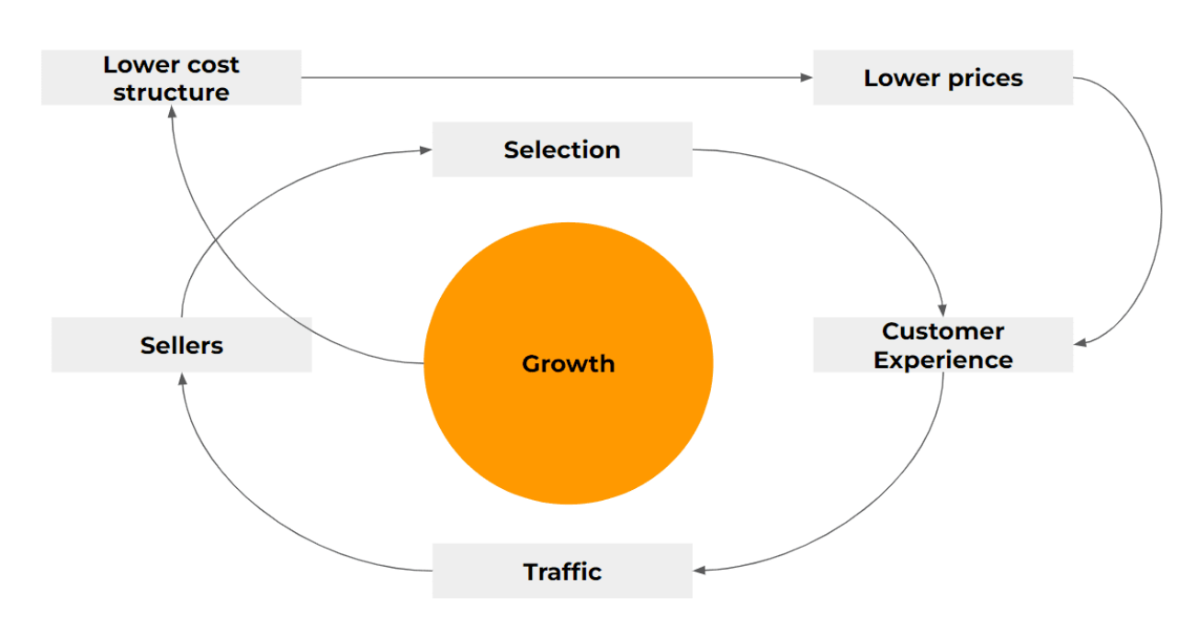
Figure 04: Strategy of Amazon (Hanley and Hubbard, 2020)
The hiring methods and policies of Amazon can be mostly explained by preexisting theories of selection and recruiting. Strict criteria are in place to ensure a good P-O fit, and the organisation places a premium on HRM's recruiting and selection processes. Senior management at Amazon views talents primarily as a source of sustained competitive advantage, which provides a strategic foundation for the company's recruiting practices. Employer branding is real and valuable, as shown by Amazon's hiring practices (Hanley and Hubbard, 2020). To recruit top personnel that will thrive in the company's culture, Amazon has effectively branded itself unique with intangible traits and features. A large body of research, however, indicates that interviews are ineffective in ensuring P-O fit, perhaps because interviewees may purposefully hide aspects of their genuine selves to win over prospective employers. Paradoxically, many companies, including Amazon, still use interviews to choose employees.
2.4.2. Performance and Reward Management
A performance and incentive system that has caused controversy at Amazon exists. Earnings at Amazon (2018) include a regular salary plus a signing bonus and restricted stock units (RSUs). Medical insurance, a 401(k) plan, a family support network, an adoption subsidy, paid leave, discounts, and a leave share and ramp programme are just a few of the welfare benefits that workers get. To save expenses and keep highly engaged personnel, Amazon pays less incentives to new hires and more to those who have been with the firm for a minimum of two years. A full-fledged performance management system is put into place by Amazon. According to Matthews et al. (2018), team performance is influenced by the accomplishments of the team leader, so there is no particular assessment for teams. Every September, the business has a basic mid-year evaluation, and from December to April of the following year, they have their year-end review (Bussin, 2016). At the same time, most compensation and promotion choices are made at year's end. There is a lot of labour involved with performance assessment as employees are required to do self-evaluations and peer reviews by the 14 leadership principles. Aside from the immediate input that management receives, the organisation also promotes an environment where workers will notify one another. Even before the change in 2016, Amazon would do things like rate workers' performance and fire the worst performers.
The common understanding is that performance management is the glue that holds an organization's goals to the efforts of its employees. Different schools of thought within performance management have proposed different approaches to motivating and developing employees, as well as a stricter focus on improving performance. Amazon has a more strenuous approach to performance development because it puts a lot of pressure on employees via open and honest peer assessment. Amazon, on the other hand, has the characteristics of a conventional business than your average American online startup. A standardised method for reviewing employee performance is provided by traditional performance evaluation systems. Line managers are expected to assess their employees' performance within a framework of predetermined performance evaluation meetings or reports, as devised by Amazon's central HR services. Amazon is just one of several companies that have implemented performance-based compensation. There are two parts to an employee's sense of reward, according to McGregor's Two-Factor Theory: the internal (such as work-life balance and possibilities for professional growth) and the external (such as pay rate and working conditions). There are two components to the value of human resources at Amazon. Capital reward, also known as RSUs, and labour reward, or conventional pay, are two components of total compensation. By combining a competitive base income with employee stock ownership, Amazon achieves a tight alignment of individual and organisational aims.
It is possible to understand Amazon's performance and incentive system using preexisting ideas and frameworks (AmazonJobs, 2019). Amazon distributes a portion of its income to each employee as a means of attracting and retaining talent. Using the Two Factor Theory, we can make sense of this. Amazon is also quite conventional and stringent in its approach to performance management, as seen in its performance evaluation method. Research indicates that performance-based remuneration is polarising due to its promotion of excessive workplace stress, inter-employee rivalry, and discriminatory behaviour towards certain individuals. The open peer-review system, continuous critique of workers, extended working hours, and extraordinary endeavours to attain exceptional performance within Amazon were all declared to impose an excessive burden upon executives and staff members.
2.5. Ingredients of Amazon’s retail dominance
To succeed in the Amazon era, one must comprehend the secrets of Amazon's success. It wasn't rocketing science for Amazon CEO and founder Jeff Bezos to find out that consumers value simplicity and quickness. A century ago, when it was establishing its empire via mail-order catalogues, Sears was well aware of this. Even before Bezos's firm came up with the idea of an online marketplace, other companies had already done it. One company that was on that bandwagon a long time ago is eBay. In many cases, Amazon wasn't the pioneer.
While Amazon's head start in e-commerce is undeniable, the company's skill in integrating its features is as crucial. Aiming to discourage people from shopping and spending with its competitors, Amazon has built an environment to eliminate any obstacles, no matter how big or tiny, that customers may encounter while making a purchase. The frequency with which customers place orders on the site provides obvious evidence of such behaviour (Soper, 2016).
To get insights on Amazon and hundreds of other retailers, research company Rakuten Intelligence utilises anonymised data from over one million US e-commerce buyers. Customers who shop on Amazon spend less overall, but they shop there twice as often, compared to those who shop at other stores. From what we can see, even for smaller purchases—the type they would have waited to make in a store—they are increasingly using Amazon (J., Goldfinch and Chinta, 2018). (Note: Rakuten Intelligence claims it is unaware of the %age of their data pool that consists of Prime subscribers.)
The "flywheel" effect, first described by author and professor Jim Collins, describes how a system's many moving parts work together to accelerate the whole, and it is exactly what has happened in Amazon's ecosystem, where years of effort and incremental improvements have paid off. Companies like Disney are living proof of this concept, as their movies, theme parks, products, and now streaming services all work together to create an integrated, self-sustaining ecosystem (AmazonJobs, 2019).
Collins, who was working on Good to Great, the book that would explain his flywheel idea, presented to Amazon's management in 2001, and it wasn't until then that the company learned how its flywheel worked. In his 2013 Amazon book, The Everything Store, Brad Stone detailed the result:
To be more specific, the current Amazon website did not exist when the company first began selling books online in 1995. "In the beginning, Amazon's distribution methods were not very scientific," Stone said. "Initially, the firm did not keep any inventory on hand. After a consumer places an order for a book, Amazon an order for it, and a few days later, the book arrives. Amazon would then put the book in storage before sending it to the consumer. Most Amazon orders take a week to arrive, and for rare or hard-to-find titles, it may take much longer. Its system of user ratings and reviews was one of its first inventions (Hanley and Hubbard, 2020).
With a combination of customer-facing products and a clever strategy that magnified the network effects they produced, Amazon had already set the stage to establish the flywheel that keeps it driving forward today, whether they knew it or not.

2.5.1. Simplicity of purchase
The "1-click" ordering feature, which allowed customers to pay and ship with a single click, was launched by Amazon in 1997, the same year it went public. It made shopping easier, made it so consumers couldn't back out of their purchases while entering their payment and shipping details, and ultimately persuaded them to let Amazon keep their data (Tuytens, M. and Devos, 2012).
2.5.2. Reasonably priced
By relying on wholesalers for better terms wherever possible, cutting margins to increase market share, and taking advantage of its low-cost structure as an online retailer without storefronts to operate, it was able to keep costs low. Using the savings, it generated from improving its logistics and operations, it continued to lower costs to attract customers (Tung and Berkowitz, 2020).
2.5.3. Delivery that is both quick and free
Amazon restructured its warehouses and increased shipping speeds under the supervision of Jeff Wilke, a prominent executive who focuses on the global consumer experience. At first, consumers could pay more for ultra-fast delivery. then started offering "Free Super Saver Shipping" on orders above $99 in 2002, however then cut the price to $49 and then $25. It served as an introduction to subsequent endeavours, Prime among them (Kantor, Weise and Ashford, 2021).
2.5.4. Success Prioritising Growth Above Profit
Bezos told investors he was playing the long game when Amazon's earnings were almost non-existent in the first decade. He was wagering that if Amazon could keep undercutting rivals and attract more consumers, profits would arrive eventually. "The stronger our market leadership, the more powerful our economic model," he would write in his now-famous 2004 speech to shareholders. Gaining a dominant position in a market may lead to more profits, faster capital flow, and better returns on investment.
At the same time, the corporation is earning more and more money from the selling of other services. Amazon also pays third-party sellers for things like advertising, fulfilment and shipping fees, commissions, and revenues for its profitable cloud computing sector, Amazon Web Services (AWS). Through its other operations, Amazon can finance ambitious initiatives like warehouse automation and the expansion of its own jet and truck fleets, which allow it to transport more and quicker, while also investing in its core retail sector, which accounts for 57% of total sales. Now more than ever, Amazon is more than simply a store. According to analysts, the corporation may need to diversify its business model outside retail if it wants to sustain its present rate of development (Bloomberg, 2019a). According to Sucharita Kodali, an e-commerce and retail researcher at Forrester, "They'll see so much growth from physical goods retail." Books, batteries, and clothing sold to consumers have lower profit margins than services targeted at companies; as a result, these goods may get less attention from Amazon when the company shifts its emphasis to technology, logistics, or both. Additionally, the business has branched out into healthcare and financing. At the same time, the flywheel continues to spin.
2.6. Contingency Management Theory
The contingency method of management is predicated on the notion that the efficacy of management is reliant or contingent upon the interaction between the implementation of management behaviours and particular circumstances (Hanley and Hubbard, 2020). According to the notion, management approaches should change depending on the situation. Since the result and timing of Brexit are still uncertain, this could represent a good match for Amazon both before and after the event. The British pound's decline in value towards the United States dollar is only one example of how speculation may cause an unforeseen chain reaction that impacts factors like currency changes. With more online shoppers than any other European Union country, the United Kingdom is a model of e-commerce success. The United Kingdom has excellent international connections and is often called an entry point to Europe (Schein, 2017). Consequently, Amazon will be able to minimise disruptions by adopting the principle of contingency management along with fusing leadership styles, notwithstanding the dangers involved.
2.7. Unchanging strategy
Even while the majority of a company's motivating reasons are subject to quick change, there exist certain things that do not alter no matter what. Most of these criteria, says Amazon's upper management, centre on consumer insights. Customers are key stakeholders and contributors to the corporation's success, thus naturally, the business prioritises their needs. For instance, the majority of Amazon shoppers are looking for a combination of choices, reasonable costs, and speedy delivery. Different companies in the same industry may have different priorities, therefore they may decide to leave certain things off the list.
The leadership at Amazon appears to have found success with a strategy to change that focuses on fixing the underlying causes. For example, if the company's pricing were to skyrocket or its delivery time was to significantly increase ten years from today, no client would remain interested in being affiliated with it. No matter what the future holds for the broader e-commerce industry, they will always be the driving forces behind the company's operations. Many see this as a competitive advantage for Amazon, primarily their plans are often based on fleeting concerns that will fade with time (AmazonJobs, 2019). In addition to concentrating on things that won't change over time, the company's leadership is aware of how quickly the world is getting more open and how important it is for businesses to have flawless information. Assuring proper utilisation of supplied information via mining, storage, and application is crucial for integrating the firm's activities with its consumers.
Creating a fantastic service for consumers while spending a shorter period addressing the service is how great companies are built, says Amazon's leadership. Just like the rest of Amazon, Bezos along with his staff are based on the belief that, no matter how bad things become right now, things will eventually get better and stabilise (Tuytens, M. and Devos, 2012). This form of guarantee also helps them to coordinate their actions, which is crucial for the long-term success of the company's growth plans. Crucial is the development of a system of checks and balances that enables the leadership to assess the practicality of previously held beliefs about a certain investment plan.
2.8. Summary
Transformational leadership remains highly favoured among leaders in today's world as it allows them to effectively collaborate with diverse individuals, recognise and address changes and obstacles, generate solutions through teamwork, develop innovative strategies and perspectives, and motivate others. Bezos effectively demonstrates the essential quality of a strong leader by displaying a keen focus on embracing and advancing innovations. He is unwilling to commit to a single position for a certain duration (Bloomberg, 2019a). Bezos deems it essential to constantly relocate and explore novel strategies and prospects for his organisation and the individuals associated with it. His aptitude for staying updated on the newest advancements may be attributed to his intense focus on customer satisfaction and willingness to embrace the customer's perspective. Various sorts of innovations exist, and Bezos can discern the most efficient ones for his firm and endeavours.
Chapter 3: Research Methodologies
3.1. Introduction
The significance of leadership management in organisational operational management has seen fast growth in the present environment of commercial globalisation. Several impactful leadership styles have gained popularity during the last two decades. The management style has been superseded by the effective leadership paradigm. Multiple studies on leadership abilities and styles have examined effective traits and behaviours of leaders in effectively managing, guiding, counselling, educating, and directing organisational teams or personnel. Research has shown that effective leaders may inspire their followers by engaging in political activities as well as social causes. Inspirational leaders have motivated their followers to engage in innovation, creativity, performance, and personal development, thus contributing to the improvement of the social fabric. This research will analyse the managerial approach and structure of Jeff Bezos, the creator and developer of Amazon, who is considered a pioneer in entrepreneurial and e-commerce ideas (Tung and Berkowitz, 2020). The paper will evaluate Jeff Bezos' implementation of a successful leadership management strategy, which has contributed to his status as one of the most influential leaders in the e-commerce sector. After examining several publications, it has been determined that Amazon's CEO employs an authoritative leadership style. This style involves selecting a small group of individuals to occupy top leadership positions. The CEO takes calculated risks to maximise the advantages for the organisation.
The search method would include combined digital and physical inquiry. The online searches will use systems such as the Scopus database, Google Scholar, as well as ProQuest.
Moreover, a thorough examination will be carried out by closely examining the bibliographies of relevant articles and research. The study will specifically examine the research that was published between January 2019 and March 2023. The data obtained from the chosen studies will thereafter be examined using a method known as thematic analysis. During the analysis, it is crucial to scrutinise notable commonalities and trends in the data that are pertinent to the study's aims. This chapter will outline the methodology used in this research to accomplish its goals. To assure the accuracy and reliability of the information as well as the conclusions drawn from the study, it is essential to use an appropriate research technique (J., Goldfinch and Chinta, 2018). This section will provide a clear explanation of the selected approach, including the research approach, methodology for research, study design, procedures for collecting data, and methods for evaluating the results. This chapter outlines the research methodology used for the inquiry. This encompasses a wide range of fields, such as the philosophy of investigation, investigation methodology, research design, research assessment, and tools for data collecting and analysis.
3.2. Research Philosophy
Experimental studies may be used to explore probable causal relationships. Nevertheless, given the thoroughness of the experimental settings in this data collection phase, it would be more suitable to examine them during future research attempts. This study is based on analysing previous research efforts that use empirical methodologies to assess hypotheses and theories. There is a disagreement among people since it is difficult to reach a consensus on the extent of achievement accomplished. Diverse research findings suggest that the lack of agreement might be ascribed to differences in research methods, sample sizes, and measurement protocols.
The purpose of this research is not to scrutinise the particular experiences of people or assess their significance. Instead, the focus will be on detecting patterns and connections within the data. For researchers, it is essential to comprehend the philosophical foundations that underlie their work to develop a successful research methodology. A research philosophy encompasses a cognitive approach to understanding and interpreting the phenomena under investigation and the knowledge acquired from them.
3.3. Research Approach
The primary investigators systematically examined the chosen publications employing a systematic data extraction procedure, enabling them to collect information about the approach used in the study, the number of participants, and outcomes. A cohort of thirty individuals was chosen for the research and thereafter a comprehensive questionnaire. Following the data collection process, the obtained material was subjected to narrative synthesis, which included analysing the data to identify patterns and relationships. The inquiry used a descriptive research methodology (Bloomberg, 2019a). To get more insights into the participants' behaviours, construct a meticulously organised online survey via Google Forms as well as distribute it to them via a messaging application such as WhatsApp. The questionnaire queries were derived from prior research projects and academic literature. Various variables may influence individuals' perceptions of Amazon and its global influence. Initially, we gathered the demographic information of the participants, including their age, educational attainment, gender, as well as any other relevant particulars.
This investigation relied on secondary sources such as publications, scholarly publications, and databases. Research was carried out to collect data for the research and guide the design of the questions. Secondary data extraction utilized many search engines to gather and assemble these articles. The data from the selected studies will next undergo a procedure called thematic analysis. Thoroughly evaluating the data involves identifying significant trends and common themes which are relevant to the objectives of the research. To achieve its objectives, this study used the methods outlined in the following section. Gupta and Gupta (2022) emphasise the need to use a suitable research methodology to ensure the credibility of the information and the validity of the research results.

Search Strategy
Empirical search in Google Scholar

Amazon revolution

Jeff Bezos
Keywords

People management

Results - 108
Leadership style
.

Not Relevant – 60 (eliminated)
Relevant - 48

Literature review was conducted for specified topic

Figure 05: search strategy for literature review (By Author)

3.4. Research Strategy
Counting keywords in specified units like pages, phrases, or particular phrases is a frequent way to investigate the amount or breadth of social information exposure. Researchers employed several indexes to assess the usefulness and credibility of social information publications. The United Nations International Compact along with the Governance of Responsible Investment in Sustainability Reporting Standards were among them. An analysis of the amount and quality of information disclosed in financial statements and other business communications may be done using the disclosure rating, as stated by Hooks and van Staden (2011). Finding important phrases that fit the disclosure index criteria and then encoding them according to the selected quality evaluation scale constitutes the standard procedure for doing a literature review using the disclosure index. To analyse theme material and get meaningful conclusions, written descriptions must be classified.
3.5. Research types
All of the methods, techniques, and equipment that are used to gather information and data to analyse it and find new, undiscovered truths are together called "research methodologies." There are three separate types of study, according to Caponecchia et al. (2020): quantitative, qualitative, and mixed. This dissertation made use of quantitative research methodologies, such as surveys. In the instance of quantitative data collection, researchers might compare this to the capacity to collect data and information right away from the ground up. Evaluation of the questionnaire and distribution of questionnaires to management and employees of different organisations also contributed to the quantitative data collection. A combination of both primary as well as secondary information was chosen because each would increase the likelihood of appropriate conclusions being drawn from the data. The claim that the original data was obtained via a survey defines the data collection process in that kind of research. Examining Jeff Bezos's leadership role in Amazon's revolution and the effects on organisational performance, this research uses quantitative methodologies. The main purpose of the research is to look at what drives and impacts Amazon's management style.
3.6. Sampling
Choosing a representative sample from a larger population to conclude is known as sampling. In analytics, there are several possible sampling methods. It is important to note that while choosing a sampling approach, the objective of the statistical research should be considered. In their study, the researchers employed a random sampling approach. If a conventional random sampling procedure is used, then every person has an equal probability of getting selected. Every single person in a population is considered in a basic random sample. Using this method, we will ask as many people as we can to fill out the survey (Tuytens, M. and Devos, 2012). This led to the distribution of 45 questionnaires to the general public. We used the aforementioned parameters for the desired population as a guide to randomly choose participants. After participants were sent a briefing regarding the research's aims and rationale, the survey was conducted online. Just thirty out of forty-five people who were requested to complete the survey succeeded in doing so. Analysis was then performed on the data derived from the responses.
Participants will range in age from eighteen to sixty-five and work in Amazon Inc.

3.7. Construction of questionnaire
Questionnaire construction refers to the act of crafting a set of questions that effectively captures a substantial amount of pertinent information related to a certain area of research. Questionnaires normally consist of two sorts of questions: close-ended and open-ended. The questionnaire's focus on open-ended replies enables the collection of qualitative data. The closed-ended design of the surveys enables the collection of quantitative information. Data collection for this research has used the use of questions that are closed-ended. Data from participants was gathered via a Likert scale with a score of five. Individuals may express their degree of agreement or disagreement through the use of a Likert scale, which allows them to rate a statement on a scale ranging from zero to five. Participants may indicate their level of dissatisfaction or satisfaction with a statement or problem by choosing one of five options from a Likert scale.
3.8. Research Design
To further evaluate the social information disclosure quality and find relevant keywords, the researchers also used the GRI Sustainable Development Reporting Guidelines. Allegedly, the GRI criteria cover all bases when it comes to Amazon, including economic, environmental, as well as social factors. Assigning a keyword or keywords to each viewpoint allowed the author to build their analytical keywords.
The use of content analysis is linked with two significant advantages. At first, the technique is quite objective once the subjective process of choosing the precise variables is over. As a result, the results are unaffected by the particular research. In addition, this method's mechanical design opens the door to the prospect of using bigger sample quantities. However, there are certain restrictions with content analysis (Bloomberg, 2019a). The analysis might be skewed due to content selection bias, which means the selection may not be exhaustive. Even more specifically, the issue is related to the "walk and talk problem," the difficulty of coordinating one's words and deeds.
3.9. Data Collection
To determine the impact of Amazon's people management and Jeff Bezos's leadership on the company's growth and development, this research used a wide variety of data collection and analytic techniques. Nevertheless, the research will also take into consideration the possibility that readers' own beliefs and perspectives impact how they perceive and react to a provided questionnaire regarding Amazon and Jeff Bezos.
This research will heavily rely upon primary sources because of the survey-based structure of the information gathering and analysis techniques. Content evaluation is an approach to study that involves examining the meaning of words and studying previous outcomes to achieve research objectives by comprehensively evaluating as well as analysing large quantities of qualitative material from several sources. This study employs many techniques for data collecting and analysis. Given the reliance on surveys for gathering and analysing information, this research will heavily use primary sources of information (Tung and Berkowitz, 2020). Content assessment requires a thorough evaluation and evaluation of large volumes of qualitative data from multiple sources for the purpose of determining terms and assessing historical impacts. Content evaluation employs criteria that involve integration strategies and defined outcomes to categorise material appropriately. This research will also examine Amazon's revolution and people management strategy using secondary data, which includes previously published papers. To get valuable insight into the actions, interactions, and outcomes for the business, it is necessary to download and appropriately analyse these data. Content evaluation employs criteria such as integration strategies and defined outputs to categorise material effectively.
3.9.1. Research Process
The methodology used for data collection is outlined below:
- One possible approach is to administer a survey comprised only of binary questions, requiring respondents to answer by selecting appropriate options.
- A heterogeneous group of individuals received a reference to the Google form.
- The survey was closed after the allotted 48 hours had passed.
- Finally, the results of the survey are going to be evaluated.
3.9.2. Elimination of Biases
Bias is identified as the systematic introduction of error through sampling or evaluation by researchers through the preference for one outcome as well as response over others. At every point in the study process, from ideation to data collecting to analysis to dissemination, bias might enter. Researchers mitigated the possibility of bias in their results by selecting participants at random. No random selections were made for the samples used in this analysis. That way, everyone in the community has a fair shot at becoming a research subject. Whenever the researcher is not involved in topic selection, there is less room for bias.
3.9.3. Validity and reliability
If you want your study to be believable and trustworthy, you need to make sure you have a good strategy, use appropriate methodologies and samples, and follow it closely and consistently. To guarantee the dependability of the research, the survey has been designed to collect data using the most dependable manner (Likert scale). Just as the research topic evolved, so did the study's technique. A Likert scale represents one of the most popular and reliable methods of data sorting. The data is quite reliable and has probably not been tampered with in any way considering that it has been gathered via Google Forms.

3.10. Ethical Considerations
It is critical to keep several ethical factors in mind when doing secondary research. Ensuring accurate citation and recognition of all sources employed is crucial to prevent allegations of plagiarism as well as misrepresentation. Beyond that, researchers must be careful not to violate any intellectual property laws, such as those that prohibit the unlicensed use of copyrighted material. The potential impact of the inquiry on the individuals or groups involved must be carefully considered, and their right to privacy and secrecy must be ensured (Tung and Berkowitz, 2020). Scientists doing study must be fully aware of their own biases and assumptions and must take steps to ensure that they do not influence their findings. Ethical secondary research, in general, requires a process that is both careful and reflective, with an emphasis on openness, accuracy, and respect for all people involved.

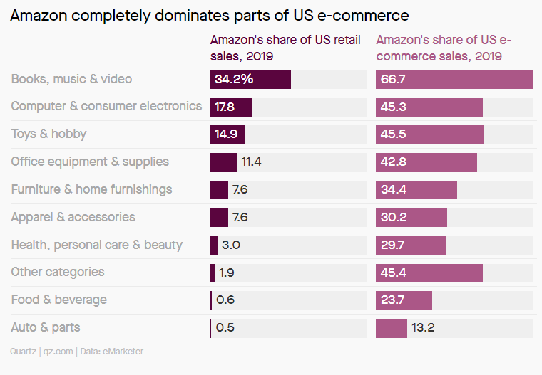
Figure 06: Amazon completely dominates parts of US e-commerce (Tung and Berkowitz, 2020)

Chapter 4: Findings and Results
4.1. Introduction
Amazon's analytics and monitoring technologies keep a close eye on employee output all day long. Without involving a human supervisor, Amazon's software for management may detect when employees are falling behind and send out warning letters, identify who needs "retraining," or even fire them. Workers are encouraged to leave by the corporation itself. Amazon sees it as a chance to hire younger workers who bring new ideas and perspectives to the table. If you're a full-time employee with a minimum of twelve months of service at an Amazon fulfilment centre and you want to quit, the company gives a $10,000 separation bonus per year. The catch is that employees will be permanently banned from working for Amazon when they take the offer.
4.2. Key Results/findings
The six questions selected are aligned with the leadership of Jeff Bezos and how it impacts people working within Amazon.

4.2.1. Results from the questionnaire

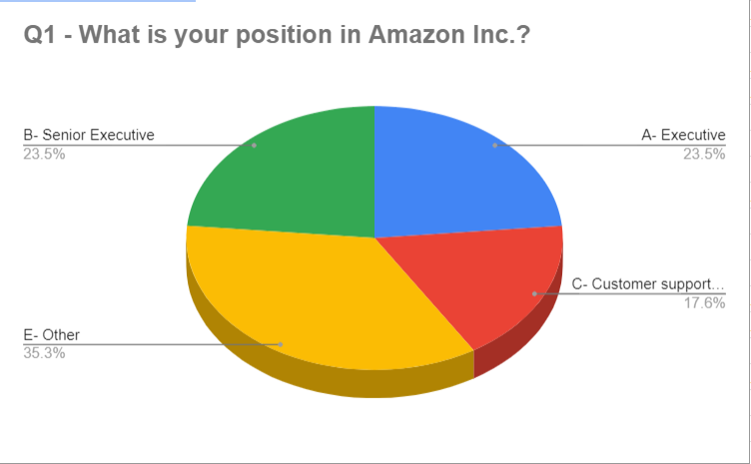
Figure 07

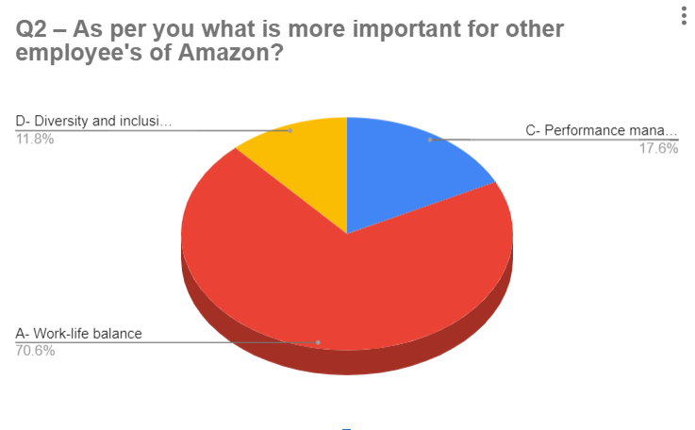
Figure 08: Importance for Amazon’s employees (By author)
This question justifies how employees are managed and how it impacts them. To assess and advise on Jeff Bezos's leadership style, the parameters requested for these questions are meant to provide some areas that workers would want to focus on. Another difficult aspect of Amazon's current leadership style is how the company treats its employees. One common complaint levelled against online retailers and cloud service providers is that it is too strict with their workers and puts an unhealthy emphasis on productivity over work-life balance (Bloomberg, 2019a). Getting the best out of its employees has been crucial to the company's success up to this point, so this problem can be tough to solve. The results that can be deduced from this question are that 70.6 per cent of people want work-life balance, 11.8 per cent want diversity plus inclusion and the remaining 17.6 per cent want performance management. So, people working in Amazon require more work-life balance and the HRM of the organization must work for that to achieve effective people management.
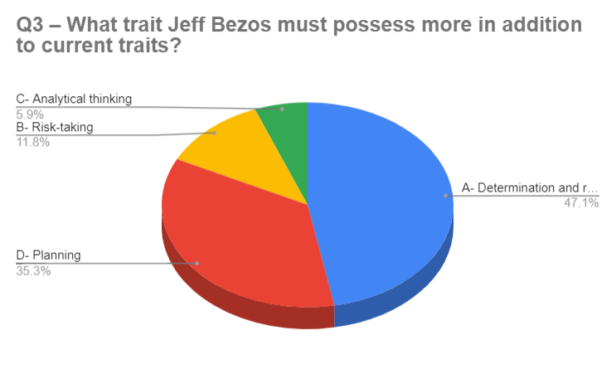
Figure 09: Traits Jeff Bezos must possess (By Author)
This question justifies that Amazon's leadership is maintaining the company's profitability despite its present narrow profit margin. So far, the company has been successful in overcoming this challenge by relentlessly exploring new business sectors, making the most of its people resources, and implementing innovative procedures. Journalists with an eye for numbers were quick to knock Amazon, claiming the firm would go under if Borders and Barnes & Noble joined the online sales arena. Since Amazon didn't start making money until 2001, most of these criticisms were justified. Conversely, Jeff Bezos was optimistic about the possibilities offered by the internet and ready to cash in on the digital bubble. The results are that 35.3 per cent of people want more planning, 11.8 per cent risk-taking, 5.9 per cent analytical thinking and 47.1 per cent determination as traits that Bezos must possess additionally.

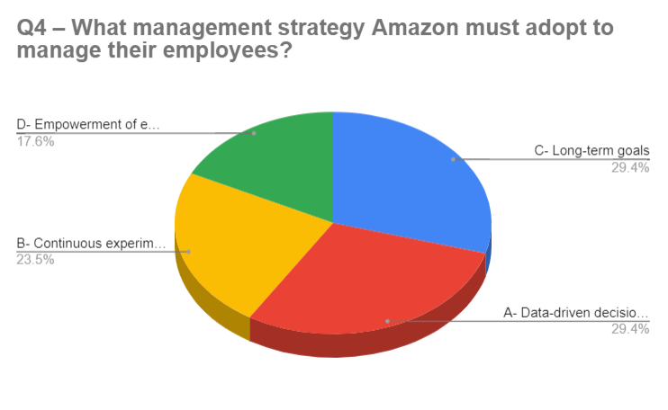
Figure 10
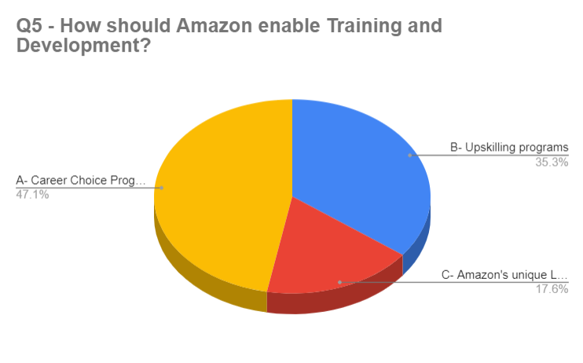
Figure:11
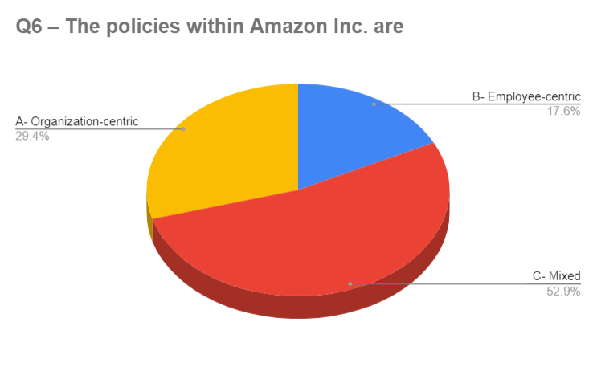
Figure: 12
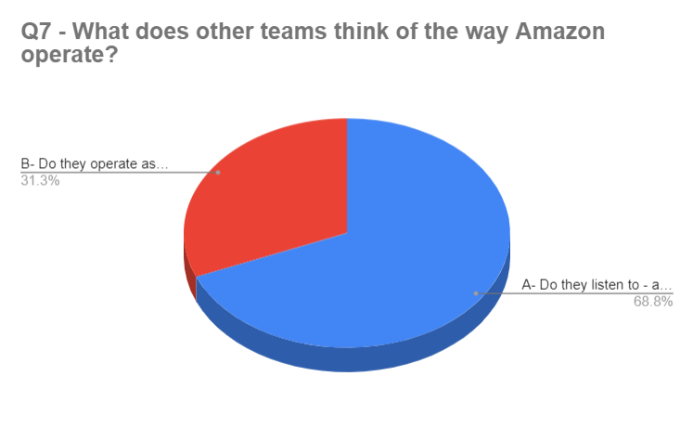
Figure: 13

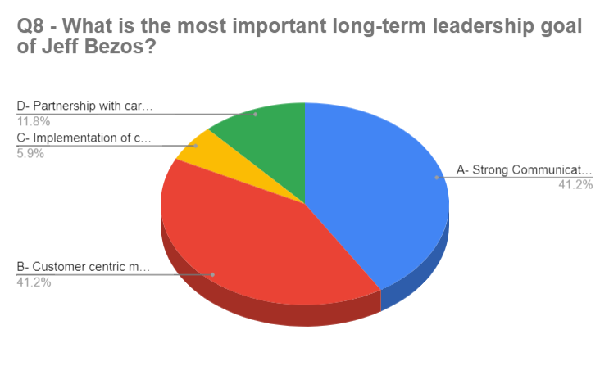
Figure 14: Leadership goal of Bezos (By Author)
This question analyses the long-term leadership goal that Bezos must adopt to effectively run his business and manage people. And because of its training and development strategies, which promote innovation, experimentation, and failure, among other things, Amazon ranks well as a learning organisation. This point is confirmed by this query. The results assert that 41.2 per cent want strong communication, 41.2 per cent want customer-centric methodologies, 11.8 per cent want partnership and 5.9 % want implementation as long-term goals that Bezos must implement to effectively manage his leadership skills.

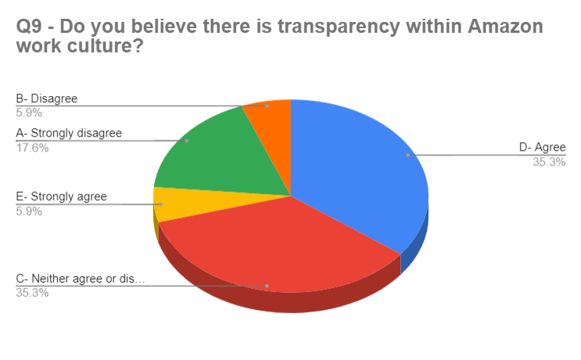
Figure 15: Is there transparency within Amazon (By Author)
This question analyses the work culture of Amazon so that it can get a reflection on employees and work on their betterment. This question is chosen because Amazon is known for being highly focused on customer satisfaction. The founder and CEO, Jeff Bezos, is a transformational leader who believes that by prioritising the well-being of employees, they will in turn provide excellent service to customers, creating a mutually beneficial situation. 5.9 per cent disagree 17.6 per cent people strongly disagree and 35.3 per cent are neutral. While 5.9 per cent strongly agree and 35.3 per cent strongly agree that there is transparency within Amazon.
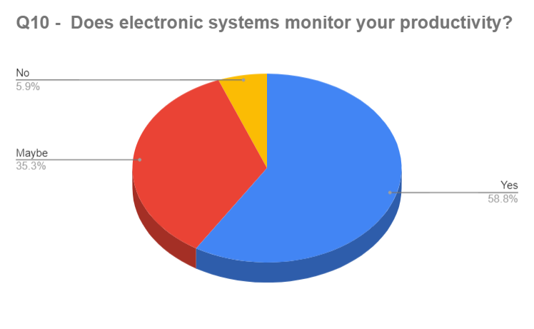
Figure 16: Does electronic system monitor productivity (By Author)
It is again important for any business organization of any size to measure the effectiveness of its HR management function. Amazon employs many indicators, including E-NPS (Employee Net Promoter Score) and employee happiness index, to evaluate its performance. Furthermore, further suggestions have been proposed to enhance its efficacy. This inquiry examines the rationale for electronic surveillance and its effects on workers, as well as the shifts in Bezos' leadership. 58.8 per cent of people responded with yes, 35.3 per cent of people were not sure and 5.9 per cent of people refused that their performance is monitored within Amazon.
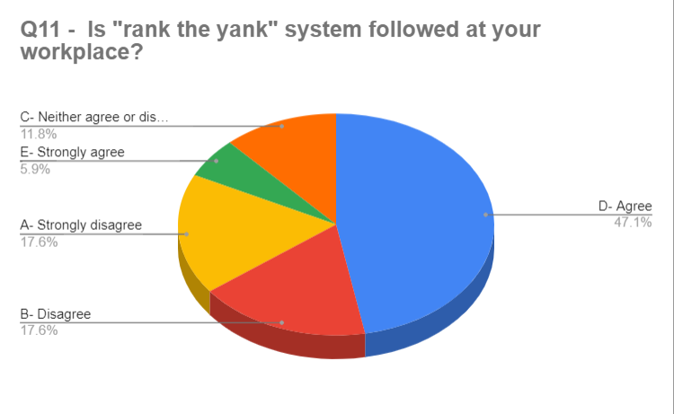
Figure 17: Is rank the Yank system followed (By Author)
Sometimes, the labour market is extremely competitive and there is a shortage of skilled labour or employees. Therefore, the human resources department must either provide more resources to attract personnel from other organisations or develop its internal talent pool. This may be seen as succession planning for the organisation or, more specifically, as a necessary analysis of management via the process of rank evaluation. 5.9 per cent strongly agree and 47.1 per cent strongly agree about the Yank system. 11.8 per cent of people were neutral about ranking the Yank system. 17.6 per cent of people disagreed and 17.6 per cent of people strongly disagreed about ranking the yank system in Amazon’s work culture.

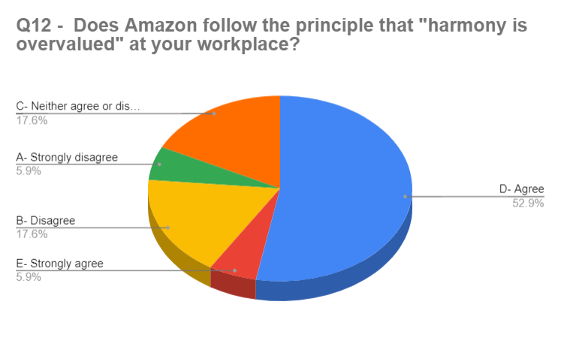
Figure 18: Is harmony overvalued at Amazon (By Author)
Harmony is essential for any organisation as it may suppress candid criticism and promote courteous commendation for poor ideas. Instead, Amazon employees are given instructions to "disagree and commit" - to critically analyse their colleagues' ideas, providing comments that may be direct and even uncomfortable, before ultimately supporting a choice. The results show that 5.9 per cent strongly agree and 52.9 per cent people agree that harmony is overvalued at Amazon. While 5.9 per cent strongly disagree and 17.6 per cent disagree, remaining neutral about that. So, the findings are that harmony for employees is valued at Amazon during people management.
4.2.2. Results concluded from research
From the inception of sales, Bezos has always prioritised enhancing societal efficiency and generating additional value. Amazon's primary objective is to prioritise long-term competitive advantage above immediate income generation. Amazon serves as an equitable company, yet it has a flexible and dynamic organisational structure. Amazon has created a unique guideline called the "two-pizza regulation" to fit with its business objective. This rule specifies that teams should be maintained sufficiently in size to be served with just two pizzas (Kantor, Weise and Ashford, 2021). Small team sizes provide both heightened sensitivity and increased engagement. In addition, Amazon's company culture encourages employees to surpass traditional norms to cultivate inventive concepts and resolutions. Amazon offers a comprehensive staff training programme. According to Amazon (2018), the firm views every worker as having a growth potential and considers staff training simply a crucial means of enhancing workers' personality and capabilities. Bezos often emphasised the need to treat workers' personalities on par with the collective character of Amazon via training. Specifically, Amazon's training programme facilitates workers' engagement with the organization's culture and values. By acquiring a comprehensive comprehension of Amazon's business philosophy, individuals will enhance their performance in terms of both personality and skill. The approaches used by Amazon may be attributed to the application of strategic human resources management, or SHRM theory. According to SHRM, an organisation needs to have a method of aligning HR choices with strategic objectives or using standards of excellence to enhance organisational performance. Specifically, the corporation forms small teams to minimise disparities in hierarchy, promote employee self-governance, and allocate resources towards worker training and growth. Amazon also promotes the practice of sharing within specific groups and departments as a means to stimulate creativity.
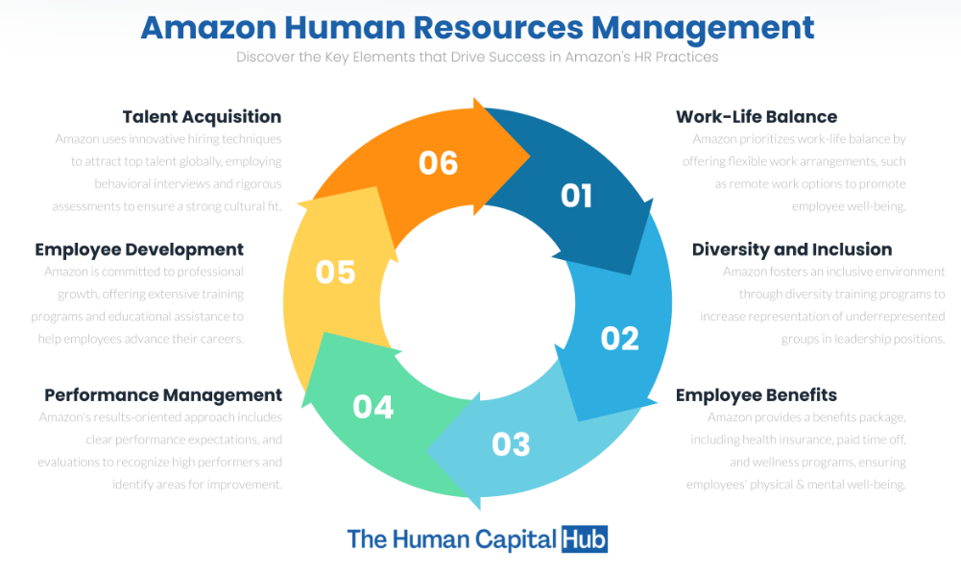
Figure 19: Amazon’s Human resources management (Soper, 2016)
Amazon’s Strategic HRM methodology of "best fit" emphasises the strategic alignment of top management decisions with worker behaviour in a way to fosters Amazon's growth as a successful e-commerce giant. By comprehending and acknowledging the business culture and operating in a versatile team-oriented fashion, workers will be incentivized to suggest innovative concepts and enhance organisational efficacy. The research results of the Society for Human Resource Management (SHRM) may largely elucidate Amazon's human resources (HR) policy. Amazon has deliberately organised and structured its human resource operations, such as staff training, in a way that supports the achievement of its strategic objectives, such as continual innovation and creating additional value for society. This approach aligns with the concept and features of Strategic Human Resource Management (SHRM) as described by Howland (2017). Nevertheless, the SHRM theory does include a few constraints. Amazon has several departments including various tasks and job roles, such as technical, economic, marketing, as well as logistics. This raises the challenge for the Society for Human Resource Management (HRM) on the need to formulate distinct HR policies for different categories of workers. In such a case, a range of more extensive equity concerns would arise. In addition, the notion of "best practices" is inherently contradictory, since they are context-dependent and not universally applicable in most instances.
Bezos has implemented a rigorous procedure for recruiting and selecting persons with exceptional abilities. Amazon employs a standardised and streamlined recruiting process facilitated by Bar Raiser. The organisation has established two compulsory criteria for recruiting, namely performance plus qualifications. Simultaneously, the organisation places significant emphasis on the possibility of long-term advantages that people may provide (J., Goldfinch and Chinta, 2018). Amazon designates Bar Raisers to rigorously assess applicants based on business culture as well as management principles. Bar Raisers also engage in discussions with other investigators after the selection phase and possess the authority to block applications, so ensuring that applicants enhance the talent expectations for the whole organisation. Bezos recognises that cultivating a diverse workforce is crucial for Amazon's ongoing innovation and sustained competitive advantage. Consequently, he actively seeks out and welcomes individuals with varied backgrounds and creative abilities. To minimise recruiting expenses, Amazon eschews conventional written examinations and instead uses online applications and screening processes.
Recruiting and screening employees are essential human resources strategies in contemporary organisations. The standard process includes assessing the needs of the firm or workforce, conducting a job-competency assessment, developing job descriptions along with individual specifications, drawing applications, choosing applicants, setting up meetings, and assisting with the onboarding and introductory process. This procedure applies to Amazon, as stated by Bratton and Gold (2012). recruiting has significant value for organisations like Amazon as a shortage of applications might result in a dearth of skilled individuals, while ineffective recruiting can result in additional expenses for training. Amazon has cultivated a reputation as an exemplary workplace. The corporation consistently emphasises its commitment to making history and constructing a lasting enterprise to recruit unique minds that share confidence in Amazon. Selection involves the process through which managers employ certain approaches to choose candidates from a pool of persons for job vacancies (Vallas, Johnston and Mommadova, 2022). Organisations should give priority to person-organisational (P-O) fit whenever selecting persons, as it allows them to gain a competitive advantage, recruit and preserve outstanding workers for long-term expansion, and reduce turnover among their workers. Amazon highly values the concept of Person-organisational fit. For instance, the company selectively recruits individuals who have a deep understanding of their Fourteen principles of leadership along with a passionate belief in Amazon's vision.
The current theories concerning recruiting and selecting employees are mostly capable of effectively explaining Amazon's operations and practices. The corporation prioritises recruitment as well as selection as a crucial aspect of human resource management (HRM) and establishes stringent criteria to ensure a strong person-organization fit (P-O fit). Amazon's recruiting practices are strategically designed since senior management views talents as a valuable resource for maintaining a lasting competitive edge. In addition, Amazon's recruitment and selection methods demonstrate the genuineness and importance of employer identity. Amazon has successfully cultivated a distinct personality for its brand by highlighting intangible characteristics and qualities. This strategy aims to recruit talented individuals who will thrive in the company's organisational culture (Kantor, Weise and Ashford, 2021). The assessment of team performance is not based on a particular criterion, but rather on the accomplishments of the team manager. The company does its fundamental mid-year assessment every year during September and conducts year-end evaluations from November to April of the subsequent year. Generally, pay adjustments as well as promotions typically are granted at the end of every year. Evaluating performance requires staff workers to engage in self-assessment and peer review centred around the Fourteen principles of leadership, which is a significant undertaking. Additionally, the organisation promotes a culture of reporting on one another among workers, while the management can promptly receive criticism. Before the 2016 change, Amazon assessed and terminated workers based on their performance rankings.
Performance management is frequently regarded as a method of connecting individual endeavours to corporate goals. Performance management can be classified into two separate approaches: a severe strategy focused on improving performance, and a liberal strategy aimed at inspiring and developing employees. Amazon has a rigorous approach to performance enhancement since the corporation places significant pressure on its workforce via a public peer review process. In contrast to typical American online firms, Amazon operates as a more conventional organisation. Conventional performance evaluation methods provide a standardised procedure for evaluating worker efficiency (Vallas, Johnston and Mommadova, 2022). Amazon's human resources departments centrally devise the procedures that require supervisors and managers to review staff performance using an assortment of performance evaluation meetings or reports. In addition, several corporations, such as Amazon, are implementing a system of remuneration that is contingent on performance. McGregor's 2-Factor Concept classifies workers' opinions about rewards among two categories: internal elements, which include a balance between work and personal life and development opportunities, and external ones, such as pay level. Inside Amazon, the significance of human resources consists of two primary aspects. The first component is remuneration for labour or a conventional wage, while the other component is remuneration for capital. In addition to offering a competitive base pay, Amazon also incorporates employee’s ownership of stocks, which fosters a strong alignment among individual and organisational objectives.

4.3. Discussion
4.3.1. Bezos Leadership: Theoretical Perspective
In contemporary times, leadership is enhanced and cultivated via the use of many ideas, concepts, and procedures. Given the current multitude of definitions and interpretations regarding leadership, it might be rather simple to get disoriented and bewildered by the available choices. Leadership is more than just organising individuals and equipping them with objectives and tools to facilitate their tasks. Leadership is a work style and procedure that inspires and empowers individuals, enabling them to comprehend their demands and influence. Various forms of leadership are established to offer leaders with reliable assistance and recommendations on how to achieve success in their chosen field. Such leaders should refrain from coercing others or compelling them to adhere to the proposals put forward by others. Transformational leaders possess the capacity to see the essence of tasks, manoeuvre through transitions, and determine the appropriate method of action to take in specific circumstances (Claus, 2019).
Bezos embodies a visionary leader, demonstrating a readiness to go into many fields, make informed decisions, and include people in his pursuits. He is eager to discuss and explain each element of his work, including the technological builders and transcriptions (Soper, 2016). Individuals fortunate enough to collaborate with Bezos acknowledge that this leader is captivating, owing to his aptitude for using his fortune and personal passions to foster diverse initiatives and propel the digital revolution in a manner that resonates with the general public.
The defining characteristics of his leadership style are his ambitious nature and his views. His unwavering dedication to his clients and colleagues imbues him with strength and confidence. He can easily recognise and understand a single error and fix the functioning of a system, just as he can persuade millions of others to embrace his views and have faith in his methods. Furthermore, it is intriguing to see how Bezos implements his concepts across many undertakings. He aims to reconcile them by using his core beliefs and demonstrating the logicality of his choices. E-commerce as well as Internet technologies significantly disrupt conventional trades and transportation systems. Bezos consistently embraces change plus re-evaluations to comprehend core principles, generate novel propositions, and fulfil the demands and expectations of the general populace (Vallas, Johnston and Mommadova, 2022). He recognises the need to effectively allocate both human resources and corporate resources. Hence, it seems logical for him to allocate the resources based on the type of activity performed. Bezos realises a fundamental yet highly effective truth: within the offline setting, thirty per cent of the assets of an organisation are used to ensure a positive customer experience, while seventy per cent are allocated to marketing. Conversely, in the online realm, seventy per cent of resources must be dedicated to creating a satisfactory customer experience, with the remaining thirty % being focused on promoting it. He firmly believes that working through online employment improves his understanding of his customers and allows him to assess the skills of his personnel as well as their capacity to recognise both positive characteristics and faults of their tasks.
4.3.2. Leadership Attributes in the Work of Bezos
The quality and results of leadership are often determined by the behaviours and traits shown by the individuals engaged in this process. Annually, scholars and policy-makers cultivate novel tactics and methodologies to cultivate effective leadership. They highlight and emphasise the essential attributes that should be considered. The case of Bezos illustrates that competing is not a prerequisite for being an exemplary leader. Sufficiently identifying personal needs and capacities and providing individuals with information about their responsibilities in society is enough. Simultaneously, this leader exemplifies the process of cultivating essential characteristics and effectively using them in appropriate contexts and moments (Kantor, Weise and Ashford, 2021).
A leader must maintain unwavering attention and concentration on a given job under all circumstances. Several factors must be considered throughout the process of company development. Nevertheless, there are often several superfluous elements and intricacies that must be eliminated or altered. During Bezos's interviews, he acknowledged the significant influence of word-of-mouth communication. This trait is crucial both in personnel management and in consumer research (Claus, 2019).
Confidence becomes another essential characteristic of a leader. A leader might possess several innovative ideas and recommendations. However, if one lacks confidence in all aspects of what is being presented, the worth of such labour may be rendered null. Bezos exhibits not just unwavering confidence in his concepts but also an intense enthusiasm for any endeavour he seeks to engage in. His prominent self-assurance is seen in his successful Amazon company, his accomplishments within the information technology sector, and his adeptness in engaging with others who show interest in him on his terms (Soper, 2016). His assurance may be seen by some others as an indication of egoism. However, it is false. People need competent leaders, and Bezos undoubtedly falls into this category owing to his company's self-awareness and capacity to prioritise significant matters. Bezos also asserts that the prosperity of any enterprise hinges on individuals' willingness to both honour and confront one another's choices. Leaders are required to champion their perspectives and strive to broaden their opportunities rather than engaging in several tries and seeking fresh concessions.
The compilation of leadership traits is extensive. Multiple contemporary thinkers, journalists, and authors use diverse methodologies to provide a compelling portrayal of an effective leader. Attributes like as receptiveness, fervour, enablement, magnanimity, and optimism all significantly contribute to the formation of a resilient leader. Most of these attributes may be identified in a single individual, namely Jeff Bezos (Vallas, Johnston and Mommadova, 2022).
4.3.3. Achievement of Bezos in Organisational Performance and the Transformation of Amazon
Ignoring the existence of revolutionary technology in the contemporary world is incorrect. Its objective is to emancipate individuals and highlight the capacity of technology in various economic sectors. The most recent accomplishment of Bezos along with his team has already yielded several advantages for Amazon. The firm provides artificial intelligence to enhance human intellect and support life via the use of computers and efficient software. The Internet's influence continues to grow exponentially with each passing day.
Forecasting its potential growth in the next years is challenging. However, Bezos demonstrates that it is unnecessary to attempt to forecast its capabilities or potential impacts, but rather to use what is essential in the present instant. If individuals can acquire anything, they should not delay in clarifying the results but rather take immediate action due to their capability. Bezos' self-assurance is crucial as he strategically takes actions that he is knowledgeable about and collaborates with those whom he has trusted (Claus, 2019). He establishes the objectives and ensures that the organisation achieves them within a certain timeframe. Although the completion of such work may pose difficulties, the process of developing novel solutions and instructing others is consistently engaging and demanding.
Currently, Bezos is renowned as the architect of among the most impactful and triumphant upheavals worldwide. The dominance of Amazon poses a formidable obstacle for several enterprises that engage with consumers and for any organisations striving to provide novel services and assistance. Amazon is a conglomerate of a reputable service corporation, a highly skilled workforce, and a loyal customer base (Vallas, Johnston and Mommadova, 2022). Every individual led by Bezos identifies and resolves each new difficulty that arises at every phase. His excellent leadership abilities facilitate the coordination of work across many global areas and foster unity among individuals, irrespective of their disparities in preferences, ages, nationalities, and other variables.
4.4. Summary
The performance and reward structure of Amazon may be understood by using current theories and models. As a recruiting and retention strategy, Amazon distributes a portion of its income to each employee. According to the 2-Factor Theory, this makes sense as, Amazon is also quite conventional and stringent in its approach to performance management, as seen in its performance evaluation method. According to research, performance-based compensation is divisive because it encourages unhealthy levels of workplace stress, unhealthy levels of internal competition, and unjust treatment of employees. Considering Amazon's renowned practice of transparent peer review, persistent scrutiny of employees, extended working hours, and relentless pursuit of exceptional performance, it seems plausible that this situation may occur.

Chapter 5: Conclusions and Recommendations
5.1. Introduction
Ultimately, Amazon's approach towards employee management has both advantages and disadvantages. An efficient SHRM framework as well as a standardised hiring procedure that prioritizes P-O fit are in place at this organisation. As a result, Amazon is well-known as a forward-thinking, efficient business that strives to increase its social impact. Many talented individuals with a strong belief in Amazon's culture are also drawn to the company. The business implements an economically viable incentives management approach to attract and retain talented individuals, namely via the provision of significant welfare benefits and equity ownership opportunities (J., Goldfinch and Chinta, 2018). However, Amazon's assessments of performance are too stringent. Daily, the executives of this firm consistently demand increasing levels of productivity from their employees. As a result, a significant number of employees experience dissatisfaction in their excessively demanding occupations and have challenges in achieving a harmonious equilibrium between work and personal life.
5.2. Conclusion from Literature Review
Amazon's continuous pursuit of outstanding performance has led to a significant turnover rate, which negatively impacts both the organization's reputation along the well-being of its workers. Amazon paradoxically portrays itself as a pioneering firm while failing to provide its most valuable asset—its pioneers—with the respect it deserves.
As per Jeff Bezos' "two pizza standards" theory, "conferences should be conducted in groups of sufficient size to ensure that each member can be adequately supplied with a mere two pizzas." The organisational structure of Amazon exemplifies this. The organisational structure is matrix-like, having both divisions and functional small teams (Claus, 2019). Worldwide hierarchies, geographical divisions, along global function-based groupings are three of their primary features. The corporation can support effective operation management as well as do away with equipment along with effort duplication thanks to the worldwide function-based organisation. The chief executive officer's office, company growth, financial, and accounting departments, international consumer business, administration, legal, and customer service constitute their primary areas of responsibility. The second feature, the Global hierarchical system provides a command structure for managing e-commerce operations. Administrative oversight over the firm is the goal of this job. Thirdly, there are divides based on geography. It has two divisions, one for the North American market and one for the international market, and its primary function is to oversee online sales. Through both of these divisions, the organisation can tackle regionally specific concerns. With the help of its matrix structure, the firm has consistently expanded its reach in the global e-commerce sector. With its hierarchical structure and function-based groupings, Amazon.com, Inc. can carry out management orders with ease. In addition, the regional divisions handle issues specific to the particular region's online retail sector and associated economic situations. One drawback of the matrix form is the limitations it imposes on adaptability and flexibility. It is suggested that Amazon reduce its grip over these structural features and instead empower its regional and localised offices to be more responsive and flexible. Because of this, the business will be able to run more efficiently.
Ultimately, Amazon's strategy for personnel management exhibits both advantages and disadvantages. The organisation employs efficient Strategic Human Resource Management (SHRM) techniques and a standardised recruiting and selection procedure, emphasising the Person-Organization fit (P-O fit). Thus, Amazon has solidified its reputation as a forward-thinking and productive corporation that consistently strives to provide more societal benefits. Additionally, it appeals to several innovative individuals who possess a strong conviction in Amazon's environment. The organisation employs a cost-efficient incentive management approach to recruit and retain skilled individuals, particularly via generous benefits and stock ownership opportunities. Nevertheless, Amazon's monitoring of performance seems excessively stringent. The corporation consistently exerts pressure on workers to increase their workload, imposing unreasonably stringent demands. Consequently, several individuals experience dissatisfaction with the very demanding work environment along with struggles to achieve a work-life balance. Amazon's relentless pursuit of outstanding performance has resulted in an unusually high turnover rate, which harms the company's image and raises the cost of human resources. To enhance its performance, Amazon's HRM must change its focus from performance-centric to a more human-centred approach.
5.3. Conclusion from primary research
Data collection for this study relies on interviews with a convenience sample of 18 people because of time constraints. Primarily, Amazon's human resources management ought to prioritise individuals above productivity. Research suggests that people management approaches have the potential to greatly affect several important indicators, such as performance management, recruitment and selection. If Amazon wants to make its reward and performance-based system less stressful, unjust, and full of irrational internal competition, it ought to modify it. For instance, to assist its workers in better balancing their personal and professional lives, Amazon could enhance its supporting networks. Instead of enforcing stringent performance standards on its employees, Amazon could invest effort in understanding their needs to offer them the necessary motivational factors to foster enthusiasm and creativity.
Nevertheless, several studies indicate that interviews are not a reliable method for efficiently assessing Person-Organization fit. This is due to the possibility that interviewees may deliberately hide their genuine selves to provide a more appealing image to the prospective employer. Amazon employs a contentious method for managing employee performance and distributing rewards. Amazon's pay scheme comprises a basic salary, an arrival bonus, plus reserved shareholdings (Amazon, 2018). The firm provides a variety of perks to its employees, including healthcare coverage, a savings plan for retirement (401(k)), a support system for families, financial help for adoption, programmes for sharing leaves and gradually returning to job duties, discounts for employees, and compensated time off. Amazon offers small incentives to newly hired employees but provides more significant prizes to individuals who have been working with the company for a minimum of two years. This strategy aims to minimise expenses and keep highly engaged and committed individuals inside the organisation (Amazon, 2018). Amazon employs a thorough performance oversight system.
5.4. Conclusion from Case Study
Jeff Bezos, the former Chief Executive Officer and current Chairman of Amazon has achieved remarkable success as a CEO and entrepreneur for more than two decades. The core of his leadership philosophy is on organisation, emphasising the use of small, specialised teams led by individuals who are solely responsible for decision-making. Additionally, he employs principles such as Type one, Type two, and entropy to guide the decision-making process. Bezos' words, such as his 1997 address to shareholders, were cited in every CEO's message to shareholders. He underscores the significance of the web, customer focus, and 'Day 1' mindset in the rapidly changing and ever-evolving online sector (Jeff Bezos’ Leadership Principles: A Case Study on the Amazon CEO and Chairman’s Business and Culture Building, 2024).
Amazon's primary concept is a strong focus on customer satisfaction, which has resulted in efficient and coordinated outcomes. To maintain agility and efficiency throughout its expansion, Amazon strategically structures its teams to be compact, adaptable and focused only on one objective. This enables rapid decision-making and the capacity to make mistakes and rectify them. Bezos employs mental models to assist teams in prioritising activities, so exemplifying the significance of leadership concepts and customer focus in achieving consistent organisational outcomes.
Jeff Bezos, the owner of Amazon, underscores the need to adopt a client-focused method of doing business. In his 1997 shareholders letter, he underscored the significance of consumers, affirming their perceptiveness and intelligence, and highlighting the alignment between brand image and reality. Bezos thinks that this emphasis is the key factor for Amazon's worldwide supremacy. He has the belief that consumers want superior products, and the corporation's desire to please them motivates them to innovate on their own.
Amazon Prime exemplifies a mindset focused on satisfying customers since it first encountered internal challenges but eventually resulted in significant long-term advantages. The corporation's success is credited to the commitment it fosters for its services, despite clients using it less often than competitors (Claus, 2019). Amazon's profitable business model relies on making fixed-cost expenditures, and the more profitable orders are placed via the platform, the faster the fixed costs are recovered. Amazon's emphasis on customer happiness enables it to enhance its goods and services proactively, rather than reactively in response to external market pressures. This approach ensures that customer satisfaction remains high in dynamic contexts and prevents customer attrition.
Jeff Bezos, the CEO of Amazon, highlights the significance of invention and failure as integral components of the company's triumph. He contrasts the method of working downwards from customer demands with the 'skills ahead' approach, which entails acquiring new skills or capabilities to fulfil customer wants. Bezos has the belief that by preserving the Day 1 mindset, Amazon can attain the magnitude and triumph of a major corporation while preserving the essence and character of a smaller entity (Kantor, Weise and Ashford, 2021).
Amazon's principles of leadership include the practice of adopting a long-term perspective, which facilitates the exploration of novel concepts and encourages the acceptance of failure and the iterative process necessary for innovation. This method effectively aligns with a strong focus on customer satisfaction, enabling Amazon to diligently work over an extended period to provide a resolution. Bezos views decision-making as a strategic endeavour that prioritises achieving market dominance above short-term profit management.
Bezos implements an operational framework based on the sagacity of Warren Buffett, which he deems advantageous as long as he makes three sound judgements daily. He has implemented many high-risk strategies that have led to immediate financial setbacks, such as reducing prices to attract a larger customer base. Bezos thinks that consistently and persistently focusing on the "price-cost structural loop" would result in Amazon having a more robust and valuable firm. This strategy decreases expenses as a proportion of revenue since a significant portion of Amazon's expenses are generally stable and can be more effectively controlled on a bigger scale.
Jeff Bezos, the creator of Amazon, highlights the significance of opposing intermediaries, adopting external patterns, and upholding a robust company culture. He advocates for corporations to prioritise comprehending and providing the appropriate elements, rather than depending on substitutes for influence or comprehension. Bezos also highlights the need to adopt social changes, like as machine learning and artificial intelligence, which may pose challenges for major organisations. Amazon's success is heavily reliant on both cultural plus workplace values. Bezos highly esteem ingenuity, truthfulness, and relentlessness, since these form a self-perpetuating, steadfast, and resistant business culture. Amazon employs six-page narratives to uphold these standards, with internal memos usually spanning from 2 to 6 pages. These tales compel deeper contemplation and comprehension of priorities and the interconnectedness of things (Kantor, Weise and Ashford, 2021).
Effective recruitment is another crucial element contributing to Amazon's success. Bezos outlined three inquiries for recruiting managers within his 1998 shareholder’s letter: "Will they regard this individual in high regard?", "Will this individual enhance the overall effectiveness of the organisation they are joining?", and "In what aspect could this individual excel?" This notion posits that individuals' extra competencies and hobbies may enhance the work environment and provide significant fresh insights.
To enhance communication, Amazon has included "bar elevating data points" into interview dashboards and has designated a particular job for cultural watchdogs, referred to as Bar Raisers. By sticking to these concepts, Amazon can sustain its initial position and stimulate innovation. Jeff Bezos emphasised the need to establish rigorous benchmarks inside Amazon during his 2017 shareholder's letter. The user divided these elements into three categories: inherent or learnable, applicable to everyone or specialised to a certain field, and assembling teams with the requisite abilities to attain exceptional benchmarks. Amazon has the belief that it is important to incorporate and maintain high standards within its culture by implementing effective recruiting methods.
Experimental failures are deemed unacceptable due to their negative impact on customer satisfaction. However, they may be accepted in light of their purpose to establish a novel customer experience paradigm. Rapid decision-making is crucial for sustaining momentum and keeping a Day 1 mindset while enabling people or groups to make prompt judgements. Bezos also supports the concept of 'two pizza teams', which refers to tiny, independent teams that are responsible for a certain product area or function.
Amazon is very modular and can grow practically infinitely by including more stickle brick groups. These teams function rapidly without any internal procedural or managerial burdens, maintaining a flat organisational structure. Bezos advocates for the need to explore several avenues to achieve success concerning innovation in goods or services, a strategy that is particularly relevant in a decentralised setting (Claus, 2019). As a result, the Amazon third-party vendor marketplace business was established, contributing roughly 58 % of Amazon's retail revenue by 2018. The results from these teams may be conceptualised as equally digital and tangible items. Bezos' first 1997 shareholder statement has been characterised as a 'complimentary mini-MBA', offering complimentary business assets to instruct on the construction of a technological enterprise. To summarise, Amazon's emphasis on integrating business, managerial, and cultural ideas into its operations has produced substantial outcomes.
5.5. Recommendations
A proposition has been made to Amazon suggesting a modification of its performance and incentives management system to reduce occurrences of unfairness, stress, as well as unnecessary internal competitiveness. In order to improve the ability of its employees to manage their professional and personal lives, Amazon may upgrade its support network. Amazon might want to stop enforcing stringent performance criteria and instead get insight into the genuine needs of its employees, to offer them the necessary spiritual motives and rewards that foster enthusiasm and creativity. To mitigate employee turnover and maltreatment, Amazon might improve the working conditions for its employees.

5.6. Main Contributions
When considering Jeff Bezos's tenure as CEO of Amazon, it is appropriate to examine the issue of leadership qualities and their impact on organisational success. He has been considered one of the greatest examples of transformative leadership because of his attributes, which include self-assurance, meticulousness, awareness of the requirements of individuals, teams, and clients, and a concentration on getting things done. Lastly, he is willing to lend a hand whenever asked and is prepared to put his resources to work in a manner that might have a global impact.
5.7. Limitations and Suggestions for Future Studies
Avoiding overexploitation and excessive turnover would be easier if Amazon provided a more favourable working environment for its workers. Additional research should not exclusively concentrate on analysing the functions of Jeff Bezos's leadership style upon Amazon's revolution. Various methodologies regarding people management like recruitment and selection, and performance management must be utilized and implemented in a certain way to improve the outcomes. Little research has been conducted on such topics and the methodologies should also aim to reveal significant contextual factors or mechanisms that shape their effects on the development of Amazon. Moreover, it is important to highlight that the analysis of Amazon's people management has been limited in its extent, therefore requiring additional investigation in this domain. A larger sample size might be used in future research. Future research might benefit from looking at how geographic location influences marketing strategy development, considering the possible regional differences in customer choices, likes and dislikes and contentment levels. I had very limited resources for research but there is potential in my work it can be explored more.

References
- AmazonJobs, 2019. US Benefits and Stock. [online] Available at: https://www.amazon.jobs/en/benefits [Accessed on 26 April 2019]
- Bloomberg, 2019a. Company Overview of Amazon.com, Inc. [online] Available at: https://www.bloomberg.com/research/stocks/private/snapshot.asp?privcapId=18749 [Accessed on 26 April 2019]
- Claus, L., 2019. HR disruption—Time already to reinvent talent management. BRQ Business Research Quarterly, 22(3), pp.207-215.
- Khandelwal, J. and Rajotia, K., 2017. A Review of the Changing Dynamics of Talent Acquisition. International Journal of Engineering and Management Research (IJEMR), 7(2), pp.351-355.
- Hanley, D.A. and Hubbard, S., 2020. Eyes Everywhere: Amazon’s Surveillance Infrastructure and Revitalizing Worker Power. Open Markets Institute.
- J., Goldfinch, B. and Chinta, R., 2018. Multi-dimensional nature of innovation at Amazon. International Journal of Business Innovation and Research, 15(1), pp.1-13.
- Jeff Bezos’ leadership principles: A case study on the Amazon CEO and chairman’s business and culture building (2024) Hustle Badger. Available at: https://www.hustlebadger.com/what-do-product-teams-do/jeff-bezos-leadership-principles/ (Accessed: 11 February 2024).
- Kantor, J., Weise, K. and Ashford, G., 2021. The Amazon that customers don’t see. The New York Times, 15.
- Schein, A., 2017, September. Taylorism and Amazon: Scientific management at the world's most successful retail company. In 10th Annual Conference of the EuroMed Academy of Business (pp. 1554-1564).
- Soper, T., 2016. Amazon to “Radically” Simplify Employee Reviews, Changing Controversial Program Amid Huge Growth. Geek Wire, 14.
- Stewart, A. and Long, K., 2021. Amazon insiders and documents suggest compensation changes may be on the way amid widespread dissatisfaction with low pay. Available at: https://www.businessinsider.com/amazon-suggests-changes-employee-pay-compensation-attrition-competition-2021-12 IR=T. https://www.aboutamazon.com/. [Accessed on 19 January 2022].
- Tung, I. and Berkowitz, D., 2020. Amazon’s disposable workers: High injury and turnover rates at fulfillment centers in California. National Employment Law Project, 6.
- Tuytens, M. and Devos, G., 2012. Importance of system and leadership in performance appraisal. Personnel Review, 41(6), pp.756-776.
- Vallas, S.P., Johnston, H. and Mommadova, Y., 2022. Prime Suspect: Mechanisms of Labor Control at Amazon's Warehouses. Work and Occupations, 49(4), pp.421-456.

Appendix

Appendix - I
Ques 1: What is your position in Amazon Inc.?
- Executive
- B- Senior Executive
- C- Customer support Executive
- D- Manager
- E- Other
Ques 2: As per you what is more important for other employees of Amazon?
- Work-life balance
- B- Employee development
- C- Performance management
- D- Diversity and inclusion
Ques 3: What trait Jeff Bezos must possess more in addition to current traits?
- Determination and result orientation
- Risk-taking
- Analytical thinking
- Planning
Ques 4: What management strategy Amazon must adopt to manage their employees?
- Data-driven decision-making
- Continuous experimentation
- Long-term goals
- Empowerment of employees
Ques 5: How should Amazon enable Training and Development?
- Career Choice Programs
- Upskilling programs
- Amazon's unique L&D philosophy
- Career Choice Program
Ques 6: The policies within Amazon Inc. are
- Organization-centric
- Employee-centric
- Mixed
Ques 7: What does other teams think of the way Amazon operate?
- Do they listen to - and incorporate -feedback?
- Do they operate as per policies only.
Ques 8: What is the most important long-term leadership goal of Jeff Bezos?
- Strong Communication management
- Customer centric marketing strategies
- Implementation of cloud computing
- Partnership with carrier and parcel services
Ques 9: Do you believe there is transparency within Amazon work culture?
- Strongly disagree
- B- Disagree
- C- Neither agree or disagree
- D- Agree
- E- Strongly agree
Ques 10: Do electronic systems monitor your productivity?
- Yes
- No
- Maybe
Ques 11: Is "rank the yank" system followed at your workplace?
(“rank the yank” is a term used to describe when companies rank their employees against one another, then terminate the employees who are dead last in the rankings.)
- Strongly disagree
- Disagree
- Neither agree or disagree
- Agree
- Strongly agree
Ques 12: Does Amazon follow the principle that "harmony is overvalued" at your workplace?
- Strongly disagree
- Disagree
- Neither agree or disagree
- Agree
- Strongly agree

Declaration form


