L

S
Data Handling and Business Intelligence
BA (Hons) Business Management
Data Analysis and Visualisation
Student ID: 2030045
Table of Contents

Introduction 2
Part-1 2
Part-2 9
Conclusion 18
Reference List 20

Introduction
Businesses generate massive amounts of data on a regular basis in today's data-driven environment. This information is derived from a variety of sources, including consumer contacts, social media platforms, sales transactions, and more. However, gathering data is not sufficient. It is critical to convert this data into actionable insights that can be used to drive business choices. This is where data management and business intelligence come in. Data management include gathering, cleaning, and translating raw data into an analysed format. In contrast, business intelligence refers to the process of analysing data to acquire insights that may be utilised to make educated decisions (Niu et al., 2021). Various areas of data management and business intelligence will be explored in this assessment, both in paper and through data analysis, which will be delivered along with the assignment activity. It will also include a brief presentation of business intelligence, as well as an exploration of various data visualisation tools and approaches, as well as a discussion of best practises for data analysis and some data mining and text mining tools. Finally, the exam will include a brief presentation of data analysis tools such as SPSS and Excel to highlight their importance.

Part-1
Pre-Processing Data
Data preparation is the process of turning raw data into a desirable form which usable information may be obtained. Before running any analysis, the dataset is pre-processed to check for missing values, noisy data, and other anomalies. It entails a number of processes, like as cleaning and restructuring, to guarantee that the data is ready for analysis and to increase the accuracy of the conclusions produced from the study. Pre-processing operations may include finding and dealing with missing data, dealing with anomalies normalising data, and changing data to a more acceptable format for analysis (Malley et al., 2019).
The following data is required to determine the drop or rise in average pricing (room reservation price) from 2017 to 2021.
- Year of Arrival
- Average Price
- Reservation Status
The "Arrival Year" is essential since the average price must be examined from 2017 to 2021. As a result, the arrival year (and time) of the visitors is necessary.
The "Booking Status" is the most important factor influencing the average price. When a booking is canceled, there is generally no further value offered to the hotel. As a result, in the event of a booking cancellation, the average price will not be considered.
The goal of the study is to identify the average price over time, and after collecting all of the prices, the actual analysis will begin.
In this Data pre-processing step, the data from the given heading will be collected and then moved to another excel tab for easy analysis, as seen in the photos below:
- Firstly, the necessary data column is selected and copied to another tab.
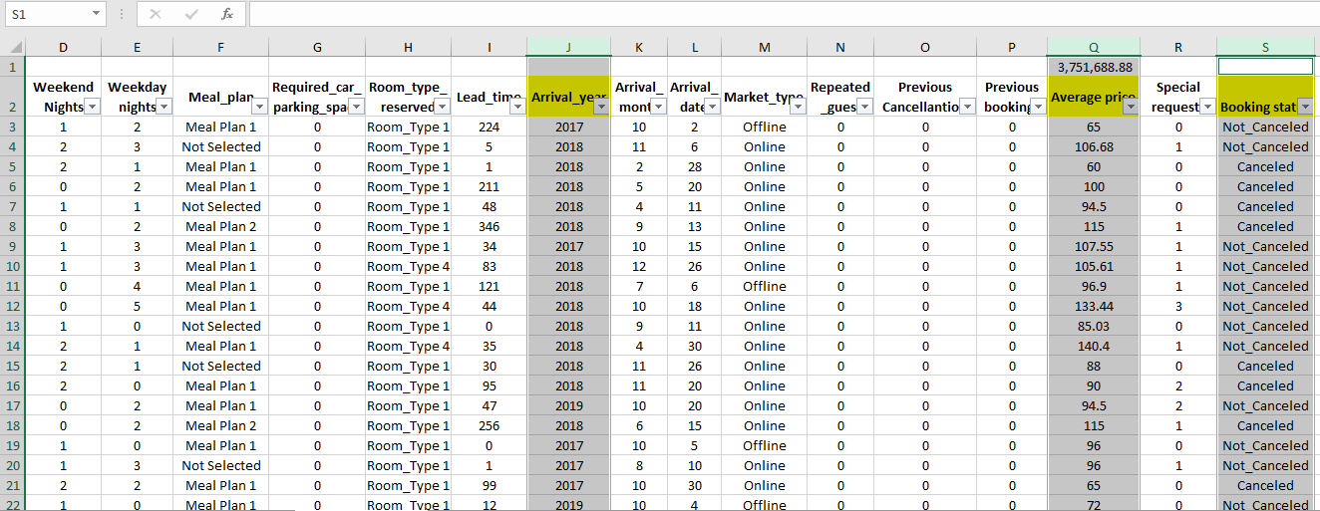
After copying the data the filter option has been used to make it more easily to find the clustered data which would be very much important.
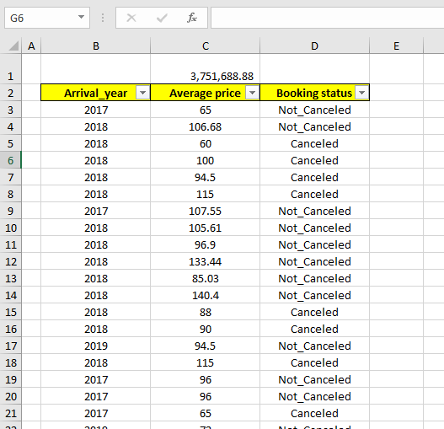
Along with it a “Subtotal” function has been added to easily count the average rate of the hotel room for a perspective.
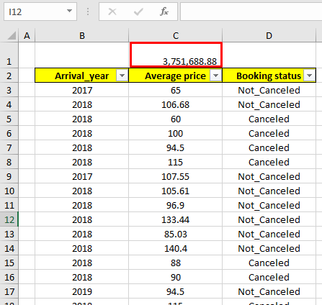
Analysing Data
The process of analysing, cleansing, manipulating, and modelling data in order to obtain observations and conclusions from it is referred to as data analysis. It entails using various analytical and computational techniques to massive datasets in order to identify patterns, correlations, and trends. Data analysis may be used to generate data-driven choices and forecasts in a variety of sectors, including business, healthcare, social sciences, and engineering. Exploration of data visually, identification of outliers or anomalies, summarization of data using descriptive statistics, and testing hypotheses using statistical inference may all be part of the process. In essence, data analysis is the process of transforming raw data into meaningful and valuable information that can be utilised to solve issues, make educated decisions, and gain insights into complicated phenomena utilising tools and procedures (Burnerd et al., 2008).
From the above listed column, the “Not Cancelled” has been sorted from the “Booking Status” Column. Then the each “Year” has been selected and then the sum of the Average price is collected and presented in the table for further analysis.
Arrival Year | Average Price
2017 | 466159.06
2018 | 1829216.13
2019 | 11374.19
2020 | 13334.55
2021 | 14023.05
2022 | 103220.15

The information indicates the average price of various unidentified products from 2017 to 2022. In 2017, the average price was 466,159.06, but it skyrocketed to 1,829,216.13 in 2018. However, the average price fell dramatically to 11,374.19 in 2019, then fell further to 13,334.55 in 2020. In 2021, the average price grew somewhat to 14,023.05, and in 2022, the average price increased significantly to 103,220.15.
Visualising Data
Data visualisation refers to the practise of representing data and information visually. Data visualisation tools make it simple to examine and understand patterns, anomalies, and trends in data via the use of graphical representations such as charts, graphs, and maps. In addition, it enables employees or company owners to communicate with non-technical audiences without introducing confusion. In the era of Big Data, data visualisation tools and technologies are indispensable for sifting through mountains of information and arriving at well-informed conclusions. Human eyes are drawn to and catch colourful objects, for example. Data visualisation is another type of visual art that piques people's attention and keeps them focused on the message. As a result, visual representations of data are more successful than other methods of data presentation (Panos and Mavridis, 2020).

Alternate Method of Finding the Value
- Pivot Table: A pivot table takes a user-specified data field and translates each column's heading into a data option that the user may easily alter. It's a simple data analysis tool that can swiftly answer a variety of crucial business queries. It can process vast amounts of data at once. These tables enable users to go through hundreds of data points and distil the information into simple, quantifiable findings (Dierenfeld and Merceron, 2012).
Using the pivot table, the full data is selected first and then the relevant items are dragged to perform the analysis and find the value which is also obtained through a different medium of analysis. The result is presented below for more understanding.
Booking status | Not_Canceled
Sum of Average price
Arrival_year | Total
2017 | 466159.06
2018 | 1828543.04
2019 | 11374.19
2020 | 13334.55
2021 | 14023.05
2022 | 103220.15
Grand Total | 2436654.04

- SUMIFS function
With the help of the “SUMIFS” function the total average value is calculated which contained both the not cancelled and cancelled booking part. Then the cancelled part sum is calculated and then finally subtracting it the final average value is found which is presented below:
Year | Total Average Price | Cancelled Average Price | Final Average Price
2017 | 549304.11 | 83145.05 | 466159.06
2018 | 2984721.57 | 1156178.53 | 1828543.04
2019 | 18015.29 | 6641.1 | 11374.19
2020 | 20857.3 | 7522.75 | 13334.55
2021 | 19436.8 | 5413.75 | 14023.05
2022 | 159353.81 | 56133.66 | 103220.15

Part-2
How many students are male and female?
Gender
 |  | Frequency | Percent | Valid Percent | Cumulative Percent
Valid | Female | 1056 | 49.5 | 49.5 | 49.5
Valid | Male | 1077 | 50.5 | 50.5 | 100.0
Valid | Total | 2133 | 100.0 | 100.0

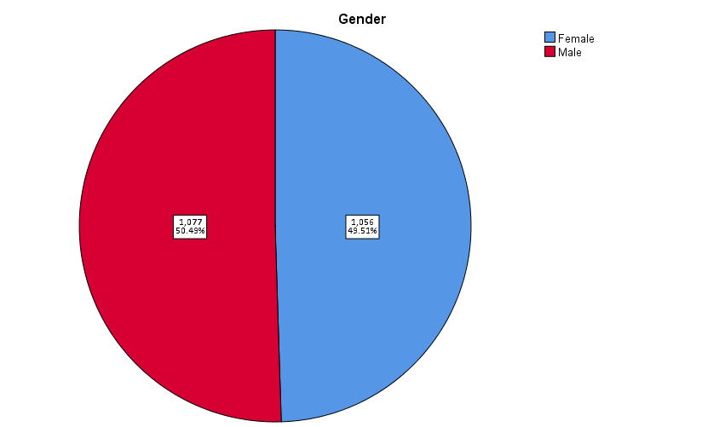

How many student qualifies and does not qualify for reduced/free lunch?

Lunch
 |  | Frequency | Percent | Valid Percent | Cumulative Percent
Valid | Does not qualify | 1215 | 57.0 | 57.0 | 57.0
Valid | Qualifies for reduced/free lunch | 918 | 43.0 | 43.0 | 100.0
Valid | Total | 2133 | 100.0 | 100.0

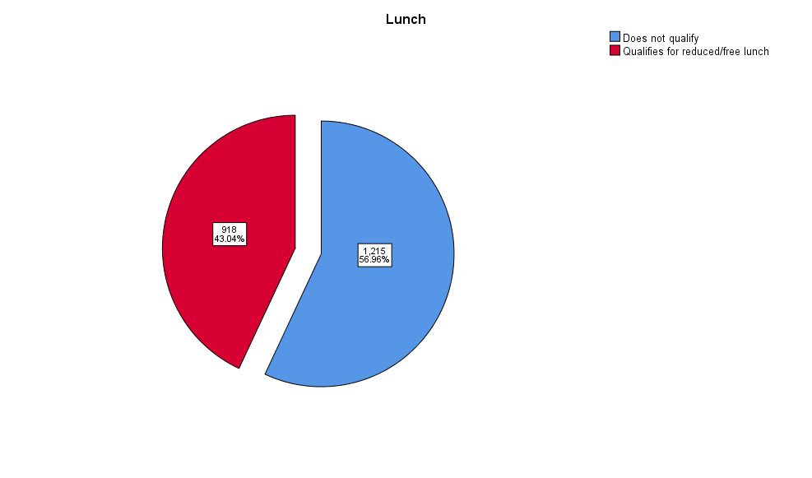

What are the mean and median of students who qualifies and does not qualify for reduced/free lunch?

Lunch
 |  | Frequency | Percent | Valid Percent | Cumulative Percent
Valid | Does not qualify | 1215 | 57.0 | 57.0 | 57.0
Valid | Qualifies for reduced/free lunch | 918 | 43.0 | 43.0 | 100.0
Valid | Total | 2133 | 100.0 | 100.0

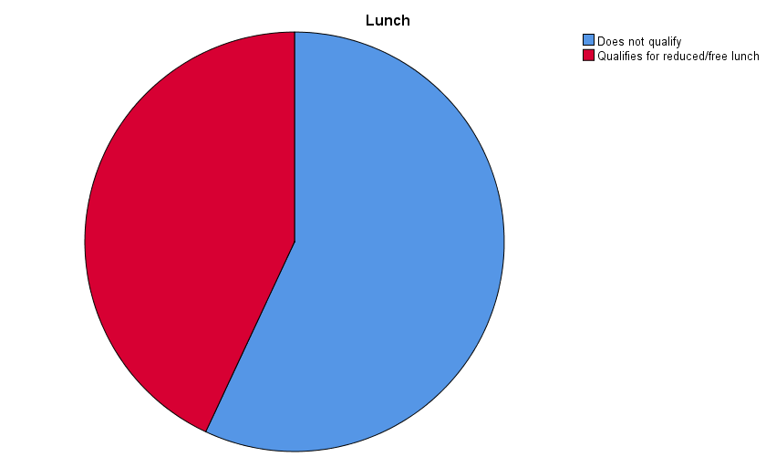

What are the mean and median differences of students pre-test and post-test scores?

Case Processing Summary
 | Cases
 | Included |  | Excluded |  | Total
 | N | Percent | N | Percent | N | Percent
Pretest | 2133 | 100.0% | 0 | 0.0% | 2133 | 100.0%
Posttest | 2133 | 100.0% | 0 | 0.0% | 2133 | 100.0%

Report
 | Pretest | Posttest
Mean | 54.96 | 67.10
Median | 56.00 | 68.00

Using the dataset Student_Score.csv provided in conjunction with SPSS, give a specific example of Clustering (ex. K-Means Clustering). Show your workings with screenshots and clearly explain your results.

Descriptive Statistics
 | N | Minimum | Maximum | Mean | Std. Deviation
Student_No | 2133 | 14 | 31 | 22.80 | 4.229
Pretest | 2133 | 22 | 93 | 54.96 | 13.563
Posttest | 2133 | 32 | 100 | 67.10 | 13.987
Valid N (listwise) | 2133

Initial Cluster Centers
 | Cluster
 | 1 | 2
Zscore(Student_No) | 1.23046 | -1.37070
Zscore(Pretest) | -2.35609 | 2.80497
Zscore(Posttest) | -2.29518 | 2.35206

Iteration Historyª
Iteration | Change in Cluster Centers
Iteration | 1 | 2
1 | 2.307 | 2.569
2 | .061 | .054
3 | .024 | .023
4 | .015 | .014
5 | .011 | .011
6 | .003 | .003
7 | .003 | .002
8 | .004 | .004
9 | .001 | .001
10 | .001 | .001
a. Iterations stopped because the maximum number of iterations was performed. Iterations failed to converge. The maximum absolute coordinate change for any center is .001. The current iteration is 10. The minimum distance between initial centers is 7.416.

Final Cluster Centers
 | Cluster
 | 1 | 2
Zscore(Student_No) | .65914 | -.62249
Zscore(Pretest) | -.81788 | .77240
Zscore(Posttest) | -.82717 | .78117

Number of Cases in each Cluster
Cluster | 1 | 1036.000
Cluster | 2 | 1097.000
Valid |  | 2133.000
Missing |  | .000

With real world (practical) examples, most common data mining and text mining methods are discussed for each that can be used in the contemporary business.
In today's world, organisations acquire and store inconceivable amounts of data, which will subsequently be utilised to transform these huge amounts of data into insights that will help them develop a better business. This is where data mining comes in. The term "data mining" refers to the process of extracting information from raw data sets. Data mining may also assist an organisation uncover fraud, mistakes, and inconsistencies, which can result in business loss and reputation harm. Data mining is used in many sectors and circumstances, but the aim is the same to comprehend more about consumers and the business. Text mining is a technique that comprises a number of operations that aid in the extraction of information from textual information that is unorganized. Text mining methods are procedures that mine text for insights (Suresh and Harshni, 2017) In this regard, data mining and text mining are quite similar. Some common data mining and text mining methods with real life examples and which could be used in contemporary business are discussed below:
Classification: One of the main and most fundamental techniques in data mining and text mining is classification, which is also one of the most common. Nearly every industry can benefit from this method. Assigning data points based on their use to categories is a process of categorizing large data sets. Essentially, this process is the same as clustering. The classification of data records is based on the way they are grouped into different segments. Through classifications, businesses can gain deeper insight into demographics, target audiences, or user bases.
Consumers who buy groceries are grouped by grocery stores using classification methods, which helps forecast buying patterns. Customer segmentation is one of the most prevalent applications of categorization in business. Businesses may use this strategy to categorise their consumers based on their purchasing habits, demographics, interests, and other attributes. To attract and keep clients, this data may be utilised to develop targeted marketing tactics and personalised incentives.
Association: This strategy is also often used in data mining and also in text mining. It is also known as relation analysis since it is used to detect a connection between two or more items by recognizing the hidden pattern in the data set. This approach is used in market basket analysis to forecast customer behaviour and is frequently used to assist businesses in determining marketing research and strategy.
The study of impulse purchases is an example of an association. Studies suggest that when out buying necessities for their children, parents are also more likely to pick up some gourmet snacks or a unique drink. Statistical correlation may be used to examine these buys. It has several more applications in business. It is a great tool for stores to utilise when suggesting similar items to customers. If a customer buys a smartphone, tablet, or video game console, association analysis might recommend accessories like charging cables, game add-ons, and cases.
Clustering: Data Clustering is a data mining and text mining process that clusters different forms of data into one category in order to better organise that data when many aspects and characteristics are involved. It's comparable to classification in that it groups bits of data together based on similarities (Agnihotri et al., 2018).
A corporation may maintain a vast database of consumer information, such as purchase history. The organisation may group similar clients together based on common criteria such as age, gender, purchasing behaviour, and preferences by employing the clustering data mining process. Clustering is a technique for optimising supply chain operations by grouping items or suppliers based on their characteristics, allowing firms to simplify their procedures and decrease costs. It may also be used to group together comparable items or services, enabling firms to provide personalised product suggestions to clients based on their interests.
Prediction: This method employs previously observed trends or currently available data sets to make predictions about the future. Classification, pattern matching, trend analysis, and connection mining are just some of the other common mining techniques that often work in tandem with prediction (Weiss et al., 2010).
An accounting firm collects a significant amount of data, which is then utilised to forecast the revenue that each item would earn based on prior sales data. It represents a continuous-valued function that identifies numeric data values that are missing. Prediction technique is most commonly utilised in sales, marketing, and risk management. To boost sales and marketing activities, it is used to discover new consumers, target marketing campaigns, and forecast customer behaviour. It may also be used to identify possible dangers and forecast future occurrences like fraud.
Regression: This data mining and text mining method is implemented to determine the link between two variables in order to the causal relationship may be utilised to predict the outcome. Predicting property prices, for example, depending on numerous parameters such as location, number of bedrooms, square footage, and other pertinent factors. In this case, regression analysis may be used to create a system that predicts a house's sale price based on multiple input data. It is used in a variety of sectors to analyse business and marketing behaviour, trends, and financial forecasting.

Discussion on the advantages and disadvantage of using SPSS and Excel using relevant practical
 | SPSS | Excel
Advantages | SPSS provides simplicity by emphasising a user-friendly interface, making it simple to use. It has a number of tools for data modification and analysis, and the output is simple to understand. This makes the beginners to easy adapt to it.  SPSS is a versatile software that can be used in a diverse set of fields such as marketing research, healthcare, social sciences, education, and others. It provides users with an extensive selection of statistical analysis methods, including regression, factor analysis and so on.  With SPSS, importing data from external sources such as Excel is effortless, and once the data is imported, it can be readily utilized for analysis purposes.  SPSS provides the ability to document data as well. It permits researchers to maintain a metadata directory, and it also serves as a centralized database of information regarding the data, such as its meaning, origin, format, usage, and relationships with other data (Rahman and Muktadir, 2021). | Excel is usually regarded as the finest way to save data since it is the most commonly used application in the world, with 750 million users.  Spreadsheets are extremely customizable, particularly when one understands how to use their plethora of formulae and functions. A spreadsheet may simply be used to produce any form of document, including a calendar.  Spreadsheets may be freely modified by everyone in the team, which increases cooperation. Other technologies may restrict some permissions based on team members' titles or administrative positions, but spreadsheets do not.  Because Excel is widely utilized and endorsed, spreadsheets prepared in it may be readily shared and utilised by others. It is also interoperable with other Microsoft Office products like Word and PowerPoint, making it simple to incorporate Excel data into other papers or presentations (Lilley, 2016).
Example | Currently, SPSS software is being used by over 80% of colleges in the US to identify patterns that aid in predicting a student's likelihood of succeeding in the future. By utilizing a blend of different factors, it helps in detecting students who may be at risk. Furthermore, healthcare organizations can leverage SPSS Statistics to establish a data-driven care model that enhances quality, decreases costs, and results in improved patient outcomes. | Excel allows one to effortlessly track his income and spending while also maintaining a record of them. This is especially useful for those who wish to track their spending, save money, and prepare for the future.
Disadvantages | SPSS lacks the appeal towards many users. Even though the software is great this lack of appeal is making it lag behind.  Because a single-user licence is not available, purchasing SPSS requires a subscription to either a monthly or annual payment plan. This can be an expensive prospect, especially for non-profit organisations or students who want to use the software.  SPSS lacks algorithms that may assist one with deciding on the best statistical test, which appears to be a challenge for beginners in statistical data analysis.  While SPSS provides a variety of analysis tools, it may not be appropriate for every sort of data analysis. It may also have limits in terms of customisation as well as information analytics capabilities (Rahman, 2020). | When the data in Excel is too large, the programme may slow down, especially if the information is all in one file. Trying to split the material into smaller files may result in some of it being lost or missing.  Spreadsheet data is rarely stored in a centralised location. So, it is very probable that it will come into the hands of non-IT personnel who are uninformed of the worth of data and may harm it.  Excel's statistical analysis skills are restricted in relation to other statistical analysis applications such as SPSS or R, making it unsuitable for complicated statistical studies.  Although Excel has collaboration features, monitoring modifications can be a difficult task, and multiple users may not be able to modify the same cell simultaneously. This can lead to issues of version control and data errors (Hyde and Maier, 2016).
Examples | SPSS provides non-parametric tests, but does not support the Kruskal-Wallis or Friedman tests. This might cause problems for users when analysing data that does not adhere to parametric test assumptions. | Excel files are easily shared and duplicated, posing a data security concern if sensitive data is contained in them. There is also the risk of being infected by a virus through damaged excel files. Excel additionally fails to offer real-time collaboration and might be challenging to utilise for collaborative project teams.

Conclusion
Finally, in today's data-driven world, data processing and business intelligence are critical components for firms to prosper. Businesses may use the correct tools and approaches to transform raw data into actionable insights that can drive informed choices and corporate success. This issue is large and involves ongoing learning and adaptation, from successfully gathering and storing data to applying data visualisation tools and methodologies for analysis. Individuals and organisations may stay competitive and make informed decisions that lead to success by grasping the fundamentals of data management and business intelligence.

Reference List
Agnihotri, D., Verma, K. and Tripathi, P., 2018, April. Pattern and cluster mining on text data. In 2014 fourth international conference on communication systems and network technologies (pp. 428-432). IEEE.
Burnard, P., Gill, P., Stewart, K., Treasure, E. and Chadwick, B., 2008. Analysing and presenting qualitative data. British dental journal, 204(8), pp.429-432.
Dierenfeld, H. and Merceron, A., 2012. Learning analytics with excel pivot tables.
Hyde, K.M. and Maier, H.R., 2016. Distance-based and stochastic uncertainty analysis for multi-criteria decision analysis in Excel using Visual Basic for Applications. Environmental Modelling & Software, 21(12), pp.1695-1710.
Lilley, D.G., 2016, January. Computational Methods Using Excel/VBA for Engineering Applications. In International Design Engineering Technical Conferences and Computers and Information in Engineering Conference (Vol. 42578, pp. 487-490).
Malley, B., Ramazzotti, D. and Wu, J.T.Y., 2019. Data pre-processing.
Niu, Y., Ying, L., Yang, J., Bao, M. and Sivaparthipan, C.B., 2021. Organizational business intelligence and decision making using big data analytics. Information Processing & Management, 58(6), p.102725.
Panos, A. and Mavridis, D., 2020. TableOne: an online web application and R package for summarising and visualising data. BMJ Ment Health, 23(3), pp.127-130.
Rahman, M.S., 2020. The advantages and disadvantages of using qualitative and quantitative approaches and methods in language “testing and assessment” research: A literature review.
Rahman, A. and Muktadir, M.G., 2021. SPSS: an imperative quantitative data analysis tool for social science research. Int. J. Res. Innov. Soc. Sci, 5, pp.300-302.
Suresh, R. and Harshni, S.R., 2017, March. Data mining and text mining—a survey. In 2017 International Conference on Computation of Power, Energy Information and Commuincation (ICCPEIC) (pp. 412-420). IEEE.
Weiss, S.M., Indurkhya, N., Zhang, T., Weiss, S.M., Indurkhya, N. and Zhang, T., 2010. Overview of text mining. Fundamentals of Predictive Text Mining, pp.1-12.

