Rosie Evans
ECGE4002P: Academic Study Skills
7th November 2019

Contents Page:
1.0 Portfolio task 1
1.1 Mindmap ......................................................p3
1.2 Skills audit ...................................................p4
1.3 Success .......................................................p5
2.0 Portfolio task 2
2.1 Developing critical thinking ..........................p5/p6
3.0 Portfolio task 3
3.1 Developing critical writing ............................p6/p7
4.0 Presentation link ……………………………...p7
Reference list ....................................................p8

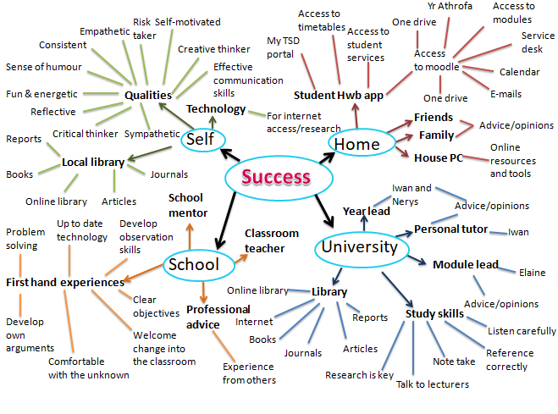

1.1 Mindmap
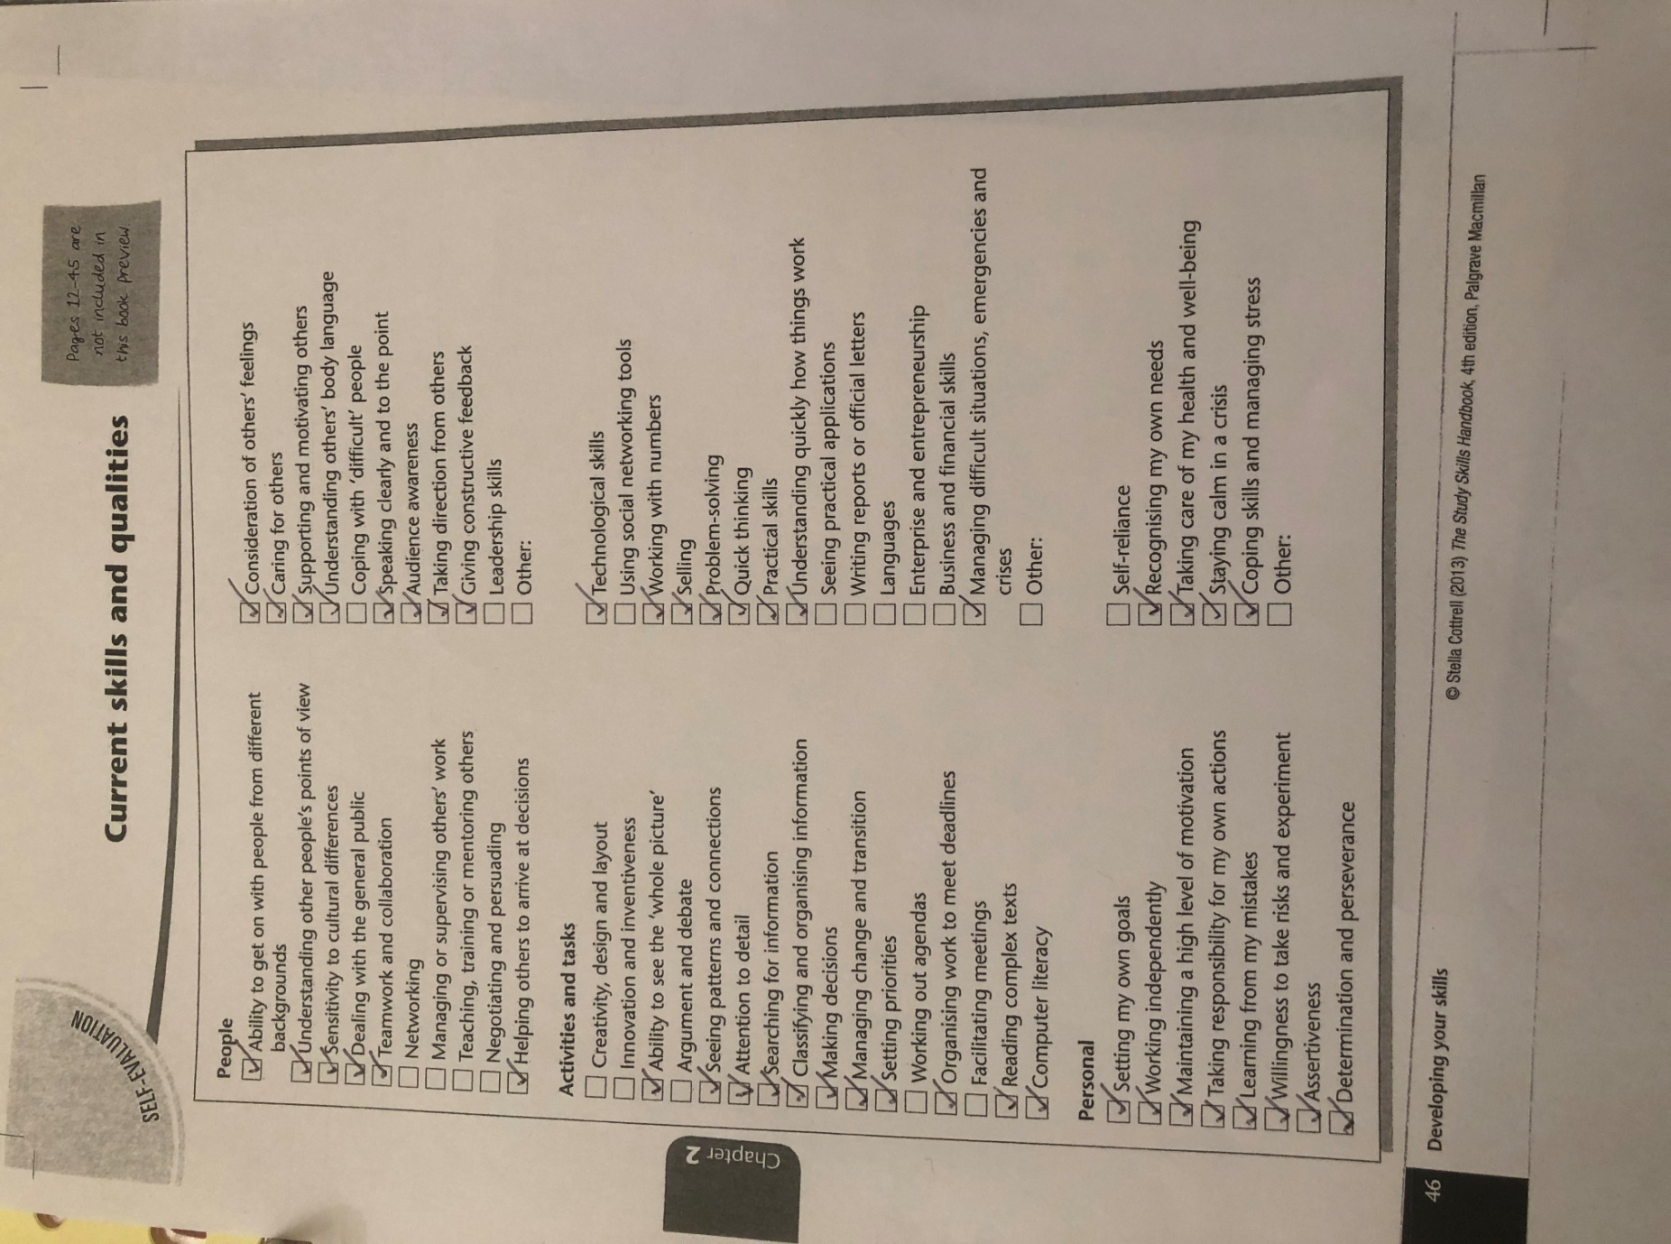
1.2 Skills audit

1.3 Success
To me, success is about being the best teacher I can be and changing children’s lives for the better. I see success as about me as a students and as a teacher. It is about me being an ambitious, capable learner as well as being a healthy, confident role model for the pupils. I believe that to be able to teach children successfully I need to share knowledge and understanding as well as helping them develop their confidence. I strongly believe that in order to become a successful teacher, I need to fulfil my desire to guide and assist children in their early years and beyond.
Success is learning through a variety of teaching methods to fully understand the aims of becoming as successful as a teacher. These could include independent study, group work, directed tasks and online learning. Additionally, to become the best teacher possible, I need a positive mental attitude towards the teaching profession as well as improving my knowledge and understanding of the subject area. I am fully aware of the tough challenges that this profession faces but this only serves to deepen my desire to make a difference.
2.1 Developing critical thinking
Cottrell (2019) starts off her study skills by explaining what critical thinking is and why people think critically. She explains that critical thinking is the cognitive activity and the process of deliberation to reach a final conclusion after critically evaluating evidence and going through a complex thought process. She believes mental process relies upon each individuals skills, qualities and knowledge from previous experiences.
Cottrell (2019) states that critical thinking is about trusting yourself, being self-confident having high self-esteem and being resilient when challenges occur. However according to NHS.UK (2017), self-esteem is how much somebody values them self and if they have self-worth. A sense of achievement can help increase critical thinking skills and positive outcomes are more likely when somebody feels better about themselves and the work they are conducting (Nhs.uk, 2017).

Self-confidence is based upon how much confidence a person has. It is a personal judgement about how you feel about how you have performed. Those with high self-confidence do not doubt themselves and trust their own judgement which leads to them solving problems differently (NHS.UK, 2017). On the other hand, Meggitt (2011) argues resilience is the ability to cope with life challenges, such as thinking and evaluating critically and finding ways to overcome them and thrive. These all show that a critical thinker knows their own limits.

Cottrell (2019) carries on illustrating that critical thinking is about exploring evidence in a particular way by identifying hidden messages more accurately. Chapter one of Cottrell's book goes on to identify the benefits of critical thinking. These include improving attention span, keeping focused and analysing appropriately. Cottrell follows on by writing how important professionalism is and why it helps when self-reflecting.

Cottrell's belief shows that critically thinking brings precision to work and helps when writing accurate academic work. She explains that critical thinking may be a slow process but after practice, skills get build and over time analysing critically gets easier and quicker.

In chapter one, Cottrell says that critical thinking skills should be everyday skills which are used and can be transferred. Some examples include problem solving, identifying trends, looking at various perspectives, knowledge and research skills. She believes it can engage emotions and feelings and can help people reach their conclusions after critically viewing it.

Moving on, Cottrell feels that accurate judgements cannot be made by crucial thinkers if beliefs, pre-conceptions and judgements are taken into account. She believes that barriers could be overcome and accurate judgements and conclusions could be made.

3.1 Developing critical writing

The Foundation Phase Framework is a statutory framework for childcare settings in Wales. It sets out the Welsh governments’ requirements for children between the ages of three and seven. The criterion is aimed at all practitioners to enable encourage and nurture children to be creative, imaginative, and help them enjoy learning. I feel that this framework works well and continues to in all early years’ settings. The settings need to be aware of the aims and objectives of the Framework. It emphasises the skills, knowledge and understanding that every child is able to develop through this crucial developmental period in their lives. The key elements in the framework include experiential learning, learning through play, active involvement and time to develop confidence through reading, writing and speaking (Thomas and Lewis, 2016).
Based on the journal article Approaches to Education, I believe there are benefits for children when they spend as much time as possible playing actively both indoor and outdoor. Children learn through the type of environment they are in and use their senses to discover. I feel the indoor environment in a childcare setting should be planned carefully and appropriately as it must accommodate children’s interests and needs as well as engaging children in various activities.
From the Donaldson report and the new curriculum to be introduced in 2022, I can infer the skills that will be taught and encouraged will be transferrable and interlinked with skills needed in the workplace. Nowadays, employees which to have various transferable skills use these through different tasks in everyday living. The new curriculum is an holistic approach which encourages open-minded thinking, and engages the interest of the children.
In my opinion, children will learn quicker when their whole body is involved in an activity. Prof. G. Donaldson (2015) believes children's learning will be holistic. I agree that the children will make multiple connections whilst being independent learners. This can not only help at the time but it can also help when they are solving multiple problems, testing their abilities and completing a focused task. I think children could relate their experiences with their work and they may enjoy their learning more. A child centred learning environment can help children to further develop their learning abilities.

I feel that a child centred learning environment, such as a primary school, is based more on the children learning for themselves. The direction of teaching the pupils has moved to a different level. It now involves children expressing themselves, interacting with others, making choices, testing ideas, solving problems and making discoveries. In my opinion, this is done through self-motivation. I identify self-motivation as necessary for being a successful independent learner. It is through this that a child’s development is improved and they are more likely to meet their rate of development as highlighted on their centile chart (Meyer et al., 2008).

4.0 Presentation link

Reference List:
Cottrell, S. (2019) The Study Skills Handbook 5th Ed. London: Red Globe Press
Davies, S (2011) 'Approaches to Education' The Welsh Journal of Education, 15(1), pp.24-45.
Learning.gov.wales. (2015). Learning Wales. [online] http://learning.gov.wales/resources/browse-all/foundation-phase-framework/?lang=en [Accessed 11 Oct. 2018].

Meggitt, C. (2011). Children and young people's workforce. London: Hodder Education.
Meyer, B., Haywood, N., Sachdev, D. and Faraday, S. (2008). What is independent learning and what are the benefits for students?. [online] Mobilise.kyrateachingschool.com. https://mobilise.kyrateachingschool.com/assets/uploads/files/PLC2-New-Learning-Whatisindependentlearningandwhatarethebenefits_161115_161346.pdf [Accessed 11 Oct. 2018].

NHS.UK. (2017). Raising low self-esteem - NHS Choices. [online] https://www.nhs.uk/Livewell/mentalhealth/Pages/Dealingwithlowself-esteem.aspx [Accessed 9 Apr. 2018].

Professor Graham Donaldson CB. (2015) Successful Futures: Independent Review of Curriculum and Assessment Arrangements in Wales. Cardiff: Welsh Government.

Thomas, A. and Lewis, A. (2016) An Introduction to the Foundation Phase. London: Bloomsbury Academic.

