Critical valuation on the current
_{situation at Asda}
_{Bethan Knott}
₁₉₀₄₉₇₄
University of Wales Trinity Saint David
_{20th March 2020.}
_{Executive Summary}
This report has identified the problems that Asda’s have encountered. The major problem it has identified is the decrease in profits due to the deepening of the recession. The recession was a part of the reason but then the German discount stores Aldi and Lidl played a big part by offering cheaper products and stealing Asda’s customers. People moved stores to shop as it was cheaper so meant they were saving money at a financially hard time of life for everyone. The problem has been reached by using analytical tools nature, scope and impact, a SWOT analysis helping to identify Asda’s strengths, weaknesses, opportunities and threats and a PESTLE analysis highlighting the political, ecological, sociological, technological, the law and environmental factors that Asda’s face.
There is also a list of options available to see how Asda can improve their profits and their relationships with both staff and customers and there is a action plan following that to show the communicating, monitoring and reviewing process.
_{Contents Page}
1.0 Introduction 5
2.0 Findings 6
2.1 Overview of the Organisation 6
2.1.1 History of Asda 6-7
2.1.2 Asda products and services 8
2.2 Investigating Asda 9
2.2.1 Nature 9
2.2.2 Scope 9
2.2.3 Impact 9
2.3 Swot 10
2.4 Pestle 11-12
3.0 Conclusion 13
3.1 Main area of concern in the organisation 13
4.0 Options 14
4.1 Sales strategy 14
5.0 Action plan 15
5.1 communication 15
5.2 Monitor 15
5.3 review 15
6.0 Appendices
8.0 References 20
- _{Introduction}
The chief executive officer of Asda has requested this report on the 6th January 2020 and is going to be produced by the marketing director at Asda. This report has to be submitted by 20th March 2020.
The purpose of this report is to provide a detailed examination of the problems that Asda are currently facing. There are currently several problem areas Asda have highlighted as loss of profit and customers. To this end this report has been requested to investigate Asda’s main problem. The report will gather information on this by using tools such as SWOT and PESTLE. The report will then offer a conclusion and explore options to improve the problems that’s Asda’s face. The report will also contain a communication, monitoring and review template. This report has utilised secondary research materials to aid the investigation. These sources include textbooks, journals and websites.

- _{Findings}
_{2.1 - Overview of organisation}
_{2.1.1 – The History of Asda}
Timeline of the history of Asda is available in appendicies.
Asda was founded in West Yorkshire in 1949 by a family of butchers called the Asquith’s who chained up with a chain of dairies run by the Stockdale’s and they come up with the name Asda. Both families believed in keeping prices low and determined for the company to progress.
Piggly Wiggly’s provided the world’s first self-service store In America, in the 1960’s after visiting Piggly Wiggly’s the Asquith’s returned home to imitate their ideas back in the UK. They purchased an old Cinema in Leeds which was a big venue meaning they could bulk buy allowing them to keep the costs low whilst earning a profit. By the mid 60’s Britain was starting to grow, rationing was some time ago and the economy was having a period of great prosperity. Purchasing cars was soaring and people had shopping to be done. People had money so could afford to buy fridge freezers which allowed them to bulk buy. A business opportunity arose selling fuel, they found a small Yorkshire supplier who imported fuel from America allowing Asda to sell low cost fuel. They were making a low profit but attracting customers to the store as they could get both their fuel and groceries at the same place.
In the 1980’s the founder of NEXT George Davies began trading clothes using the fashion brand name – George. George also liked to keep prices as low as possible by selling good quality clothes at a low price which brought in customers and increased profits. (S4RB, 2020).
In the 80’s rivals Tesco’s and Sainsbury’s expanded, Asda tried to follow them but mistakenly the management thought that price would not be so important to everyone now as people seemed to have more money and therefore was losing its reputation for keeping costs low. Asda combined with MFI and Allied Carpets which proved unprofitable and also lost a lot of money by buying 61 Gateway stores.
By the 1990’s Asda were in debt of 1 billion pounds and were losing their once very loyal customers. This saw the joining of Archie Norman who was the new management at Asda. He Fixed all the problems at Asda starting with the staff, he introduced staff incentives. A lot of people were sacked, redundancies were made, and a great deal of management was changed. Archie reduced fruit and vegetable prices overnight and sales increased, by 1995 Asda was back to business. Asda then went on to sell books at a reduced price which was breaking the law as part of the 100-year-old price agreement so they found themselves in court. They fought a case in court which lasted two years and they won. In the 1990s Pharmacies were able to fix the price of medicines so that nobody could sell them cheaper, Asda decided they were going to break this agreement and lowered the cost of all over the counter medicines and once again faced court. They persuaded the courts that consumers were getting ripped off and won the case, so the law was changed. Being able to sell books and medicines at a discounted price were very important factors of Asda’s turnaround. Archie began looking into the American supermarket, Walmart. He stole Walmart’s moto ‘everyday low price’. Towards the end of the 90’s Walmart were looking to expand their business worldwide and wanted to buy Asda as it was a company that copied what they were doing successfully. Walmart purchased Asda in 1999 for 6.7 billion. (Our History, 2020)
2008 saw the global financial crash but Asda continued to make a profit because they were known for their low price but as the recession carried on Asda started going downhill. The loyalty of customers is no longer what it used to be. Aldi and Lidl stealing all Asda’s customers by selling at hugely discounted prices that Asda couldn’t beat. The German companies had been in Britain since the early 90’s but as the recession continued to get worse in 2009 customers were all going here to get their money’s worth. The effect this had on Asda was huge as they were no longer known for selling at the lowest prices and by 2016 Asda said they had the worst sales figures to date. (Inside Asda: Bigger, Better, Cheaper? - Channel 5, 2020).
Staff at Asda were told that they had to sign a new contract by November 02 2019, they say that they were told if they did not sign this new contract that they would face being jobless. The new contract included a pay rise to £9per hour but there was to be no paid breaks and working bank holidays would become compulsory. One worker said that developing pressure on staff has just exacerbated the issue, with in-store cuts making them work additional hours and feeling depleted. Another employee at Asda have said that they no longer work as a family and that they are just a number working there now (Munbodh, 2020).
_{2.1.2}
The products and services Asda offers are groceries, online shopping, clothing, books, money, pharmacy and an opticians. (Asda.com - Online Food Shopping, George, & more, 2020)
_{2.2 Investigating Asda}
_{2.2.1 - Nature}
The nature of the problem that Asda faces is loss of profit due to the Recession.
(Asda has suffered the worst sales fall in its 67-year history - here's what it did wrong, 2020)
_{2.2.2 - Scope}
The scope of this problem is that when the recession hit , Aldi and Lidl stole Asda’s customers by dramatically lowering their prices which attracted custom.
_{2.2.3 – Impact}
The impact this has had on Asda is a financial loss due to the German stores Lidl and Aldi offering much cheaper prices people changed their usual place to shop to save money as after the recession hitting the UK shoppers had to reassess their spending habits. By these stores offering discounted prices this no longer meant that Asda was known for its low prices and therefore lost a lot of customers.
_{SWOT Analysis}
_{2.3 - SWOT Analysis}
Full Swot is available in appendices.
After a full SWOT analysis was undertaken on Asda the strengths that Asda’s have is that it is the third largest retailer in the UK making them higher than Aldi and Lidl. (Top 10 UK Retailers Retail Economics, 2020). Asda has a large variety of services available which the German discount stores Aldi and Lidl’s don’t have. One of the main ones being online shopping. Online shopping is very popular these days and Asda offers this as well as a click and collect service which means the customers can order their shopping online and just collect at a time that is convenient for them. They also have a pharmacy, opticians, café and a travel money bureau.
A weakness of Asda is that when the recession got worse in 2009, Aldi and Lidl offered discounted prices to everyone and at these financially hard times customers were going to the German stores as they had to be careful with the little money they had. This meant that Asda lost their reputation for being known for their low prices and lost customers. Another major weakness that Asda has is that it has very few global presences compared to other retailers. There are many benefits of going global obviously one being having a greater number of customers. (Language, 2020)
Asda’s have many opportunities available to them. A great opportunity for them is that many more people these days are shopping online so they have a great advantage compared to other retailers that are not yet online. Another opportunity is that they could expand globally to increase their customer base and hopefully increase profits.
Asda also faces a lot of threats, one being there is a lot of competition, especially with Aldi and Lidl offering cheaper prices than them, which is forcing Asda to keep prices as low as they possibly can which must be adding a lot of pressure to them.

_{Pestle Analysis}
_{2.4 – Pestle Analysis – Macro}
The political factors that may impact on Asda are the laws they have to follow. Companies have to be very careful to make sure they abide by these laws or they could find themselves in serious trouble. A low minimum wage would mean that Asda would make more profit and have a better chance of survival, but a high rate of taxation would stop Asda’s from being able to achieve their maximum profits. Moving on to the economic factors a big one relating to Asda’s decline is the recession. At first the recession helped Asda as they were known for their low prices, so everybody shopped there but as the recession continued into 2009 competition come in the name of Aldi and Lidl which stole Asda’s customers. The high cost of living has had an impact on Asda’s profits as there is less money available to spend on shopping. A positive is the increase in demand for online shopping but comes with the cost of employing more staff then for jobs like delivery drivers or pickers. An increase of unemployment would mean there is a higher amount of jobs than demand, meaning people would be willing to work for a lower wage which would help Asda. The social factors connected to Asda are the demographics of the populace, which means their individual ages and sexual orientations, endlessly sway whether a specific item might be advertised to them. Cosmetics is for the most part obliged ladies, so focusing on a greater part male populace would be less populace than focusing on a populace that is for the most part female. Also, a change in lifestyle would alter the type of products that people buy so Asda need to keep up with the trends to sell items that people want at that time. Technology plays a very important part of the success of Asda. Technology is changing all the time and if you want to be a successful business you need to keep up with the most recent technology, for example self-scanning products are now available which people can just scan their items and put them straight into a bag, which saves them queuing at the end and emptying all their items on to the conveyor belt to then be packed once again. Online shopping is a major way a large amount of people do their shopping these days. It is convenient if people do not drive and it can be done from the comfort of our own home. It can either be delivered straight to your door or can be icked up by using the click and collect option. One of the key factors is law. Laws are there to be abided by. When employing staff Asda need to make sure they are adhering to all the rules otherwise they would face a law suit. Regularly Asda arrangements alone are insufficient to effectively protect Asda and its employees, making it seem an unfortunate work environment that may reject skilled workers. Discrimination laws are set by the government to secure the workers and guarantee that everybody is dealt with decently and given similar chances, paying little mind to sex, age, inability, ethnicity, religion or sexual direction. Laws are in place to make sure that a products are of a good quality and safe for the customer. Retailers often find that these laws have an impact creating a higher price. The last factor is Environmental. One of these could be the weather conditions. If there is bad weather there is a chance that Asda may not have their deliveries so run out of stock, therefore people that have ordered online also will not receive their orders so that would not be achieving customer satisfaction and they may go elsewhere. Another environmental factor related to Asda is recycling. Recycling is an important part of everyday life now to try and save the planet and some customers like to know that their retailers recycle all their waste. Companies that produce a large amount of waste may have to by law make sure they recycle.
See appendicies for Pestle Analysis.

_{3.0 Conclusion}
_{3.1}
Based on this report an analysis has been undertaken using nature scope and impact, SWOT, pestle, the five why’s and the Ishikawa diagram. They have concluded that the main problem where Asda started to see a decline in sales was when the recession started to deepen in 2009. When the recession first started Asda reputation of being the worlds low cost supermarket was still accountable but then discounted German stores Aldi and Lidl caused major concerns to Asda as they started selling products at a dramatically lower price meaning all Asda’s once loyal customers were going there where the prices were lower. Due to the recession people were looking for the cheapest prices possible so they could save money where applicable and then decided to stick with them instead of going back to Asda. This affected Asda the worst from the big 4 supermarkets as it was losing its reputation for always getting the best value at low prices for the customers therefore putting the money back in to customers pockets. After the planned merger with Sainsburys collapsed in 2019, Asda’s remained to look weak as they still have not come up with a solution to try and increase profits.
Despite this Asda’s have many strengths such as being the third largest retailer in the world, they have a great range of different products and services available unlike Aldi and Lidl who offer fewer products in basic conditions.
_{4.0 Options}
_{4.1 New Sales Strategy}
Asda could introduce a new sales strategy by following rivals Aldi and Lidl, offering fewer of certain products instead of a large range of one product. This would allow them to get more discounts as they could buy in bulk and then be able to sell at a lower price therefore attracting more customers.
As proved before when Archie Norman took over Asda, they need to start with their staff by looking after them. Happy staff would ensure customer satisfaction is high and happy customers would tell their friends and family about it and they would return to the store bringing in higher profits. Lidl and Aldi have very basic settings and not known for good customer service so this is a big advantage Asda could have over them.
_{5.0 Action Plan}
_{5.1 Communicated}
In order to be successful in the retail business, it is essential to form strong relationships with the customers. Engaging is a massive aspect of maintaining customer loyalty. Whether it is a small or large retail business, it is challenging to connect with each individual customer. Communication needs to start within the business as this is one of the major employability skills so is key from the top management to the store workers to ensure that the store is run effectively and customer satisfaction is met.
5.2 Monitored
This could be monitored over a 12 month period by keeping record of any profits made.
_{5.3 Reviewed}
If these are reviewed and no profits are made they need to look at why these options have failed and come up with a new plan to increase profits.
See appendices for action plan.
_{6.0 Appendices}
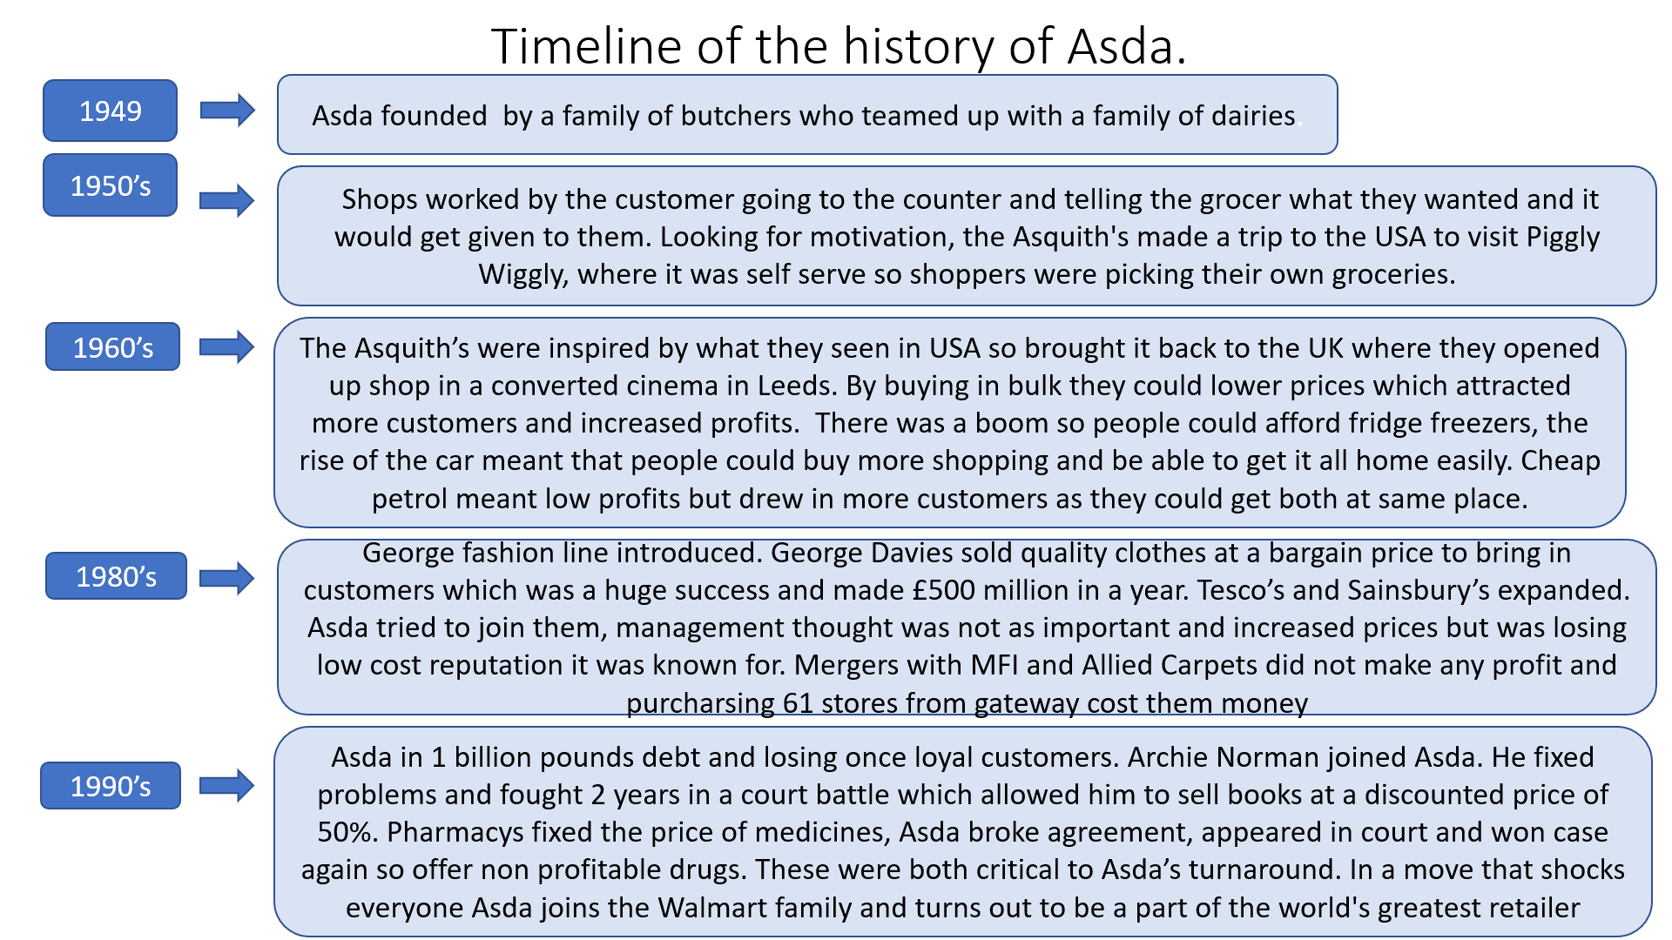
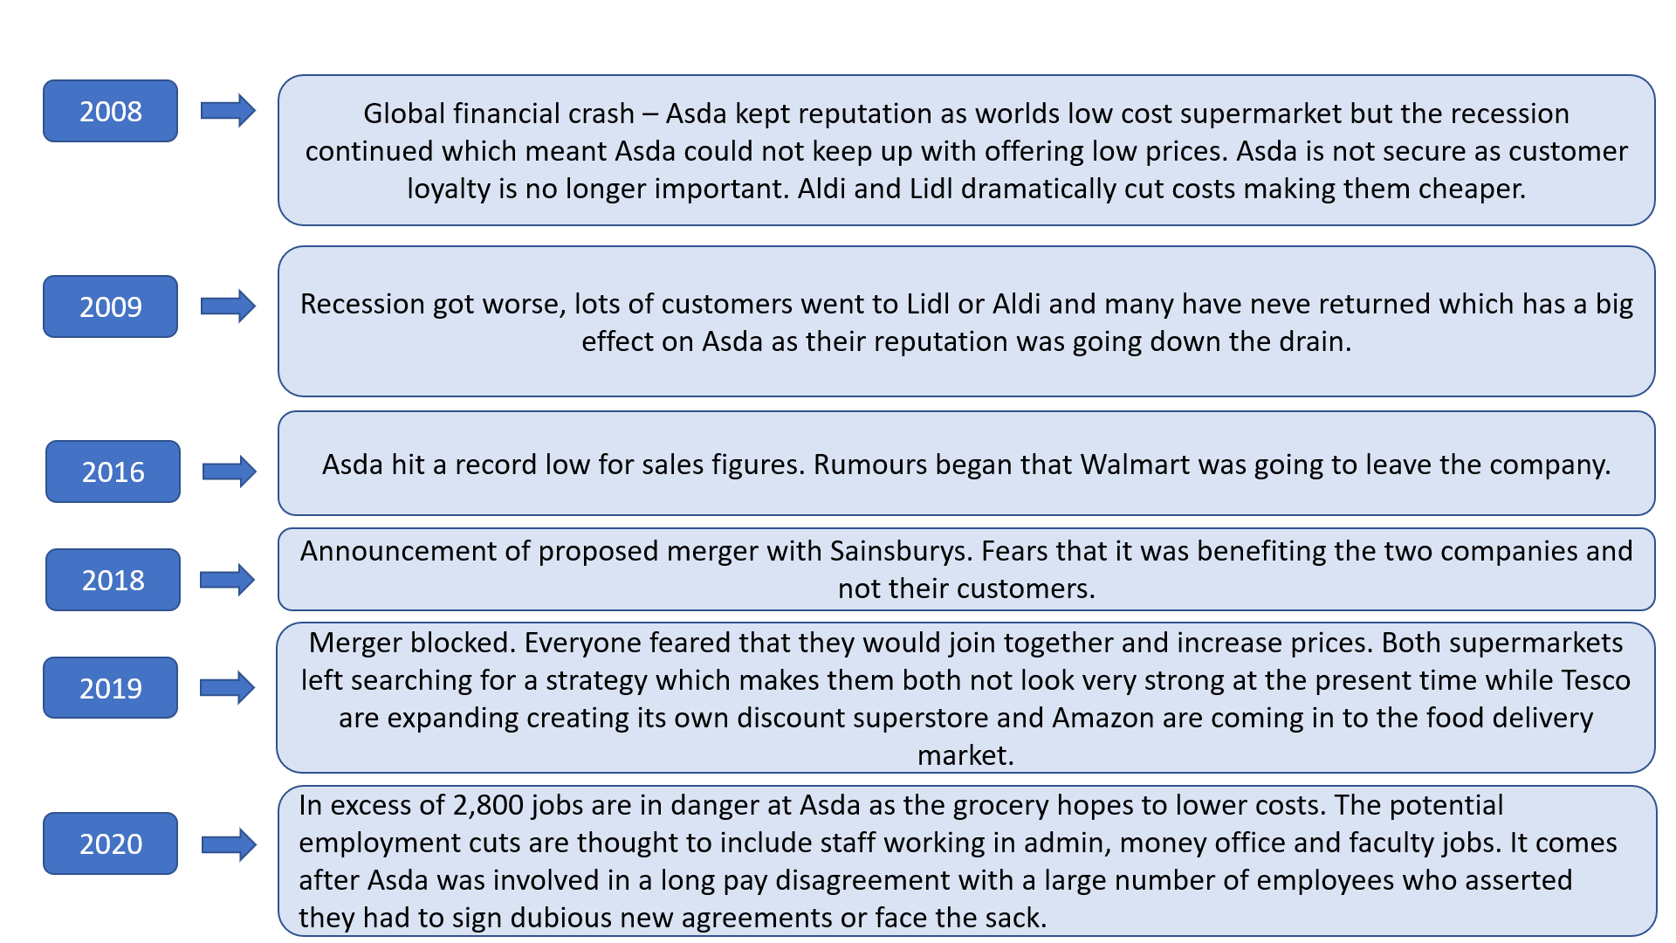

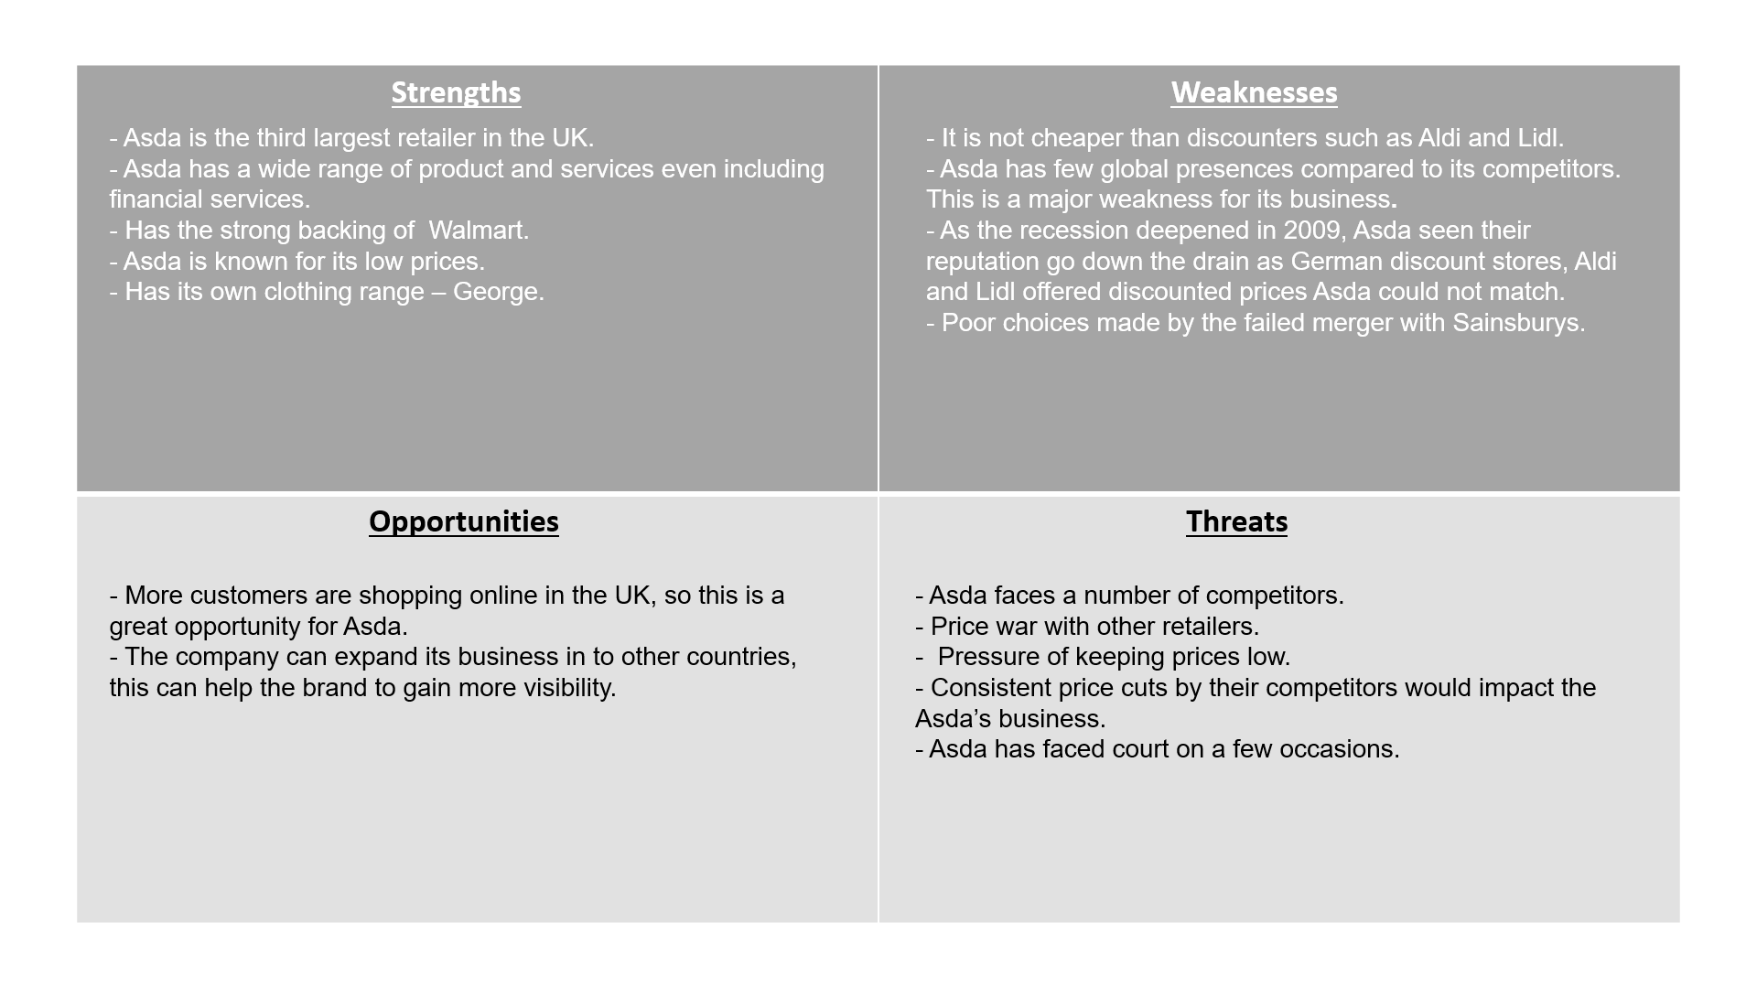
_{Swot Analysis}
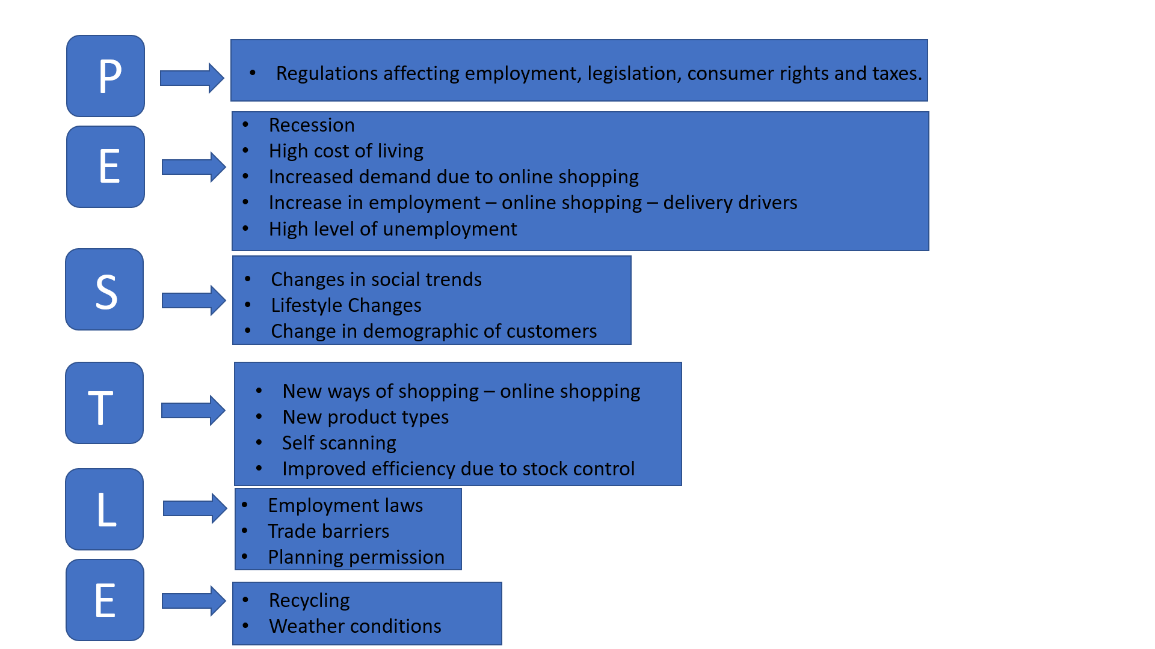
_{Pestle Analysis}
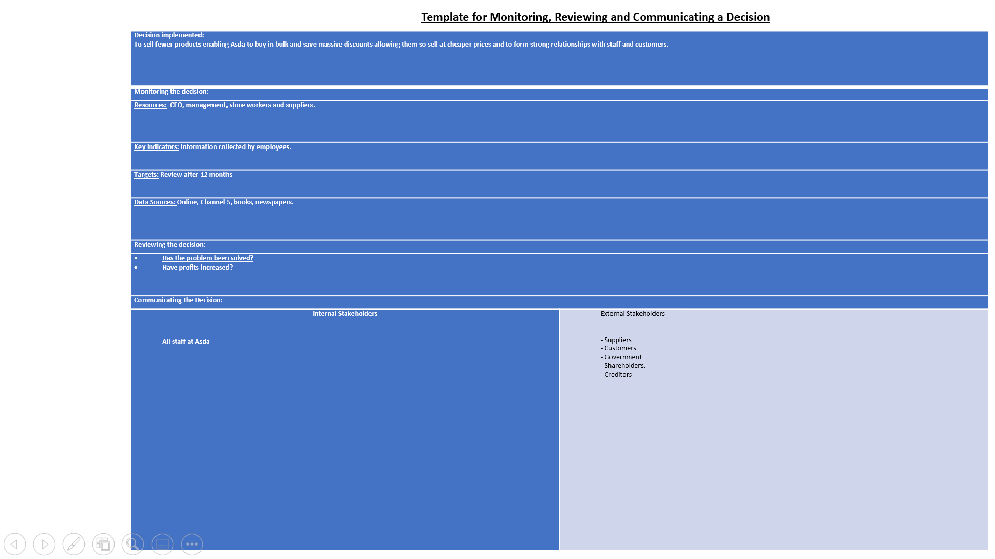
_{Action plan template.}
_{References}
- Munbodh, E., 2020. Asda staff say forced new contract changes have turned them into "prisoners." [Blog] Available at: <https://www.mirror.co.uk/money/asda-workers-say-unfair-new-18870030> (Accessed 12 March 2020).
- ‘Top 10 UK Retailers’ Available at: https://www.retaileconomics.co.uk/top-10-retailers-uk-top-10-retailers
(Accessed 26 March 2020).
₋ Language, D., 2020. What Are The 7 Benefits Of Going Global.
Available at: http://blog.dynamiclanguage.com/what-are-the-7-benefits-of-going-global
(Accessed 25 March 2020).
- Channel 5. 2020. Inside Asda: Bigger, Better, Cheaper? - Channel 5.
Available at: https://www.channel5.com/show/inside-asda-bigger-better-cheaper/
(Accessed 1 March 2020).
- Corporate - ASDA. 2020. Our History
Available at: https://corporate.asda.com/our-story/our-history
(Accessed 8 March 2020).
- S4RB, T., 2020. The History Of Asda - Pocket Tapping For 52 Years.
Available at: https://blog.s4rb.com/the-history-of-asda-pocket-tapping-for-52-years
(Accessed 27 February 2020).
- Asda.com. 2020. Asda.Com - Online Food Shopping, George, & More.
Available at: https://www.asda.com/about/own-brands
(Accessed 12 March 2020).
- The Independent. 2020. Asda Has Suffered The Worst Sales Fall In Its 67-Year History - Here's What It Did Wrong.
Available at: https://www.independent.co.uk/news/business/analysis-and-features/asda-becomes-the-latest-grocer-to-be-sucked-into-the-supermarket-vortex-a6882936.html
(Accessed 27 March 2020).

