
Unit name: Global Ethics
Module code: (BMBM6008)

Ethics and Business Decision-Making
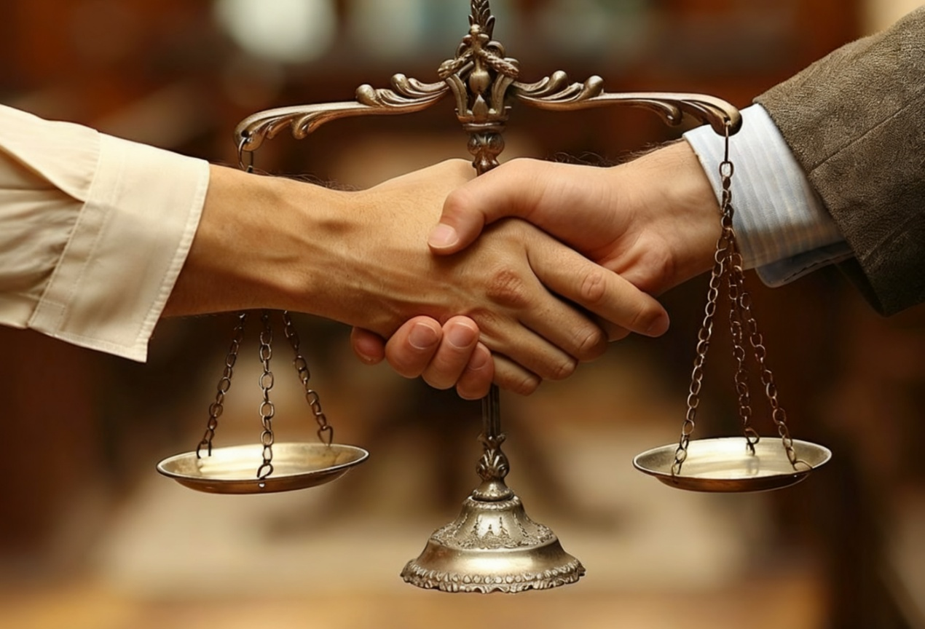
Prepared for: Arpu Kumar
Written by: Tianyu Li
Date submitted: November 19th

Executive Summary
This report looks at the close relationship between ethics and business decisions. In today's interconnected world, businesses are no longer under pressure just to make money but to accept their social responsibilities. This article first examines the basic principles of business ethics such as utilitarianism, deontology and virtue ethics. It then looks into how these ethical principles are related to strategic decisions in organizations. The report assesses the business ethics practices and failures by studying some of the recent cases from five years ago. The discussion involved questions relating to the role of businesses, their social responsibilities and external intervention. Finally, the report will conclude that making ethical decisions is not a hindrance to profit-making but rather a part of a long-term sustainable growth plan.
Table of Contents
1. Introduction 1
1.1 The Modern Business Dilemma 1
1.2 Defining Business Ethics 1
2. Philosophical Foundations of Business Ethics 1
2.1 Utilitarianism: The Greatest Good 1
2.2 Deontology: Duties and Rights 2
2.3 Virtue Ethics: Character and Culture 2
3. Ethics in Real-World Decision-Making and Planning 3
3.1 Strategic Planning and Corporate Social Responsibility 3
3.2 Ethical Challenges in Operations and Supply Chains 3
3.3 The Role of Corporate Culture and Leadership 4
4. Critical Evaluation: Contemporary Case Studies 5
4.1 Positive Example: Patagonia’s Ethical Commitment 5
4.2 Negative Example: The Volkswagen Emissions Scandal Revisited 5
5. Conclusion 5
6. Recommendations 6
7. Reference List 7

- Introduction
  - The Modern Business Dilemma

The 21st century world has meant that companies operate within an increasingly interconnected and transparent world. News travels very quickly in this new world. Consumers, employees and investors increasingly scrutinize companies based on their products and profits but are taking a closer eye on their values and actions (Eccles, Ioannou & Serafeim, 2019). As a result, leaders are faced with a choice: whether to choose a profitable but likely immoral approach, or to stick to their own moral bottom line.(Friedman, 1970). One of the most controversial topics in this kind of problem is whether enterprises should seek profits for shareholders or serve society. A vivid modern example is the way and method of pricing drugs in the pharmaceutical industry. A sharp modern example is the method the pharmaceutical industry uses to price drugsrom a utilitarian perspective (funding future research), a company may defend the high price of a life-saving drug, but from a deontological perspective, when patients cannot afford it, this may be regarded as a violation of the responsibility to protect lives. This report will demonstrate that a narrow focus on short-term profits often leads to long-term failure, and that a moral approach is the key to sustainable success.

1.2 Defining Business Ethics

Business ethics refers to the study of moral and ethical issues arising in business or the market. It covers a wide range of ethical standards and can be applied to business practices and includes the core strategies of the enterprise and the daily behavior of employees (Crane & Matten, 2019). This is a duty to respect the law. Enterprises should provide ethical practices to all relevant stakeholders, whether employees, customers, suppliers or the enterprise and social environment. For example, enterprises use certain data tracking methods through websites(Fisher & Lovell, 2020). Although the law does not clearly indicate that this is illegal, the ethical practice is to let users clearly know and agree. These are the standards enforced by the General Data Protection Regulation (GDPR) and other regulations, but this should become a basic code of ethics.
- Philosophical Foundations of Business Ethics
To understand how to make ethical decisions, it is helpful to look at the philosophical theories that form the basis of modern ethical thinking. There are three main theories that are particularly relevant: utilitarianism, deontology and virtue ethics.
  - Utilitarianism: The Greatest Good

Utilitarianism was founded by philosophers Jeremy Bentham and John Stuart Mill, under which the most ethical decision is one that leads to the greatest benefit for the greatest number of people (Sandbu, 2021). In a company setting, managers guided by utilitarian principles would make decisions based on a cost-benefit analysis considering both the positive and negative consequences for all stakeholders. For example, a company may decide to invest in expensive pollution control devices as benefits offered in terms of community health are far greater compared to the costs being paid by the company. An issue with utilitarianism in practice is if it benefits majority it can often mean harm caused to minority. In this instance if an automated process is being introduced in an organisation by doing so efficiency can be increased thus cost at which consumers are obtaining products or services can be reduced and profits made by shareholders can be increased which means benefits for many people from this situation but more automated machines mean human workers become redundant thus causing harm (Bowie, 2017). Thus one limitation is inability for theory protect indivi.
  - Deontology: Duties and Rights

Although there are very different approaches to ethics, not all of them share the same standards. Deontological ethics, as developed by philosopher Immanuel Kant, argues that behaviors can be inherently right or wrong aside from their consequences and it is built on responsibilities, rules and respect for rights (Brenkert & Beauchamp). A deontology perspective in business would hold that companies have a moral obligation not to lie, deceive or steal even if doing so would result in better consequences. For instance, deontologists might maintain that the use of child labor is always wrong even if it is cheaper for consumers and increases the company’s profits. Today, this can apply to data privacy. According to a deontologist approach, social media firms must always be transparent regarding their data collection and never sell user data without explicit consent and neither do it secretly and generate a lot of profit. This is because deceiving users is inherently wrong and violates the responsibilities of honesty and respecting users’ autonomy. This view puts forward clear regulations that enterprises or people can follow, but the way it is applied may be too rigid. It is impossible to help when there is a conflict of responsibilities, such as when shareholders pursue profit or employees have a conflict of responsibilities to ensure employment.(Ross, 1930).

2.3 Virtue Ethics: Character and Culture
Virtue ethics does not focus on actions or consequences rather it focuses on traits of moral agents. Aristotle argued these should be focused upon "What kind of person should I be?" Or "What would a moral person do?" (Solomon, 2018). In business it suggests whether businesses or people within them should be honest or fair in decision-making. A company guided by virtue and ethics will strive to establish a corporate culture that makes doing the right thing a habit. For instance, a manager will build trust and loyalty among team members not because it increases productivity but because that’s proper way human beings should treat each other. The Body Shop founded by Anita Roddick is a powerful example. Long before buzzwords like environmental protection, CSR and fair trade had gone mainstream in the business landscape, the company had already built its entire brand around these virtues. The company does not test its products on animals not because of pressure from consumers (utilitarianism) or because specific rules dictate such actions (deontological ethic), but because this aligns with the virtues that the company wishes to portray - compassion, love and respect for life (Hartman, 2021). The challenge of virtue ethics lies in the fact that it is not as specific as other theories and relies on a common understanding of the composition of "virtue".
- Ethics in Real-World Decision-Making and Planning

These are not just abstract philosophical ideas; they are ideas that will shape the way in which a company runs its daily operations and how it plans its future. Incorporating these morality into corporate strategy is key to ensuring sustainability in the long run.

3.1 Strategic Planning and Corporate Social Responsibility
Strategic planning refers to the process of defining a firm’s long-term goals and identifying the best way in which they can be achieved. Today, moral considerations play an integral part in shaping this process.This is usually formalized through corporate social responsibility (CSR) and environmental, social and governance (ESG) frameworks. Corporate social responsibility refers to a business model that helps companies assume social responsibility towards themselves, stakeholders, and the public (Carroll & Brown, 2019). Incorporating ethical aspects in day-to-day strategy allows a business to acknowledge its role in a broader society and take necessary steps. It has been increasingly found that having good CSR performance can enhance a firm’s reputation, increase customers loyalty towards it (Eccles et al., 2019). For example, Unilever’s “Sustainable Living Initiative” forms a fundamental part of their strategy wherein it aims at decoupling their growth from environmental impact while also having a positive social impact (Unilever, 2023). This approach is rooted in utilitarian view of generating maximum positive impacts along with shaping a positive character of the firm. Another example is how IKEA has invested heavily in order achieve “climate good” by 2030 wherein it intends on reducing more greenhouse gas emissions than those which are emitted from their value chain. This strategic decision which is taken can be attributed to have been taken owing to long-term view on sustainable development starting right from procurement of raw materials till designing products and logistics operations demonstrating how ethical goals could be seamlessly incorporated into business model (IKEA, 2022).
  - Ethical Challenges in Operations and Supply Chains
Probably the most challenging ethical decisions that a company makes are in its operations and global supply chain. The pressure to reduce costs and improve efficiency can lead to unethical behaviour, such as substandard working conditions, low wages or environmental damage. "The Rana Plaza factory collapse in Bangladesh in 2013 is a distressing example of turning a blind eye to these ethical issues (Reinecke & Donaghey, 2021)". Since then consumers and NGOs have escalated their scrutiny over the origin and production process of products. The deontological point of view is firm on the stance that companies have the obligation to make sure basic human rights are being respected throughout their supply chain at any cost. In practice this means having a tough supplier code of conduct, auditing suppliers on a regular basis and being transparent. Blockchain technology is currently being used by IBM among others to build more transparent and ethical supply chains, giving customers information on where their products are coming from (IBM, 2022). Fairphone is a tech company that does just that. The company explicitly focuses on running an ethical supply chain. It sources minerals for its smartphones from conflict-free zones, makes sure that factory workers get paid fair wages and designs phones that are easy to repair so they generate less electronic waste. This business model adheres to the ethics of responsibility (that is, the responsibility not to harm human beings or destroy the earth) and ethics (that is, to shape the character of the enterprise based on fairness and sustainable development), even if this model leads to an increase in product prices and a decrease in profits in the short term. (Fairphone, 2023).
  - The Role of Corporate Culture and Leadership
In a word, decision-making full of morality and ethics will be influenced by organizational culture and leadership. Because the style of the senior management is very important, if the leader or senior management of the enterprise shows the importance of morality, the message and philosophy conveyed to the employees will be very strong (Brown & Trevino). On the contrary, if leaders value profit over any other thing, employees may feel they have to do likewise even though it would require acting unethically. A well-known example is Wells Fargo’s scandal in which its employees opened up millions of fake accounts in order to meet sales targets set by top executives (Office of Comptroller of Currency, 2020). This can only be interpreted as a failure in virtue and ethics as it suggests that corporate culture awards immoral behaviour. Danish pharmaceuticals company Novo Nordisk is an excellent example of how this should be done. Its articles of incorporation mandate it to balance financial return with social and environmental considerations. This triple bottom line principle is rooted into its DNA and a key component on how performance is evaluated making sure the company’s culture reinforces behavior in the right direction (Novo Nordisk, 2023). Establishing an ethical culture needs more than putting down some lines on paper; it requires continuous training, having open channels for reporting issues (whistleblowing), rewarding ethical behaviour rather than only financial outcomes for employees’ behaviour (Schwartz, 2021). For instance,Salesforce has a Chief Ethicaland Humane Use Officer responsible for making sure that its technology was being used for responsibly, which demonstrates the leadership's profound commitment to the entire organization.
- Critical Evaluation: Contemporary Case Studies

We will examine examples from real life that could help us understand how these theories can work.

4.1 Positive Example: Patagonia’s Ethical Commitment

Patagonia is an outdoor clothing company that is often regarded as a model of ethical enterprises. The company's philosophy is: "We run our business to save our homeland." This concept has always permeated the company, whether from senior management or employees. In 2022, the founder Yvon Chouinard was very innovative in transferring the ownership of the company to an organization specializing in designing trust funds and a non-profit organization dedicated to responding to environmental crises(Patagonia, 2022). This decision ensures that the company's profits are no longer limited to business investment, but more to protect the natural environment. This behavior can be analyzed from three moral levels. From the level of utilitarianism, the enterprise's goal is to create benefits for the global environment. From the moral level, the enterprise is very responsible for the environment. From the moral and ethical level, the enterprise shows excellent sincerity and integrity and is consistent with the values of the enterprise.This long-term, value-driven approach has also built a highly loyal customer base, demonstrating that ethics and profitability can be consistent(White, 2023).

4.2 Negative Example: The Volkswagen Emissions Scandal Revisited
The Volkswagen "Dieselgate" scandal that broke out in 2015 remains a powerful lesson for unethical decision-making. The company installed software in its diesel engines, which can detect them during tests and modify their performance to improve the results. In actual driving, the pollutants they emit are as high as 40 times the legal limit (EPA, 2015). Although this scandal broke out more than five years ago, it is evident from the ongoing litigation and discussions on corporate governance that its impact and lessons remain highly relevant today (Eain, 2020). This scandal was a disastrous failure. A utilitarian analysis shows that it has caused huge harm: damaging public health, seriously losing trust, and imposing fines of billions of dollars. Morally speaking, this is an obvious example of lies and deception. In terms of virtue and ethics, it reveals a corporate culture that values victory and technological originality rather than honesty and compliance. This scandal shows what happens when moral considerations are completely separated from technical and financial planning.
- Conclusion

This report indicates that in business, morality is not an optional additional condition; It is a fundamental aspect of sound decision-making and strategic planning. The philosophical foundations of utilitarianism, deontology and virtue ethics provide a valuable framework for analyzing moral dilemmas.In today's society, these principles can be reflected in many aspects. For example, the integration of corporate concepts and strategies, the importance of market ethical management and corporate moral culture can be highlighted. The encounter between Patagonia and Volkswagen is in stark contrast. Patagonia has established brand value and resilience with consistent and firm moral concepts, while Volkswagen has suffered great losses in terms of corporate reputation and finance due to the lack of moral concepts. Therefore, the purpose and philosophy of the enterprise should not be limited to profit, but also create value for people related to interests such as society and the environment.. It is concluded that external supervision is combined with strong internal management to a certain extent, and moral responsibility is maintained under the premise of pursuing profits.

6. Recommendations

To implement ethical behavior in business, what a company should do is:
- Establish a comprehensive ethical framework.
- Embed ethics in strategic planning
- Invest in ethical training and leadership development
- Enhance supply chain transparency.
- Protect whistleblowers and encourage open dialogue.

When businesses follow these recommendations, they help to lay the foundation for ethical behavior. This, in turn, will drive a successful and sustainable relationship with society.

7. Reference List
1. Bowie, N.E., (2017). Business Ethics: A Kantian Perspective. 2nd ed. Cambridge University Press.
2. Brenkert, G.G. and Beauchamp, T.L., (2022). The Oxford Handbook of Business Ethics. Oxford University Press.
3. Brown, M.E. and Treviño, L.K., (2022). The Role of the Leader in Building Ethical Culture. Journal of Business Ethics, 175(1), pp. 1-15.
4. Carroll, A.B. and Brown, J.A., (2019). Corporate Social Responsibility: A Review of Current Concepts, Research, and Issues. Business & Society Review.
5. Crane, A. and Matten, D., (2019). Business Ethics: Managing Corporate Citizenship and Sustainability in the Age of Globalization. 5th ed. Oxford University Press.
6. Eccles, R.G., Ioannou, I. and Serafeim, G., (2019). The Impact of Corporate Sustainability on Organizational Processes and Performance. Management Science, 60(11), pp. 2835-2857.
7. EPA, (2015). Volkswagen Violations.
8. Ewing, J., (2020). Faster, Higher, Farther: The Volkswagen Scandal. W. W. Norton & Company.
9. Fisher, C. and Lovell, A., (2020). Business Ethics and Values: Individual, Corporate and International Perspectives. 5th ed. Pearson Education.
10.Freeman, R.E., Harrison, J.S. and Zygli dopoulos, S., (2020). Stakeholder Theory: Concepts and Strategies. Cambridge University Press.
11. Friedman, M., (1970). The Social Responsibility of Business is to Increase its Profits. The New York Times Magazine, 13 September.
12. Gentile, M.C., (2021). Giving Voice to Values: How to Speak Your Mind When You Know What's Right. Yale University Press.
13. Gereffi, G. and Lee, J., (2019). Economic and Social Upgrading in Global Value Chains and Industrial Clusters. Journal of Business Ethics, 133(1), pp. 25-38.
14. Hartman, E.M., (2021). Virtue in Business: Conversations with Aristotle. Cambridge University Press.
15. IBM, (2022). IBM Food Trust: A new era for the world's food supply.
16. Near, J.P. and Miceli, M.P., (2022). Effective Whistleblowing: A Review of the Literature. Academy of Management Annals, 16(1), pp. 1-40.
17. Office of the Comptroller of the Currency, (2020). OCC Assesses $250 Million Civil Money Penalty Against Wells Fargo.
18. Patagonia, (2022). Earth is Now Our Only Shareholder.
19. Reinecke, J. and Donaghey, J., (2021). The Rana Plaza Disaster: A Catalyst for Change in Global Supply Chains? Journal of Business Ethics, 45(2), pp. 89-104.
20. Ross, W.D., (1930). The Right and the Good. Oxford University Press.
21. Sandbu, M.E., (2021). The Economics of Morality. Harvard University Press.
22. Schwartz, M.S., (2021). Corporate Ethical Virtues: A Framework for Building an Ethical Organisation. Business Ethics Quarterly, 31(3), pp. 345-370.
23. Trevino, L.K. and Nelson, K.A., (2021). Managing Business Ethics: Straight Talk about How to Do It Right. 8th ed. John Wiley & Sons.
24. Unilever, (2023). Unilever Sustainable Living Plan.
25. White, K., (2023). Patagonia's Purpose-Driven Profit: A Case Study in Sustainable Business. Stanford Business Press.

