

CHILDREN, YOUNG PEOPLE AND FAMILIES
BHMP5004
STUDENT: EVELYN BELFON 1812690
LECTURER: DR GULNAR ALI
MAY 2020

Table of Contents

INTRODUCTION 3
GABRIEL FERNANDEZ 3
RISK FACTORS 4
MULTI AGENCIES FAILINGS 4
DCFS SOCIAL WORKERS 4
CHILD PROTECTION SERVICES 5
LOCAL SHERIFF’S OFFICE 5
DCFS COUNSELLOR 6
SCHOOL 6
AT THE TIME OF GABRIEL’S DEATH 6
PREVENTION 7
WORKING IN PARTNERSHIP TO ACHIEVE BETTER SAFEGUARDING STANDARDS 7
ACTS OF LEGISLATION 7
CHILD AND FAMILY SERVICES IMPROVEMENT AND INNOVATION ACT 2011 8
CHILD ABUSE PREVENTION AND TREATMENT ACT (CAPTA) REAUTHORISATION ACT 2010 8
CHILD ABUSE PREVENTION AND ENFORCEMENT ACT 2000 8
CHILD ABUSE PREVENTION AND TREATMENT AMENDMENTS ACT OF 1996 8
RECOMMENDATIONS 8
CONCLUSION 9
REFERENCES 10
APPENDIX A 12
APPENDIX B 13
APPENDIX C 14

INTRODUCTION
This report highlights the case study of Gabriel Fernandez an 8-year-old boy who suffered extreme cruelty at the hands of his abusive mother and her equally abusive boyfriend which ultimately ended in Gabriel dying without dignity. We look at the agencies involved in the lead up to his death and review how the services could have worked with more uniformity to secure a better outcome. Also, I will look at the failings of the social workers and take a brief look at some of the legislation that should have been applied in this case to protect the 8-year-old boy.

GABRIEL FERNANDEZ
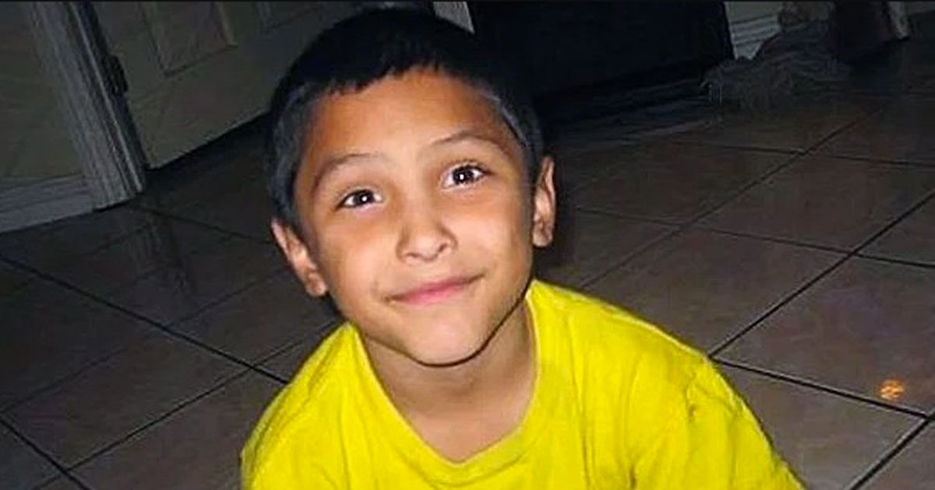
The Mirror Newspaper 2020
Gabriel Fernandez was born into a low-income family who lived under the care of the Los Angeles Department of Children and Family Services (DCFS). The family also had interactions with Child Protective Services (CPS) and the local sheriff's department. Despite the high number of agencies involved in his case, Gabriel’s accusations of abuse and his plea for help fell on deaf ears.
Gabriel first came to the attention of DCFS soon after his birth in 2005 due to his mother caring for him in a substandard manner. Gabriel's maternal great uncle and his male life partner stepped in to take over the care of Gabriel and this was a successful union. The young boy grew up in a happy and loving environment for the time he spent with this part of the family (Mitchell, 2020).
However, in 2012 at the age of eight, Gabriel’s mother took him into her care because she planned to claim child welfare payments for him. Gabriel’s two older siblings state that abuse of their younger brother started as soon as he arrived into the house. Their mother, Pearl Fernandez and her boyfriend, Isauro Aguirre verbally abused and tortured Gabriel, they called him gay which was a direct reflection on Gabriel's uncle and his male partner who were his sole carers up to that point. Along with the verbal abuse, Gabriel was severely beaten by the entire household, his mother and her boyfriend would threaten the two older siblings with violence if they did not join in. Neither of the siblings was subjected to the same harsh, inhumane and vitriolic treatment suffered by Gabriel.
Tortured daily, Gabriel had little chance of escape, he was not allowed to use the toilet, he was only given cold baths and pepper spray was frequently used in his face. A particularly brutal scenario, involved Gabriel running in circles in a room with both adults and both siblings taking turns shooting a BB gun at him. Other examples of the extreme physical abuse Gabriel endured included his face and the top of his head being used as ashtrays, and he was bound, gagged and placed in a half-sized storage cabinet in the parent’s bedroom at night which was then sealed with a padlock. Gabriel slept, urinated and defecated in the storage cabinet and was sporadically fed small amounts of food by his siblings when the parents were not watching. When he came out, his mother and the boyfriend would feed Gabriel out-of-date and spoiled food and he was even forced to eat cat litter. This systematic level of abuse eventually resulted in Gabriel's death (Hanlon & Pelisek, 2020).

RISK FACTORS
According to the Centre for Disease Control and Prevention (CDCP), having a greater understanding of the type of risk factors present within a family, such as
socioeconomic inequality, mental health issues, unemployment, child neglect, child abuse or drug misuse enables the social workers to adjust the care package to suit the needs of the family. Pearl Fernandez was an extremely high risk, it is believed she had a learning difficulty, bipolar, she also suffered from post-traumatic stress disorder and depression that was probably brought about from the attempted rape and gang rape she experienced as a young teen, she was also known to be a drug user.
Adult abusers often come from families where maltreatment is commonplace and this type of recidivism tends to pass over to the next generation (Antle, 2009). It would be easy to see how living in a perpetual cycle of violence would naturally transcend to the child or young adult being raised in such an environment. (Solomon 2016), found those child welfare agencies intended to reduce the suffering of neglected and abused children but they remained fully aware of the very nature of recidivism and how it would make this quite a challenge (see appendix B).

MULTI AGENCIES FAILINGS

DCFS SOCIAL WORKERS

The supervisor of DCFS California was a highly qualified social worker with 20 years of experience. Being a devout Christian however, he believed strongly in the ‘preservation of the family’ and therefore thought the best course of action was for troubled families to be supported to preserve the family unit even when this entailed keeping the abused child in the home of the abusing parents. Pearl Fernandez was known to DCFS from 2003 until 2013 and within that time there had been 60 calls to their offices with complaints about Pearl and how she was raising her children. Only 8 of those calls were investigated and all complaints were deemed unfounded, therefore nothing happened. When a junior social worker raised concerns about Gabriel’s position within the home because she felt there was imminent danger, her complaint was dismissed by the senior, more experienced social worker.
DCFS failed to fulfill its basic legal duty of protecting a known abused child. At no time did the department considered Gabriel’s wellbeing or ensured his safety while living in his mother’s care. The senior social workers’ religious beliefs hampered his judgment on the severity of the situation and at the time of Gabriel’s death he was involved in falsifying the paperwork in the case to lessen his and his department's responsibility (see appendix C) (Therolf, 2018).

CHILD PROTECTION SERVICES

Due to reports of abuse from Pearl's family, Child Protection Services (CPS) visited the home but never found strong enough evidence of abuse so, they were very reluctant to remove Gabriel from the home of his mother and her boyfriend (Hall & Pocklington, 2020).

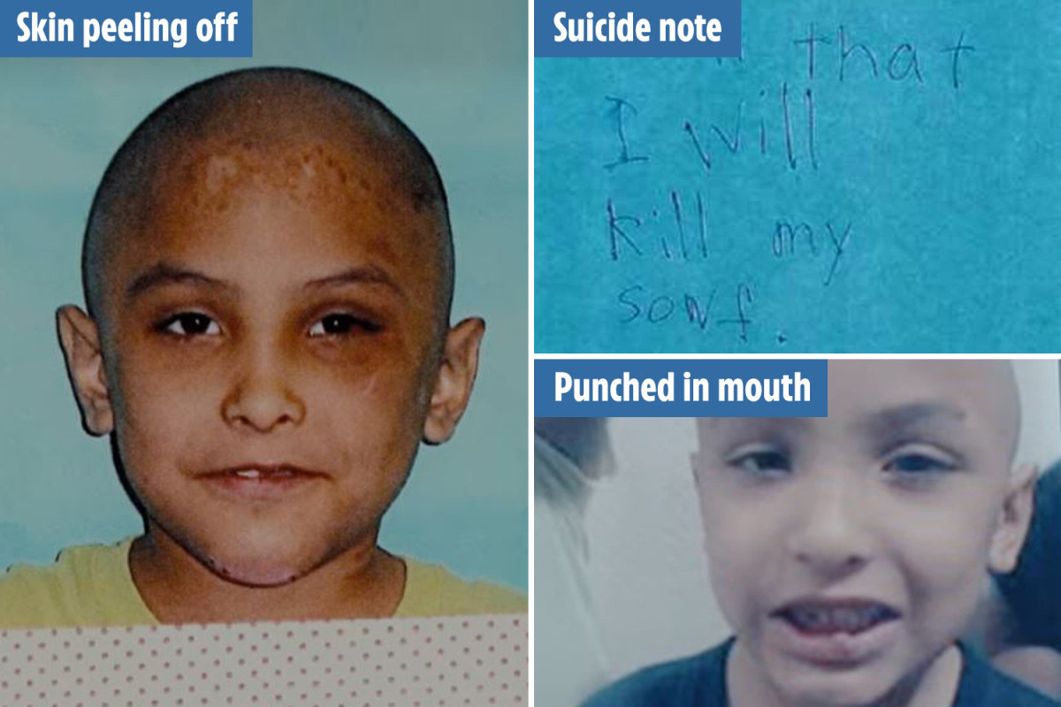
The Sun Newspaper 2020

LOCAL SHERIFF’S OFFICE

The local sheriff’s office was sent to Gabriel’s home on several occasions and concluded that there were no visible signs of abuse, therefore, no report was written, making it impossible for specially trained detectives to look further into the case. The police officers who spoke to Gabriel did not believe him and accused him of lying. They also ignored the concerns of a security guard who witnessed bruising and cigarette burns on Gabriel’s face and head. The local sheriff’s office failed him as they had ample chances to protect him by simply passing on complaints to the appropriate team (Booth Law, 2020).

DCFS COUNSELLOR

DCFS assigned a counsellor to the family, however, this was not beneficial to Gabriel as all his conversations happened in the presence of or relaid back to his mother for verification, resulting in a retraction of his complaints. When the counsellor informed the social workers of her sessions, they had little interest in the disturbing information she had gathered, even Gabriel’s cry for help with a suicide letter and the verbalisation of wishing he was dead went unchallenged (Booth Law, 2020).

SCHOOL

The persecution of Gabriel was daily and on the occasions, he was allowed to attend school, his teacher noted bruises, scratches, scaly skin, and scabs on top of scabs. One of his teachers, also noted his mother would dress him in female clothing to humiliate him around his peers. After confirmation of the abuse from Gabriel, his teacher contacted the childline twice but in both circumstances, no one returned her calls. She then reported it to the local sheriff's office and they, in turn, made a visit to the house but took no action. Had the school reported this suspected abuse to the school district Gabriel might have had intervention from another agency (see appendix A) (Therolf, 2018).

AT THE TIME OF GABRIEL’S DEATH

In May 2013, the ambulance service was called to the home of Gabriel Fernandez. The ambulance crew noted he was naked and unresponsive and two days later Gabriel succumbed to his injuries.
At the autopsy, it was revealed that the young boy had two cracks in his skull, several fractures to his ribs, severe burns all over his body, his teeth had been knocked out, pellets from a BB gun were lodged in various parts of his body, one still embedded in his groin and cat faeces were lodged in his throat. The majority of Gabriel’s body was covered with bruises and scabs (Therolf, 2018).

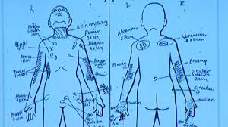
ABC7 News.com 2020

PREVENTION

WORKING IN PARTNERSHIP TO ACHIEVE BETTER SAFEGUARDING STANDARDS

Working in partnership with other agencies will only enhance the service offered to a family in crisis. The agencies will need to establish policies that could be agreed upon as to how they share and implement information to benefit the service users. Working out the strategies of how each agency will coexist will be beneficial. Regular monitoring should take place to assess how effective the partnership is. Having a fair structure where no one is discriminated regardless of their socio-economic status, religious standing or ethnic background would be paramount to success.
Great communication and a high level of professional working standards are needed to achieve the best possible outcome. To do this, you need trust, commitment, good communication, flexibility, and respect (Jelphs and Dickson, 2008).

ACTS OF LEGISLATION

Each of the 50 states of America receives money from the Federal Fund and the individual states are responsible for the administrative and legal structures of child welfare services and programs. The only stipulation for receiving and maintaining funding is to comply with the requirements and guidelines set out by the Federal Government (Child Welfare Information Gateway, 2019).

CHILD AND FAMILY SERVICES IMPROVEMENT AND INNOVATION ACT 2011
The 2016 amendment to the Child and Family Services Improvement and innovation act of 2011, requires a time-limited family reunification service that would facilitate the removed child’s safe and timely reunion with the parents. This can only go ahead once it has been satisfied that peer to peer mentoring and parenting classes have been utilised (Child Welfare Information Gateway, 2019).
This amendment came too late for Gabriel, had he been able to remain living with his uncle and slowly be reintroduced to his siblings, mother and her boyfriend the outcome may have been different.

CHILD ABUSE PREVENTION AND TREATMENT ACT (CAPTA) REAUTHORISATION ACT 2010
This amendment is to provide grants to private or public organisations or agencies to assist in the development or expansion of effective collaboration among the Child Protection Services (CPS) and other entities such as Domestic Violence Organisations (Child Welfare Information Gateway, 2019).
Although this Act was active when Gabriel was still alive there seemed to be no indication that information was shared amongst the agencies involved to offer Gabriel and his family the appropriate support.

CHILD ABUSE PREVENTION AND ENFORCEMENT ACT 2000
Within each state, the law enforcement teams can utilise the Federal grants to reinforce the laws concerning neglect and child abuse. The Act also gives them the ability to design and promote programmes teaching parents how to prevent child abuse and neglect (Child Welfare Information Gateway, 2019).
Gabriel’s mother could have benefited from such resources.

CHILD ABUSE PREVENTION AND TREATMENT AMENDMENTS ACT OF 1996
This 2001 amendment required all 50 states to terminate the parental rights regarding abandoned infants or if the parent caused severe or deliberate bodily injury resulting in the death of the child (Child Welfare Information Gateway, 2019).
There were visible signs of severe trauma and abuse on Gabriel’s body which was ignored by the social workers, teachers, counsellor and the Sheriff's department. They all failed the basic ‘duty of care’ and failed to protect Gabriel repeatedly.

RECOMMENDATIONS
- Supervisors should read the entire file before approving the closure of a case.
- Once the paperwork has been filled in, case-workers should not be able to amend or delete any of the original notes.
- Once police are called in to investigate, a written report should be recorded and referred to officers who are specially trained in child neglect and child abuse cases.
- Social workers should limit the number of chances given to the parent of an abused, looked after, or neglected child.
- Child protection service providers should not interview a vulnerable or at-risk child when their abuser is present.
- Where physical abuse is present, a medical professional and other healthcare professionals should be consulted and their findings recorded and shared amongst the agencies involved.
- The abused child should be reintroduced into the family in short periods therefore, allowing the abused child, siblings and accused parents time to reconnect under close supervision.
- Liaise more often with other agencies and organisations that specialise with neglected and abused children which in turn will enhance social worker's understanding. Work cohesively with the other agencies and organisations to provide a better service in protecting children in the system.
- The Federal Government should take a more critical look at children’s services to ensure the funding is justifiably allocated. This can be done by setting up a federal team in each state to monitor and implement appropriate changes where needed.

CONCLUSION
In conclusion, Gabriel’s story highlights the dangers of the lack of interagency communication and information sharing and the extreme vulnerability of at-risk children in a system built to safeguard them. Structured interagency cooperation could help prevent such devastating results especially in time-sensitive situations where decisive and swift interventions may be necessary.

REFERENCES
ABC7 News.com, A. com (2020) Gabriel Fernandez case: Court says social workers won’t face charges in Palmdale boy’s death, ABC7 Los Angeles. Available at: https://abc7.com/5820797/ (Accessed: 4 May 2020).
American Society for the Positive Care of Children (2020) Nation’s Voice For Children, American SPCC. Available at: https://americanspcc.org/ (Accessed: 4 May 2020).
Antle,B. Barbee, A et al (2019) The prevention of child maltreatment recidivism through the Solution-Based Casework model of child welfare practice | Elsevier Enhanced Reader. doi: 10.1016/j.childyouth.2009.06.008.
Booth Law (2020) Abuse Stories: The Death of Gabriel Fernandez, Torrance Personal Injury and Sexual Abuse Lawyer | Los Angeles Metro Area. Available at: https://booth.law/gabriel-fernandez-death/ (Accessed: 5 April 2020).
Centre for Disease Control and Prevention (2020) Risk and Protective Factors|Child Abuse and Neglect|Violence Prevention|Injury Center|CDC. Available at: https://www.cdc.gov/violenceprevention/childabuseandneglect/riskprotectivefactors.html (Accessed: 8 April 2020).
Child Welfare Information Gateway (2020) ‘Major Federal Legislation Concerned With Child Protection, Child Welfare, and Adoption’, Child Welfare, p. 28.
Hall & Pocklington (2020) Six unanswered questions about Gabriel Fernandez’s harrowing Netflix case - including his suspicious suicide note, The Sun. Available at: https://www.thesun.co.uk/news/11113391/gabriel-fernandez-trial-netflix-death/ (Accessed: 14 April 2020).
Hanlon & Pelisek (2020) Everything to Know About Gabriel Fernandez’s Tragic Abuse Case Examined in Netflix Docuseries, PEOPLE.com. Available at: https://people.com/crime/gabriel-fernandez-everything-to-know-abuse-case-netflix-docuseries/ (Accessed: 3 April 2020).
Mitchell, M. (2020) Gabriel Fernandez: Why did Gabriel Fernandez leave his Great Uncle’s care? | TV & Radio | Showbiz & TV | Express.co.uk. Available at: https://www.express.co.uk/showbiz/tv-radio/1263455/The-Trials-of-Gabriel-Fernandez-why-leave-Great-Uncle-care-Michael-Lemos-Carranza?int_source=traffic.outbrain&int_medium=traffic.outbrain&int_term=traffic.outbrain&int_content=traffic.outbrain&int_campaign=traffic.outbrain (Accessed: 5 April 2020).
Schwebke, S. (2019) ‘Audit finds LA County Family Services failing to protect children from abuse’, Daily News, 22 May. Available at: https://www.dailynews.com/la-county-dcfs-failing-to-protect-children-from-abuse-state-auditors-find (Accessed: 3 May 2020).
Solomon, D. et al. (2016) ‘Cumulative risk hypothesis: Predicting and preventing child maltreatment recidivism’, Child Abuse & Neglect, 58, pp. 80–90. doi: 10.1016/j.chiabu.2016.06.012.
The Mirror Newspaper (2020) Nurses relive horrific injuries of boy killed by mum as she thought he was gay, mirror. Available at: https://www.mirror.co.uk/news/us-news/gabriel-fernandez-murder-nurses-describe-21643764 (Accessed: 4 May 2020).
The Sun Newspaper (2020) The Trials of Gabriel Fernandez director reveals harrowing child abuse left Netflix crew ‘a wreck’, The Sun. Available at: https://www.thesun.co.uk/tvandshowbiz/11111081/the-trials-of-gabriel-fernandez-director-netflix-crew-wreck/ (Accessed: 4 May 2020).
Therolf, S. by G. (2018) ‘Why Did No One Save Gabriel?’, The Atlantic. Available at: https://www.theatlantic.com/family/archive/2018/10/la-county-dcfs-failed-protect-gabriel-fernandez/571384/ (Accessed: 3 April 2020).

APPENDIX A

- 2003 – 2012, 60 complaints filed against Miss Fernandez and Mr Aguirre, only 8 investigated by DCFS and CPS, both agencies declared complaints were unfounded.
- 2004 a relative of Miss Fernandez informed CPS that she was beating her oldest son. They concluded it was unfounded.
- 2005 Gabriel was born and shortly after placed in the care of his maternal great uncle.
- 2007 complaint was filed against her Miss Fernandez for threats to break her young daughters' jaw. Claims were unfounded, however, she was sent to jail for weapon charges.
- 2012 September, Miss Fernandez gets custody of Gabriel.
- 2012 October, school teacher made several calls to childline, calls went unanswered.
- 2012 November. Gabriel’s counsellor reported that he was forced to perform oral sex on an adult female relative.
- 2012 December. The school reported another incident and asked the sheriff's office to investigate. This was conducted in front of Gabriel’s mother and he retracted his statement.
- 2013 January. The schoolteacher rang DCFS to report BB gun pellets marks on Gabriel's face.
- 2013 May. Gabriel was pronounced dead, Booth Law 2020.

APPENDIX B

CHILD ABUSE STATISTICS USA
When we hear about child neglect or child abuse cases we often have a preconceived notion of what these children and their families look like but in stark reality, all types of abusive behaviour occur in homes. It could be physical abuse, domestic violence, emotional abuse, sexual abuse, shaken baby syndrome, child neglect or trafficking and exploitation, regardless of what type it is, it is prevalent across all socioeconomic status, religion, education level or ethnic and cultural backgrounds. No group of people is immune from some form of violence.

Type of problem per million
Child maltreatment 4.1
Child abuse 7.5
Prevention 3.2

Type of problem percentage
Neglected 74.9
Sexually abused 8.6
Psychologically maltreated 7.1
Physically abused 18.3
American Society for the Positive Care of Children 2020
- Approximately 142,301 children received foster care.
- In 2017, 1,720 children died from neglect and abuse.
- It is estimated that around five children die from abuse each day.
- 80.1% of all child deaths are at the hands of at least one parent.
- 75.4% of children die from neglect.
- 41.6% of children die from physical abuse.
- Per 100,00, 2.68% of deaths were boys as opposed to 2.02% being girls.
- In 2017 the rate for children who were sexually abused stood at 65,000.
- A staggering 90% of sexual abuse victims knew their abusers personally.
- 54.1% of women abused children more than men which stands at 45.0%.
- 585 billion dollars is the estimated cost to the United States for services in neglected and abused children, American Society for the Positive Care of Children 2020.

APPENDIX C

Years after Gabriel Fernandez death Schwebke (2019), writes about the failings of the Department of Children and Family Services and their continued ineptness to protect abused and neglected children. Their inability to remove children from unsafe and abusive situations promptly resulted in these children having to suffer for longer than necessary. Only 72% of safety assessments were carried out by the social workers, therefore, the remainder was left to fall through the cracks. Several of these assessments were submitted without the social workers making a home visit.

