

ACCB6017
Usability Engineering – Component 1 Technical Report

Name: Olimpiu Robu

ID:2233652

Module Tutor: Nassir Ibrahim

Contents
Introduction 4
A. Persona Research Methods and Target Audience Definition 4
B. Usability Issues to be Addressed 14
C. Initial Wireframe Storyboards 17
C.0 Wireframe Overview - Screen 1: Main Menu [fig 12] 18
C.1 Wireframe - Screen 2: Game Mode and Character Selection [fig 13] 19
C.2 Wireframe Overview - Screen 3: Core Game Board View [fig 14] 20
C.3 Wirefr Overview -Screen 4: Suggestion/Accusation Flow [fig15/16] 21
C.4 Wireframe Overview - Screen 5: Game Resolution/End [fig 17/18] 22
C.5 Wireframe Overview - Screen 6: Communication Flow [fig 19] 24
D. Feedback Collection Process on Storyboard 25
D.1 Feedback Collection Process (Usability Validation) 26
D.2 Feedback Summary and Analysis 26
D.3 Proposal for Potential Future Improvements and Expansions 26
References 27
Appendices 28
Appendix 1 28
Appendix 2 33
Appendix 3 35
Appendix 4 37
Appendix 5 45
Appendix 6 45

Figure 1 shows the age group graph 8
Figure 2 shows player familiarity with mystery board games 9
Figure 3 shows preferred mode of play graph 10
Figure 4 is a graph for most important gameplay features 10
Figure 5 graph with the save ability importance 11
Figure 6 shows the likelihood of regular play 11
Figure 7 graph with the interface preferences 12
Figure 8 shows the visual style preferrence 12
Figure 9 graph for the devices used for playing 2D games 13
Figure 10 table for the summary for usability solutions 17
Figure 11 shows the Wireframe Storyboards 18
Figure 12 Main Menu Wireframe 19
Figure 13 Game Mode and Character Select Wireframe 20
Figure 14 Core Game Board Wireframe 21
Figure 15 Suggestion/Accusation Wireframe 22
Figure 16 Suggestion/Accusation Confirmation Screen Wireframe 23
Figure 17 Game Resolution Wireframe 1 24
Figure 18 Game Resolution Wireframe 2 25
Figure 19 Chat Feature Wireframe 26

User Requirements and Prototype

Introduction
The computer game design task centres on adapting the classic mystery board game, CLUEDO, into a UWTSD-themed digital experience: “Oh no! The Vice-Chancellor has been murdered!”. CLUEDO is fundamentally a strategy game requiring players to use reasoning, deduction, and elimination to solve a hidden "who, what, where" scenario[1]. The objective of this technical report is to document the translation of complex strategic requirements and mobile performance constraints into definitive usability engineering solutions. Usability is defined by the effectiveness, efficiency, and satisfaction with which a user can achieve goals. Usability is quantitatively assessed through effectiveness (the ability to deduce the solution accurately), efficiency (quick turn handling and minimal performance lag), and user satisfaction (intuitive controls and appealing aesthetics)[2]. Therefore, this design process begins with User Research, the methodical study of target users and their needs, to ensure the interface is intuitive, seamless, and user centred. This approach guides the creation of user requirements, personas, and wireframe storyboards appropriate for a mobile application. The approach utilises a User-Centred Design (UCD) philosophy, ensuring that the interface design mitigates the intrinsic cognitive load of propositional logic deduction while adhering to stringent performance standards mandated for modern mobile gaming [[2, 3].

A. Persona Research Methods and Target Audience Definition

The preliminary design phase leveraged a rigorous, mixed-methods user research approach to define the target audience, combining quantitative survey data with qualitative segmentation techniques [4]. This methodology was crucial for grounding the four detailed personas in observable trends while allowing for the necessary qualitative detail regarding user goals and pain points[see appendix 1].

Persona 1: Liam Davies (Full-Time Student)
Liam represents the traditional full-time student demographic, characterised by a flexible, entertainment-driven approach to digital gaming.
Demographic: Age 18–24, Full-time Student, Single.
Goals & Scenario: Liam's primary motivation is a highly engaging and customisable experience. He expects immediate immersion, requiring realistic animations and effects and the ability to personalise his game experience through a customisable avatar or token. His desire to explore all modes (single-player vs AI, local, and online multiplayer) necessitates seamless transitions and functional equivalence across these environments.
Dislikes: Key dislike points revolve around immersion compromise, such as inconsistent or poorly executed visual feedback, and the perceived loss of strategic control in multiplayer where covert communication is absent.
Main User Experience Requirements (UXRs):
• Aesthetic and Immersive Design: Prioritisation of realistic animations and thematic elements to maximise satisfaction.
• Security and Social Control: Mandatory implementation of private chat or whisper options to facilitate secure, confidential strategic communication.
• Flexibility: The system must provide configurable difficulty when playing against AI.

Persona 2: Sarah Chen (Part-time Student)
Sarah embodies the pragmatic part-time student, whose limited time mandate’s high reliability, efficiency, and strict adherence to game logic to minimise frustration.
Demographic: Age 25–34, Part-time Student, Device preference: Mobile phone (Very likely).
Goals & Scenario: Given constraints imposed by balancing work and study, Sarah requires an experience defined by fairness and operational integrity. Her primary goal is competitive online multiplayer engagement that is guaranteed by accurate rule enforcement (Very important). Her need for reliable progress tracking requires the game to allow easy saving and resumption of play.
Dislikes: She has a low tolerance for technical inconsistencies or glitches that could challenge the integrity of the game's core logic. Furthermore, complex, visually cluttered interfaces detract from efficiency (Aesthetic and minimalist design heuristic), driving her preference toward abstract views.
Main User Experience Requirements (UXRs):
• Accuracy and Reliability: The paramount requirement is accurate rule enforcement to maintain competitive fairness and trust.
• Cognitive Load Reduction: Preference for a Simplified abstract view and a digital notepad to manage and track complex deduction steps efficiently.
• Session Management: Highly reliable save/resume functionality to accommodate intermittent play schedules (inferred from part-time status and very likely mobile use).

Persona 3: Dr. Elara Vance (Education Professional)
Dr. Vance represents the experienced user archetype from the academic staff community, prioritising efficiency, familiarity, and desktop reliability over casual features.
Demographic: Age 45–54, Education professional (Lecturer, admin, etc.), Very familiar with the game.
Goals & Scenario: Dr. Vance seeks a high-fidelity digital translation of the classic board game, primarily for desktop use. Her main objective is gameplay efficiency, ensuring the mechanical aspects do not impede the intellectual challenge. This translates to the critical requirement for smooth dice rolling and movement (Very important), reflecting the usability criteria of efficiency.
Dislikes: Unresponsive or laggy interfaces, particularly concerning movement mechanics, are detrimental to her experience. She actively avoids social communication features, noting: "I don’t use chat features".
Main User Experience Requirements (UXRs):
• Efficiency of Interaction: Core requirement for Smooth dice rolling and movement to preserve rapid gameplay flow.
• Predictable Interface: Preference for the Classic board view (top-down) and high-performance reliability on a Desktop or laptop.
• Focused Experience: Exclusion of non-essential social tools or communication channels.

Persona 4: Amina Khan (Self-Employed/Freelancer)
Amina requires highly intuitive controls and flexibility to integrate competitive gaming into an unpredictable professional schedule.
Demographic: Age 45–54, Self-employed or freelancer, primarily uses mobile phone (Somewhat likely).
Goals & Scenario: Amina needs quick access to online multiplayer, emphasising the need for an interface that minimises cognitive friction (Recognition rather than recall heuristic). Her core goal is efficient strategic play that utilises intuitive game controls (Somewhat important) to reduce time spent learning application mechanics.
Dislikes: Complex, non-standard controls or excessive menu navigation inhibit quick engagement. She prefers limiting social interaction to public chat only, avoiding the higher time investment and cognitive load of private coordination.
Main User Experience Requirements (UXRs):
• Low Cognitive Load: Prioritisation of Intuitive game controls to enable quick entry and execution of game actions.
• Accessibility: Design must allow for seamless access and function on a mobile device to fit flexible working hours.
• Minimalist Communication: Design should favour streamlined, public interaction tools over complex private channels.

A.1 Methodology for Persona Construction
The foundation of the persona research was the analysis of survey data, which established key preferences and demographic characteristics. The largest segment of respondents fell into the 35–44 age group, closely followed by 45–54 and 25–34, suggesting the target audience skews toward slightly older professionals or part-time students rather than solely the 18–24 demographic [fig 1].
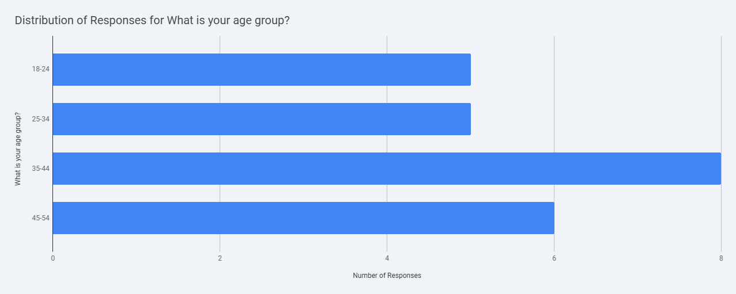
Figure 1 shows the age group graph
Here's a summary of the key insights:
Player Preferences and Engagement
- Familiarity with Murder Mystery Board Games: Most respondents are "Somewhat familiar" with murder mystery board games, indicating a good base of players with some experience.
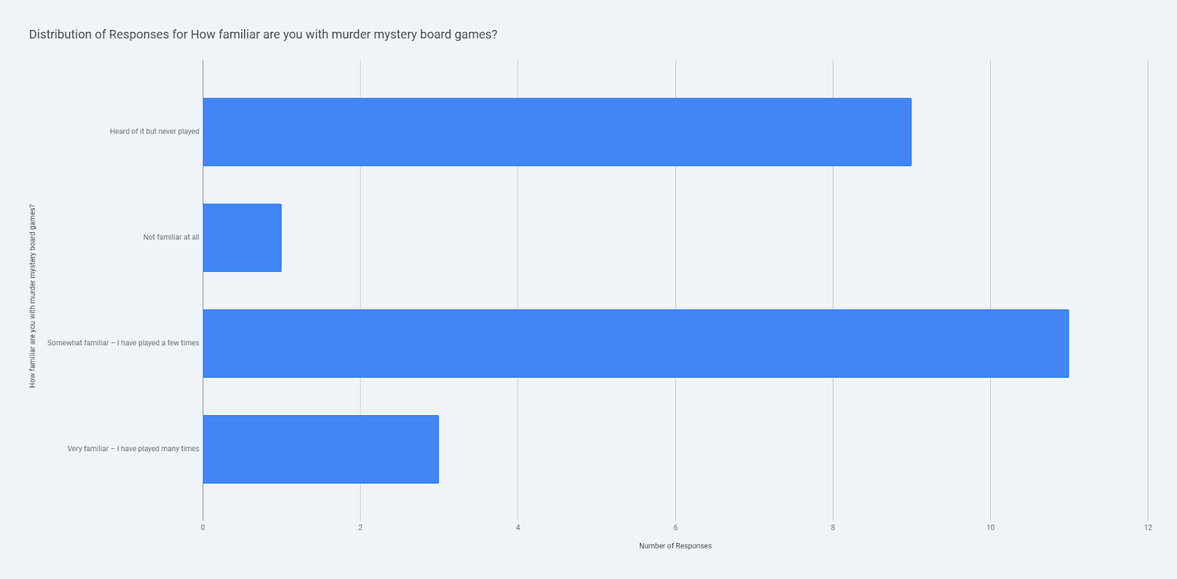
Figure 2 shows player familiarity with mystery board games
- Preferred Mode of Play: "Online multiplayer" is the most preferred mode, closely followed by "Single-player vs AI," and "All of the above" is also popular, suggesting a desire for flexible play modes.
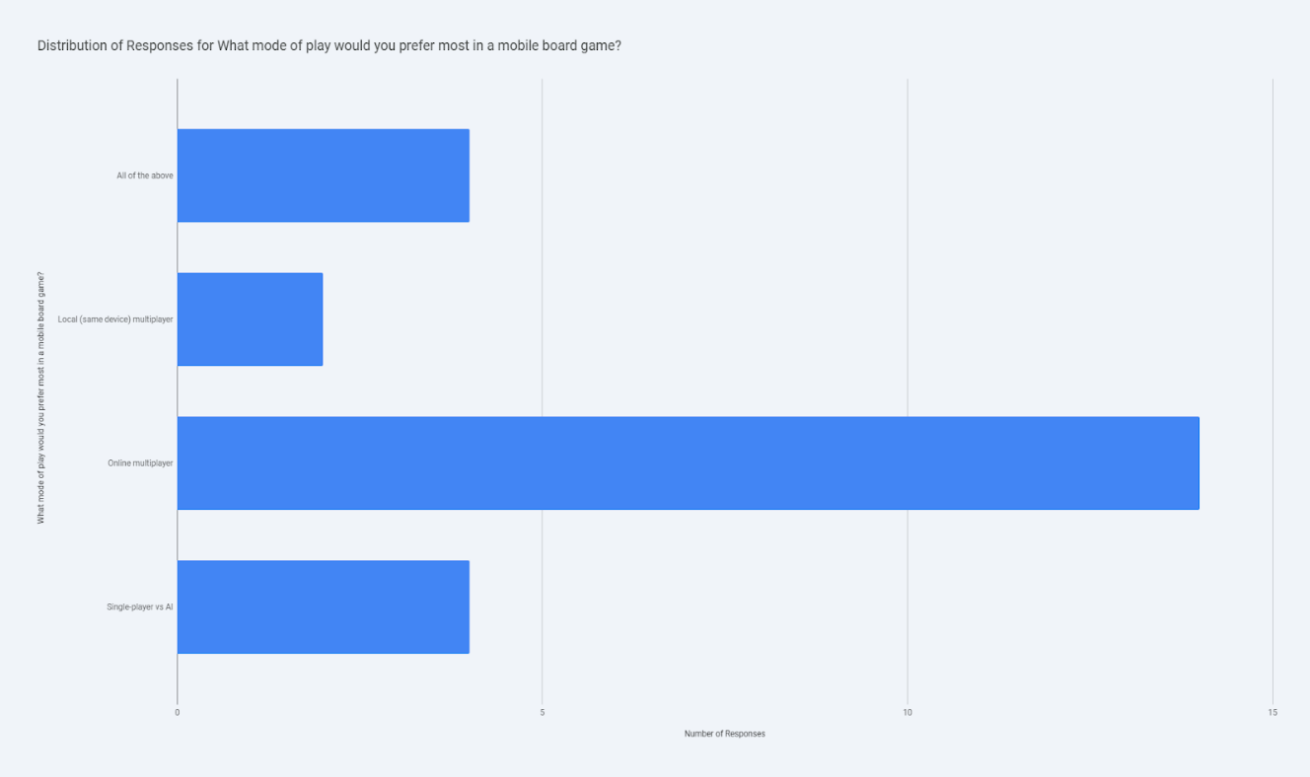
Figure 3 shows preferred mode of play graph
- Most Important Gameplay Feature: "Quick turn handling" and "Realistic animations and effects" are equally important, highlighting a preference for both efficiency and immersive elements.
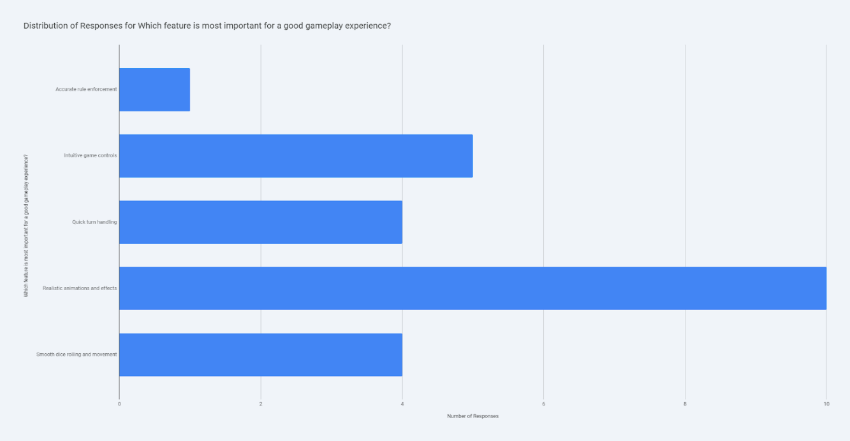
Figure 4 is a graph for most important gameplay features
- Importance of Save and Resume: The ability to save and resume a game is considered "Very important" by most respondents, emphasising the need for convenience.
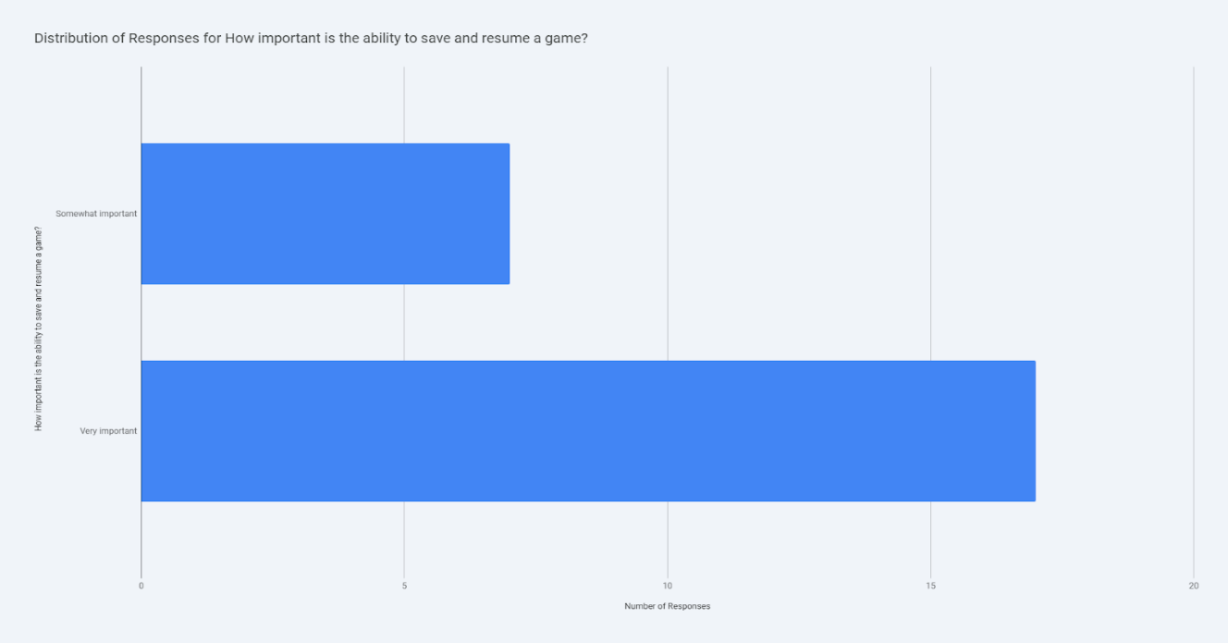
Figure 5 graph with the save ability importance
- Likelihood of Regular Play: Most respondents are "Somewhat likely" or "Very likely" to play a well-designed digital murder mystery game regularly, indicating strong potential for player retention.
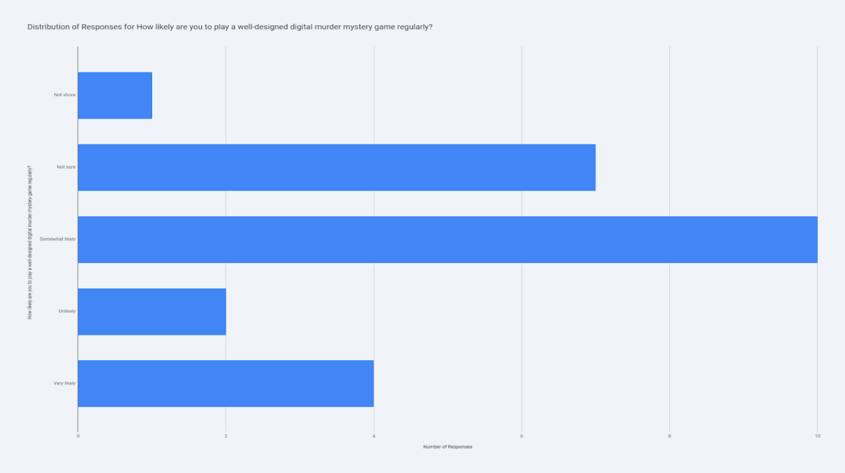
Figure 6 shows the likelihood of regular play
Interface and Visual Preferences
- Preferred Interface Type: "Classic board view (top-down)" is the most preferred interface, followed by a "2D interactive environment."
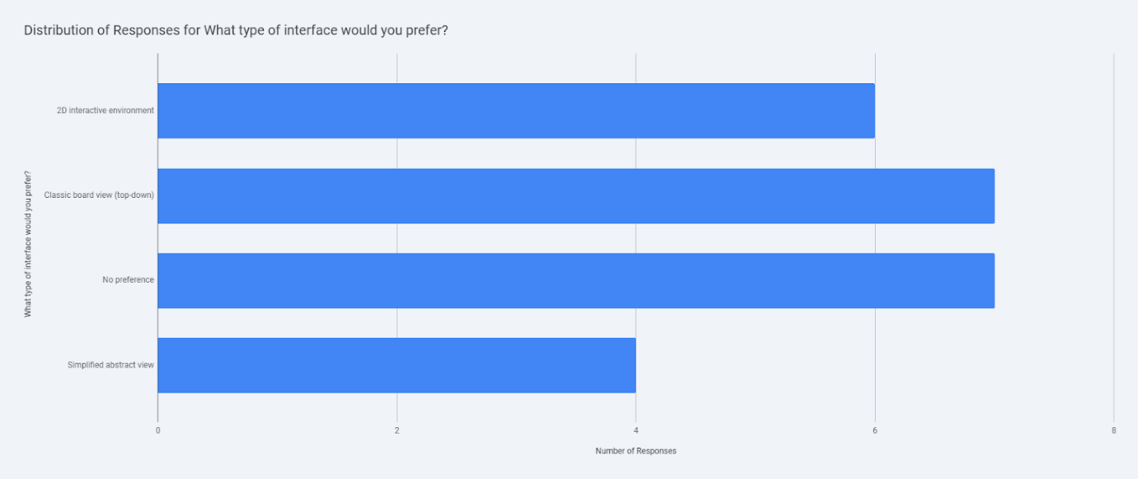
Figure 7 graph with the interface preferences

- Preferred Visual Style: "Themed or customisable look" is overwhelmingly the most preferred visual style.

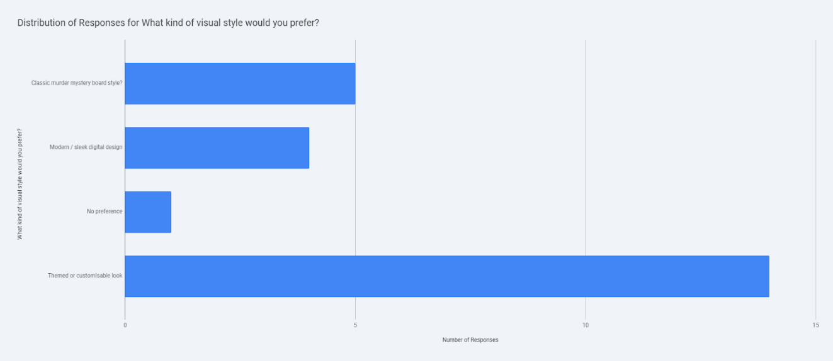
Figure 8 shows the visual style preferrence

- Device Preference: "Mobile phone" is the most popular device for playing 2D board games.
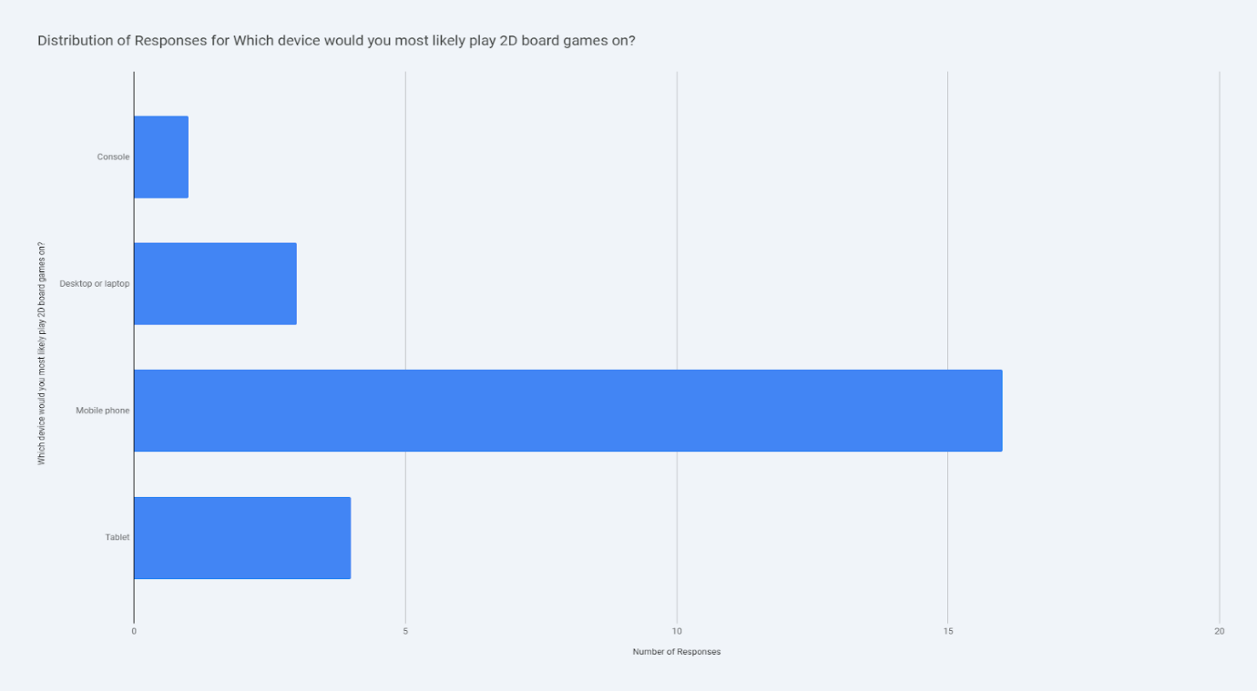
Figure 9 graph for the devices used for playing 2D games

These insights can be valuable for designing and marketing a digital murder mystery board game.

Critically, the research established three fundamental axes of user preference that guided persona segmentation:
- Context of Use: Identifying the conflict between users requiring dedicated session time (Dr. Vance) and those needing intermittent play sessions due to time constraints (Sarah Chen, Amina Khan). This led to the paramount requirement for Session Persistence (UXR 5), deemed "Very important" by most respondents [see appendix 2].
- Cognitive Management Preference: Distinguishing between users who prioritise an immersive, realistic view with animations (Liam Davies, UXR 8) and those who favour a simplified, abstract interface to minimise visual clutter and distraction (Sarah Chen, UXR 10) [see appendix 2].
- Social Strategy Preference: Segmenting users based on the need for confidential communication (UXR 11), required for alliance building and bluffing in multiplayer (Liam Davies, Sarah Chen), versus those who avoid chat features altogether (Dr. Vance, Amina Khan) [see appendix 2].
The four constructed personas—Liam Davies (Full-Time Student), Sarah Chen (Part-time Student), Dr. Elara Vance (Education Professional), and Amina Khan (Self-Employed)—were designed to represent these conflicting needs, ensuring the resulting interface is robust and versatile across the identified user base.
A.2 Insights and Implications of Persona Research
The detailed analysis of user requirements established a causal link between the demographic composition and the core design necessities of the game.
Causal Relationship: Cognitive Demand and UXR 2
The demographic skew towards older and time-constrained professional users (35–54 age groups) necessitates careful management of the game’s intrinsic complexity [fig 1]. CLUEDO is fundamentally a knowledge game reliant on propositional logic and deductive reasoning based on limited, dynamic information acquired through suggestions and refutations[1]. This process places a heavy tax on working memory, resulting in high cognitive load. The strong and universal mandate for a Clue Tracking System (Digital Notepad, UXR 2) is therefore a direct user-led requirement designed to compensate for these cognitive limitations[4]. By externalising the mental tracking process into a reliable, visual system, the design ensures the game remains effective and manageable across the primary user segment, preventing frustration and lowering the barrier to entry.
Implication: Mobile Performance Alignment with UXR 6
The research identified the Mobile Phone as the most popular device for playing 2D board games among respondents [fig 9]. This preference elevates technical performance from a secondary attribute to a critical prerequisite for usability. According to the IEEE Standard for Mobile intelligent terminals are inherently resource-limited, susceptible power management issues. If performance is compromised—for instance, by animation lag or "frame drop"—the user experience transitions rapidly from satisfied engagement to severe frustration. Consequently, the requirement for Smooth Interaction Flow (UXR 6) must be intrinsically linked to compliance with external technical mandates, specifically the optimisation mechanisms defined within standards like the IEEE 2861M-2021, to guarantee a stable experience on the preferred platform [5].

B. Usability Issues to be Addressed

The design of the UWTSD mystery game is anchored in resolving four critical usability challenges identified through persona analysis, employing established heuristics and technical standards to ensure effectiveness, efficiency, and satisfaction.
B.1 Addressing High Cognitive Load (Deduction Management - UXR 2)
The core intellectual challenge of CLUEDO involves complex deductive reasoning based on propositional logic. Expert players often deduce information not merely from cards they hold, but from cards they know opponents do not hold, based on who answers or passes on a suggestion[4]. This complexity represents a significant barrier to learnability and efficiency, particularly for users like Sarah Chen and Dr. Vance who require fast, reliable information processing.
Design Solution and Heuristics
The implementation of the Dedicated Clue Tracking System (UXR 2) provides an essential cognitive aid. This tool adheres strictly to the usability heuristic of Recognition rather than recall, minimising the demands placed on the user's memory. Furthermore, it reinforces the Visibility of system status heuristic by presenting the current state of known, possible, and absent cards in a persistent, readily available visual format[2]. By supporting the management of complex logical statements, the system transforms demanding mental calculation into reliable visual confirmation[4][4, 6].
Literature Support
Academic literature confirms the necessity of this approach in digital tabletop games. Research indicates that game design features which minimise unnecessary cognitive burden, such as immediate feedback and well organised layouts, improve learning outcomes and user adoption. Intuitive interfaces with multimodal or well-structured data presentation aid in distributing cognitive load across sensory channels, making interactions less mentally taxing [3].

B.2 Maximising Learnability and Control (UXR 7)
For time-constrained users like Amina Khan, the self-employed professional, the system must offer a low barrier to entry and minimal friction during gameplay. The requirement for Intuitive Game Controls (UXR 7) minimises the time spent learning application mechanics, allowing the user to focus purely on strategy.
Design Solution and Heuristics
Interaction design must adhere to the heuristic of Consistency and standards, ensuring controls follow established platform conventions and use clear, recognisable visual affordances[3, 7]. Mobile game usability literature stresses that design patterns must accommodate the different input modalities of mobile devices compared to desktop systems. Furthermore, incorporating the heuristic User control and freedom is vital, providing clearly marked "emergency exits" or undo functions to allow players to easily exit complex interaction sequences or correct mistakes without significant frustration[3].
B.3 Supporting Advanced Social Strategy (UXR 11)
CLUEDO is a social strategy game where bluffing, alliance formation, and covert information exchange are essential components of sophisticated play[1, 3, 7][1]. The student personas, Liam and Sarah, both explicitly required a mechanism for confidential strategic communication.
Design Solution and Heuristics
The Private Communication Channel (UXR 11), implemented as a "whisper" or private chat function, is necessary in online multiplayer settings. This feature upholds the heuristic Match between system and the real world by digitally enabling the covert strategic behaviour essential to maintaining the game's depth and satisfying user expectations regarding social interaction [8].
B.5 Usability Solutions Summary and Trade-Off Management
The comprehensive approach to usability requires the explicit management of potential design conflicts, particularly those arising from the tension between user preference and technical capability.
Usability Challenge | Primary UXR | Nielsen's Heuristic Applied | Technical Justification/Standard Link
High Cognitive Load | UXR 2 (Tracking System) | Recognition Rather Than Recall / Visibility of System Status | Mitigation of propositional logic complexity in deduction.
Social Strategy Loss | UXR 11 (Private Chat) | Match Between System and Real World | Facilitation of non-public bluffing and alliance formation.
Interface Learnability | UXR 7 (Intuitive Controls) | Consistency and Standards | Minimising friction for time-constrained users (Amina), leveraging mobile design principles
Figure 10 table for the summary for usability solutions

C. Initial Wireframe Storyboards
• Provide screenshot(s) of your storyboards
The storyboards translate the prioritised Must Have (M) UXRs into functional, mobile-first wireframes, ensuring the interaction flow is seamless and the complex deductive elements are managed effectively [see appendix 3]. The design adheres to constraints appropriate for a mobile phone screen, which is the preferred device for the majority of the target audience. 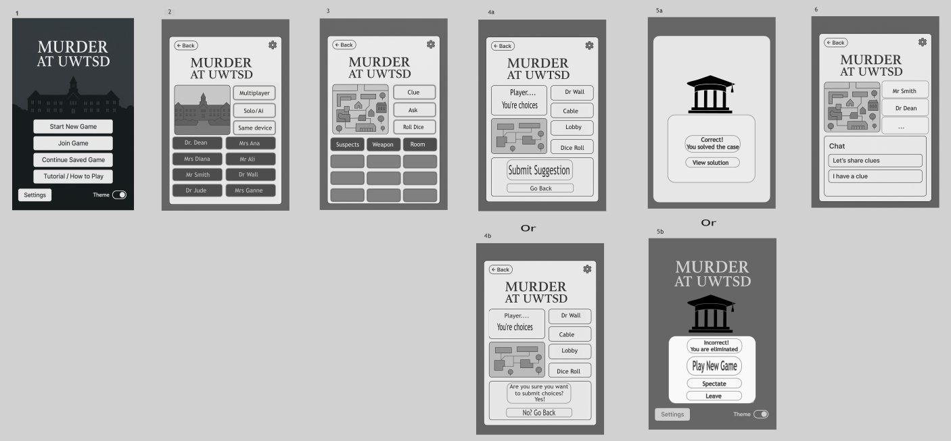
Figure 11 shows the Wireframe Storyboards

C.0 Wireframe Overview - Screen 1: Main Menu [fig 12]
The first wireframe, the Main Menu, establishes the UWTSD theme and addresses foundational UXRs. Its structure ensures rapid access to all game modes (Start/Join Game, UXR 3) and critically supports mobile efficiency via the prominent Continue Saved Game button, satisfying Session Persistence (UXR 5). The inclusion of a Tutorial feature minimises friction for new users, enhancing Intuitive Game Controls (UXR 7). This page, acting as an efficient launch point, directly influences the required Smooth Interaction Flow (UXR 6) by avoiding heavy graphical load at startup.

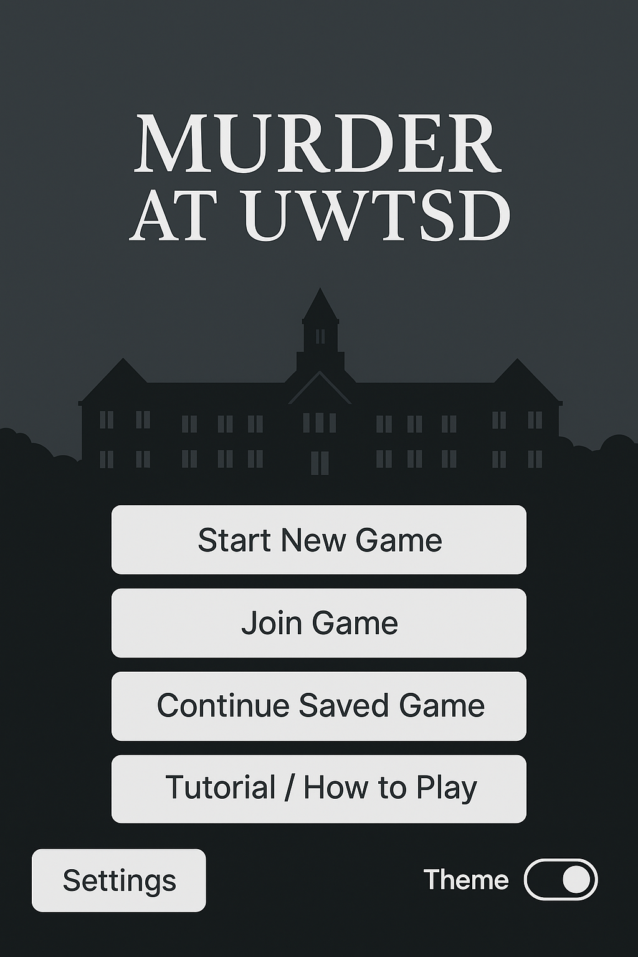
Figure 12 Main Menu Wireframe

C.1 Wireframe - Screen 2: Game Mode and Character Selection [fig 13]
This screen is the primary routing hub, fulfilling the Flexible Game Modes (UXR 3) requirement by clearly separating Solo/AI, Online Multiplayer, and Local Play options for user satisfaction (Liam Davies, Sarah Chen). The lower panel simultaneously functions as the Character Selection area (UXR 9), allowing the player to quickly personalise their experience before proceeding to setup. Its clean, sequential design is crucial for maximising the efficiency (UXR 6) and learnability (UXR 7) demanded by time-constrained users.
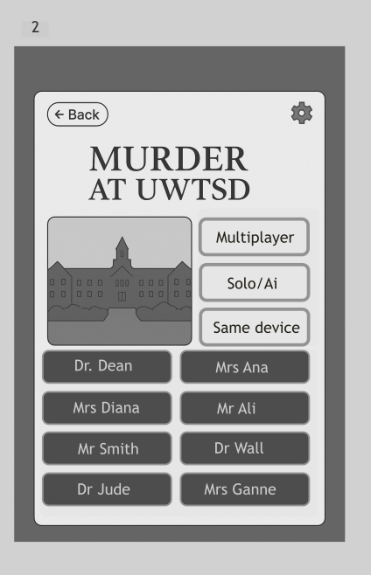
Figure 13 Game Mode and Character Select Wireframe

C.2 Wireframe Overview - Screen 3: Core Game Board View [fig 14]
This screen serves as the core interface for turn execution, built around the simplified UWTSD campus map (Classic Board View, UXR 10) to satisfy the familiarity needs of veteran players. Large, highly visible action buttons for 'Clue' (Notepad), 'Ask' (Suggestion/Accusation), and 'Roll Dice' prioritise Intuitive Game Controls (UXR 7) and maintain the required Smooth Interaction Flow (UXR 6). The lower panel, segmented by Suspect, Weapon, and Room, represents the entry point for the Dedicated Clue Tracking System (UXR 2). This clean layout is essential for mobile efficiency and minimises cognitive load during strategic decision-making.
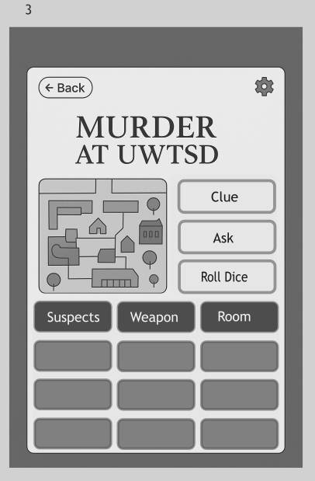
Figure 14 Core Game Board Wireframe

C.3 Wirefr Overview -Screen 4: Suggestion/Accusation Flow [fig15/16]
This screen details the critical Suggestion/Accusation flow, which rigorously enforces Accurate Rule Enforcement (UXR 1) by clearly displaying the selected combination (Suspect, Weapon, Room). The layout is designed to maximize Intuitive Game Controls (UXR 7), guiding the user through the logical choice process. The map fragment offers essential spatial context (UXR 10). Furthermore, the confirmation dialogue (4b) provides a final verification step and critical User Control and Freedom, allowing players to back out and correct errors before committing a binding move. This mitigates frustration for all personas.

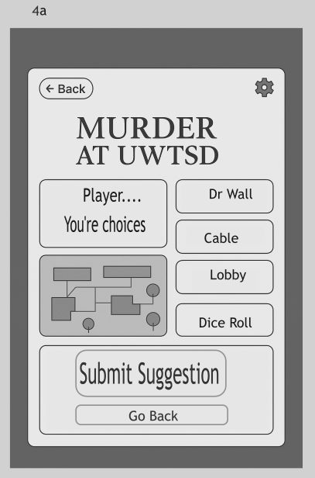
Figure 15 Suggestion/Accusation Wireframe

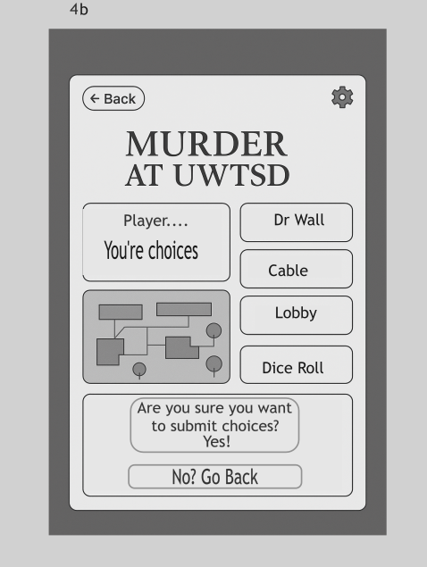
Figure 16 Suggestion/Accusation Confirmation Screen Wireframe

C.4 Wireframe Overview - Screen 5: Game Resolution/End [fig 17/18]
This mandatory screen pair (5a/5b) resolves the game state, providing unambiguous feedback essential for competitive trust and Accurate Rule Enforcement (UXR 1). The failure screen (5b) confirms elimination but crucially maintains Smooth Interaction Flow (UXR 6) and User Control by offering immediate options to 'Spectate' or 'Leave' the current game. This supports the efficiency needs of busy personas (Sarah Chen, Dr. Vance) who need to quickly resume their intermittent schedules without being penalised by the interface flow. The clear visual hierarchy ensures high visibility of the system status.

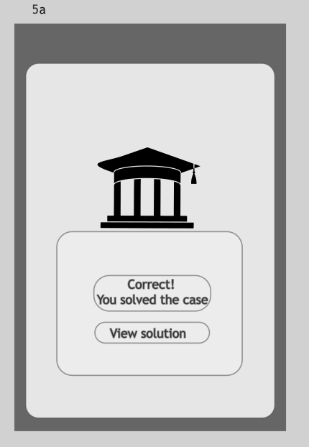
Figure 17 Game Resolution Wireframe 1

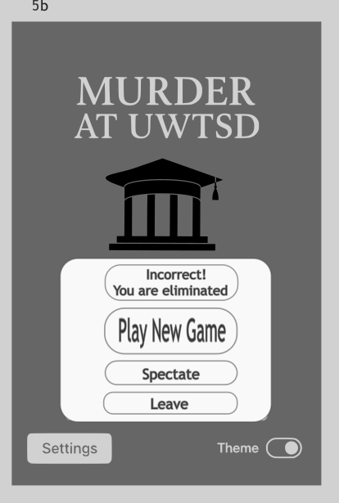
Figure 18 Game Resolution Wireframe 2

C.5 Wireframe Overview - Screen 6: Communication Flow [fig 19]
This screen is the interface for social interaction, directly implementing the Private Communication Channel (UXR 11), which is essential for enabling strategic social interaction and bluffing in multiplayer (Liam Davies). The design promotes Smooth Interaction Flow (UXR 6) and mobile efficiency by offering streamlined chat options, minimising the cognitive load associated with typing lengthy messages during turn-based play. This layout ensures easy player targeting while upholding the strategic depth required by competitive personas.

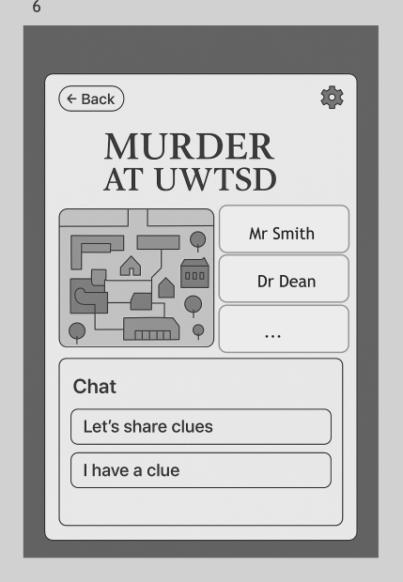
Figure 19 Chat Feature Wireframe

D. Feedback Collection Process on Storyboard

To validate the usability of the wireframe prototypes, a robust evaluation plan was designed, focusing on quantitative satisfaction scores and detailed qualitative feedback linked to the defined UXRs [see appendix 5 and 6].

D.1 Feedback Collection Process (Usability Validation)
The proposed validation method involves a moderated, remote usability testing protocol utilising two instruments: the standardised System Usability Scale (SUS) [4]and a Targeted Post-Scenario Questionnaire [4, 9]. Test subjects were pre-screened to ensure comprehensive coverage across the four defined personas (Liam, Sarah, Dr. Vance, Amina), mapping their demographics and preferences to task scenarios. We used the Think-Aloud Protocol to capture qualitative feedback, assessing user effectiveness and identifying errors during interaction.

D.2 Feedback Summary and Analysis
The analysis of the combined feedback yielded positive validation of the core design goals but highlighted areas for iteration.
Positive and Negative Feedback Summary
Positive feedback affirmed the centralised design strategy: the Digital Notepad (UXR 2) was highly successful in reducing cognitive load, and the Suggestion Flow (UXR 7) proved intuitive. However, key usability issues emerged: despite automatic saving (UXR 5), one user explicitly requested a visible "pause button," revealing a lapse in providing transparent User Control and Freedom for managing intermittent play [see appendix 6]. Furthermore, test scores showed inconsistent confidence in the security of the Private Communication Channel (UXR 11), and one user noted the flow "Felt awkward," indicating necessary refinement to the Smooth Interaction Flow (UXR 6) [see appendix 6].

D.3 Proposal for Potential Future Improvements and Expansions
Future work will focus on enhancing strategic and technical layouts. For Customisable AI Difficulty (UXR 4), we will implement sophisticated AI strategies based on probabilistic inference and multi-faceted deduction (e.g., tracking "not held" cards) to maintain a challenge for veteran players. For Smooth Interaction Flow (UXR 6), the performance evaluation metric will be shifted from simple FPS to the Fusion FPS standard (IEEE 2861M-2021) to rigorously measure and optimise the application's fluency, addressing the lag and "frame drop" friction noted during testing [5].

References

[1] D. M. Hansen and K. D. Hansen. D. M. Hansen and K. D. Hansen. Clues about bluffing in clue: Is conventional wisdom wise? IEEE Transactions on Games IEEE Transactions on Games 1313(3), pp. 310–314. pp. 310–314. 2021. . DOI: 10.1109/TG.2019.2957353.
[2] Z. Feng. Z. Feng. Heuristics for board game usability testing. Presented at 2023 IEEE Conference on Games (CoG). 2023, . DOI: 10.1109/CoG57401.2023.10333187.
[3] R. S. Robson and N. Sabahat. R. S. Robson and N. Sabahat. Heuristic based approach for usability evaluation of mobile games. Presented at 2020 International Conference on Computing, Electronics & Communications Engineering (iCCECE). 2020, . DOI: 10.1109/iCCECE49321.2020.9231175.
[4] H. Ismail, M. E. Ayoubi, M. Qassem and F. A. Areefi. H. Ismail, M. E. Ayoubi, M. Qassem and F. A. Areefi. Assessing the impact of gamification tools' usability on student engagement: A comparative study in engineering education. Presented at 2024 4th Interdisciplinary Conference on Electrics and Computer (INTCEC). 2024, . DOI: 10.1109/INTCEC61833.2024.10603117.
[5] Anonymous IEEE Standard for mobile gaming performance evaluation and optimization. IEEE Std 2861-2021 pp. 1–31. pp. 1–31. 2021. . DOI: 10.1109/IEEESTD.2021.9626693.
[6] R. Sobrino-Duque, N. Martínez-Rojo, J. M. Carrillo-de-Gea, J. J. López-Jiménez, J. Nicolás and J. L. Fernández-Alemán. R. Sobrino-Duque, N. Martínez-Rojo, J. M. Carrillo-de-Gea, J. J. López-Jiménez, J. Nicolás and J. L. Fernández-Alemán. Evaluating a gamification proposal for learning usability heuristics: Heureka. International Journal of Human-Computer Studies International Journal of Human-Computer Studies 161161pp. 102774. pp. 102774. 2022. .
[7] A. Nugroho, P. I. Santosa and R. Hartanto. A. Nugroho, P. I. Santosa and R. Hartanto. Usability evaluation methods of mobile applications: A systematic literature review. Presented at 2022 International Symposium on Information Technology and Digital Innovation (ISITDI). 2022, . DOI: 10.1109/ISITDI55734.2022.9944401.
[8] M. L. Arifianto and I. F. Izzudin. M. L. Arifianto and I. F. Izzudin. From gaming to learning: Assessing the gamification of discord in the realm of education. Presented at 2021 7th International Conference on Education and Technology (ICET). 2021, . DOI: 10.1109/ICET53279.2021.9575079.
[9] L. Grindei, A. Ciupe, B. Orza and S. Meza. L. Grindei, A. Ciupe, B. Orza and S. Meza. Students’ perception on integrating collaborative tools into electrical engineering education. Presented at 2021 9th International Conference on Modern Power Systems (MPS). 2021, . DOI: 10.1109/MPS52805.2021.9492599.

Appendices

Appendix 1
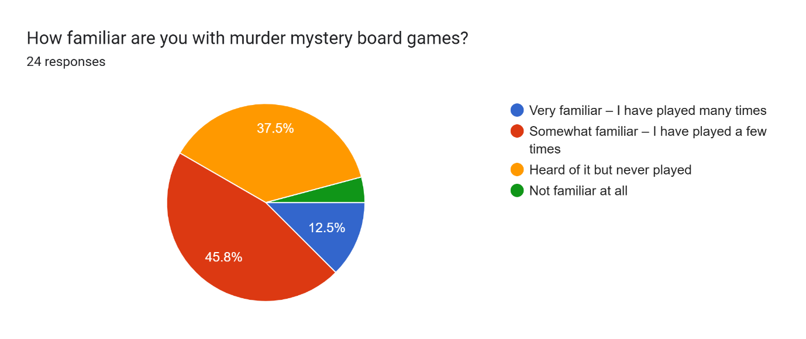
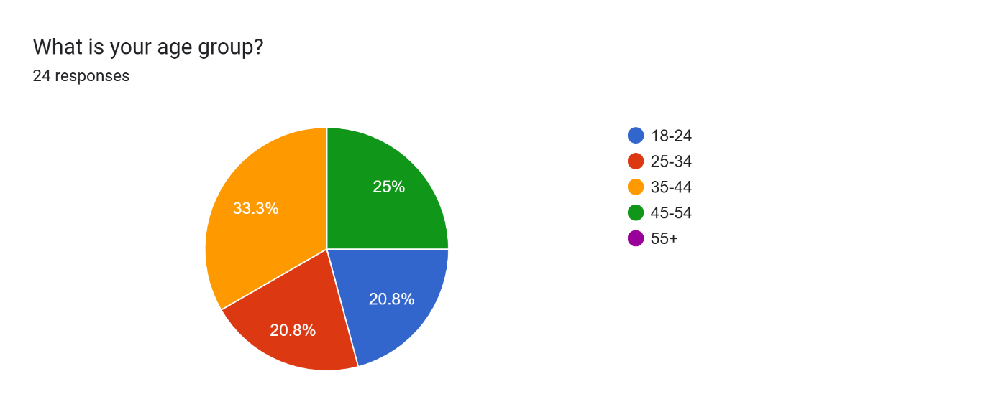
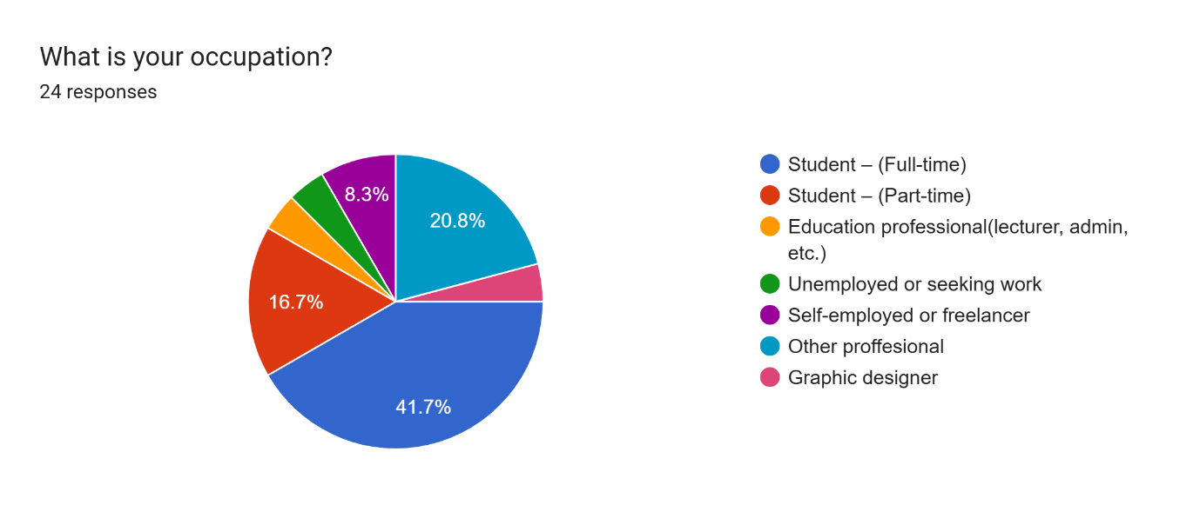
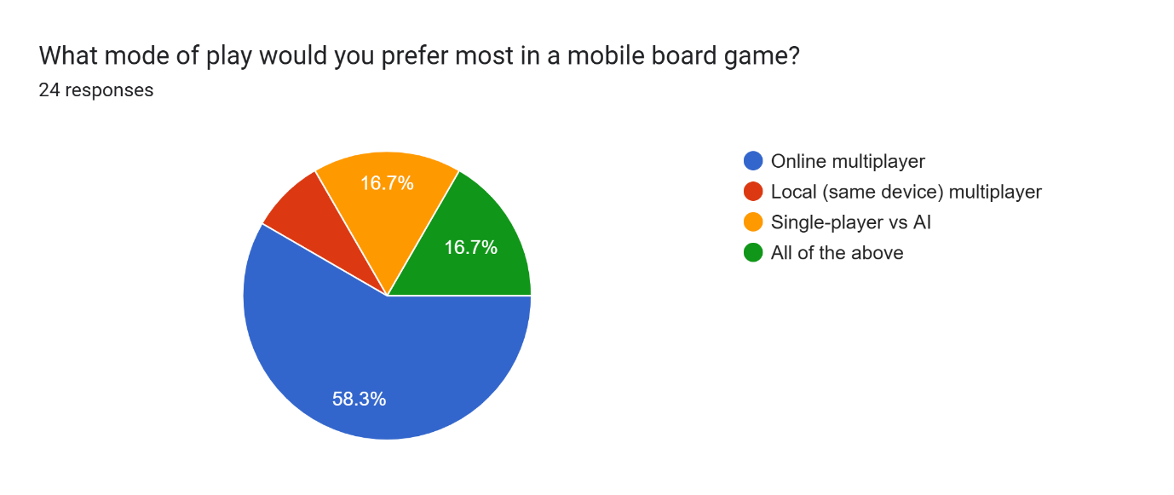
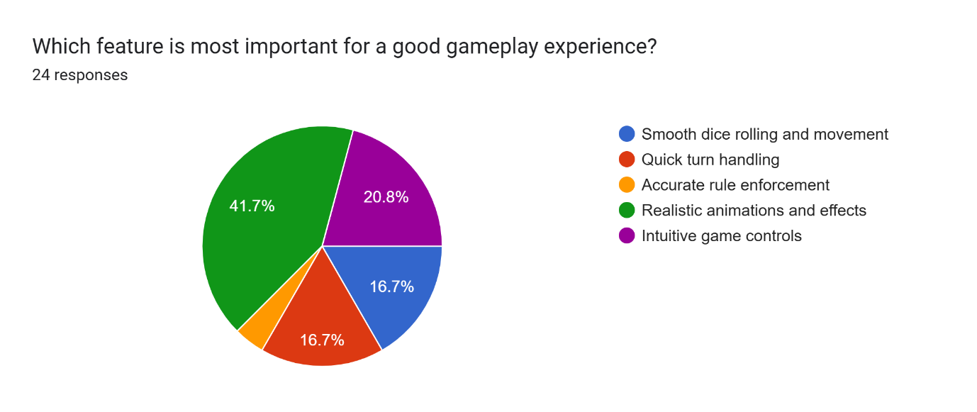
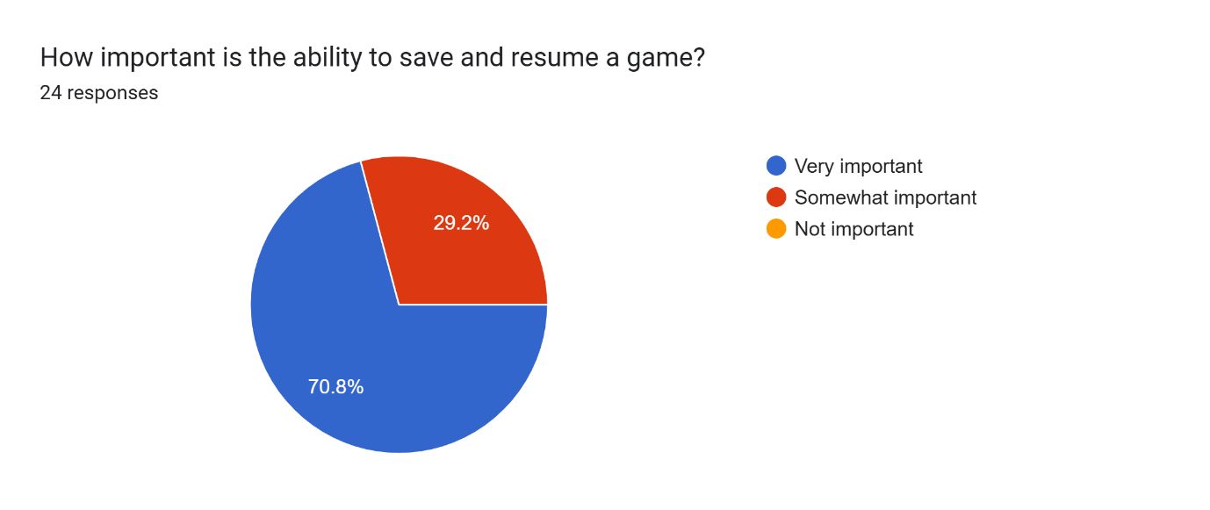
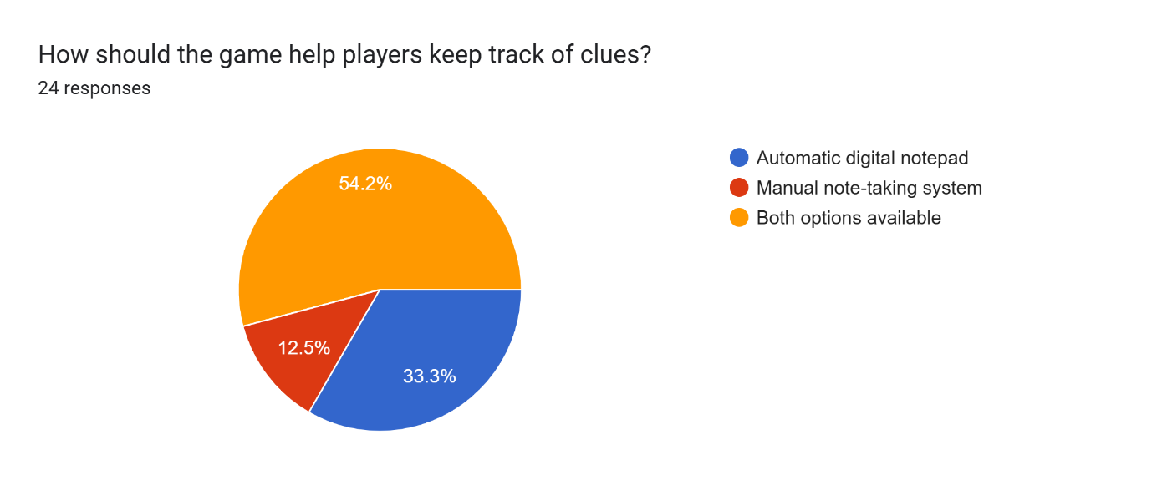
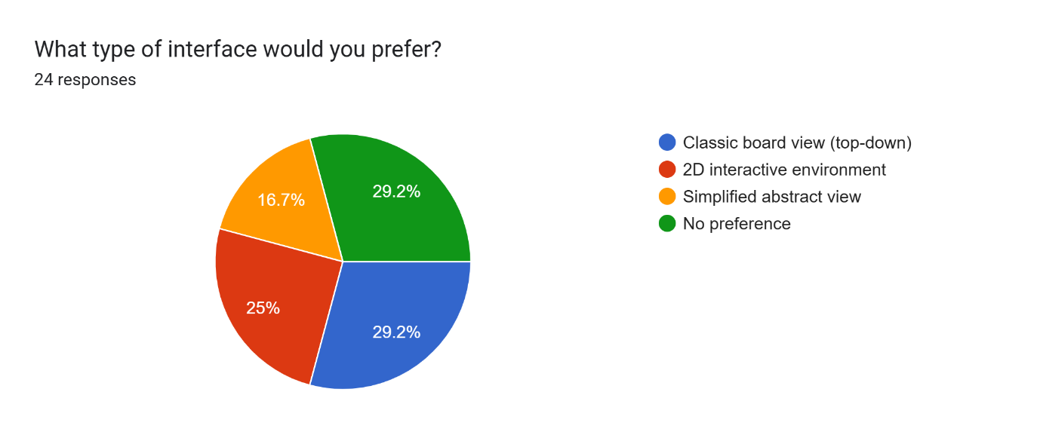
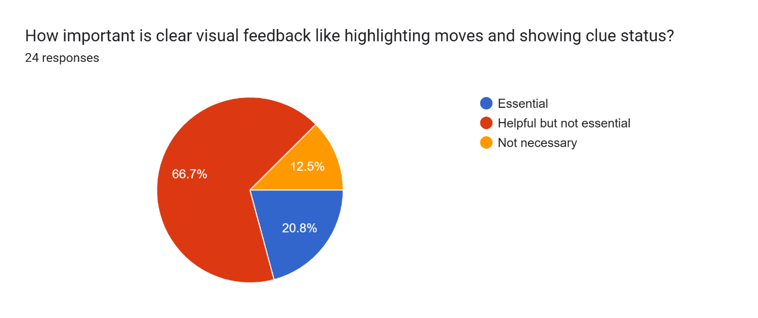
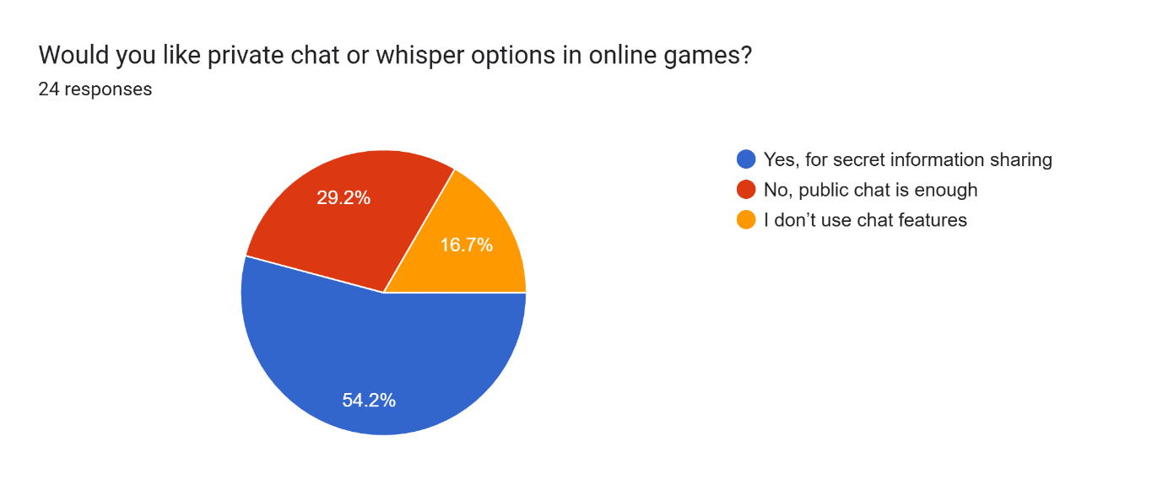
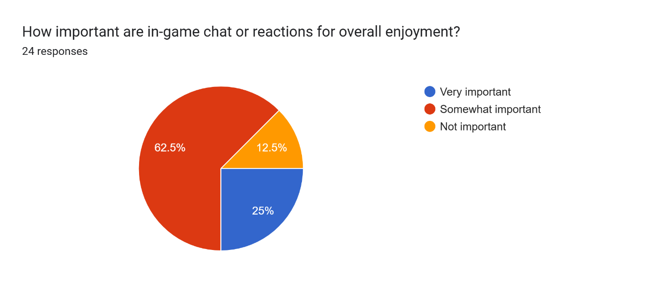
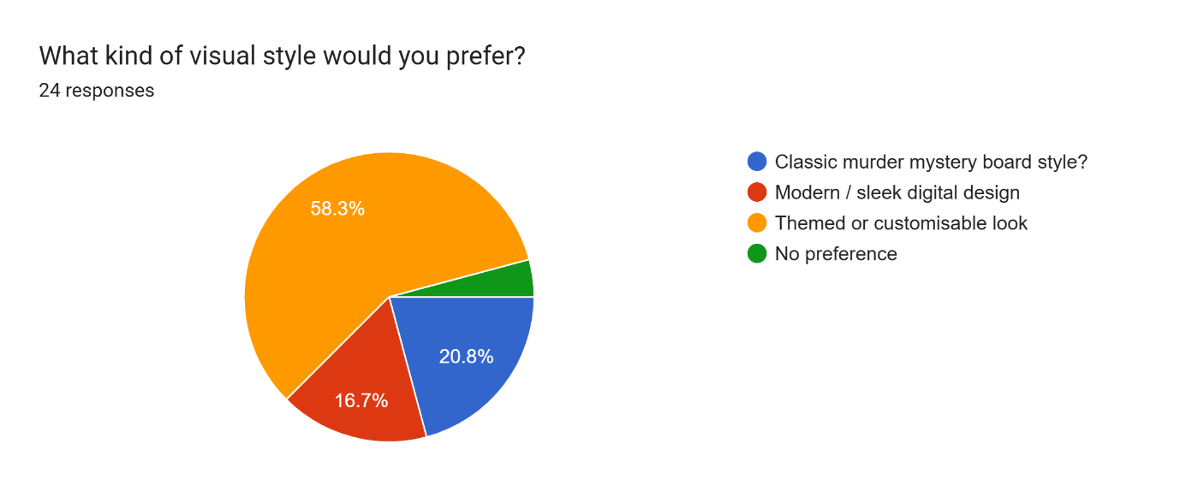
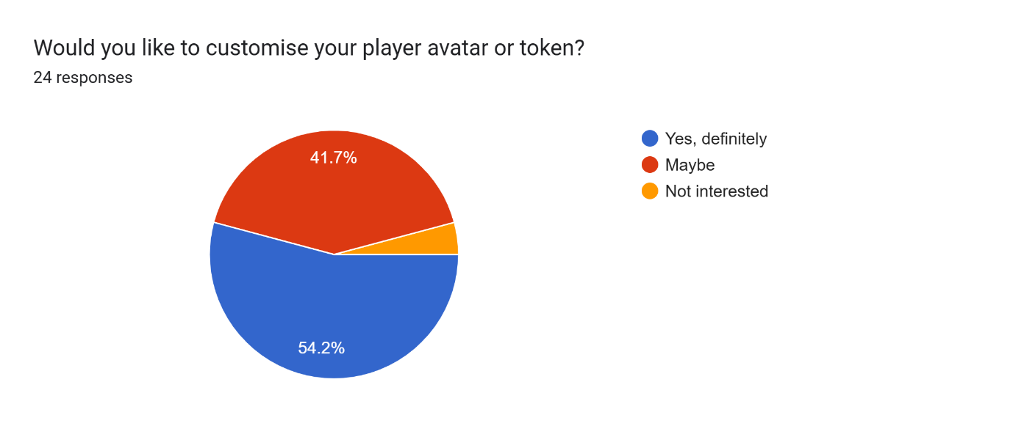
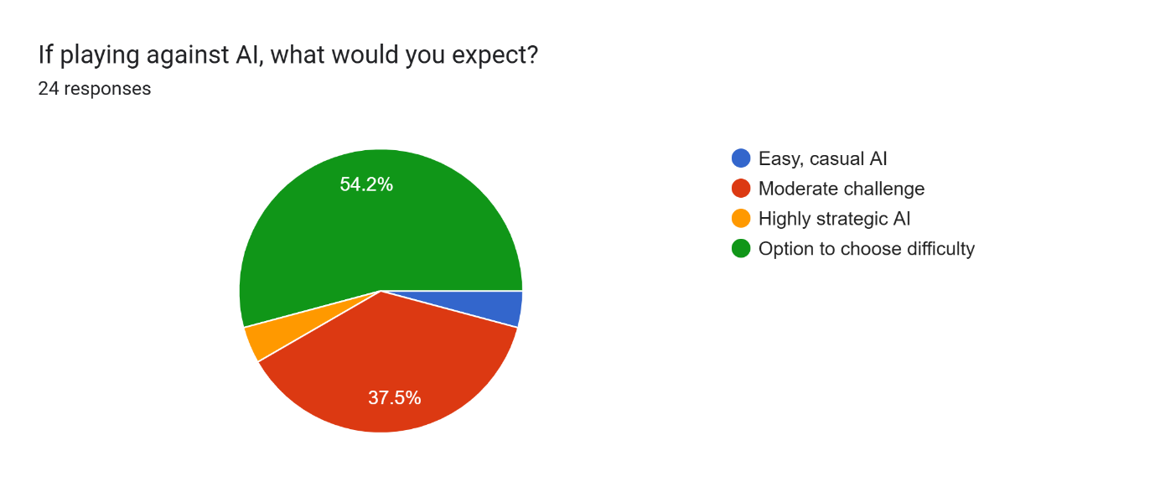
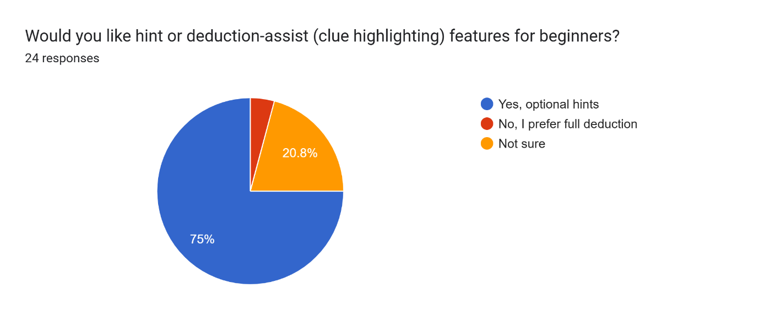
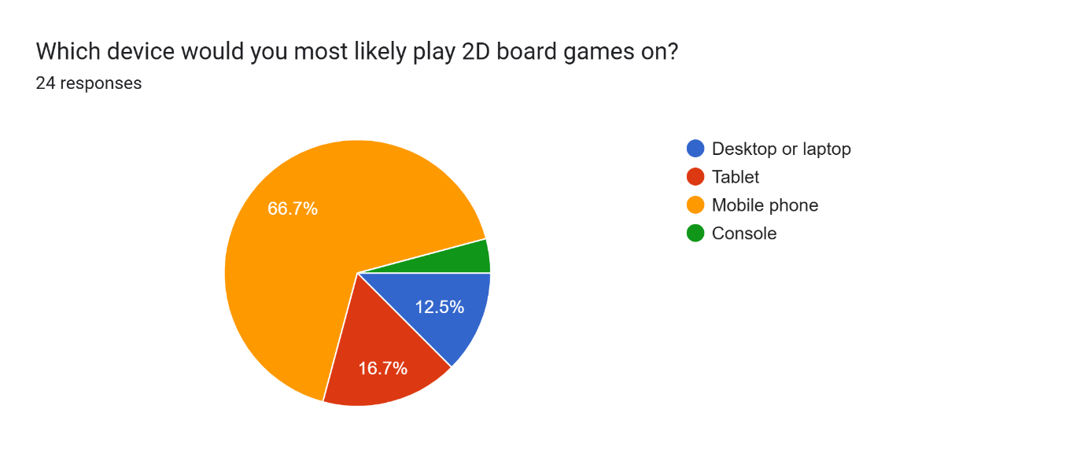
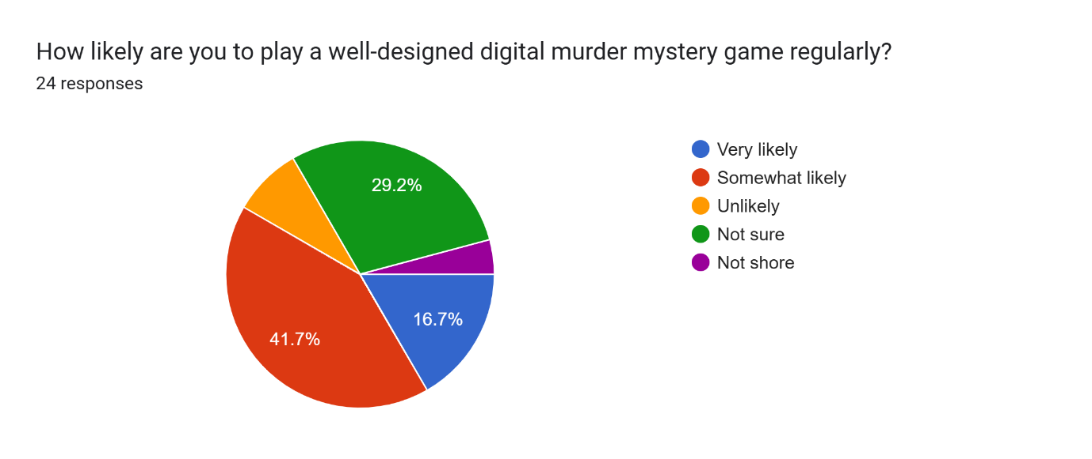

Appendix 2

Category | UXR | Derived From Persona / Source Data
Core Gameplay | Accurate Rule Enforcement: The game must strictly enforce the rules of deduction, ensuring competitive fairness. | Sarah Chen (Part-time Student), who prioritized "Accurate rule enforcement".
Core Gameplay | Dedicated Clue Tracking System: The system must incorporate a digital notepad for reliable tracking of clues. | Sarah Chen (Part-time Student), Dr. Vance (Education Professional).
Core Gameplay | Flexible Game Modes: The user must be able to select from multiple modes: Single-player vs AI, Local multiplayer, and Online multiplayer. | Liam Davies (Full-time Student), Dr. Vance (Education Professional).
Core Gameplay | Customizable AI Difficulty: The player must be able to choose the AI's difficulty level (e.g., moderate, strategic). | Liam Davies, Sarah Chen, Dr. Vance, Amina Khan (All selected AI challenge options).
Technical/Efficiency | Session Persistence (Save/Resume): The ability to easily save and resume progress is required for intermittent play. | Sarah Chen (Part-time Student), noting it is "Very important".
Technical/Efficiency | Smooth Interaction Flow: Movement, dice rolls, and turn sequences must be highly smooth, responsive, and efficient. | Dr. Vance (Education Professional), prioritizing "Smooth dice rolling and movement".
Interface/Aesthetics | Intuitive Game Controls: Must be simple and easily recognizable to minimize cognitive load and learning time. | Amina Khan (Self-employed), valuing "Intuitive game controls".
Interface/Aesthetics | Visual Immersiveness The game should feature realistic animations, effects, and a customizable visual theme. | Liam Davies (Full-time Student), prioritizing "Realistic animations and effects".
Interface/Aesthetics | Player Customization The ability to customize the player avatar/token must be included. | Liam Davies (Full-time Student).
Interface/Aesthetics | Interface View Preference The system should offer options for both the "Classic board view" and a "Simplified abstract view." | Liam Davies, Dr. Vance, Sarah Chen (Reflecting varied preferences).
Social/Communication | Private Communication Channel The game must include a private chat or whisper function for confidential strategic communication in online games. | Liam Davies, Sarah Chen (Stating "Yes, for secret information sharing").
Support/Learning | Optional Learning Aids Optional hint or deduction-assist features should be available for new players. | Dr. Vance (Education Professional).

Appendix 3
The above list translates in the below one
Priority | UXR | Description | Rationale (Usability Principle)
Must Have (M) | UXR 1 | Accurate Rule Enforcement | Mandatory for effectiveness; the core deduction logic must be flawless for the game to function as intended.
Must Have (M) | UXR 2 | Dedicated Clue Tracking System | Essential for mitigating cognitive load and ensuring the user can perform necessary deduction steps.
Must Have (M) | UXR 5 | Session Persistence (Save/Resume) | Mandatory for mobile efficiency, accommodating the time constraints of part-time and professional users.
Must Have (M) | UXR 6 | Smooth Interaction Flow | Mandatory for perceived efficiency and satisfaction, ensuring animations (like dice rolls/movement) do not lag.
Must Have (M) | UXR 7 | Intuitive Game Controls | Mandatory for learnability and efficiency (low barrier to entry), minimizing frustration during game actions.
Should Have (S) | UXR 3 | Flexible Game Modes (All of the above) | Highly recommended to satisfy all user types and maximize appeal (Single-player, Local, Online).
Should Have (S) | UXR 4 | Customisable AI Difficulty | Important for satisfaction and engagement, ensuring the game remains challenging for experienced players (like Dr. Vance) and manageable for novices.
Should Have (S) | UXR 10 | Interface View Preference (Classic vs. Simplified Abstract) | Important for diversity, addressing users preferring minimalist (Sarah Chen) versus classic (Liam/Dr. Vance) design aesthetics.
Should Have (S) | UXR 11 | Private Communication Channel (Chat/Whisper) | Crucial for supporting sophisticated social interaction and strategic bluffing necessary in multiplayer Cluedo-type games.
Could Have (C) | UXR 8 | Visual Immersiveness (Realistic animations) | Desirable for aesthetics and maximizing engagement (Liam Davies) but not required for core functionality.
Could Have (C) | UXR 9 | Player Customisation (Avatar/Token) | A desirable feature for personalisation, but non-essential for game mechanics.
Could Have (C) | UXR 12 | Optional Learning Aids (Hints/Deduction-assist) | Helpful for novice players but secondary to the automated clue tracking system (UXR 2).
Won't Have (W) | None |  | All elicited requirements are deemed necessary (M, S) or beneficial (C) for the defined scope of the initial digital release.

Appendix 4

Appendix 5
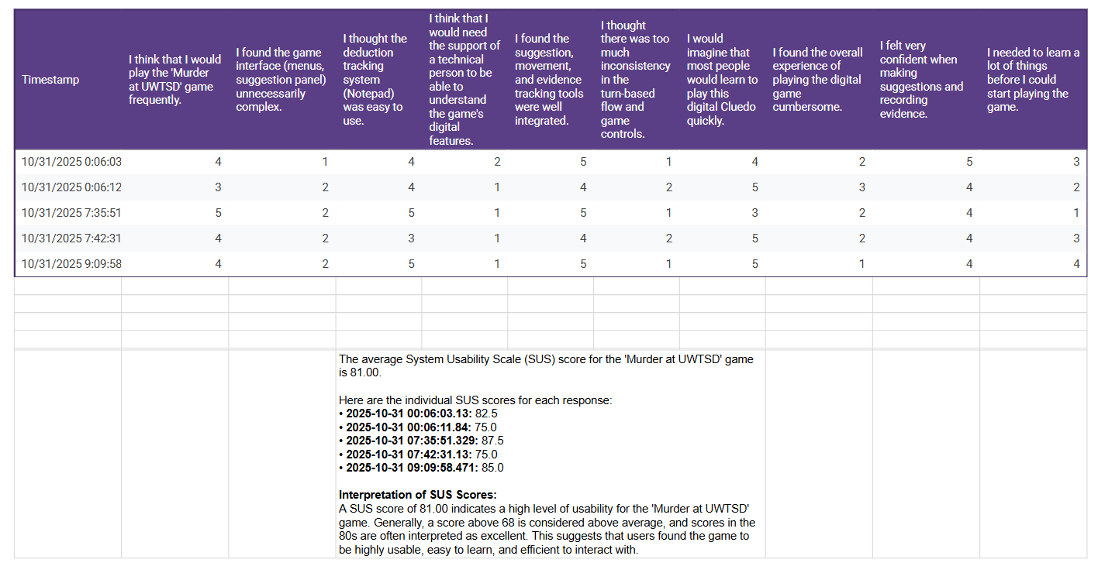

Appendix 6



