
Skills for the Workplace
Module Assignment Submission
Student Name: | Daniela Ventrice
Student Number: | 1910840
Module No: | BMSK5001
Module Title: | Developing workplace critical thinking

Statement of Confirmation of Authenticity
By the act of making this submission, the student declares that this is the work of the student named above. The work has not, in whole or in part, been knowingly presented elsewhere for assessment, or where assessment has been built on a previous assessment, this has been identified. Where materials have been used from other sources it has been properly acknowledged. If this statement is untrue, the student acknowledges that an assessment offence has been committed.
Attention is drawn to the plagiarism and unfair practice policies of both the University and of ILM.
Permission for ILM to use this script
ILM uses learners’ submissions – on an anonymous basis – for assessment standardisation. By submitting, both the centre and the learner agree that ILM may use this script on condition that identifying information is removed. However, if you are unwilling to allow ILM use this script, please refuse by ticking the box: □

Table of Contents
An analysis of impacts and influences on beliefs, values and attitudes within a factory working environment 3
Beliefs, Values and attitudes 5
Beliefs pyramid diagram 7
Relevant management theories 10
The scientific theory by Fredrick Winslow Taylor (1911) 10
Elton Mayo – Human relations Theory (1933) 12
Line balancing 13
Concluding Evidence 14
Appendix 1 – Pearson’s RED Model 15
Appendix 2 - Pettinger’s assumptions – mind map 16
Bibliography 17
References 18

An analysis of impacts and influences on beliefs, values and attitudes within a factory working environment

This report has been written to help develop critical thinking. To promote awareness of critical thought by identifying different management theories relating to a factory working environment,
This report also discusses the beliefs, values, and attitudes of individuals and the diversity amongst employees that work and operate on a production /assembly line.

Throughout the report elaboration will be brought on the following things:
- Beliefs, values and attitudes in individuals.
- Influences that impact on beliefs values and attitudes in a factory working environment.
- Management theories that hold relevance to a factory working environment.
- The influences that can impact on individuals and their beliefs values and attitude within a factory working environment.

Different methods were applied and used by creating different mind maps and concept charts. This helped to analyse the information to make sure all sources were up to date and relevant, as well as accurate and authoritative to serve its purpose of being included in this document. The Pearson’s RED (See appendix 1) was another method applied to critically assess information strategically in three stages. Pearson refers to this as the three keys to successful critical thinking. The three keys are:
- Recognising the message, the information is bringing forward and what is it saying.
- Which source did it come from and how up to date the information is?
- Evaluate all findings with reason to gain a clear understanding that is logical and makes sense.
All diagrams have been devised by the writer of the report unless stated otherwise. Sources that support this report can be found at the end in references and the bibliography section.

Beliefs, Values and attitudes
Every individual is uniquely built from their belief and driven from what they value most.
Belief’s, values and attitudes are mental, moral, and ethical dispositions adopted by individuals Pettinger, (2010). An individual’s belief can also be described as their own view of truth, Ministry of business, (2021) something that appears true to everyone based off their own experience.
Beliefs are influences and overtime, these beliefs turn into something a person will value, morally, Pettinger, (2010). Beliefs can be influenced from birth through the influence of family, family traditions, religion, and up bringing. Some beliefs can be adapted over time and may alter the more an individual experiences as they progress through life.
It’s important to always know that Beliefs can alter, they can change, or they can stay the same. Ministry of business. (2021).
Not all beliefs are the same and there is not necessarily any wrong belief, because it is what an individual feels to be true. Turner, M, M, (2004), (beliefs, values, experience, and world views).
The way an individual views the world is based on experience and emotion. Futurelearn.com [undated]. Attitudes are built off emotion and reasoning within a person and is what the individual is then guided by. An individual’s belief and value will stimulate a process on a mental level to initiate action. must trigger a reaction to respond. Kumar, M. (2018).
The Attitude is the ‘response data’. How an individual interprets the experience is dependent on the emotion and is usually reflected through the persons behaviour. Iulian Ionescu, (2022).

According to Richard Pettinger’s in his book titled ‘Organisational Behaviour: Performance management in practice’, Pettinger, R. (2010), Beliefs Attitudes and values are organized and summarized in the following way:

- Feelings – Pettinger tells us that emotional aspects are always present in all work, for instance, working relationships with other people, the environment and work demands can alter how an individual feels and this can impact not just their work-related value but also impact the ability to perform as well as they usually would. The more communication that takes place between individuals, emotion will constantly change resulting in a change of behaviour and external attitude will be reflected externally Individual’s value how they feel. Feelings can alternate from positive to negative and there is no way to stop another’s view or belief, their choice and behaviour, because every individual as previously mentioned is driven by what they value and what they feel is important to them. you can’t control what people to do but the only thing you can do is control how you respond. emotional intelligence is key to be able to operate from an unbiased position but is not gained by hearing and seeing only the things that resonates with your own beliefs.

- Professional – How an individual feels within the work environment can also have effect, Things like capabilities and skillsets can influence belief alter value and change behaviour. For example, criticism on work standard would have an impact on an individual, likely to make them second guess themselves and if they are right for the job, they can lose belief in themselves, hold less value to their work role and motivation and enthusiasm will lesson. Recognition for good working effort will promote an individual to feel a sense of achievement, know they are capable and boost morale and motivation to want to turn up for work and work well. for work effort alone will promote a positive response. Work effort can be impacted if an individual feels under appreciated. because they tend to put in less effort in their job role. On a professional level everyone has the same belief that they turn up for work to receive a monthly wage.

- Social – Social beliefs are things like how an individual contributes to society, how they engage in group and social events, who and what they choose to engage in. Relationships with neighbours and peers and work colleagues.

- Personal – religion is more of a rooted belief, meaning the individual has been influenced since birth and raised within that culture. Political beliefs hold strong value to an individual, personal belief of how one should behave in and amongst society. with personal beliefs if criticised emotions, be negative and their behaviour will mirror that.

- Informational – The nature and quality of information can impact an individual and change their belief pattern. information can be positive or negative, it can be true or false. The way in which an individual’s receives information can also have effect. Considerations are needed of how information is delivered and the way in which it is delivered.

- Behavioural – Pettinger tells us individuals tend to act in a particular way in any given situation, the way in which an individual responds can be influenced by how an individual is approached. In my opinion emotional intelligence plays a big part here as to how a situation can end if approached in the wrong way.

Beliefs pyramid diagram

By using Pettinger’s summary to create a mind map (see appendix 2), helped establish a framework tom work from and identify the possible influences that impact on the beliefs and values of individuals when working on a production / assembly line or working in a factory environment.
The diagram below has been adapted from Maslow’s hierarchy of needs. (Maslow, A, (1943), holding relevance to the values and beliefs that have become apparent from the research conducted on beliefs and values on a production / assembly line working environment
This choice of diagram was devised and shows the levels of beliefs influences that alter behaviour and impact on attitude externally.

Diagram to show levels of beliefs and process that influences external behaviour

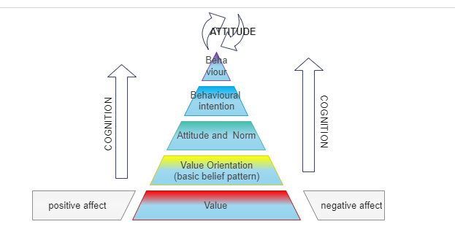

Diagram created using EDRAWMAX.COM, (EDRAWMAX,2022).

Feelings can fluctuate at any given moment whether it be a positive or a negative emotion, animosity with another employee can cause conflicts which can disrupt the momentum of others and impact on product performance. Employee work standard is likely to lessen if there is tension in the working environment.

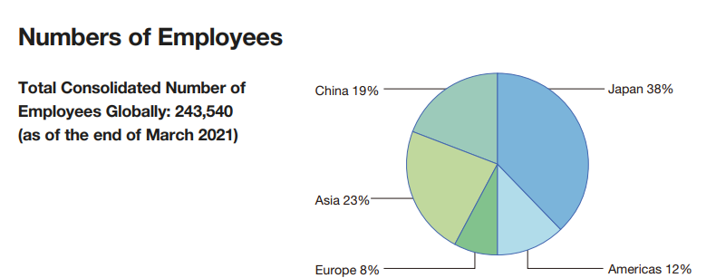
When working on an assembly / production line like Panasonic Inc,2022) different personalities will bring a whole range of value and beliefs to the workplace environment. The diagram below shows the global number of Panasonic employees as of March 2021. it has been included to briefly show the scale and the diversity in the culture differences alone,

Image taken from: Panasonic.com
Human Resources Development and Promotion of Diversity. (Panasonic). (2022).

Professionally, the beliefs and values Panasonic hold regarding the employees states in their policy that they wish to be a company and I quote “That creates an organization and culture where diverse people can fully utilize their talents irrespective of gender, age, or nationality. Thus, we regard the promotion of human resource development, diversity and inclusion as a crucial part of our business strategy”. (Panasonic Inc, (2022). Recognition goes toward the effort Panasonic put in, to create strategies to benefit without any discrimination. The assumption can be made that Panasonic are aiming for equality for all, because evidently, they want to make their employees the best they can be and the overall objective of the, working well and fully capable for the company. Once workers realise, they can achieve, do they then exceed when it comes to work effort. Elevating people and promoting them to do well helps to create work synergy because each employee utilizes to the best of their ability are happy in their surroundings and most importantly feel valued as an individual.

Relevant management theories

There are many management theories that are used regular in businesses worldwide Study Now. (2020).

The scientific theory by Fredrick Winslow Taylor (1911)
The first theory discussed is one that is most recognised and used throughout all modern manufacturing businesses is Fredrick Taylors scientific Theory Taylor, F. (1911). Taylors scientific approach Taylor, F, (1911) was purposely derived by himself to improve productivity and work efficiency especially when having to manage a large group of people or a large workforce.
Also known as Taylorism (K Enock 2006, C Beynon 2017) this scientific approach acted from four principles these principles are:
- Develop a science for each element of work
- Scientifically Select, Train, Teach, and Develop the worker
- Cooperate with the Worker
- Divide the Work and Responsibility
Ward. P, (2021).

The first approach Taylor took was to strategically separate job tasks, looking at each task individually and allocating time for each separate workstation needed. Taylor believed that each task should be completed as efficiently as possible , he believed workers should be assigned a particular job based on skill and expertise, and each worker should be monitored , evaluating the abilities on the quality and quantity of their work, Taylor did not believe workers were entitled to receive the same wage and, thought it was not cost effective, however Taylor did voice concern on the Importance of developing the workers so they are efficient at their work, production count would be greater to a more higher quality output. Lumen Learning (2022). Back in the industrial age this was probably enough to get workers to work to the best ability purely because of poverty and survival.
Taylor’s concept was methodically approached scientifically in order to determine and standardize the one best way of doing a job. Establishing A clear division of tasks and responsibilities and increased pay for high-performing employees. Objectively Taylor assumed that workers were motivated purely by money. Whwhen (2022).
Today in 2022, Taylor’s approach probably wouldn’t work as well or be as effective in the long run If wages were measured and individuals were paid according to their skillsets and capabilities, there would be disagreements and conflicts often.
As a factory worker we are all designated to a position on the assembly line, each employee is stationed at the production / assembly line designation to a small job role. Each role / task has an average completion time, this is to ensure production can meet and maintain in demands. As the product passes each station it is slowly built up until it reaches the last station and goes through to testing. This is very relevant to Taylor’s theory and makes sense that that would be the best possible way because there would be less mistakes because big jobs are made into more smaller jobs and with many people working together more products can be produced quicker.

Daily targets need to be met to stay on top of customer demand and delivered to the quality that is expected. With an approximate target of 800 – 1000 televisions being manufactured on 1 production assembly line alone it is vital that everything is accounted for , and segmented in a way where jobs are manageable to an individual that is designated to that role with all methods and strategies being thoroughly executed , with continuous monitoring in order for there to be no mistakes or faults The scientific theory plays a massive part in a factory environment and its production processes, which is why it is known to be the father of all scientific theories. Whwhen. (2022). Taylor’s approach is a could way to maintain good efficiency and effectiveness when referring to production but what happens if the employees aren’t happy?
If employees aren’t happy this can impact production performance on a whole – for instance they may take longer to complete the designated job task that they have been assigned to, they may lose concentration and make little mistakes but because the production line operates in a linear fashion, meaning the line is a one way process / flow, W. Grzechca (2016), the other employees stationed further along may be disrupted not able to complete their job because of the mistake at the previous station. This will create a negative effect and impact the production line also. Problems may arise if an employee is not trained on a particular station, they cannot perform the task another employee is responsible for, this can cause restriction and create problem areas that could’ve otherwise been avoided. Which is why Panasonic as a company want to train and get employees to hold various skillsets which gives the line more adaptability if faced with any issues as staff sickness and or shortages. Trained staff gives more flexibility when assigning job roles on the production / assembly line and there has been times where one employee has had to juggle two job tasks and two stations because of staff shortages.

Elton Mayo – Human relations Theory (1933)

Another theory relevant to a factory working environment is Elton mayo’s theory of human relations. this theory emphasises on the importance of employees and how to promote a good, motivated worker, this theory is also relative because Panasonic believe that developing human resources is essential because of the diverse staff employment, they also believe the company should be an organization diverse people can fully utilize their talents irrespective of gender, age, or nationality. All efforts are directed to the promotion of human resource development, diversity, and inclusion, to successfully provide a broad range of opportunities for anyone with ability and ambition, and actively strive to create an environment where work feels meaningful. Panasonic.com, (2022). Constantly adapting a creating new strategies in accordance with society and how they can attain a solid workforce. because without the people maintaining a successful company wouldn’t be possible.
Below are some of the key fundamentals of Elton mayo’s human relations theory:

- Humans are complex and different factors influence their behaviour
- Group dynamics (team relations) influence job performance and output
- Managers should understand that employees have unique needs, and one size doesn’t fit all; communication is essential...
- People aren’t solely motivated by compensation; finding meaning in their work is important as well.
Harappa Learning (2021).

Line balancing
Line balancing is a strategy process that helps keep balance and maintain good workflow. According to corning data.com (who are a professional enterprise that deal consultations and implantation services) there is a method referred to as line balancing.
Line balancing is and I quote “a flow-oriented production strategy for improving productivity and cost-efficiency in mass production processes”. Corning data international, (2021).
The benefits of the line balancing strategy are:

- Reduces the amount of idle time in workstations
- Facilitates a streamlined flow of the production process
- It helps to create the right number of workstations and the number of operations to have in each station.
- Achieves high employee morale and camaraderie by consolidating processes
- Improves the rate of production and the output quality of the produced items
- Maximizes workforce utilization and production capacity
- Reduces wastage

This strategy appears to hold similarities to both Taylors scientific theory, but also holds relevance to Elton mayo’s and you could assume was devised from both theories. Line balancing has continued to be used regular in order to create good consistent flow to production in terms of quality and quantity.

Concluding Evidence

After researching the management theories, I began to understand there are many theories relative to a factory working environment, but each address different elements in order to make the same source objective and that is effectiveness and efficiency. Panasonic have to put every effort into developing human resources because it’s the employees that make the whole company come together as a workforce, Taylor’s approach can only influence so much because Society is constantly changing as times do and everyday as individuals we adapt alter learn and grow, meaning we are uniquely driven by our unique individual purpose
For good synergy all employees need to be happy in order to come together and work well.
Knowing how to approach an individual in a way where a response is a positive one and addressed in the right way and in the right manner, with as less conflict and disruption as possible. know strengths and weaknesses to have the ability to see opportunities and threats help to manoeuvre through choices in work profession and personal life, one thing to expect when working with others is mistakes will happen and these mistakes are needed when learning any new skill. Human behaviour thrives off acceptance from others so when a particular view is shared, amongst friends for example it elevates emotion and makes people feel good. it also has the potential to then spark motivation. The person sharing will naturally want to share more when others hold the same views and values. (Athene's Theory of Everything: God is in the neurons, 2018).
The ability to adapt to changes within work environments, make independent choices, act on initiative are all necessary requirements and must be like second nature. If nothing changes, there is no progression. And no one gets it right straight off when venturing into something new.
By being aware of influences and effects, brings greater understanding and can help to decide which direction to take and how to approach situations with staff accordingly.
Good choices or bad choices. Awareness of self and surroundings. Concepts are schools of thought that stem from imagination and ideas in a person’s mind. ideas acquired through awareness to the experience or situation, though awareness and perception Theories are facts not yet proven, theories are “what appear to be “and are concepts that can only be discerned through first-hand experience as humans we cannot grow bigger brains but expand awareness of self and of others, be open to suggestions accept criticism and be ready for change by expanding awareness theories concepts will alter and theories will adapt. The response approach needs to be from an unbiased position and a certain level of emotional intelligence needs to be present
Making the wrong decision or saying the wrong thing due to poor judgement can lead to conflict growing and feelings of negativity. However, Einstein himself built his success on making mistakes which establish the obvious that mistakes are needed. Intellectual ventures, (2021) to learn and, strengthen skills, to grow in confidence and adaptability, awareness, and knowledge. But more importantly to feel in a safe comfortable environment that is built on trust that is built from un understanding and supporting one another.

“I have not failed. I’ve just found 10,000 ways that won’t work.”
Thomas, A, Eddison
(Fearless motivation, 2021).

Appendix 1 – Pearson’s RED Model

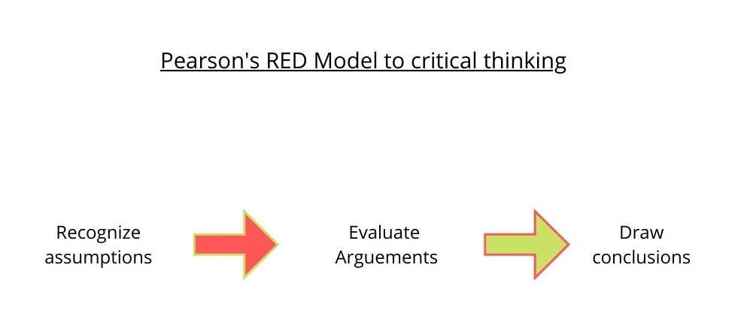

Pearson’s North America. (2015)
[Video link ](7) Pearson's RED Model of Critical Thinking - YouTube

Appendix 2 - Pettinger’s assumptions – mind map

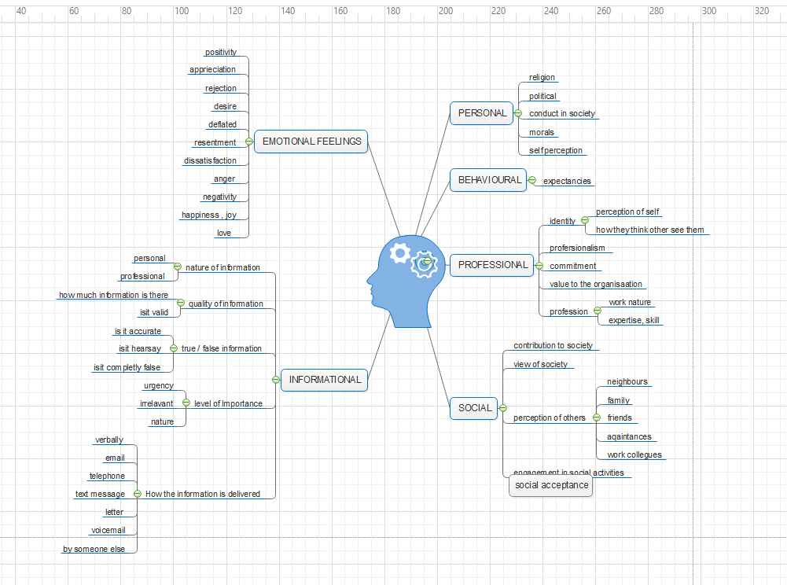
Mind map created from Pettinger’s assumptions (Pettinger,2010)

LGraph created using Edraw max. (Edraw max, 2022).

Bibliography

Pettinger (2010), book, title: Organisational Behaviour: Performance management in practice, Chapter 2, Author Richard Pettinger (2010), Accessed on 9th March 2022.

McCann, Leo. “From Management to Leadership.” The SAGE Sociology of Work and Employment, edited by S Edgell, E Granter, and H Gottfried, SAGE, 2015., Accessed 27th March 2022.

W. Grzechca (2016), Manufacturing in Flow Shop and Assembly Line Structure International Journal of Materials, Mechanics and Manufacturing, Vol. 4, No. 1, February 2016, Accessed 27TH March 2022.

H. Onur Bodur, David Brinberg, and Eloïse Coupey ( 2000) , Source Link : JCP0901.VP (communicationcache.com) , Title : Belief, Affect, and Attitude: Alternative Models of the Determinants of Attitude , Authors : H. Onur Bodur, David Brinberg, and Eloïse Coupey , JOURNAL OF CONSUMER PSYCHOLOGY, 9(1), 17–2 , 2000 ,Accessed 14th March 2022.

References

Lumen Learning(2022), URL : Different Management Theories | Organizational Behaviour and Human Relations (lumenlearning.com) , Title : different management theories. Authored by: freedom learning group, [Undated ] .Accessed 27th March 2022.

Iulian Ionescu, (2022). URL : How Our Beliefs and Values Shape Our Behaviour: A Beginner's Guide (iulianionescu.com) , Title: How our beliefs shape our behaviour – a beginners guide .Updated 11th March 2022, Accessed 26th March 2022.

Ward),(2021) , URL : Frederick Taylor’s Principles of Scientific Management Theory | NanoGlobals , Title : Frederick Taylor’s Principles of Scientific Management Theory . Published October 3rd, 2021. Accessed 19th March 2022.

Corning data international, 2021). URL What is Production Line Balancing? - Corning Data .
Title: What is production line balancing, Undated ,2021. Accessed 17th March 2022.

Ministry of business , 2021) , Title : Personal beliefs, values, attitudes and behaviour , ministry of business innovation and employment, URL : Personal beliefs, values, attitudes and behaviour | IAA , Dated 2021 , Accessed 7th march 2022.

Whwhen. (2022), URL : Why Is Taylor The Father Of Scientific Management (askingthelot.com) , Title : Why is Taylor the father of scientific management, Published 8th February 2022 , Accessed 27th March 2022.

K Enock 2006, C Beynon (2017) , URL: Management models and theories associated with motivation, leadership and change management, and their application to practical situations and problems | Health Knowledge , Title : Management models and theories associated with motivation, leadership and change management, and their application to practical situations and problems , past , 2017 , Accessed : 10th March 2022.
Harappa Learning ,(2021) , URL : Elton Mayo’s Human Relations Theory - Harappa , Title : Elton Mayo’s Human Relations Theory For Management , Published 14th June 2021, Accessed 27th March 2022.

Cahyo, W N; Khaeruzzaman, W A; Hasibuan, F W) (2019) , Improving the performance of an assembly line to increase production capacity using value stream mapping: A study case - ProQuest.

Cherry , K .(2018) Kendra Cherry , Reviewed by Rachel Goldman, PhD, FTOS , Updated on February 17, 2021.

Kumar. M. (2018), Owlcation The Relationship Between Beliefs, Values, Attitudes and Behaviours, Website: https://owlcation.com/social-sciences/Teaching-and-Assessing-Attitudes Published : 23rd July 2018 , Accessed on 10th march 2022.

Cherry , K , 2021) , What Is Self-Concept and How Does It Form? (verywellmind.com) , Title: What Is Self-Concept? The Psychological Exploration of "Who Am I?”, Accessed on 10th March 2022.

iEduNote, 2021) Title: Difference between Values and Attitudes (Explained), Intellectual ventures, 2016) [Video Weblink - https://www.youtube.com/watch?v=GPStciKfZLQwebsite:, Accessed 16th March 2022.

Study now) (2020), Video Link: (96) Frederick Taylor: Theories, Principles & Contributions to Management - YouTube : platform source: YouTube, title: Frederick Taylor: Theories, Principles & Contributions to Management YouTube channel – study now, Published 12th august 2020. Accessed 15th March 2022.
Juneja, P. (2001-2015), Title: What is motivation? URL: https://www.managementstudyguide.com/what_is_motivation.htm , MSG Management Study Guide, written by: Prachi Juneja Reviewed by Management Study Guide Content Team, Accessed on 07 March 2022.

Turner, M, M) [Undated]. Values and Beliefs, Coaching today. PDF FILE, Mike Munro Turner
Tutorialspoint.com , 2021) , URL : Employee Motivation - Self-Motivation - Tutorials point , Article title : employee motivation - self motivation. Accessed 11th March 2022.

Kumar, M. (2018), Title: The Relationship Between Beliefs, Values, Attitudes and Behaviours, URL : The Relationship Between Beliefs, Values, Attitudes and Behaviours - Owlcation , Author Mohan Kumar , Published 23rd July 2018 , Accessed 11th march 2022.

Fearless motivation , 2021) , Title : Thomas Edison Quotes – Failure IS the Road to Success! , website: https://www.fearlessmotivation.com/2018/07/04/thomas-edison-quotes/ Fearless motivation, published: July 4th 2018, Accessed: 09th March 2022.

Panasonic.com (2022), URL: sdb2021e-employee.pdf (panasonic.com). Accessed: 11th March 2022.
Google Scholar, (2021), URL: www.googlescholar.co.uk, 2021, Accessed 07th March 2022.
Edraw max, (2022), Diagram template creator, URL: www.edrawmax.com , 2022, Accessed 26th March 2022.

Edison T [Undated] , URL : https://www.intellectualventures.com/buzz/insights/failing-for-success-thomas-edison, Failing for success , Thomas Edison , Published: 26th January 2016, Accessed: 19th March 2022.

