


Research, Analyse, and Investigate Cybersecurity Incidents and Perform Digital Forensics Assessment: Task 2
Daniel James
2218766@student.uwtsd.ac.uk

ACCA7031: Digital Forensics Analysis

Table of Contents
1.0 Evidence and Chain of Custody 3
1.1 Evidence Inventory 3
1.2 Chain of Custody 3
2.0 Methodology 4
2.1 Tools Used 4
2.2 Mobile and Communication Analysis 5
2.3 File and Artefact Analysis 5
3.0 Findings and Analysis 7
3.1 Communication and Timeline Analysis 7
3.2 File and Metadata Analysis 11
3.3 Deleted and Encrypted Artefacts 12
3.4 Suspect Role Assessment 12
4.0 Challenges and Limitations 13
5.0 Conclusion 13
6.0 Recommendations 14
7.0 Appendix 14
Appendix A – Timeline 14
Appendix B – Communication Artefacts 14
Appendix C – Metadata Artefacts 16

1.0 Evidence and Chain of Custody
The investigation focused on identifying evidence relating to the attempted theft and sale of Quantum Tech’s proprietary AI chip design patent (QT-AI-2025). The supplied evidence included forensic extractions of mobile devices linked to suspects, alongside a forensic image of a removable storage device.

1.1 Evidence Inventory
Table 1 provides an overview of the evidence examined, including the associated suspect, evidence type, acquisition format, and forensic tool used during analysis.
Table 1: Digital evidence inventory
ID | Evidence | Device | Suspect | Evidence Type | Analysis Tool
E01 | Huawei_POT-LX1 P Smart.ufd | Huawei Phone | Emma | Mobile Device | Cellebrite Physical Analyzer, FTK
E02 | Samsung GSM_SM-A137F Galaxy A13.ufd | Samsung Galaxy A13 | Joe | Mobile Device | Cellebrite Physical Analyzer, FTK
E03 | Detected Model_Note 14.ufd | Note 14 Phone | - | Mobile Device | Cellebrite Physical Analyzer, FTK
E04 | Detected Model_Nokia C2 2nd edition.ufd | Nokia Phone | - | Mobile Device | Cellebrite Physical Analyzer, FTK
E05 | EmmaFlashDrive.E01 | USB Flash Drive | Emma | Removable Storage Device | FTK, Autopsy, PhotoRec

1.2 Chain of Custody
The forensic images and device extractions were supplied as a part of a controlled forensic investigation scenario. As a result, the original seizure and acquisition of the evidence was conducted prior to the investigation. The supplied evidence included forensic extractions from multiple Android device and a forensic image of Emma’s USB flash drive.
All analysis was conducted within a controlled forensic environment using read-only forensic practices to preserve evidential integrity. Cellebrite Physical Analyzer, FTK, and Autopsy were used to examine the supplied evidence without modifying the original forensic images or extracted artefacts.
The supplied forensic images and mobile device extractions were verified within Cellebrite Physical Analyzer and FTK using the integrity information available within the forensic containers. As the original acquisition process was conducted prior to the investigation, the original acquisition hash values were not provided alongside the supplied evidence. As a result, independent verification against the original source devices could not be performed.

2.0 Methodology
The supplied forensic images and mobile device extractions were analysed using industry-standard forensic tools within a controlled forensic environment. Cellebrite Physical Analyzer was used for mobile device examination, including recovery of communication artefacts, application data, call logs, metadata, and timeline activity. FTK and Autopsy were used to analyse the USB forensic image, recover files, review metadata, and perform keyword searches.
Encrypted and deleted artefacts were identified during the analysis and examined using additional forensic utilities. Password recovery attempts against the encrypted “Open.docx” document were conducted using office2john.py and John the Ripper Jumbo within a Linux environment. File carving and deleted file recovery were performed using PhotoRec.
Recovered artefacts from WhatsApp, Facebook Messenger, Instagram, file metadata, and device timestamps were correlated across multiple evidence sources to reconstruct a timeline of events relating to the attempted disclosure of Quantum Tech’s intellectual property.

2.1 Tools Used
Table 2: Overview of the tools used.
Tool | Purpose
Cellebrite Physical Analyzer | Mobile device analysis and communication recovery
FTK | File analysis, indexing, and metadata examination
Autopsy | USB analysis and file recovery
John the Ripper Jumbo | Password recovery attempts against encrypted Office documents
PhotoRec | Deleted file carving and recovery
Linux Forensic Utilities | Hash extraction and supporting forensic analysis

2.2 Mobile and Communication Analysis
Mobile device extractions were examined using Cellebrite Physical Analyzer, as demonstrated in Figure 1, to identify communications, media files, metadata, call logs, and application artefacts associated with Emma, Joe, and Norman. WhatsApp, Facebook Messenger, and Instagram communications were reviewed to identify discussions relating to patent transfers, meetings, offshore payments, and file exchanges. Recovered timestamps, deleted messages, and location metadata were correlated across multiple devices to support timeline reconstruction and suspect profiling.

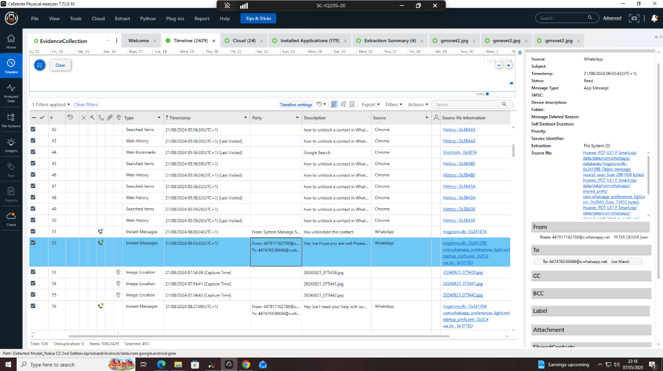
Figure 1: Cellebrite Physical Analyzer displaying recovered WhatsApp communication artefacts and associated timeline activity from the examined mobile device extraction.

2.3 File and Artefact Analysis
The forensic image of Emma’s USB flash drive was analysed using FTK and Autopsy to identify files associated with the QT-AI-2025 patent. File metadata, timestamps, and deleted artefacts were examined to identify evidence of file transfer or concealment activity.
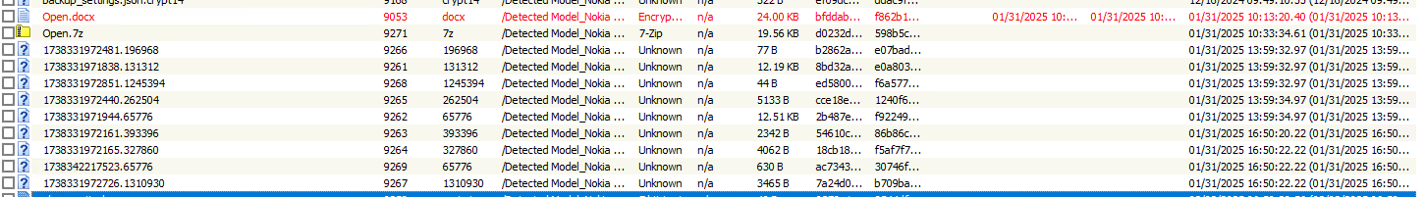
Figure 2: FTK displaying the encrypted file and associated archive recovered during forensic analysis of Nokia device.
As shown in Figure 2, an encrypted Microsoft Office document (“Open.docx”) and archived file (“Open.7z”) were identified during analysis. Figure 3 explains the password recovery attempts against the encrypted document using John the Ripper following Office hash extraction using office2john.py. Despite extended recovery attempts, the document remained encrypted.
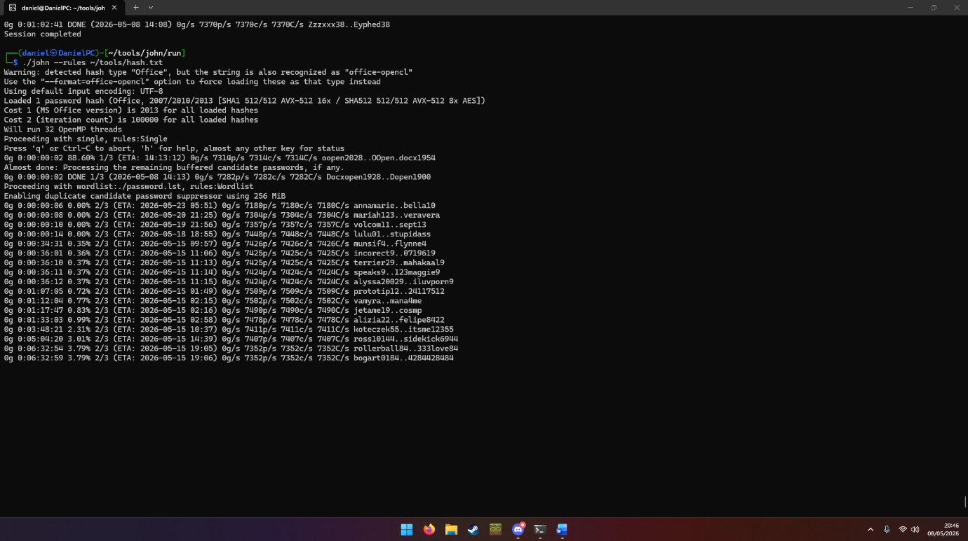
Figure 3: John the Ripper performing an extended password recovery attempt against the extracted Office document hash.

3.0 Findings and Analysis

3.1 Communication and Timeline Analysis
A timeline of significant artefacts was reconstructed using recovered WhatsApp, Instagram, and Facebook Messenger communications, alongside metadata extracted from media files and recovered documents. Correlation of timestamps, GPS metadata, and communication records identified sustained coordination between Emma, Joe, and Norman relating to the suspected disclosure and sale of Quantum Tech intellectual property. Table 3 summarises the key evidential events identified, the full timeline can be found in Appendix B.
Table 3: Summary of evidential events.
Date/Time | Source | Event | Evidential Significance | Supporting Evidence
21/08/2024 | WhatsApp | Emma discusses “sensitive” AI-related information with Joe | Initial coordination relating to confidential intellectual property | Appendix B1
22/08/2024 | WhatsApp / GPS Metadata | Joe shares a live location and later travels to Hannover | Supports meeting-related activity discussed in communications | Appendix B1 Appendix C1
29/08/2024 | WhatsApp / GPS Metadata | Joe references travel to Glasgow for meetings | Corroborated by embedded image GPS metadata | Appendix B1  Appendix C1
09/09/2024 | Instagram Direct Messages | Joe identifies a potentially interested buyer | Expansion of negotiations and intermediary activity | Appendix B2
20/11/2024 | WhatsApp | Emma requests updates regarding negotiations and offers | Ongoing coordination activity | Appendix B2
31/01/2025 | WhatsApp | Discussions relating to “demo samples” and “5M” offshore transfer | Financial motive and suspected transaction planning | Appendix B3
31/01/2025 | Facebook Messenger | Norman discusses staged release of “blueprint” material | Suspected buyer coordination | Appendix B4
31/01/2025 | File Metadata | “Open.docx” and “Open.7z” created | Possible preparation and packaging of confidential material | Appendix C2

Analysis of the recovered communications identified ongoing contact between Emma and Joe across multiple platforms between August 2024 and January 2025. Initial WhatsApp conversations dated 21/08/2024 identified Emma informing Joe that she possessed sensitive AI-related information and was considering selling the material to external parties. Joe responded positively and later discussed identifying potential buyers during client meetings, indicating early coordination activity relating to the suspected unauthorised disclosure of company intellectual property.
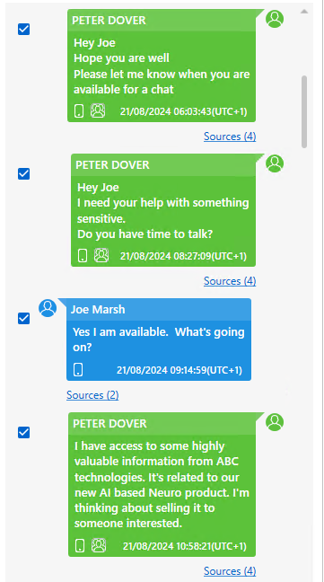
Figure 4: WhatsApp communication recovered showing discussions between Emma and Joe relating to AI-related information and potential buyers.
Subsequent communications recovered between August and November 2024 demonstrated continued negotiation activity and meeting coordination. Joe references travelling to Glasgow and Hannover to meet contacts relating to potential deals, while embedded GPS metadata recovered from images on the Samsung Galaxy A13 device corroborated the locations discussed within the communications. Although the recovered images themselves were not evidentially significant, the metadata supported the reconstructed communication timeline and movement of the suspects during relevant periods of activity.

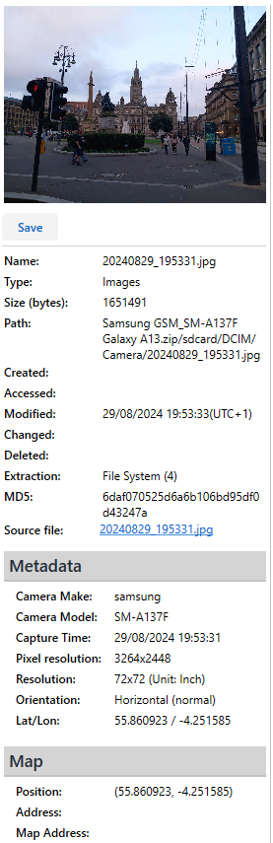
Figure 5: Embedded GPS metadata recovered from an image on the Samsung Galaxy A13 device identifying travel activity consistent with recovered communications.
Instagram direct messages recovered from the Huawei device further identified Joe requesting additional information regarding the quantity of confidential material Emma was willing to provide to potential buyers. The associated Instagram usernames also assisted in linking the recovered accounts to the identified suspects.
Communications recovered from 31/01/2025 indicated a significant escalation in activity. WhatsApp conversations references demonstration samples, offshore financial arrangement, and a “5M” transfer pending confirmation. Multiple recalled and deleted messages were also identified during this period potentially indicating attempts to conceal communication activity.
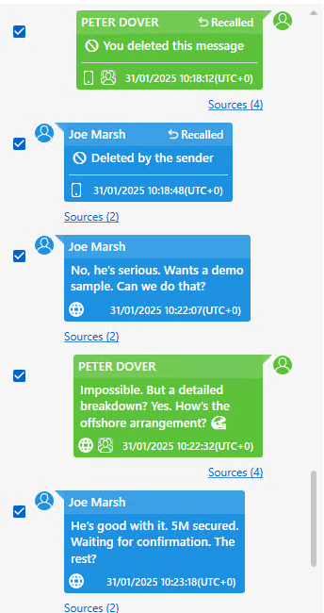
Figure 6: WhatsApp communication recovered from Huawei device referencing demonstration samples, offshore arrangements, and financial negotiations.
Facebook Messenger communications recovered between Emma and Norman further indicated active coordination relating to the transfer of confidential material referred to as a “blueprint”. Norman discussed dividing the material into staged releases for security purposes, while Emma insisted the agreement involved the delivery of the material in full. Emma later stated that the material would be transferred within 48 hours before stating “after that we are ghosts”, suggesting awareness of wrongdoing and intention to avoid future communication following completion of the transaction.
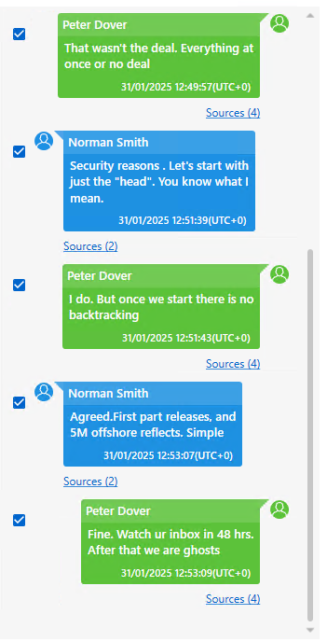
Figure 7: Facebook Messenger communication between Emma and Norman discussing the staged transfer and offshore arrangements.
Call log analysis was conducted across the examined devices to identify direct communication events between the suspects. However, no directly relevant calls linked to the identified investigation timeline were recovered from the extracted call records. Similarly, examination of Gmail application artefacts, cached mailbox data, and recovered email records did not identify evidentially relevant communications relating to QT-AI-2025.

3.2 File and Metadata Analysis
File analysis conducted using FTK, as shown previously in Figure 2, identified an encrypted Microsoft Office (“Open.docx”) and a compressed archive (“Open.7z”) recovered from the Nokia device. Metadata associated with both files identified creation timestamps of 31/01/2025, corresponding with the period of increased communication activity relating to demonstration samples, offshore arrangements, and financial negotiations.
The timing correlation between the recovered communications and file creation metadata suggests the files may have been prepared for transfer or concealment during the suspected transaction process. However, the contents of “Open.docx” could not be accessed due to encryption and password protection.
Additional GPS metadata recovered from image artefacts on the Samsung Galaxy A13 device identified locations in Glasgow and Hannover, supporting travel and meeting discussion recovered from WhatsApp communications. Analysis of Emma’s USB flash drive using FTK, Autopsy, and PhotoRec did not identify any directly relevant patent files or evidentially significant deleted artefacts.

3.3 Deleted and Encrypted Artefacts
Several deleted and encrypted artefacts were identified during analysis. Multiple recalled and deleted WhatsApp messages were recovered within conversations between Emma and Joe during periods of increased negotiation activity, potentially indicating attempts to conceal communication activity. Encrypted WhatsApp backup databases (“msgstore.db.crypt14”) were also recovered from multiple devices. However, the associated decryption keys were not recoverable from the supplied extractions, preventing further examination of the encrypted message databases.
Password recovery attempts were conducted against the encrypted “Open.docx” document using Office hash extraction and John the Ripper; however, the document remained encrypted and inaccessible. The recovery attempt is shown previously in Figure 3.

3.4 Suspect Role Assessment
The recovered evidence suggests Emma acted as the primary insider involved in the attempted disclosure of Quantum Tech intellectual property. Communications recovered from WhatsApp and Facebook Messenger identified Emma coordination negotiations, discussing offshore financial arrangements, and preparing materials referred to as a “blueprint”.
Joe appeared to act as an intermediary between Emma and external contacts by coordinating meetings, identifying potential buyers, and manging negotiations. GPS metadata recovered from the Samsung Galaxy A13 device supported travel activity discussed within the recovered communications.
Norman was identified as the suspected buyer involved in the negotiations relating to the transfer of confidential material. However, insufficient identifying artefacts were recovered to conclusively attribute a specific device directly to him.

4.0 Challenges and Limitations
Several limitations affected the extent of evidence recovery during the investigation. The forensic images and mobile device extractions were supplied prior to analysis, meaning the original acquisition process and source device hash values could not be independently verified.
Encrypted artefacts also limited the scope of the analysis. Although an encrypted Office document (“Open.docx”) and WhatsApp backup databases (“msgstore.db.crypt14”) were recovered, the contents could not be accessed due to unavailable decryption keys and unsuccessful password recovery attempts.
Additional limitations included the absence of evidentially relevant email communications and the inability to conclusively attribute a specific device directly to Norman due to the limited artefacts recovered from the supplied evidence. Despite these limitations, sufficient communication records, metadata, and file artefacts were recovered to support the findings presented within this report.

5.0 Conclusion
The forensic analysis identified sustained communication and coordination activity between Emma, Joe, and Norman relating to the suspected disclosure and sale of Quantum Tech’s intellectual property. Recovered WhatsApp, Instagram, and Facebook Messenger communications, alongside file metadata and GPS artefacts, supported the reconstructed timeline of events and identified discussions relating to buyers, offshore financial arrangements, and transfer of confidential material.
Although several encrypted artefacts could not be accessed, sufficient evidence was recovered to support the conclusion that Emma acted as the primary insider, Joe acted as the intermediary, and Norman acted as a suspected buyer involved in the attempted unauthorised disclosure and sale of proprietary company information.

6.0 Recommendations
Quantum Tech should review internal access controls, restrict removable storage device usage, and implement enhanced monitoring of employee access to sensitive intellectual property. Additional security awareness training relating to insider threats and data handling procedures is also recommended.
Law enforcement should consider further investigation into the offshore financial arrangements and any external parties involved in the attempted transactions. Further forensic examination of cloud backups, encrypted artefacts, and associated accounts may also assist in recovering additional evidence material relating to the suspected disclosure of QT-AI-2025.

7.0 Appendix

Appendix A – Timeline
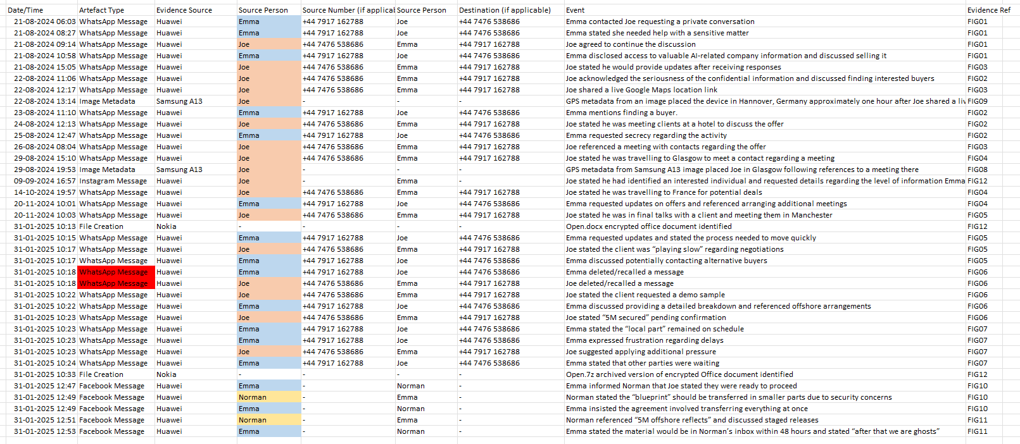

Appendix B – Communication Artefacts
Figure B1 – Initial WhatsApp discussion
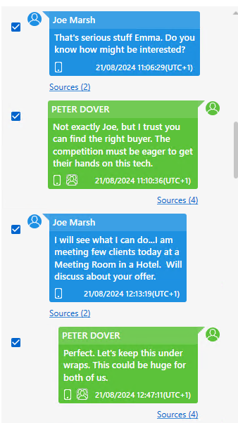

Figure B2 – Meeting coordination and live location sharing
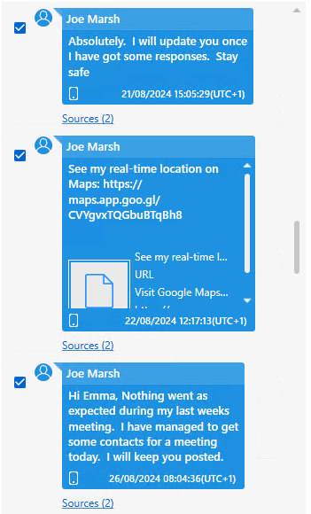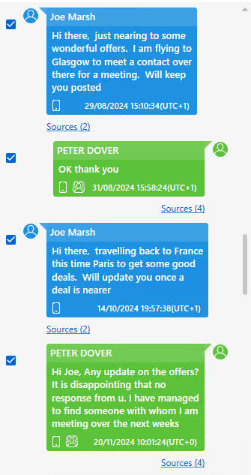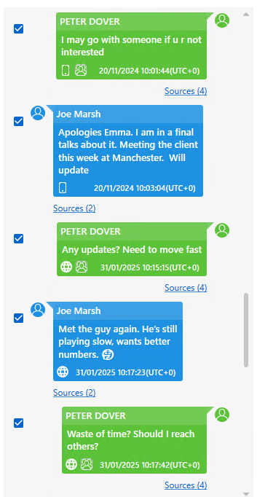

Figure B3 – Offshore negotiation and demo sample discussion
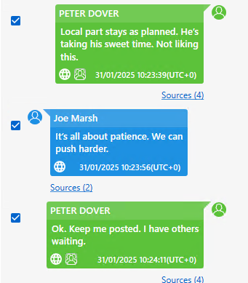
Figure B4 – Facebook Messenger discussion
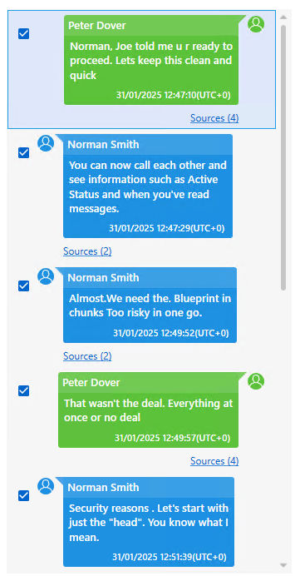
Figure B5 – Instagram communication artefacts
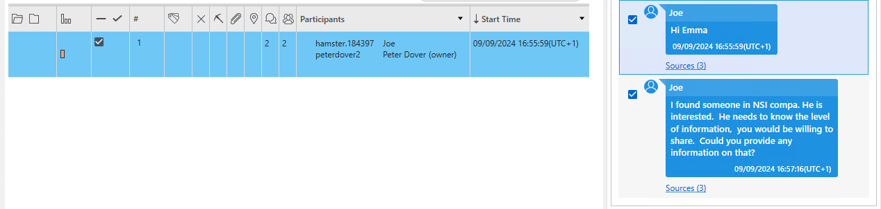

Appendix C – Metadata Artefacts
Figure C1 – GPS Metadata
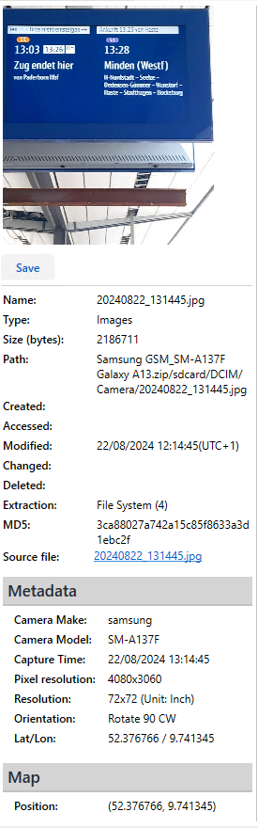

Figure C2 – Open.docx metadata

