Cover Page

E-Portfolio

Module
ECPS4018

Contents page

Summary (1.1) 3
Infographic (1.2) 5
Essay Plan (1.3) 6
Library Search Screenshots 10
Summary of Sources 12
Reference List 13

Task one (1.1)
Title of chosen journal article - The bear necessities of stress
Mark Wetherell (2022), Professor of Psychobiology at University of Northumbria, explains that after experiencing a shock, the brain initiates a stress response (‘fight, flight or freeze’), sending messages first via the sympathetic adrenal system, which secretes adrenaline and noradrenaline through the nervous system, then the hypothalamic pituitary adrenal pathway releases cortisol into the bloodstream.

Cortisol regulates the body’s internal systems such as the immunity and reproductive systems, to maintain health. Research shows that chronic stress causes cortisol levels to remain high, as demonstrated by caregivers' studies (e.g. Lovell et al., 2011; 2012; 2014), who reported high numbers of health concerns. Patients with illnesses such as chronic pain also have higher cortisol levels, and this is known to affect cancer mortality rates.

Wetherell and Sidgreaves created the multitasking framework (2005) which enabled everyday stressors to be produced and studied in laboratories. Participants performed multiple tasks on computers while simultaneously listening out for a particular tone (Wetherell & Carter, 2014). Later experiments included an examiner informing participants they were not performing good enough. Participants showed elevated heart rate and blood pressure (Wetherell et al., 2017).

Cortisol releases extra energy, enabling faster processing and acting reaction, when required, and a study of anxiety levels of both expert and novice skydivers before a skydive, based on cortisol levels from saliva samples. Results showed that anxiety levels and skydiving experience, had no impact on cortisol levels (Hare et al., 2013).

Cortisol also helps offset daily stress, (Elder et al., 2016) as confirmed in a sleep lab study. Cortisol levels were monitored, and findings demonstrated cortisol is released in the morning, with levels reducing throughout the day (Stalder et al., 2016). People anticipating a stressful day were found to have higher cortisol levels upon waking (Wetherell, et al., 2014). Where the stress anticipated i.e. skydiving, is cancelled the night before, cortisol levels were found to be normal upon waking (Wetherell et al., 2017).

Task two
Infographic:
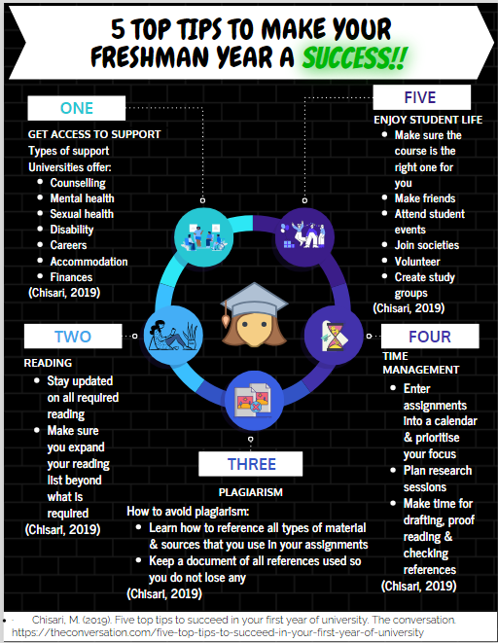

Task three: Essay Plan
- I started by highlighting the command words ‘Describe’ and ‘Discuss’ and familiarised myself with their definitions.
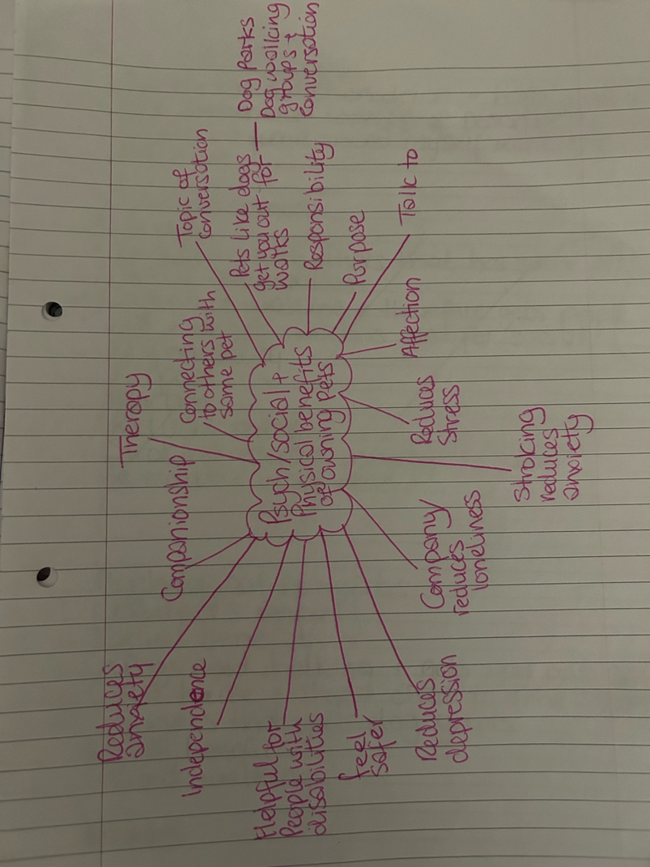
- brainstormed as seen below:

- I organised the results into three categories: Psychological, Social and Physical.
- I conducted a library search for journal articles, I read through them to see if there was any supportive or unsupportive information for the benefits of owning pets.
Title: Describe and discuss the psychological, social, and physical benefits of owing a pet.
Introduction: I will introduce the topic to the reader and say why I think it’s important, and how I’m going to do this.
Main body:
Supportive information on the psychological benefits of having pets based on the evidence found on reducing anxiety in inpatients, children and those with dementia. Also discuss the cons of owning pets such as cost, upkeep and responsibility stress.
Paragraph 1: Psychological benefits of owning pets

Supporting Literature:
- From Regulating Emotions to Less Lonely Screen Time: Parents' Qualitative Perspectives of the Benefits and Challenges of Adolescent Pet Companionship (Charmaraman, et al., 2022).
- Expectations for dog ownership: Perceived physical, mental and psychosocial health consequences among prospective adopters (Powell, et al., 2018).
- Compatibility between Humans and Their Dogs (González-Ramírez, 2019).
- Using Pet Therapy to Decrease Patients’ Anxiety on Two Diverse Inpatient Units (Mulvaney-Roth, et al., 2023).
- The perceived costs and benefits of pet ownership for homeless people in the UK: practical costs, psychological benefits and vulnerability (Howe, et al., 2018).
- Homelessness and Companion Animals: More than Just a Pet? (Slatter, et al., 2012).
- What Are the Benefits of Pet Ownership and Care Among People With Mild-to-Moderate Dementia? Findings From the IDEAL programme (Opdebeeck, et al., 2021).
- The effects of assistance dogs on psychosocial health and wellbeing: A systematic literature review (Rodriguez., 2020).

Paragraph 2: Social benefits of owning pets
Supporting Literature:
- Expectations for dog ownership: Perceived physical, mental and psychosocial health consequences among prospective adopters (Powell, et al., 2018).
- The effects of assistance dogs on psychosocial health and wellbeing: A systematic literature review (Rodriguez., 2020).
- The relationship between dog ownership, dog play, family dog walking, and pre-schooler social–emotional development: findings from the PLAYCE observational study (Wenden., 2021).
Paragraph 3: Physical benefits of owning pets

Supporting Literature:
- Expectations for dog ownership: Perceived physical, mental and psychosocial health consequences among prospective adopters (Powell, et al., 2018).
- The effects of assistance dogs on psychosocial health and wellbeing: A systematic literature review (Rodriguez., 2020).
Paragraph 4: Why owning pets could have a negative impact on psychological, social and physical well-being
Supporting Literature:
- Compatibility between Humans and Their Dogs (González-Ramírez, 2019).
- The perceived costs and benefits of pet ownership for homeless people in the UK: practical costs, psychological benefits and vulnerability (Howe, et al., 2018).
Conclusion: A summary of the main body and any recommendations for further reading

Library Search Screenshot (around 2 searches)
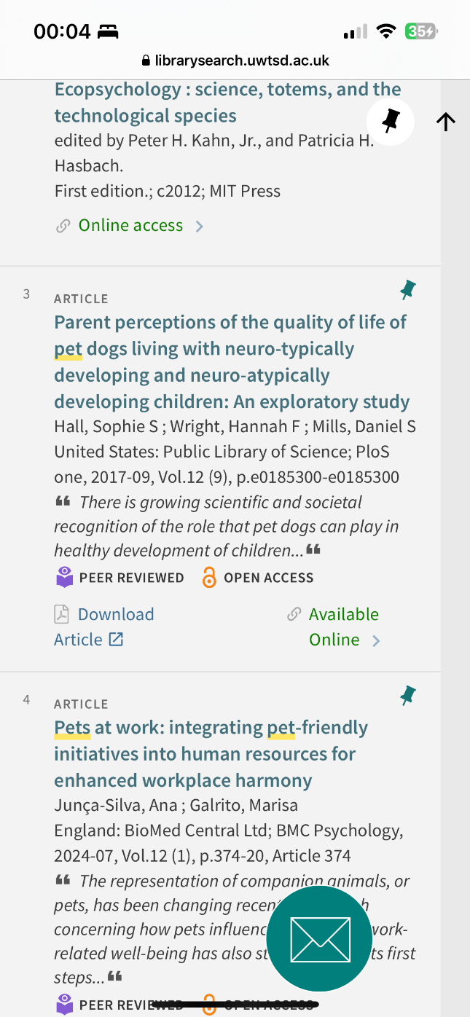
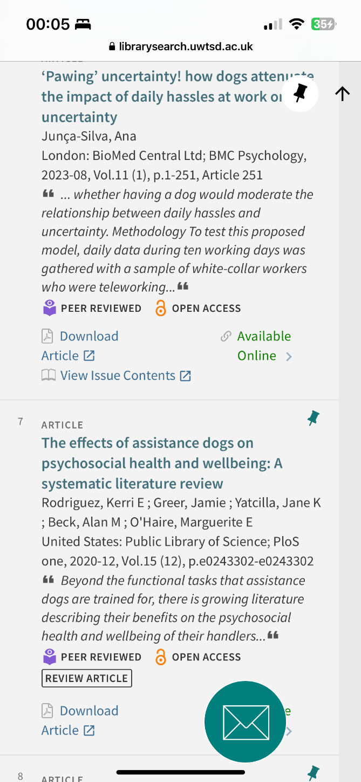

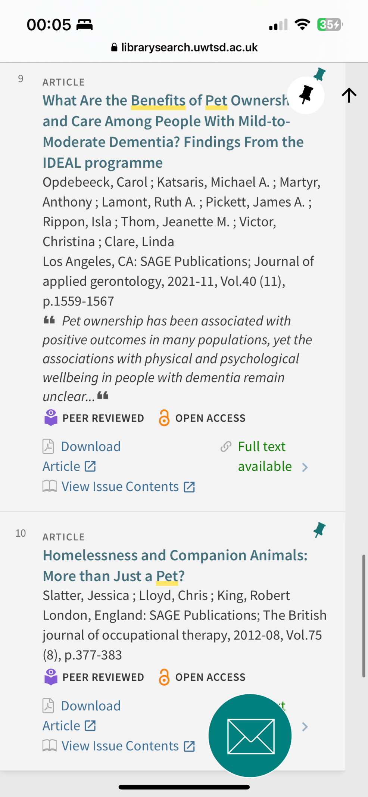
Summary of sources
I decided to use the sources that I chose because:
- They were from journal’s
- Peered reviewed
- Supporting the subject content
- They were found on the library's website

References (All references for each task)
- Charmaraman, L., Cobas, S., Weed, J., Gu, Q., Kiel, E., Chin, H., Gramajo, A., & Mueller, M. K. (2022). From Regulating Emotions to Less Lonely Screen Time: Parents’ Qualitative Perspectives of the Benefits and Challenges of Adolescent Pet Companionship. Behavioral Sciences, 12(5), 143-. https://doi.org/10.3390/bs12050143
- Chisari, M. (2019). Five top tips to succeed in your first year of university. The conversation. https://theconversation.com/five-top-tips-to-succeed-in-your-first-year-of-university
- González-Ramírez, M. (2019). Compatibility between Humans and Their Dogs: Benefits for Both. Animals (Basel), 9(9), 674-. https://doi.org/10.3390/ani9090674
- Howe, L., & Easterbrook, M. J. (2018). The perceived costs and benefits of pet ownership for homeless people in the UK: practical costs, psychological benefits and vulnerability. Journal of Poverty, 22(6), 486–499. https://doi.org/10.1080/10875549.2018.1460741
- Mulvaney-Roth, P., Jackson, C., Bert, L., Eriksen, S., & Ryan, M. (2023). Using Pet Therapy to Decrease Patients’ Anxiety on Two Diverse Inpatient Units. Journal of the American Psychiatric Nurses Association, 29(2), 112–121. https://doi.org/10.1177/1078390321999719
- Opdebeeck, C., Katsaris, M. A., Martyr, A., Lamont, R. A., Pickett, J. A., Rippon, I., Thom, J. M., Victor, C., & Clare, L. (2021). What Are the Benefits of Pet Ownership and Care Among People With Mild-to-Moderate Dementia? Findings From the IDEAL programme. Journal of Applied Gerontology, 40(11), 1559–1567. https://doi.org/10.1177/0733464820962619
- Powell, L., Chia, D., McGreevy, P., Podberscek, A. L., Edwards, K. M., Neilly, B., Guastella, A. J., Lee, V., & Stamatakis, E. (2018). Expectations for dog ownership: Perceived physical, mental and psychosocial health consequences among prospective adopters. PloS One, 13(7), e0200276–e0200276. https://doi.org/10.1371/journal.pone.0200276
- Rodriguez, K. E., Greer, J., Yatcilla, J. K., Beck, A. M., O’Haire, M. E., & Santana, G. L. (2020). The effects of assistance dogs on psychosocial health and wellbeing: A systematic literature review. PloS One, 15(12), e0243302–e0243302. https://doi.org/10.1371/journal.pone.0243302
- Wenden, E. J., Lester, L., Zubrick, S. R., Ng, M., & Christian, H. E. (2021). The relationship between dog ownership, dog play, family dog walking, and pre-schooler social–emotional development: findings from the PLAYCE observational study. Pediatric Research, 89(4), 1013–1019. https://doi.org/10.1038/s41390-020-1007-2
- Wetherell, M.A., Craw, O., Smith, K. & Smith, M.A. (2017). Psychobiological responses to critically evaluated multitasking. Neurobiology of Stress, 7, 68-73.
Wetherell, M. (2022). The bear necessities of stress. Psychologist, 35(10), 42-45. https://www.bps.org.uk/psychologist/bear-necessities-stress

AI Acknowledgements
Programmes used in this assignment are as follows:
- Microsoft Word
- Microsoft Word Editor
- Vengage
- UWTSD Online Library Search
- Microsoft 365

Please find all articles used in this assignment cited and referenced in APA7 style.
I can confirm that I did not use AI tools or materials to research or create this assignment.
C.Jones

