university of wales trinity SAINT DAVID
INDIVIDUAL ASSIGNMENT
ON COMMUNITY ENGAGEMENT
NAME OF STUDENT: ANDREEA ELISABETA MAGOS
10/15/2020

ESSAY ON COMMUNITY ENGAGEMENT
NAME OF LECTURER: DALE CLARKE

Table of Contents
1.0 Introduction 2
2.0 Company`s background 3
3.0 Mission and values 4
4.0 Role of employees to achieve the company`s goal 6
5.0 Samsung customers and their expectations 7
6.0 Selected role in the organisation 8
7.0 Importance of training in an organisation 9
8.0 SWOT Analysis of Samsung Electronics Ltd. 10
9.0 Conclusion 13
10.0 Bibliography: 13

SAMSUNG ELECTRONICS LTD.

1.0 Introduction
The purpose of this assignment is to conduct an investigation upon Samsung Electronics Ltd and to produce an evaluative report about the business insights. The steps followed to conduct the investigation are:
-identifying the sector in which Samsung operates, its mission and values.
-identifying its customers and their expectations in terms of goods and services
-explaining the role of employees and how they help the organization achieving its goals
-explaining about training and development
The report also includes a SWOT analysis of the business in order to support all the explanations.

2.0 Company`s background

Samsung Ltd. was founded in South Korea and it is one of the world's most significant electronic gadget produces. Samsung is producing a wide range of hardware including media gadgets, semiconductors, machinery and memory chips. It has gotten one of the most well-known names in innovation and it is South Korea's fifth producer of total exports.
Samsung was founded as a food exchanging store on March, 1938 by Lee Byung-Chull and the business was based on exchanging goods produced around the city and trading them to China and surroundings. After the Korean War the business ventured into exchanging materials and opened the biggest woollen factory in Korea. After the war, Lee centred in to building up his nation and his business has profited by defensive strategies received by the government. Samsung initially entered on gadgets market in 1969 with a few hardware including the high contrast TV`s.
During the '70s the organization extended and new auxiliaries like Samsung Heavy Industries, Samsung Shipbuilding and Samsung Techwin were set up. They started sending out home hardware abroad. After the partition of the branches they made an aviation division.
In 1990, Samsung kept extending but despite its success, the company battled corporate scandals and various patent violation and extortion suits. In the same time, Samsung made and grew new items on electronic market, for example, LCD screens and moved into top-five situations in worldwide market shares.
In 2000, Samsung made the Galaxy cell phones arrangement, which immediately got one of the smash hit cell phones on the planet.
2010 got Samsung creating and extending the Galaxy arrangement with another item, Galaxy Tab. (P. Bondarenko, 2020)

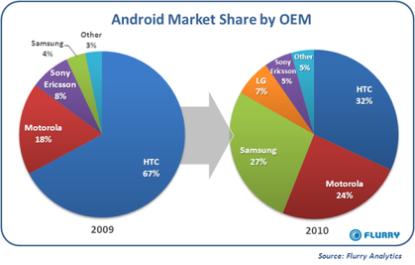
Source: Flurry Analysis
The image illustrates the growth of Samsung market shares between 2009 and 2010.It can be observed that in 2009 Samsung held only 4% of the market, taking a huge leap in the following year where they held another 23% of the market, placing their Android technology on the third place. (W. Oremus, 2013)

3.0 Mission and values

Nowadays, the businesses are facing a period of contention where legal and institutional restrictions are encouraged or disappear and impediments are deteriorating. To fight the world over, companies need to clench to innovative methods and complete open organization that dispenses with all restrictive and severe establishments and practices. The HR, advancement, publicizing delivering, also, plan workplaces are getting a regularly expanding number of noteworthiness as actual resources thereafter. So far Samsung has used these advantages effectively. (Chul Jung, S., 2014)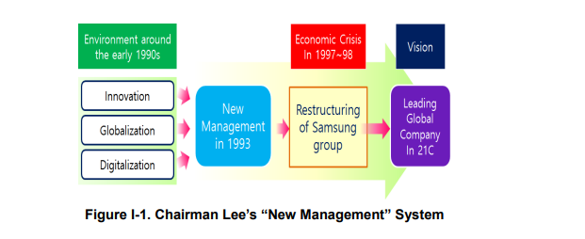
Source: International Journal of Software Engineering and Its Applications Vol. 8, No. 12 (2014)

In 1993, at Frankfurt, director Lee announced the “New Management” scheme of Samsung Electronics. Since then, Samsung changed itself from a local producer to an worldwide company with a strong brand worth and qualitative produce on the markets
As fig I-1 presents, the new idea of management will help Samsung to take control over the markets by becoming a leading global company in the 21st century. . Different orders of Samsung's New Management plan of action were made in a way that will be significantly influenced by Samsung's leader's system, specifically new organization request, new care, and net human resources ideal models. Samsung announced "Open HR" to prepare for an "Open Era" .The company dropped isolation subject to academic preparation and gender for HR which lifts anticipated capacities of company employees. The value chain model was proposed additionally, referencing to Michael Porter`s book from 1986,” Changing patterns of international competition”. He presented the value chain as a model for the distinctive evidence and assessment of those activities containing an organization's worth chain. Inside the value chain, there are two specific plans of activities that a firm grasps. The at-first arrangement of activities is regarded to be fundamental, as they are truly related to the products or services that a firm propose to a customer. (Chul Jung, S., 2014)

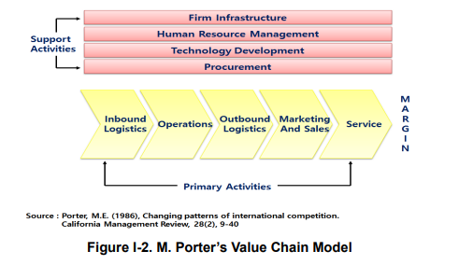

Support activities make up the subsequent set. Those activities identify with capacities that are contained inside a company's framework that helps the performance of the company's essential activities. These exercises, regardless of whether they are essential or backing movement, are associated. (Walsh, 2011). Likewise with Porter’s value chain (Figure I-2), all exercises inside the chain are associated and should be seen together or associated in order to succeed. .( Chul Jung, S., 2014)

4.0 Role of employees to achieve the company`s goal
In an organization, representatives will truly require their words on the guidelines that apply to the organization. As such, work discipline for employees is required, in light of the fact that what the organization intends to accomplish will be hard to accomplish if there is no work discipline. Workers ought to comprehend that having great work discipline implies that a helpful preferred position will be accomplished, both for the organization and for the representatives themselves clarified that work discipline is the 6th operational capacity of human asset the board, which is the most significant in light of the fact that the better representative discipline, the higher the degree of control with the goal that worker work execution is better. Representative work motivation is one of the components that will decide the organization's goal in accomplishing its objectives. Organizations need to give consolation that can give mindfulness and ability for representatives to fill in as wanted by the organization; this consolation is called work inspiration. Be that as it may, giving inspiration isn't simple. Inspiration speaks on the mental level that lead to activity.. Regarding work motivation, strengthening is a related issue (R. D. Parashakti & M. Ekhsan, 2020).
Samsung's Open HR advances equivalent chance, put employee`s aptitudes first, and recognise their capability. Reward and improvement ought to be intensely separated dependent on people aptitudes. For Samsung to prosper, it’s depending on the workforce. With the presentation of new administration Samsung has pushed further ahead its objective of worldwide top notch organization dependent on its "People first" management philosophy. New HR encouraged new administration structure by building capital in human resources and changing the mindfulness furthermore, workers activities. As a key exertion to quicker long term talents to enter worldwide business sectors, local specialists are sent to abroad branches to connect with new people and different cultures. More than 4,700 local specialists have been posted in 80 nations since 1990. Provincial authorities likewise play a part in spearheading developing markets. In addition, these local specialist give business chances to assemble immense local information around the globe. Samsung executed an exhibition based reward framework both compensation and advancement. While emphasizing individual performance more than most companies in the Far East, it emphasized group and company performance. (Chul Jung, S., 2014)
In order to push its workers capacities Samsung applies McClelland's Learned Needs Theory. The reason of this theory is that there are three factors that drive an individual: affiliation, achievement and power. Samsung offers a right work environment and the employees have all the motives of being content with working with one another as a team. Regarding achievement, this is showed up from the amount of progress that Samsung has cultivated. It is one of the world's most well-known advancement associations. Understanding that they're giving items and that their troublesome work has an explanation helps keep the agents prodded. In conclusion, power comes to agents as headways. Samsung offers equal progression chances to all of its employees. By applying McClelland's Learned Needs Theory, Samsung keeps up satisfactory degrees of employee’s motivation inside its association (J.Crifasi, 2016)

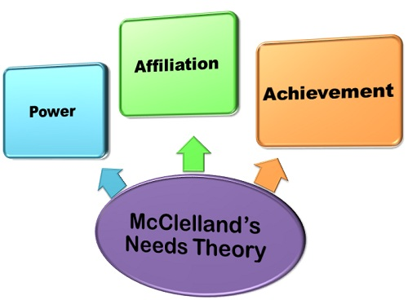
Source: businessjargons

5.0 Samsung customers and their expectations
Samsung`s targets a vast range of consumers which can vary from daily usage devices such as tablets and smartphones to industrial equipment.
The age group of consumers vary between 20 to 50 years old, sometimes much older, as long as the individuals are capable to utilize and to procure the products that Samsung has to offer.
Teenagers to middle aged people (14 to 25) are Samsung`s target gathering as the items that they usually procure are smartphones and gadgets always in trend with new technologies.
According to Nielsen research, this group prefers social media to connect with friends play games and improve their social life, and for that they are using multiple screens while watching their programs, playing or socialising. (Business wire, 2010).As the development and compact world changes, Samsung is similarly changing its manner towards customer experience. As opposed to what SVP Customer Care Michael Lawder calls the "break, fix model" where customers just went to the brand to fix their wrecked contraptions and thereafter proceeded onward, Samsung is presently revolved around building suffering, significant relationship with its customers that go past the unpredictable assistance fixes. The idea is that as customers become more connected with their contraptions; they can similarly end up being more connected with the brand. More contraptions infer there is greater chance to create steadfast Samsung clients. (Morgan, 2020)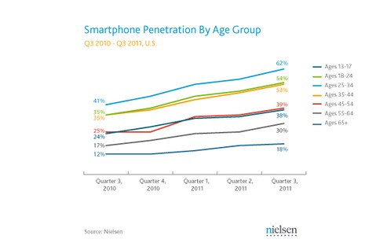 Source: Nielsen

6.0 Selected role in the organisation
Samsung Inventory Management
Inventory management is vital for a business functionality and enables firms to exceed or meet the market demands in a manner that maximizes its profitability.Stock control plays a role to the success or failure of the enterprise and it is critical for a number of reasons:
-involves costs associated with storage and if it is managed efficiently, lesser storage space will be required.
-excess inventory can result a rise in the company`s capital that could help the growth of the firm.
-an inventory system that is efficient in lower costs can help corporations in pricing their products in a manner that is more competitive.
Most successful firms have incorporated the Just in Time (JIT) inventory management approach. (Muller, M., 2019)
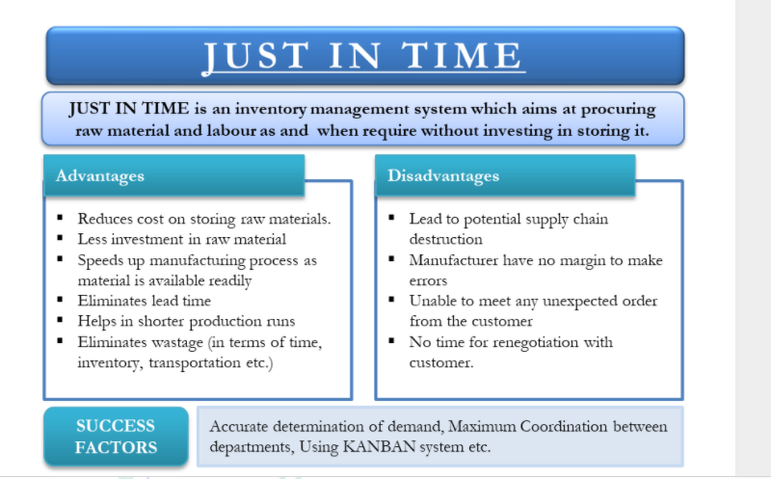
Source: eFinanceManagement.com

Samsung earns a significant percent of its revenue by following JIT System. The competition in electronics and mobile market is rising, for example Samsung uses the Android operating system on its devices, a system that is been used by competitors and as a result, Samsung is forced to price its products in a narrow range in comparison to similar products on the market. If competitors are able to offer alternative products that are lower than Samsung`s then the company could lose its customers. As a result, to bring the prices of its products down, Samsung must ensure that it lowers its production cost but not losing the quality of the products by implementing the JIT inventory approach. (Jung & Chung, 2016, p. 753).

7.0 Importance of training in an organisation

Training and development in the long run increase the productivity of workers just as of the business. It has appropriately been expressed; representative’s advancement is the best approach to progressive viable new development. Associations must have representatives who can quickly overcome the progress of the market. Companies need to place assets into on-going delegate planning and headway in order to both keep labourers and be productive. The 21st century will be positive for those employees, which can learn quickly and conform to changes than their opponents. Planning improves delegates' drive and nature of work, in this way helping them to be more devoted to achieving the various levelled targets and objections and accordingly redesigning labourers’ sufficiency inside the organization. Immediately, preparing and advancement influencing on agent proficiency has not just improved the success of the organization, yet likewise help the prospering of most countries that has put into thought the arrangement and transport of getting ready and improvement of workforce at public level. As the public strategies intend to improve nation's human resources, this preferably accordingly results to the budgetary advancement of the nation.
( Miamian, Muhammad & ND, & Yazdanifard, Assc. Prof. Dr. Rashad, 2013.)

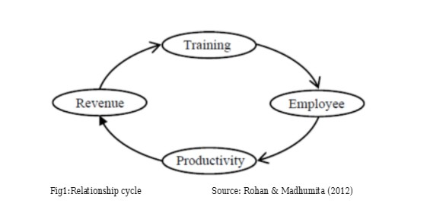

8.0 SWOT Analysis of Samsung Electronics Ltd.

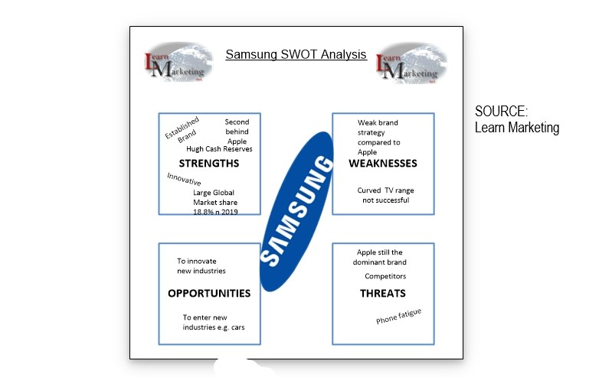

As we can observe in the image, the SWOT analysis is giving us an idea of the situation of Samsung Electronics and how she is facing the competition and the continuingly changing market.

- Strengths:
-Wide range of products
- Samsung place first position on market shares
-Recognisable brand name
-Customer loyalty
-Biggest TV screen producer
-Product innovation
-Adaptability to new technologies and ideas.

- Weakness:
-New competitors on the market with more affordable prices
-Brand strategy
-Declining sales on smartphones
-Smartphones are the main income resource.
- Opportunities
-Diversifying. With the cell phone market immersed and customers purchasing elective brands there is an open door for Samsung to differentiate into new markets for example electric vehicles to adjust their item portfolio and make the most of chance of developing business sectors.
-To expand to other markets, such as India or Africa

- Threats
- As the working class are getting all the more monetarily shaky and extended in certain business sectors they are bound to choose elective brands, for example, Xiaomi and Huawei
- Apple is as yet the prevailing player inside the market.
- Technology has arrived at a phase where customers don't feel they need to update each year .The Corona Virus could highly affect the creation of Samsung telephones as a little rate is made in China. (Samsung SWOT Analysis 2020, 2020)

9.0 Conclusion

To sum everything up, Samsung has proved during all these years that if you follow a strategic plan of business, keep up with new technologies, improved management, and training and never underestimate customer needs, a company can be successful and could be in top 5 companies of the market for years. The only question is: will Samsung be able to defeat the competitors and to become the market leader in everything they do by conquering all markets?

10.0 Bibliography:

Bondarenko, P., 2020. Samsung | History & Facts. [Online] Encyclopedia Britannica. Available at: https://www.britannica.com/topic/Samsung-Electronics
[Accessed 15 October 2020].

Crifasi, J., 2020. Samsung – Motivation. [online] jakecrifasi. Available at: https://jakecrifasi.wordpress.com/2016/02/19/samsung-motivation/
[Accessed 15 October 2020].

Jung, S.C., 2014. The analysis of strategic management of Samsung Electronics Company through the generic value chain model. International Journal of Software Engineering and Its Applications, 8(12), pp.133-142.

Jung, U, & Chung, BD 2016, ‘Lessons from the history of Samsung’s SCM innovations: focus on the TQM perspective’, Total Quality Management & Business Excellence, vol. 27, no. 7/8, pp. 751-760.

Learnmarketing.net. 2020. Samsung SWOT Analysis 2020. [online] Available at: https://www.learnmarketing.net/Samsung-SWOT-analysis-2020.html
[Accessed 15 October 2020].

Morgan, B., 2020. The Connected Customer with Samsung. [online] Forbes. Available at: https://www.forbes.com/sites/blakemorgan/2018/01/29/the-connected-customer-with-samsung/#2ce1c4c638e4
[Accessed 15 October 2020].

Muller, M., 2019. Essentials of inventory management. HarperCollins Leadership.

M., Muhammad &, Nda & Yazdanifard, Assc. Prof. Dr. Rashad. (2013). The Impact of Employee Training and Development on Employee Productivity. 2. 91-93.

Parashakti, R.D. and Ekhsan, M., 2020. The Effect of Discipline and Motivation on Employee Performance in PT Samsung Electronics Indonesia. Journal of Research in Business, Economics, and Education, 2(3), pp.653-660.

Porter, M.E., 1986. Changing patterns of international competition. California management review, 28(2), pp.9-40.

Snowdon, B., & Stonehouse, G.: Competitiveness in a globalized world: Michael Porter on the microeconomic foundations of the competitiveness of nations, regions, and firms, Journal of International Business Studies, vol.37, no.2, pp. 163-175 (2006)

Oremus, Will. "Samsung Is Crushing Apple in Smartphone Sales." Slate Magazine. N.P., 26 Apr. 2013. Web. 18 Dec. 2013.

Walsh, P.R., 2011. Creating a “values” chain for sustainable development in developing nations: where Maslow meets Porter. Environment, Development and Sustainability, 13(4), p.789.

WIRE, B., 2020. Nielsen To Measure Samsung’s Digital Out-Of-Home Signage Networks. [online] Businesswire.com. Available at: https://www.businesswire.com/news/home/20100218006016/en/Nielsen-Measure-Samsung%E2%80%99s-Digital-Out-of-Home-Signage-Networks

