Katarzyna Kolowrocka (1805961)
18.11.2019

The Beliefs, Attitudes, and Values that Contribute to an Organisational Success
SPEAKER NOTES - POSTER

Contents
1.0 Introduction 2
2.0 Main Findings 2
3.0 Conclusion 7
4.0 References: 7
5.0 Appendix 8

Introduction

This paper critically evaluates, how values influence organisational success.
The author has used Toulmin’s model (Toulmin, 1958), illustrated by diagram 1, to support her arguments.

Main Findings

Based on research material (Titov, 2017), organisational success is defined as an organisation’s ability to accomplish its goals. Different factors describe its success, such us:
- Financial stability
- Culture based on shared values
- Stakeholder satisfaction.

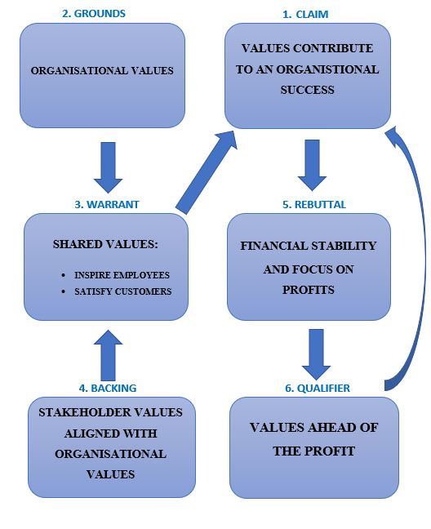Figure 1 Values that contribute to the organisational success based on Toulmin Model (Kolowrocka, 2019)
CLAIM
It is essential to use the values as a tool to achieve organisational success (Titov, 2017).
GROUNDS
To ensure long-term success and employee retention, it is organisation’s responsibility to establish clear, well-defined values that employees could easy to follow (Salopek, 2001).
Examples of organisational values are included in Appendix 1.
WARRANT
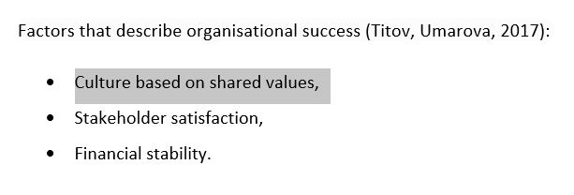
Within successful organisations, where management strategies are based on shared values, employee and customer loyalty and satisfaction are generated. (Titov, 2017).
Employees
Organisations, where employees behave according to organisation’s values are more successful (Barrett, 2017), because their staff have higher work satisfaction and motivation levels. Employees not only use their energy, and enthusiasm to achieve organisational goals, but also are more reliable to clients.

Customers:
Organisation values are used as a strong marketing tool, to inspire customers, increase their satisfaction and loyalty to the business (Titov, 2017).
BACKING
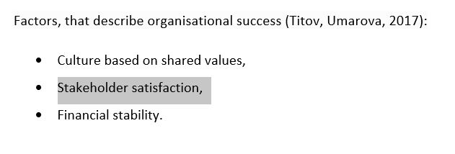
When stakeholders’ values are aligned with organisational values, that lead to long-term organisational success.
EXAMPLE
Whole Foods grocery chain accredits its success to an organisational management structure, based on values, that promote making the world and individual’s lives better. (Cheretis, 2014) Whole Foods take into account stakeholders’ expectation (Dembek et al., 2016), and focuses on values that benefit employees, suppliers, customers, and the environment.
To exemplify company’s commitment to local communities, Whole Foods give low-interest loans to independent local farmers, suppliers to support their businesses.

Whole Foods expose on their webpage, environmentally friendly efforts, such us:
- recycled paper used for packaging,
- vegetable-based composting to decrease waste,

Whole Foods is very serious about their efforts to support the local community and environment. Therefore, customers are loyal to the brand because those values are personally important to them.
REBUTTAL
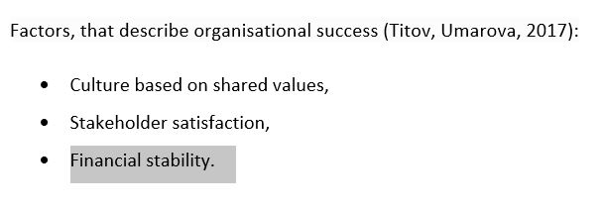
In addition to values being important for organisational success also financial stability and profit are essential. According to the famous maxim of Milton Friedman (1970) that the only responsibility of business is to make a profit. (Mühlbacher, 2019). An organisation that is profit-driven, create company wealth.
QUALIFIER
For successful organisations, financial gains are a secondary objective and occur as a result of the ethical behaviour and values. (Cheretis, 2014).
Example:
- On Google’s “philosophy page” one of the values states, "You can make money without doing evil." (www.google.com)
Google do not allow advertisement to be displayed on their pages, unless they are relevant. Google do not accept “pop–up advertising, which interferes with a customer ability to see the content” (www.google.com)

Conclusion

In summary, clear and shared values are the most important indicators an organisation’s long-term success. Organisation’s values are expressed in individual’s behaviour where employees are more motivated, committed, satisfied, and loyal. Shared organisational values will also result in satisfaction of stakeholders.
Based on examples of Google and Whole foods both companies treat profit as a secondary option. Google values focus on the users and Whole Foods on stakeholders’ expectations.

4.0 References:

Barrett, R., (2017), Building a Values-Driven Organization: A Whole-System Approach to Cultural Transformation, Boston: Butterworth Heinemann.
Cheretis, D., Mujtaba, B., (2014), Maximizing Long-Term Value and Conscious Capitalism at Whole Foods, Vol. 79, Iss 3, Corpus Christi: Society for the Advancement of Management.
Dembek, K., Singh, P., Bhakoo ,V., (2016), Literature review of shared value: A theoretical concept or a management buzzword?, Vol. 137, Iss. 2, Journal of Business Ethics.
Gorenak, M., Kosir, S, (2012), The Importance of Organisational Values for Organisation, International Conference: Management, Knowledge and Learning.
Holdren, A., (2011), Google AdWords: Managing Your Advertising Program, Sebastopol: O’Reilly Media.
https://www.google.com/about/philosophy.html accessed 05/11/2019
Kolowrocka, K., (2019), The Beliefs, Attitudes, and Values that contribute to an organisational success, Cardiff: UWTSD

Mühlbacher, H., Böbel, I., (2019), From zero-sum to win-win - Organisational conditions for successful shared value strategy implementation, Vol. 37, Iss. 3, European Management Journal
Salopek J., (2001), Do the right thing, Vol 55, Iss 7, Training and Development
Titov E., Umarova, L., (2017), Impact of Real and Propagated Values on Organisational Success, Congruence of Personal and Organizational Values: Intech Open
Toulmin, S.E., (1958), The use of arguments, Cambridge: University Press

5.0 Appendix 1


