

DAV(ACCB4002)

Ana Sacajiu
2013021
Data Analysis and Visualisation
(ACCB4002)
Lecturer: Anupam Mazumdar

Table of Contents
List of Figures 2
Introduction 3
Dataset Description 4
Appropriate set of testable hypotheses 4
T-test for unequal variances: 5
State Hypotheses 5
Null Hypotheses 5
Alternative Hypotheses 5
Hypotheses for Different Significance Level 5
Application of techniques Used 8
Visualizations from the Data 9
Results 11
Conclusion 11
Reference 11

List of Figures

Figure Name | Description of the figure | Page number
Figure 1 | f-test to measure variance | 4
Figure 2 | t-test for p=0.01 | 6
Figure 3 | t-test for p=0.10 | 7
Figure 4 | t-test p=0.02 | 8
Figure 5 | Scatter plot | 9
Figure 6 | Bar graph | 10
Figure 7 | Column graph | 10

Introduction

This report consists of testing of findings of the BBC news of UK, they identified that the infection rates of Covid-19 of White and BAME patients of UK is varying and the hypothesis is made on the basis of that. This report includes the t-test for unequal variances which is to be performed on the Data. Graphs, applications and results are been discussed in this report.
The t Test is one of most commonly used statistical tests.Its primary purpose is to determine whether the means of two groups of scores differ to a statistically significant degree.

As in my example I have two groups of White and BAME patients and I will measure the data transport time for each patient group.
I want to show that there is a difference so the null hypothesis is that they are the same :
$H_{0}$ : µ₁ = µ₂

If the difference between the means is statistically significant then I will reject $H_{0}$ and assume that there is a difference between the 2 groups of patients
There are two kinds of t Tests-those for groups whose members are inde- pendent of each and those for two groups whose members are paired in some way (e-g., pretreatment and posttreatment measures or pairs of siblings). Since the counseled and control groups in our hypothetical study were not paired in any way, we would use the t Test for independent samples. [1]
Also ,t Test assume that both of populations being considered are essentially distributed.[1]

Dataset Description

The Dataset consist of UK news data, related to the infection rate of Covid-19. The ages of BAME and White patients is been given. 50 patient’s data from both the categories are there and the age of these patients is given in the Dataset. The age lies in the range of 20 to 50 years. The patient number is there which shows the primary key for the data. The infection rate of covid-19 and in order to find out the truthfulness in the findings the hypotheses analysis will be done.

Appropriate set of testable hypotheses
F-test two sample for variance:

This test was performed to calculate the variances of two samples and thus to be able to correctly deduce the hypothesis test.

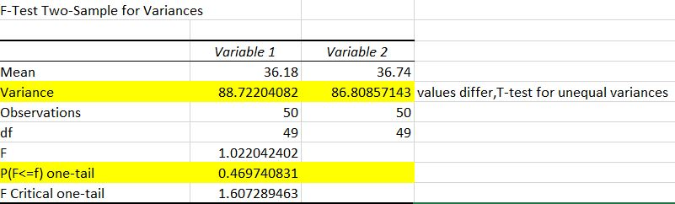
Figure 1 f-test to measure variance

From this test I can see that the variances are not close in value, the variances are different After all these results I will perform the test for the unequal variances.

T-test for unequal variances:
This t Test form assumes that the various of both ranges of data are different. This is the hypotheses which can be done on two independent population which are having unequal variances. This test of two types, one-tail and two-tail t-test.

State Hypotheses
Hypothesis is an approximate value which can be tested for investigation and testing can be done to find the truthfulness of the data. There are two types of hypothesis which are null hypothesis and alternate hypothesis. They are useful in research purpose they provide clarification to the research.

Null Hypotheses

Null Hypothesis is denoted as H_{o}, if it is rejected then it states the opposite of what the researcher has expected or predicted.
The null hypothesis is that there is no difference between populations of White
Patient and BAME in the level of empathy that they offer to a stranger.
In statistical terms :

$H_{0}$ : µ₁ = µ₂

Alternative Hypotheses

Alternative or research hypotheses are the opposite of the null hypothesis. In this case, the alternative hypotheses would be that there is a difference between populations of White
Patient and BAME in the degree of empathy that they offer to a stranger:[1]

${ H}_{A }: µ1≠$ µ2

Hypotheses for Different Significance Level
1. P = 0.01
For the significance value 0.01, the result is analyzed:
Step 1:
If the t-stat value is less than the t-critical values from the observation it can be seen that the null hypothesis cannot be rejected.
t-stat value = -0.298
t critical two tail value = 2.626
It is clearly seen that the t-stat value is less than the t critical value and thus the Null hypothesis cannot be rejected.
Step 2:
From the result, it can be seen that the p-value for two tail is greater than the significance value then the null hypothesis cannot be rejected, thus from the both cases it is seen that the Null hypothesis which is made cannot be rejected (Excel-easy n.d.).

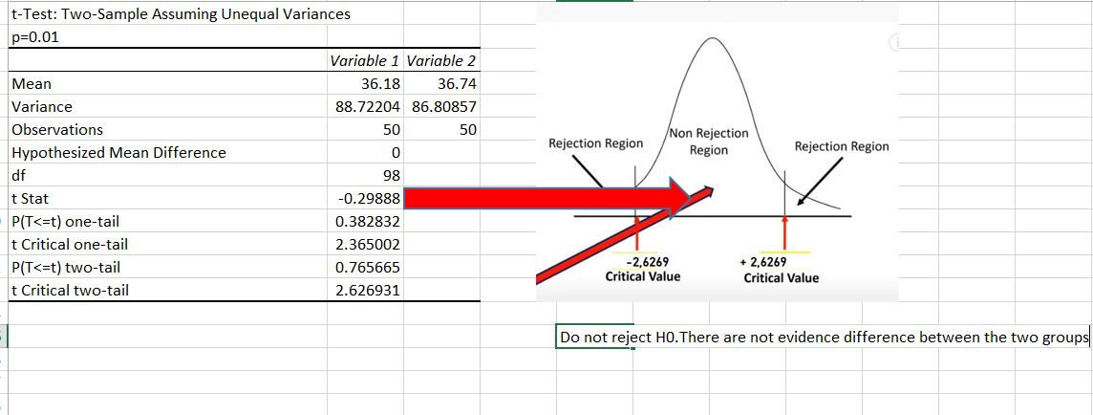
Figure 2 t-test for p=0.01

2. P = 0.10
For the significance level 0.10, the test is performed and found the following result. In which the probability value is found out in the results, the t-critical values.
The Analysis of the result can be done in following ways:
Step 1:
Null hypothesis cannot be rejected if the value of t stat is smaller than the value of t critical one tail. Here from the observation, it can be seen that the t stat value is -0.298 is smaller than 1.660 then the null hypothesis cannot be rejected and the infection rates between the BAME and White patients is varying as it was said by the BBC news of UK.
Step 2:
In this step the p-value is taken in consideration, if the value of p is greater than alpha which is 0.10, and the p-value for two tail is 1.666 then the Null hypothesis cannot be rejected (Excel-easy n.d.).

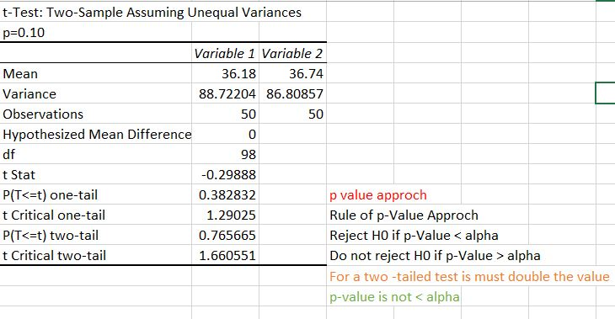

Figure 3 t-test for p=0.10

3. P = 0.02
At the significance value of 0.02, the values can be analyzed as:
Step 1:
The t-stat value from the observation is: -0.298
The t critical two tail value: 1.660
It is seen that the t-stat value is less than the t critical value then the Null hypothesis cannot be rejected.
Step 2:
Here,
P-two tail value: 0.765
Significance value = 0.02
It is clearly seen that the p-two tail value is greater than the significance value. And null hypothesis is hard to reject (Excel-easy n.d.).

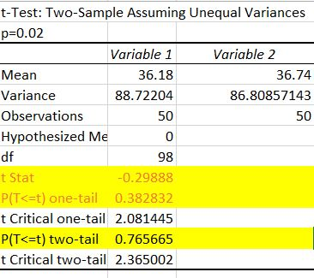
Figure 4 t-test p=0.02

Application of techniques Used

- It is used to test variety of population on which some assumptions are made.
- By using the hypothesis, the credibility of the sample data can be checked.
- It provides the researcher whether the assumption he/she has made is correct or not.
- Random samples and big sample regarding any population can be tested using the hypothesis.
- T-test can be used for equal and unequal variances

Visualizations from the Data

The scatter plot shows the two populations at various distributed points.

Figure 5 Scatter plot

Bar graph:
The bar graph shows the Data of Various patients at different place.

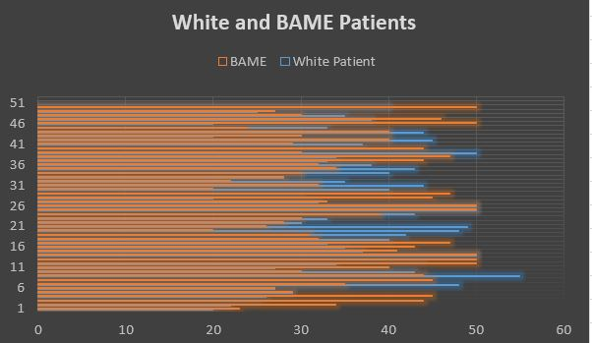
Figure 6 Bar graph

Column graph:
Column graph shows the Data in column form of both the WHITE and BAME patients.

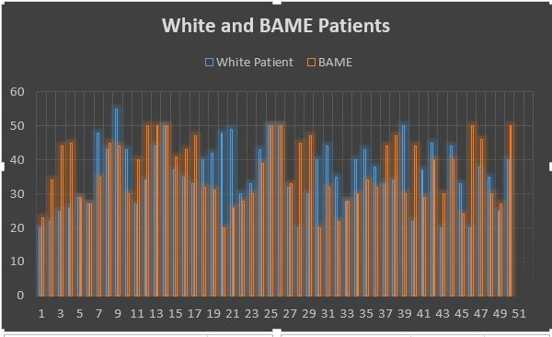

Figure 7 Column graph

Results
From the observation it can be seen that the Null hypothesis in all the significance levels at p=0.10, 0.01, 0.02 and it is found that the Null hypothesis cannot be rejected in all the cases so the assumption which was made as the infection rates in the BAME and White patients is varying is true.

Conclusion
In this report, the hypothesis testing is done using the Data analysis function of excel, the Data of patients of UK of two community BAME and White of infection of COVID-19, the t-test for various significance level was done. And appropriate graphs and the application of appropriate technology was discussed.

Reference

[1] Kranzler, J. H. (2018). Statistics for the terrified, Rowman & Littlefield, New York (USA) , p.130 – p.148

