

PROBLEM SOLVING AND DECISION MAKING

STUDENT NAME: ERIOLA DIKU
STUDENT ID: 1906510
MODULE NAME: PROBLEM SOLVING AND DECISION MAKING
LECTURER NAME: NADEEM MIRZA

Contents
INTRODUCTION 3
IDENTIFICATION OF THE PROBLEM 4
POSSIBLE SOLUTIONS 4
CREATING NEW IDEAS 6
DECISION MAKING 7
CONCLUSION 7
REFERENCES 7

INTRODUCTION
Every workplace is characterised by the presence of a team, which is a group of individuals, who work together in order to achieve the same goal. They are complex structure as they are formed by individuals vastly different from each other (Bednarz,2012). Most of the times creating a solid group can be incredibly challenging as they may occur different problems. These can depend on different factors and can be vastly different. Some of them can be for example lack of communication, bad leadership, or disputes between team members (Hamel, n.d.) This report will focus on some work-based problems I personally experienced during the last period. Making use of different problem-solving tool and techniques, I will describe the problem and try to evaluate and propose different solutions to solve them.

IDENTIFICATION OF THE PROBLEM
Working in big team can be exciting and can teach you how to work and help each other with people who are different from you and from each other. Even if the goal is the same, everyone has different solutions and ways of doing the job, so it is really important to find like a “meeting point” and share our own ideas and accept the other’s ones, in order to avoid problems and conflicts. I have been working in a pub near Monument station, called The Oyster Shed, for almost one year. I really liked working in there since the beginning as the atmosphere between the team member is nice and everyone helps each other. However, it did not take me long time to start to notice the first problems there were in there. The team is big, and the managers are numerous as well. Lack of communication and misunderstanding started to become more and more a problem. The misinterpretation of each other actions brought the team many times to conflict and misunderstanding caused many problems as well. This can cause even more problems when there are people all from different countries. Different language and culture may lead even more to misunderstanding as it can be much more difficult for them to understand certain things (Duggan, n.d.). Poor communication between team members limit the capacity to achieve certain goals and to optimize the performance. It also leads to uncertainty and confusion. People do not know what to do and how to handle certain situations. So, all this brings chaos and conflicts (Kokemuller,2019). Effective communication helps also understand not only your role but also everyone else’s role and it clarifies the ideas on what must be done. All this also brings luck of trust and makes it difficult for the new members to feel part of the time (Bass,2018).

POSSIBLE SOLUTIONS
Finding an affective solution for problems is not always easy. However, there are some methods that can help us identify the problem, understand its root causes and so arrive to a solution. The steps to follow are finding, defining, describing and diagnose the problem and only after it is possible to test the diagnosis and try to make some changes (The Conver Company, 2020). To properly identify a problem is to identify its root causes. There is a diagram, which goes under the name of fishbone diagram, that can be made in order to do so.

FISHBONE DIAGRAM
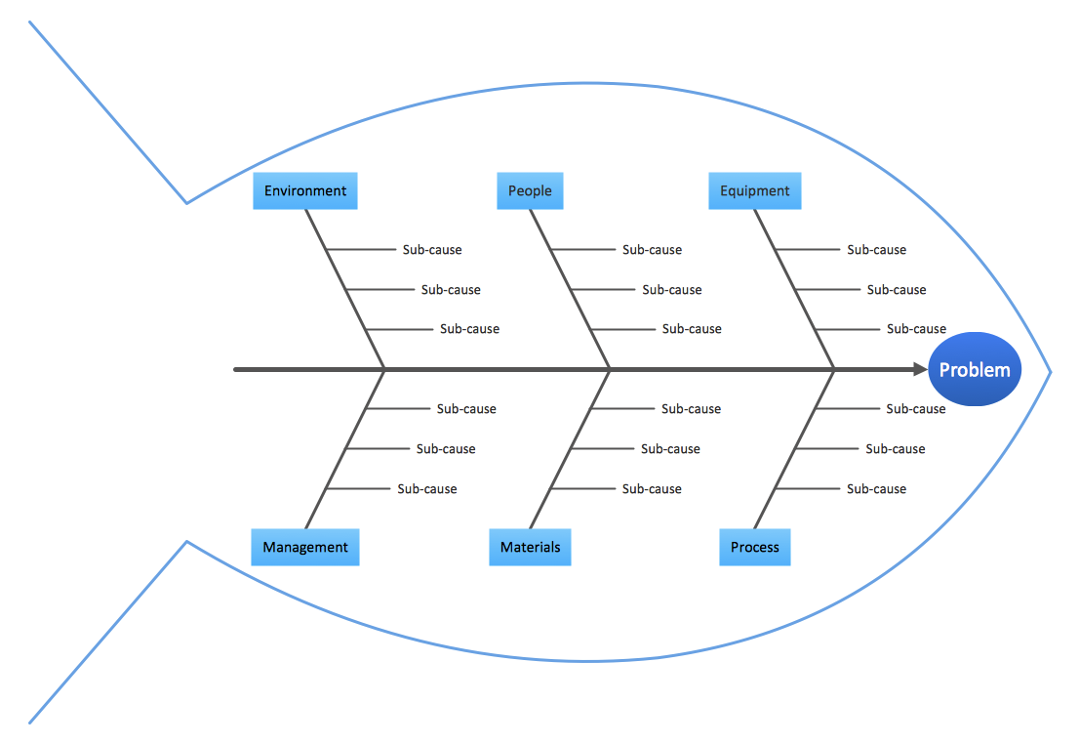
https://www.bing.com/images/search?q=fishbone+diagram+what+is&form=HDRSC3&first=1&scenario=ImageBasicHover

The image above shows a fishbone diagram, also known as Ishikawa cause and effect, which is a tool that can be simply created during a team meeting in order to identify a certain problem and understands its origins. The steps that need to be taken are different. It starts with the identification of a problem, which needs to be written in the head of the fish. Then it is needed to identify some of the causes which need to be written in the place where the bones of the fish are. Other contributing factors to this causes must be written in order to branch out the bones. These can be different such us regulations or procedures. This process must be carried on until the root of the problem is identified (WhatLs.com, 2020). In my case we need to put “lack of communication and misunderstanding” as head of the fish. In this case the causes are different such as management, huge number of staff, people coming from different countries, staff that changes very often, environment, company policies. In addition of all this causes we do have also different sub-causes. In the following scheme I will try to do a fishbone analysis for my workplace.
ENVIRONMENT LOT OF MANAGERS
- DIFFERENT WORKING STYLE AND WAY OF THINKING

- BIG RESTAURANT AND SO LOTS OF THING THAT NEED TO BE DONE
LACK OF COMMUNICATION AND MISUNDERSTANDING
- HUGE NUMBER
- DIFFERENT COUNTRIES OF ORIGIN
- COUNTINUOSLY CHANGING MEMBERS

- CONTINUOSLY CHANGING MENU
- CHANGES IN THE POLICY

STAFF LOT OF CHANGES

Summarising all of the points mentioned before I can say that the main sources of this problem are the numerous changes taking place all the times and the fact that everyone seems to work more as an individual following their own idea, instead of communicating and going to a common conclusion. Depending on the manager on duty we have all the time to behave and do things in a different way. This can be very confusing for the people who are new in the place. You never understand how it is the correct way to do a certain thing. It is also very confusing the fact than every day we do have a special menu and not always it is communicated to us. The company also, has been changing some policies due also to the current situation and not all the staff has been informed correctly.
These ones mentioned are only the problems that came out from my personal point of view and reflection. However, all this should be done during one team meeting where everyone is able to share their own ideas and so try to find a solution and improve our performance.

CREATING NEW IDEAS
Creating new ideas is fundamental to make thing work. We always need changes to solve the different problems we face in our everyday life. To create them we can use different tools such as attribute listening, brainstorming, or visioning. Attribute listening is the process of analysing a problem by dividing it in smaller parts (or attributes) in order to arrive to a solution. These attributes can be for example physical, social, or psychological (Saha,2017). By brainstorming we mean a group problem solving method. This means all the group members must meet and talk about a certain problem and situation and discuss their idea. This is very important because hearing different point of views and ideas can give a general view of the situation and understand how to act (Rouse,N.D). Whereas by visioning we mean the support of a certain vision or ideas for the future of a group of people working together (Keller,N.D). All these tools should be used in every workplace.

DECISION MAKING
The process of decision making is very important. There can be two types of decision making: creative or rational. Rational decision making is a process which throughout some specific steps help you find a solution for a problem. The first one is to identify and define the problem. Then identify the decision criteria and generate a list of alternatives. This last step is especially important because we do need to generate as many alternatives as we can in order to find a solution for the problem (All mind tools, N.D.). This method can be very useful and precise. It makes use of the reason to generate alternatives and solution. Whereas, when talking about creative thinking, we mean thinking in a different way, not in a rational one. It requires you to see a certain situation from a different perspective and find new and innovative solutions (Doyle,2020).

CONCLUSION
In conclusion, every workplace is characterised by his own problems and things that need to be solved. When working in a big team everything becomes more difficult to manage. It is fundamental to find a way and a solution for them and make everything work because the problems not only affect the staff but all the business. Thinking rationally can bring a lot of benefits but sometimes we do need to think out the box and try to find different and innovative solutions. It is not always enough to change or improve certain working method, but there can be also the need to upset the whole system. It is very important to organise meetings with the staff and let them express their own ideas and point of view. Only in this way the team will be able to grow and void different conflicts. Also, having different points of view can give us a general view of the whole situation and understand the things that are not really working.

REFERENCES
- All mind tools (n.d). Available at: https://allmindtools.com/rational-decision-making-model/. Accessed date: 15/08/2020.
- Bednarz, T. (2012). Strategies and Solutions for Solving Team Problems. Available at: https://www.qualitydigest.com/inside/quality-insider-article/strategies-and-solutions-solving-team-problems.html. Accessed date 13/08/2020.
- Bass, A. (2018). Why Is Team Communication Important When in Teams? Available at: https://careertrend.com/why-is-team-communication-important-when-in-teams-4233172.html. Accessed date: 18/08/2020.
- Doyle, A. (2020). What Is Creative Thinking? Available at : https://www.thebalancecareers.com/creative-thinking-definition-with-examples-2063744. Accessed date: 15/08/2020
- Duggan, T. (n.d). Challenges of Poor Team Communication. available at: https://work.chron.com/challenges-poor-team-communication-8813.html. Accessed date: 18/08/2020
- Hamel, G. (n.d). Problems that Occur in a Team. Available at: https://work.chron.com/problems-occur-team-7434.html#:~:text=%20Problems%20that%20Occur%20in%20a%20Team%20,the%20end%20goal.%20Even%20inexperienced%20workers...%20More%20. Accessed date: 18/08/2020.
- Keller, S. (n.d). Visioning. Available at: https://sswm.info/planning-and-programming/decision-making/deciding-community/visioning. Accessed date: 15/08/2020.

- Kokemuller, N. (2017). The Disadvantages of One-Way Communication. available at: https://bizfluent.com/info-8307652-disadvantages-oneway-communication.html. Accessed date: 13/08/2020.
- Rouse, M. (n.d). Brainstorming. Available at: https://whatis.techtarget.com/definition/brainstorming. Accessed date: 16/08/2020
- Rouse, M. (n.d). fishbone diagram (Ishikawa cause and effect). Available at: https://whatis.techtarget.com/definition/fishbone-diagram. Accessed date: 13/08/2020.
- Saha, M. (2017). Idea Generation Using ‘Attribute Listing’ Creativity Tool- An Example. Available at: https://medium.com/@shahmm/attribute-listing-creativity-technique-an-example-c47d26a5310c. accessed date: 16/08/2020.

