Date: 12 November 2024
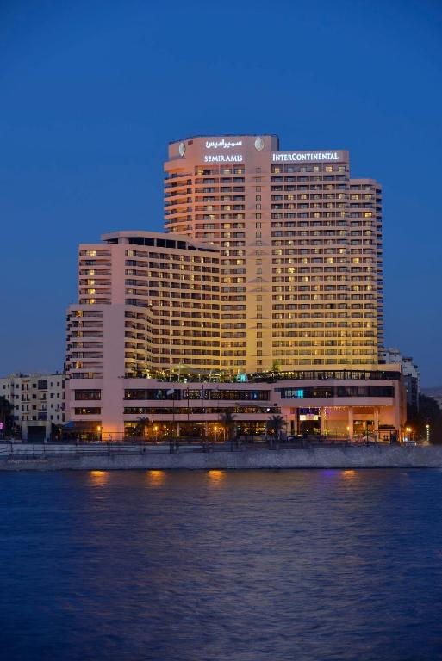  Consulting company: Optima Consulting LTD |  (Canva,2024).  CONSULTING TO IMPROVE THE QUALITY OF ROOMS AND SERVICES AT INTERCONTINENTAL CAIRO SEMIRAMIS – OPERATIONS AND MAINTANANCE DEPARTMENT  Consultant: Andreea Balanescu  Student ID: 2211130

Client: Intercontinental Cairo Semiramis Hotel

I acknowledge the use of Grammarly (https://www.grammarly.com/) on 12 November 2024 to check my work.
I confirm that I have not used any AI tools in the research and creation of this assignment. I confirm that I have not presented any AI-generated materials as my work. I confirm I have copies of my drafts, notes, and other resources I used, which I may be asked to provide in evidence

Table of Contents

Executive summary 3
1. Introduction 6
2. Analysis 8
2.1. Describing the problem 9
2.2. The problem’s impact on the hotel 12
2.3. The causes of the problem 12
2.4. PESTLE Analysis 13
2.5. SWOT Analysis 15
2.6. TOWS Analysis 16
3. Recommendations and Change Management 17
3.1. Facilities modernisations and recommendations for improvement 17
3.2. Implementation strategies and changes in management procedures 19
3.3. Impact evaluation and success measurement 22
3.4. Potential benefits of recommendations 23
3.5. Costs’ estimation and financial implications 24
4. Action plan 25
5. Conclusion 28
6. References 30
Appendix 1. The delivery stage consulting engagement 38

Executive summary

InterContinental Cairo Semiramis Hotel deals with a series of operational problems that directly impact clients’ experiences and market positioning. Among the main deficiencies, there is outdated rooms and facilities, worn furniture and outdated air conditioners that do not meet any more modern standards. Moreover, common spaces like the lobby and restaurants need modernisation to create an attractive and comfortable environment. The lack of a preventive maintenance programme worsens the situation, leading to unplanned repairs and a bigger risk of non-functional essential equipment. These aspects led to negative feedback from guests and decreased the attractiveness of the hotel, especially for clients from the luxury segment. In a competitive market, such as the hospitality one in Cairo, it is crucial that the hotel approach these challenges to maintain its status and to attract new guests, assuring a quality experience and a favourable positioning.
The detailed analysis of the InterContinental Cairo Semiramis hotel’s situation highlighted more critical aspects that contribute to current problems. Clients’ feedback on platforms such as TripAdvisor and Booking.com reflects dissatisfaction regarding the lack of comfort and reduced standards, which affect the reputation of the hotel.
The hospitality Industry in Egypt is in continuous growth at a solid 6.2% pace in 2023 and is expected to continue to develop well during the projection period of 2023-28. In today's competitive market, brand awareness is vital for acquiring customers. To compete with low switching costs, it's crucial to differentiate on quality, pricing, and audience. Major players have diversified portfolios, catering to individual travellers and business clients.
This research identifies opportunities and provides analysis and advice for the organisation's client business development using quality improvement initiatives such as Six Sigma used in process improvement and quality management, removing the causes of errors and variations, for high-quality guest experience, and TQM (Total Quality Management), quality production and management addressing the main principles, to identify organisational problems. Effective hospitality consulting involves empowering clients by providing them with the tools and resources they need to address their challenges, rather than simply solving their specific problems. Developing solutions analysing the client organisation SWOT, strategic planning TOWS and external factors PESTEL. Implementing continuous improvement strategies combined with key elements of change management along with measuring the success to remain relevant in the hospitality industry. To establish and maintain a competitive advantage, the client should successfully manage change and welcome innovation.
These findings highlight the need for investments in modernisation and preventive maintenance to support competitiveness and attract new clients, thus maintaining a top position in the luxury hospitality market.
In order to approach the problems identified, there are recommended the next strategical actions:
- Complete renovation of rooms.
- Implementing a preventive maintenance programme.
- Modernisation of common spaces.
- Staff training.
As a result, the solutions suggested for InterContinental Cairo Semiramis will help to improve the guest experience, increase competitiveness, and optimise operational expenses. Renovating the rooms, executing a preventative maintenance programme, and modernising the common areas will result in a more appealing and comfortable atmosphere that meets the requirements of premium clients. Staff training will ensure a smooth transition and greater operational efficiency, ultimately adding to the hotel's long-term success. Through these efforts, the hotel will be able to strengthen its market position and provide a memorable experience to its guests, hence promoting revenue development and increasing its reputation.
To address these challenges, recommendation of instituting a systematic preventive maintenance program, improving staff training in service quality, and developing a contingency staffing plan. Furthermore, a guest feedback system will be developed to provide continuous insights into service performance.
The purpose of Optima Consultant is to identify the core reasons for organisational problems, identify symptoms versus causes, investigate contributing elements, and design solutions.
The research explores the root cause analysis, qualitative data (competition comparison) and quantitative data (market analysis), to identify the client's organisational problems and develop solutions, breaking down the problem using the 5 Whys Techniques to the problem-solving continuum, implementing continuous improvement strategies to monitor the progress and for continuous learning.
Implement change management, clear communication, employee involvement, training and support, monitoring and feedback, understanding resistance to change, building trust and transparency, enhancing stakeholders, and relying on stakeholder engagement. Presenting outcomes, extracting relevant inferences from obtained data, and recommending cost-effective and timely implementation plans, concluding with the utilisation of the service line.

Introduction

This report aims to analyse and offer solutions for the problems encountered by InterContinental Cairo Semiramis in terms of room conditions and maintenance. Although the hotel is situated in an excellent area, on the banks of the Nile and is known for its luxurious facilities, the recent feedback from the guests highlights a series of deficiencies that negatively influence the general experience. Specifically, clients frequently reported outdated rooms with non-functional equipment, cleaning issues and a bold smell of smoke in certain areas. These issues not only reduce the clients’ comfort but also affect the hotel’s reputation in a competitive industry. This detailed analysis will explore the causes of these problems and offer practical solutions that will help the hotel maintain its luxury standards, improve clients’ satisfaction and protect its reputation in the high-end hospitality market.
InterContinental Cairo Semiramis was opened in 1987 and enjoys a privileged location on the Nile’s bank, in the heart of Cairo city. The hotel has 721 rooms and apartments, on 28 floors, catering for both guests that travel for business and leisure and offers luxury facilities, including fine-dining restaurants, a spa centre, an exterior pool and a modern fitness centre. Besides all these, the hotel is equipped with rooms for conferences and events, being a popular choice for conferences and international meetings (Intercontinental Hotels&Resorts, 2024).
This hotel earned a solid reputation as a top destination in Egypt’s capital city, attracting tourists and professionals from all over the world. However, to maintain this position, the hotel must constantly update its rooms and facilities to meet the high expectations of its clients. Therefore, modernisation is essential to ensure its place in an extremely competitive hospitality market and to offer an authentic luxury experience in Cairo.
Optima Consult is a consultancy company specialising in solutions for the hospitality industry. Dedicated to helping hotels improve the quality of services and optimise operational processes. Launched by experts with extensive experience in hotel management, the company offers personalised consultancy, using data-based methods to identify and solve each client's unique challenges.
As management consulting has developed in practice and significance, it has absorbed many of the ethics issue resolution processes of other occupational groups, most notably the adoption of codes of ethics for both the industry and individual businesses (Kipping et al., 2012).
The company’s mission is to support the hotels in achieving a superior level of performance, increase clients’ satisfaction and contribute to improving their reputation on the market. Relying on a combination of strategic analysis and innovative solutions to maximize the potential of each hotel's unity. Within this project, Optima Consult will use approaches such as PESTLE, SWOT and TOWS to offer well-founded recommendations, meant to support InterContinental Cairo Semiramis in the continuous improvement of experiences offered to its guests.
In order to analyse, breakdown and efficiently solve the problems identified at InterContinental Cairo Semiramis, using methods for identifying organisational problems such as SIX SIGMA and TQM (Total Quality Management), embrace strategic planning to gain a detailed perspective on the situation and to develop sustainable improvement strategies.
- PESTLE Analysis. Evaluate the external factors that influence the hotel’s operations. This analysis is essential in the hospitality context because the hotel operates in a location where political instability, a developing economy and environmental requests are constant challenges (Keith, 2024). Moreover, it will examine the way in which the COVID-19 pandemic modified these external influences, impacting clients’ demands and operation standards.
- SWOT Analysis. Identify the internal strengths and weaknesses of the hotel, as well as the external opportunities and challenges. This framework offers a clear image of the hotel’s capacities and on the way in which these can be used or improved to face current challenges (Papp, 2023).
- TOWS Analysis. It will be used to transform SWOT conclusions in clear strategies. This framework allows to combine the strengths with the opportunities to create proactive solutions, while the weaknesses and threats are managed through mitigation strategies (Dieffenbacher, 2023).
These methods offer a solid base for a comprehensive hotel evaluation and to development of applicable recommendations to optimise the operations and increase clients’ satisfaction.

Analysis

Egypt reached a new record in 2023, hosting about 15 million visitors, surpassing the previous peak of 2010, likely to continue into 2024. However, currency devaluation hampered performance in the first quarter. According to STR, the capital's citywide occupancy rate was recorded at 65% for the year ending March 2024. Over the same period, the average daily rate (ADR) was USD 123, a 10% decrease from the same period the prior year. As a result, revenue per available room (RevPAR) decreased by 19% year on year to USD 80, (Ghantous, 2024). Prospects analysing the performance, for the future of InterContinental Cairo Semiramis.
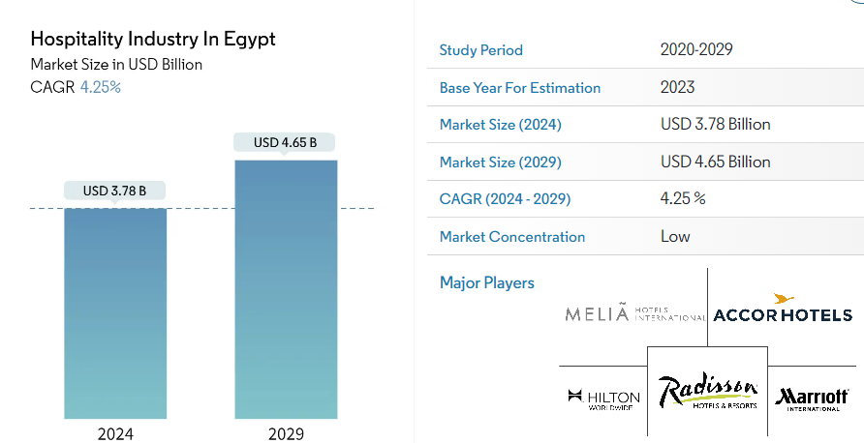
(MordorIntelligence, 2024).
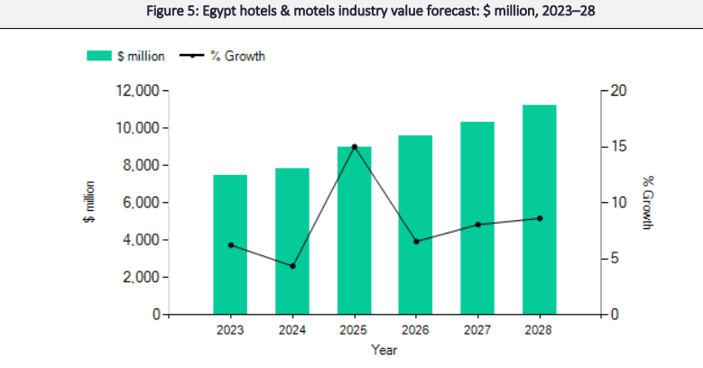
MarketLine Advantage (2024).

Describing the problem

A consultant is an impartial advisor who offers value by assisting management in identifying and implementing desirable changes appropriate for their circumstances (Newton, 2010).
Analysis of the root cause, breaking down the problem using the 5 Whys Technique to implement lasting solutions (MindTools, 2024). The main problem identified at InterContinental Cairo Semiramis is regarding the outdated rooms and facilities that negatively influence the general experience of the guests. The clients frequently reported that essential aspects, such as climatization, minibars and general maintenance of the rooms are not meeting the expected standards for a luxury hotel. In many cases the equipment is non-functional, or the rooms have obvious signs of wear, which affects the comfort and general impression of guests, especially in the intense heat of Caito, where air conditioning becomes essential.
These deficiencies harm the hotel’s reputation. On the website page and popular feedback sites, such as Bookin.com and TripAdvisor, many guests highlighted these problems, affecting the public image of the hotel and minimising its appeal to future clients. An affected reputation by negative feedback can discourage potential visitors, leading to a decrease in bookings and, implicitly, a drop in incomes. Moreover, some guests mentioned that the current level of comfort does not justify the premium prices of the hotel, which can determine the loss of competitiveness in a market where there are many options for luxury accommodation.
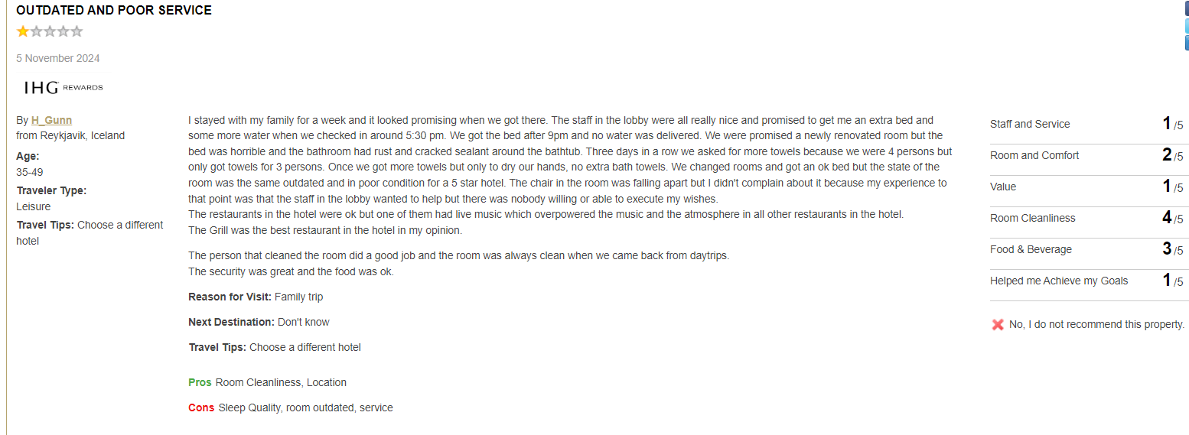
(Intercontinental Cairo Semiramis, Reviews, 2024).
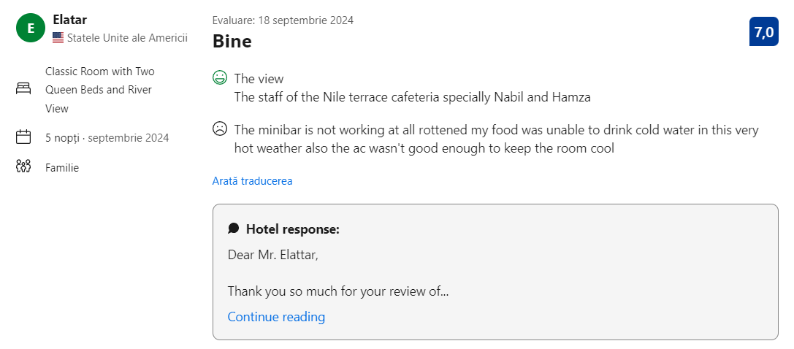 (Booking.com, 2024)
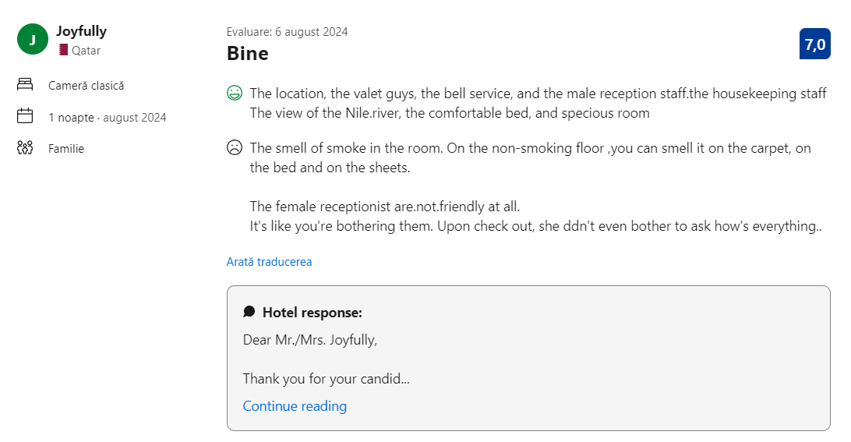
(Booking.com, 2024)
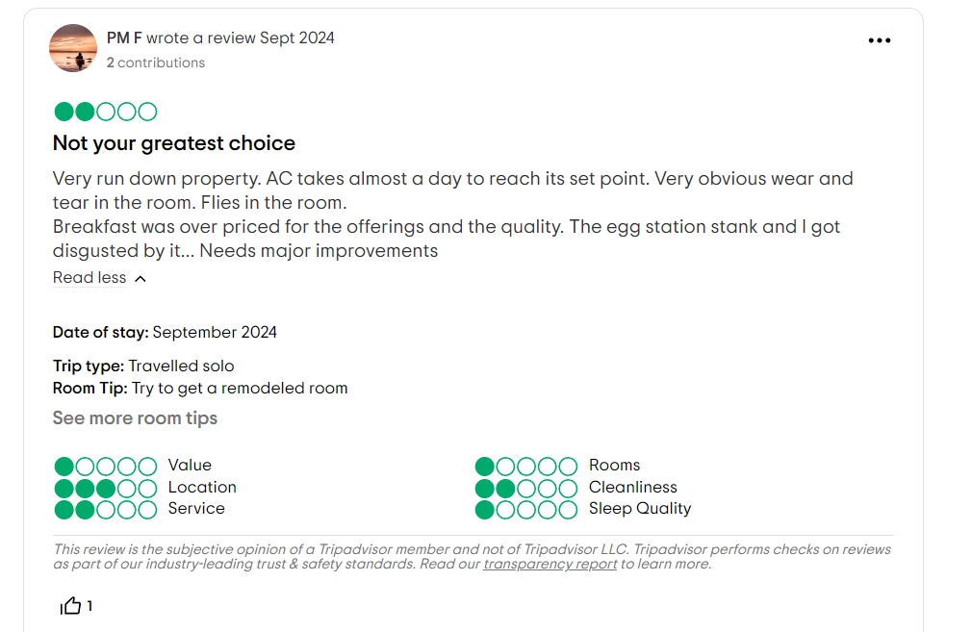
(TripAdvisor, 2024).

The causes of these problems can be multiple. The lack of consistent investments in modernisation is a key factor because the rooms and facilities have not been renovated at the pace required to meet the current hospitality standards. Moreover, inappropriate maintenance contributes to the constant deterioration of equipment and furniture and these deficiencies not only affect the guests’ experience but can also generate additional costs in the long term for repairs and replacements (Nalley, 2023).
Therefore, the problem of outdated rooms and facilities negatively affects both clients’ satisfaction and the hotel’s profitability. This aspect requires a strategic intervention to reestablish the quality standards of the hotel, thus improving the guests’ experience and protecting hotel’s reputation in face of a demanding clientele (Kim and Kim, 2022). This further analysis will explore these problems in-depth, offering applicable solutions to support InterContinental Cairo Semiramis in maintaining its leader position on Cairo’s luxury hospitality market.

The problem’s impact on the hotel

The problems regarding outdated rooms and facilities from InterContinental Cairo Semiramis affect the hotel on many key plans.
- Reputation. The negative feedback on popular platforms such as Booking.com and TripAdvisor significantly impacts the public image of the hotel. Clients repeatedly mention problems regarding rooms’ conditions, such as inappropriate climatization and unpleasant smells. These negative reviews are easily accessible to potential clients, which reduces trust and makes the hotel less appealing to those who are looking for luxury experiences. In the hospitality industry, where reputation can determine clients’ choices, this negative feedback contributes to a negative general perception of the hotel (Meng et al., 2018), (Gabbard, 2023).
- Incomes. A low level of client satisfaction directly affects occupancy and income. Unhappy clients are less willing to come back and can discourage potential visitors through their feedback. The hotel risks losing not just loyal clients, but also new guests who look for high-quality alternatives. Moreover, an affected reputation can force the hotel to offer discounts to attract clients, which can negatively affect long-term profitability (Nobar and Rostamzadeh, 2018).
- Scope. Problems regarding rooms’ quality also influence other critical areas, such as occupancy rates and incomes from events. In a top location such as Cairo, the demand for luxury hospitality is high and the problems regarding clients’ comfort threaten the hotel’s ability to compete efficiently. A low occupancy rate, caused by negative feedback and lack of modernisation, affects the hotel’s capacity to generate consistent incomes and position as a top destination for tourists and businesspeople that are looking for a high-quality experience (Abdelwahab and Mohammad, 2014).

The causes of the problem

The problems that InterContinental Cairo Semiramis deals with are the result of many fundamental causes that contributed to the current state of the rooms and facilities.
- The lack of investments in modernisation. A possible cause is the fact that the hotel did not allocate enough resources to renovate and modernise the rooms over time.
The hospitality industry is extremely competitive and the luxury standards evolve very quickly. Without periodic investments in improvements, the rooms and facilities are becoming outdated which can generate a less satisfying experience for guests. Constant modernisation is essential to stay relevant and to offer guests the expected comfort (Karagiannis, 2024), (Truong et al., 2020).
- Proper maintenance. Another major cause is the lack of an efficient maintenance programme. The problems such as non-functional air conditioners and faulty minibars indicate a poor-managed maintenance system. Inappropriate equipment not only reduces the guests’ comfort but, at the same time, inappropriate maintenance can lead to bigger costs for major repairs or complete replacements, which affect the operating budget of the hotel (Chan, 2024).
- Costs’ management. The financial decisions, such as prioritising other investments over room renovation can be another important factor. Luxury hotels often allocate financial resources to expand other services or facilities that can attract more clients, such as restaurants and event spaces. However, neglecting guests’ rooms which are essential for the basic comfort of guests, can directly affect the level of satisfaction and their return, negatively influencing the long-term profitability of the hotel (Ivanov, 2014).

PESTLE Analysis

The PESTLE analysis evaluates the political, economic, social, technological, ecological and legal influences on an organisation (CIPD, 2024). In this context, it is crucial for InterContinental Cairo Semiramis because it offers a complete perspective on the external factors that affect the hospitality industry. This allows the hotel to identify external challenges and opportunities, contributing to creating a modernisation strategy adapted to the local and international context.
Factor | Description
Political | Political instability in Egypt can discourage international tourists and influence the hospitality industry, affecting safety and business regulations. The hotel needs to be prepared to answer to political changes, adapting to the possible new legislative requirements and the impact on tourism demand.
Economic | The inflation and exchange rate volatility directly affects the hotel’s income. The low buying power and economic instability limit the tourists’ budgets, influencing their capacity to choose luxury hotels. The hotel needs to stay competitive, adapting itself to attract clients with relevant offers in a dynamic economic context.
Social | The clients’ expectations are higher, especially following the COVID-19 pandemic. The guests pay a lot of attention to comfort, hygiene and air quality. The hotel needs to constantly improve its facilities, including modern hygiene facilities and efficient climatization systems to satisfy the modern requirements of demanding clients.
Technological | The new technologies from the hospitality industry, such as optimisation and energy-saving solutions can improve clients’ experiences and reduce operational costs. Implementing some efficient climatization equipment and smell control solutions can raise the hotel’s standards, contributing to a more attractive luxury experience.
Ecologic | The trends towards sustainability influence tourists’ preferences. The hotel can earn a positive image by adopting eco-friendly measures, such as minimizing energy consumption and optimising waste management. Modernisations can be done with a minimum impact on the environment, aligning with the increasing sustainability expectations.
Legal | The hotel needs to respect local and international regulations, including health and safety standards. These require continuous investments in facilities and equipment to maintain compliance. The strict safety and hygiene norms, frequently updated, need quick adaptation to make sure that the guests have a safe and pleasant experience.
(GBR Editorial Team, 2022), (Swot&Pestle IHG, 2017), (Adamkasi, 2016).

SWOT Analysis

SWOT analysis identifies the strengths, weaknesses, opportunities and threats of an organisation, offering a complete image of the current situation (Schooley, 2024). In the InterContinental Cairo Semiramis context, SWOT is essential to understand the competitive advantages of the hotel and areas of improvement.
Strengths
- Strategical location. Situated on the Nile’s bank, the hotel offers a unique view and easy access to the main attraction in Cairo, which makes it appealing to tourists and business guests.
- Professional staff. Employees are well trained and offer excellent services, which contribute to a positive experience for clients.
- Solid reputation. The hotel is popular with business guests for its services and facilities.
Weaknesses
- Outdated rooms. The rooms’ facilities are outdated and do not meet anymore the current standards, which can decrease clients’ satisfaction.
- Inappropriate maintenance. Defect equipment and deficiencies in maintenance affect the general comfort, contributing to negative feedback.
- Guests’ experience. The lack of modernisation affects the luxury image of the hotel and the general experience of guests.
Opportunities
- Modernisation. Investments in renovating the rooms and facilities can improve comfort and the hotel’s attractiveness, attracting more guests.
- Attracting new clients. A modernisation can attract tourists and businesspeople that are looking for superior accommodation standards.
- Growth of luxury tourism. The demand for luxury tourism is growing and the hotel can take advantage of this trend by improving the offers and services.

Threats
- Intense competition. Other luxury hotels in Cairo offer modern facilities, which increases the risk of losing clients.
- Negative feedback. The negative feedback negatively influences the booking decisions, affecting the occupancy rate and income.
- Impact on occupancy rates. The lack of modernisation and fierce competition can lead to a drop in occupancy rates, thus affecting the long-term viability of the hotel (IHG Hotels, 2023), (Gowrea, 2018).

TOWS Analysis

TOWS analysis for Intercontinental Cairo Semiramis suggests clear strategies that value the strengths and manage weaknesses, offering a framework for increasing competitiveness and improving guests’ experience (OXFORD COLLEGE OF MARKETING, 2018).
- SO strategies (strengths + opportunities). By modernising the rooms, the hotel can attract new clients, using its central location and current popularity. The modernisation will consolidate the reputation as a luxury destination, answering the growing demand for modern facilities. Moreover, promoting the location and unique views can amplify the hotel’s attractiveness, helping it to stay competitive (de Bruin, 2019).
- ST strategies (strengths + threats). The hotel can face competition by improving its facilities and offering premium experiences. For example, renovating the spa and fitness centres could attract guests who are looking for complete leisure services. Modernising these areas, together with the rooms, can contribute to more satisfied guests and positive feedback, thus consolidating the competitive advantage of the hotel (VisualParadigm, 2023).
- WO strategies (weaknesses + opportunities). In order to exploit the growing demand for comfort and hygiene, the hotel could invest in repairs and maintenance, improving rooms’ facilities. Updating the equipment and improving cleanliness will create a comfortable environment, attracting tourists who are looking for modern accommodation. Moreover, implementing new technologies can offer added attractiveness (Dieffenbacher, 2023).
- WT strategies (weaknesses + threats). Renovating rooms can reduce the negative feedback’s impact and can attract more clients that otherwise would choose the competition. By approaching the identified deficiencies, the hotel will ensure a constant qualitative experience, thus limiting the impact of competition and improving the occupancy rate (Jonathan, 2023).

Recommendations and Change Management

Change management refers to periods of upheaval when drastic action is necessary for an organisation's survival and prosperity. Change is transitioning from a current state to a desired outcome (Cameron, Green and Davies, 2020).

Facilities modernisations and recommendations for improvement

In order to increase guests’ satisfaction and improve the hotel’s reputation, there are necessary investments in rooms and facilities modernisation. These detailed recommendations are created to increase hosts’ comfort, reduce negative feedback and attract more clients from the premium segment.
- Rooms’ renovation
Rooms’ renovation is a priority to improve the guests’ experience and align with the current expectations of the luxury market. There are recommended next updates:
- Furniture. Replacing the old furniture with modern, ergonomic and high-quality pieces that add a note of luxury and comfort. The chosen furniture should be durable and easy to maintain, making sure it satisfies the guests’ functional and aesthetic needs (Dastan, 2023).
- Air conditioner and climatization equipment. Installing some new, efficient and energetically efficient air conditioning systems is essential, especially in the climatic context of Cairo. Modern equipment will improve thermal comfort and will reduce maintenance costs (Niza et al., 2022).
- In-room technologies. It is recommended to install modern TVs, with intelligent functions, such as charging facilities for mobile devices, thus offering guests access to last-generation technology. These kinds of improvements answer to the needs of guests who want a comfortable and convenient environment (Mbarushimana, 2024).
Complete renovation of the rooms will reduce negative feedback regarding comfort and will attract tourists who are looking for a premium experience. Moreover, modernised rooms will allow the hotel to adjust its prices, justifying bigger prices due to superior accommodation standards (El-Sayed, Abdelkawi and Abed, 2023).
- Improving maintenance quality
It is recommended to implement a preventive maintenance programme to ensure the optimal functioning of equipment and to prevent unseen problems. This programme will include:
- Periodic inspections of essential systems, such as air conditioning installations, household tools and electric equipment. A dedicated maintenance team can identify and solve the problems before they affect the guests (Dr Mohammad Najafi, 2024).
- Periodic reviews of equipment and rooms’ facilities, as well as public facilities. This kind of programme will allow the hotel to maintain a high-quality standard and optimise long-term reparation costs (Green, 2023).
- Training the staff on inefficient maintenance techniques to quickly detect problems and to intervene proactively.
Improved quality maintenance will reduce the risk of equipment failure and will offer guests a fuller and more comfortable experience.
- Modernising common spaces
In order to create a unitary luxury experience, it is recommended to modernise common spaces, including:
- Lobby. A modern lobby with elegant furniture, a well-projected lightning system and exquisite décor will create a strong first impression for guests. Adding some relaxation and socialization spaces will encourage the guests to spend more time in the hotel (William, 2024).
- Restaurants and relaxation area. Modernising the restaurants with comfortable furniture updated interiors and modern equipment in the kitchen will support guests who look for a luxury culinary experience (Gössling and Michael Hall, 2021).
- Spa and fitness. Updating the wellness and fitness facilities will attract guests interested by complete relaxation services. It is recommended to use modern fitness equipment and eco-friendly options for energetic efficiency (Freitas and Lacerda, 2019).
Renovating the common spaces will consolidate the luxury image of the hotel and will create an environment that is both functional and aesthetically pleasing. This not only improves guests’ experience, but also the hotel’s position as a preferred destination in Cairo (Sharma, 2022).

Implementation strategies and changes in management procedures

In order for modernisations to be efficiently implemented and the transition to be as smooth as possible, it is essential to a detailed planning and efficient change management. These strategies include well-defined stages for implementation, staff training and approaching the change resistance.
The change leads to improved performance, and so the organisation’s future operational results are attained. Operations take place today and are about today. Consulting is completed now, but it is for tomorrow,

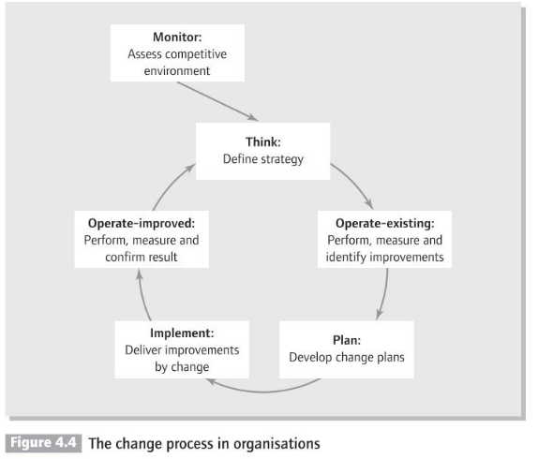
(Newton, 2010, p.65).
To improve process efficiency and eliminate defects by identifying and removing the causes of mistakes and variations utilising Six Sigma in process improvement and quality management- define, measure, analyse, improve, and control. Eliminate faults systematically to attain excellence (ÜLEN and GÜLMEZ, 2020). The hotel's sigma score and the level of expectation for service quality were compared, the variables that caused the low quality were determined, and the appropriate recommendations and suggestions were offered to the organisation.
Implementing TQM (Total Quality Management) -Improving quality, good services, quality production, quality management and customer satisfaction, integrating all organisational functions to focus on main principles: employee involvement, integrated system, continuous improvement, and communication (Hussain and Khan, 2020).

- Planning the implementation stages
The modernisation can be done in stages to minimize operational interruptions. This staged approach allows the hotel to continue to offer services to guests while the improvements are done. The plan is:
- Stage 1-Rooms’ renovation. In this first stage, the modernisation works will be focused on a complete renovation of rooms. These works could be done on floors, thus reducing the perturbations for guests staying in other parts of the hotel. Prioritising the rooms will allow the hotel to maintain a part of its operational capacity during renovations (Seacoast Construction, 2022).
- Stage 2-Modernising common spaces. After finishing the rooms, the common spaces, such as the lobby, restaurants and relaxation facilities will be modernised. In this stage, the hotel may temporarily close the common areas or it could gradually renovate to maintain the access of guests to some services (Parina, 2023).
These stages will allow the hotel to operate in parallel with modernisation works, maintaining the income and reducing the negative impact on clients’ experience.
- Staff commitment and training
In order to ensure a smooth transition, the staff needs to be informed regarding challenges and training to adapt to the new procedures and tasks. The recommended actions include:
- Clear communication. The staff needs to be updated with all changes details, from the new work programme to changes in responsibilities. The periodical informing sessions will be essential (Bucăţa and Rizescu, 2018).
- Training sessions. Training the staff to use the new equipment and answer to the needs of operational standards will increase efficiency. For example, the housekeeping team can be trained to use new products and equipment, adapting to the modernisation standards (Bagchi, 2023).
- Staff commitment. Encouraging the staff to actively participate in the changing process can reduce resistance and increase enthusiasm. Through brainstorming sessions, the staff can offer ideas to improve the transition, thus increasing the feeling of ownership and involvement (George and Massey, 2020).

- Change resistance management
The changes can generate resistance, so a well-defined management strategy is crucial. This includes:
- Open feedback and communication. It is essential to collect periodic feedback from employees to understand the possible challenges and to solve them quickly. The hotel can organise bi-monthly feedback sessions to discuss the progress and address the concerns of the staff (Michalis, 2024).
- Support for employees. Managers can offer emotional and professional support to employees affected by changes, including coaching or counselling sessions. The staff needs to feel supported to quickly adapt to the new conditions (Wu et al., 2021).
- Recognition programme. Recognising and rewarding employees that actively contribute to the success of transition is essential. Through recognition programmes, such as giving bonuses or distinctions for performance, the staff will be motivated to actively participate or adapt to the new changes (Yang, Jiang and Cheng, 2022).
These strategies will facilitate the transition and will help the hotel to successfully implement the modernisations while maintaining a positive and supportive work environment for employees.

Impact evaluation and success measurement

In order to determine to recommendations’ efficiency, it is essential to implement clear evaluation methods and monitor the change's impact on clients’ experiences, operations and incomes. These measurement tools will allow the hotel to track the progress and make adjustments if necessary.
- Key performance indicators (KPI)
It is suggested that some specific KPIs be used to evaluate the success of implementing the recommendations.
- Clients’ satisfaction rate. This can be measured through post-accommodation surveys, collecting feedback about rooms, facilities and service quality.
- Occupancy rate. Its growth indicates an increased attractiveness of the hotel following the modernisation. The occupancy rate can be monthly monitored to follow the trends.
- Positive feedback. The feedback’s number and pattern are strong indicators of improved guest experience. An increase in positive feedback is a sign of modernisation’s efficiency.
- Clients’ loyalty. The returning rate of clients is essential and its increase indicates a positive experience that inspires loyalty (Brown, 2021), (O’Brien, 2022).

- Periodic evaluation of clients’ satisfaction
Clients’ satisfaction needs to be monitored constantly through online surveys and feedback. The hotel can implement post-accommodation feedback surveys, addressing questions regarding rooms’ quality, facilities and services. Moreover, direct feedback can be collected through online surveys or mobile applications, allowing a detailed analysis of guests’ experiences. The monthly satisfaction reports and periodical analysis of feedback allow the hotel to track the improvements and adjust processes, if necessary, to ensure an optimal experience for guests (VO, Chovancová and Tri, 2019).

- Finances’ monitorization
In order to evaluate the financial impact of modernisation, it is recommended continuous monitoring of incomes and savings is done following the implementation. It is suggested to track the return on investment (ROI) for each modernisation stage. Comparing the monthly and seasonal incomes before and after implementation, the hotel can observe growing trends. Moreover, the saved costs through preventive maintenance and reduced need for major repairs can contribute at increasing the profitability in the long-term, confirming the efficiency of the modernisation strategy (Rafique, 2024).

Potential benefits of recommendations

Implementing the recommendations will bring significant benefits to the InterContinental Cairo Semiramis hotel, from the guests’ satisfaction and income growth to optimise operational costs in the long term.

- Improving clients’ satisfaction
Modernising the rooms and common facilities will significantly contribute to increasing clients’ satisfaction. The guests will benefit from more comfortable rooms, modern amenities and improved facilities, all these being essential for a premium experience. These improvements will reduce the negative feedback, thus building a positive image on the feedback platforms. A renovated hotel attracts better recommendations and more bookings from happy clients, thus stimulating organic marketing. In an industry where feedback strongly influences the clients’ choices, a solid reputation will attract more guests in the long term (Ali et al., 2021), (Selander, 2024).

- Increasing the occupancy rate and incomes
Modern amenities and an updated luxury standard will make the hotel more appealing to guests, leading to a growth in the occupancy rate. Rooms and common spaces modernisation will allow the hotel to improve the prices per room, thus increasing the medium incomes. Clients are willing to pay more for comfort and superior experience and by adapting to the market’s expectations, the hotel will efficiently compete with other luxury locations in Cairo. This will increase profitability, allowing the hotel to reinvest in improvements and maintain its top market position (Heo and Hyun, 2015).

- Streamlining the operational costs
Implementing a preventive maintenance programme and replacing old equipment with some modern and energetically efficient ones will contribute to reducing unplanned repair costs. Moreover, the modern air conditioning equipment and updated technological systems are less likely to need frequent repairs, maintaining the operational costs low. In the long-term, these measures will optimise the energetic efficiency and reduce resource waste, continuing to the hotel’s financial sustainability. The hotel will thus allocate more resources for continuous improvements and to maintain a high-quality level of services (Katz, 2024), (Wu, 2024).

Costs’ estimation and financial implications

The implementation of modernisation recommendations and operations’ streamlining will require a significant budget. This section details the main categories of costs and highlights the importance of evaluating rentability to assure investments’ success.

- Renovation and modernisation costs
Complete renovation of the rooms and common spaces requires a considerable investment. The expenses include costs for luxury furniture, modern climatization equipment, advanced technology and interior design. Depending on the total number of rooms and size of common spaces these costs will vary. It is recommended to allocate a detailed budget, taking into consideration a medium renovation cost per room that covers all necessary amenities. The hotel needs to prioritise renovations that can generate the quickest growth of occupancy rate and clients’ satisfaction, thus recovering a part of costs through bigger prices (Piorkowski, 2020), (Sara, 2023).

- Staff training and maintenance costs
The implementation of a preventive maintenance programme will require initial spending for creating a plan and buying the necessary equipment. However, the long-term costs will be reduced because all unplanned reparations will drop. Moreover, staff training is essential to adapt to the new procedures and equipment, assuring efficient and qualitative maintenance. The training costs include specialised resources and sessions that will support the staff in understanding and proper implementation of changes (Eisner, 2022).

- Rentability evaluation
To evaluate the investments’ efficiency, it is required a financial feasibility study, focused on the return on investment (ROI) and recovery period. By calculating ROI, the hotel can determine if the investments are justified concerning anticipated incomes. The increased occupation rates, together with bigger prices, will contribute to investment’s recuperation. Moreover, well-planned modernisations will allow the hotel to stay competitive in the long term, thus increasing the financial stability and improving the general profitability (Fernando, 2024), (Elphick, 2023).

Action plan

This action plan details the proposed solutions for hotel modernisation to improve guests’ experience, optimise costs and increase competitivity. Each action is aligned with the identified problems, having clear objectives, precise deadlines and a planned budget for efficient implementation.
Strategic planning is a methodical process for defining the organisation's direction, setting priorities, and aligning resources to achieve long-term objectives. It entails assessing internal and external issues, identifying opportunities, and developing action plans. Embracing strategic planning can improve decision-making, manage risk, and advance long-term goals (Bryson, 2018).

Number | Problem | Solution | Wanted result | Duration | Completion date | Planned budget
1 | Out-dated rooms and used equipment | Complete renovation of the rooms, including furniture replacement, installing efficient air conditioners and equipping them with modern technology such as smart TVs and adjustable lighting systems | Increased guests’ satisfaction and reducing the negative feedback regarding comfort, increasing attractiveness for premium customers | 6 months | 30/06/2025 | ₤2.000.000
2 | Poor quality of maintenance and repairs | Implementing a preventive maintenance programme with periodical inspections of essential equipment and systems to prevent their failure | Reducing unplanned repairs costs and improving guests’ experience by assuring a constant functionality of equipment and room facilities | 3 months | 31/03/2025 | ₤150.000
3 | Unattractive common spaces | Modernising the lobby, restaurants and leisure areas through contemporary decors and implementing advanced technologies, such as smart lightning system and redesigned social areas | Improving the first impressions and offering an attractive and comfortable environment for guests, consolidating the hotel’s reputations as a luxury destination | 5 months | 31/05/2025 | ₤1.000.000
4 | Lack of staff training and adaptation | Organising training sessions for staff for using new equipment and familiarizing with the new maintenance procedures, so that the staff can offer superior quality services | Creating an efficient and adaptable work environment, assuring a smooth transition and high performance of staff in the new modernized operational context | 2 months | 28/02/2025 | ₤50.000
5 | Evaluating the investments’ success | Conducting a feasibility study and monitoring the KPIs, including clients’ satisfaction, occupancy rates and return on investment to evaluate modernizations’ efficiency | Assuring a constant monitorization of efficiency and investments’ rentability, allowing proactive adjustments to achieve the long-term financial and operational objectives | Continuous | Continuous evaluation | ₤25.000 (annually)
(Elphick, 2017), (CSP Building Experience, 2024), (Hollander, 2024).
Each solution is aligned to the hotel’s objectives to improve guests’ experience, increase incomes and optimise costs. Moreover, the plan includes details about the expected results, implementation period, completion dates and estimated costs.

Conclusion

In conclusion, the detailed analysis of InterContinental Cairo Semiramis highlighted a series of opportunities to improve guests’ experience and optimise operations. The key problems identified include outdated rooms, inappropriate maintenance and the lack of modernisation of common spaces. These aspects affect both clients’ satisfaction and competitiveness in a dynamic and ever-growing market. The research started and implemented methods to identify the problems, root cause analysis, Six Sigma, 5 Ways techniques along with TQM strategies for continuous improvement initiatives and measuring success, in implementing strategic planning to achieve long-term goals.
The recommendations presented in this report focus on complete modernisation of rooms and common space, implementing a preventive maintenance programme and improving staff training. These actions are essential to increase the hotel’s attractiveness to clients from the premium segment and to improve operational efficiency. By renovating the rooms and upgrading them with modern equipment, the hotel will offer a high standard of comfort, assuring guests an accommodation experience in line with a luxury hotel.
Moreover, implementing a preventive maintenance programme will reduce long-term repair costs and will ensure the constant functioning of equipment. The training sessions for the staff are crucial to facilitate the transition towards the new operational procedures and to ensure an adaptable and efficient work environment. These investments in staff are fundamental for long-term success because trained and motivated staff directly contribute to creating a high-quality experience for guests.
Besides operational benefits and guests’ satisfaction, these recommendations will have a positive financial impact by increasing the occupancy rate and income. The hotel will attract more clients from the luxury segment, justifying the bigger prices for modernised rooms. Moreover, optimising the costs through preventive maintenance and the use of energetically efficient equipment will contribute to an increase in profitability in the long term.
Besides the main recommendations, highlighting the importance of continuing to monitor the impact of these modernisations on operations and clients’ satisfaction. The hotel needs to implement periodic evaluations, using key performance indicators, such as occupancy rate, clients’ feedback and return on investment. These evaluations will offer a clear image of the strategies’ efficiency and will allow prompt adjustments, if necessary.
At the same time, highlight the fact that the investment in updating equipment and infrastructure not only will improve service quality but will also contribute to increasing operational sustainability. Reducing the costs by using energetically efficient equipment will contribute to a sustainable future and the hotel will benefit from long-term economies.
Appreciating the opportunity to contribute to improving the experience offered by the hotel Optima Consultant self-assured that implementing these recommendations will bring significant benefits. Strongly believe that the proposed approach will support the hotel’s position as a top destination in Cairo, offering the guests a memorable luxury experience.
The proposal report will offer a clear and practical vision of the steps to modernise the hotel, expressing our desire to continue this collaboration and to be your trusted partner in future development initiatives. Through a common commitment and engagement for quality and innovation, we are prepared to support InterContinental Cairo Semiramis Hotel in achieving its strategic objectives and maintaining its leading reputation in the hospitality industry.

References

Abdelwahab, A. and Mohammad, A. (2014) Managing Demand for Hotel Establishments during Downturn Times and their Impact on Hotel Revenues: A Case Study of Cairo Hotels. Available at: https://www.mybib.com/#/projects/VKqRP2/citations/new/webpage (Accessed: 15 October 2024).
Adamkasi (2016) PESTEL/PESTLE Analysis of Egypt. Available at: https://freepestelanalysis.com/pestelpestle-analysis-of-egypt/.
Ali, B.J., Gardi, B., Othman, B.J., Ahmed, S.A., Ismael, N.B., Hamza, P.A., Aziz, H.M., Sabir, B.Y., Sorguli, S. and Anwar, G. (2021) ‘Hotel service quality: The impact of service quality on customer satisfaction in hospitality’, International Journal of Engineering, Business and Management, 5(3), pp.14–28. Available at: https://doi.org/10.22161/ijebm.5.3.2.
Bagchi, R. (2023) The Crucial Role of Continuous, Well-Planned On-the-Job Training in Running a Successful Housekeeping Operation in a Hotel. Available at: https://www.linkedin.com/pulse/crucial-role-continuous-well-planned-on-the-job-training-rajat-bagchi-zhycf/ (Accessed: 16 October 2024).
Booking.com (2024) InterContinental Cairo Semiramis, an IHG Hotel. Available at: https://www.booking.com/hotel/eg/intercontinental-cairo-semiramis.ro.html#tab-reviews (Accessed: 11 October 2024).
Bryson, J.M. (John M. (2018) Strategic planning for public and nonprofit organizations: a guide to strengthening and sustaining organizational achievement. Fifth edition. Hoboken, New Jersey: Wiley.
Brown, T. (2021) 7 most important hotel KPIs in the hospitality industry. Available at: https://www.mews.com/en/blog/hotel-industry-kpis.
Bucăţa, G. and Rizescu, A.M. (2018) ‘The Role of Communication in Enhancing Work Effectiveness of an Organization’, Land Forces Academy Review, 22(1), pp.49–57. Available at: https://doi.org/10.1515/raft-2017-0008.
Cameron, E., Green, M. and Davies, M. (2020) Making sense of change management: a complete guide to the models, tools and techniques of organizational change. Fifth edition. London; Kogan Page.
Canva (2024) Optima Consultant Logo. Available at: https://www.canva.com/design/DAGVtVRyTZw/8kGH2PT_75whcw57cgfp2w/edit (Accessed: 6 November 2024).
Chan, J. (2024) What is Hotel Maintenance? Available at: https://limblecmms.com/maintenance-definitions/hotel-maintenance/ (Accessed: 5 November 2024).
CIPD (2024) PESTLE Analysis. Available at: https://www.cipd.org/en/knowledge/factsheets/pestle-analysis-factsheet/ (Accessed: 5 November 2024).
CSP Building Experience (2024) A Comprehensive Guide to Successful Hotel and Guest House Renovations. Available at: https://cspbuilds.com/a-comprehensive-guide-to-successful-hotel-and-guest-house-renovations/ (Accessed: 21 October 2024).
Dastan, B. (2023) Choosing the Right Hotel Furniture: Best Choice. Available at: https://busedastan.com/choosing-the-right-hotel-furniture/ (Accessed: 21 October 2024).
de Bruin, L. (2019) SWOT Analysis (and TOWS Matrix) EXPLAINED with EXAMPLES | B2U. Available at: https://www.business-to-you.com/swot-analysis/ (Accessed: 1 November 2024).
Dieffenbacher, S.F. (2023) TOWS Matrix Explained: How to Make Informed Business Decisions. Available at: https://digitalleadership.com/unite-articles/tows-matrix/ (Accessed: 1 November 2024).
Dr. Mohammad Najafi (2024) The Importance of Periodic Inspection of Electrical Systems. Available at: https://www.linkedin.com/pulse/importance-periodic-inspection-electrical-systems-mohammad-najafi-dtrce/ (Accessed: 21 October 2024).
Eisner, C. (2022) How To Create A Preventive Maintenance Plan. Available at: https://www.getmaintainx.com/blog/preventive-maintenance-plans (Accessed: 5 November 2024).
El-Sayed, S.F., Abdelkawi, A.H. and Abed, M.A.A. (2023)’ Hotels’ Renovation Effect on Customers’ Loyalty and Occupancy Rates’, The International Journal of Tourism and Hospitality Studies, 4(2), pp.89–102. Available at: https://doi.org/10.21608/ijthsx.2023.195770.1052.
Elphick, D. (2017) Hotel renovation and remodelling on a budget. Available at: https://www.littlehotelier.com/blog/running-your-property/renovate-bnb-budget/ (Accessed: 3 November 2024)
Elphick, D. (2023) Hotel investment: What is a good ROI for a hotel? Available at: https://www.littlehotelier.com/blog/increase-your-revenue/hotel-investment/(Accessed: 3 November 2024).
Fernando, J. (2024) Return on investment (ROI): How to calculate it and what it means. Available at: https://www.investopedia.com/terms/r/returnoninvestment.asp (Accessed: 25 October 2024).
Freitas, A.L.P. and Lacerda, T.S. (2019) ‘FITNESS CENTERS: WHAT ARE THE MOST IMPORTANT ATTRIBUTES IN THIS SECTOR?’, International Journal for Quality Research, 13(1), pp.177–192. Available at: https://doi.org/10.24874/ijqr13.01-11.
Gabbard, D. (2023) ‘The Impact of Online Reviews on Hotel Performance’, Journal of Modern Hospitality, 2(1), pp.26–36. Available at: https://doi.org/10.47941/jmh.1558.
GBR Editorial Team (2022) External Environmental Analysis Of InterContinenal (IHG) Hotels And Resorts. Available at: https://www.george-business-review.com/external-environmental-analysis-of-intercontinenal-ihg-hotels-and-resorts/ (Accessed: 22 October 2024).
George, V. and Massey, L. (2020) Proactive Strategy to Improve Staff Engagement. 18(6), pp.532–535. Available at: https://www.ncbi.nlm.nih.gov/pmc/articles/PMC7516666/.
Ghantous, R. (2024) Key figures and insights: Egypt’s hospitality scene. Available at: https://www.hospitalitynewsmag.com/the-hospitality-landscape-in-egypt/ (Accessed: 5 November 2024).
Gössling, S. and Michael Hall, C. (2021) The Sustainable Chef. Available at: https://doi.org/10.4324/9781315187488.
Gowrea, V. (2018) SWOT analysis of InterContinental Hotels Group Plc |. Available at: https://www.howandwhat.net/swot-analysis-intercontinental-hotels-group-plc/.
Green, D. (2023) Hotel Preventive Maintenance Checklists: A Complete Guide. Available at: https://www.clickmaint.com/blog/hotel-preventive-maintenance-checklist (Accessed: 22 October 2024).
Heo, C.Y. and Hyun, S.S. (2015) ‘Do luxury room amenities affect guests’ willingness to pay?’, International Journal of Hospitality Management, 46, pp.161–168. Available at: https://doi.org/10.1016/j.ijhm.2014.10.002.
Hollander, J. (2024) 8 Smart Hotel Room Gadgets That Every Property Should Have. Available at: https://hoteltechreport.com/news/smart-hotel-gadgets (Accessed: 11 October 2024).
Hussain, M. and Khan, J. (2020) ‘KEY SUCCESS FACTORS OF TOTAL QUALITY MANAGEMENT (TQM) FOR THE HOSPITALITY SECTOR. A CRITICAL REVIEW OF THE LITERATURE’ Available at: https://www.researchgate.net/publication/343398746_KEY_SUCCESS_FACTORS_OF_TOTAL_QUALITY_MANAGEMENT_TQM_FOR_THE_HOSPITALITY_SECTOR_A_CRITICAL_REVIEW_OF_THE_LITERATURE European Journal of Hospitality and Tourism Research Vol.8, No.2, pp.1-17, July 2020, Published by ECRTD-UK.
IHG Hotels (2023) InterContinental Hotels Group SWOT Analysis Sample UK. Available at: https://www.studentsassignmenthelp.co.uk/answers/intercontinental-hotels-group-uk-swot-analysis/.
Intercontinental Cairo Semiramis (2024) Reviews. Available at: InterContinental Cairo Semiramis Reviews (ihg.com) (Accessed: 5 November 2024).
Intercontinental Hotels&Resorts (2024) InterContinental Cairo Semiramis. Available at: https://www.ihg.com/intercontinental/hotels/us/en/cairo/croha/hoteldetail (Accessed: 11 October 2024).
Ivanov, S. (2014) Hotel Revenue Management: From Theory to Practice. Zangador.
Jonathan (2023) Understanding TOWS Analysis: A Comprehensive Guide to Strategic Planning. Available at: https://simplifyingmarketing.com/tows/ (Accessed: 25 October 2024).
Karagiannis, M. (2024) The Evolution of Guest Expectations in the Hotel Industry. Available at: https://medium.com/hotel-tech/the-evolution-of-guest-expectations-in-the-hotel-industry-a4fbce9fa257.
Katz, E. (2024) 6 Essentials for a Preventative Maintenance Program. Available at: https://wint.ai/blog/6-essentials-for-a-preventative-maintenance-program/ (Accessed: 21 October 2024).
Keith (2024) PESTEL Analysis for Hotel Industry - PESTLE ANALYSIS OF COMPANIES AND BRANDS. Available at: https://pestelanalysis.education/pestel-analysis-for-hotel-industry/.
Kim, Y.-J. and Kim, H.-S. (2022) ‘The Impact of Hotel Customer Experience on Customer Satisfaction through Online Reviews’, Sustainability, 14(2), p.848.
Kipping, M. et al. (2012) The Oxford Handbook of Management Consulting. 1st edn. Oxford: Oxford University Press. Available at: //doi.org/10.1093/oxfordhb/9780199235049.001.0001.
LinkedIn (2024) How can you design a visually appealing and professional consulting report? Available at: https://www.linkedin.com/advice/0/how-can-you-design-visually-appealing-professional (Accessed: 6 November 2024).
MarketLine Advantage (2024) Hotels & Motels in Egypt. Available at: https://advantage-marketline-com.ezproxy.uwtsd.ac.uk/Analysis/ViewasPDF/egypt-hotels-motels-ml-223523 (Accessed: 1 November 2024).
Mbarushimana, S. (2024) ‘The Impact of Smart Room Technology on Guest Satisfaction and Operational Efficiency’, Journal of Modern Hospitality, 3(2), pp.1–13. Available at: https://doi.org/10.47941/jmh.1956.
Meng, F., Dipietro, R.B., Gerdes, J.H., Kline, S. and Avant, T. (2018) ‘How Hotel Responses to Negative Online Reviews Affect Customers’ Perception of Hotel Image and Behavioral Intent: An Exploratory Investigation’, Tourism Review International, 22(1), pp.23–39. Available at: https://doi.org/10.3727/154427218x15202734130422.
Michalis, B. (2024) Managing Hotel Staff | How to Manage Hotel Staff. Available at: https://www.canarytechnologies.com/post/managing-hotel-staff-guide(Accessed: 20 October 2024).
MindTools (2024) 5 Whys Root-Cause Analysis. Available at: https://www.mindtools.com/a3mi00v/5-whys (Accessed: 5 November 2024).
MordorIntelligence, (2024) Hospitality Industry in Egypt Market Size (2024 - 2029).
Available at: https://www.mordorintelligence.com/industry-reports/hospitality-industry-in-egypt/market-size (Accessed: 5 November 2024).
Nalley, S. (2023) Top 10 Reasons Why Hotel Investment Fail. Available at: https://medium.com/distressed-hotel-central/top-10-reasons-why-hotel-investment-fail-7b82b47ac20e (Accessed: 2 November 2024).
Niza, I.L., Luz, I.M. da, Bueno, A.M. and Broday, E.E. (2022) ‘Thermal Comfort and Energy Efficiency: Challenges, Barriers, and Step towards Sustainability’, Smart Cities, 5(4), pp.1721–1741. Available at: https://doi.org/10.3390/smartcities5040086.
Newton, R. (2010) The management consultant: mastering the art of consultancy. Harlow: Financial Times Prentice Hall.
Nobar, H.B.K. and Rostamzadeh, R. (2018) ‘The impact of customer satisfaction, customer experience and customer loyalty on brand power: Empirical evidence from hotel industry’, Journal of Business Economics and Management, 19(2), pp.417–430.
O’Brien, M. (2022) Metrics That Matter: Using KPIs as a Guide in the Hospitality Industry. Available at: https://www.netsuite.com/portal/resource/articles/business-strategy/hospitality-kpis.shtml (Accessed: 1 November 2024).
OXFORD COLLEGE OF MARKETING (2018) TOWS Analysis: A Step-by-Step Guide - Oxford College of Marketing Blog. Oxford College of Marketing Blog. Available at: https://blog.oxfordcollegeofmarketing.com/2016/06/07/tows-analysis-guide/(Accessed: 31 October 2024).
Papp, A. (2023) Hotel SWOT analysis: discovering improvement opportunities. Available at: https://www.sabeeapp.com/blog/hotel-swot-analysis (Accessed: 1 October 2024).
Parina, K. (2023) The Ultimate Guide To Hotel Renovations: Everything You Need To Know - Go Roboted. Available at: https://goroboted.com/the-ultimate-guide-to-hotel-renovations-everything-you-need-to-know/.
Piorkowski, J. (2020) Hoteliers regularly modernize their facilities to maintain a positive image and customer satisfaction. The costs of hotel renovation projects are constantly rising. Available at: https://www.linkedin.com/pulse/hotel-renovation-guide-rising-costs-jakub-piorkowski/ (Accessed: 29 October 2024).
Rafique, F. (2024) How to measure the ROI of banking Modernization Investments! Available at: https://www.linkedin.com/pulse/how-measure-roi-banking-modernization-investments-faizan-rafique-glujc/ (Accessed: 29 October 2024).
Sara, H. (2023) Custom Hospitality Furniture Manufacturer in USA - Sara Hospitality. Available at: https://sarahospitalityusa.com/blog/hotel-renovation-costs-per-room-economy-upscale-and-luxury-breakdown (Accessed: 11 October 2024).
Schooley, S. (2024) SWOT analysis: What it is and when to use it. Available at: https://www.businessnewsdaily.com/4245-swot-analysis.html (Accessed: 1 November 2024).
Seacoast Construction (2022) How to Navigate a Hotel Renovation Without Impacting Daily Operations. Available at: https://seacoastconstruction.net/how-to-navigate-a-hotel-renovation-without-impacting-daily-operations/ (Accessed: 31 October 2024).
Selander, F. (2024) How to improve customer satisfaction in the hospitality industry. Available at: https://www.lingio.com/blog/how-to-improve-satisfaction-in-hospitality (Accessed: 20 October 2024).
Sharma, N. (2022) Adapting Hotel Design to Meet the Ongoing Evolution of the Hospitality Industry. Available at: https://www.linkedin.com/pulse/adapting-hotel-design-meet-ongoing-evolution-industry-nikhil-sharma/ (Accessed: 11 October 2024).
Swot&Pestle IHG (2023) InterContinental Hotels Group (IHG) SWOT & PESTLE Analysis - SWOT & PESTLE.com. Available at: https://www.swotandpestle.com/inter-continental-hotels-group-ihg/ (Accessed: 20 October 2024).
TripAdvisor (2024) InterContinental Cairo Semiramis reviews. Tripadvisor. Available at: https://www.tripadvisor.co.uk/Hotel_Review-g294201-d299113-Reviews-or10-InterContinental_Cairo_Semiramis_an_IHG_hotel-Cairo_Cairo_Governorate.html (Accessed: 11 October 2024).
Truong, N., Dang-Pham, D., McClelland, R. and Nkhoma, M. (2020) ‘Exploring the Impact of Innovativeness of Hospitality Service Operation on Customer Satisfaction’, Operations and Supply Chain Management: An International Journal, 13(3), pp.307–319. Available at: https://doi.org/10.31387/oscm0420272.
ÜLEN, M. and GÜLMEZ, M. (2020) ‘SIX SIGMA APPROACH TO IMPROVE SERVICE QUALITY AND A PRACTICE STUDY IN HOSPITALITY SECTOR’, Business & management studies: an international journal, 8(3), pp. 3150–3182. Available at: https://doi.org/10.15295/bmij.v8i3.1555.
VisualParadigm (2023) Using TOWS Analysis to Develop Strategic Action Plans: A Comprehensive Guide for Businesses. Visual Paradigm Guides. Available at: https://guides.visual-paradigm.com/using-tows-analysis-to-develop-strategic-action-plans-a-comprehensive-guide-for-businesses/ (Accessed: 30 October 2024).
VO, N.T., Chovancová, M. and Tri, H.T. (2019) ‘The Impact of E-service Quality on the Customer Satisfaction and Consumer Engagement Behaviors Toward Luxury Hotels’, Journal of Quality Assurance in Hospitality & Tourism, 21(5), pp.1–25. Available at: https://doi.org/10.1080/1528008x.2019.1695701.
William, J. (2024) Professional Elegance: Crafting the Design of Hotel Lobbies and Reception Areas. Available at: https://www.linkedin.com/pulse/professional-elegance-crafting-design-hotel-lobbies-areas-william-vxnqc/ (Accessed: 20 October 2024).
Wu, A., Roemer, E.C., Kent, K.B., Ballard, D.W. and Goetzel, R.Z. (2021) ‘Organizational Best Practices Supporting Mental Health in the Workplace’, Journal of Occupational & Environmental Medicine, 63(12), pp.e925–e931. Available at: https://doi.org/10.1097/JOM.0000000000002407.
Wu, W. (2024) What is Preventive Maintenance? Types, Benefits, Cost, and Examples. Available at: https://coastapp.com/blog/preventive-maintenance/ (Accessed: 25 October 2024).
Yang, T., Jiang, X. and Cheng, H. (2022) ‘Employee Recognition, Task Performance, and OCB: Mediated and Moderated by Pride’, Sustainability, 14(3), p.1631. Available at: https://doi.org/10.3390/su14031631.

Appendix 1. The delivery stage consulting engagement
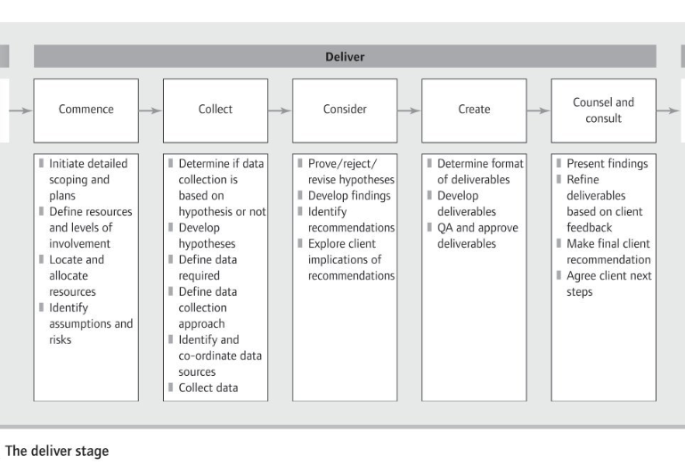
Regularly review the engagement plan and proposal

(Newton, 2010, p.131).

