UNIVERSITY OF WALES TRINITY SAINT DAVID (LONDON CAMPUS)
COURSE CODE LCMB7005
LEVEL 7
Strategic Change and Organisation
ASSSIGNMENT 1
ASSISGNMENT TITLE: Case Study: SoftBank acquisition of ARM Holdings
    - Evaluate and comment upon the strategic imperative behind the acquisition, from the view of Softbank?

    - Compare and evaluate the change implications from the viewpoints of ARM, and Softbank? (include changes in strategy, structure, org. culture, and any other elemental changes that you feel appropriate to consider)

Lecture: Professor Amare Desta
Student: Margaret Kyakunda
Student number: 1712816

Table of Contents
Introduction 3-4
Company overview Softbank Group Corp & ARM 4-5
Analysis & Overview of the Technology Industry 6
External Environmental 7
PESTEL Framework 7-9
Internal Analysis 9
SWOT Analysis 9
VRIO Framework 10-11
Strategic Imperatives of the Acquisition Softbank & ARM 12-17
Change Implications from viewpoints of Softbank & ARM 1-8-19
Post-Acquisition performance 20-21
Conclusion 22
Appendices 23-29
References 30-39

Introduction
In the competitive landscape, contemporary organisation environment of today has changed and new technologies have merged and emerging. Globalisation perspectives and industry boundary are blurrier than ever. Globalisation brought about the boost for cross- broader mergers and acquisition especially in the telecommunication sector pushing many Asian countries global. “Globalisation has played a factor for such companies as Softbank, a Japanese company emerge in markets that have traditionally been dominated by US and European competitors, the organisation adopted a global approach for international expansion”. (Lasserre, 2003, p. 17).
Japanese companies are using acquisition strategy to move into new markets and strengthen their global presence. Research done by Anon, (2020). available: www.pwc.com.au ‘unlocking Japans potential. Shows that in recent years, corporate Japan has been gradually accounting for a greater share of global mergers and acquisition due to the stagnate domestic market, and this trend of overseas acquisition is still growing due to the need of strong synergies.
SoftBank used acquisition as an instrument to double its global reach and competitiveness, in the pacific the doors opened in the 1997. (Lasserre, 2003, p. 134). The period between 1985-1990’s the largest amounts of overseas investment in the UK, was controlled by USA, Japanese, French, and German companies, who used mergers and acquisitions as a vehicle for investment, especially the technology industry has been the most popular industries for FDI in the UK as (Child et al. 2000) cited by Faulkner, D., Pitkethly, R., & Child, J. (2012-06-07).

Further suggestions of how it is reliable with a global strategy, overseas acquisitions increased drastically and helped local companies better fight against international rivals. “The acquisition strategy wave coincided with an increased economic globalisation and the technological revolution”(Martynova and Renneboog 2008) (p.25) cited by Kolev, K., Haleblian, J., & McNamara, G. (2012-06-07).
The acquisition of Arm limited well known top British designer of semiconductor chips was Europe’s biggest ever technology deal and to many business and technology insiders was the first time they have heard of SoftBank , an unknown Japanese telco a heavy weight global investor.

Softbank foresaw a paradigm shift in technology, and with the organisations desire to maintain its evolution by building ahead of potential competitors and SBG will pre-empt the imminent era of the internet of things (IoT). SBG firmly believes in singularity and believes that Artificial Intelligence (AI), will surpass human intelligence and will occur in this century and in its wake the greatest paradigm in history. www.softbank.com,(2020)
The first part of the case study will look at the background history of the two organisation’s ARM and SoftBank Group (SBG),overview of the Technology Industry, Internal & External environment analysis, Softbank’s strategic imperatives behind the acquisition, followed by the change implications from viewpoints of both organisations and finally the post-acquisition performance for both organisations.

Company Overview of Softbank Group Corp Softbank Group Corp
SoftBank Group Corporation is owned by Masayoshi Son a Japanese tech entrepreneur who is chairman and CEO of SoftBank Group Corp. (SBG). It is strategic holding company that invests in AI and other transformative technologies for the betterment of humanity. SBG invests in a partner with innovators that are building a more connected, efficient and joyful world. With its Vision Fund of $100 billion the conglomerate and the world largest technology investor, has a range of investment portfolios in internet-related companies which fit its strategic strong growth potential. (see figure 1).
Softbank Business Model
The company operates two business models:
- Operating Assets (chairman and support those companies’ operations)
- Investment Assets (SBG), does not own control but the largest shareholders and
- involved in long-term strategy refer to appendices for business segments in the group.
.
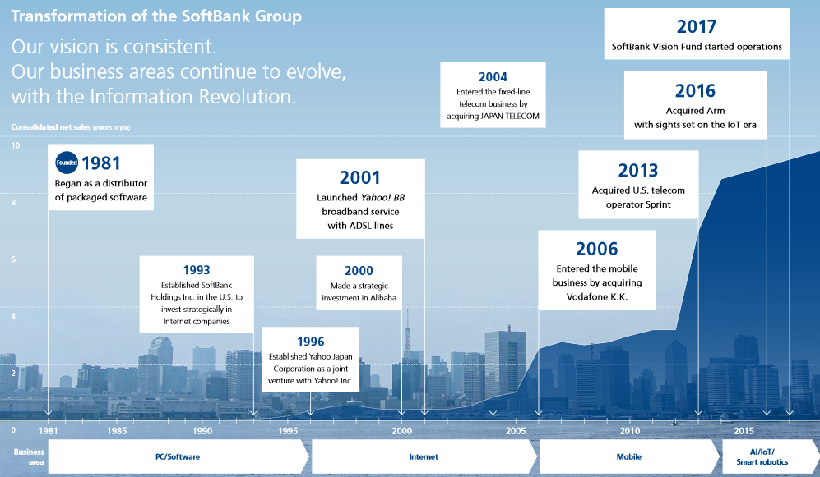
Fig.1 SoftBank diverse investment portfolio and evolution Source: www.softbank.com

Company Overview: ARM
Arm created in 1990 was a joint venture between Acorn Computer, Apple and a semiconductor manufacture VLSI Technology. The past 26 years have seen Arm turn int a billion-dollar company on the forefront of semiconductor industry worldwide. Refer to the Appendix. It should be noted that Arm does not manufacture semiconductors but designs and earns revenue by licencing the chips for a fee and earning royalty on each chip sold this makes the company unique and very efficient. Over the years there is an increase in Arm- based processors chips across the world and estimated to reach 1trillion by 2030. (refer to Figure 2)
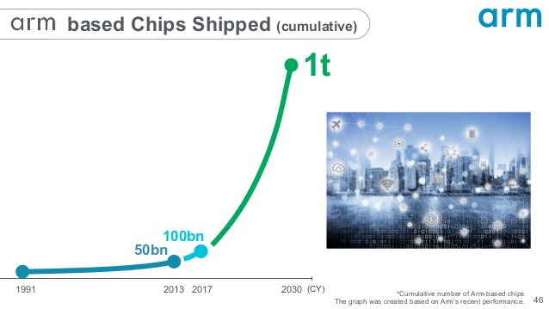Fig. 2 Source. www.softbank.com
Arm is now a subsidiary of SoftBank Group, after the historical acquisition in September 2016. (refer to figure 3)
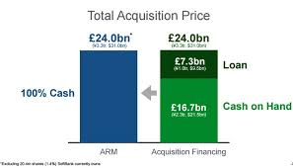
Fig 3 www.arm.com

Overview of the Technology Industry
The technology industry is known for its volatility than any other sector in the business environment. Businesses in this group must deal with effects of the broader economic cycle, due to fierce competition and new entrants and ever-changing customer behaviours in this sector shorten product cycles in the industry, leading too many to change company business models due to change in market needs. “SoftBank belongs to an industry characterized by extremely high-paced technological evolution. In the past 20 years, the ICT industry has seen the emergence of a series of new technologies for PCs, the internet, mobile phones, and smartphones, all of which have spread worldwide with an explosive speed”. cdn.softbank.jp/en/
The semiconductor company market is a prospective market with an expected revenue of over $800 billion by 2023. In the past years, the smartphone industry has grown very fast and right now it’s in the mature phase, and the driving force in the semiconductor market shifts to IoT market. With a huge demand for semiconductors ARM manufactures will be able to power-efficient systems on chips for smartphone and any other device that’s its them. With this big market. ARM could not have done it alone as its needs a lot of support and with accepting the deal from SBG which has the same vision was the best thing for the company to move forward.
This then leads to many opportunities, and most companies invest heavily to capture diverse growth and be ahead of their competitors. SoftBank Group. saw the opportunity for market growth in the internet of things (IoT)and positioned itself by acquiring ARM a leading semiconductor company to fulfil his dream and company strategy on singularity.
The technology industry in 2016 was experiencing a new trend of IoT, and this presented both new challenges and growth opportunities for telecommunication companies who had capabilities and need speed to market, SBGC seized this opportunity to invest in a business that was a strategic fit. Softbank invested in ARM, a leading global manufacturer of chips and licences to the big players in the telecom market e.g., Apple and Samsung. (Balogun & Hailey, 2008, p.18). point out that “Rapid technological change is forcing organisations to adopt new technologies and change the way they both work and interface with their suppliers and customers”.
Next section will analyse the external environment and focus on the strategic capability of SoftBank.

External Environmental Analysis
(Lynch 2009 p.73) argues that when an organisation is assessing its external environment should consider, competitors, distributers, suppliers and customers with this view when the environment is disrupted organisations need to adjust its strategy and achieve competitive advantage.
Furthermore, literature tells us that “due to environment or industry constant changes lead to organisations strategic changes and reassign or locate assets by adopting the acquisition strategy for competitive advantage. (Harford 2005) cited by Kolev, K., Haleblian, J., & McNamara, G. (2012-06-07, p.26). these shocks ranging from a change in demand conditions, gaps in technology, economy, political, social or legal, impact the external environment for firms. Here PESTEL framework is a useful tool in identifying how the future trends might impact an organisation given that the external environment of which the organisation operates in can create both strategic opportunities and threats. The framework relies on history to forecast the future. “Strategic management is concerned with future action but the best evidence about the future is derived from the past”. (Lynch, 2012, p.83). SoftBank Group Corp, to remain vigilant, it has to be aware of the external environment, in a flash, the group can miss a shift in industry trends that may occur especially in the semiconductor industry which is experiences a lot of changes.
Political
The United Kingdom was experiencing uncertainty of Brexit, many businesses were already planning to move their business to many this was not a conducive environment for investment, but the technology industry was in for a surprise when Softbank a Japanese company announced its acquisition of ARM a semiconductor British firm many considered a gem of the nation.
The Groups owner Masayoshi Son is a tech entrepreneur, risk is his game, a visionary who invests in technology next paradigm and next disruption in technology is the Internet of Things. This move to buy at uncertain times, signalled confidence to other global businesses that Britain was still a contender to do business. In this emergent environment, the strategic management teams have to and must assess their strategies before replacing any existing strategy especially if It is to invest across borders.

Economic
(Balogum et al 2008, p.55) implies that exchange rates, business cycle and various economic growth rates globally are all related to changes that impact the business environment of firms, leading to sales growth, employment changes, market boon and increased demand.
In a comprehensive study of the 1980s merger and acquisition wave, Mitchell and Mulherin (1996) cited by Kolev, K., Haleblian, J., & McNamara, G. (2012-06-07), provides strong evidence for the role of economic factors and shocks on acquisition intensity other economic global factor global factors such as recession, access to credit and increased consumer selecting and buying decisions in the technology industry.

By organisations pursuing synergies and economies of scale organisation resort to acquisitions always get an increased demand of products or services due to economic growth especially across rising product market, (Lambrecht 2004) cited by Kolev, K., Haleblian, J., & McNamara, G. (2012-06-07).
Deregulation is another underlying cause for the emergence of merger and acquisition waves. Mitchell and Mulherin (1996) cited by Kolev, K., Haleblian, J., & McNamara, G. (2012-06-07), outlines the effect of deregulation and show empirical support for its positive influence on total takeover activity. SoftBank grabbed this opportunity to buy due to the deregulation of the markets and the pound sterling being at its weakest/lowest point due to currency exchange rate and fluctuations, the deal was buying cheap, but his response was that no
Social
Social influences include due to changes in cultures and demographics. The changes in technology, society is impacted as the customer needs and demand change with it. The huge trends in digitalisation which is global, and this era of interconnection in technologies, people are affected differently due to different lifestyle and regions. This will require Softbank/ARM to design their products accordingly.

Technology
New technology leads to reallocation of capital and mergers and acquisitions appear as an efficient way to redistribute corporate asset. For example, the arrival of IoT, a technological shock in 2020 and beyond spurs the acquisition activity. This points out that the arrival of new technology, organisations have to be aware of what’s happening around them and adopt a strategy that will give them a competitive advantage.
As technology evolves the future will depend on the connectivity this connectivity the internet of things (IoT) (5G) network will play a big role and impact society as all devices ranging from mobile and broadband will be entwined, therefore Softbank has to keep an eye on competition to match any new product or service that emerges from this. With visionary leadership Masayoshi, knew that even though the technology is yet to have a big market presence, the potential of the technology supporting connected things in the future, for example, self-driving cars will be the next big thing and now is the time to invest heavily. With these technology developments will lead to creation of jobs and these are the complexes organisations must consider in strategic changes.
Environment
Organisations must take lead in keeping the environment safer and by ‘environment’ is the green issues, and contemporary businesses should have a green strategy in its strategic formulations. SoftBank Group in its acquisition strategy had to consider the green issues in different countries. Catastrophes leading to mass disruptions, currently faced with pandemic COVID-19, still is disrupting the environment, coupled with consumers becoming more inquisitive and knowledgeable and with more interest in 5G connection as little is known about its great impact on the environment especially in the technology industry.
Legal.
Embraces legislative constrains for this case restrictions on company mergers and acquisition. Investments and acquisition of foreign companies bring about its advantages and disadvantages. The legal requirements in Japan are not the same as in the United Kingdom for different industries. This is a critical area in strategic management, due to different, cultures, customers, health and safety, a decision should not be made lightly. For instance, in its acquisition, Softbank had to justify the requirements and the good thing for this acquisition to be concluded within weeks it was because, there was no conflict of interest. www.softbank.com
Another legal aspect is the huge cost of legal proceedings. This is a more complex area due to various jurisdictions with different laws. Technology companies must be on constant watch of any developments as they can pay the price for not doing so leading to penalties that can put a dent on brad reputation.
Softbank being a technological company, must be aware of what’s happening as this industry is volatile. The industry faces a lot of challenges from hackers and breach of data. ARM was experiencing hacker who set out interfere with the software. Faced with such risks sometimes hits.
To further understand SoftBank buy out of ARM, it is very crucial to look at the internal environment of the company to better assess the strategic reasons.
Internal Analysis
SWOT analysis is a technique which used to recognise the company's strength, weakness, opportunities and threats. (Johnson. G. et.al, 2009, p.83.
Acquisition SWOT analysis
Strength | Weakness
- Finance ( Vision Fund)- Invents heavily in ARM new technologies and Human Capital  - Assets ( large portfolio) make it easier to strengthen ARM  - Skilled labour force skilled engineers’ ecosystem at Cambridge and worldwide.  - New Market Entry/growth: ARM’s multiple applications across a range of markets -  - Partnerships; collaboration with customers, suppliers, dealers, and other stakeholders. Good leverage in the future if a need  - Arm global leader: R&D outsource to semiconductor companies  - Arms innovative model yields high margins- upfront licence fee and percentage per chip price.
  - ARM needs a lot of attention to a much of a handful for the already heavily leveraged soft bank.
  - R&D; spending less than its competitors within the industry that have an advantage over Softbank e.g. Intel
  - Cash flow problems, sold supercell and some of its shares in Alibaba to pay cash for the acquisition of ARM, adds to its debt.
Opportunity | Threat
- Acquisitions from both Softbank and ARM in technological companies  - Technology new products and licencing  - Automobile industry –new trend and will acquire lots of chips | - Technological changes - decreased market share.  - Intense competition – new entrants in the market  - cost of inputs could increase for SB  - The increased cost of labour in the UK.
Fig 4 Source @Margaret Kyakunda

Another tool the VRIO framework analysis makes a good case of why SoftBank bought ARM and in my view, these are some of the reasons why the acquisition took place by SoftBank exercising its investment strategy.

VRIO Framework for SoftBank
Value | Yes | Financial resources ( Vision Fund) – (Competitive advantage )
Rare | Yes | Patents &IP - (competitive advantage )
Imitable | Yes | Vision Fund, & Distribution network -((Competitive advantage)
O | Yes | Conglomerate - (Competitive advantage)

Table. 1 Source: Margaret Kyakunda
Value:
Financial resources make SoftBank a highly valuable company with its financial might its able to invest into external opportunities as they arise for example the acquisition of ARM, this was a huge investment and paid £24.3 billion and a cash acquisition.www.softbankgroup.com
Human capital is another valuable resource for the company as they are highly trained and more production output for the organisation. they are loyal and the end products translate in greater value for the end consumers of the SoftBank products.
The company patents & IP allows the firm to license products without interference cumulating into greater revenue for the organisation.
Distribution network makes in reaching out to more customers making revenue and sales for he puts as they are easily available in different markets .
Research and Development is one problem that did not give SoftBank competitive advantage and as costs where to hight and its one of the reasons it bought Arm due to its reputable R&D.
Rare:
Very few companies have a financial might as SoftBank, its visions fund worth billions set aside for investment is a rare thing not every company has this. ‘SoftBank Vision Fund plays a leading role by enabling large-scale investment activities over the long term”.
The distribution network is one of the best due to the heavy investment it done with other business.

Imitable:
SBGC Vision Fund financial resources: Competition will have to pay a high price to imitate, which new entrants and competitors don’t have.
Patents and intellectual property are hard to imitate as it is not lawful to imitate a patented product.
Organisation Capability: Organisation has to be able to organise itself to exploit its VRI resources.
The next section will now address the reasons for the acquisition.

Strategic imperatives for the acquisition from Softbank’s view.
What happened between SoftBank Group Corp. and Arm was a in my view a Cross-border acquisition “occurs between two existing companies existing in different nations by way of purchasing or amalgamating two companies”, this process can relate to the purchasing of Arm a British company by a Japanese company which was finalised in September 2016. Organisations go through an acquisition process in order to enhance growth and increase their standard in international markets. Acquisitions in tech companies are increasingly being employed as a strategy to expand in new markets and build their customer base.

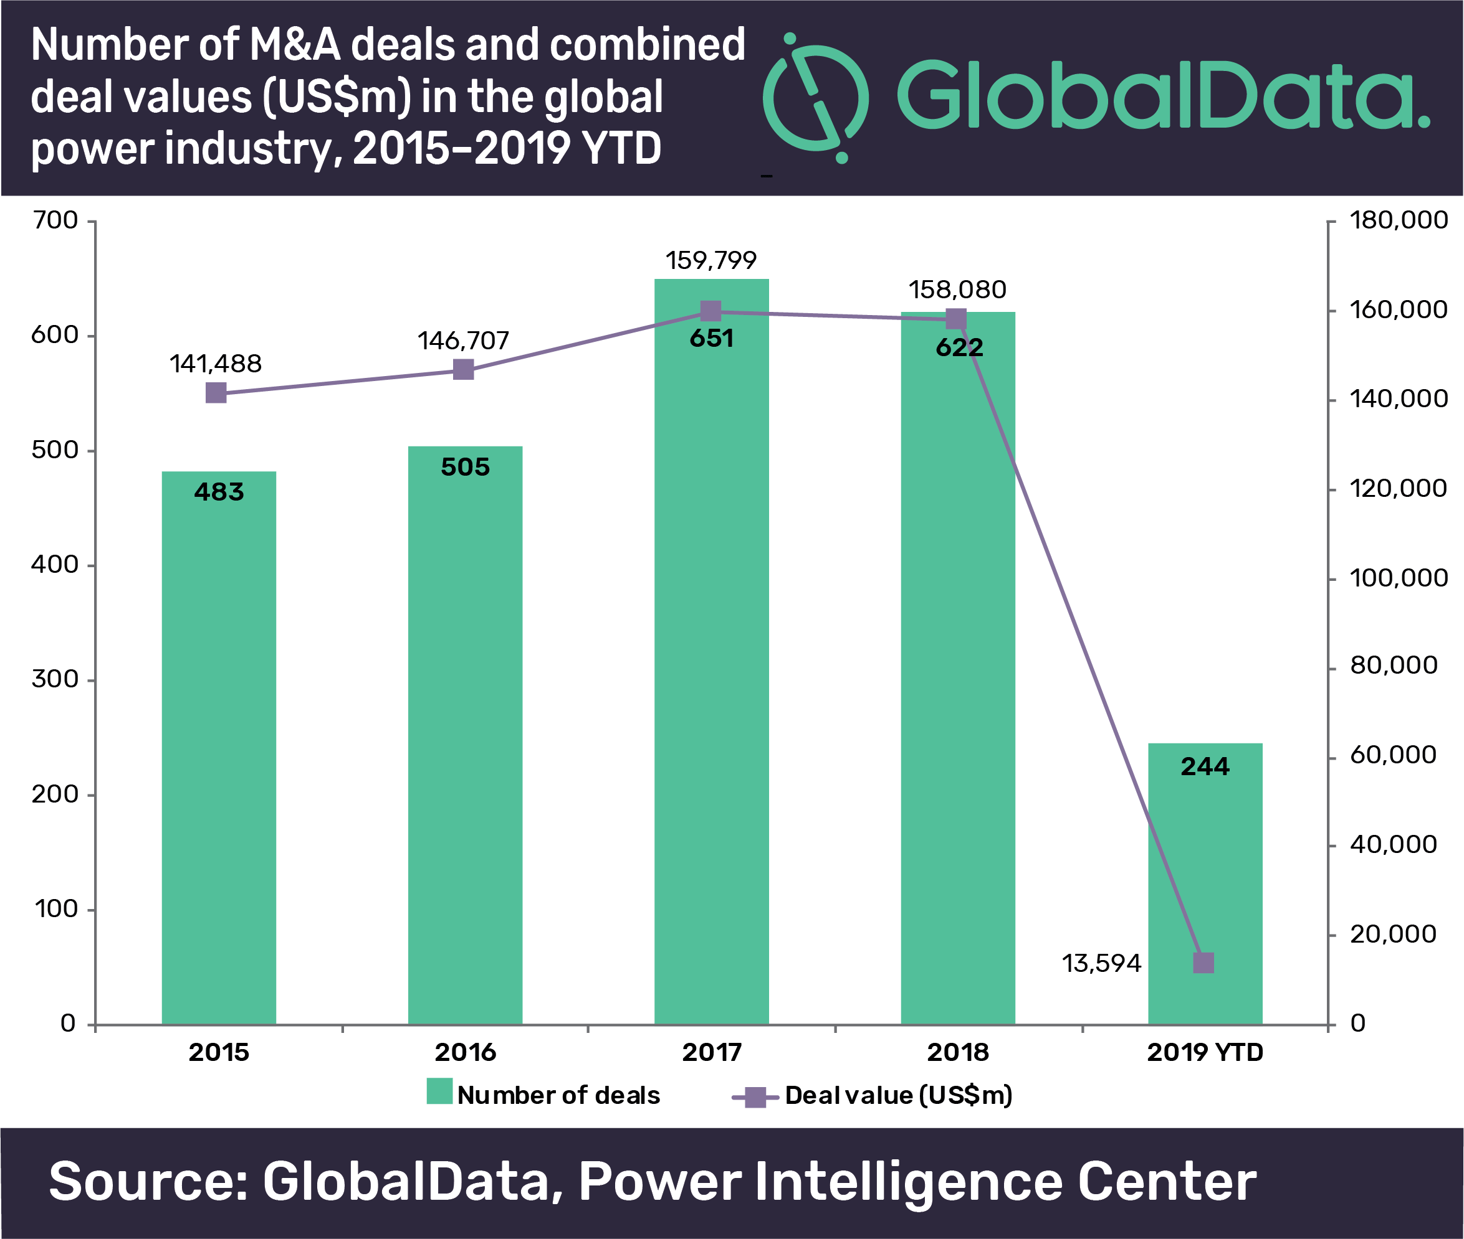
Fig 5
Managerial Motives
Managerial motives can trigger to use acquisition as a strategy driven by self-interest such as enrichment through empires.
SoftBank, founded by Masayoshi Son - the "Warren Buffett of technology investment" - wants to propel ARM onto the same level as Amazon, Apple or Alibaba by creating new microchips to help power the "internet of things". (Hippwell, 2016 pp. 44).
Change in organisations when measuring leadership performance is very important as the literature suggests (Gill (2011), organisations formulate their visions and strategies on leadership.
SoftBank Group visionary leadership steers which way the organisation goes. We also learn that it is through the vision that business conduct strategic planning to make various strategic decisions. (Hickman 2010) “strategic decisions affect how leaders handle the intended coordination of actions to align the firm to its environment”.
Shared Vision
The strategic change in Softbank when it acquired ARM raises question of how this acquisition fitted Softbank’s strategy? as literature suggests that strategic management must react to the turbulence in the environments, the technology industry is changing and evolved from PC- Internet - mobile right now the future is in IoT. To position SBGC strategically in the long term and the groups lack of assets crucial for competing in the new paradigm shift of the internet of things (IoT) , with the company’s track record on key success is by investing in the beginning of the paradigm shift.
Both companies’ strategies shared the same dream and drive to empower the world with technology, making life for the consumers of the end product easier, safe and content.
They share the same future, both groups Arm & SBG have enabled technology at the heart of a computing and connectivity revolution. Arm ships more than 40million ARM based processor chips by its partners around the world and SBG delivers mobile and fixed line connectivity to over 100million people and devices in Japan and USA , and is pioneering new ventures in AI, smart robotics and IoT by the two companies coming together they can bring potential to information revolution, with its known investment in new paradigms from Personal Computer software distribution to the Personal Computer Internet to the Mobile Internet. ARM processor chips are core to what we see as the next paradigm shift in the Information Revolution: IoT. The two forces especially Arm will be able to move faster in creating new technologies and deliver at a quick speed September 6, 2016. https://group.softbank/en(2020)

Expansion of Markets
Cluster of No. 1 Strategy, the group focuses on the potential of AI in order to expansion of markets which will bring further opportunities and in order to seize these opportunities, SB, invest to build a cluster of leading AI companies that build innovative services and business models based around the emerging capabilities of AI technology. By SBG acquisition of Arm with its unique technologies will be able to sustain the company growth. “ Arm has already 95% share of the main chips in the mobile devices and an increase in royalties per chip. “ With Arms processors will help provide AI and 5G capabilities to the next generation of smartphones in the years to come.
As new markets for electronics emerge and most used Arm’s advanced processor designs, including IoT, self -driving cars and Industrial automation. With such a big market SBG, saw the opportunity to be part of that market, for example as vehicles are becoming smarter, they will require more computational capability , this is a great opportunity in this moment in time to be well positioned to gain the share. Already Arm processor technology has been licenced by automotive chips developer companies , with all this on-board Arm was the best strategic fit, for SBG. With access to SBG Vision Fund finance, Arm will be able to use the money and invest heavily in the new technologies that can secure and manage the data in IoT device networks . IoT is going to be the biggest paradigm shift in human history and ARM will be the centre of the Internet of Things, “This is one of the most important acquisitions we have ever made, and I expect ARM to be a key pillar of SoftBank’s growth strategy going forward.” By adding both company resources, high revenues are expected in the next 30 years. https://group.softbank/en(2020)
Internet of things (IoT)
Faced with the largest paradigm shift in human history , SBG, need a company to work with and pursue sustained growth. Arm acquisition was that the company is going to be the key drive of the IoT era of SBG. “In the Internet of Things (IoT) era, Arm, as a leader in semiconductor technologies, is expected to play a central role in the SoftBank Group ’ s strategy by taking advantage of its differentiated technologies in high security and energy efficiency” https://group.softbank/en(2020)
To fully reach its potential IoT, must be secure against hacking and robust, the future smartphones will become smarter with every generation, and this will be create opportunities for both organisations, especially ARM technology will be vital for the market.
Brand Positioning/Global Leader
Softbank ambition to become a global technology powerhouse is not a secret, by holding 100% shares in ARM a highly entrepreneurial global business leader in advanced technologies, enabling partners to develop tech that creates a smarter and better connected benefits Softbank, this brings Softbank closer to its goal of singularity.

From an investment perspective of SBGC, .” The deal with ARM will increase Softbank’s growth to position it as a leader in Internet of Things (IoT).as the group are investing to capture the very significant opportunities provided by the ‘Internet of Things. https://group.softbank/en,(2020)
ARM’s strategic goal is to increase licences, which will generate more revenue as loyalty is earned per device, specifically “Enterprise and Embedded Intelligence.” SBG, will be able let ARM maintain its dedication to innovation and hasten ARM as the global leader in R&D and Patent of its licences .
Expand Customer base
With the Beyond Carrier Strategy and aim to sustain growth over the medium to long term, therefore Softbank has a great opportunity to increase its reach and expand its customer base for example, ARM is dominant in the mobile industry, well positioned and has the largest market share in the semiconductor industry and has a big customer base licencing its IP to big mobile companies like Apple and Samsung. These licences and loyalty generate a lot of income for the organisation and in the past two years has seen an increase in the chips sold globally increasing the customers base. Research by Juniper Research, it is being anticipated that the number of IoT connected devices is going to rise of over 285% and grow to 38.5 billion by 2020, from 13.4 billion in 2015.” Accessed 17 April 2020, https://www.arm.com/company.

ARM’s CEO Simon Segars acknowledges that: “Our royalty revenue growth continues to outperform the wider semiconductor industry, driven by market share gains and the increasing adoption of ARM’s latest technologies. With more end-users selecting ARM technology for products ranging from sensors to satellites to supercomputers, we expect this outperformance will continue.” Chapman, B. (27 July 2016, Wednesday, 12:02)
Diverse Global Ecosystem of Collaboration.
With view of substantial growth of its telecommunication business through its growth strategy, by adopting the acquisition strategy to form a diverse group of partnerships. with outstanding technologies and business models in specific fields. Both companies will Leverage synergies to create even more value by working together. The combined value will be greater in revenue, and reduction in expenses than on an individual basis. Arm has a diverse ecosystem of partners, who manufacture various chips using ARM processors as a core and add value to the product will be able to meet the customer demand.
With SBG finances ARM has an opportunity to acquire more technology companies related in the same area for instance since the acquisition Arm, has increased its collaboration with partners across the SBG, for example in 2018 , Sprint announced a new IoT platform using ARM’s IoT managed services technologies, to extend its customer insight capabilities. This is an advantage for Arm as SBG is extending its reach in areas ARM would not reach alone and it is exploring the groups Vision Fund Portfolio companies this will further enable ARM to find new partners and invest in new technology areas. https://group.softbank/en (2020). Therefore, investing in ARM will be enhancing the diverse ecosystem. “With its diverse ecosystem the organisation will be able to cut production costs. No other business ecosystem comes close to this group of silicon, system and software companies responsible for shipping more than 130billion Arm-based chips to-date”. The arm ecosystem more than just an ecosystem (2019). . https://group.softbank/en.
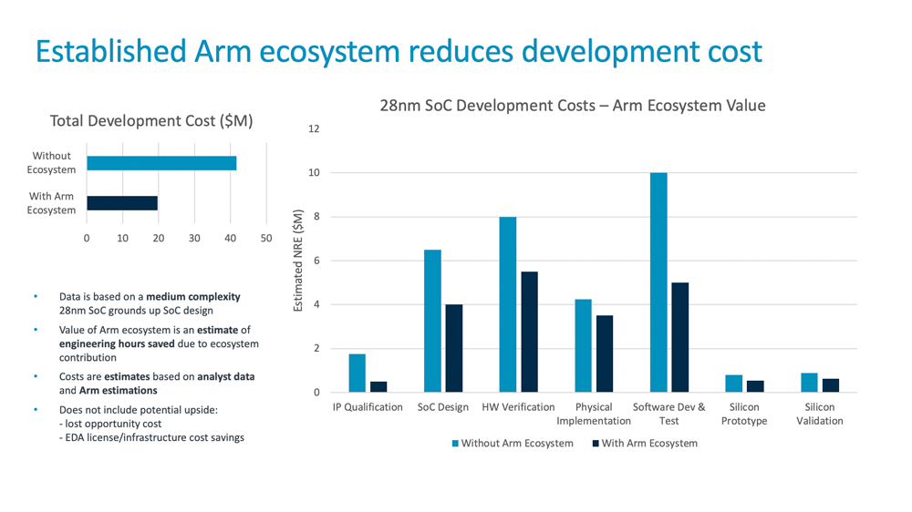
Fig 6. Source: The arm ecosystem more than just an ecosystem (2019).
Global Semiconductor Market Share
Most organisations use the acquisition strategy to gain market share as Domínguez, B., Gómez, J. and Maícas, J. P. (2018) argues that, the reason for an overseas company in this case SoftBank Group, was that ARM has a big market share and economic advantage over its competitors and new entrants, (Hovenkamp and Carl, 2018, p. 1999) it is evident from the global mobile telecommunications industry’(2020), that by using the acquisition strategy though expensive for the acquiring company as it acquires a larger share of the market in the existing market this move was backed and supported by the British government.
By acquiring ARM, SoftBank will strengthen big market share, hence big competitive advantage. ARM can build more devices than competition since it will have a head start in other areas of technology. One has to take into account that , in Softbank’s view, ARM has been a tech design house not a service oriented company but with the IoT, security becomes an important issue, with SoftBank’s infrastructure already in place, it will be an advantage in the future and with the potential synergy group, UK, Japan, USA and China will be able to help each other. ARM could not do it alone. Softbank perceives ARM valuable than companies like Google as it is a design house for chips which are used in everyday devices, they hold number one sport in the market share for any smart phone or devices in any pocket all over the world. With ARM’s technology Softbank can be able to use its label on its smartphones using it on its own networks ,it can provide both hardware and software bundle that undercuts its competition.

One of the problem ARMS has even though its position is strong in the semiconductor market, it lacks the scale when compared to its primary competitors , Intel. If you compare Softbank’s recorded revenue FY2018 to that of Intel during the same period, it was better to be acquired by SBGC, as the two combined together the facilities and technologies make it easier to compete with other big names in the industry.

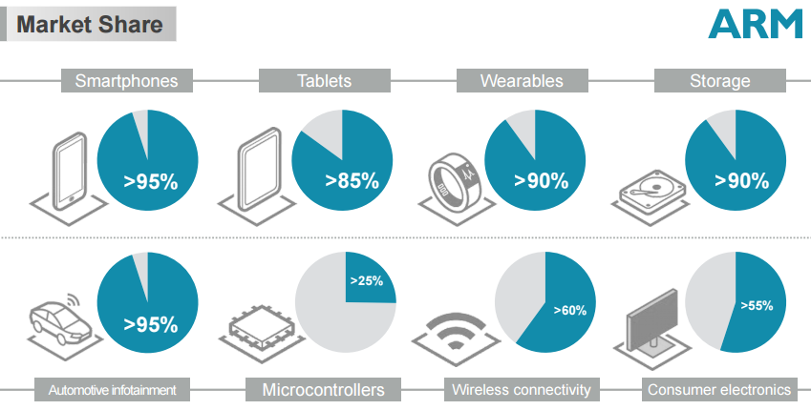
Fig. 7. Source: www.arm.com

Diverse ecosystem of Human Capital.
This brings us to another reason for the acquisition is that of, a diverse workforce cannot be overlooked in the technology industry. Empirical evidence implies “that companies can generate up to 30% higher revenue per employee, or more profitable than competitors and more likely to achieve positive business outcomes.” Fucci & Cooper, (Deloitte, April 2, 2019). Softback as a group wants to invest heavily in the best engineers, to fulfil its future dream of IoT, in its belief that the AI will work hand in hand with humans. “SBGC is investing in the UK as a world leader in science and technology development and innovation and, as evidence of this, intends to invest in multiple Arm growth initiatives, at least doubling the number of Arm employees in the UK over the next five years. ARM has built a strong ecosystem in Cambridge and has most of the brains behind new patents.
Global semiconductor Market Entry
The overall strategy of Softbank is based on the emergent approach of strategic management and falls in line with the soft bank management’s decision in acquiring ARM as a market Leader, Arm has a unique foundational technology by adding this to Softbank’s portfolio its gives it a competitive advantage in the technology sector especially the semiconductor market. SBGC desire to break into or buy their way into a promising market wanted to enhance ARM’s view by supporting it aggressively and invest in new products.

ARM benefits from Softbank operational capabilities and market reach. SBGC being a telecommunications company provides its services across various industries ( mobile, internet, fixed communications, semiconductor, energy, robotics, IoT and e-commerce.)” SBGC operates business across the world and business through different public and private subsidiaries”. (2019), pp. 1-7) ARM Ltd. SWOT Analysis. Will strengthen the both companies leading to generating high revenues and a big success.

Change implications from viewpoints of ARM & Softbank
One of the major factors of mergers and acquisitions is change. Change is a necessity for growth and survival. The realisation of potential synergies of a well-chosen acquisition in the of case ARM will put pressure on the current set and forge model of acquisition, where a Japanese company ( SoftBank) leaves the foreign acquisition to its own devices. “In the case of Japanese acquisitions, the balance is often one where supportive independence outweighs any suggestion of stifling intervention.” Japanese firms spend a lot of effort on due diligence when it comes to acquisitions but little on cultural due diligence and putting in place plans to integrate the business post acquisition.(2019); unlocking japans potential(Accessed) www.pwc.co..au
literature suggests (Gill (2011), any strategic change in organisations is based on the vision of its leader therefore when measuring leadership performance is very vital for the strategic goals and the alignment of business into the environment it operates in,( Hickman 2010).
For ARM the acquisition was a big win as its shareholders get 43% the premium per share, but for Softbank it was a big risk more was paid than what ARM was worth at the time of the deal, as the stock on the market was low. But it was a bet Softbank took, in the long run if growth materialises this could be the best strategic move in Softbank’s history and will reap a very attractive price over the long term and when this happens 5-20 years from now reaping huge reward will seem as if Softbank bought ARM at a cheap price, but at the time £24.3bn seemed a lot.
The acquisition raised questions of whether ARM is going to change in strategy after the takeover. Arm’s operations are independent, although works closely with SBG. Arm provides insight into longer term technology trends that may benefit SBG. SoftBank indicated that the deal would “maintain ARM’s neutrality and independence. in any acquisition it is critical to install a management team that is capable of understanding the cultures of the two parties and transforming it in a new culture”. (Lasserre, 2003, p.148).
The change implication for ARM was that “ the acquired company has to be provided with a strategic identity, making sure it has a specific role to play in the overall regional or global strategy” (Lasserre, 2003, p.150), for example ARM makes investment decisions independently though seek approval, if the investments in the new technologies that will drive growth in the long run and expect the revenue from these revenues to be higher and bring greater profits “let’s say in the next 5- 10 years it is the decision of SoftBank Group CEO to decide whether the profits will be reinvested back into the business or for future growth or returned to soft bank group.” www. group.com. Softbank allowing ARM to make these decisions makes the organisation feel a sense of purpose.
The culture fit for both organisations is different as the Japanese work culture is totally different from the British work culture,
Some of the challenges both companies face after an acquisition is mixture of two different cultures. For its success the two organisation has to have a plan in place especially discussed in the pre-acquisition phase. (Lasserre, 2003, p.149). Softbank adopted organisational integration beyond the frameworks of ARM with different corporate culture and this was to enable the implementation of strategies among the two companies amicably.
In any acquisition, the last stage of the process is the acquired company feels that they are involved in the strategic roles and drive the new organisation in the right direction. Employees must feel valued for any acquisitions to be a success. SBGC vowed to increase the employee headcount in the next five years the forging of two cultures will take a lot of adjustments, one of the advantages in the acquisition is that ARM maintained its business model and culture.
The ARM culture is very strong, “It has a 25 years’ experience in partnership working with licences and ecosystem to work and bring technologies to market in the most efficient way and nothing is going to change”. The good thing is that SoftBank group values ARM’s ecosystems, there is a strong alignment in what we do and believe in.” Simon Segars CEO Arm 2017.www.softbank.com

Post-Acquisition performance:
The post-acquisition phase is considered to be the most crucial part of the acquisition as it involves the managerial transition and strategic consolidation. This phase aims to establish a continuing working relation between the organisations and also to establish confidence to achieve practical results. In this case the consolidation process SBG has to make sure that ARM has a strategic identity, a specific role in the business strategy. (Lasserre,2003 P.153). In this way there is gain of devotion and assurance of managers of the acquired company.
Acquisition strategy is justified if and only if the value of the acquired company returns is going to be bigger in the long term. “The financial value of the deal is calculated on the basis of a detailed evaluation of the future cash flow which is done through the due diligence process”. (Lasserre, 2003, p. 134). SBGC in order to develop its long-term strategy is to form partnerships with the most senior organisations at the time in the information industry. (2020) group. SoftBank.
Arm is currently undergoing a transitional product cycle and continues to sign licences for new technologies. Arm operations have concentrated on the licencing of semiconductor intellectual property ( IP). Since the acquisition Arm’s primary concertation was in investing heavily in R&D, and by hiring more engineers as this expansion in the engineering capability will allow Arm to develop new technologies that will help maintain or gain share in the company’s exist sting markets as well as in the new markets Arms (refer to appendices , SBGC.'s latest financial report for details)..
The semiconductor industry due to its volatility has impacted significantly on Arm’s financial results (refer to appendix financial report fy2019). In 2018 there was a decline in the semiconductor industry, and this had an impact on Arms revenue, but saw an increase of 2.5% the following years November 2919. www.softbankgroup.com/annual report (2019). Though there was an increase the industry remains vulnerable to environmental factors such as trade disputes and sanctions against specific companies, which could have an impact on Arm’s products both licencing and service revenues thus earning less in royalties. Having said that Arm saw an increase of 3.2% in a three-month period ended September 30, 2019 as Arms licences reported a shipment of 6.4 billion Arm based chips. Refer to appendices financial report ( Arms KPI’s). ARM is optimistic that is there is stability in the market growth is expected and the more technology advances then its technology will be utilized further leading to more opportunities over the long term (2020) group. SoftBank
Fig below illustrates Arms revenues, investments and profits including pre-acquisition periods

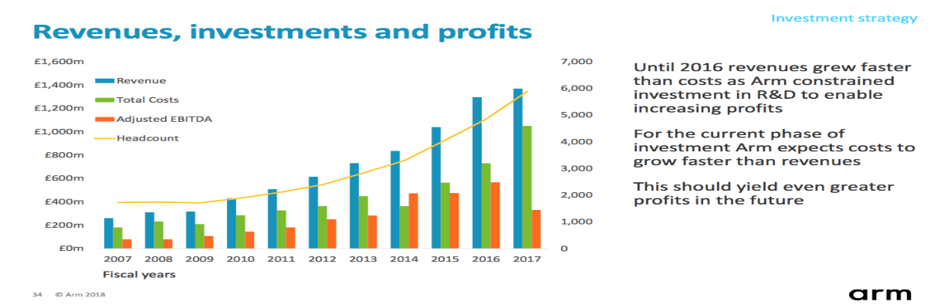
Fig 8.
2018 Arm benefited in accessing the vast resources of the SBG by increased relationships with various investment companies across the SoftBank Group, for example Sprint was making use of Arms IoT platform managed services technology extending their Arm’s data their customer insight capabilities.
Gaining or maintain share in target markets : in 2016 the company saw an increase of 17% by comparison the industry volumes grew by 6% in the equivalent period that means an increase in the share market to 34% unlike 32% in previous years- it intends to retain its share within mobile devices and increase share in networking infrastructure , serve, embedded intelligence and automotive applications. Refer to the appendices for the financial statements
On the other hand, the post finance performance for the Softbank Group strategic review.
After the acquisition of Arm, the financial results for both income and net sales segment has increased and this is due to the stable growth in the telecommunication and steady expansion in the customer base.
The last two years have seen investment expansion using the SBG Vision Fund, an increase of 69 investments and joint venture. The acquisition cost of $60.1 billion.
FY2018, value of investments have increased and contributed to SBG operating income.( refer to the annual statement in the appendices) https://group.softbank/en(2020)
. Refer to the appendices for the nine-month review of the company’s performance.
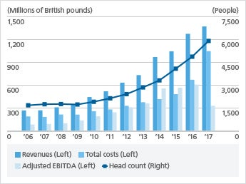
Fig 9 https://group.softbank/en

Conclusion.
Softbank’s long term strategic investment in acquisition of ARM, will pay off due to varies factors from long term integration in technology in the ecosystem, combined with a diverse portfolio of internet investment will impact the technology industry as it reaches every region of the world with much success for ARM and Softbank.

With Softbank as its owner and the full support to let ARM operate without interference, will make Arm stronger and maintain its number one position as a global leader in semiconductor chip processor designer and new markets that will be penetrated and will make it go beyond its success. I do think that without the support of Softbank Group Corp, ARM would have struggled to reach its full potential. On top of that the premium Arm is getting will enable it to fight the challenges and fight the stiff competition in a volatile environment especially in the technology industry and making the shareholders happy.

Appendices
Arm Strategic view KPI’s
Calendar years | 2018 | 2018 | 2018 | 2019 | 2019 | 2019
Calendar quarters | Q2 | Q3 | Q4 | Q1 | Q2 | Q3
Calendar quarters | 2018 | 2018 | 2018 | 2018 | 2019 | 2019 |  | SoftBank financial calendar | 2015 | 2016 | 2017 | 2018
SoftBank financial quarters | Q1 | Q2 | Q3 | Q4 | Q1 | Q2 |  |  | FY | FY | FY | FY
Revenue ($m) |  |  |  |  |  |  |  | Revenue ($m)
Technology Licensing | 85 | 124 | 125 | 213 | 125 | 87 |  | Technology Licensing | 602 | 601 | 618 | 547
Technology Royalty* | 261 | 285 | 305 | 247 | 240 | 254 |  | Technology Royalty | 833 | 974 | 1,087 | 1,098
Software and Services | 35 | 47 | 56 | 53 | 53 | 55 |  | Software and Services | 124 | 114 | 126 | 191
Total Revenue ($m) | 381 | 456 | 486 | 513 | 418 | 396 |  | Total Revenue ($m) | 1,559 | 1,689 | 1,831 | 1,836
* Technology Royalty prior to the acquisition has been restated to be consistent with the new accounting policy
(see SoftBank Group Corp.'s latest financial report for details).
Adjusted EBITDA ($m) |  |  |  |  |  |  |  | Adjusted EBITDA
Cost of Sales | 32 | 35 | 34 | 28 | 32 | 36 |  | Cost of Sales | 53 | 58 | 111 | 129
R&D Expenditure | 194 | 218 | 175 | 186 | 171 | 200 |  | R&D Expenditure | 342 | 450 | 713 | 773
SG&A Expenditure | 149 | 173 | 158 | 175 | 170 | 171 |  | SG&A Expenditure | 321 | 354 | 571 | 655
Costs ($m) * | 375 | 426 | 367 | 389 | 373 | 407 |  | Total Costs ($m) | 716 | 862 | 1,395 | 1,557
Adjusted EBITDA ($m) | 6 | 30 | 119 | 124 | 45 | (11) |  | Adjusted EBITDA ($m) | 843 | 827 | 436 | 279
* Before the acquisition long-term incentive scheme was share-based, and the costs are included in "Other operating expenses"
(see below). Post-acquisition replacement scheme is cash-based and is included in R&D and SG&A costs.
IFRS EBIT ($m)* |  |  |  |  |  |  |  | IFRS EBIT
Depreciation and Amortisation | 24 | 26 | 35 | 32 | 40 | 49 |  | Depreciation and Amortisation | 66 | 72 | 87 | 117
Foreign Exchange | (21) | (14) | (18) | 3 | (17) | (37) |  | Foreign Exchange | (18) | (7) | 82 | (50)
Other operating (income)/expense | (1,439) | (99) | 23 | 6 | 18 | 6 |  | Other operating (income)/ expense | 133 | 322 | 73 | (1,509)
IFRS EBIT ($m)* | 1,442 | 117 | 79 | 83 | 4 | (29) |  | IFRS EBIT ($m) | 662 | 440 | 194 | 1,721
* IFRS EBIT excludes expenses and charges incurred by SBG relating to the acquisition of Arm, for example the remeasurement
adjustments relating to business combination, and the amortisation of intangibles related to Arm's acquisition.
Non-Financial Data |  |  |  |  |  |  |  | Non-Financial Data
Calendar years | 2018 | 2018 | 2018 | 2019 | 2019 | 2019
Calendar quarters | Q2 | Q3 | Q4 | Q1 | Q2 | Q3
SoftBank years | 2018 | 2018 | 2018 | 2018 | 2019 | 2019 |  | SoftBank years | 2015 | 2016 | 2017 | 2018
SoftBank quarters | Q1 | Q2 | Q3 | Q4 | Q1 | Q2 |  |  | FY | FY | FY | FY
Total number of employees | 5,707 | 5,990 | 5,970 | 5,987 | 6,064 | 6,365 |  | Total number of employees | 4,064 | 4,852 | 5,886 | 5,987
Technical staff* | 4,697 | 4,940 | 4,887 | 4,858 | 4,882 | 5,126 |  | Technical staff | 3,262 | 3,960 | 4,812 | 4,858
Non-technical | 1,010 | 1,050 | 1,083 | 1,129 | 1,182 | 1,239 |  | Non-technical | 802 | 892 | 1,074 | 1,129
* The definition of “Technical Employees” has been agreed with the UK Takeover Panel, full details of which were set out in section 4 of the letter
in the scheme documentation dated 3 August 2016 and which is available on www.arm.com
Royalty Unit Analysis |  |  |  |  |  |  |  | Royalty Unit Analysis
Total reported as shipped (bn)* | 5.5 | 5.6 | 6.2 | 5.6 | 4.8 | 5.6 |  | Total reported as shipped | 15.1 | 17.7 | 21.3 | 22.9
* Royalty unit analyses are based on shipments reported by Arm's licensees in the current quarter and are therefore shipments from the prior quarter.
Licensing Analysis |  |  |  |  |  |  |  | Licensing Analysis
Licenses signed | 16 | 35 | 42 | 32 | 28 | 35 |  | Licenses signed | 182 | 113 | 141 | 125
Breakdown by processor |  |  |  |  |  |  |  | Breakdown by processor
Classic (Arm7, Arm9, Arm11) | 0 | 0 | 0 | 0 | 0 | 0 |  | Classic (Arm7, Arm9, Arm11) | 6 | 8 | 0 | 0
Cortex-A | 3 | 14 | 8 | 10 | 7 | 14 |  | Cortex-A | 46 | 21 | 45 | 35
Cortex-R | 1 | 5 | 3 | 3 | 2 | 0 |  | Cortex-R | 19 | 9 | 16 | 12
Cortex-M | 11 | 13 | 21 | 14 | 19 | 18 |  | Cortex-M | 86 | 60 | 58 | 59
Mali | 1 | 3 | 10 | 5 | 0 | 3 |  | Mali | 25 | 15 | 22 | 19
Cumulative breakdown by processor (extant license still expected to generate a royalty)
Total number of Licenses Signed | 1,593 | 1,627 | 1,662 | 1,694 | 1,671 | 1,692 |  | Total number of Licenses Signed | 1,348 | 1,442 | 1,577 | 1,694
Breakdown by processor |  |  |  |  |  |  |  | Breakdown by processor
Classic (Arm7, Arm9, Arm11) | 499 | 499 | 499 | 499 | 452 | 451 |  | Classic (Arm7, Arm9, Arm11) | 517 | 500 | 499 | 499
Cortex-A | 337 | 350 | 353 | 363 | 367 | 373 |  | Cortex-A | 265 | 290 | 334 | 363
Cortex-R | 95 | 100 | 103 | 106 | 109 | 108 |  | Cortex-R | 65 | 78 | 94 | 106
Cortex-M | 493 | 506 | 525 | 539 | 556 | 573 |  | Cortex-M | 363 | 425 | 482 | 539
Mali | 169 | 172 | 182 | 187 | 187 | 187 |  | Mali | 138 | 149 | 168 | 187
During the quarter, following a review of older licenses, a number of licenses that are no longer expected to deliver a royalty have been removed.
This has resulted in lowering the "Total Number of Licenses Signed"
/group.softbank/system/files/pdf/ir/financials/annual_reports/annual-report_fy2019_01_en.pdf

Below SoftBank earned Yen 3746.3 in
[Notes]
* Net sales, adjusted EBITDA and operating income are presented based on the amounts from continuing operations only since FY2014.
* In FY2018Q1, the Company adopted IFRS 9 and IFRS 15 (collectively, the "new standards").
■Operating results |  |  |  |  | (Millions of yen)
 | FY2014 | FY2015 | FY2016 | FY2017 | FY2018 New standards
Net sales | 8,504,135 | 8,881,777 | 8,901,004 | 9,158,765 | 9,602,236
Adjusted EBITDA^{*1} | 2,041,633 | 2,325,153 | 2,564,467 | 2,605,117 | 3,153,461
Operating income (excluding income from SoftBank Vision Fund and Delta Fund) | - | - | - | 1,000,820 | 1,097,290
Operating income from SoftBank Vision Fund and Delta Fund | - | - | - | 302,981 | 1,256,641
Operating income | 918,720 | 908,907 | 1,025,999 | 1,303,801 | 2,353,931
Net income attributable to owners of the parent | 668,361 | 474,172 | 1,426,308 | 1,038,977 | 1,411,199
[Note]
*1 Adjusted EBITDA = operating income + depreciation and amortization - gain relating to loss of control over subsidiaries ± adjustments relating to investments in SoftBank Vision Fund and Delta Fund (unrealized gain and loss on valuation of investments and effect of foreign exchange translation) ± other adjustments
The amount disclosed as EBITDA through to FY2014 is now presented as adjusted EBITDA from FY2015
■Financial position |  |  |  |  | (Millions of yen)
 | FY2014 | FY2015 | FY2016 | FY2017 | FY2018 New standards
Total assets | 21,034,169 | 20,707,192 | 24,634,212 | 31,180,466 | 36,096,476
Equity attributable to owners of the parent | 2,846,306 | 2,613,613 | 3,586,352 | 5,184,176 | 7,621,481
Interest-bearing debt^{*2} | 11,607,244 | 11,922,431 | 14,142,922 | 16,353,856 | 14,954,506
Net interest-bearing debt^{*3} | 8,182,817 | 9,248,363 | 11,207,617 | 12,928,922 | 11,325,430
[Notes]
*2 Interest-bearing debt above excludes financial liabilities relating to variable prepaid forward contract for sale of Alibaba shares. Deposits for banking business of The Japan Net Bank are not included in interest-bearing debt.
*3 Net interest-bearing debt = interest-bearing debt - cash position
Cash position = cash and cash equivalents + short-term investments recorded as current assets (both exclude those of The Japan Net Bank)
■Cash flows |  |  |  |  | (Millions of yen)
 | FY2014 | FY2015 | FY2016 | FY2017 | FY2018 New standards
Cash flows from operating activities | 1,155,174 | 940,186 | 1,500,728 | 1,088,623 | 1,171,864
Cash flows from investing activities | -1,667,271 | -1,651,682 | -4,213,597 | -4,484,822 | -2,908,016
Cash flows from financing activities | 1,719,923 | 43,270 | 2,380,746 | 4,626,421 | 2,202,291
■Major Indicators
 | FY2014 | FY2015 | FY2016 | FY2017 | FY2018 New standards
Adjusted EBITDA margin （%）^{*4} | 24.0 | 26.2 | 28.8 | 28.4 | 32.8
Operating margin (excluding income from SoftBank Vision Fund and Delta Fund) (%) | - | - | - | 10.9 | 11.4
Operating margin （%） | 10.8 | 10.2 | 11.5 | 14.2 | 24.5
Net income attributable to owners of the parent ratio （%）^{*5} | 28.0 | 17.4 | 46.0 | 23.7 | 22.0
Equity attributable to owners of the parent ratio （%） | 13.5 | 12.6 | 14.6 | 16.6 | 21.1
[Notes]
*4 Adjusted EBITDA margin = adjusted EBITDA / net sales
*5 ROE = net income attributable to owners of the parent / average equity attributable to owners of the parent for the period
■Per share data |  |  |  |  | (Yen)
 | FY2014 | FY2015 | FY2016 | FY2017 | FY2018 New standards
Basic earnings per share | 562.2 | 402.49 | 1287.01 | 933.54 | 1,268.15
Diluted earnings per share | 558.75 | 388.32 | 1275.64 | 908.38 | 1,256.53
Equity per share attributable to owners of the parent | 2,393.47 | 2,278.85 | 3,292.40 | 4,302.26 | 6,760.66
Cash dividends per share | 40.00 | 41.00 | 44.00 | 44.00 | 44.00

SoftBank Group Corp
https://group.softbank/system/files/pdf/ir/financials/annual_reports/annual-report_fy2019_01_en.pdf

References
- (Balogun & Hailey. (2008), p.18) Julia Balogun and Veronica Hope Hailey: Exploring Strategic Change 3rd Edition, 2008: Prentice Hall
- Child et al. 2000). Faulkner, D., Pitkethly, R., & Child, J. (2012-06-07). Country Cultural Differences in Acquisition Management 1. In the Handbook of Mergers and Acquisitions. : Oxford University Press. Retrieved 2 May. 2020, from https://www-oxfordscholarship-com
- Chapman, B. (27 July 2016, Wednesday, 12:02). arm-holdings-sales-jump-17-ahead-of-softbank-takeover ; [Accessed], https://www.independent.co.uk
- Domínguez, B., Gómez, J. and Maícas, J. P. (2018).
- (Hovenkamp and Carl, 2018, p. 1999)
- Kolev, K., Haleblian, J., & McNamara, G. (2012-06-07). A Review of the Merger and Acquisition wave Literature: History, Antecedents, Consequences, and Future Directions. In the Handbook of Mergers and Acquisitions. : Oxford University Press. Retrieved 2 May. 2020, from https://www-oxfordscholarship-com.
- Johnson, g, Scholes. K, & Whittington. R (2009) Fundamentals of Strategy
- Whittington, Scholes and Johnson, G., 2008. Exploring Corporate Strategy. Pearson. 8th Edition (Johnson. G. et.al 2009) pg. 83 Fundamentals of strategic management
- (Lambrecht 2004) Kolev, K., Haleblian, J., & McNamara, G. (2012-06-07). A Review of the Merger and Acquisition wave Literature: History, Antecedents, Consequences, and Future Directions. In The Handbook of Mergers and Acquisitions. : Oxford University Press. Retrieved 2 May. 2020, from https://www-oxfordscholarship-com.
- Lynch, (2012, p.83). Richard Lynch : Strategic Management 6th Edition
- Lasserre, (2003, p.17) Philippe Lasserre: Global Strategic Management 1st ed. Palgrave
- Lasserre, (2003, p.134. Philippe Lasserre: Global Strategic Management 1st ed. Palgrave
- (Lasserre, 2003) p.148. Lasserre 2003. Global Strategic Management 1st ed. Palgrave
- (Lasserre, 2003). pg. 150 Philippe Lasserre: Global Strategic Management 1st ed. Palgrave
- Kolev, K., Haleblian, J., & McNamara, G. (2012-06-07). ‘A Review of the Merger and Acquisition wave Literature: History, Antecedents, Consequences, and Future Directions’. In The Handbook of Mergers and Acquisitions. : Oxford University Press. Retrieved 2 May. 2020, from https://www-oxfordscholarship-com.
- Kolev, K., Haleblian, J., & McNamara, G. (2012-06-07). A Review of the Merger and Acquisition wave Literature: History, Antecedents, Consequences, and Future Directions. In The Handbook of Mergers and Acquisitions. : Oxford University Press. Retrieved 2 May. 2020, from https://www-oxfordscholarship-com.
- Kolev, K., Haleblian, J., & McNamara, G. (2012-06-07). A Review of the Merger and Acquisition wave Literature: History, Antecedents, Consequences, and Future Directions. In The Handbook of Mergers and Acquisitions. : Oxford University Press. Retrieved 2 May. 2020, from https://www-oxfordscholarship-com.
- Kolev, K., Haleblian, J., & McNamara, G. (2012-06-07). A Review of the Merger and Acquisition wave Literature: History, Antecedents, Consequences, and Future Directions. In The Handbook of Mergers and Acquisitions. : Oxford University Press. Retrieved 2 May. 2020, from https://www-oxfordscholarship-com.
- Mitsuru Kodama, 2019. "New Business Model Innovation in the Mobile Telecommunication Industry — A Case Study of SoftBank," World Scientific Book Chapters, in: Developing Holistic Strategic Management in the Advanced ICT Era, chapter 7, pages 275-325, World Scientific Publishing Co. Pt. Ltd
- Savitz, E., 2020. The Biggest Investing Bet On Tech Is Cheap—And Controversial. [online] Barrons.com. Available at: <https://www.barrons.com/articles/investing-in-softbank-is-a-bet-on-the-future-of-tech-51563582602> [Accessed 29 April 2020].
- [Available]<https://www.pwc.com.au/publications/pdf/unlocking-japans-potential.pdf.>[Accessed 29 April 2020].
- <https://group.softbank/en/ir/financials/annual_reports/2018/message/segars> [Accessed 29 April 2020].
- Softbank acquires ARM for $31.4 billion’ (2016) FRPT- M&A Snapshot, pp. 4–5 Available at: https://search-ebscohost-com.ezproxy.uwtsd.ac.uk/login.aspx?direct=true&db=bth&AN=118805558&site=ehost-live (Accessed: 17 March 2020).
- Anon, Softbank Corporation SWOT Analysis. ‘Softbank Corporation SWOT Analysis’ 2015, Softbank Corporation SWOT Analysis, pp. 1–9, viewed 17 March 2020, <https://searchebscohostcom.ezproxy.uwtsd.ac.uk/login.aspx?direct=true&db=bth&AN=102705401&site=ehost-live>.
- (Available)https://group.softbank/system/files/pdf/ir/financials/annual_reports/annual-report_fy2019_01_en.pdf (Accessed 25th April 2020)

- <https://www2.deloitte.com/us/en/pages/technology-media-and-telecommunications/articles/technology-industry-outlook.html> [Accessed 29 April 2020].
- https://www.independent.co.uk/news/business/news/arm-holdings-sales-jump-17-ahead-of-softbank-takeover-a7157831.html
- Ltd., A., 2020. The Arm Ecosystem: More Than Just An Ecosystem, It’s Oxygen For Soc Design Teams. [online] Arm | The Architecture for the Digital World. Available at: <https://www.arm.com/company/news/2019/04/the-arm-ecosystem-more-than-just-an-ecosystem> [Accessed 29 April 2020].
- <https://www.arm.com/company/news/2019/04/the-arm-ecosystem-more-than-just-an-ecosystem> [Accessed 29 April 2020].

