Dummy Report for Strategic Management Assignment 1 2019 –The Strategic of Lidl



OCTOBER 2018

MODULE NAME: Strategic Managemnet and sustaninability (M3X9111)
Name: qin tian
Student Number: 1903732

TABLE OF CONTENTS
1.0 Executive Summary 1
2.0 Introduction 3
2.1 Report remit 3
2.2 Background Of The Organisation 4
2.3 Definitions Of Major Concepts 5
3.0 Main Body 9
3.1Implementation Of the Strategy 10
3.2Advantages & Disadvantages Of The Strategy 12
4.0 Conclusion 16
4.1 Recommendations 16
5.0 References 18

LIST OF FIGURES
Figure 1 : porter’s generic strategies 5

1.0 Executive Summary
The intent of this report is to analyze the strategy used by Lidl.
Firstly, Lidl stifling & amp is a German global discount supermarket chain, headquartered in Neckarsulm, Germany, is owned by Schwarz Holdings and has a history of nearly 90 years. It Operates more than 10000 stores in Europe and the United States. In 1930, the first Lidl was founded in Germany. In recent years, Lidl has developed rapidly in Europe. There are more than 315,000 employees and sales of $82.4 billion worldwide.

Secondly, In this report, a simple analysis of Porter's Generic Strategies, which is divided into three parts, is cost leadership strategy, differentiation strategy and focus strategy. it is found that Lidl uses a cost leadership strategy. Lidl achieves cost leadership strategy by building its own brand, acquiring the best grocery stores in New Jersey and New York, and a market position in which the rental location is more biased and the area is smaller.

The strong point of the cost leadership strategy is that it can first help Lidl block the confrontation of existing competitors. Second, when Lidl faces price increases from suppliers, Lidl has more options to deal with it; finally, cost leadership strategies can help Lidl build a competitive advantage with other department stores and entrepreneurs in the industry do not have any chance to enter the department store market

The shortcomings of the cost leadership strategy is that new entrants and other department stores will mimic Lidl's cost leadership strategy, thus losing Lidl's competitive advantage.
Second, this strategy will make Lidl lose its ability to anticipate market changes and cannot capture changes in consumer preferences and demand.
Finally, cost leadership strategies are vulnerable to external environments, such as inflation.

In the end of the report, there are some recommendations for Lidl, such as Lidl can regularly do some questionnaires about changes in consumer preferences and needs. And Lidl can provide great quality goods to those who buy goods that only care about quality and do not care about price. Finally, although the price of goods is low, Lidl must ensure the quality of goods, now more and more people pay attention to the quality of goods.

2.0 Introduction

Lidl stifling & amp is a German global discount chain, headquartered in Neckarsulm, Germany. More than 10,000 stores in Europe and the United States. In recent years, Lidl has expanded rapidly around the world, occupying a dominant position in the department store industry. In this report, we will analyze the strategy used by Lidl and the merit and demerit of the strategy.

2.1 Report remit

Taking Lidl as an example, this report introduces the background of Lidl organisation and analyzes the marketing strategy of Lidl, and what measures Lidl has taken to realize this strategy. Then, the virtues and shortcomings of the strategy and its impact on Lidl are analyzed. Finally, some recommendations are put forward.

2.2 Background Of The Organisation

In 1930, Lidl was founded in Germany. It is a supermarket chain, owned by Schwarz Holdings, and has a history of nearly 90 years. In recent years, Lidl has developed rapidly in Europe. There are more than 10000 stores in the world, mainly in Germany, Britain, France, Portugal, Italy, Australia and the United States. (Driscoll, 2018) Lidl has more than 315,000 employees worldwide. Mission of Lidl is improving customer satisfaction with service. This can improve customer loyalty. Second, through the continuous improvement of technology and staff efforts. it can continuously innovate and optimize efficient process of Lidl, such as opening online stores, creating Lidl own brands and building factories. This can stabilize and improve the market position of Lidl, the quality of products, and the value of brand. And then Lidl establishes sustainable development relationships with business partners, such as close partnerships with local farms. Make a positive contribution to the local community. Finally, Lidl invests a lot of money in recruitment, training and development to achieve long-term success. Vision of Lidl is provided products of good quality and relatively low prices. Improve customer satisfaction as the core of the work of employees. (Featherstone, 2017)
In addition, Lidl has pledged to donate more than 250000 meals to local charities and community groups between November 6 and December 25, 2019. (Nazir, 2019)

2.3 Definitions Of Major Concepts

Porter's Generic Strategies, which is divided into three parts, is cost leadership strategy, differentiation strategy and focus strategy. (Alan,1988)
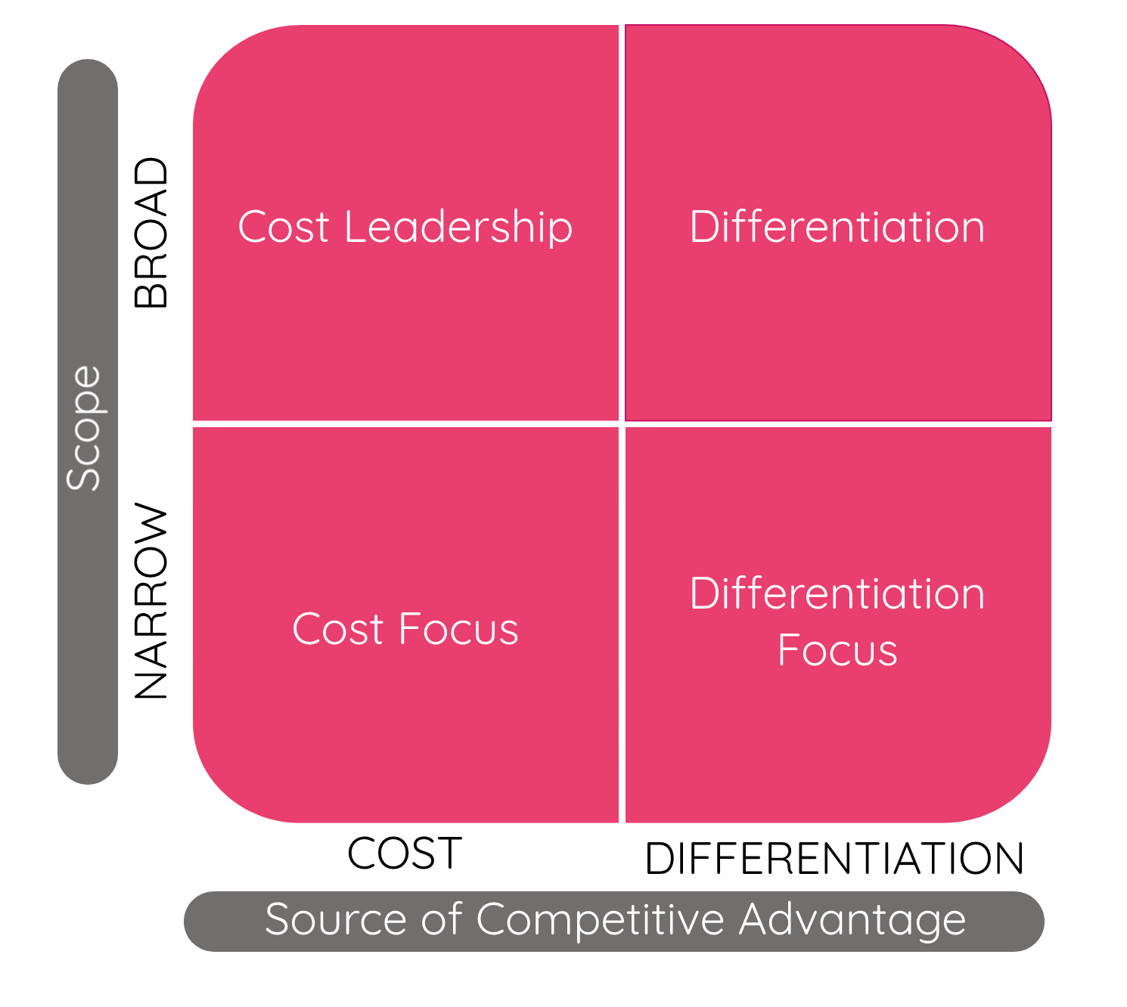
Figure 1: porter’s generic strategies
Data from: Bill Business

Cost leadership strategy：this generic strategy calls for being the low cost producer in an industry for a given level of quality. (Gamble et al, 2010)
Its competitive advantage is that the company sells its products at the average price in the market. Because of the cost leadership strategy, our cost will be lower than that of other peers. So, the company can make more profits than its competitors. Or, the company sells the product at an average price below the market. To attract customers and increase sales. It can help companies quickly occupy market share. And in the case of price war, although the company will suffer certain economic losses, the cost leadership strategy can also allow the company to maintain a certain degree of profitability. And consumers of the same goods and of the same quality usually choose lower prices, so companies that use cost leadership strategies will remain profitable for a long time. cost leadership strategy is suitable for when the industry is competitive, but also suitable for a new enterprise to enter the market. Because it can help enterprises attract customers, increase sales, increase profits. (Tanwar, 2013).

Differentiation strategy：The added value which is often characterized as increasing product features, pre and post service, and effective marketing activities, is passing to the target market. (Kokemuller, 2019)
Its competitive advantage could be uses by the company to provide different products and services, creating some specific and different product things in the whole commodity. Definitely, differentiation strategy could be achieved some methods, such as creating famous brand logo, enhancing technology, performance, functions customer service, even though their official website and other fields of uniqueness. The ideal condition is achieved by the company which has the unique characteristics in various parts. At the same time, the most important thing may be that the activities of hold by the company by differentiation strategy are always cause a high cost in products, so consumers could identify with the value of these differences, and the company should have enough ability and resources to improve their sale of their products. When consumers demand become more, and they do not care about the price of the products. Differentiation strategy can help companies find new customer groups. When the competitors of the company do not adopt the differentiation strategy, these companies could make some products which may be unique after they apply the differentiation strategy, which may establish some barriers for competitor. and would help to attract customers. Evidently, if the differentiation strategy would be finished successfully, it would be a huge advantage for the user to earn a amount of profit in an commodity. (Tanwar, 2013)

Focus strategy is divided into two types：
A low-cost focus strategy that is related to some lowest price products and services available in the market and their target customers main come from a small wide of nickel group.
A best value focus strategy is also called the focuses differentiation which is related to provide some best price-value available products or services for customers in the market. (Tanwar, 2013).
Its competitive advantage companies focus entirely on a region or special customer group. To better achieve the requirements in market and satisfy the demand of special customers. Companies that adopt focused strategies often attain more high levels of customer loyalty, a high-quality loyalty of customers could help company establish some barriers for their competitors who would like to competitive with them straightly in the market. Companies either achieve differentiation through satisfying demands of customer, or get a cost leadership when they would like to service their target customers or they could also use the two methods. For instance, a company which would like to make its profit potential could be more than the general level of the commodities. These advantages could improve the competition of companies which would face to diversity of threat in the market. (Capsim official, 2015)

3.0 Main Body
Lidl sells its products through discount stores, hypermarkets and supermarkets, and the brand has a low-cost strategy every day. At Lidl, the mission is offering our communities high quality products at low prices.
Lidl is also known as the "supermarket of the poor." (Bhasin, 2019) And Lidl hopes to provide customers with a happy shopping experience through extremely simple store layout. Lidl’s positioning is to make Lidl the preferred store for consumers to meet the needs of groceries, and keeping prices as low as possible. So we can know that Lidl is using a cost leadership strategy, and that cost leadership strategies can help Lidl attract more customers around the world. (Redman, 2019)

The core principle of cost leadership strategy is that enterprises reduce their own production and operating costs. (Pulaj, Kume, and Cipi, 2015). And sell the product at a price lower than that of the competitor. Entrepreneurs usually set up factories and use efficient production equipment to reduce costs and the control of strengthen cost and management cost. Then the company minimizes the cost of technology, service, marketing, advertising and so on. In this way, the total cost of the company will be reduced.
When the company sells the product at a price lower than that of its competitors, the company can also make a profit. But if a company wants to use a cost leadership strategy, first of all, the company should have a high market share in the market, or have a close relationship with partners, or have a strong capital chain and so on. (Bhasin,2019)

3.1Implementation Of the Strategy

Lidl aims to achieve a cost leadership strategy. Lidl's main strategy is to create its own brand. (Chipperfield, 2019) And widely use their own brands. Lidl ensures that all the products sold to customers are of high quality. And the highest sales in Lidl are their own brands, such as eggs, milk, fresh fruit, vegetables, meat and baked goods. (Potter, 2018).
Lidl's own brand products, such as pork, Piri Piri chicken, truffle, whisky, biscuits, apple juice, smoked salmon, etc., those products in the big brands were compared with private brand products in the annual taste award organized by The Grocer, which won many awards. (Perkins, 2018) And Lidl also won the 2017 Retail Awards for Flower retailers of the year. (Barr, 2019).
Recently, Lidl introduced an exciting concept to reduce food waste. From November 18th, customers can buy so-called lucky bags in all 121 stores in Denmark. The interesting thing is that the content is different at different times of the day. As a result, there are either fruit and vegetable bags or meat and sausage products. A bag of coffee, sugar, rice and tea was also planned. (New media website official, 2019)
These products account for more than 80 per cent of Lidl sales. (Bhasin, 2019). Because most products are owned by their own brands, No middleman earns the difference, which can help Lidl save a lot of cost. Therefore, Lidl can also sell the product at a lower price than its competitors while ensuring the quality of the product. Therefore, the establishment of their own brand can allow Lidl to reduce and control the total cost. Products with good quality and low prices can help Lidl attract a large number of loyal customers, thereby increasing profits and quickly occupying the market. (Garlick, 2019).

At first, Lidl’s strategy was to find the best market location where the lease location was small rather than having its own location. In this way, the rent will be reduced. It controls costs to a large extent. Because rent is often a big expense for a company. And Lidl bought the best grocery stores in New Jersey and New York. The acquisition can bring many benefits to Lidl, such as Lidl can expand its business. And Lidl’s resources and the resources of the grocery store are integrated and can be fully utilized and shared. Thus, reducing the cost of management, raw materials, production and other links. As a result, Lidl also improves its competitiveness in the industry by reducing total costs. Then, the acquisition could increase Lidl’s market share in the United States and Lidl’s position in the United States. Finally, Lidl aims to boost its distribution and will build 25 stores over the next year in United States, for example in Maryland, New York, Pennsylvania and Carolinas. (Meyersohn, 2019)

Lidl is an efficient store，a product assortment and store layout that’s refreshingly simple, all stores have the same intuitive layout, making it easier for you to find what you need quickly. Lidl is not a cookie-cutter grocery store. Lidl is revolutionizing grocery shopping. It has a less complicated process that allows Lidl to simply deliver low prices, high quality, and the best shopping experience for our customers. If consumers buy goods in Lidl, it can help consumers save much time and money. (Fitzsimons, 2019) This is one of the reasons why consumers would like to shop at Lidl. This strategy has helped Lidl attract a large number of loyal customers and increase sales. And expand Lidl's visibility and increase market share.

3.2Advantages & Disadvantages Of The Strategy

The cost leadership strategy puts Lidl in the low-cost position, which can resist the confrontation of existing competitors. Because Lidl has very strong competitors, both in the international market and in the local market. for example, Aldi and metro in Germany. There are Walmart, Tesco, Costco and Sainsbury's on the international market. (Jordan, 2018)
These are very successful and well-funded department stores. They have a certain market share and position in the market, and have a lot of loyal customers. So in the case of fierce competition, these department store managers usually use price wars. It increases the sales of goods and attracts customers. So in this case, even if competitors cannot make a profit in the competition, which can only protect the capital, but Lidl can still make a profit. (Giammona, 2018)

And Lidl use cost leadership strategy has established a huge production scale and cost advantages. Let those who want to join the department store industry entrepreneurs deterred, forming barriers to entry.
In addition, the cost-leadership strategy allows Lidl to compete with other large department stores. For example, Tesco and Sainsbury’s. Lidl, which uses cost leadership strategies, will be in a better position than they are. When Lidl faces strong suppliers to raise the price of commodity resources. Lidl in a low-cost position can have more options to solve difficulties. For example, Lidl can replace supplier products with products in its own brand. Lidl can also negotiate with suppliers on prices because leadership strategies give Lidl a financial advantage. So, Lidl doesn't have to worry too much in the face of this situation.

The cost leadership strategy used by Lidl also has some shortcomings. For example, if other department stores. Like strong competitors such as Tesco, Aldi, or new entrants in the industry. They mimic and summarize the strategies and business practices used by Lidl. Then they can develop better business solutions to make their costs lower and quality of product better, which can attract more customers. In this way, Lidl will lose its leading position in the market.

The most important thing is that Lidl, which uses a cost leadership strategy, focuses a lot of attention on reducing product costs. As a result, Lidl loses the ability to foresee changes in the market of products, and there is no way to capture changes in consumer preferences and needs. Then, Lidl may find that the product, even if it is very cheap, which is not appreciated and needed by customers. This is the most dangerous part of the cost leadership strategy.

Finally, if affected by the economy, such as inflation. It will increase the cost of production input and raise the wages of employees. At this time, the price advantage of the cost leadership strategy is reduced, so that it cannot compete with the department stores that adopt other competitive strategies.

Therefore, when choosing the cost leadership strategy, the company must correctly estimate the market demand situation and characteristics, and strive to minimize the risk of the cost-leading strategy.

4.0 Conclusion
In general, in this report, first of all, describing the background of the organization of Lidl, as well as a brief introduction to Porter’s Generic Strategies, which is divided into three parts, is cost leadership strategy, differentiation strategy and focus strategy. Lidl stifling & amp is a German global discount supermarket chain, headquartered in Neckarsulm, Germany, is owned by Schwarz Holdings and has a history of nearly 90 years. It operates more than 10000 stores in Europe and the United States. Then, taking Lidl as an example, to analyze the strategy of Lidl uses is cost leadership, which is one of the Porter’s Generic Strategies. And briefly describes how Lidl implements this strategy, as well as the impact of this strategy on Lidl and the advantages and disadvantages of the strategy, and puts forward some recommendations.

4.1 Recommendations

There are some suggestions on the cost leadership strategy used by Lidl. First of all, cost leadership strategy can make Lidl very competitive in the department store industry, but the long-term use cost leading strategy will
deprive Lidl of the ability to foresee changes in the market and changes in consumer preferences and needs that cannot be captured.
Firstly, Lidl regularly do some questionnaires about changes in consumer preferences and needs.
Secondly, Lidl can provide great quality goods to those who buy goods that only care about quality and do not care about price.
Finally, although the price of goods is low, Lidl must ensure the quality of goods, now more and more people pay attention to the quality of goods.
So, Lidl can use both cost leadership strategy and differentiation strategy to enhance competitive advantage in the industry

5.0 References
1: Alan, I. (1988). “Abstract”. Academy of Management Review. 13⁽³⁾.

2: Bhasin, H. (2019). “Marketing strategy of Lidl”. Marketing G96. [Online] Available: https://www.marketing91.com/marketing-strategy-of-lidl/. (accessed on 15th November 2019).

3: Barr, S. (2019). “Lidl whisky costing £13.49 named one of the best in the world”. INDEPENDENT. [Online] Available: https://www.independent.co.uk/life-style/food-and-drink/lidl-whisky-scotch-best-world-competition-award-alcohol-supermarket-a8798941.html. ( accessed on 15th November).

4: Capsim official. (2015). “ An introduction to Porter’s Generic Strategies”. CAPSIM. [Online] Available: https://www.capsim.com/blog/an-introduction-to-porters-generic-strategies/. (accessed on 12 November).

5: Chipperfield, D. (2019). “The secrets, tips and tricks every Lidl customer needs to know”. Bristol Live. [Online]Available:
https://www.bristolpost.co.uk/whats-on/shopping/secrets-tips-tricks-lidl-customer-1197573. (accessed on 19th November 2019).
6: Driscoll, K. (2018). “ German grocer Lidl to acquire 27 grocery stores”. Dayton Daily News. [Online] Available: https://www.daytondailynews.com/business/german-grocer-lidl-acquire-grocery-stores/mO3ouC3jJl3Qw5nrCgGqpJ/. (accessed on 11th November).

7: Featherstone, E. (2017). “Lidl remains UK's fastest-growing supermarket as sector enjoys 17 months of sales growth”. INDEPENDENT. [Online] Available: https://www.independent.co.uk/news/business/news/lidl-uk-fastest-supermarket-sales-sector-aldi-kantar-worldpanel-a8004406.html. (accessed on 15th November 2019)

8: Fitzsimons, J. (2019). “Lidl rated £21.32 cheaper per trip than some major rivals”. Mirror. [Online]Available: https://www.mirror.co.uk/money/lidl-rated-2132-cheaper-per-17767730. (accessed on 19th November 2019).

9: Gamble, A, et al. (2010). Crafting and executing strategy : the quest for competitive advantage : concepts and cases.17th ed. p. 149. Boston.

10: Garlick, J. (2019). “ How is Lidl maintaining its winning streak and what can we learn? ”. The Grocer. [Online]Available: https://www.thegrocer.co.uk/lidl/how-is-lidl-maintaining-its-winning-streak-and-what-can-we-learn/590880.article. (accessed on 19th November 2019).

11: Giammona, C. (2018). “ The Germans Are Escalating America’s Grocery Price War ”. Bloomberg. [Online] Available: https://www.bloomberg.com/news/articles/2018-01-03/amazon-gets-the-headlines-but-lidl-is-still-the-grocer-to-watch. (accessed on 10th November ).

12: Jordan, D. (2018). “Tesco's new discount chain Jack's takes on Aldi and Lidl”. BBC. [Online] Available: /. (accessed on 17th November 2019).

13: Kokemuller, N. (2019). “Differentiated Business Strategies”. Chron. [online] Available at: https://smallbusiness.chron.com/differentiated-business-strategies-20638.html. (accessed on: 09th November 2019).

14: Meyersohn, N. (2019). “Lidl will open 25 new US grocery stores over the next year”. CNN Business. [online] Available at: https://edition.cnn.com/2019/05/20/business/lidl-aldi-grocery-stores-walmart-kroger/index.html. (accessed on: 09th November 2019).

15: Nazir, S. (2019). “Lidl to donate over 250,000 meals in the Christmas run-up”. Retail Gazette. [Online] Available: https://www.retailgazette.co.uk/blog/2019/11/lidl-donate-250000-meals-christmas-run/. (accessed on 16th November 2019).

16: New media website official. (2019). “The meaningful of the sale of “Luck bag” from Lidl”. New media website. [Online] Available: http://www.xmtcb.com/qiyexinwen/201911/3807.html. (accessed on 16th November 2019).

17: Potter, M. (2018). “German discounter Lidl slows U.S. expansion: paper”. REUTERS. [Online] Available: https://www.reuters.com/article/us-lidl-usa/german-discounter-lidl-slows-u-s-expansion-paper-idUSKBN1F62GJ. (accessed on 12th November).

18: Perkins, C. (2018). “The Grocer Own Label Awards 2018: the winners”. The Grocer. [Online]Available: https://www.thegrocer.co.uk/the-grocer-own-label-accreditation-scheme/the-grocer-own-label-awards-2018-the-winners/566946.article. (accessed on 19th November 2019).

19: Pulaj, E, Kume, V and Cipi, A. (2015). “The impact of generic competitive strategies on organizational performance. The evidence from Albanian context”. European Scientific Journal. 11(₂₈), pp274.

20: Redman, R. (2019). “Big Apple Battle”. Market report, p.27. PDF [Online]Available: http://web.b.ebscohost.com/ehost/pdfviewer/pdfviewer?vid=9&sid=641c854e-efd6-47b9-80cc-de95d1cfaf9c%40pdc-v-sessmgr01. (accessed on 18th November 2019)

21: Tanwar, R. (2013). “Porter’s Generic Competitive Strategies”. IOSR Journal of Business and Management. 15(₁), pp13.

