Name: Shelley Holmes
Student Number: 2217784

Contemporary Challenges Making a Difference (ECGE4006PC)

Assignment 2:
Group video presentation

Link to the group video: https://uowtsd-my.sharepoint.com/:v:/g/personal/2217784_student_uwtsd_ac_uk/EWmXGAhWHgtGgqyY6luzKqgB6LRVdkhPkL5nxn3ukNHzyg?email=Heike.Griffiths%40uwtsd.ac.uk&e=al6kL7

Contents

Individual Video Slide Images 3

Video References: 5

Reflection on group video presentation 8

Reflection Essay References: 11

Individual Video Slide Images





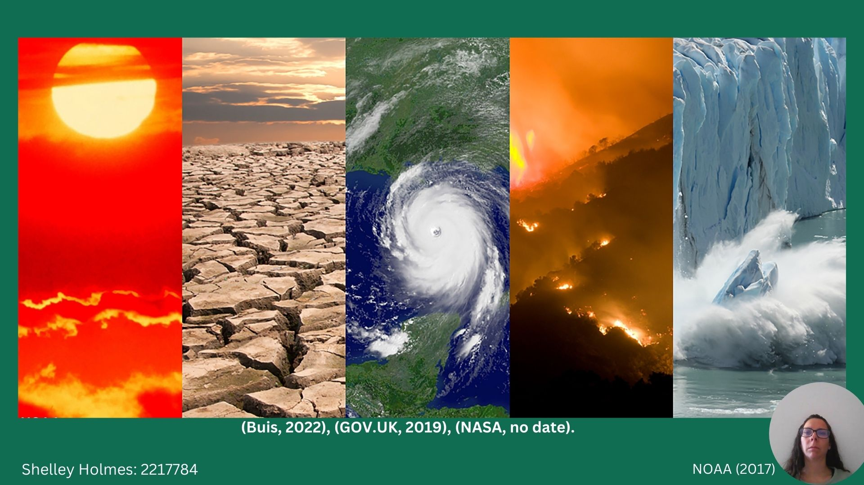
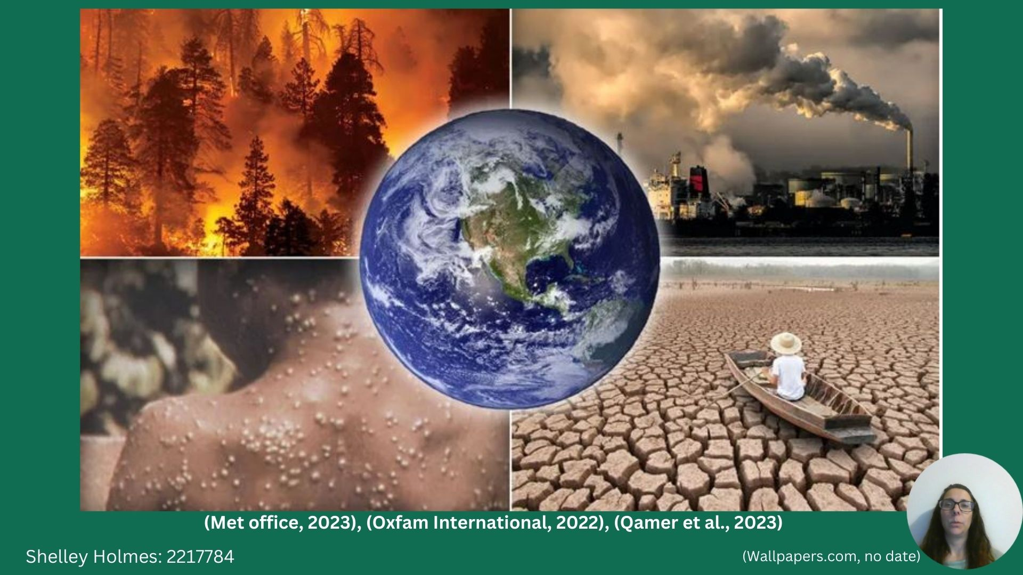

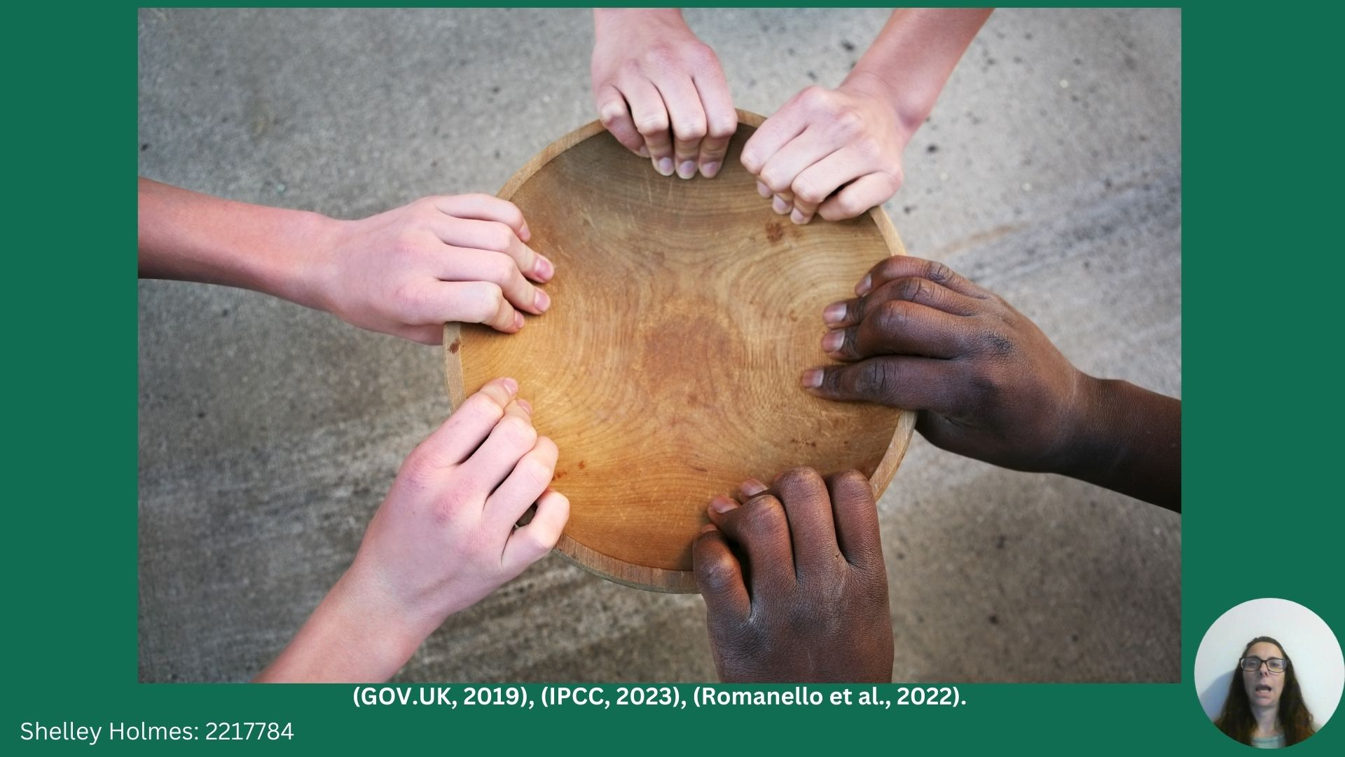

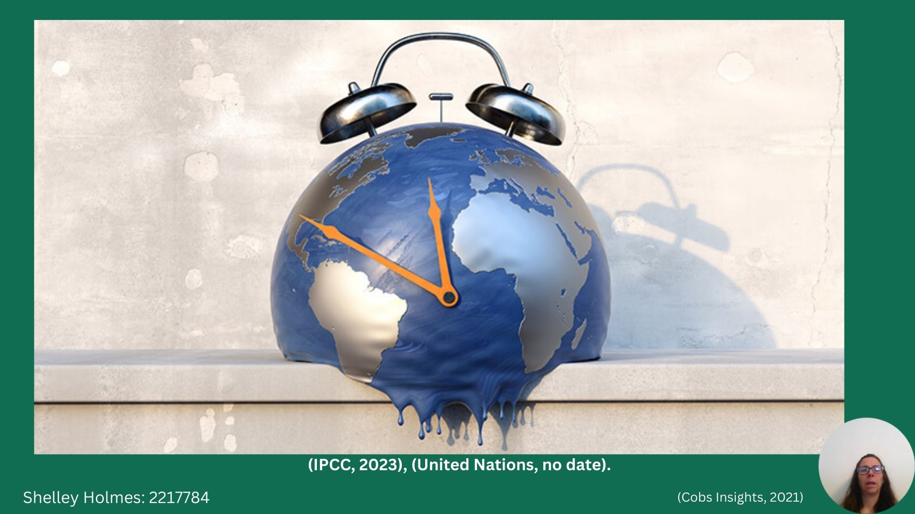

Video References:

Buis, A. (2022) ‘Steamy Relationships: How Atmospheric Water Vapor Amplifies Earth's Greenhouse Effect’, NASA Climate Change: Vital Signs of the Planet, 22 August. Available at: https://climate.nasa.gov/ask-nasa-climate/3143/steamy-relationships-how-atmospheric-water-vapor-amplifies-earths-greenhouse-effect/ (Accessed: 14 April 2023). (Shelley Holmes: 2217784)

Cobs Insights (2021) ‘How Social and Environmental Accounting Can Change the Nature of Our Game’, Council on Business & Society Insights [Preprint]. Available at: https://cobsinsights.org/2021/11/25/how-social-and-environmental-accounting-can-change-the-nature-of-our-game/ (Accessed: 14 April 2023). (Shelley Holmes: 2217784)

Gov.uk (2019) Climate change explained. Available at: https://www.gov.uk/guidance/climate-change-explained (Accessed: 14 April 2023). (Shelley Holmes: 2217784)

Gov.uk (2021) Trend Deck 2021: Climate change. Available at: https://www.gov.uk/government/publications/trend-deck-2021-climate-change/climate-change#increasing-number-of-high-impact-climate-and-weather-events-affecting-people (Accessed: 15 April 2023). (Shelley Holmes: 2217784)

Hooijer, A. and Vernimmen, R. (2021) ‘Global LiDAR land elevation data reveal greatest sea-level rise vulnerability in the tropics’, Nature Communications, 12(1), Available at: https://doi.org/10.1038/s41467-021-23810-9 (Accessed: 15 April 2023). (Shelley Holmes: 2217784)

IPCC (2022) Framing and Context of the Report. Cambridge University Press eBooks, pp. 73–130. Available at: https://doi.org/10.1017/9781009157964.003 (Accessed: 15 April 2023). (Shelley Holmes: 2217784)

IPCC (2023) AR6 Synthesis Report: Climate Change 2023. Available at: https://report.ipcc.ch/ar6syr/pdf/IPCC_AR6_SYR_LongerReport.pdf (Accessed: 14 April 2023). (Shelley Holmes: 2217784)

Met Office (2022) Effects of climate change (2022). (Shelley Holmes: 2217784) Available at: https://www.metoffice.gov.uk/weather/climate-change/effects-of-climate-change (Accessed: 14 April 2023). (Shelley Holmes: 2217784)
Met Office (2023) ‘Climate change drives UK’s first year over 10°C’, Available at: https://www.metoffice.gov.uk/about-us/press-office/news/weather-and-climate/2023/climate-change-drives-uks-first-year-over-10c (Accessed: 15 April 2023). (Shelley Holmes: 2217784)

NASA (No date) The Effects of Climate Change. Available at: https://climate.nasa.gov/effects/ (Accessed: 15 April 2023). (Shelley Holmes: 2217784)

NOAA (2017) International report confirms 2016 was warmest year on record for the globe. Available at: https://www.noaa.gov/news/international-report-confirms-2016-was-warmest-year-on-record-for-globe (Accessed: 14 April 2023). (Shelley Holmes: 2217784)

Oxfam International (2022) ‘5 natural disasters that beg for climate action’. Available at: https://www.oxfam.org/en/5-natural-disasters-beg-climate-action (Accessed: 15 April 2023). (Shelley Holmes: 2217784)

Paris Agreement - UNFCCC (2016). (Shelley Holmes: 2217784) Available at: https://unfccc.int/sites/default/files/english_paris_agreement.pdf (Accessed: April 14 2023). (Shelley Holmes: 2217784)

Qamer, F.M. et al. (2023) ‘A framework for multi-sensor satellite data to evaluate crop production losses: the case study of 2022 Pakistan floods’, Scientific Reports, 13(1). (Shelley Holmes: 2217784) Available at: https://doi.org/10.1038/s41598-023-30347-y (Accessed: 15 April 2023). (Shelley Holmes: 2217784)

Romanello, M. et al. (2022) ‘The 2022 report of the Lancet Countdown on health and climate change: health at the mercy of fossil fuels’, The Lancet, 400(10363), pp. 1619–1654. Available at: https://doi.org/10.1016/s0140-6736(22)01540-9 (Accessed: 15 April 2023). (Shelley Holmes: 2217784)

Turley, C. and Gattuso, J.P. (2012) ‘Future biological and ecosystem impacts of ocean acidification and their socioeconomic-policy implications’, Current Opinion in Environmental Sustainability, 4(3), pp. 278–286. Available at: https://doi.org/10.1016/j.cosust.2012.05.007 (Accessed: 14 April 2023). (Shelley Holmes: 2217784)

United Nations (no date) Causes and Effects of Climate Change | United Nations. Available at: https://www.un.org/en/climatechange/science/causes-effects-climate-change (Accessed: 15 April 2023). (Shelley Holmes: 2217784)

Wallpapers.com (No date). (Shelley Holmes: 2217784) Available at: https://wallpapers.com/picture/global-warming-pictures-2100-x-1268-13npgqxfewq4xedj.html (Accessed: 14 April 2023). (Shelley Holmes: 2217784)

World Meteorological Organisation (2022) Provisional State of the Global Climate in 2022. Available at: https://public.wmo.int/en/our-mandate/climate/wmo-statement-state-of-global-climate (Accessed: 14 April 2023). (Shelley Holmes: 2217784)

World Meteorological Organization (2023) ‘Past eight years confirmed to be the eight warmest on record’, 12 January. Available at: https://public.wmo.int/en/media/press-release/past-eight-years-confirmed-be-eight-warmest-record#:~:text=The%20warmest%20eight%20years%20have,contributed%20to%20record%20global%20temperatures (Accessed: 14 April 2023). (Shelley Holmes: 2217784)

Reflection on group video presentation

There is a wealth of research to suggest the considerable benefits of group working. In addition to higher achievement and increased productivity, sharing a common goal can create more supportive relationships, improved motivation, critical thinking skills and resilience. Team working can build self-esteem, drive continuous improvement and collaboration benefiting psychological health and well-being (Johnson and Johnson, 2016), (Johnson, Johnson and Smith, 2007), (Laal and Ghodsi, 2012), (Lewin, 1947), (Rezaei, 2018), (Scager et al., 2016), (Slavin, 1980). For the final assignment this term we were required to work together in a team of four to create a group video on a solution to the ‘Wicked problem’ of climate change. According to Gibbs (1988, p.9):
It is not sufficient simply to have an experience in order to learn. Without reflecting upon this experience it may quickly be forgotten or its learning potential lost. It is from the feelings and thoughts emerging from this reflection that generalisations or concepts can be generated. And it is generalisations which enable new situations to be tackled effectively.
In this essay the writer will use Gibbs’ six-stage model (1988) to reflect on the group task.

Left to form our own groups, along with another student, we approached two students whom we felt we could work effectively with to form a group of four. We met online immediately after the last lecture to discuss ideas and a way forward, we agreed to meet in person the following week at the university library. At the face-to-face meeting, we finalized our idea and allocated which sections each individual would be responsible for, agreeing on a completion date for the video which would allow enough time for the reflection essay. We stayed in regular contact via WhatsApp to ensure that we were adopting the same style and layout, meeting again on Teams, when required, to piece all sections together and add the final touches.

When I first heard about the group work I was concerned, I was worried that I would be placed in a group with other students I did not really know and who would not approach the task as conscientiously as myself. I felt relieved when I found out I could form a group with those I perceived had a similar work ethic to myself and would be motivated to complete the task in a timely manner. After the first online meeting, I was worried that a member of the team was reserved and stated they were anxious about the task, especially the Canva element. By the end of the second meeting which was a face-to-face meeting, I was feeling more optimistic about the group and the task at hand. Everyone got along well and seemed happy, positive and motivated to get the task completed. As time went on I felt more encouraged, with everyone staying in touch and supporting each other I was confident that we would produce a good quality video. I was happy to be in a group with like-minded, hardworking people whom I would be content to work with again in the future.

The task was a success, responsibility was shared equally amongst all team members and the video was completed by the time scale discussed in our face-to-face meeting. The group bonded well and stayed in regular contact via the WhatsApp group, discussing any concerns and supporting each other whenever the need arose. All members of the team contributed effectively to the video and I made sure that I offered my help and support especially with the team member who was least confident, encouraging them to feel more autonomous in the task. The video flowed well and I was happy with the result, there were no negative aspects.

Initially, I was apprehensive about the group task, evidence suggests that team working can be challenging (Aggarwal and O’Brien, 2008), (Hall and Buzwell, 2013), (Hillyard, Gillespie and Littig, 2010), (McCorkle et al., 1999). I was also concerned that some students on the course procrastinate which can have a negative impact on grades, mental health and well-being (Day, Minsks and O’Sullivan, 2000), (Ferrari, Johnson and McCown, 1995), (Ferrari, O’Callghan and Newbegin, 2005), (Klassener, Mullner and Rajani, 2008). Realizing that we were able to select our own groups I felt more at ease and set about approaching other students I felt I could work well with, who showed some levels of self-efficacy (Bandura, 1977), (Kozlowski and Ilgen, 2006). According to De Cooman et al. (2016) teams that perceive they have a mixture of supplementary and complementary team members perform better and have a strong sense of team cohesion and collective efficacy thus improving motivation and performance (Bandura, 1997), (Elms, Gill and González-Morales, 2022), (Li et al., 2020), (Tasa, Taggar and Seijts, 2007). Although after the first online meeting, I had some concerns about one member of the team not contributing as much as the others I quickly realised that it was a lack of confidence rather than a lack of interest. As described by Akbari and Sahibzada (2020), a lack of self-confidence can affect academic achievement, self-esteem and future success therefore it was important to offer help and support to this member of the team and promote collective efficacy. With studies showing that face-to-face meetings provide a more supportive environment, increased productivity and further opportunities for effective communication (Gera, 2013), (Hollingshead, McGrath and O’Connor, 1993), (Kozlowski and Ilgen, 2006), (Warkentin, Sayeed and Hightower, 1997) we felt it important that our planning meeting was undertaken in this way. This meeting went well and the positivity continued throughout the task, all parties completed their sections of the video by the time scale agreed and remained in regular contact throughout discussing any concerns or worries.

In conclusion, the group task was beneficial, it created a support network, a mini team which has continued to help and support each other since the assignment (Peterson and Miller, 2004). Staying in regular contact with each other has allowed for team bonding and an exchange of skills benefiting the whole team as highlighted by French and Kottke (2013), Peterson and Miller (2004) and Soetanto and MacDonald (2017).

I feel that identifying and approaching students who have a similar work ethic was of benefit and I would try to replicate this again in future group work. I am, however, aware that group dynamics vary and not every team will work together as well. Going forward I would take into account team models and stages of team development for example Tuckman (1965), Marston (1928) and the Thomas and Kilmann conflict model (1974) to ensure that group work continued to be a positive experience.

Reflection Essay References:

Aggarwal, P. and O’Brien, C.L. (2008) ‘Social Loafing on Group Projects,’ Journal of Marketing Education, 30(3), pp. 255–264. Available at: https://doi.org/10.1177/0273475308322283 (Accessed: 25 April 2023).
Akbari, O. and Sahibzada, J. (2020) ‘Students’ Self-Confidence and Its Impacts on Their Learning Process,’ American International Journal of Social Science Research, 5(1), pp. 1–15. Available at: https://doi.org/10.46281/aijssr.v5i1.462 (Accessed: 26 April 2023).
Bandura, A. (1977) ‘Self-efficacy: Toward a unifying theory of behavioral change.,’ Psychological Review, 84(2), pp. 191–215. Available at: https://doi.org/10.1037/0033-295x.84.2.191 (Accessed 25: April 2023).
Bandura, A. (1997) Self-Efficacy: The Exercise of Control. Macmillan.
Day, V.W., Mensink, D. and Pardalos, P.M. (2000) ‘Patterns of Academic Procrastination,’ Journal of College Reading and Learning, 30(2), pp. 120–134. Available at: https://doi.org/10.1080/10790195.2000.10850090 (Accessed: 24 April 2023).
De Cooman, R. et al. (2016) ‘Creating Inclusive Teams Through Perceptions of Supplementary and Complementary Person–Team Fit,’ Group & Organization Management, 41(3), pp. 310–342. Available at: https://doi.org/10.1177/1059601115586910 (Accessed: 26 April 2023).
Elms, A.K., Gill, H. and González-Morales, M.A. (2022) ‘Confidence Is Key: Collective Efficacy, Team Processes, and Team Effectiveness,’ Small Group Research, 54(2), pp. 191–218. Available at: https://doi.org/10.1177/10464964221104218 (Accessed: 26 April 2023).
Ferrari, J.R., Johnson, J.A. and McCown, W. (1995) Procrastination and Task Avoidance, Springer eBooks. Springer Nature. Available at: https://doi.org/10.1007/978-1-4899-0227-6. (Accessed: 24 April 2023).
Ferrari, J.R., O’Callghan, J. and Newbegin, I. (2005) ‘Prevalence of procrastination in the United States, United Kingdom, and Australia: arousal and avoidance delays among adults’, North American journal of psychology, 7(1), p. 1–. Available at: https://www.proquest.com/docview/197980168?parentSessionId=jEyDzI4znNxi9BqYSMrsUXYeAB7iLJvE8aiCJ1wDCdk%3D&pq-origsite=primo&accountid=130472 (Accessed: 25 April 2023).
French, K.A. and Kottke, J.L. (2013) ‘Teamwork satisfaction: Exploring the multilevel interaction of teamwork interest and group extraversion,’ Active Learning in Higher Education, 14(3), pp. 189–200. Available at: https://doi.org/10.1177/1469787413498034 (Accessed: 26 April 2023).
Gera, S. (2013b) ‘Virtual teams versus face to face teams: A review of literature,’ IOSR Journal of Business and Management, 11(2), pp. 01–04. Available at: https://doi.org/10.9790/487x-1120104 (Accessed 26: April 2023).
Gibbs, G. (1988) Learning by Doing: A Guide to Teaching and Learning Methods.
Hall, D.H. and Buzwell, S. (2013) ‘The problem of free-riding in group projects: Looking beyond social loafing as reason for non-contribution,’ Active Learning in Higher Education, 14(1), pp. 37–49. Available at: https://doi.org/10.1177/1469787412467123. (Accessed: 25 April 2023).
Hillyard, C., Gillespie, D. and Littig, P.J. (2010) ‘University students’ attitudes about learning in small groups after frequent participation,’ Active Learning in Higher Education, 11(1), pp. 9–20. Available at: https://doi.org/10.1177/1469787409355867 (Accessed: 25 April 2023).
Johnson, D. and Johnson, F. (2016) Joining Together: Group Theory and Group Skills.
Johnson, D.W., Johnson, R.T. and Smith, K.A. (2007) ‘The State of Cooperative Learning in Postsecondary and Professional Settings,’ Educational Psychology Review, 19(1), pp. 15–29. Available at: https://doi.org/10.1007/s10648-006-9038-8 (Accessed: 21 April 2023).
Klassen, R.D., Krawchuk, L.L. and Rajani, S. (2008) ‘Academic procrastination of undergraduates: Low self-efficacy to self-regulate predicts higher levels of procrastination,’ Contemporary Educational Psychology, 33(4), pp. 915–931. Available at: https://doi.org/10.1016/j.cedpsych.2007.07.001 (Accessed: 24 April 2023).
Kozlowski, S.W.J. and Ilgen, D.R. (2006) ‘Enhancing the Effectiveness of Work Groups and Teams,’ Psychological Science in the Public Interest, 7(3), pp. 77–124. Available at: https://doi.org/10.1111/j.1529-1006.2006.00030.x (Accessed 25: April 2023).
Laal, M. and Ghodsi, S.M. (2012) ‘Benefits of collaborative learning,’ Procedia - Social and Behavioral Sciences, 31, pp. 486–490. Available at: https://doi.org/10.1016/j.sbspro.2011.12.091 (Accessed: 21 April 2023).
Lee, P.P. et al. (2011) ‘Internet Communication Versus Face-to-face Interaction in Quality of Life,’ Social Indicators Research, 100(3), pp. 375–389. Available at: https://doi.org/10.1007/s11205-010-9618-3 (Accessed: 26 April 2023).
Lewin, K. (1947) ‘Frontiers in Group Dynamics,’ Human Relations, 1(1), pp. 5–41. Available at: https://doi.org/10.1177/001872674700100103. (Accessed: 21 April 2023).
Li, J. et al. (2020) ‘Employee–Organization Relationships and Team Performance: Role of Team Collective Efficacy,’ Frontiers in Psychology, 11. Available at: https://doi.org/10.3389/fpsyg.2020.00206 (Accessed: 26 April 2023).
Marston, W.A. (1928) Emotions of normal people. Available at: https://doi.org/10.1037/13390-000 (Accessed: 26 April 2023).
McCorkle, D.E. et al. (1999) ‘Undergraduate Marketing Students, Group Projects, and Teamwork: The Good, the Bad, and the Ugly?,’ Journal of Marketing Education, 21(2), pp. 106–117. Available at: https://doi.org/10.1177/0273475399212004 (Accessed 25: April 2023).
Peterson, S.J. and Miller, J.S. (2004) ‘Quality of College Students’ Experiences During Cooperative Learning,’ Social Psychology of Education, 7(2), pp. 161–183. Available at: https://doi.org/10.1023/b:spoe.0000018522.39515.19 (Accessed: 26 April 2023).
Rezaei, A. (2018) ‘Effective Groupwork Strategies: Faculty and Students’ Perspectives,’ Journal of Education and Learning, 7(5), p. 1. Available at: https://doi.org/10.5539/jel.v7n5p1. (Accessed: 21 April 2023).
Scager, K. et al. (2016) ‘Collaborative Learning in Higher Education: Evoking Positive Interdependence,’ CBE- Life Sciences Education, 15(4), p. ar69. Available at: https://doi.org/10.1187/cbe.16-07-0219. (Accessed: 21 April 2023).
Slavin, R.E. (1980) ‘Cooperative Learning,’ Review of Educational Research, 50(2), pp. 315–342. Available at: https://doi.org/10.3102/00346543050002315. (Accessed: 21 April 2023).
Soetanto, D. and MacDonald, M. (2017) ‘Group work and the change of obstacles over time: The influence of learning style and group composition,’ Active Learning in Higher Education, 18(2), pp. 99–113. Available at: https://doi.org/10.1177/1469787417707613 (Accessed: 26 April 2023).
Tasa, K., Taggar, S. and Seijts, G. (2007) ‘The development of collective efficacy in teams: A multilevel and longitudinal perspective.,’ Journal of Applied Psychology, 92(1), pp. 17–27. Available at: https://doi.org/10.1037/0021-9010.92.1.17 (Accessed: 26 April 2023).
Thomas, K.R. and Kilmann, R.H. (1974) ‘Thomas-Kilmann Conflict Mode Instrument,’ PsycTESTS Dataset. Available at: https://doi.org/10.1037/t02326-000 (Accessed: 26 April 2023).
Tuckman, B. (1965) ‘Developmental sequence in small groups.,’ Psychological Bulletin, 63(6), pp. 384–399. Available at: https://doi.org/10.1037/h0022100. (Accessed: 21 April 2023).
Tuckman, B. and Jensen, M.E. (1977) ‘Stages of Small-Group Development Revisited,’ Group & Organization Studies, 2(4), pp. 419–427. Available at: https://doi.org/10.1177/105960117700200404. (Accessed: 21 April 2023).
Warkentin, M., Sayeed, L. and Hightower, R. (1997) ‘Virtual Teams versus Face-to-Face Teams: An Exploratory Study of a Web-based Conference System,’ Decision Sciences, 28(4), pp. 975–996. Available at: https://doi.org/10.1111/j.1540-5915.1997.tb01338.x (Accessed: 26 April 2023).

