Dissertation Proposal

Student Name: Yilan Men
Student Number: 2006394
Programme of Study: Fine Art: Studio, Site & Context
Module: Research in Practice (ADAD5004)
Lecturer: Paul Duerinckx
Three Keywords: Misogyny & Power Structure & Chinese Female Art
Word Count: 2400

Introduction
This piece of writing will analyse the keywords ‘misogyny’ and ‘power structures’, using the theories of following thinkers, Kate Manne, Chizuko Ueno, and Michel Foucault. Kate Manne's theory will be used to construe misogyny and Foucault's theory will be used to scrutinise power structure, while Ueno's theory will address both of them. The keyword “Chinese female art” will be analysed through a discussion of three works by three artists, Xi Liu, Jing Xiang, and Zhen Guo.

The study will also show how misogyny is profoundly ingrained in our lives, how patriarchal power structure creates and depends on it, and how misogyny and power structure influence and are reflected in Chinese female art. The analysis will be followed by a further exploration of the relationship between these keywords and my own practice and research, developing a question that will be investigated in greater depth in the dissertation next year.

Keywords Analysis

Misogyny: Ostracising Women and Feminisation Makes Men Manly
One is not born, but rather becomes, a woman. (Beauvoir, 1989, p. 273)

What is misogyny? In short, misogyny is discrimination and hatred against women based on gender which plays a central role in the gender binary system, and it is deeply rooted in the core of self-affirmation of men which leads to them becoming sexual subjects (Ueno, 2015).

To explore how misogyny manifests itself in life in a more straightforward approach, the misogynist would be a more tangible subject for discussion than the idea of misogyny itself. A misogynist is an individual who enforces the idea of misogyny. Not only do those who are misogynists discriminate against women, but they also want to exclude homosexuals - because homosexuals lose their status as sexual subjects and are reduced to sexual objects to be penetrated, that is, ‘feminised’ (Ueno, 2015). While the misogyny’s targets included homosexuality among men, it is common for men to have ‘male homosocial desires’ (Sedgwick, 1985), which differs from the former, since it is a need of being identified and recognised by their own kind under the rule of the patriarchy.

Misogyny is manifested in various aspects of our society. For instance, in pornography, it is often the case that women fall for a man because of his great sexual prowess, and this is because pornography itself is a product of a culture that is primarily targeted men as the main audience. The reason men are pleased by such content is that this "domination through pleasure" is a more ultimate form than domination through violence, power, or wealth since the spontaneous submission of the dominated reduces the cost of domination and makes it secure and stable (Ueno, 2015). At the same time, it is a self-righteous fantasy projection that ignores the true feelings of the sexual object in the sexual act, due to the inequality between the subject and the object.

Another example of misogyny is “loving mothers, erasing others” (Manne, 2018). The prescriptive nature of the category of “mother” as a cultural ideal of selflessness and devotion also binds women themselves (Ueno, 2015), to be specific, that the social roles of women in patriarchal culture are that of subordinate to men and they are taught to adhere to the norms and expectations that conduct the social roles (Manne, 2018). This explains why, on the surface, “mothers” do not seem to be the target of misogyny, yet “others” who are not in this category are justifiably discriminated against by patriarchal ideology.

“Others” are often referred to as “prostitutes” or “unwed mothers” because they are not dominated or controlled by a particular man, they are women who “exercise the right to sexual self-determination (Ueno, 2015)”. In fact, most prostitutes and unwed mothers are also nothing more than victims of patriarchy, and it is the usual practice of the perpetrators to shift the cause onto the victim (Ueno, 2015). This tactic is supported and evidenced in Manne’s (2018) “Suspecting Victims”.

Women's misogyny is self-loathing, though some of these women may not perceive it as such. They achieve this by presenting themselves as exceptional individuals among the women, by ostracising women other than themselves, thus, passing on the misogyny. However, this means of creating privileged "exceptions" does no harm to the mechanism of discrimination and is even an accomplice to the repeated production of it (Ueno, 2015).

When the identical thoughts or actions are expressed or performed by a female or a male counterpart, they may be reckoned differently in the first place, where identical activities appear to be different due to a lens of unequal prior distrust or a gendered delegation of tasks (Manne, 2018). Therefore, whether it is women who want to pass on the misogyny or women who live with self-loathing, they are all social minorities and suffer from the “violence of categories”, because it is the social majority that creates and divides categories (Ueno, 2015). This viewpoint also leads to the next keyword to be analysed, power structure.

Power Structure: How the Patriarchal Mechanism Works to Exploit Women
Repression operated as a sentence to disappear, but also an injunction to silence, an affirmation of nonexistence, and, by implication, an admission that there was nothing to say about such things, nothing to see, and nothing to know. (Foucault, 1984, p. 293)

Patriarchy is not merely psychological domination and oppression but cannot be separated from its material basis; sexual domination is not a mere ideology or psychology, but an explicitly material ruling enforced through social and economic. In the social facet, historical norms and expectations established for centuries still suppress the emancipation of women's self-awareness; in the economic aspect, women are side-lined in the workforce and the female labour is considered insignificant (Ueno, 2020).

Foucault’s discussion of power structure is more subtle and complex, it is not simply ‘us versus them’, the powerful oppressing the powerless, or men versus women. The nuance comes from all of us being conduits of the (invisible) power structure – we internalise societal norms and end up policing each other. Thus, power structures and dominance are a result of social discourse. For example, in the socialisation of procreative behaviour in the early modern era, sex was transformed into discourse driven by a goal to eliminate from reality those forms of sexuality that were not compatible with the strict economy of reproduction (Foucault, 1978).

The socialisation of procreative behaviour has also become the basis for the sexual domination of women in modern families. Although such domination is directly embodied in the family because, patriarchy as an institutional power structure, is capable of cross-sectoral power penetration and is closely linked to other social spheres, women face sexual domination in other social spheres even when they do not enter monogamous families (Ueno, 2020). This gives rise to the situation that modern women are exploited as a reproducer in both the market and domestic domains.

Chinese Female Art: Where the Label of Feminism is Seen as a Stigma
You are a woman, but you avoid the feminist position, this ‘collective silence’ caused by many individuals has led many good female artists into a state of chronic death. (Guo, 2020)

There are three artists and three works of them to be discussed around this keyword, and each of the artists represents a different type of woman growing up in modern Chinese society and culture. The first two are artists who were born before China’s reform and opening up in the 80s, and the third one is an investigation of the interpretation of female self-identity by a new generation of women artists.

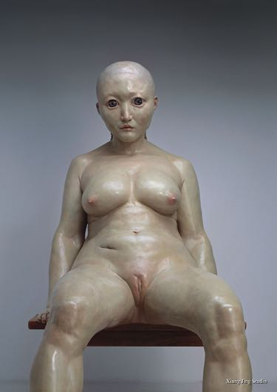
The first one is Jing Xiang (1968-present), who is thought to be the first woman artist to create naked sculptures (Tate, 2013), and one of her most famous works of sculptures – Your Body, a piece made of fiberglass and paint which measures 270×160×150 cm. A massive nude slumps in a chair, her eyes vacantly gazing into the distance (Walsh, 2013). The scar, folds, and the plastic touch are applied to the skin of the figure, which represent the reality of imperfections of the female body in a straightforward way.
Fig 1. Your Body, Jing Xiang, 2005

At the time this work was created, the artist has unconsciously challenged the established values in Chinese society. The work was eventually shown in a solo exhibition organised by Xiang herself as it was not invited to any of the exhibitions, and the reaction of the audience to the work was that it was terrifying and discomforting. Such reactions were provoked because there were no artworks created from a female perspective, and women in Chinese culture are always to be sacrificed for their families (Tate, 2013). She has brought the subjectivity of women into the public eye and to some extent broke the male fantasy of the female body.

However, according to the artist, the work is merely a vehicle for carrying her thoughts, rather than a reflection of the state of gender in China (Walsh, 2013). I am not entirely convinced of this, or that Xiang's own consciousness believes this, but I think her subconscious might have a different answer. Apart from the avoidance of facing this issue, it can be found in the interviews with her, that although she talked about how traditional social system has made or influenced women artists ‘disappear’ and how it has become an obstacle for women artists (Tate, 2013), she has shied away from talking about feminism, refused to be labelled as a feminist artist, and even circumvented from being one of the female artists.

Jing Xiang is one of the many women artists who have leaned toward studying the topics of gender in a subtly code way due to their ambivalent relationship with the concept of feminism (Guest, 2020b) as well as her predicament as an artist in China where challenging the status quo can render nasty results.

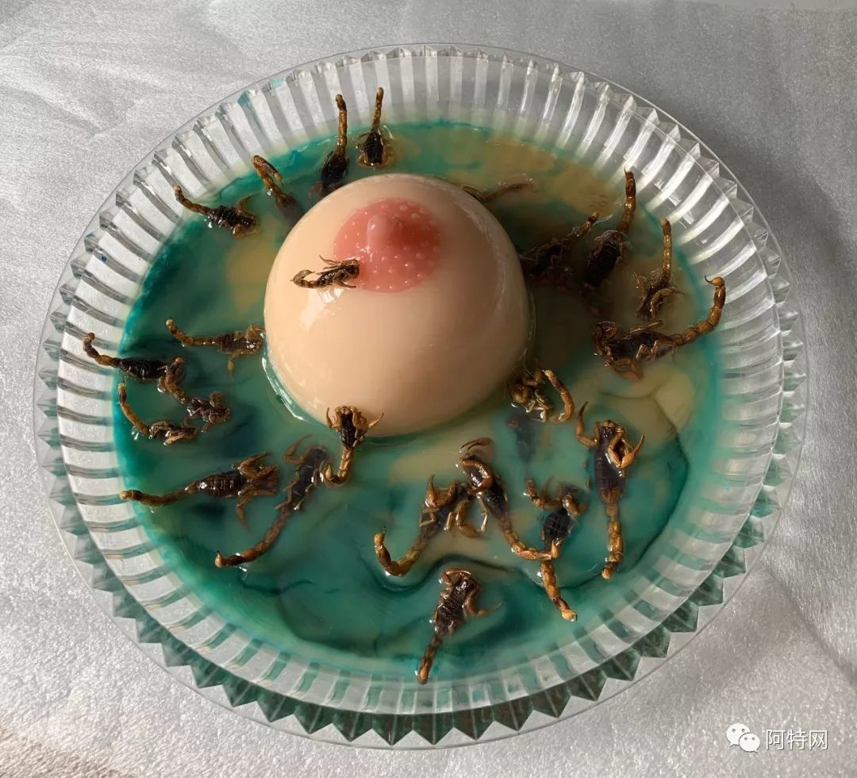
The second artist is Zhen Guo (1955-present), who has had a more difficult experience than Xiang. She went to the United States with her ex-husband as a visiting scholar, had to take on the financial stress of two people to support her ex-husband, and had been subjected to repeated domestic violence by her ex-husband during this period (Gao, 2019). And it is her painful experience, and more cosmopolitan background, that make her identify strongly as a feminist artist.
Fig 2. 蛰(Sting), Zhen Guo, 2019

In her work 蛰(Sting), a swarm of scorpions surrounds, covets, and climbs on a breast, just as in traditional Chinese thought and ritual, women are taught from an early age how to give of themselves selflessly to the family, and the generations in a family depend on the self-giving of women to survive. One can see her very direct dissatisfaction with the nibbling and exploitation of women by traditional Chinese culture and moral upbringing – an imperceptible cultural mentality that makes women see sacrifice as a necessary quality and virtue, suppressing the awakening of the individual self and leading to a complete loss of female autonomy (Gao, 2019). Her personal experience of this gender-based injustice leads to a heavier sense of grief and anger in her works and a firmer identity as a feminist artist than Xiang.

Generally speaking, as time and civilization have developed, the more recent the generation, the more outspoken they are in confronting gender inequality, and
given the timing of their birth, education, and career development, Xiang Jing is considered to be a comparatively newer generation than Zhen Guo. They both have lived through the era of “women hold up half the sky”, and Xiang believed that this has improved women’s status to a certain degree (Tate, 2013), nevertheless, Zhen Guo did not think this has made much difference. In my point of view, I am more inclined to agree with Guo because the authorities and mainstream media in China exhibit a marginalisation of women, as I argued in my first-semester essay.

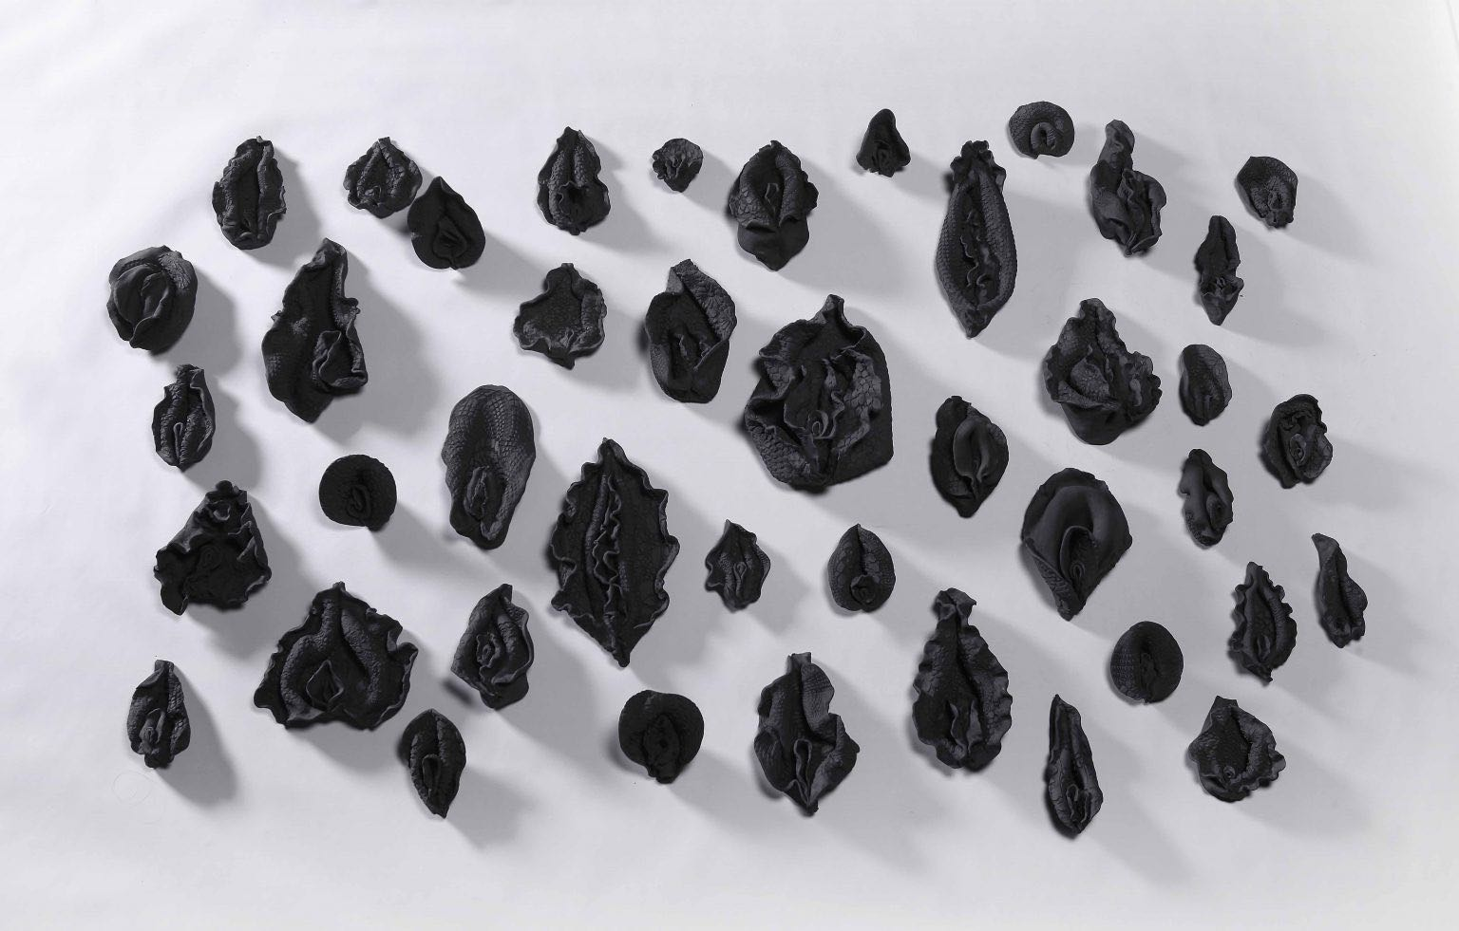
The last artist is Xi Liu (1986-present), who clearly acknowledges feminism's influence in works and her sophisticated work Our God is Great. The work is an installation that included 52 porcelain vaginas coloured in black with the use of Chinese ink, it represents the organs of reproduction in an anatomically precise way (Guest, 2020a).
Fig 3. Our God is Great, Xi Liu, 2018-2019

Her life experience has candidly informed her works; her birth to the family was regarded as a major disappointment (Guest, 2020a), which I can personally relate to, and such dejection could be easily perceived, especially for a child, as a sign of denial of her existence.

Liu has been fascinated by ceramics and its fragility reminded her of her childhood memory during the making process, and she chose to work with ceramics to overcome her trauma in an artistic method. In Xi Liu's deeply humanist body of work, the notion of mending, or healing, has a lot of resonance. Her feminism is based on the realisation that patriarchal gender standards deform both men and women, restricting our collective possibilities (Guest, 2020a).

Xi Liu is a solid example that Chinese society is beginning to accept these forms of artistic expression that were previously unthinkable. Even if this is not to the liking of the authorities, the awakening of female consciousness among the people, especially women of my generation, is unstoppable.

Research Question for the Dissertation
After the exploration of the three keywords above, the connection between them is strong and inseparable. The abstract concepts of the keywords are dissected to a more concrete level with an attempt at contextualisation.

The research question of “How the is narrative of misogyny is interpreted and demonstrated in Chinese female art by Chinese female artists under the patriarchal power structure in modern China?” is the one posed, as a starting point for the dissertation to further develop. Followed by many sub-questions derived from this research question that could be studied to support the main question in more detail in terms of historical background, cultural context, etc., such as “How is misogyny divulged in traditional and modern Chinese society?”, “How does ‘misogyny’, as a concept introduced from the West, align and conflict with the Chinese cultural context?”, “How did the status of women change during the transition from feudalism to socialism?”, “Why has ‘Women hold up half the sky’ not really changed the gender situation in China?”, “How misogyny in Chinese society has led to the disappearance of female artists?”, and “Why are only a few women artists willing to recognise themselves being feminists?”. Questions like these will be considered to be possible entry points for future research.

Bibliography
Beauvoir, S. de (1989) The Second Sex. New York: Vintage Books
Foucault, M. (1984) The Foucault Reader. ed. by Rabinow, P. New York: Pantheon Books
Foucault, M. (1978) The History of Sexuality. New York: Pantheon Books
Gao, M. (2019) ‘郭桢《中国女性艺术》代表性艺术家 (Guo Zhen “Chinese Women’s Art” Representative Artist)’. CCARTD [online] available from: https://zhuanlan.zhihu.com/p/69956274 [Accessed on 27 April 2022]
Guest, L. (2020b) ‘How Women Artists Are Navigating China’s Complex Feminist Landscape’. NüVoices [online] available from: https://nuvoices.com/2020/07/20/how-women-artists-are-navigating-chinas-complex-feminist-landscape/ [Accessed on 20 April 2022]
Guest, L. (2020a) ‘Liu Xi’s Paradox’. Randian [online] available from: http://www.randian-online.com/np_feature/liu-xis-paradox/ [20 April 2022]
Guo, Z. and Ni, A. (2020) ‘对话女权主义艺术家：郭桢 (Conversation with Feminist Artist: Guo Zhen)’. CCARTD [online] available from: https://www.163.com/dy/article/FBETDN0205385X4T.html [Accessed on 23 April 2022]
Manne, K. (2018) Down Girl: The Logic of Misogyny. New York: Oxford University Press
Sedgwick, E.K. (1985) Between Men: English Literature and Male Homosocial Desire. New York: Columbia University Press
Tate (2013) ‘Xiang Jing 向京’. Tate [online] available from: https://www.tate.org.uk/research/research-centres/tate-research-centre-asia/women-artists-contemporary-china/xiang-jing [Accessed on 24 April 2022]
Tate Research Centre: Asia (2018) Gender in Chinese Contemporary Art [online] Tate. available from: https://www.tate.org.uk/research/research-centres/tate-research-centre-asia/event-report-gender-chinese-contemporary-art [Accessed on 26 April 2022]
Ueno, C. (2020) 父权制与资本主义 (Patriarchy and Capitalism). The Simplified Chinese Edition. Hangzhou: Zhejiang University Press
Ueno, C. (2015) 厌女 (Misogyny). The Simplified Chinese Edition. Shanghai: Shanghai Joint Publishing Company
Walsh, M. (2013) ‘The Art of Insecurity: Chinese Sculptor Xiang Jing’. Wall Street Journal [online] available from: https://www.wsj.com/articles/BL-CJB-18040 [Accessed on 24 April 2022]

List of Figures
Figure 1. Your Body, Jing Xiang, 2005. Accessed from: http://www.xiangjingart.com/en/index.php?g=portal&m=article&a=work_image&id=174&image_index=9486 [Accessed on 24 April 2022]
Figure 2. 蛰(Sting), Zhen Guo, 2019. Accessed from: https://zhuanlan.zhihu.com/p/69956274 [Accessed on 24 April 2022]
Figure 3. Our God is Great, Xi Liu, 2018-2019. Accessed from: https://nuvoices.com/2020/07/20/how-women-artists-are-navigating-chinas-complex-feminist-landscape/ [Accessed on 24 April 2022]

