Questionnaire.
My group of people decided to organize ourselves to prepare a business which will bring profit for us in the future. This kind of business already exist on the market which means that business works well and should work for a next decade. Nursery is not innovating but it is a good method of cooperation to give benefits to business environment as well as customers.
During team working exercises we have developed questionnaire with ten different questions. These questions are based on our knowledge and experience. Our main aim was to find a way to potential customer and find out what will make him happy.
The main aim was important but also, we had to remember about analytical research. Therefore, I have prepared two questions to analyse demand on our service. My first question asked people how many days per week do they send their kids to nursery. This question will help us to assess what chances we have to fill our nursery. The results show that opinions are different, and it is difficult to say which answer has been most answered. Five, three and zero days were the most scored answers.
Second question I have asked people was how much they spend for a nursery per week. This question can help us to provide important information about our competitors and how much we will be able to earn during the business.
Comparing both questions, we can achieve result of how much costs one day in competitor’s nursery. After quick calculation we can say that people spend approximately 34 pounds per one day in nursery.

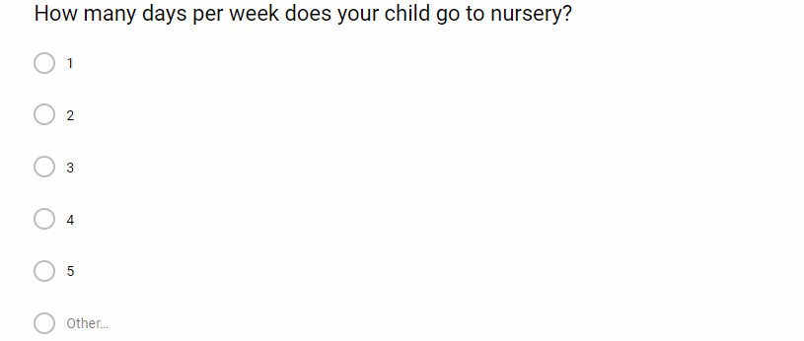
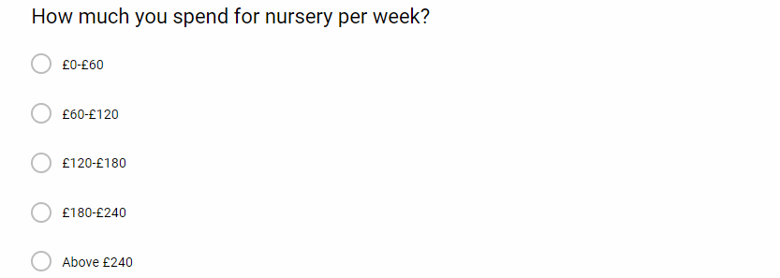
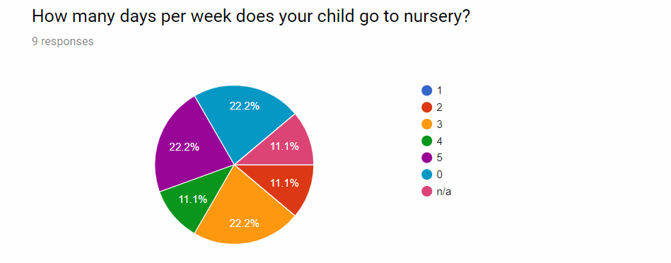
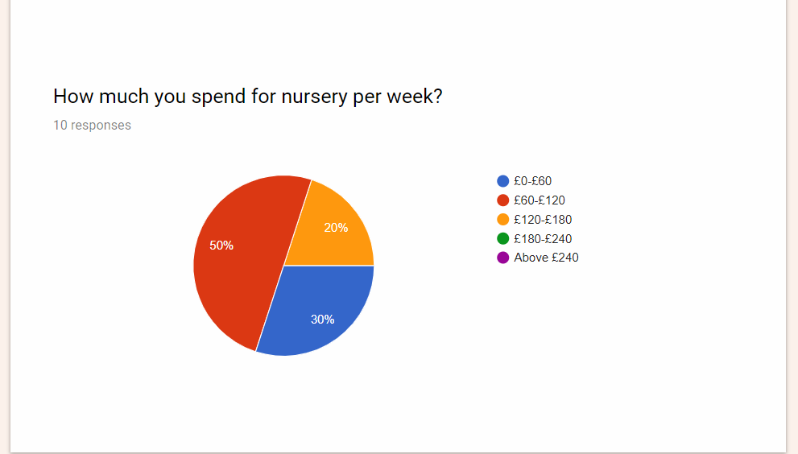

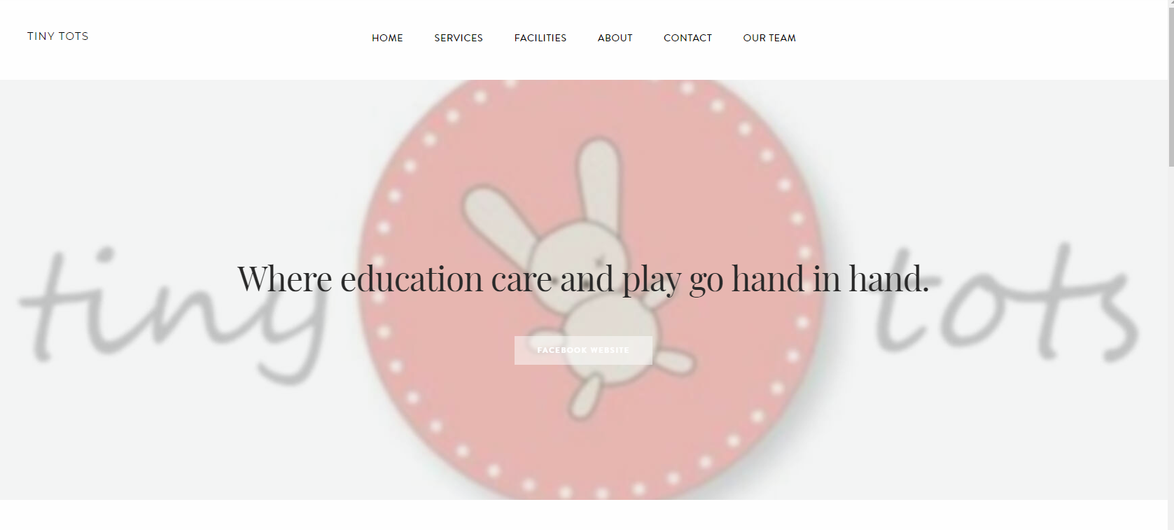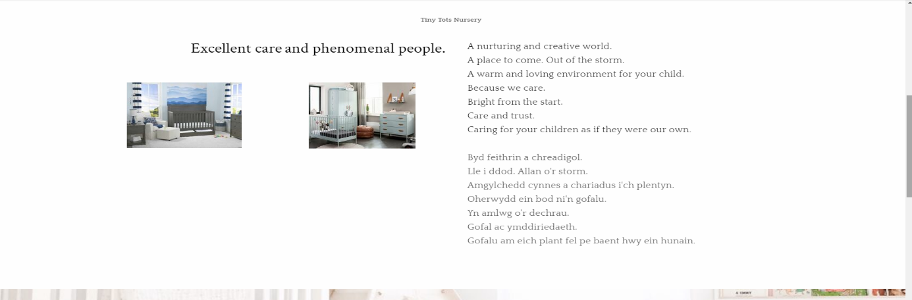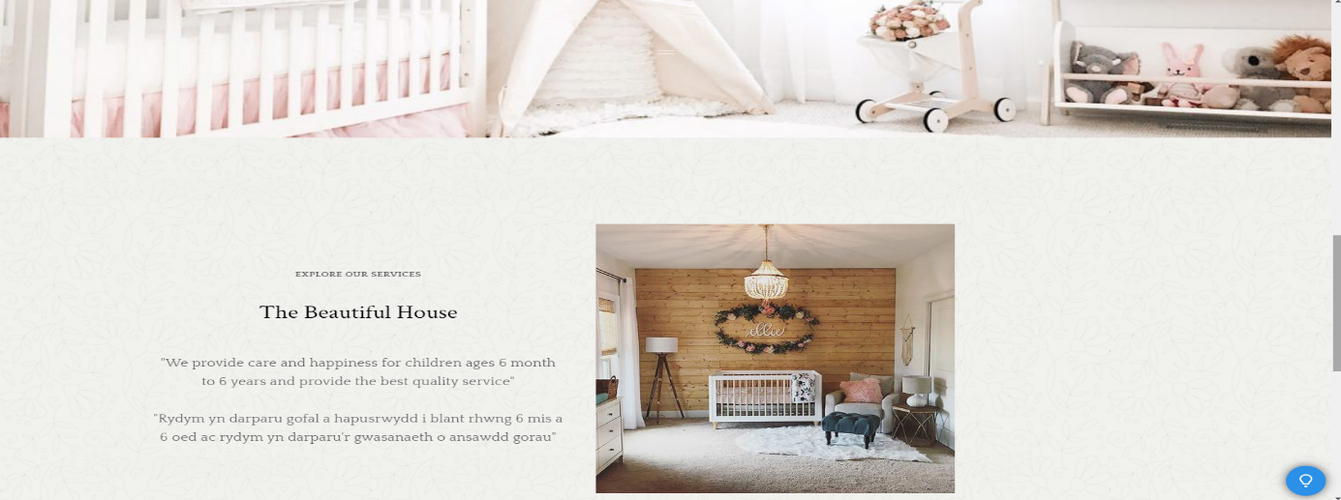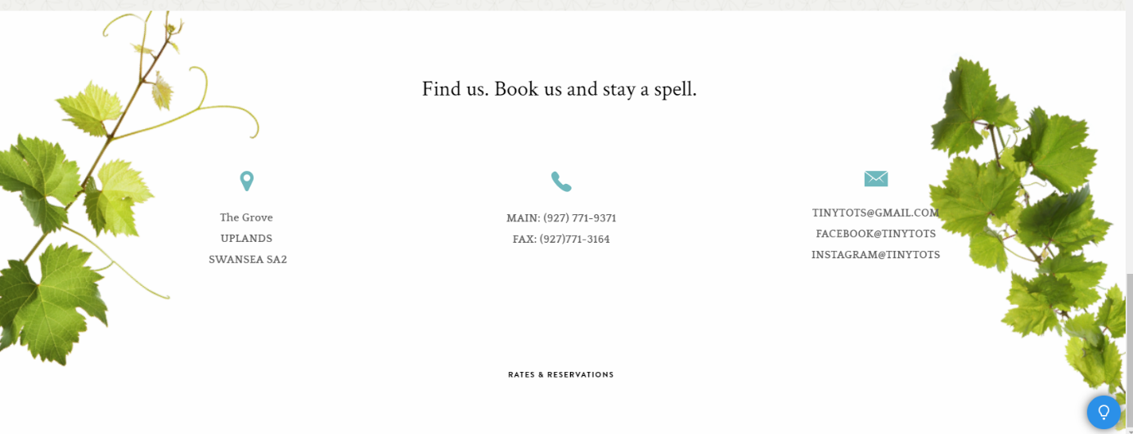

Website.
Marketing is important thing for all of businesses around the world. To achieve success, we have to find a way to reach our potential customers. One of these ways is a network communication. Website, where our customers will find out what we can offer them and basic information about business will help them to decide to which nursery their kids will go.
Our website has been developed in a short period. It is unbelievable how fantastic results we achieved during this time. It is possible thanks to website creators. Modern network tools help people to build website and therefore we have done it.
I was responsible for a main page of website. I have added a big logo of our business on the top with clear slogan motivating people to choose us. Nice and tidy pictures with a good resolution are saying to potential customers that our nursery is nice and tidy as well. Clear visibility and easy access to important links are the key between good communication with people. I have also decided to translate website to Welsh language to reach larger group of receivers. Maybe no one speaks Welsh in our business, but we considered to employ students who might have that skill. This is opportunity to spread information around Welsh families.
In my opinion marketing in network is the most important thing now. Almost everyone use internet to share their views and comments. Therefore, website should be engaging for everyone.

Gmail account used to create the website:
Username: kamil1712240@gmail.com
Password: dob11.03.91

