
Engineering Problem
Callum Clement

Semester 2

Engineering Design
Kevin Rogers

2400570

Contents Page
Introduction 2
Report 3
Client Brief 3
Key Legislation 3
Specification 3
Time Plan 4
Research 5
Annotated Sketches 6
CAD Model 9
Technical Drawings 10
Manufacturing processes 11
Justification 12
Conclusion 13
Reference List 14

Introduction

This assignment will cover the redesign of a tank lid with the intention of ensuring the lid is easier to lift but also able to be able to use by one person. It will cover multiple iterations and design ideas followed by a final idea with a CAD model to accompany the design. Key legislation will be taking into consideration, additionally specifications and a time plan will be produced for the product.

Report

Client Brief
A client has a tank used for anodisation for aluminium parts. This tank is stainless steel and contains a solvent made of 30% sulphuric acid and for health and safety has a lid placed on top. The client wishes for the lid to be redesigned as it is difficult to place and remove and requires two people to lift it to place and remove it. The tank dimensions and material must remain the same, but the lid can be completed redesigned.

Key Legislation
Legislation needs to be considered whether that be for the manufacturing of the product of the designing process following drawing and design standards such as BS8888 for technical drawings or BS EN ISO 16792 for digital models and drawings.
Other legislation to consider is the safety regulations for the employees operating these vats and removing the lid such as LOLER regulations which covers lifting regulations and Manual Handling Operations Legislation of 1992 which covers all manual and physical lifting which is directly related to our situation. The general Health and Safety at Work Act which covers many areas within a working environment to keep employees and other people safe.

Specification
The product is aimed at manufacturing businesses who require tanks of a similar design whether that be for anodisation or anything else they see fit.
There is no specified time frame for this work to be complete but as they are regularly used it would be in the best interests to get this developed and installed as soon as possible so a time frame of 6-8 weeks is likely to be getting the new lid designed, tested and manufactured for the vats within the business.
The function of the lid is to safely cover a vat with an acidic solvent within. The newly designed lid would be to make it easier to replace onto the vat and be able to be operated by one individual.
There are some design constraints within this project. Only the lid can be modified to make this work, and the dimensions and materials of the vat must remain the same.
There must also be room above the vat to place aluminium components within the vat.
The product size will remain the same with an overall length of 1770mm and width of 1020mm but with only a height of 10mm rather than the original 20mm
There is not a main concern with the aesthetics of the lid, it will be made using an aluminium alloy, specifically 6082 aluminium alloy which is readily available in the UK and far lighter and cheaper than the stainless steel that was originally used.
The product is design to be used for long term use which no moving parts fitted such as hinges which reduces the amount of maintenance required and in turn improves the durability of the lid for long term use. There will be a pully system in use which would need to be maintained by lubricating the pulleys to help reduce wear overtime.
For safety I need to consider that the lid is suitable and able to safely cover the vat without issues but also have no sharp edges making it safe to handle without causing harm.
There are many of the vats in use in the volume of low hundreds so it would be in the best interest to keep it as low cost as possible to be able to afford the production.
The manufactured lids need to be tested to ensure they are safe to operate.

Time Plan

The development process is going to be split into 5 main areas. The planning, research, design, manufacturing and the implementation. To help create a schedule a Gantt chart was created to track when each section of the development should be completed by.
Figure 1- Gantt Chart of development process

Research

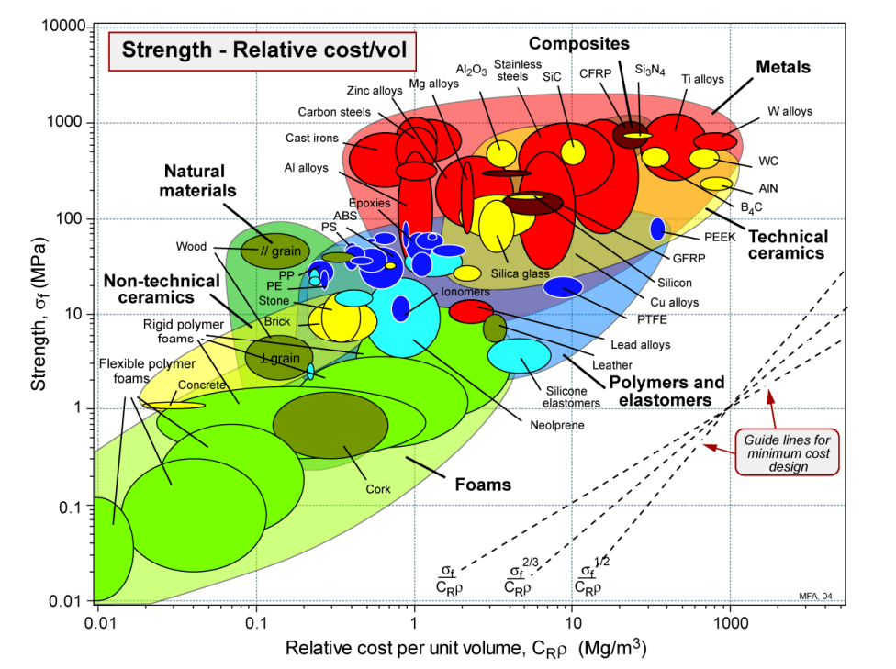
There are a few ways to make the lid easier to lift and capable to be done so by one person. One possible way would be to reduce the weight of the lid itself which would be done by redesigning it with a different material which is lighter and still capable of withstanding the same conditions as the stainless steel. Conveniently aluminium is quite a capable material and is around a third of the mass of stainless steel and cheaper, the main concern being the strength of the material as this is a safety product it would be required to protect those around and be able to withstand the weight of a person at the minimum so it would be ideal to look into some aluminium alloys if they were to be used as a replacement to the stainless steel. A common aluminium alloy in the UK is 6082 Aluminium and can be tempered to increase its strength known as 6082T6.
Figure 2- Graph showing strength against relative cost
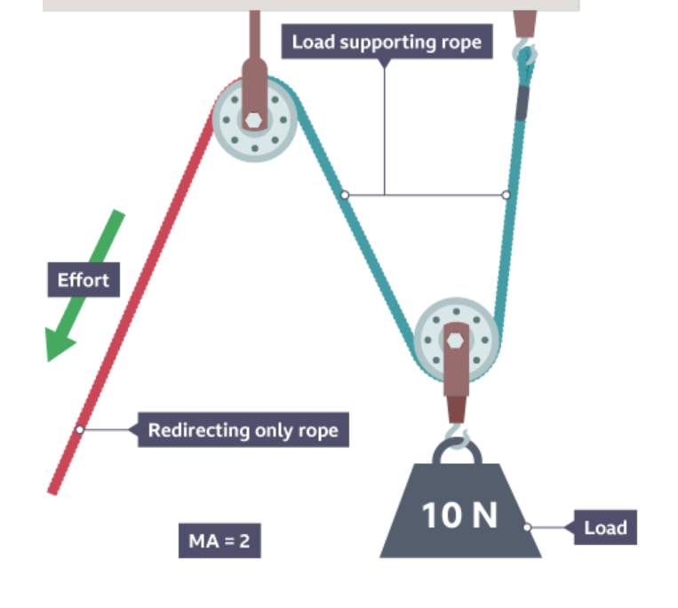
A basic way to make something easier to lift is with a lever. By using a lever, you can increase the torque applied by changing the length. A lever works with a beam placed on a fulcrum and the longer the distance from the fulcrum the greater the torque so if something was on one side of the beam and you placed a force twice the distance along the beam it would require half the effort, the downside to this is the room this would take up and it would not be easier to operate.
Figure 3- Annotated diagram of a two-pully system
One final method is with a pulley system, when using a pulley system, the load is distributed between the rope and reduces the effort based on the number of pulleys. With two pulleys the force required is half which would be ideal for this situation as we are aiming to make this lid able to be lifted by one person instead of two, so by installing two pulleys it would half the effort required making it suitable to be lifted by one person

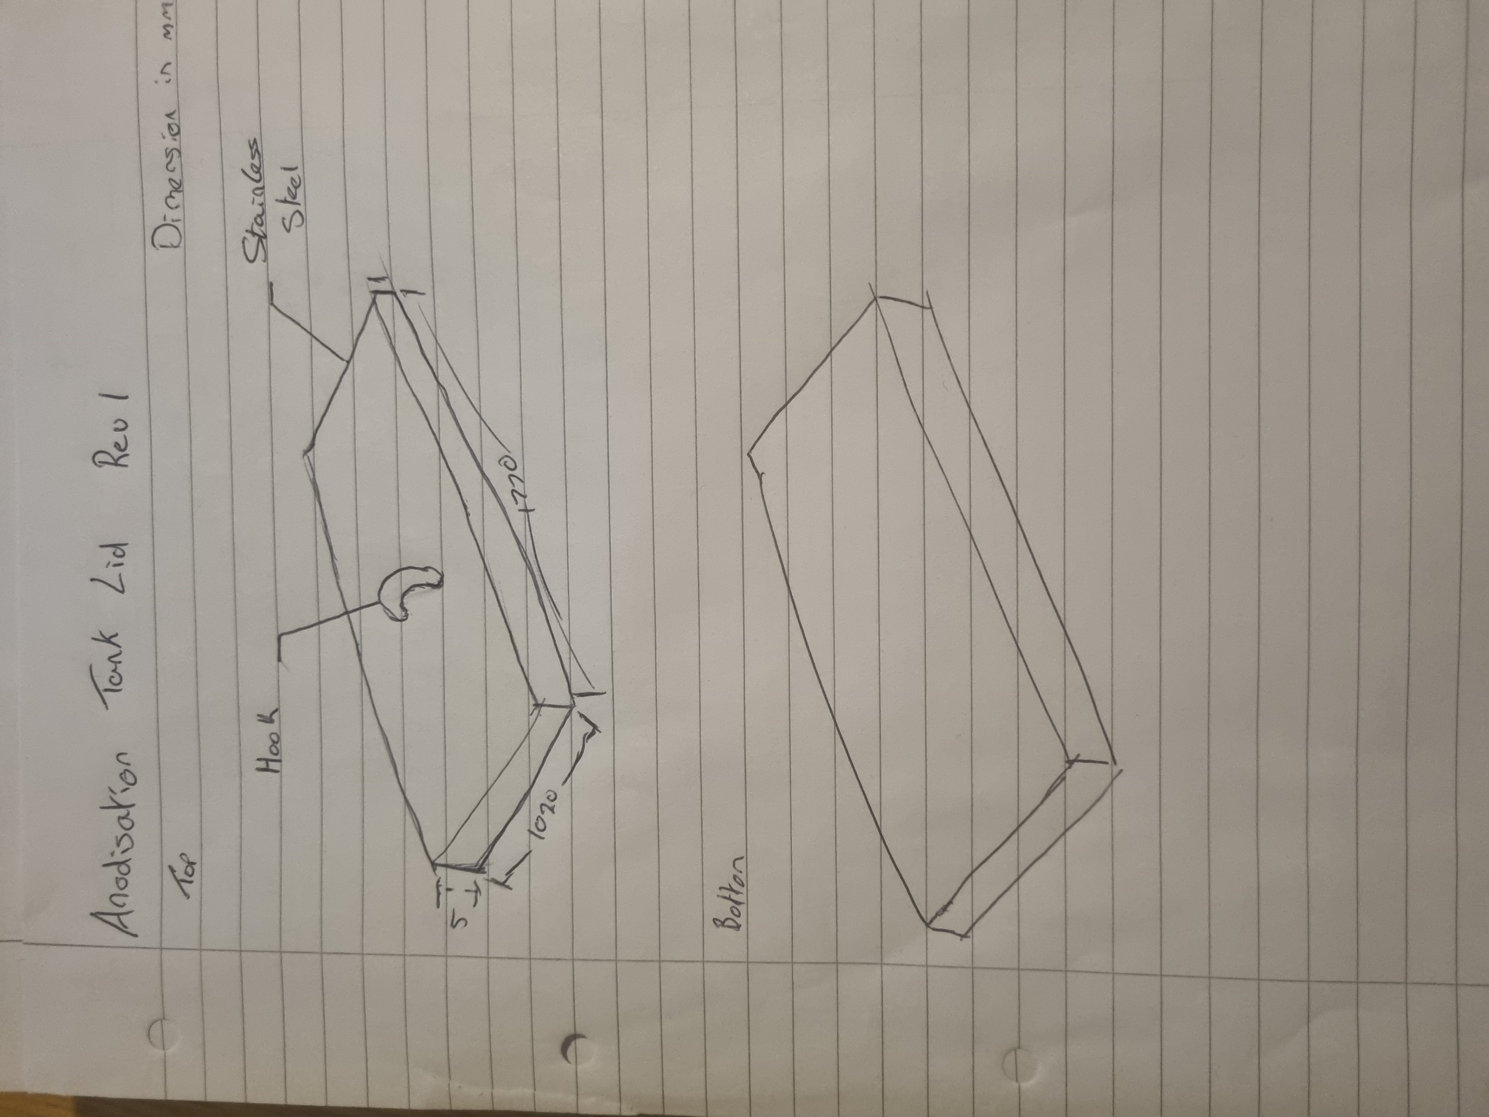
Annotated Sketches
Figure 4- First Revision of the vat lid
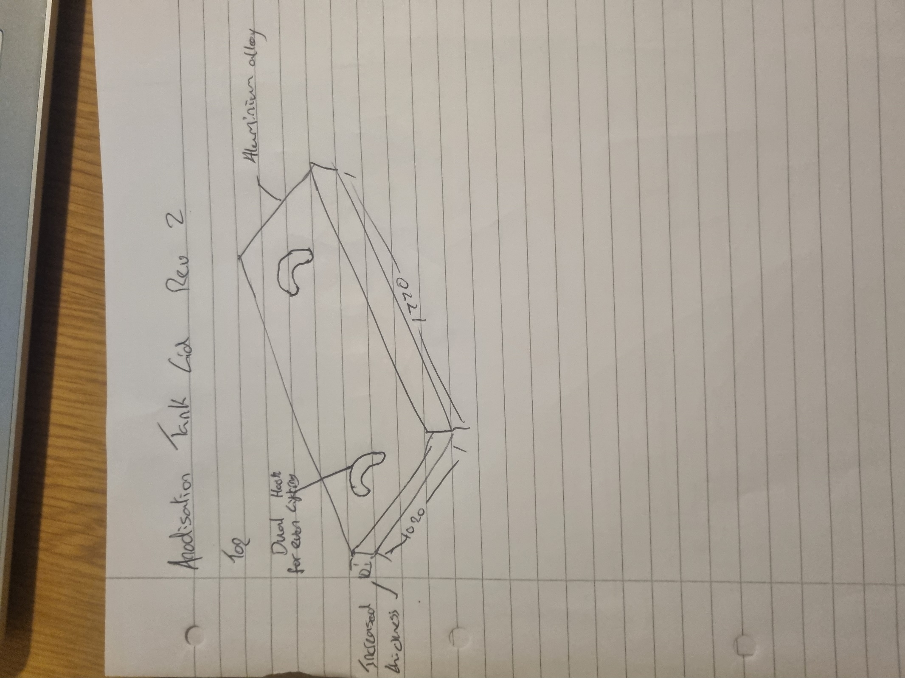
Figure 5- Second Revision of the vat lid
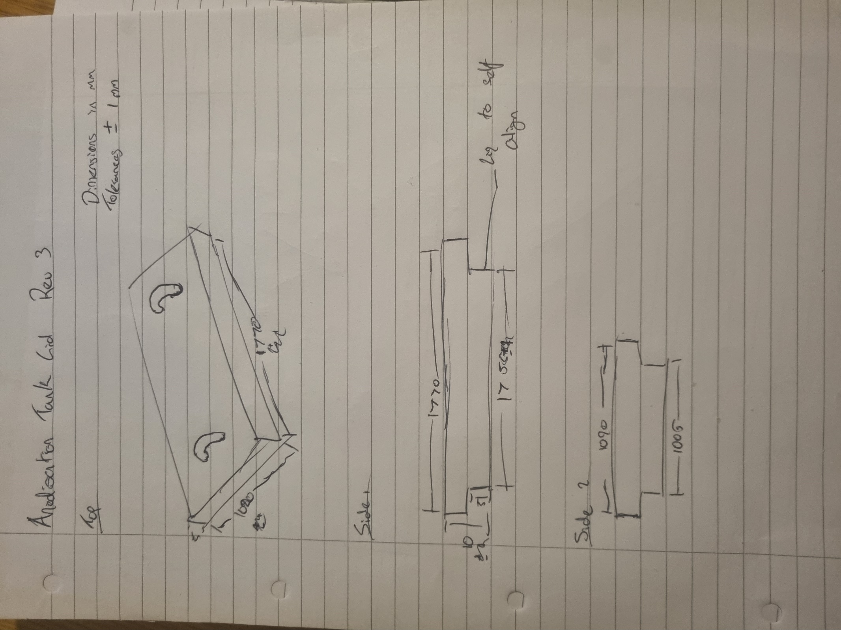
Figure 6- Third Revision of the vat lid

CAD Model
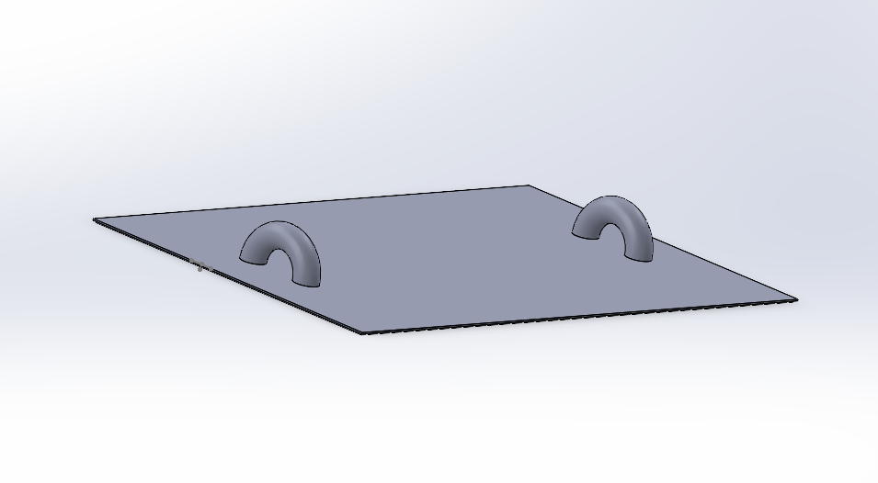
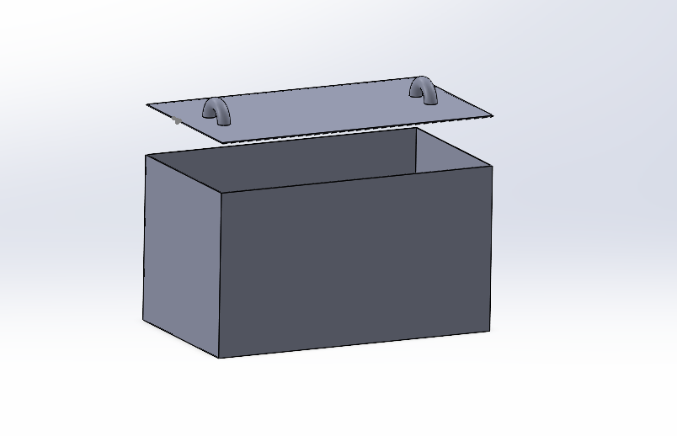

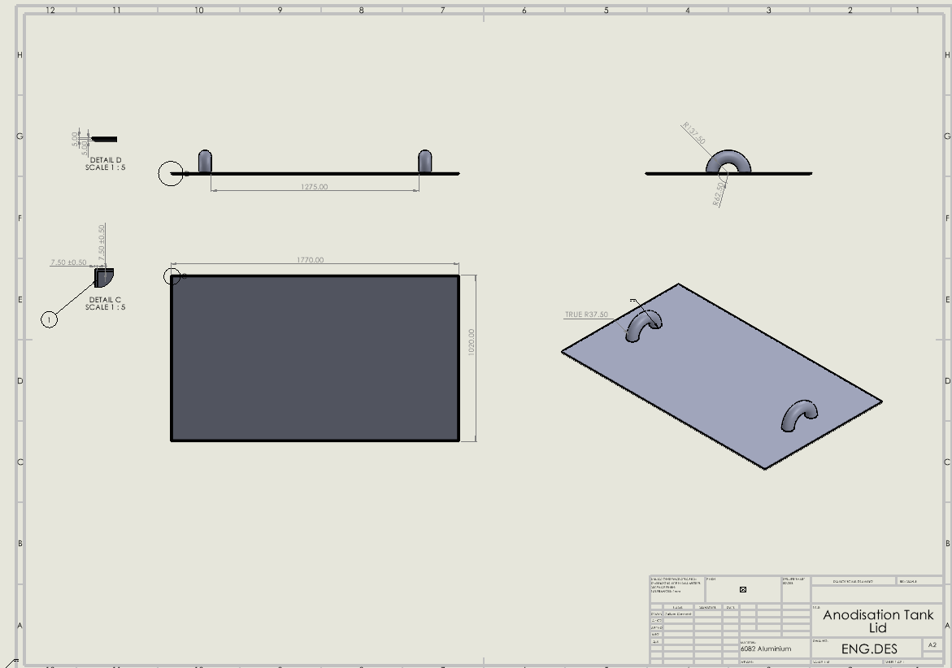
Technical Drawings

Manufacturing processes

The newly designed lid is made from a 10mm thick sheet of 6082 Aluminium Alloy. The sheet is milled to size using the original length and width. The dimension of the lid is a length of 1770mm, width of 1020mm and height of 10mm. The underside of the lid is milled along the edges by 7.5mm along each side with a depth of 5mm creating a smaller underside dimension by a total of 15mm on length and width. This lip underneath will help align the lid with the vat to make the replacement of the lid easier.
Two hooks for the lid are then welded onto the top of the lid equally spaced apart, this means that when the rope is placed through them for the pulleys the lid will lift equally and will be safer and easier to control.
A compound two pully system will be required to be fitted. Using two pulleys reduces the effort to lift the lid, this combined with the aluminium alloys lighter mass means the new lid should be marginally easier to lift

Justification

When redesigning the lid, a main goal was to reduce the weight of the lid which would make it safer to use not just for making it capable to be lifted by one person. The choice of material took a bit of time to come up with but eventually settled on the 6082 aluminium alloy due to it not being very reactive, the metal does not corrode like some steels would. This specific alloy is stronger than most aluminium alloys but is also placed marginally well with its density and price. This alloy is able to be welded to whereas some are not but is used quite commonly with welding which made it easier to attach the hooks to the lid.
The reasoning behind the lip on the underside of the lid was to allow for it to be easier to fit onto the vat as when it is lower the recessed lip allows for it to self-centre into the gap on the vat. It made is safer for the operator and just simpler rather than having a lid which covers the outer edges of the vat.
The choice of a pulley system over using levers or hydraulics is due to pulleys being cheaper and simpler than hydraulics and takes up a smaller amount of room compared to levers. Using pulleys reduces the effort required and can take up a minimal amount of room. Additionally, if it was required more pulleys can be fitted into a system if the load changes.

Conclusion

In conclusion I believe that the final design worked out well with good use of research to alter the design while also trying to keep myself to a constraint to keep it reasonable. Ultimately if I redid this and theoretically had a high budget I may have redesigned it using a more complex method with hydraulics or gas struts to make the final design a very minimal effort lid but believe the design I came up with went well and would work quite effectively.

Reference List

Granta Design. (2009) CES EduPack 2009: Materials and Process Selection Charts. Cambridge: Granta Design Ltd.

1st Choice Metals (n.d.) 6000 series aluminium grades guide. Available at: https://www.1stchoicemetals.co.uk/aluminium/grades-guide/6000-series/ (Accessed: 3 April 2025).

Helmenstine, A.M. (2020) Aluminum or aluminium alloys. ThoughtCo. Available at: https://www.thoughtco.com/aluminum-or-aluminium-alloys-603707 (Accessed: 3 April 2025).

BBC Bitesize (n.d.) Levers and pulleys. Available at: https://www.bbc.co.uk/bitesize/guides/z7gyb82/revision/3 (Accessed: 3 April 2025).

Halliday, D., Resnick, R. and Walker, J. (2013) Fundamentals of Physics. 10th edition. Wiley

