INFORMATION ENGINEERING EXAM

accc4004
Bogdan-nicusor halinga || student id: 1715162
2018
The “Pick Veggies” have recently expand and they wish to upgrade their entire database. To be a successful, I think that firstly we must to design an Entity Relationship Diagram. This will help us to find witch are the main entities and their attributes. After we found the main entities we can decide the relationship between them. We must take care to avoid the repetitions because this will cause errors in future.
While we done the Entity Relationship Diagram we can design the Use Case Diagram. This will help us to find which the actors are and what activities will do each one. The Use Case Diagram will help us to design the Data Flow Diagram. The DF Diagram will show us the entire process of actions and this one will be much more complex then Use Case Diagram.

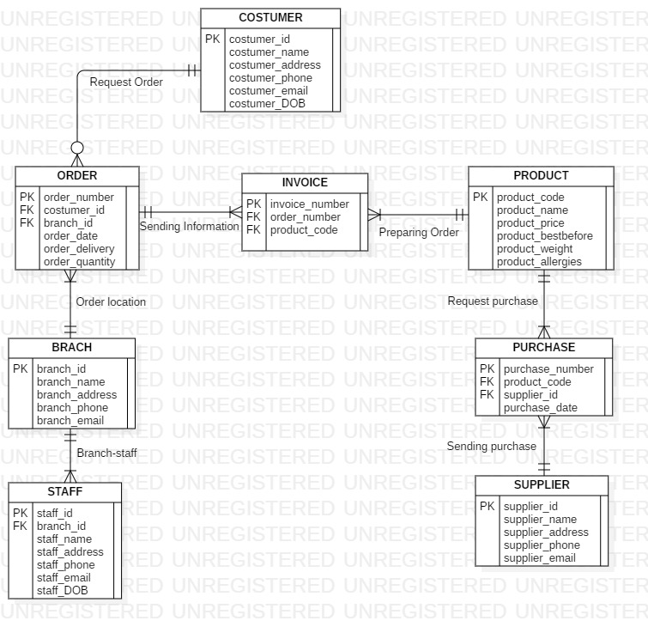
Fig. 1: Entity Relationship Diagram
Costumer (costumer_id, costumer_name, costumer_address, costumer_phone, costumer_email, costumer_DOB)
Order (order_numer, costumer_id*, branch_id*, order_date, order_delivery, order_quantity)
Invoice (Invoice_number, order_number*, product_code*)
Product (product_code, product_name, product_price, product_bestbefore, product_weight, product_allergies)
Branch (branch_id, branch_name, branch_address, branch_phone, branch_email)
Staff (staff_id, branch_id*, staff_name, staff_address, staff_phone, staff_email, staff_DOB)
Purchase (purchase_number, product_code*, supplier_id*, purchase_date)
Supplier (supplier_id, supplier_name, supplier_address, supplier_phone, supplier_email)

On the Fig. 1 you can analyse the Entity Relationship Diagram for the “Pick Veggies”. In this diagram I respected all their objectives. There you can see PURCHSE – this is the place where all purchases made will be recorded for stock check or future analyse –, COSTUMER – this is the place where all costumers information will be saved for future use – and ORDER – this is the place where all their sale are reordered for future use, like calculate their profit. Like you can see, none of the attribute are repeating (except the Foreign Keys) and that means will not generate errors in future. To avoid the repetition, I created a new Entity when the relationship between two entities was Many-to-Many to separate them and instead one Many-to-Many relationship, I have two One-to-Many relationship.
As well from the Entity Relationship Diagram the company can collect all data necessary for the invoice. They can use invoice number, costumer details (name, address, contact), order details (date of order, where was made the order) and product details (product code, product price).
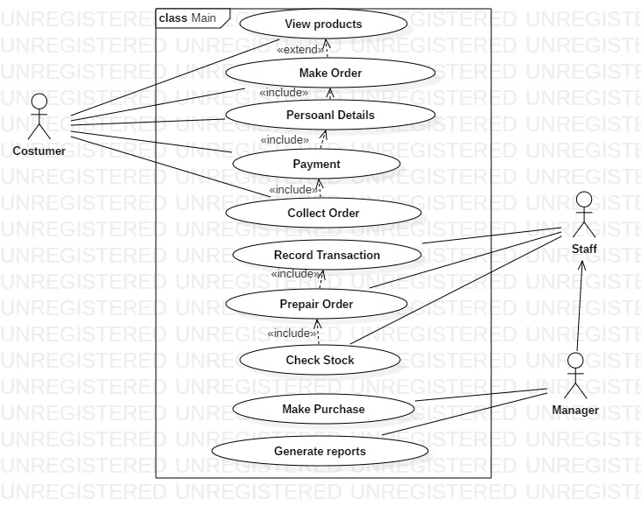
Fig. 2 Use Case Diagram

Like I said in introduction, the next step after the Entity Relationship Diagram is Use Case Diagram. The Use Case Diagram will help us to understand the main activity on the business and the main actors. On our case the main actors are: the costumers, staff persons and the management team.
As well the Use case diagram will help us to understand the dependency of actions. Like you can see, to complete an order is necessary to do more than one action (to complete the order, the client must give his details and to pay the order and then collect it).
The Use Case Diagram made me to understand how the business will works in general and made my work easiest for next Data Flow Diagram.

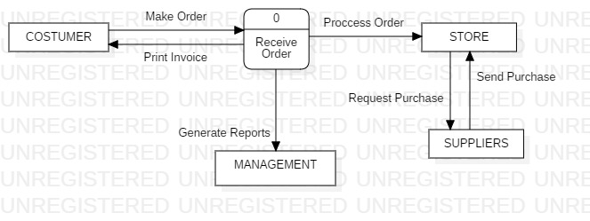
Fig.3 Data Flow Diagram – Level 0

In Fig. 3 you can see the first level of my Data Flow Diagram. There is a very basic system of who will work the business. The costumer is making an order, they process the order and print invoice. On the next level we will see more detailed process.
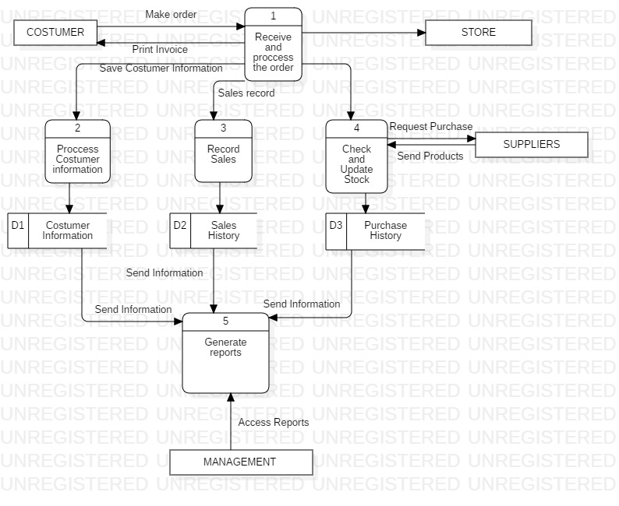
Fig.4 Data Flow Diagram – Level 1

Like you can see in Fig. 4, the level one of Data Flow Diagram is more detailed then previous level. Here you can see that after the costumer made the order the process is more complex. Firstly the record the costumers details and insert it database (D1), then they record the sale in database (D2), then they check and update the stock. If the stock of products is low they will request new purchase from their supplier and will record the purchase in another database (D3). Using all databases the management team can analyse and generate report.
The costumer information will help them to know the favourites products of different people, as well they will know who often the clients will buy that products. Using date of birth they can do same discounts on the costumer’s birth day.
Using the Purchase History they can analyse how often order some product, analyse if the price was rising on a supplier and if is necessary to change that supplier.
Using Sales history they can make different report like quarterly and yearly profits, the sales of different products to see if that product is selling a lot or isn’t and after this they can decide to if will continue or not with that product.

In conclusion I can say that if the “Pick Veggies” will use my diagrams they will manage well all the information needed for their business.

