Curtis Stephens
1903184 University of Wales Trinity Saint David
ACCA5033 – Changemakers and value creation – Assignment 2

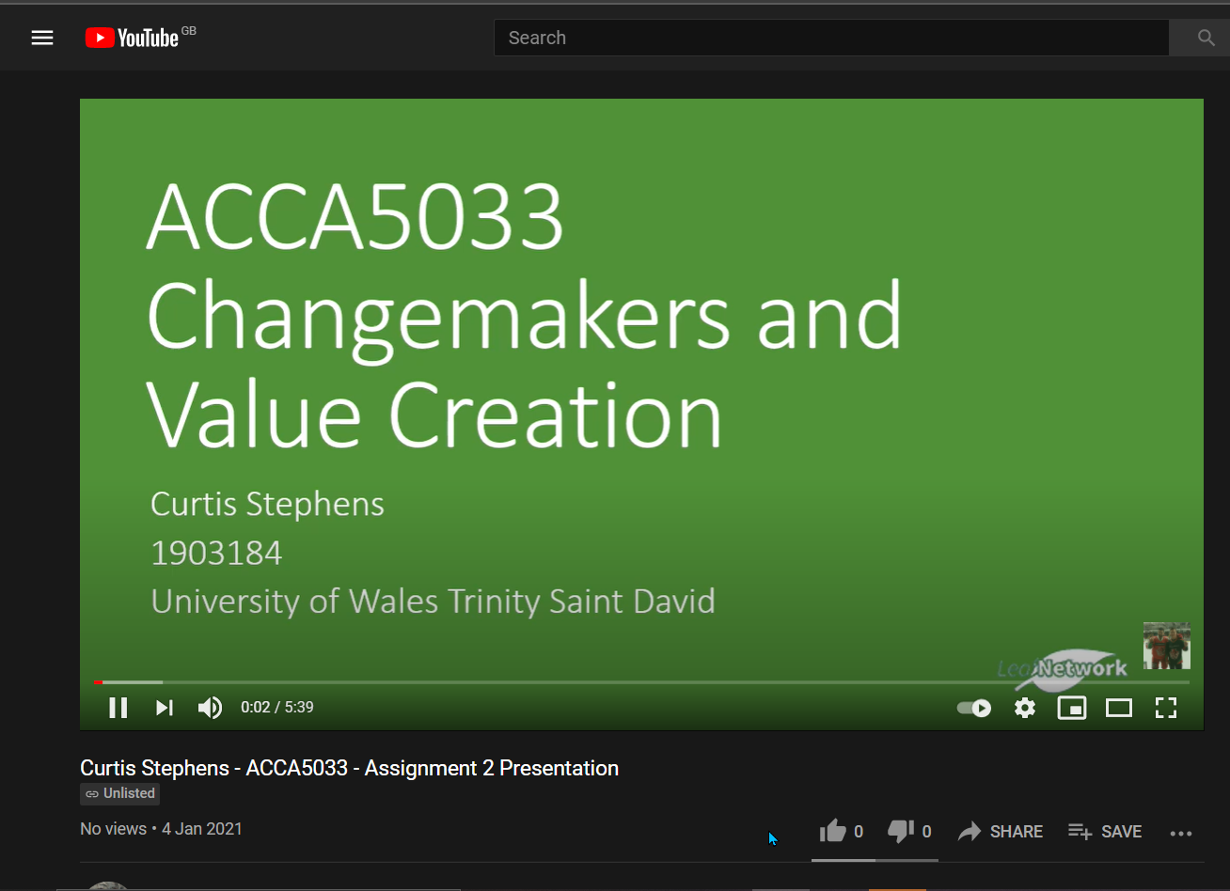
(157) Curtis Stephens - ACCA5033 - Assignment 2 Presentation - YouTube

