

Forecasting movies success using Machine Learning
by
Silvia Diana Iagar
1805743

Supervisor: Dr. Terry Walcott

Project submitted as part of the requirements for the award of BSc (Hons) Cloud Computing

2021

Declaration of Originality
I, Silvia Diana Iagar declare that I am the sole author of this Project; that all references cited have been consulted; that I have conducted all work of which this is a record, and that the finished work lies within the prescribed word limits.
This work has not previously been accepted as part of any other degree submission.
Signed: S. D. Iagar
Date: 20.07.2021

FORM OF CONSENT
I, Silvia Diana Iagar hereby consent that my Project, submitted in candidature for the B.Sc Cloud Computing degree, if successful, may be made available for inter-library loan or photocopying (subject to the law of copyright), and that the title and abstract may be made available to outside organisations.
Signed: S.D. Iagar
Date: 20.07.2021

Copyright Acknowledgement
I acknowledge that the copyright of this project report, and any product developed as part of the project, belong to University of Wales Trinity Saint David, Swansea.

Abstract

Predicting movie box office success has been a study issue for decades because every year, hundreds of films surprise investors, either positively or negatively, depending on how well the picture does at the box office compared to early predictions. Previous researches have yielded mixed results when using movie critic reviews as one of the sources of information for forecasting box office results.
This project aims to use data mining to create a predictive model for movie forecasting to assist filmmakers in making financial agreements throughout the immediate phases of film creation, using just information from the films' ratings and data mining techniques. This strategy seeks to optimise the investor's decision-making process at the project's inception. The prototype model will be developed using the WEKA 3.8 decision tree and the NetBeans 12.0 integrated development environment.

Acknowledgement

I would like to convey my heartfelt thanks to Dr. Terry Walcott, my thesis supervisor, for his advice, supervision, and support during this project. I would like to thank the University of Wales Trinity Saint David (UWTSD) for offering an outstanding learning atmosphere that will undoubtedly benefit my future profession and efforts. I am grateful to the Cloud Computing faculty, particularly lecturer Renuga Jayakumar, for the ongoing academic assistance throughout my time at UWTSD.
Table of Contents

Abstract
Acknowledgements
Table of Content
List of Figures
List of Appendices
List of Abbreviations
Glossary

- Introduction 1
1.1 Background/Motivation 2
1.2 Aims and Objectives 2
1.3 Report structure 3
- Literature Review 4
- CRISP-DM Methodology 9
3.1 Business Understanding 10
3.2 Data Understanding 12
3.3 Data Preparation 12
3.4 Modeling 13
3.5 Evaluation 13
3.6 Deployment 13
- A Machine Learning Approach in Predicting Movies Success 15
4.1 Machine Learning Life Cycle 15
4.2 Supervised Learning 17
4.3 Algorithms Exploratory Research 18
4.4 Technology Diversity 20
4.5 Integrating Weka into Java 23
4.6 Risk Analysis 24
- Design and Implementation 25
5.1 Data Collection 25
5.2 Processing Data in Weka 26
5.3 Weka Cross Validation 27
5.4 Identifying the Algorithm 30
5.5 Splitting the Dataset 31
5.6 Processing the Train and Test Dataset with the Selected Algorithm 36
5.7 Integrating Jar Weka into Java NetBeans Library 37
5.8 NetBeans Code 38
5.9 Prediction Output 39
- Testing Layouts with New Dataset 40
- Evaluation 43
- Conclusion and Recommendation 44
- References 45
- Appendices 49

List of Figures
Figure 1. CRISP-DM Methodology 9
Figure 2. Global Box Office Revenue 10
Figure 3. 2020 Top 20 Global Box Office markets 11
Figure 4. Global Theatrical & Home/Mobile Entertainment Market 12
Figure 5. Methodologies Statistics 14
Figure 6. Machine Learning Life Cycle 15
Figure 7. Supervised Learning 17
Figure 8. RapidMiner 21
Figure 9. KNIME 21
Figure 10. WEKA 22
Figure 11. NetBeans 23
Figure 12. Pre-Implementation Risks 24
Figure 13. Weka 3.8 error 24
Figure 14. Design mechanism 25
Figure 15. IMDB Data 26
Figure 16. IMDb Dataset visualization in Weka 26
Figure 17. Dataset in .arff format 27
Figure 18. IMDb dataset in Weka 28
Figure 19. Naïve Bayes Algorithm 29
Figure 20. KStar Algorithm 29
Figure 21. J48 Algorithm 30
Figure 22. Algorithm comparison 30
Figure 23. J48 tree 31
Figure 24. Remove Percentage Instance 32
Figure 25. Modifying the percentage 32
Figure 26. Train Dataset 33
Figure 27. Train Dataset in .arff format 33
Figure 28. Modifying the percentage to 30% 34
Figure 29. Test dataset 34
Figure 30. Replace Class column attributes 35
Figure 31. Class Column modified 35
Figure 32. Test dataset in .arff format 36
Figure 33. Train dataset with J48 algorithm 36
Figure 34. Using the Test dataset 37
Figure 35. Prediction on Test dataset 37
Figure 36. Adding Jar Weka in NetBeans 38
Figure 37. NetBeans Source Code 38
Figure 38. Code Path 38
Figure 39. Prediction Output 39
Figure 40. IMDb Testing Dataset 40
Figure 41. Data Partitioning 40
Figure 42. Train Set 40
Figure 43. Test Set 41
Figure 44. Weka Prediction 41
Figure 45. Testing Set Path 41
Figure 46. Testing Dataset’s Output 42

List of Appendices
Original Gantt Chart 49
Updated Gantt Chart 49
NetBeans Source Code 50

List of Abbreviations

AI – Artificial Intelligence
IMDb – Internet Movie Database
KDD – Knowledge Discovery in Databases
DNN – Deep Neural Network
OLS – Ordinary Least Square
MIAS – Movie Investor Assurance System
RNN – Recurrent Neural Network
SVM – Support Vector Machines
CRISP-DM – Cross Industry Standard Process of Data
ML – Machine Learning
RL – Reinforcement Learning
NB – Naïve Bayes
WEKA – Waikato Environment for Knowledge Analysis
SQL – Structured Query Language
GUI – Graphical User Interface
TP – True Positive
FP – False Positive
TN – True Negative
FN – False Negative

Glossary
Artificial Intelligence – relates to the imitation of human intelligence in robots instructed to comprehend and act like humans.
Internet Movie Database – is a big online database that contains information about movies from all around the world.
Knowledge Discovery in Databases – is a method for obtaining meaningful data from a set of material. Data preparation and selection, data purification, incorporating existing knowledge into data sets, and properly interpreting the observed results are all part of this widely used data mining technique.
Neural Network – is a collection of algorithms that aim to discover underlying correlations in data using an approach similar to how the human brain works.
Deep Neural Network – is a neural network with more than two layers that has a specific amount of complexity.
Recurrent Neural Network – is a form of neural network with loops that enables data to be stored inside the network. Recurrent Neural Networks, in brief, use their reasoning from prior experiences to predict future events.
Ordinary Least Square – Linear Regression is a term that refers to the process of predicting the future. It tries to fit a line to minimise the sum of squared errors between anticipated and actual values in order to assess the connection between a dependant and a target variable.
Support Vector Machines – is a data-driven machine learning approach for categorization and regression analysis.
Cross Industry Standard Process of Data – is a six-phase development method that encapsulates the data science life cycle precisely.
Machine Learning – is a data analysis approach that automates the creation of analytical models.
Reinforcement Learning – is the technique of instructing a machine learning algorithm on how to make a series of judgments.
Cross-validation – is a pre-processing method for evaluating machine learning models on a small dataset.
Naïve Bayes algorithm – it is a basic learning method that employs the Bayes rule together with the strong assumption that the characteristics are conditionally independent.
KStar algorithm – is an instance-based classification algorithm, which implies that the classification of a test dataset is determined by the class of comparable training instances, as specified by some similarity function.
J48 classifier – generates a decision tree and uses this technique to generate it (an extension of ID3).
Confusion Matrix – is a graphical depiction of the predictions of a classification issue.
Graphical User Interface - is a form of user interface that uses visual indication representations to allow people to interact with technological equipment.
.arff format – is an ASCII text file (plain text files) that contains information on a collection of instances that share a set of characteristics. This file is structured uniquely.

- Introduction

The film business is a massive enterprise, and it arouses a great deal of interest. Actors and directors are assigned to projects that may or may not be produced or given to someone else. As a result, the film business appears to be highly unpredictable. This level of unpredictability and the projected loss of future revenue to streaming sites such as Amazon Prime, Netflix, Hulu etc. There is a demonstrated need to seek tools and applications that may assist in determining the box office performance of a given film.
By this premise also holds for movie audiences. They would like also to determine why a movie starring Hollywood heavy hitters such as a Robert De Niro is a flop. Interestingly, movie producers are becoming more aware of the burgeoning opportunities of their respective films in alternate markets such as Europe, Asia, Africa, and the Caribbean peninsula. And so, forms of artificial intelligence are being used for predicting various forms of certainty in the movie sector.
Filmmaking, therefore, offers a potentially high economic gain. The difference between a film that fails financially and creatively and one that succeeds might be as minor as who plays the lead part. It is like understanding the Holy Grail of Hollywood by trying to discern the distinctness amid a billion-dollar film and a complete failure [1].
What AI does now is easier and quicker than people to recognise patterns of knowledge and recurring incidents. And new companies take advantage of AI tools to evaluate data and current patterns to forecast the financial success of a film by searching past trends using machine learning, including the output of an actress. Analysing this knowledge for decades reveals how the eye can best represent emotions, ideas, and places. Some organisations use AI to analyse complete scripts for public, race, gender, and box office figures. Eventually, directors will use these algorithms as production continues to produce their films [32].
Even though such developments are so thrilling for the film industry, they are also a little troubling. These developments in the entertainment world are as fascinating and upsetting as they are. What does it mean if algorithms decide what movies are made? Who is the true star, and who is worthy of credit? The cinema has always been about imagination and originality for at least the last 70 years.
Most importantly, what about humans if artificial intelligence reveals our stories? Who is going to be seen in these films? Or human or machinery? In 2019, the box office's worldwide figures 2019 were USD 43,5 billion. According to ComScore, the decline went up by 46.2% compared to $1.816 billion in 2020. If a computer could predict the effectiveness of a film before its debut, it would be an invaluable achievement. The Avengers, Lord of the Rings, Avatar, and The Dark Knight trilogy, were successful franchise movies from previous years. Any of the films were made in the entire box office for around 300 million dollars. Yet those films required massive budgets, including financial assistance from lenders, to match their earnings [2].
Films of famous stars, directors and designers will also advocate this activity such that it becomes easy that the influence of the backers will guarantee the film's success. However, the star's quality is an elusive feature, which it seems impossible to examine. When the artist gets more successful, the more films it makes, which also ensures higher revenues.

  - Background/Motivation:
The performance of a film before release is challenging to estimate. It was previously thought that the film's popularity was determined by the names of its directors, the cast, production companies, their wild variations, and big budgets etc. But at times, the most anticipated achievement often becomes an absolute disappointment and made film-makers aware that the outcomes of a film and the need for data mining to analyse the causes had too many other fundamental factors to affect them.
The favourable outcome of a film at the Box Office relies on consumer reviews and critiques. In saving the film from failing, all the vast names throughout the film do not make up for the consequences of these scores. These scores are "influencing" the viewer as they watch the movie and serve as "predictors" of the film box office show. The user's interest to watch a film affects the revenue indirectly and explicitly forecasts the success of the box office [3].
Films can affect their ranking in several dimensions. This research intends to investigate the elements that influence film ratings. With the aid of the Internet Movie Database (IMDb), carefully analysed and assessed potential variables may affect the ranking of a movie.
IMDb is a publicly available user-managed website with information on over 400,000 films and TV shows. IMDb is the common film rating database of consumers and is commonly used [4].

1.2 Aims and objectives
It is feasible to perform assumptions about possible results by asking the right questions about such details. The question which will ask is about forecasting the box-office result of upcoming movie releases. In contrast, movie critics reports apply to the viewpoints of a smaller community of domain experts. It would be interesting to know if the analysts' or the audience's intelligence generates a more robust signal that permits better forecasting of movie box office success.
This study seeks whether an aspirant film manufacturer or film corporation with specific technical ability can predict if their film idea is a profitable venture by leveraging the massive amount of online information and the ever-growing capacity of the computing device, and what techniques could be used to do so.
The analysis' primary goal is to evaluate several forms of learning and select the one that best matches this assignment. After a meticulous examination of what is now available on the vend in indication of algorithms, a deeper grasp of the algorithms employed with this type of analysis will be provided.
Following the examination of the algorithms, the next step will be to identify a database that has a wealth of information relevant to the learning approach. The purpose is to choose and prepare data in the most efficient way possible for the algorithms used.
After the data has been prepared, the next step is to produce a Java application that forecasts whether or not the film will be successful.
The area's priorities will include:
- Java functionalities, machine learning, and a general knowledge of which Java resources are necessary for AI training.
- Using test results to create a prototype system.
- Research into the code and the outputs of the algorithm.
This research aims to examine the relationship between features and machine learning probability of success to evaluate a framework for data pre-processing. The success levels would be possible when using this method if you were to predict the rating and profits of the box office. The following steps should be taken:
- Investigate and grasp the application of machine learning.
- Information gathering for the research project
- A contrast of data mining approaches
- An evaluation of several sorts of algorithms
- Preparing data
- Algorithmic data testing and training
- Use of the mining instruments Weka and Java

  - Report Structure

This report is broken into an additional nine chapters, one of which is Chapter 1, the Introduction. Chapters include the following:
- Chapter 2 – Literature Review: The literature review explores past learning approaches and assesses training models and contemporary prediction algorithms.
- Chapter 3 – Methodology: The research strategy to get the required information is explained in this chapter.
- Chapter 4 – A Machine Learning approach in predicting movies success: A general overview of machine learning, supervised learning, and algorithms will be presented in this chapter. Following that, several machine learning-based technologies will be explored.
- Chapter 5 – Design and Implementation: This section will cover the architecture of the prediction model and the rationale for selecting some algorithms over others and code samples demonstrating how it created the implementation.
- Chapter 6 – Testing layouts with the new dataset: This chapter analyses the new data examined to get results that support a conclusion.
- Chapter 7 – Evaluation: This chapter contains the author's reflections on the project's experience and lessons.
- Chapter 8 – Conclusion and Recommendation: This chapter will summarise the project's accomplishments and determines whether more study is necessary.
- Chapter 9 – References: This contains a list of all references consulted.

- Literature Review

This chapter will explain machine learning and how it may use it to improve movie success prediction. Will present the commonly used learning techniques previously used will first, followed by evaluating learning models and current algorithms relevant to prediction. A choice is made about the most appropriate strategy for guaranteeing the effective delivery of the proposal detailed in the first chapter of this study.
The amount of data collected, processed, and disseminated by different organizations has increased dramatically in recent years. Examples include the massive amounts of data collected at grocery store checkout counters, the avalanche of data collected by network monitoring software, the constant feeds of aerial photos given by Earth-observing satellites, and so forth.
One immediate challenge in these areas is deciding how to derive valuable information from large data sets.
The sheer volume of data outstrips our ability to sift through it in search of helpful knowledge manually. To swiftly evaluate and summarise data, researchers have resorted to data mining techniques. In a nutshell, data mining is the approach of digitally extricating useful information from large amounts of data.
Knowledge Discovery in Databases considers data mining to be a crucial component of another technique. KDD is the whole method of altering raw data into exciting information, and it includes some transformation processes such as data pre-processing, data mining, and post-processing [5].
Over a weekend or at a festival, movies are the main draw. Individuals in huge numbers, family, and friends all flocked to local theatres for a guaranteed good 2.5 hours, but forecasting such a result is never straightforward. There is no one definitive answer whether the film will make big money at the box office or not. As a result, several articles and journals published about how movie performance can be forecast during the pre-production periods and reviewed them in this literature review.
Littman was the first to investigate multivariate regression models for forecasting movie box-office performance. He's looked at how factors including costs of production, critical' reviews, genre, distributor, distribution period, and the lead actor's achievement background affect a film's box office results. Predictor variables included in such studies include the number of theatres in which the film is expected to be released, the film's parental ranking, and the film's budget Exploring variables impacting movie success has been an intriguing area of research since Littman's work as the movie business has continued to develop. As a result, a multitude of articles has appeared in the domain [6][7].
Many researchers concentrated on elements of a film that should be present, such as good actors/actresses, storey, directors, and so on, but most of them ignore how involved the viewers are. To see this, we can use Movie Success by Hype analysis, which grants relevant information about how enthusiastic the viewers are. Ajay Siva, Abhilash Jain, and Pratik Karat created a model in which they used a web crawler to mine tweets about the movie, collect them, and calculate how many tweets contained the movie title per hour, which they mapped out on a table. A week before the film's release, they began this process, mining and collecting related tweets every second by USER ID. Second, they measured how many followers a specific user has because it predicts the reach of that tweet. If a person who many people follow talks about a movie in their tweet, the chances are that their followers will build interest as well, contributing to the buzz developed and then success on the release day. It was made possible by mathematical formulas that produced either an integer or a decimal and used the ratio principle. So, contextually, if the value produced was like, chances were that the movie would be good, and if it were not, chances were that it would not be successful. The research successfully patented a model that could mathematically forecast success or doom using the chatter and buzz of tweets [8].
For another paper, Mestyan, Yasseri, and Kertesz analyzed Wikipedia for data to evaluate the likelihood of a good movie. Were used several variables and linear regression to predict the opening weekend of the film. These results were calculated with four different measures. The first thing is the number of views that an article linked to the movie received on Wikipedia. The second is the number of editors that were writing the essay. The third is contributors posting their material, and the fourth is Collaborative rigour. They derived a couple of conclusions from their analysis: one was the availability of data, and the other was the use of reviews to indicate audience interest, making it possible to forecast movie success quickly [9].
When the engagement and hysteria have been addressed, it is crucial to confirm whether the film still has any notable elements. As the film will be released, it will be unable to divulge all, but that is just what the topic requires. Zhou, Zhang, and Yi were working on a report that finds a similar connection between failure and income. The authors have used Deep Neural Networks to input the exciting data from the movie poster to produce a forecast income. They claim that deep neural networks (DNNS) are excellent in image classification and speech recognition. They utilized the DNN as their suggested method, extracting characteristics from the movie poster to contribute the most to success and money and producing data that predicted box office statistics [10].
When it comes to money-making aspects like heroines and heroes, posters, and trailers, even the textual storyline may be regarded to foretell a lot about a film's future. Kim, Lee, and Cheong offered The Deep Learning Approach, which predicts a project's success or failure by examining its plot and description. Their data set labels something as profitable or non-profitable established on the analysts and audiences' scores. Parts of the summary are disassembled into sentences, and their sentiment score puts together the positive and negative scores for every sentence. Finally, any output is amalgamated to regard a movie summary as either a hit or miss [11].
According to Quader and Gani [12], previous movies' box office success has varying factors, some accepted by the public. The Bangladeshi film investors could see who new filmmakers and artists will be valuable. In addition to these two significant features, their data collection includes features are Pre-Release and Post-Release. These components meant to anticipate the conclusion of the film before its release. They mined movie info, specifically for these sites, such as from Meta's critics and critics from Rotten Tomato meter to Box Office Mojo's and Rotten Tomato meter. They used the second method to study all movies and then left only foreign ones to summarise. They assessed the overall amount of earnings that actors and actresses had made up to that point, as well as other related film features and scores, then compared it to a fixed accounting number. This result shows the Microsoft Bi desktop is a Natural Language Processing application that classifies texts as positive or negative with a positive/negative sentiment resulting in 1.0 and 0.5 as 'highly positive'. In contrast, grey/negative means 0.0 as "negative." They trained many support vector machines and neural networks against each other, where they considered the neural networks to be significantly more reliable than others.
Discussing Ahmed, Waqas and Tanvir [13], they concluded that intuition and judgement are not necessary to analysis but merely in line with it. They first obtained a complete dataset of the Grading Machine Learning on the movies and then fine-tuned it. The Hybrid model uses elements like input and produces either "blockbuster or flop outputs”, depending on supervised learning. They pulled data from Kaggle, used it in their templates, and complied with the Movie gender, age, name, and name of the Director and specific movie function attributes. They aimed to quantify experience, reviews, and Facebook likes and scores of actors and actresses to then divide them into nine various revenue classifications. They were meant to have produced a mathematical representation of what they wanted to do. It seemed to be the only forecasting model in the literature that failed to consider whether the deal had been signed while evaluating data from social media. Only a combination of 18 factors may be used to classify a flop, all of which are completely supported by previously suggested flop and hit predicting models. Only a few have been tested.
There is plenty to consider, but nothing diminishes the significance of the influence of several other factors, as explored by Patrick Topf. He mentions genre, age rating, production cost, release date, and release date as crucial factors in the overall film's success or failure. The Ordinary Least Square Analysis (OLS) investigates the various influences mentioned in the thesis statement. Regression analysis used these variables as contingent factors: Total Box Office Gross (Domestic), Star Power, Cumulative Review, Season, Genre, Age Rating, Sequel. However, they then explained how they arrived at and the factors affecting Total Box Office Revenues based on ticket sales, although this actor has appeared in at least three films in the top ten highest-grossing films over the last decade. As previously stated, they have been referred to as sub-to or simply the subliminal.
Similarly, each of the variables generated negative or positive values as well. They ended up seeing that several of the instrumental variables showed promising results. All their parameters point to a viewer, hence bringing them to the film's goal [14].
Whereas multiple researchers deviated from the standard and developed their methods for forecasting the accomplishment of a film's box office , Babita, Jangid, Jadhav, et al. stayed true to the fundamental determinants such as social media and other aspects of the film such as genre, ratings, gross, and budget, to name a few, as well as social media networks as Twitter and YouTube. Their proposed system consisted of the stages like the Data Collector were collecting information about the movie from IMDb, other social media, etc. Feature Extraction where features were extracted with sentiment analysis, then the score was calculated for each tweet. Finally, using algorithms such as linear and polynomial regression would make predictions for ratings and the movie's income [15].
Social media is and has been crucial in the suggested technique. In this one, Krushikant, Jose, et al. produced a predictive model comprised of the genres of well-performing movies as ranked by IMDb, the fame of its cast and filmmakers as insinuated by their social media accounts and followed. Finally, how many comments and views to work with YouTube? They used PHP coding, which was run by a wamp server. It was done to determine how many views and comments the video with the ID regularly received on YouTube.
Similarly, other data, as previously described, was measured, and mapped into a table diagram daily. They then performed a sentiment analysis on the content of the comments, classifying them as harmful, optimistic, or neutral. The comments were labelled as either because positive or negative terms were already organized in a register. It was then assigned to appropriate anywhere based on its presence and frequency in the comments. The neutral was assigned to comments that contained the same amount of positive and negative terms. They then used mathematical formulas to rank the attribute values from 1 to 10. The films were then classified as Hit, Neutral, or Flop, based on their box office performance. And as they gathered information, they organized it into a table that implied either success or failure. They conclude by noting that the leading lady is critical to the film's success, that a genre with a successful film and a sequel both decide large numbers, while a lesser-known face working in an unsuccessful genre may result in a loss [16].
If speaking about features and determinants, this is best described in Lash and Zhao's study on the Who, What, When of the profitability. They labelled significant parts in categorizing them as Who, revering to the cast of the movie. When speaking of its release date and What, this meant the story synopses. They carried out their research, having their first step be acquiring data from the two most important sources, namely IMDb and Box Office Mojo. Secondly, they mentioned doing an intensive cleaning of irrelevant data to avoid any extra waste data and then it was assorted in a consistent format. Thirdly and most importantly, they did what they regarded as feature engineering. The authors used the gathered data to facilitate their predictive model, and the elements were then segregated into Who, When, What, and Hybrid. They then used the MIAS mechanism to produce predictions and tested this against the other two methods to assess how accurate it would be and found out that MIAS fared better at predicting movies. Their model also assisted the investors looking to place bets on a film by letting them apply their "what-if analysis" where an input of, for instance, the cast or release date was done, and the output would aid the investors with the increase and decrease in profitability. The movies also pronounced their predictive model to be of use to stakeholders in the movie industry or teams and crew in other creative realms [17].
Philipp Omenistch presents a simple forecasting model based on machine learning and visual analytics. He used the last film data gathered from various sources, including tweets about the film, IMDb data, and Bitly connection numbers. The data analysis came next, and he used the software Tableau to make significant correlations portrayed in figures and diagrams. He then used neural networks to train his model, which included a neuron and backpropagation. Finally, he used the Release Date to make predictions out of the many features because he felt that the numbers a movie makes are often heavily influenced by the time of year it is released [18].
Borga Deniz and Robert B Hasbrouck have produced a study called "When to Greenlight" to investigate the pre-release determinants for US releases. The authors say that the Academy Awards can also recognize high-earning films with excellent content and a watchable genre, but only after the film has been released and that their research focused on determining what factors or reasons can be used in the decision-making and investment processes to assure studio investors that the release day and after would bring good returns. To begin, they mapped their variables onto a table, naming every pre-release aspect of the film, such as genre, budget, star power, and ratings, to name a few. They then ran these through a correlation test to determine which of these are the primary determinants and predictors of box office success in the United States. They discovered that genre and variables associated with it generate six of the thirteen significant predictors. They also state that whether a film is animated, an adaptation or PG-13 directly affects the Box Office. They have then mapped these results into another table in their analysis, where each variable showed what coefficient, it produced with the US box office. When it came time to put the model to the test, they used the ordinary least square method and came up with a revised list of the most critical predictors, including Budget, Sequel, Animation, Sport, Adventure, and Star Power. And then estimated how many numbers each of these will add to the film's overall earnings. And here are a few examples: A movie in the adventure genre grosses 31 million dollars. The star power of the leading actors nets an astonishing 22 million dollars. The animation and sports genres earn 52 million and 70 million dollars, respectively, while the sequel makes a whopping 47 million dollars. To summarise, their analysis presents with proof the most critical and definitive variables of a film's future that they estimated and set out to minimize risks of investing in a movie and finding out what the verdict will be at an early point [19].
In terms of regional cinema, Xinyi Zhang acknowledged how influential the entertainment industry has become but asserts that China's entertainment industry might be lagging and thus suggested the process and study. Her paper compiled data from box office reports from 2013 to 2018, after which it was cleaned to delete any films with lost or incomplete material, as well as box office warnings of less than ten million dollars. She then extracted data about people's reviews, thoughts, and feedback from pages with a high level of public participation, such as Douban, Microblog, Baidu, and other social networks. She then implements the multiple linear regression mechanism and details her steps along the way. Zhang assigns a significance score to each variable, names the particular set, and creates a "K sub-training sample set" using a bootstrap sample. The author makes a random forest and its significance score to quantify or mark the effect of each film's instrumental factor. It is done so that Zhang can gain insight into the causes that have the most significant influence on the box office forecasts. Then converts the method to a statistical representation of the multiple linear regression equation and performs correlation checks to verify that what she thought generated is occurring. Zhang concludes with her goals, stating that she did all of this to see if the films released in 2019 performed as predicted by regression and RNN research, determining that RNN produced significantly more reliable results. To conclude, she suggested that her paper examines the factors that contribute to box office performance and is used to make predictions; however, the paper tests multiple linear regression and recurrent neural networks against her hypotheses to determine the of these methods/analysis yields the more reliable data [20].
Jeffrey Ericson and Jesse Grodman have attempted to describe the reasons for a film's success using machine learning techniques. They forecasted five distinct facets of success. They gathered relevant data by extracting, parsing, and cleaning everything they retrieved using Python and JavaScript. They concluded that films with over 100 votes were more likely to receive a higher rating due to the more significant number of votes. They reasoned that having less than 100 votes would be insufficient for their dataset and excluded films with fewer votes. The budget was stated only about inflation, as the populace did not seem to directly affect it. They began with locally weighted linear regression since it is efficient. SVM was the second machine learning technique they used. SVM developed higher classification rates than locally weighted linear regression. It is because several additional feedback elements were added [21].
Based on the findings of relevant literature, it may be concluded that forecasting movie box-office outcomes is a challenging issue that academics have been investigating for decades. The success of a film may be predicted using a variety of methods, with varying degrees of success. The sample size of the movies is critical for developing a model capable of learning from the training data while doing regression analysis using machine learning techniques.
While film critic evaluations do not appear to have much predictive value on their own, when combined with other characteristics, they may help explain more variance and contribute to the development of a powerful predictor.

- Methodology

Today, data science and analytics are utilised globally to assist businesses in making the most informed and profitable decisions possible. Companies employ a variety of models to structure their business data. The CRISP-DM DM (Cross-Industry Standard Process for Data Mining) model is one such model [33].
This study will adapt to the CRISP-DM (Cross-Industry Standard Process for Data Mining) methodology, developed as an industry guideline in the data mining segment.
The study’s matter was stimulated by the fact that many organisations integrate the CRISP-DM model to better comprehend the past and current business scenarios and anticipate future sales and revenue circumstances.
This approach divided into six phases, each of which corresponds to a stage in the life of a data mining program. Figure 1 depicts the CRISP-DM reference model.
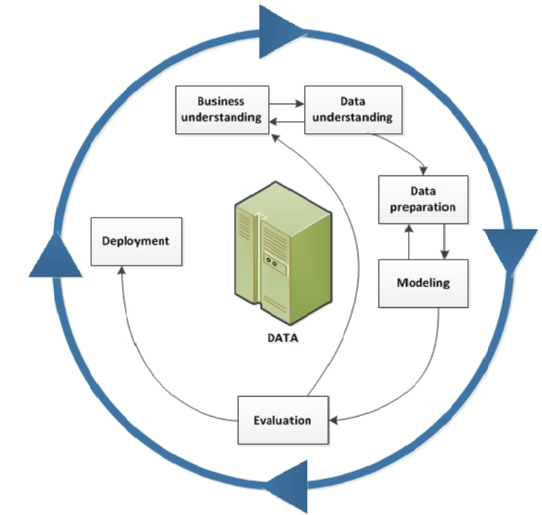
Figure 1. CRISP-DM Methodology [22]

The figure shows the very complexity of the data mining process, with interactions between the distinct phases and the outer circle representing the cyclic nature of the process. It is essential to indicated that once a model is implemented, the process is not complete and needs periodic and criterion updates to ensure that the initial model's requirements are still in place. The model continues to operate with the designed output that the company expected. A vital feature of this approach is the prescription of an initial step concerned with understanding the business context; at this point, it has to set desired outcomes and commercial criteria and translate this information into a description of the data mining challenge and develop a starting plan to reach these objectives [22].

3.1 Business Understanding
The primary aim of Market Understanding is to provide developers and users with information on the significance of data in the business model, and the method to do so is to give meaning to the objectives and context.
Drilling down to identify the problem more clearly is one of the first activities during the Business Understanding phase. The topic may, for example, be reduced to determining which films would be successful. The essential idea here is that a clear image of a business's high-level aims and precise quantitative markers for determining the success or failure of a project must be established before getting started [22].
It is feasible to establish a quick presentation of the structure and the business setting to have a better concept of the film industry's context and project needs and success criteria.
The pandemic had a significant impact on the film business, with movie theatres being forced to close for an undetermined amount of time and production companies putting off, postpone, or even cancel the filming of new films. The Box Office closures in 2020 had disastrous consequences for cinema operators, who are experiencing their first drop-in box-office sales in over a decade, resulting in worldwide box office revenues of $12 billion, compared to $42.5 billion in 2019, the result of which has been occurring for more than a decade. Owing to their contribution of $2.2 billion in worldwide box office sales for the first time, China outdid the United States and Canada by two and a half-billion dollars. China, Russia, India, and the Republic of Korea are the only countries found in the top five most lucrative global box office industry ranks and whose contributions were less than one billion to the total were used in the chart above. While the rest of the world may have either produced- or is only as effective in making movies, there are still several other movie industries worldwide, namely in Asia, which are valuable examples of the principle at workable markets [2].

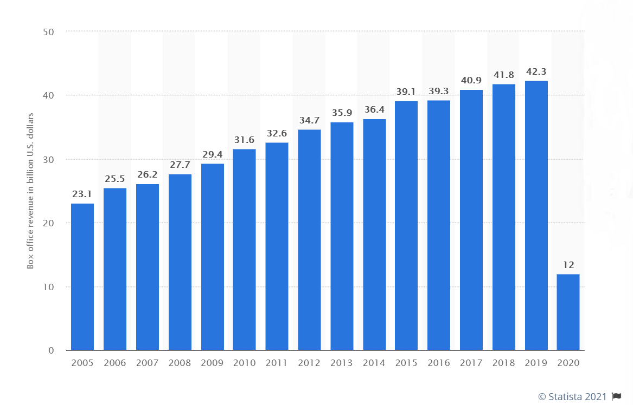
Figure 2. Global Box Office Revenue [2]
The annual box office dropped by 72% in a challenging year for the film theatre manufactory in 2020.
The international box office generated $9.8 billion in ticket sales, amounting to 81 per cent of the complete foreign arena. In 2020, the Asia Pacific area accounted for a significant amount of the revenue, with China (#1, $3 billion), Japan (#3, $1.3 billion), and South Korea (#5, $0.4 billion) accounting for three of the world's top five box office vends. During the pandemic, the EMEA region lost 61 per cent of its sales, falling to $3.3 billion, while Latin America lost 82 per cent of its revenue, falling to $0.5 billion.
The Box Office in the North American market, which comprises the United States and Canada, fell by 80% ($2.2 billion), resulting in 240 million entrances in 2020. The number of film admittances in the United States has oscillated between 1.24 billion and 1.36 billion since 2011. Conferring to the MPA, in 2020, the conventional audience bought 1.5 tickets, over from 4.6 the year before.
Although streaming home video assumed for 82 per cent of the complete entertainment business in 2020, less than half of the people in the United States and Canada went to the movies. Streaming sales in the US have more than doubled in the previous four years, rising from $11.4 billion in 2016 to $26.5 billion in 2020. In contrast, conventional television revenues have fallen by more than half, from $8 billion in 2016 to $3.5 billion in 2020. Since 2016, box office receipts have consistently exceeded $11 billion, until plummeting to $2.2 billion in 2020 due to the Covid-19 epidemic.
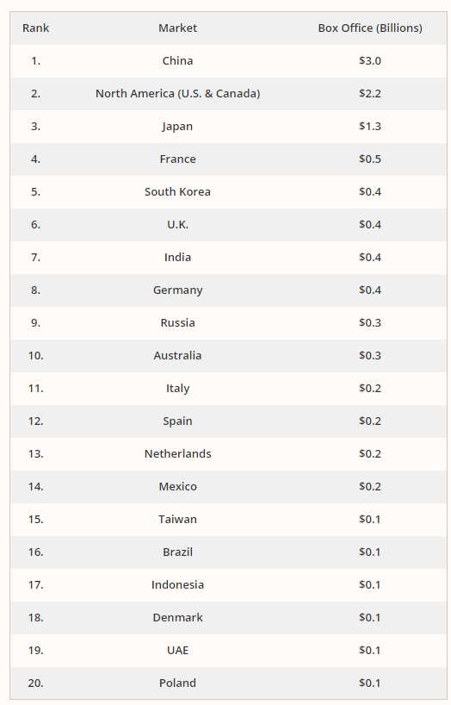
Figure 3. 2020 Top 20 Global Box Office markets [2]
Due to the epidemic, viewers stayed at home, disrupting theatre income, resulting in a significant rise in home entertainment revenues. In 2020, Home Entertainment will generate a record $68.8 billion in revenue, driven nearly completely by digital–traditional media accounting for only $7 billion of that amount. The gross revenue from theatrical and home entertainment was $80.8 billion in 2018, a decrease of 18 percent from the previous year's total of $98.3 billion [2].

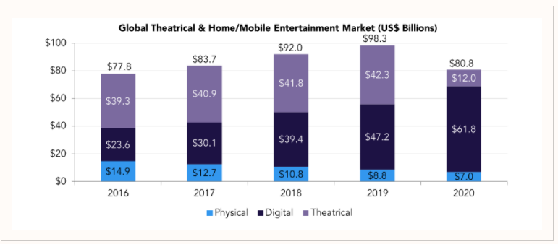
Figure 4. Global Theatrical & Home/Mobile Entertainment Market [2]

3.2 Data Understanding
The second phase in gaining control of the data is to comprehend better the meaning of what you have and the intended and actual outcome of the data. It examines the accuracy of the information on several criteria, such as if the data is complete if the values are correct, and whether the requirements for data entry are in place [22].
It is imperative to test and gauge the viability and trustworthiness of the final findings since it reveals how much time it would be required to complete this analysis. It is now a well-known fact that by IMDb project data, what algorithm and method lead to the outcome and current status and significance of the data. What current algorithm and process are following to reveal the fact? How well does the data meet the project's goals? What is the result? What is the current state of the data? How does this benefit the algorithm and its execution?

3.3 Data Preparation
Data preparation consumes the majority of time in any machine learning initiative, accounting for 60% to 80% of total time. This section of the project included performing a series of transformations, encoding, and cleaning operations on the data to prepare it for use as input to the models created.
It is critical to remember that text cleaning is a problem-specific job. It is not always possible to produce a thoroughly cleaned text since inevitable trade-offs between different methods must be considered to achieve the best possible outcomes for the project's goal [22].
In light of this situation, the following tasks were completed to clean and format the text:
- removing the apostrophe
- deleting unnecessary words from the document
- erasing unnecessary columns
- extending contracted word forms
- case normalisation

3.4 Modelling
Modelling is the fourth phase of any machine learning project. This phase is in charge of ensuring that the project's goals are accomplished or contributed.
While this is the most glamorous aspect of the project, it is also the quickest since there is nothing to change if anything else is completed accurately. If the outcomes can be enhanced, the technique is set up to go back to data preparation and optimise the data that is currently available.
The problem was modelled as a supervised learning task, more precisely a classification task, with the dependent variable being a binary variable called Performance Level (BAD/GOOD/EXCELLENT).
The presence of a dependent variable describes supervised learning, the value of which to forecast, and a set of independent variables used to predict the dependent variable. Its objective is to master an operation that outlines the input to the output. It accomplishes this by learning directly from data. After being conditioned on sample data with labelled output, the model can learn a function that maps the input to the production [22].
The dataset was derived from the IMDb database, which provides accurate data on movies and their scores. A predictive data mining methodology called classification-decision trees (J48) was added to the dataset.
J48 is a Java implementation that is open source. The algorithm can be used for both discrete and continuous attributes and training data that contains missing values for the attributes. The features applied to J48 was used to substitute for missing values, decision tree pruning, the set of continuous attributes values, and rule formulation. Among the many characteristics of films, it would decide which film characteristics have the most significant impact on its rating: title, year, genres, meta score, director, star1, star2, star3, star4, and IMDb score [4][23].

3.5 Evaluation
If the procedure has completed all of the first four steps, you can perform the fifth step: verification. If the findings are incorrect, the method permits the researcher to look into the matter and establish the source of the issue so that the results can be inaccurate. Still, they would not prevent a critical examination of it.
It is now time to get down to the brass tacks regarding case specifics and review the model. A model that fails to deliver on its promise will be either corrected to increase the project's expectations of the movie industry or redesigned to enhance its ability to meet those expectations.
The result was achieved with the model mentioned above, as anticipated, with a prediction rate of 99.7% [22].

3.6 Deployment
The sixth and final phase is Deployment, which entails presenting the findings practically and unmistakably to ensure that the project meets its objectives. It is the only move that is not part of a cycle. Moreover, relying on the necessities, the deployment stage could be as easy as producing an article or as system as applying a rerunning data mining method in the film industry. CRISP-DM has established itself as the unofficial industry norm method model for data mining, with an ever-growing number of implementations across a diverse range of industries. This technique has existed for an extended period and seems to be here to stay.
This approach follows a very rational and forward-thinking sequence of steps. Since it evaluates all aspects of a data mining project and allows for circular reasoning during its implementation, it is stable and trustworthy. Unsurprisingly, most developers and project managers prefer it, given that the alternatives are very close [2][22].

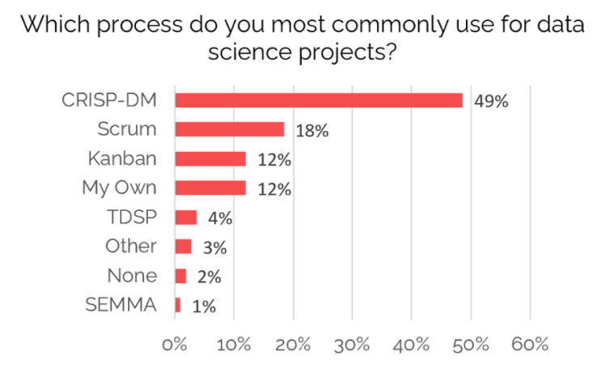
Figure 5. Methodologies Statistics [2]

The significant benefit of CRISP-DM is that it is a cross-industry standard. It indicates that this technique may be used in any Data Science project, regardless of domain or destination.
Another benefit of the CRISP-DM method is its adaptability. It makes it possible for models and procedures to be faulty from the beginning. It provides a lot of flexibility, which helps with the systematic improvement of hypotheses and data analysis techniques over time.
At the point of implementation, the CRISP-DM approach allows for creating a long-term strategy based on incremental iterations.

- A Machine Learning approach in predicting movies success

The first section of this chapter provides an overview of machine learning and its algorithms. Following that, it will examine several machine learning-based technologies and carry out a risk assessment of the machine learning method.
Machine learning (ML) is a popular branch of artificial intelligence that focuses on understanding sample data and applying multiple models to create new data that can be used to address a range of digitalization issues. The learning algorithm is fed training data, and the learning algorithm develops a new set of rules or algorithms established on the inference data. A machine learning model is a name given to this new collection of rules or algorithms. The same machine-learning algorithm will create different machine learning designs depending on the training data set [36].
The learning algorithms and the massive amount of training data available online have aided recent advances in machine learning. As we all know, when it comes to machine learning algorithms, an algorithm is a collection of instructions for a computer to follow that a programmer creates. On the other hand, machine learning algorithms are not the same as predetermined bit-by-bit instructions from a computer specialist; they are algorithms that grant the computer to acquire from the data supplied and create new instructions onward, allowing the computer to complete the work at hand [24].

4.1 Machine Learning Life Cycle
Machine learning has made it possible for computers to learn without being pattern recognition. How does a machine learning system, on the other hand, work? As a result, the machine learning life cycle may be used to represent it. The machine learning life cycle is a bit-by-bit operation for developing a successful machine learning program. The life cycle's main objective is to find a solution to the issue or task [23].

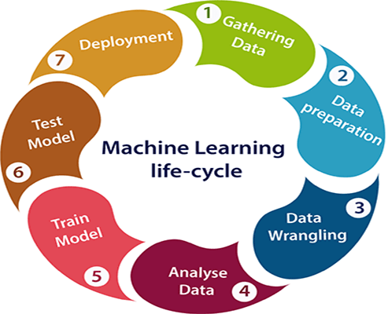
Figure 6. Machine Learning Life Cycle [23]

The machine learning life cycle is divided into seven stages, which are listed below:
- Gathering data – this stage identifies the numerous data supplies, as data may acquire from distinct sources, including files, databases, the internet, and mobile devices. It is a critical stage in the life cycle.
- Data preparation – is the process during which data is organised and prepared for use in machine learning training.
- Data Wrangling – is the procedure for cleansing and adapting unprocessed information into a usable layout.
- Analyse Data – this section will create a machine learning technique that will evaluate the data utilising different analytical approaches and then examine the results.
- Train the model – in this stage, the model is trained to enhance its performance and provide a more accurate solution to the problem.
- Test the model – after training the machine learning model on a particular dataset, the model is tested. This phase verifies the model's correctness by presenting it with a test dataset.
- The final stage of the machine learning life cycle is deployment, which involves integrating the model into a real-world system.
The machine learning life cycle is essential as it specifies each individual's role in a company's informatics operations, from management through manufacturing. It investigates each program from initiation to finalization. It provides a high-level overview of how a whole data science effort results in a real-world commercial advantage. Failure to correctly carry out any of these phases may outcome in incorrect vision or models with limited functional benefit [23].
Although machine learning can model a variety of techniques, the three most frequently used learning methods, counting on the operation and the amount of training needed, are as follows:
- Supervised learning
In supervised learning, the data were categorised to ensure that the compiled code or training data had the intended output identification. This technique compares the actual output to the labelled production; hence, it effectively acts on error generation and then adjusts the model depending on the error base. For example, in the financial market, past data is utilised to anticipate future volatility, which is an everyday use of supervised learning. Based on previous data, the supervised learning approach may predict statistically likely future events.#
- Unsupervised learning
Since the input parameters are not categorized with the desired outcome, this approach depends on correlations between the data to identify patterns and trends in the unlabelled data. Because unlabelled data resources are considerably more numerous than labelled data resources, this method is widely used. Without being instructed, unsupervised learning algorithms may identify hidden patterns in raw, complex, and unstructured data. It can, for example, transactional input data from a grocery shop to an unsupervised learning algorithm to discover tendencies among women who buy scented and unscented soaps.
- Reinforcement learning
By trial and error, reinforcement learning (RL) algorithms produce a set of decision-making sequences. Unlike supervised learning, it does not necessitate a qualifying data set with an associated response indicator. It functions in a game-like surrounding, complete with an operator, a bonus, a fine, and an aim. The RL algorithm aims to optimise the total compensation it receives for each successful decision and its punishment for each erroneous decision after giving it the agent's initial starting points and setting the target. Although the programmer defines the payment rules, the direction or sequence of the decision is uncertain and must be solved by the RL model. In bidding and advertising, when a cluster-based multi-agent system is utilised to present adverts and perform bidding, real-time reinforcement learning can be used. Games are a popular and practical illustration of how RL is used, with the alpha Go game being the most popular [25].

4.2 Supervised Learning
Supervised learning is an important technique that enables a computer programme known as an 'Algorithm' to recognise and identify a particular data set. This method involves two data sets: one for preparation and another for research. The aim is for the algorithm to learn from the tagged data in the training dataset and then categorise the untagged data in the test dataset efficiently.

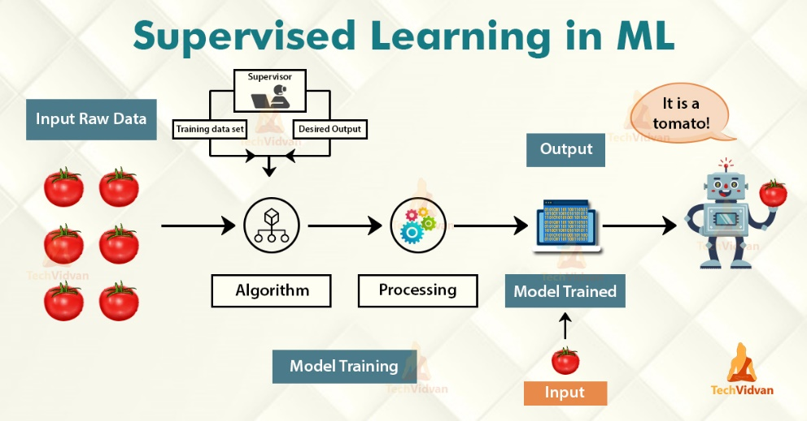
Figure 7. Supervised Learning [43]

The training set is created up of m' controlled combinations (x1, y1), (x2, y2), and so on (xm, ym). xm (m=1,2, 3,...) denotes a specific version or combination of components from a simple part data speck, whereas ym denotes the matching mark for that example data speck.
Suppose the IMDb data is utilised, for example. In that case, xm represents a single attribute such as Title or a collection of details such as Title, Year, Director name, Genres, etc. In contrast, ym represents the output mark as 'Good' or 'Bad' under the tab Performance Level. In controlled research, the training data collection consists of untagged data in n calculation form, that may be depicted mathematically as (xm+1, xm+2,...., xm+n), where xm+n indicates the learnt value or best estimate. For instance, in the research, xm+n can offer the finest estimate of the untagged test data that is 'Good' or 'Bad' of the Performance Level.
In supervised learning, there are two critical methods for data analysis:
- Linear Regression – are deployed to forecast the values of constant target variables.
- Classification Techniques – - are used to forecast the significance of unrelated input parameters.
In supervised learning, the linear regression approach is usually used to deal with quantitative data to estimate, forecast, and discover relationships between those data. However, this case study requires the processing of qualitative data through the classification system in supervised learning. The classification model forecasts discrete responses and categorises the training results. In their most basic form, classification models estimate a mapping function (f) between the input and the approximate output [25].

4.3 Algorithm exploratory research
This study compares three different benchmark classification strategies to determine which one best fits the implementation and training data collection.

- Naïve Bayes
The Naive Bayes (NB) is a type of linear algorithm well-known for its speed, simplicity of implementation, and relative robustness. Provided the class variable, NB implies that the value of each function in the dataset is independent of the importance of any other process. NB is a probabilistic model that estimates the posterior likelihood p(c7|dM) of a text dM belonging to the class c7 using the equation:

P(x|y) = $\frac{P\left(x | y\right)*P\left(x\right)}{P\left(y\right)}$
Were:
- 𝑝(𝑐7|𝑑M): is the posterior likelihood of class (c, target) in the presence of a predictor (d, attributes).
- 𝑝(𝑐7): is the anticipated possibility that class c will exist.
- 𝑝(𝑑M|𝑐7): is the chance or the expectation of predictor dM given a class cM.
- 𝑝(𝑑M): is the predictor's preceding possibility.
Because of their versatility and high accuracy, NB classifiers have been used in text detection, spam filtering, and sentiment analysis studies. The NB classifier is a straightforward classifier that performs well on textual data. One drawback of the NB classifier is that it needs far less preparation time than other classifiers. It is due to the independence assumption, which makes computation p(c7|dM) easier. According to Harish, the NB classifier has a drawback in that it poorly performs when features are strongly correlated. It may fail to understand the number of word occurrences in the feature space.[26]

- KStar
The K* algorithm is a predictor that handles symbolic, real-valued features and missing data by using entropy as a distance metric. This algorithm is an instance-based learner that utilises this sort of assessment.
The K* algorithm uses data hypothesis to determine the range between two instances by utilising the K* functionalities, defined as:
$$K*\left(C∨a\right)=-log2P*\left(C∨a\right)$$

P(C|a) is the description possibility of an instance in category C, which is derived by adding the possibilities from a to each occurrence in C.
This method is available as a class called "KStar" in Weka 3.6.10's Lazy classifiers package [26][41].

- J48
Quinlan's first algorithm, ID3, was enhanced to become C4.5, and J48 is a publicly available Java practice of C4.5. C4.5 is a classifier that takes trivial classifiers into account. C4.5 is capable of utilising both discrete and continuous attributes, as well as training data that contains missing attribute values. Supplementary characteristics of J48 include missed value accounting, decision tree pruning, constant attribute worth ranges, and rule derivation.
It has been utilised in several applications.
It referred to as J48 in WEKA instruments. Root nodes have several offspring, while leaf nodes have none. In a decision tree algorithm, the branch nodes represent a test result, while the root nodes represent the test itself. It is a top-down system in which the problem divided into sub-problems, and the corresponding decision tree built incrementally concurrently. A leaf node is a grouping or judgment located at the bottom of the tree, while a decision node contains branches. The root node of a tree is the highest decision node that aims to highlight. To handle category and numerical data, decision trees can be utilised [26][41].
J48 uses a statistical machine-learning method as a classification algorithm to determine the outcome worth of a new dataset established on the different attribute worth of the existing data. A decision tree's internal nodes reflect the other characteristics; the node divisions show the potential values for these attributes in the observed sampling. The final knots reveal the dependent variable's ultimate value.
Algorithm:
INPUT
- Training Dataset = D
OUTPUT
- Decision Tree = T DTBUILD (*D)
- T=φ.
- T= Create root node and label with splitting attribute.
- T= Add arc to root node for each split predicate and label.
- For each arc D= Database created by applying splitting predicate to D.
- If stopping point reached for this path, then T’= create leaf node and label with appropriate class.
- Else T’= DTBUILD(D); T= add T’ to arc.

- Cross Validation

K-fold Cross Validation is a pre-processing concept used to assess machine learning design facing a restricted training set. The operation begins with the constant 'k,' that establishes the collection of classes where the training data should be split.
The number of folds in the validation procedure is indicated by the value of k; for example, if k=6, the approach is known as 6-fold cross-validation. The parameter specifies the efficiency of a machine learning design's predictions on hidden data. The technique onsets by arbitrarily rearranging the data set and subsequently dividing it into k bundles. Each bundle is labelled as a test data set, with the extra bundle as a training data set.
Additionally, a procedure is applied to the training sample to compare it to the test data set, and the assessment rate is maintained whilst the design is destroyed. The method is repeated with the kth class. Because each sample is only utilised once, the model may be trained k times. Pre-processing the training data before the validation process is one of the essential processes. It refers to parameter tweaking inside a loop instead over a more extensive data collection. If the data is not adequately organised, data loss happens, and the model becomes positive.
The findings summarized as the value of the model's ability level, which is usually the model's variance, such as the standard deviation or standard error.
In this case study, it was performed tenfold cross-validation on the training IMDb dataset collection using the WEKA 3.8 programme, which resulted in the algorithm J48 being selected as the best [28] [40] [41].

4.4 Technology diversity
Data mining is a concept that refers to algorithmic data evaluation techniques that are applied to extensive and intricate data sets. Data mining is used to retrieve confidential information from large quantities of data (substantial amounts of data, dubbed Big Data) to find still more hidden associations, trends, and patterns. Here data mining techniques come in handy.
Data mining tools facilitate the management of vast volumes of data and establish conceivably significant flows and motifs. The complexity of data mining applications is increasing, as is the tool range.
While many of the techniques derived from mathematics, data mining is an interdisciplinary endeavour that combines computer science and mathematical discoveries with machine-learning technology and artificial intelligence. These strong approaches are integrated into data mining software, which allows for the analysis of large data sets.
This research would add the software RapidMiner, WEKA, and KNIME to review the best data mining tools. It has shown that consumers employ several applications, as data mining techniques possess distinct strengths that can mix. Primarily, data mining methods are consistent with one another. However, even with only one decent all-purpose instrument, a beginner can accomplish a great deal.

- RapidMiner
RapidMiner (initially referred to as YALE, or 'Yet Another Learning Environment') is a widely used data mining application. According to a KDnuggets study, it was the most widely used data mining approach in 2014, surpassing the R tool. Even if you lack specific programming abilities, it is entirely free and straightforward to use. Nonetheless, it has a broad spectrum of operators. Entrepreneurs in particular heavily use this tool.
RapidMiner was developed in Java and featured over 500 operators who use various approaches to find data connections. Data mining, text mining, site mining, and even mood analysis are all choices. Additionally, the software supports the import of Excel tables, SPSS directories, and data sets from various databases, as well as the integration of the WEKA and R data mining methods. As a result, it serves as a comprehensive all-arounder.

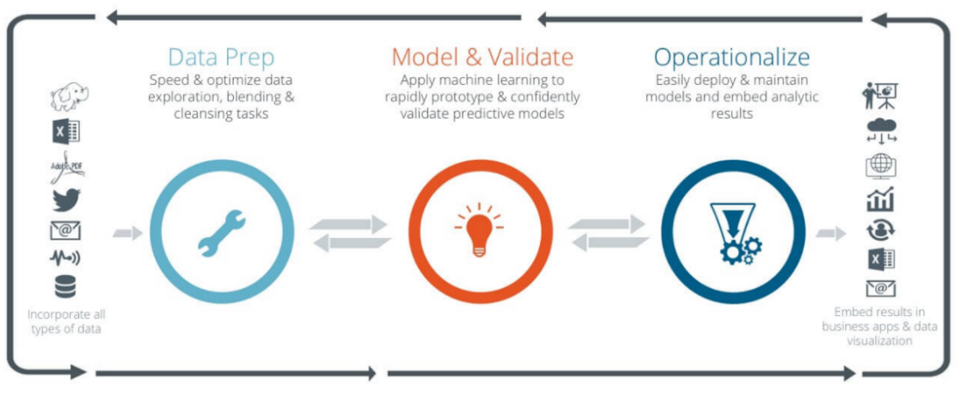
Figure 8. RapidMiner [29]

RapidMiner automates the data mining process from start to finish, including the presentation of reports. RapidMiner Studio, RapidMiner Server, and RapidMiner Radoop are the three main modules of the tool, each performing a particular type of data mining. Additionally, RapidMiner cleans and optimises the data before analysis, allowing for faster subsequent processing. Any of these three modules are available in both a free and a fee-based edition.
RapidMiner excels at predictive analytics, which is the process of forecasting future events established on accumulated data. RapidMiner is one of the most capable data mining programmes when comparing them [29].

- KNIME
KNIME was developed at the University of Constance and has gained traction among a large international developer community. While KNIME was initially intended for commercial usage, it is currently accessible as open-source software. It was created in Java and edited in Eclipse. This tool's set of capabilities is impressive when compared to other data mining tools. This programme, which includes over 1,000 plugins and pre-built framework kits, allows for discovering hitherto undiscovered data structures. Additional commercial applications can be added to the units.
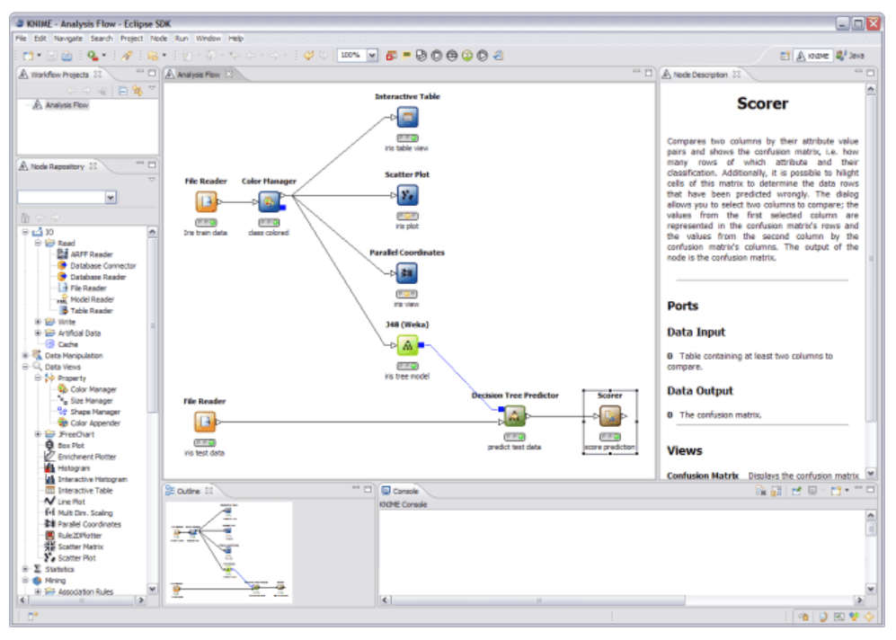
Figure 9. KNIME [29]

Among its features, integrated data processing is fascinating - KNIME is one of the essential methodologies in this field, allowing the integration of multiple machine learning and data mining algorithms. It is also helpful for data pre-processing, such as downloading, transcoding, and loading data. It is a data mining platform that is data flow orientated due to its modular pipelining.
KNIME has been utilised in pharmacological studies and as a robust data mining approach in the financial data sector since 2006. KNIME, on the other hand, is widely used in the business intelligence (BI) industry [29].

- WEKA

WEKA (Waikato Environment for Knowledge Analysis) was established as a non-proprietary software by the University of Waikato. The data-mining programme is designed in Java and works on Windows, Mac OS X, and Linux. It is well-known for its powerful machine learning capabilities and can handle all vital data mining tasks, such as clustering, association, regression, and classification.

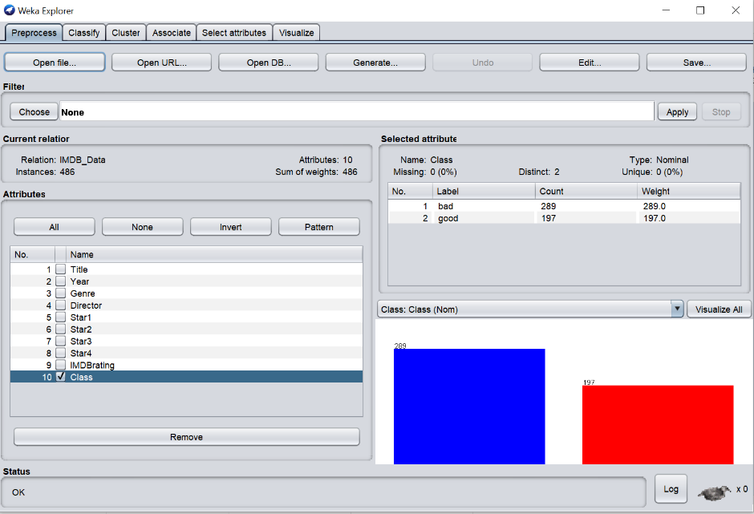
Figure 10. WEKA [26]

WEKA can also connect to SQL databases and process the necessary data further. WEKA's forte is classification: the data mining platform is well-known for its broad classification capabilities, including artificial neural networks, decision trees, the ID3 and C4.5 algorithms.
It is widely employed in education, science, and industry. It has many integrated utensils for doing everyday machine learning chores and grants easy access to notorious toolboxes like as scikit-learn, R, and Deeplearning4j [26][29].
Weka is a robust tool with a graphical user interface (GUI) that enables users to import datasets, conduct statistical experiments, apply various machine learning methods, and evaluate the correctness of their models with great precision. Consequently, Weka is recommended for novices since it allows users to focus on the machine learning process rather than on the underlying theory, complex mathematical foundations, or programming elements, which may acquire later. Weka is a convenient tool that, when appropriately used, may be used to create models that can answer the issues above.
Weka was chosen over RapidMiner or KNIME for this experiment because it is better suited for the type of prediction that will perform.
- Regarding the language chosen for the prediction and programme development in Java, Weka is the right data mining platform for this task since it provides support and is designed specifically for this language.
- It is more advantageous for data mining in terms of clustering and association.
- It allows the user to select from a range of algorithms in order to obtain the forecast.
- Weka has excellent support, as shown by the abundance of tutorials available online.

4.5 Integrating Weka into Java
Weka offers direct access to a library of algorithms. This capability permits the use of algorithms created in other Java-based systems. Weka packages are available for installation using built-in package management. A package's Javadoc is available on the Weka. Sourceforge website, accompanied by the package's name.
This research paper used NetBeans IDE with the JDK from Oracle as a programming language.
NetBeans IDE is a free programming surrounding (IDE) for developing applications on Windows, Mac OS X, Linux, and Solaris.
The integrated programming environment (IDE) streamlines web, enterprise, desktop, and smartphone apps on the Java and HTML5 platforms. Additionally, the IDE supports PHP and C/C++ programme creation.
NetBeans IDE is a market-leading tool for building Java platforms, business, desktop, and smartphone apps. It is often the primary IDE to support new JDK, Java EE, and JavaFX versions. It comes with unconventional assistance for standard high tech like Maven and provides intelligent examination to aid comprehend and maintain the applications.
With its start to finish application progress capabilities, fast-evolving Java Editor, and constant agility and accomplishment intensifications, NetBeans IDE decides the common for application progress with ground-breaking technology [27][31].

Figure 11. NetBeans [27]
  - Risk Analysis

This section discusses the risks that had an immediate and pragmatic impact on the project's scope and duration, resulting in a deviation from the plan as initially agreed. These incidents may take on a variety of forms due to their unpredictable nature. Two types of hazards can occur during the development process: pre-and post-implementation risks [41].

- Pre-implementation hazards
When embarking on this type of project, pre-implementation hazards may arise, and as indicated in the below image, there are just a few to consider.

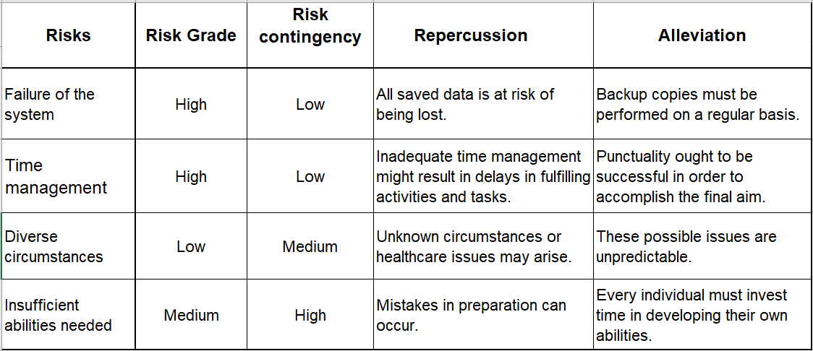
Figure 12. Pre-Implementation Risks

- Post-implementation risks

One risk of post-implementation is demonstrated by specific issues with the IMDb dataset used. Thus, the prediction model's overall design has been modified from its initial design. Initially, thousands of films were employed; however, only 492 films were used.
Another potential post-implementation risk was associated with Weka 3.8. When the Jar Weka 3.8 incorporated into Java NetBeans, and after developing the code, a similar error with the one shown in the following image happened when running NetBeans' prediction.

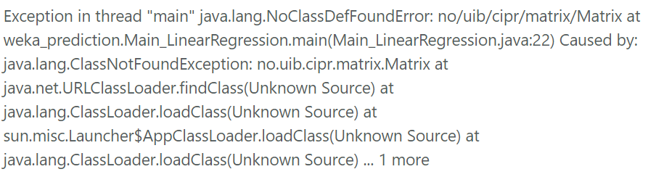
Figure 13. Weka 3.8 error

Because the above issue indicates that there was a difficulty with loading weka. core, it is necessary to go to the weka repository (https://svn.cms.waikato.ac.nz/svn/weka/ branches/stable-3-8/weka/lib/) and download and include the following jars into the project:
- mtj.jar
- arpack_combined_all.jar
- core.jar
Another way to resolve the issue mentioned above is to instal Weka 3.6 while continuing to use Weka 3.8 and to use Jar Weka 3.6 in Java NetBeans Library rather than Jar Weka 3.8.
- Design and Implementation

Each stage of the forecasting process is described in detail in this chapter, which also serves as an introduction to the forecasting model. Figure 11 depicts the entire mechanism.

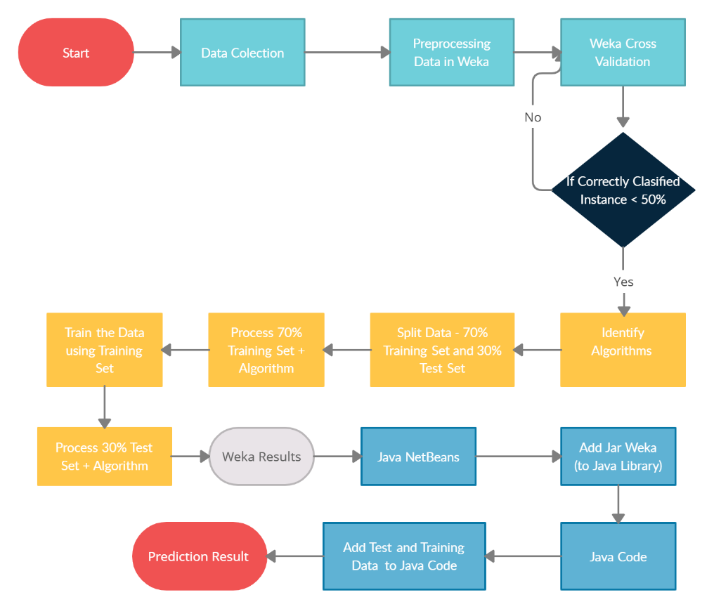
Figure 14. Design mechanism

  - Data Collection

Data used for this study was granted by Internet Movie Database (IMDb). IMDb is a publicly available user-managed website with information on over 400,000 films and TV shows. IMDb is the common film rating database of consumers and is commonly used [4].
The data used has the following attributes shown in Figure 15:
- Title
- Year
- Genres
- MetaScore
- Director
- Star1
- Star2
- Star3
- Star4
- IMDBrating
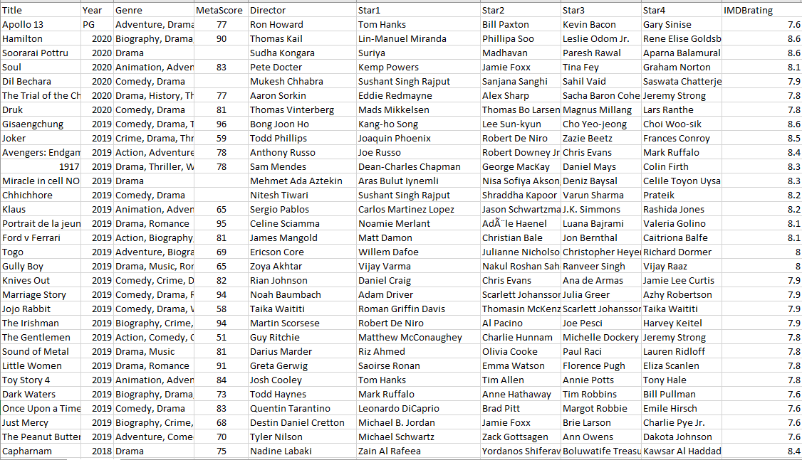
Figure 15. IMDB Data

  - Processing data in WEKA

The obtained data contained a high number of unwanted components, resulting in inaccurate analysis. For example, the data set had null fields and columns irrelevant to the current research. As a result, the data must pre-process to meet the analysis type's requirements. After cleaning the dataset by eliminating the apostrophe and deleting superfluous words and columns (see Methodology Chapter), a new column entitled Class was introduced in which movies classed as Bad, Good, or Excellent based on IMDb rating. Following the addition of the column, it will upload the dataset into Weka for processing.

When launching Weka 3.8.5, choose the Explorer button; once inside, click the Open File button in the Preprocess tab and pick the IMDB.csv dataset; then click the Open button.

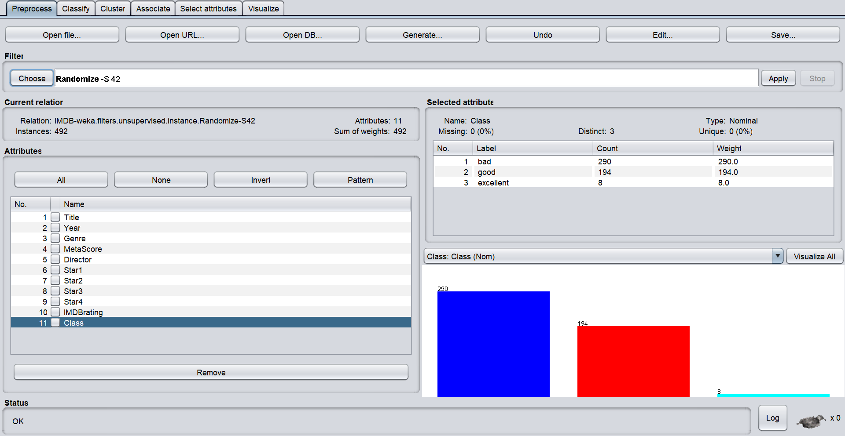
Figure 16. IMDb Dataset visualization in Weka

Because the dataset is in.csv format, it will need to be converted to a .arff format after being submitted in Weka. A .arff file is an ASCII text file that contains information on a collection of instances that share a set of characteristics. This file is structured uniquely. If data stored in a different file, it must be converted to a .arff file, as Weka only works with .arff files. ARFF files are split into two parts. The first part contains information about the header, followed by information about the data. The ARFF file's header section provides the relation's name, a list of its characteristics (the columns in the data), and their types [28][38].

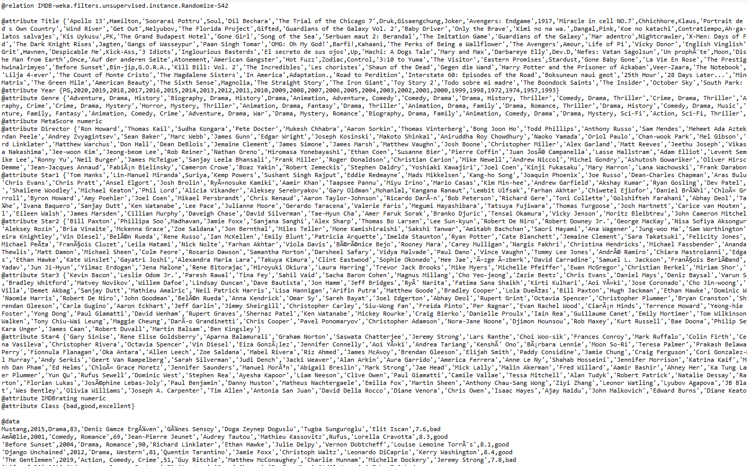
Figure 17. Dataset in .arff format

  - Weka Cross Validation

Cross-validation is a pre-processing approach used to evaluate machine learning design using a limited dataset. Cross-validation is generally used in applied machine learning to assess the competency of a machine learning model on previously unknown data. To test how the model will perform in general when used to produce predictions on data that was not utilised during the model's training.
It is critical to note that the dataset has been stratified before being divided into k folds. Stratification separates the dataset into folds with about equal proportions of class labels in each fold. Stratification is a technique used to eliminate bias in the training of classifiers. The primary asset of k-fold Cross Validation is that it minimises the dataset's variance by utilising the entire dataset. However, because the model trained k times, this technique has a more considerable computational cost than the hold-out method. Weka supports k-fold cross-validation and divides information into k folds using stratification [38].
The Cross-Validation section will compare the three different benchmark classifications. After the comparison, will be chosen an algorithm for the prediction model.
The performance of the algorithms will be assessed using a Confusion Matrix, which counts the number of True Positives (TP), False Positives (FP), False Negatives (FN), and True Negatives (TN) to measure accuracy for a simple binary classification issue. A confusion matrix is a graphical description of the outcomes of a classification problem's predictions. The confusion matrix includes information on how the model's predictions relate to the actual values in its most basic form. The following are the definitions of the following predicted outcomes:
- True Positive (TP) is the total of correct forecasts which result in a positive categorization.
- False Positive (FP): the total of inaccurate forecasts which result in a good categorization. A budget is the total amount of resources allocated to the production of a film.
- True Negative (TN): the number of accurate forecasts pointing in the direction of the negative classification.
- False Negative (FN): the number of times an incorrect prediction has been made in the direction of the negative class [28][38].
Once the primary dataset has been loaded into Weka, must be selected the Class column. After choosing the Class attribute, the Classify tab must be clicked, as illustrated in Figure 18.

Figure 18. IMDb dataset in Weka

In the Classify tab, the Choose button must be clicked and selected the algorithm that will be tested through cross-validation. After the algorithm is selected, must be clicked the Start button.

- Naïve Bayes Algorithm
The results of Weka Naïve Bayes after tenfold cross-validation are displayed in Figure 19, along with the percentage scored by this method. Naïve Bayes achieved 93.69 percent of categorised data being right, and only 6.3 percent is wrong.
Thus, for class A, Naïve Bayes properly categorised 260 occurrences True Positive and wrongly classified 22 instances False Negative. For class B, the same method ranked four instances False Positives, 186 instances True Negative and four instances for False-negative. For Class C, the algorithm categorised one instance False Positive and classified 7 True Negative.

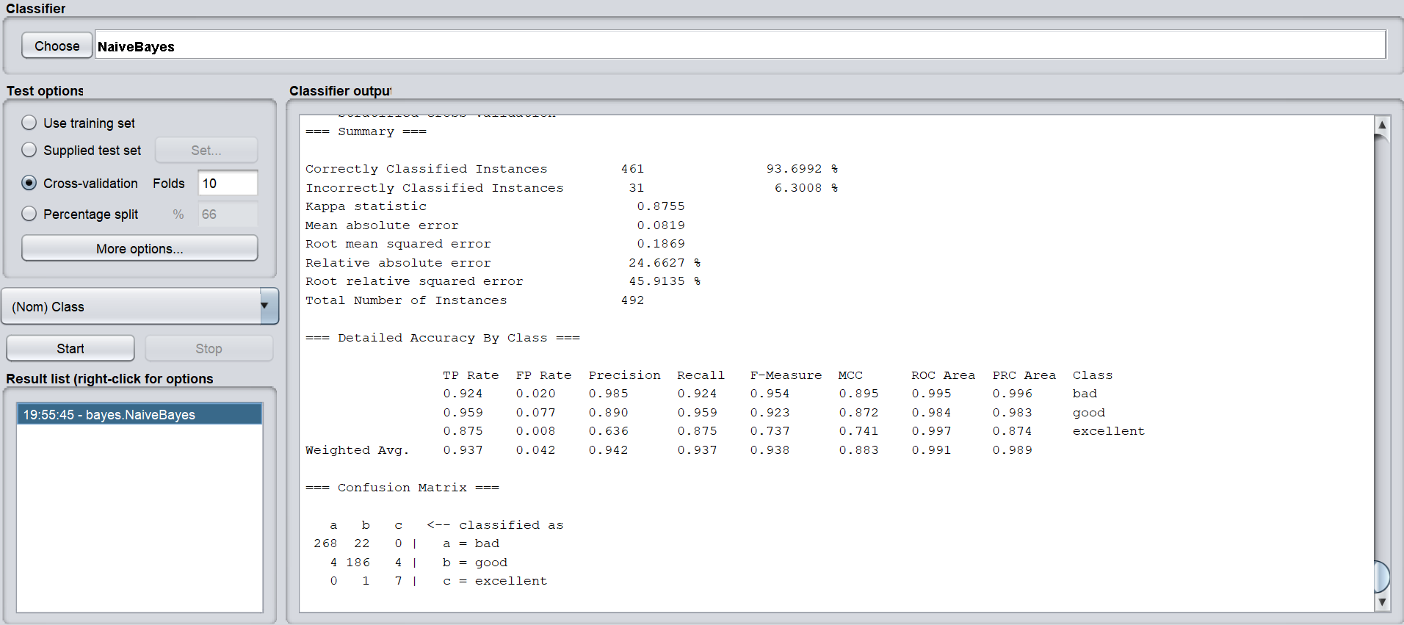
Figure 19. Naïve Bayes Algorithm

- KStar Algorithm

The results of the KStar algorithm after tenfold cross-validation are displayed in Figure 20, along with the percentage scored by this method. KStar achieved 94.3% of categorised data being right, and only 5.69% is wrong.
For class A, KStar properly categorised 284 occurrences True Positive and wrongly classified six instances False Negative. For class B, the same method properly categorised 15 instances False Positives and erroneously classified 177 instances True Negative and two instances False Negative. For Class C, the algorithm ranked five instances False Negative and three instances for True Negative.

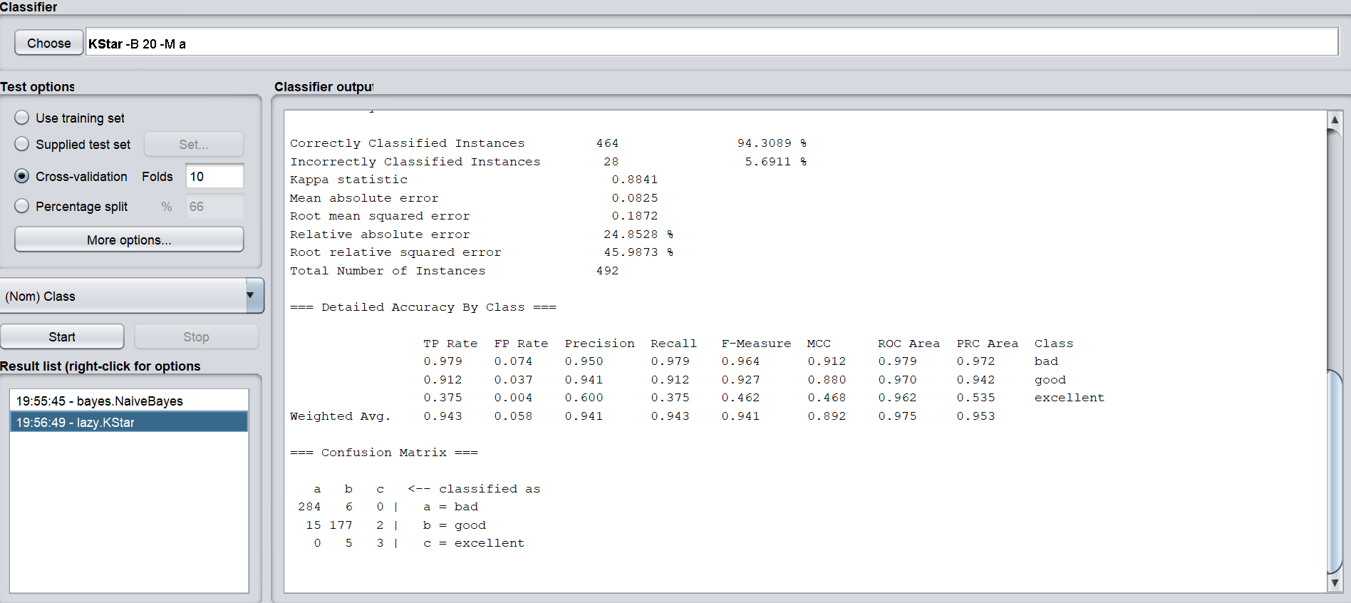
Figure 20. KStar Algorithm

- J48 Algorithm

The results of the J48 Algorithm after 10-fold cross-validation and the percentage scored by this Algorithm are presented in Figure 21. J48 has one of the highest percentages of all of the algorithms tested. With about 99.79% of correctly categorised data and only 0.20% incorrectly labelled data.
J48 correctly classified 290 True Positive occurrences in class A. The same approach categorised 192 True Negative examples and one False Negative instance under class B. The Algorithm classified eight instances of True Negative as belonging to Class C.

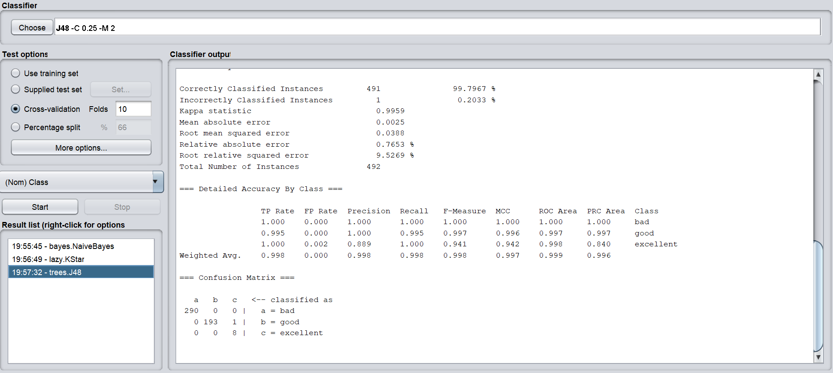
Figure 21. J48 Algorithm

  - Identifying the algorithm

Following the thorough review of different algorithms, the J48 is chosen through the cross-validation process among the algorithms described above.

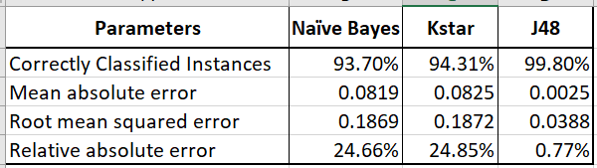
Figure 22. Algorithm comparison

The three algorithms were evaluated using four metric evaluations, as indicated in the above picture before the J48 method was chosen.
- Correctly classified instances - signifies the total of True Positive and True Negative instances The efficiency is estimated to reduce the amount of correctly detected occurrences by the total of instances.
- Mean Absolute Error - a metric for determining how close forecasts or predictions is to actual outcomes. The mean absolute error is calculated as follows: The mean fundamental error, as the name implies, is the average of the total errors, where is the forecast and is the actual value.
- Root mean squared error – observers the discrepancy between the parameters predicted by a model or estimate versus the values (including sample and population values). It is symbolic. The difference between anticipated and actual values expressed as a sample standard deviation.
- Relative absolute error - is a metric for evaluating a predictive model's performance. Machine learning, data mining, and operations management are the most common applications. The Relative Absolute Error is presented as a rate when a mean error (residual) is compared to errors created by a primary or naive model.
J48 algorithm had the highest Correctly classified instances percentage with 491 instances and only one instance incorrectly classified.
J48 algorithm also had 0.0025 Mean Absolute Error, 0.0388 Root mean squared error and 0.7653 % Relative absolute error, which was smaller than the other two algorithms analysed.
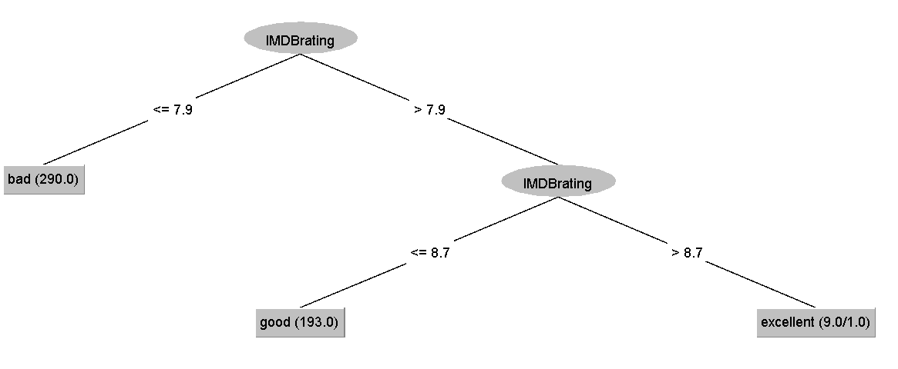
Figure 23. J48 tree

  - Splitting the dataset

It is a methodological error to train the entire dataset and then test the prediction function on the same data. It referred to as overfitting, and an independent test set is necessary to avoid it. The dataset is partitioned into two distinct sets in supervised machine learning studies: the train set and the test set. The test set is omitted from the learning process and is not used to determine the parameters of the prediction function. The primary data will be divided into two datasets: the Train dataset will comprise 70% of the data, and the Test dataset will contain 30%. The split on the Preprocess tab will be performed by selecting the Choose button in the Filter section, then selecting the RemovePercentage option, as shown in Figure 24.
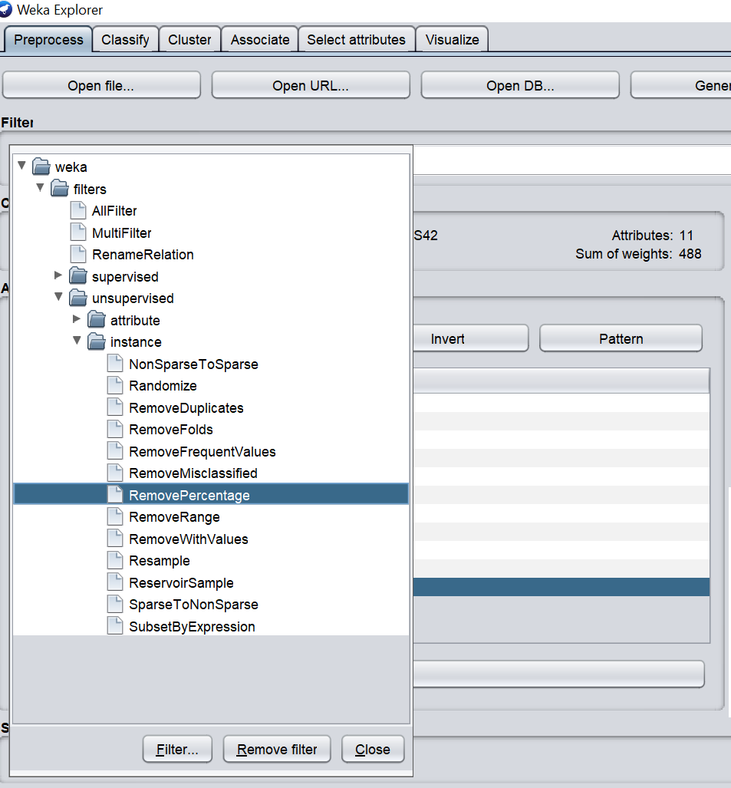
Figure 24. Remove Percentage Instance

Double-click on the RemovePercentage button to access the RemovePercentage tab, where the percentage for the Train dataset may be changed from the default 50 percent to the 30 percent required for this research. Then click on the Ok and Apply buttons to save and apply the changes.

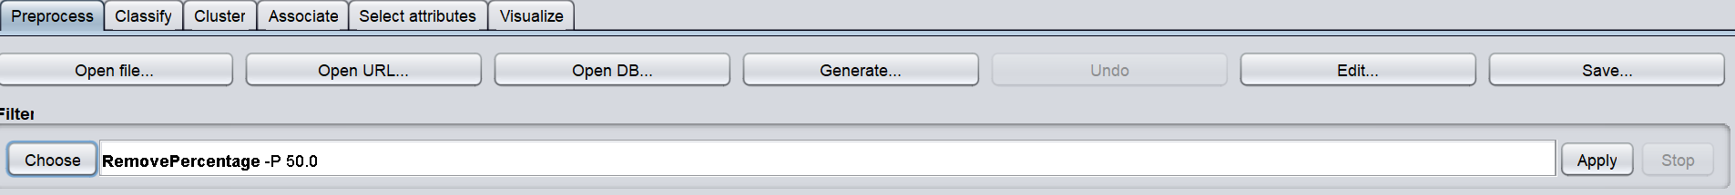
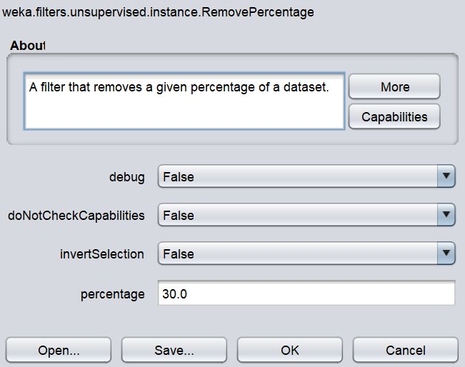
Figure 25. Modifying the percentage

Once clicked on the Apply button after making your selection, the primary dataset will be changed and will now show just 344 instances out of a total of 492 instances in the primary dataset.
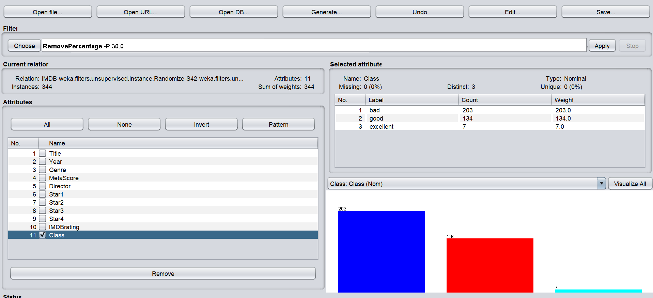
Figure 26. Train Dataset

The Save button, must be pressed to save the Train dataset in the... .arff format as illustrated in Figure 27.

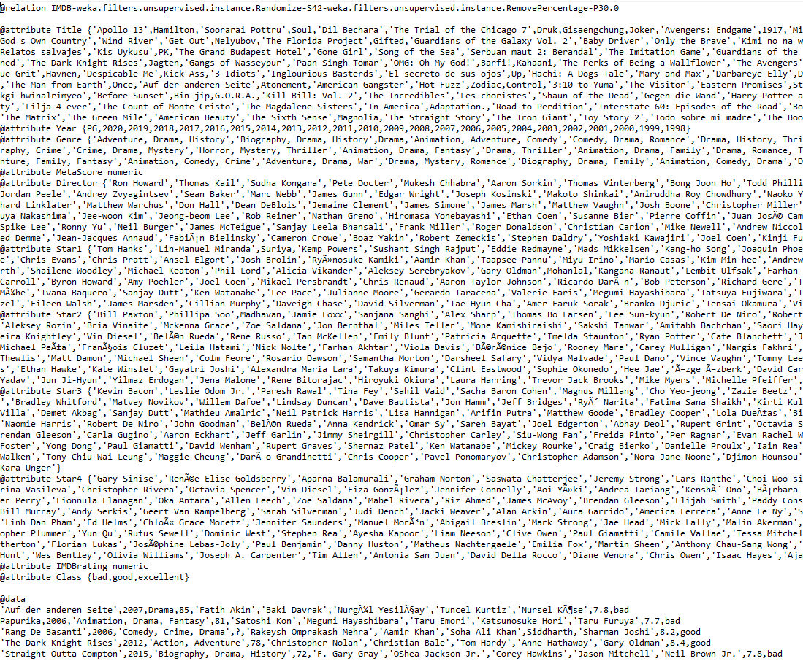
Figure 27. Train Dataset in .arff format

After saving the Train dataset, press the Undo button to adjust the proportion for the Test dataset to 30% of the primary dataset. Then follow the same procedures as for the Train dataset, except that it should change the InvertSelection tab to True rather than False, and then click Ok and Apply.

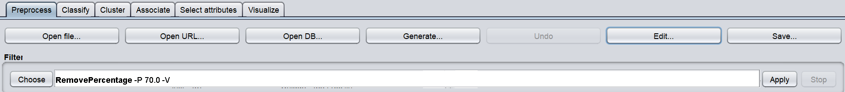
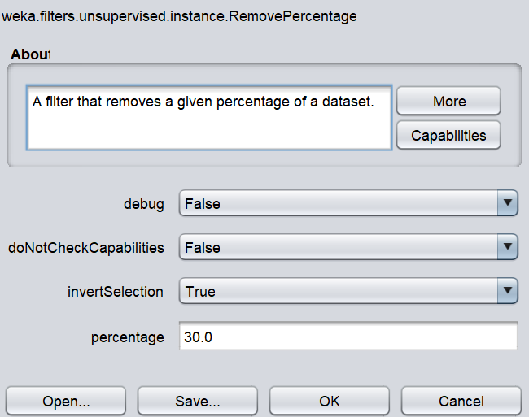
Figure 28. Modifying the percentage to 30%

When the Apply button is clicked, the Test dataset will have 148 instances rather than the 492 instances in the main dataset.

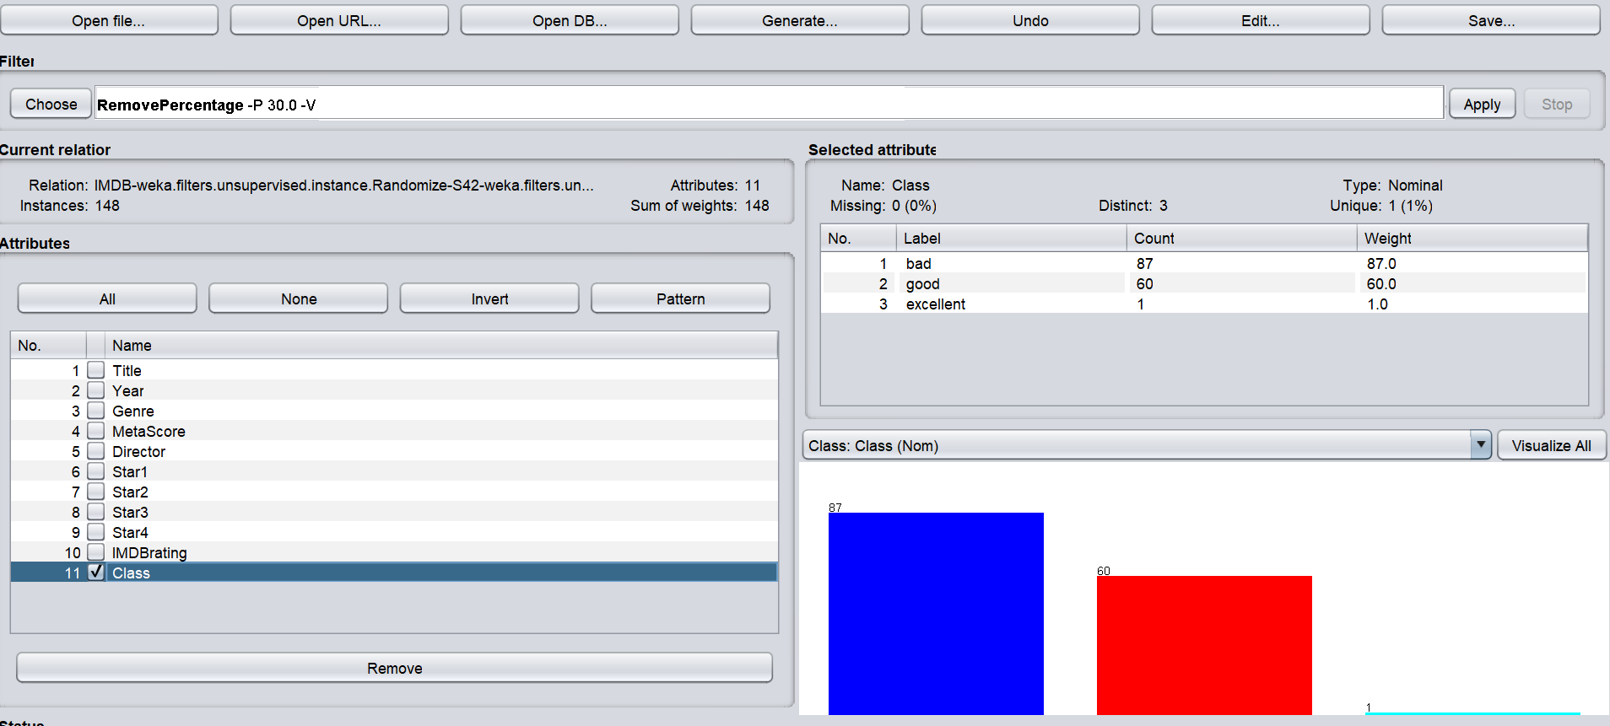
Figure 29. Test dataset

It will be necessary to change the Class column in the Test dataset from the Bad, Good, and Excellent attributes to the '?' attribute to obtain a prediction. It is demonstrated in the image below. When the Edit button is clicked, as shown in Figure 29. Once the Edit button has been clicked, right-click on the Class column, and select 'Set all values to...', a small window will appear where the '?' will be introduced and then click Ok.

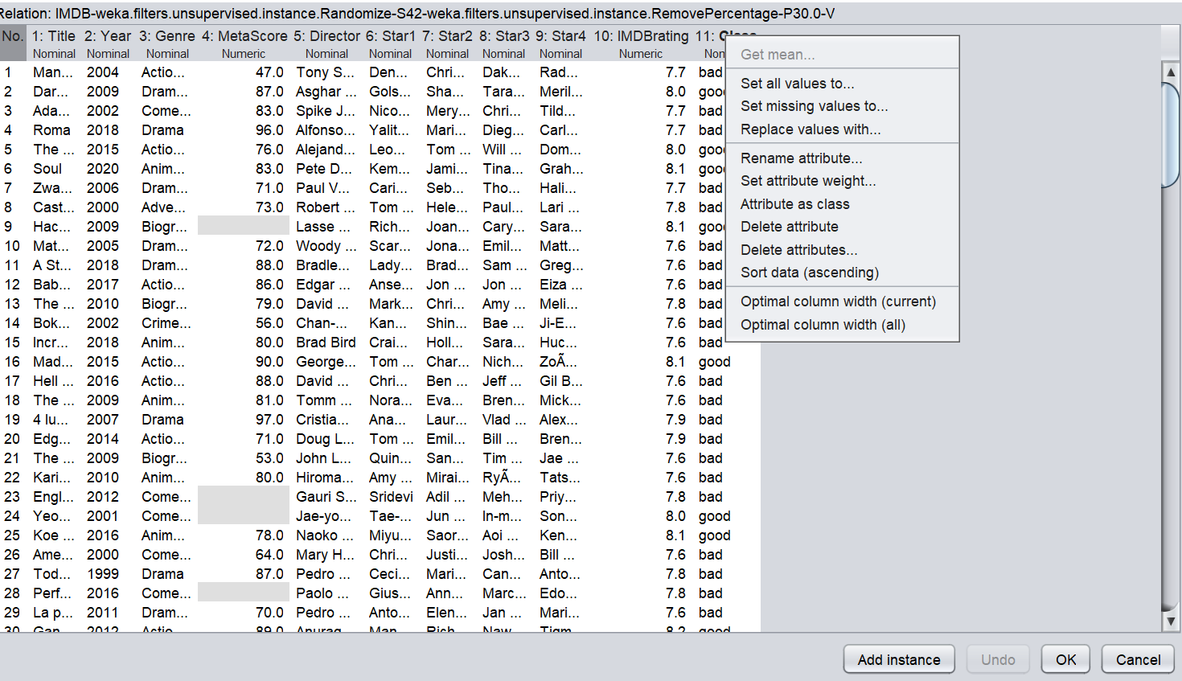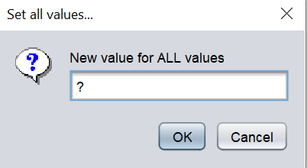
Figure 30. Replace Class column attributes

After clicking the Ok button, all characteristics in the Class column were changed, as seen in Figure 31.

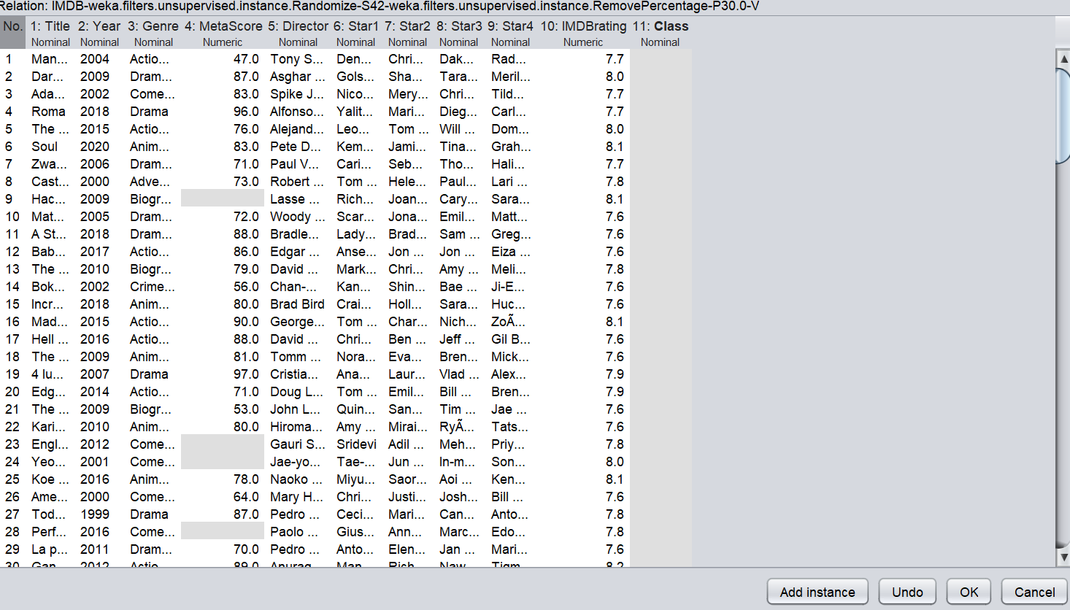
Figure 31. Class Column modified

After making changes to the Class column, the Ok button will be clicked. The Save button must be selected to save the Test dataset in the .arff format.
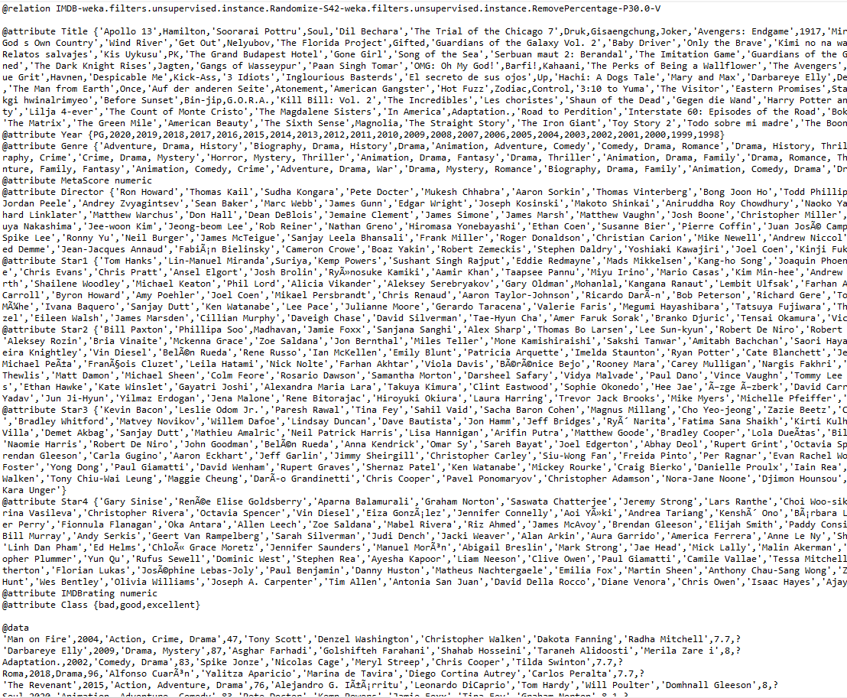
Figure 32. Test dataset in .arff format

  - Processing the Train and Test datasets with the selected algorithm

As previously stated, the dataset was partitioned into Train and Test subsets. Once the Train dataset has been uploaded to Weka, the J48 algorithm must be selected in the Classify tab, followed by the Use Training Set option and the Start button.

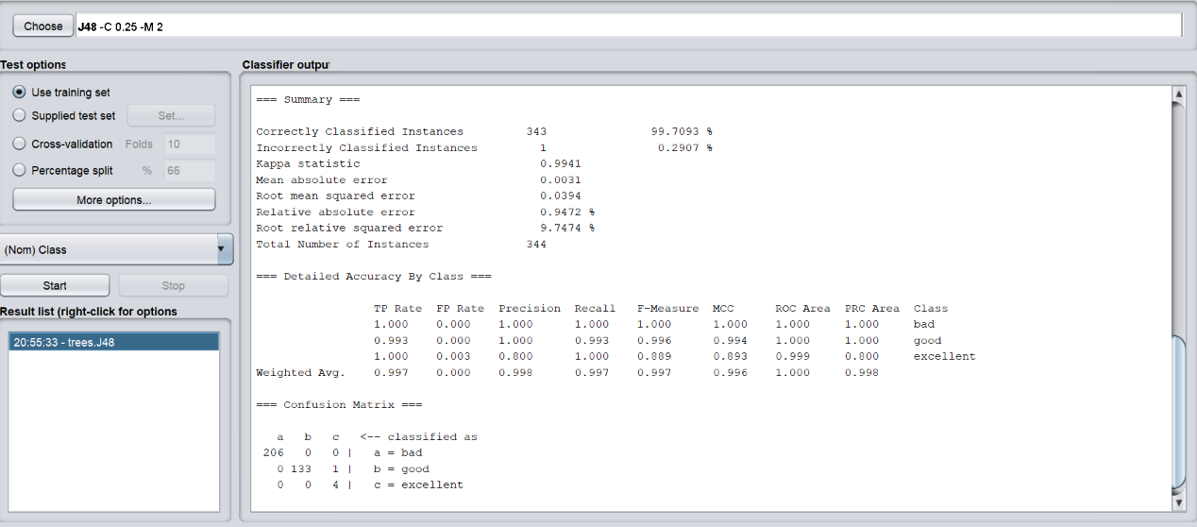
Figure 33. Train dataset with J48 algorithm

The Test dataset will be utilised to derive the prediction once the Train dataset has been balanced. After selecting the Supplied test set option, the Set button will be pressed. A tiny box will open, prompting the user to pick the Open file, upload the Test dataset, and then click the Close button. Before selecting the Start button, you must first choose the More options button, change the Output Prediction from Null to Plain Text, click the Ok button, and finally, the Start button.
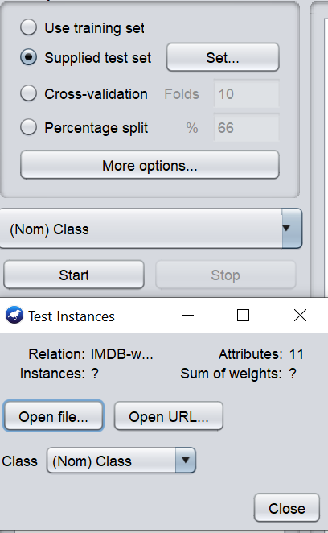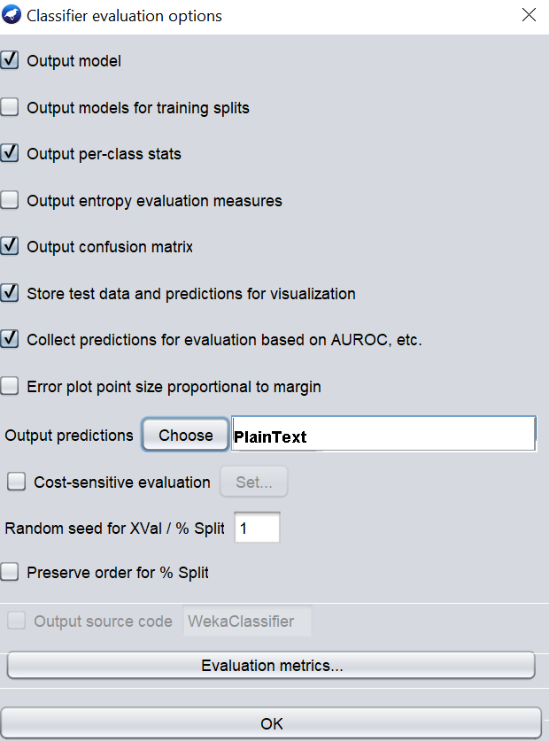
Figure 34. Using the Test dataset

As can be seen in the figure below, after the Start button was pressed, the prediction was made on the test set.

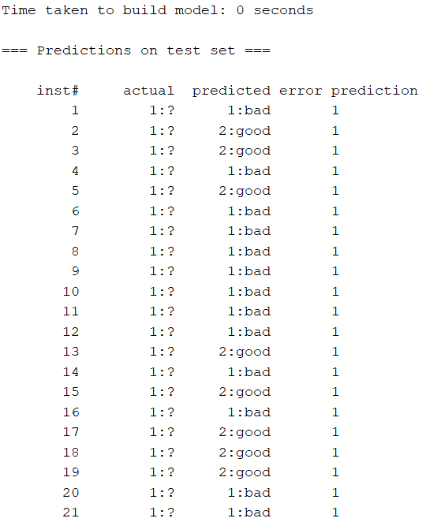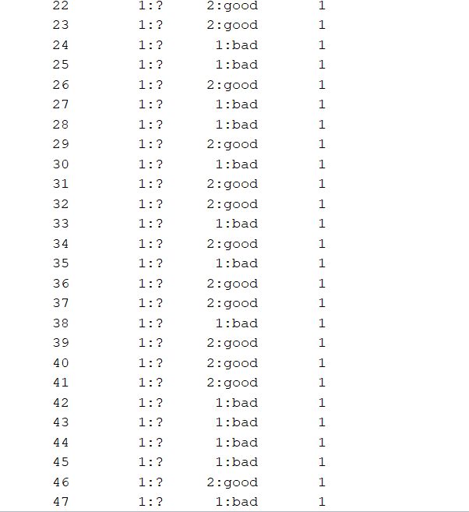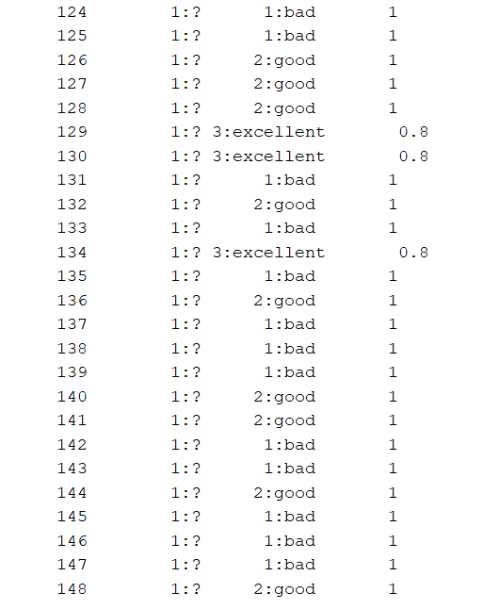
Figure 35. Prediction on Test dataset

After making the prediction, right-click on the Test prediction, choose Visualize classifier error, and save the prediction model as J48.

  - Integrating Jar Weka into Java NetBeans library

For this study, in NetBeans, a new project called java application/ is developed. The JAR files used to expose the Weka API to NetBeans may be found while exploring the Java Library. As a result, it can act in Java with the identical ease as the Weka GUI. Subsequently, the weka.jar file is picked.
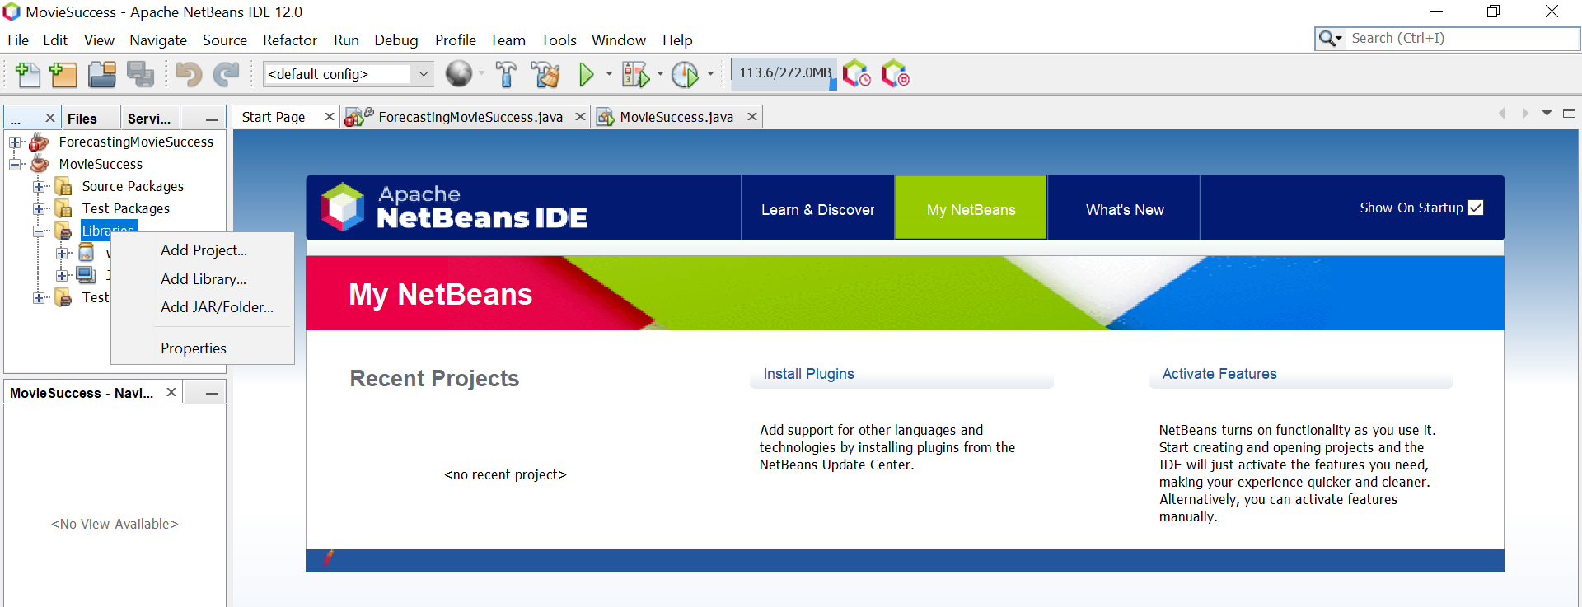
Figure 36. Adding Jar Weka in NetBeans

  - NetBeans code

Following the selection of the weka.jar, programming begins with creating a new Java class in the Default Package. Finally, the finish button is pressed, and the source code for the class path, data sort, and a few other things is modified.

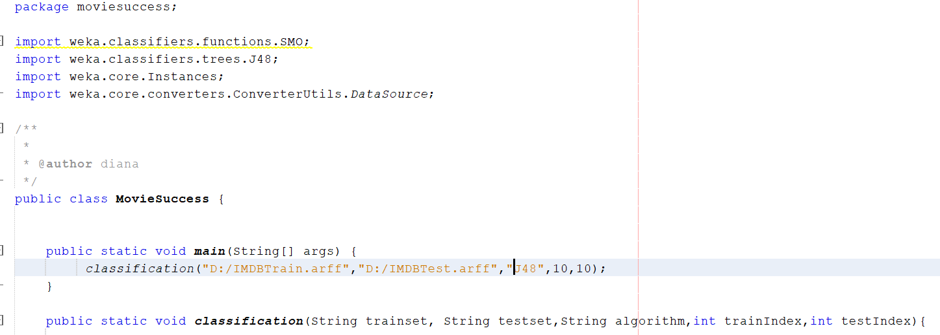
Figure 37. NetBeans source code

Once the layout has been finished, it must be saved to file. The design is saved in twofold layout in the WEKA Explorer by clicking right on the outcome aspect for the application in the "Result list" preference on the category tab. Ultimately, the model is saved with the location and file name 'MovieSuccess'. It is good to keep track of where the WEKA model is held in the file and double-check that the WEKA model is the same when it is accessed someplace else. This lowers the possibility of compatibility difficulties. Predictions may be made now that everything has been set up.

It is necessary to provide a path for the training and test sets in the line codes and specify what attributes the system should compute. This example is number 10 since the dataset utilised has 0 characteristics, but the Java index count begins at zero.
Figure 38. Code path

  - Prediction output

The Java output for the Testing set, seen in figure 32, is represented by the below picture. The output is expressed in binary, with 0.0 being the forecast for a Bad movie, 1.0 representing the prediction for a Good movie and 2.0 representing the prediction for an Excellent movie.

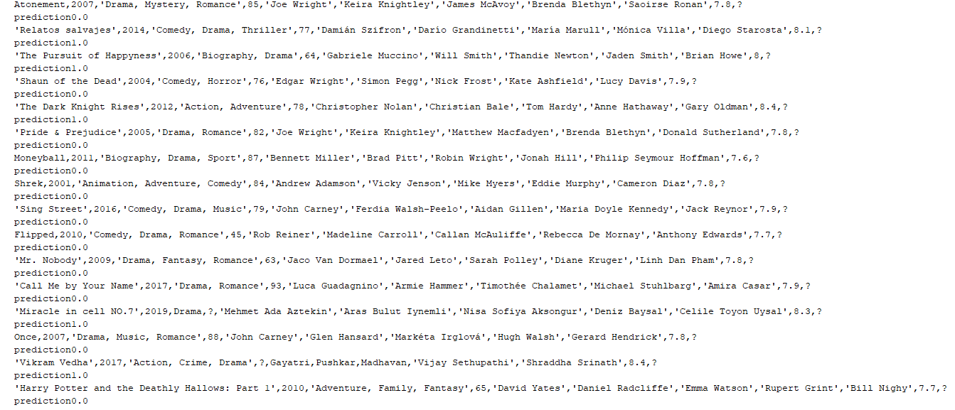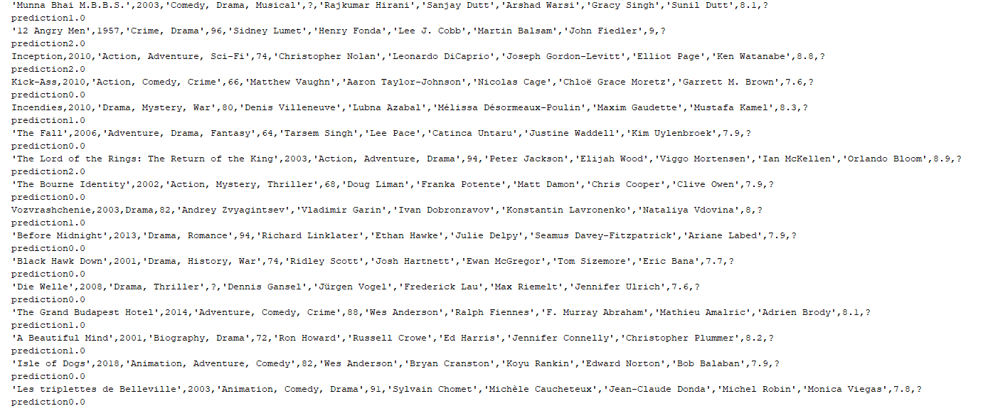
Figure 39. Prediction output

- Testing layouts with new dataset

Following the procedures described in the preceding chapter, the testing was carried out utilising various sets of IMDb unprocessed data. The dataset is divided in a 70:30 ratio between the training and testing datasets. The dataset contains enough information for a model learning process to be successful to create the model. It is necessary to use the last 30% of the dataset to validate the model. The training dataset contains all of the data that has been labelled, whereas the testing dataset contains all of the information that has been left untagged or hidden. The total amount of sampling utilised in this investigation is depicted in Figure 41.

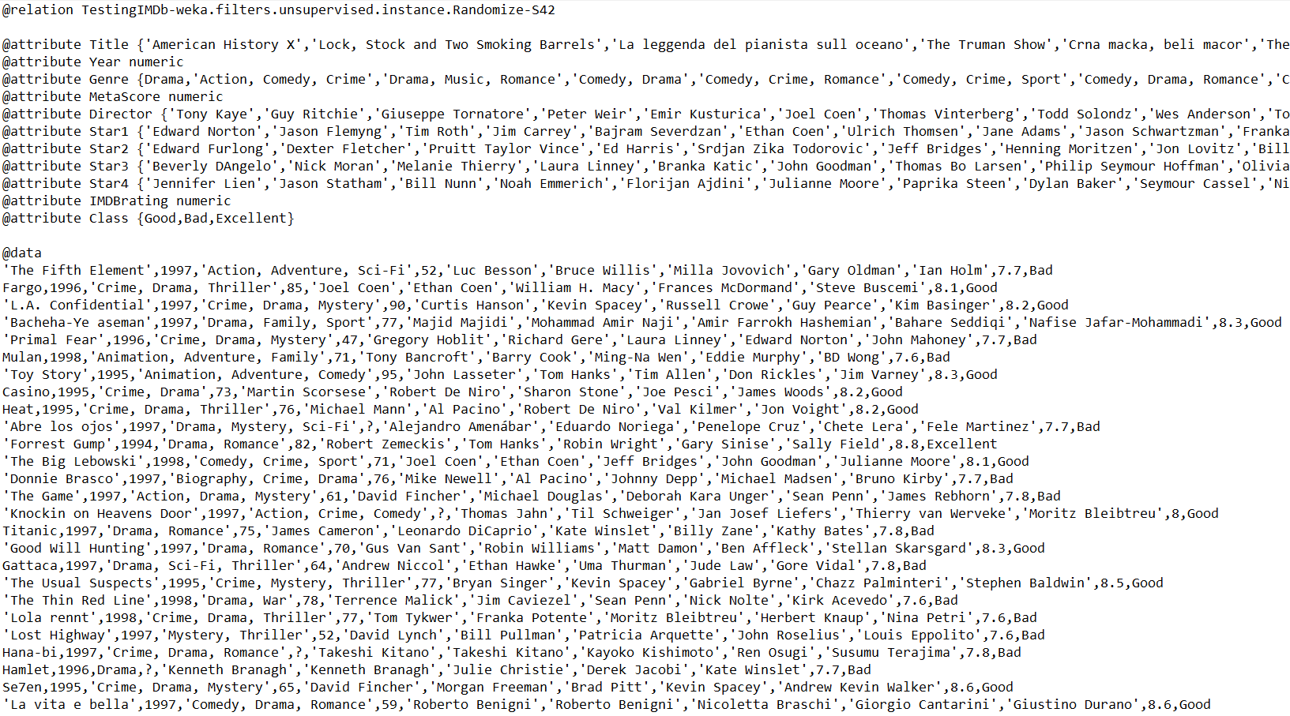
Figure 40. IMDb Testing Dataset

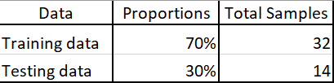
Figure 41. Data partitioning

After splitting the sample dataset and the Train dataset in. .arff format has been uploaded into Weka, the J48 algorithm must be selected in the Classify tab.

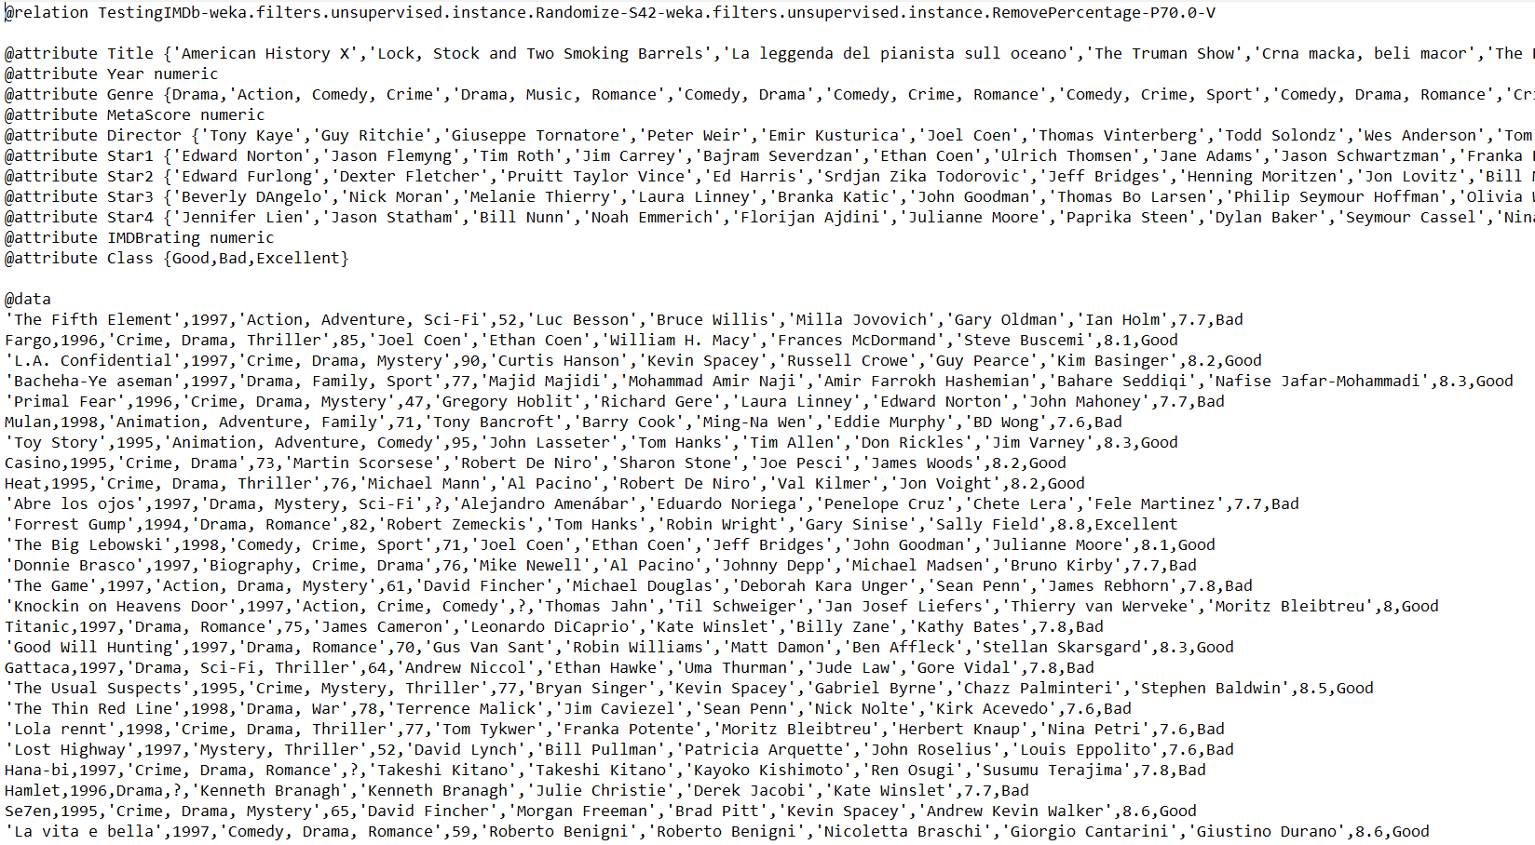
Figure 42. Train Set
To proceed with training, the dataset using the specified method, the option "Use Training Set" must be selected in the Weka Classify tab. Following completion of this phase, the data will be tested against the training model. As seen in figure 43, for the testing to be valid, the values from the previous instance named "Class" were changed with a question mark "?".

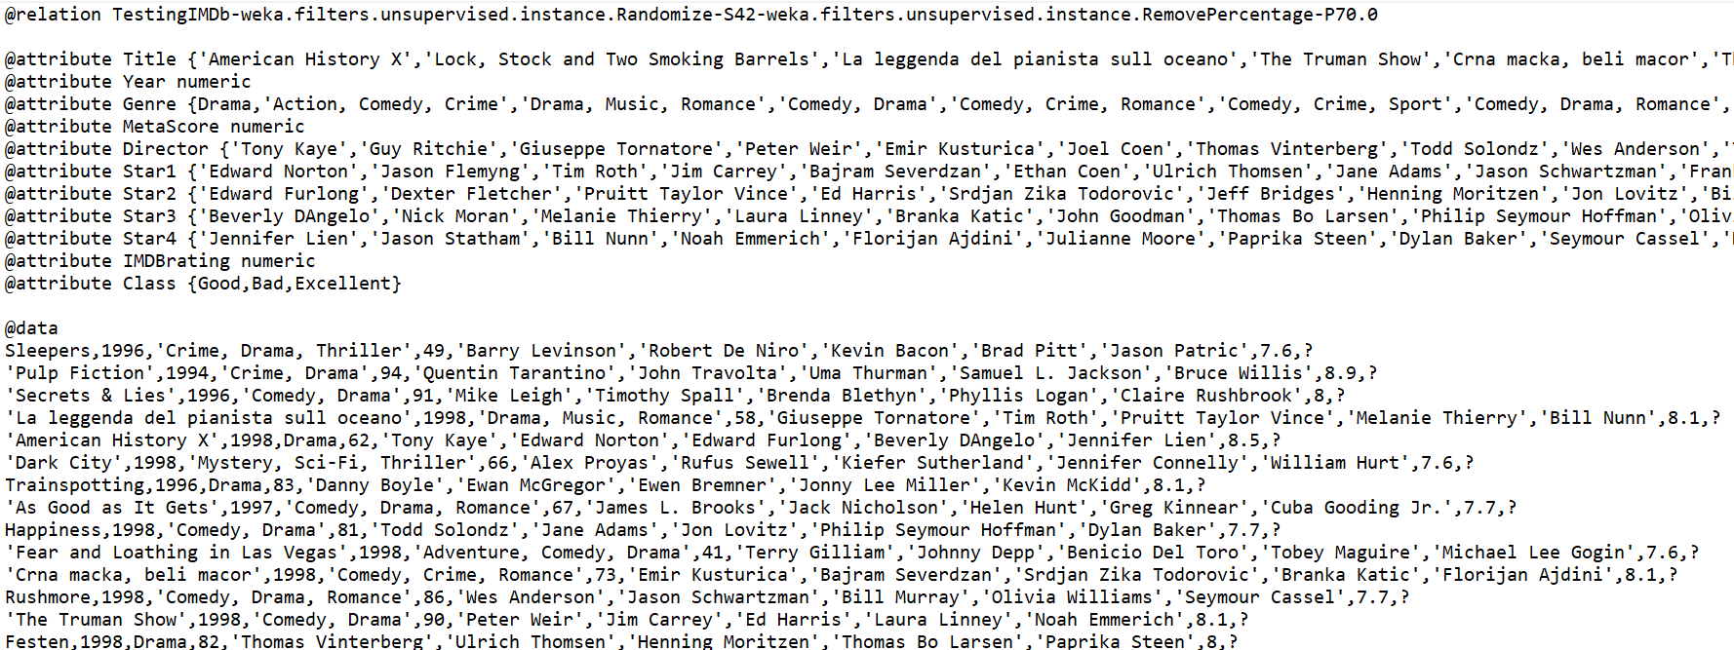
Figure 43. Test set

As it can be seen in the image bellow the J48 algorithm’s testing in Weka was successful and the prediction was made.

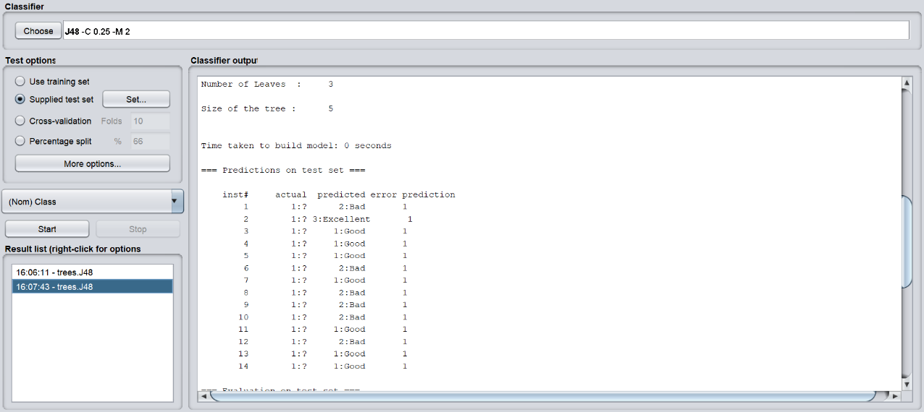
Figure 44. Weka prediction

Following the saving of the prediction model, the next step is to implement the Weka prediction model in Java NetBeans.
It is necessary to include the path for the training set and the path for the test set in the line codes, as well as to set the numerical characteristics that the system will need to compute.

Figure 45. Testing set path

After including the path, the Java code must be executed to generate the forecast for the testing datasets.

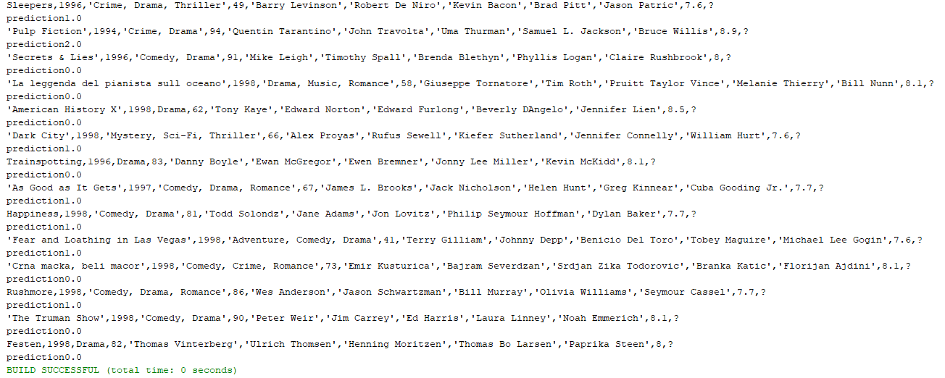
Figure 46. Testing dataset’s output

Figure 46 shows the Java output for the testing dataset. The Java code is executing well, and there are no problems displayed. The result is expressed as a binary number, with 0.0 being the forecast for bad movies, 1.0 representing good films and 2.0 illustrating the prediction for an excellent film.

- Evaluation

Although this experiment might be considered a success, there were still flaws with the techniques and the project as a whole; hence, this part will focus on suggested improvements for future studies. Although the overall research was rigorous, one area that required more investigation was the simulation software. Because of specific difficulties with the IMDb dataset utilised, the general design of the prediction model was altered from its initial design. Initially, thousands of movies were used; however, only 492 movies were used following the design modification. This problem might have been easily averted if the study into the Weka software had been carried out more quickly and thoroughly.
Another area that needs improvements is the Java software field, which is new to the author of this paper and so requires more research, solving mathematical challenges, working on side projects, developing code, and learning new technologies.
Time management also was an area for improvement in this research since the prediction model was finished later than planned due to a problem with the IMDb dataset. To help with time management, a Gantt chart was created to plan the duration of each work; this Gantt chart is given in the appendices. Although this Gantt chart was extremely beneficial throughout this project, it could not be followed entirely owing to unanticipated events.
This study has certain drawbacks. For one thing, as previously stated, there may be sample biases. As can be seen, the dataset contains a reasonably representative sample of film ratings. However, the scarcity of budget and revenue data may have introduced some bias into the experiment's dataset, even though we included just 10% of all films made over the 23 years.
Another disadvantage is that the sample dataset did not contain the profit margin placed on the production cost and box office income. To most of the filmmakers, box office income is their sole source of funding. Disney's animated films, for example, generally earn substantially from the marketing of movie-related goods such as clothes and toys. Aside from ticket sales, the selling and rental of DVDs may be a significant source of income for certain films. Collecting non-box office revenues, on the other hand, is more difficult because they might accrue for years after a film's release.
However, this study has significant practical implications for decision-makers in the film business. This model might be utilised as a complement to the green-lighting procedure by film producers. The model might be a helpful tool for distributors and theatre owners in determining which films to pick, distribute, promote, and play.

- Conclusion and Recommendation

This research’s primary objective was to develop a machine learning design that may forecast films' box office success and, as a secondary goal, allow to decrease movie producers' cost and time spent on analysis. The model was validated using the IMDB dataset. The system compared three different algorithms: Naïve Bayes, KStar, and J 48. Weka 3.8 was used to compare and identify the optimal implementation algorithm.
To determine the optimal method, each one was evaluated on the same dataset using 10-fold cross-validation. By comparing the Correctly categorised instances, Mean Absolute Error, Root Mean Squared Error, and Relative Absolute Error, the choice was made to continue utilising the J48 method rather than Naive Bayes or KStar.
Based on the outcomes of training and testing, it can conclude that Artificial Intelligence can forecast the success of a film.
Box office prediction takes more skill due to its reliance on the user to correctly understand the various representations of the data and deduce the correct conclusions.
Such predictions might be improved by including new variables and expanding the size of the dataset. Such approaches can be utilised to create an automated programme that can recommend movies to viewers based on their popularity. Furthermore, by adding particular features into hybrid techniques, such a system may be evolved into a recommender system. Moreover, user emotions can be employed to improve film performance and forecasting.

- References

[1] You Jin Kim, Yung Joon Lee, Yung Gyung Cheong. Prediction of a movie’s success using plot summaries using Deep learning models. Proceedings of the second story-telling workshop,2019, p. 127–135. Available: https://www.aclweb.org/anthology/W19-3414.pdf [Accessed: 06 January 2021].
[2] "Global box office revenue 2020 | Statista", Statista, 2021. [Online]. Available: https://www.statista.com/statistics/271856/global-box-office-revenue/. [Accessed: 06 January 2021].
[3] Galvao, M. & Henriques, R. “Forecasting Movie Box Office Profitability,” Journal of Information Systems Engineering & Management, 2018. Available:https://www.semanticscholar.org/paper/Forecasting-Movie-Box-Office-Profitability-Galvao-Henriques/6d4f1003fd164ffe30e2e45dd252715efecf9e61 [Accessed: 10 January 2021].
[4] Datasets.imdbws.com, 2021. [Online]. Available: https://datasets.imdbws.com/. [Accessed: 12- Jan- 2021].

[5] D. Arora, "A REVIEW OF MACHINE LEARNING TECHNIQUES OVER BIG DATA CASE STUDIES", International Journal of Innovative Research in Computer Science & Technology, vol. 8, no. 3, 2020. Available: 10.21276/ijircst.2020.8.3.34. [Accessed: 13 January 2021].

[6] B. Litman, Predicting Success of Theatrical Movies: An Empirical Study. The Journal of Popular Culture, 1981, pp. Vol.16(4), p.159-175. Available: https://onlinelibrary.wiley.com/doi/abs/10.1111/j.0022-3840.1983.1604_159.x [Accessed: 20 January 2021].
[7] Barry R Litman and Linda S Kohl. Predicting financial success of motion pictures: The’80s experience. Journal of Media Economics, 1989, p. 35-50. Available: https://www.tandfonline.com/doi/abs/10.1080/08997768909358184 [Accessed: 20 January 2021].
[8] A. SivaSantoshReddy, P. Kasat and A. Jain, "Box-Office Opening Prediction of Movies based on Hype Analysis through Data Mining", International Journal of Computer Applications, vol. 56, no. 1, pp. 1-5, 2012. Available: 10.5120/8852-2794 [Accessed 9 February 2021].
[9] M. Mestyán, T. Yasseri and J. Kertész, "Early Prediction of Movie Box Office Success Based on Wikipedia Activity Big Data", PLoS ONE, vol. 8, no. 8, p. e71226, 2013. Available: 10.1371/journal.pone.0071226 [Accessed 11 February 2021].
[10] Y. Zhou, L. Zhang, and Z. Yi, "Predicting movie box-office revenues using deep neural networks", Neural Computing and Applications, vol. 31, no. 6, pp. 1855-1865, 2017. Available: 10.1007/s00521-017-3162-x [Accessed 19 February 2021].
[11] Y. Kim, J. Lee, and Y. Cheong, "Prediction of a Movie’s Success From Plot Summaries Using Deep Learning Models", Proceedings of the Second Storytelling Workshop, Association for Computational Linguistics, pp. 127–135, 2019. Available: https://www.protothema.gr/files/2019-08-05/ch/models.pdf. [Accessed 26 February 2021].
[12] N. Quader and M. Gani, "A Machine Learning Approach to Predict Movie Box-Office Success", 20th International Conference on Computer and Information Technology (ICCIT 2017)At: Dhaka, Bangladesh, pp. 7-54, 2018. Available: https://www.researchgate.net/publication/322138608_A_Machine_Learning_Approach_to_Predict_Movie_Box-Office_Success. [Accessed 21 February 2021].

[13] Usman Ahmed, Humaira Waqas, Muhammad Tanvir Afzal. Preproduction box office successquotient forecasting. Soft Computing, 2020, p 49 – 52 Available: https://www.springerprofessional.de/en/soft-computing-9-2020/17867480 [Accessed 23 February 2021].

[14] P. Topf, "Examining Success in the Motion Picture Industry", The Park Place Economist, vol. 18, no. 1, p. 69-72, 2010. Available: https://digitalcommons.iwu.edu/parkplace/vol18/iss1/15/. [Accessed 26 February 2021].

[15] Babita M Jangid, Chaitali K. Jadhav, Swati M Dhokate, Grish M. Jadhav, Dr G.M Bhandari. “Movie popularity prediction using social media and conventional features.” International Journal of Innovative Research in Science, Engineering and Technology.2017, vol. 4, no. 9, Available: https://www.coursehero.com/ [Accessed 26 February 2021].

[16] Krushikant, Merin Jose, Supreme Motnam Chan, Kathy J. Liszka and Frederigo De Gregorio. “Prediction of movie box office using social media.” International conference of advances in social media networks and mining. p1-6 2013, Available: https://www.coursehero.com/ [Accessed 03 March 2021].

[17] M. Lash and K. Zhao, "Early Predictions of Movie Success: The Who, What, and When of Profitability", Journal of Management Information Systems, vol. 33, no. 3, pp. 874-903, 2016. Available: 10.1080/07421222.2016.1243969 [Accessed 7 March 2021].

[18] P. Omenistch, "Predicting movie success with machine learning and visual analytics", Faculty of Informatics, pp. 1-38, 2014. Available: https://www.scribd.com/. [Accessed 12 March 2021].

[19] B. Deniz and R. Hasbrouck, "When to greenlight a movie, examining pre -release factors that determine future box office success", International Journal of Economics and Management Sciences, pp. 35-42, 2012. Available: https://www.hilarispublisher.com/open-access/when-to-greenlight-examining-the-prerelease-factors-that-determine-future-box-office-success-of-a-movie-in-the-united-states-2162-6359-2-127.pdf [Accessed 13 March 2021].

[20] X. Chang, "Possible forecasting method for forecasting", Advances in Economics, Business and Management Research, pp. 2-15, 2020. Available: https://www.scribd.com/. [Accessed 17 March 2021].

[21] J. Ericson and J. Grodman, "A Predictor for Movie Success", Stanford University, pp. 1-5, 2013. Available: http://cs229.stanford.edu/proj2013/EricsonGrodmanAPredictorForMovieSuccess.pdf. [Accessed 17 March 2021].

[22] "IBM Knowledge Center", Ibm.com, 2021. [Online]. Available: https://www.ibm.com/support/knowledgecenter/SS3RA7_sub/modeler_crispdm_ddita/clementine/crisp_help/crisp_overview.html. [Accessed: 17 March 2021]. CRISP-DM
[23] "Tutorials - Javatpoint", www.javatpoint.com, 2021. [Online]. Available: https://www.javatpoint.com/machine-learning-life-cycle. [Accessed: 17 March 2021].
[24] A. Bhatia and B. Kaluza, Machine Learning in Java. Birmingham: Packt Publishing Ltd, 2018.
[25] "What is Supervised Learning?", Ibm.com, 2021. [Online]. Available: https://www.ibm.com/cloud/learn/supervised-learning. [Accessed: 17 March 2021].
[26] Waikato, 2021. [Online]. Available: https://www.cs.waikato.ac.nz/ml/weka/. [Accessed: 03 April 2021].
[27] Oracle, 2021. [Online]. Available: https://www.oracle.com/java/webcasts/. [Accessed: 04 April 2021].
[28] S. Das, S. Das, N. Dey and A. Hassanien, Machine learning algorithms for industrial applications. Cham: Springer, 2021.
[29] "Which datamining tool to use?", Stackoverflow. [Online]. Available: https://stackoverflow.com/. [Accessed: 10 May 2021].
[30] V. Sarcar, Interactive Object-Oriented Programming in Java. Berkeley, CA: Apress, 2020.
[31] K. Arnold, J. Gosling and D. Holmes, The Java programming language. Upper Saddle River, N.J: Addison-Wesley, 2009.
[32] H. Arabnia, D. De la Fuente, E. Kozerenko, J. Olivas and F. Tinetti, Artificial Intelligence. Bloomfield: C.S.R.E.A., 2018.
[33] A. Datta and R. Goswami, "The Film Industry Leaps into Artificial Intelligence: Scope and Challenges by the Filmmakers", Rising Threats in Expert Applications and Solutions, vol. 1187, pp. 665-670, 2020. Available: https://link.springer.com/chapter/10.1007/978-981-15-6014-9_80. [Accessed 12 May 2021].
[34] C. Schröer, F. Kruse and J. Gómez, "A Systematic Literature Review on Applying CRISP-DM Process Model", Procedia Computer Science, vol. 181, pp. 526-534, 2021. Available: 10.1016/j.procs.2021.01.199 [Accessed 15 May 2021].
[35] W. Ayele, "Adapting CRISP-DM for Idea Mining", International Journal of Advanced Computer Science and Applications, vol. 11, no. 6, 2020. Available: 10.14569/ijacsa.2020.0110603 [Accessed 15 May 2021].
[36] S. Pawar, "Prediction of Movie Performance Using Machine Learning Algorithms", International Journal for Research in Applied Science and Engineering Technology, vol. 8, no. 2, pp. 667-672, 2020. Available: 10.22214/ijraset.2020.2102 [Accessed 20 May 2021].
[37] "Prediction of individual preference for movie poster designs based on graphic elements using machine learning classification", Electronic Imaging, 2021. Available: 10.2352/issn.2470-1173.2021.11.hvei-163 [Accessed 1 June 2021].
[38] S. Das, S. Das, N. Dey and A. Hassanien, Machine learning algorithms for industrial applications. Cham: Springer, 2021.
[39] J. Rout, M. Rout and H. Das, Machine learning for intelligent decision science. Singapore: Springer, 2020.
[40] S. Gupta, M. Kaur, S. Lakra and Y. Dixit, "A Comparative Theoretical and Empirical Analysis of Machine Learning Algorithms", Webology, vol. 17, no. 1, pp. 377-397, 2020. Available: 10.14704/web/v17i1/web17011 [Accessed 1 June 2021].
[41] "Evaluation of Data mining for Prediction Techniques Based on Weka Tool", International Journal of Innovative Technology and Exploring Engineering, vol. 8, no. 93, pp. 447-451, 2019. Available: 10.35940/ijitee.i3083.0789s319 [Accessed 2 June 2021].
[42] Avi Goldfarb., Joshua Gans. and Ajay Agrawal., Prediction Machines: The Simple Economics of Artificial Intelligence. Harvard Business Review, 2018.
[43] Techvidvan, 2021. [Online]. Available: https://techvidvan.com/tutorials/supervised-learning/. [Accessed: 22- Mar- 2021].

Appendices

- Original Gantt Chart
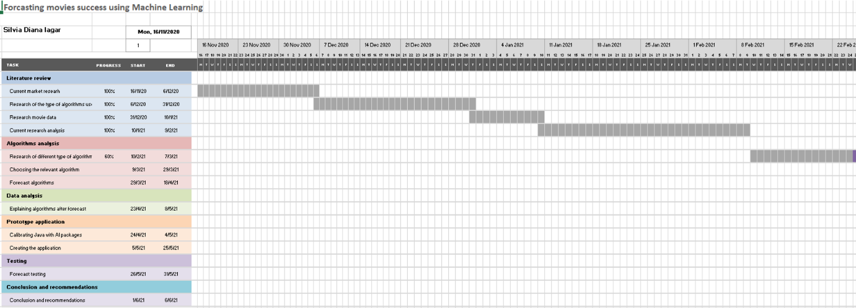

- Updated Gantt Chart
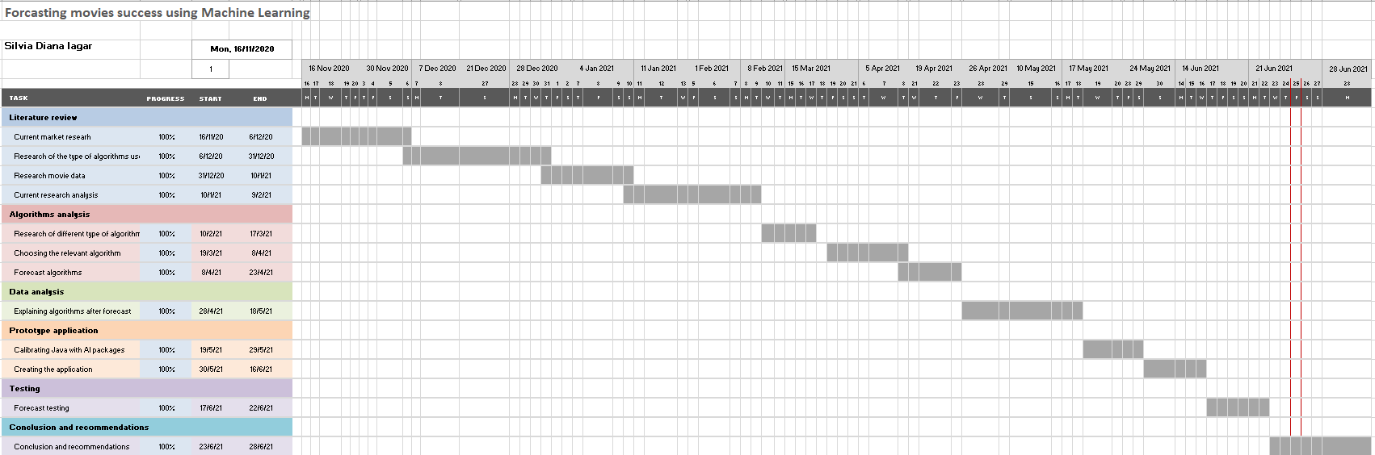

- NetBeans Source Code

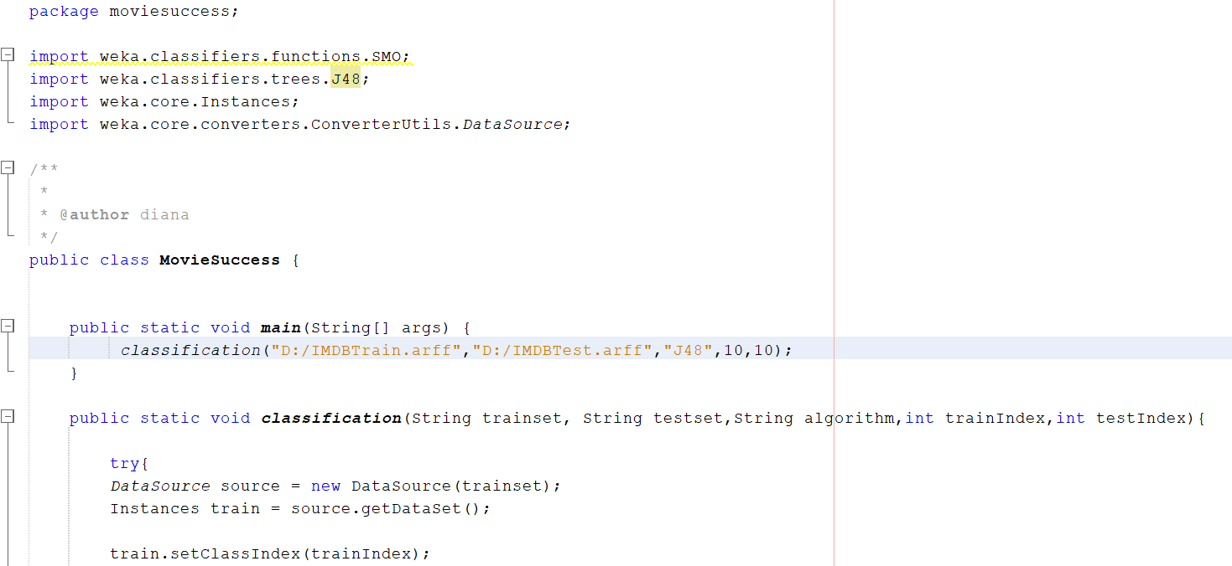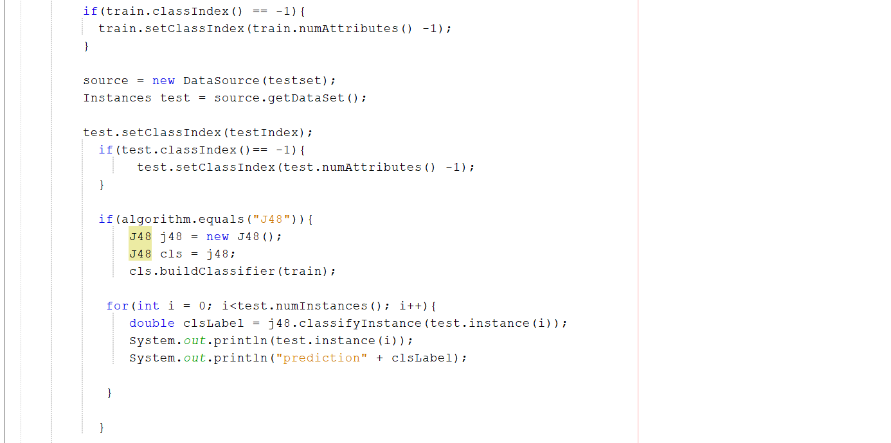
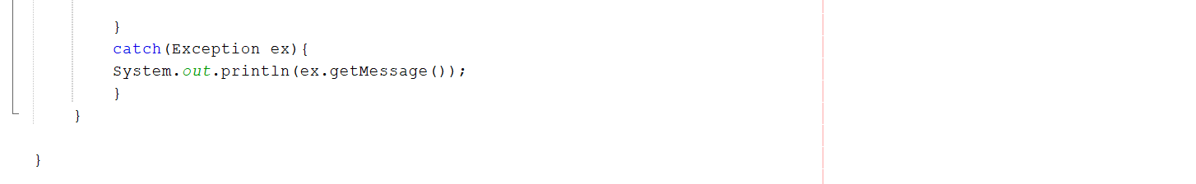
PROJECT RESEARCH Approval Form (Ethics)

Have you considered whether there are any problematic ‘ethical issues’ in your proposed research project? If not, you really should talk to your Course Tutor or Supervisor to discuss if there are any issues you need to address.

If you have already completed an ‘Ethics Approval Form’ within your Faculty/School, you do not need to complete this form. However, you haven’t considered the ethics issues in your proposal, you need to complete this form.

Not all details necessarily apply to your area of study, so you may leave some boxes blank, but do try and complete it as fully as you can. All sections deal with potential ethical issues which need careful consideration before you commence your research, to ensure you deal with them properly (in accordance with the law, for example). You may find it easier to complete the form with assistance from your tutor/supervisor.

Name: | Silvia Diana Iagar
Project/Research Title: | Forecasting movies success using Machine Learning
Name of Supervisor: | Dr. Terry Walcott
School/Dept. | Cloud Computing
Faculty: | University of Wales Trinity Saint David
Proposed Start Date: | 16.10.2020 | End Date: | 20.07.2021

1. Summary of planned research please indicate briefly below the purpose of your planned project/research, together with your aims, main research questions and research design – you can continue onto a separate sheet if necessary
Using just information from the films' ratings and data mining techniques, this project seeks to utilise data mining to develop a prediction model for movie forecasting to aid filmmakers in establishing financial arrangements during the early phases of film creation. This method aims to optimise the investor's decision-making process at the start of the project. The WEKA 3.8 decision tree and the NetBeans 12.0 integrated development environment will be used to create the prototype model.

2. Methodology you need to be clear about the methodology you intend to use in your study; this could include any number of methods, so either tick those shown below (where appropriate) or put the details in the box marked *

 | Interviews |  | Participant Observation |  | Use of personal data
 | Focus groups |  | Questionnaire | X | Literature Review
 | Performance |  | Presentation | X | Other (state below)*

Resources for Java NetBeans and Weka, IMDb website

3. Participants - Does your proposed project/research involve human participants?

 | 1. Yes, as a primary source* |  | 2. Yes, as a secondary source* | X | No- go to section 4

*If you have ticked yes, you are likely to need an Advanced CRB check before undertaking your study

If yes, indicate who your participants are:

 | Early years/Pre-School children |  | Adults - give details below
 | School age children |  | Vulnerable people - give details below
 | Young People aged 17-18
 | Unknown at this stage

4. Other Ethical issues (tick all that may apply to your research)

 | Administration of drugs incl. alcohol |  | Deprivation
 | Unpleasant stimuli in any manner or form |  | Active deception or withholding information
 | Collection of highly personal information |  | Payment

5. Are there any ethical concerns other than those listed above?

6. If there are any ethical concerns, please state how you intend to minimise any risk of harm or distress that could be caused

You should enclose the research proposal form, together with any materials (e.g. questionnaire, interview schedule) when submitting this form to your tutor/supervisor.

Student Signature: S.D Iagar Date: 20.07.2021
**********************************************************************************
Supervisor’s Signature : Dr. Terry Walcott Date: 20.07.2021
Ethics clearance given at Faculty Level
Clearance not given at Faculty level – forwarded for discussion at the next meeting of the University Ethics Committee. Details below:
Comments:

Chair’s Initials |  | Date

Details on this form will always be dealt with in accordance with the terms of the Data Protection Act 1998. The completed form will be retained on the student’s file after approval (for audit purposes) and may be forwarded firstly to the Faculty Board and thereafter to the University Ethics Committee for a discussion of the issue highlighted.

