

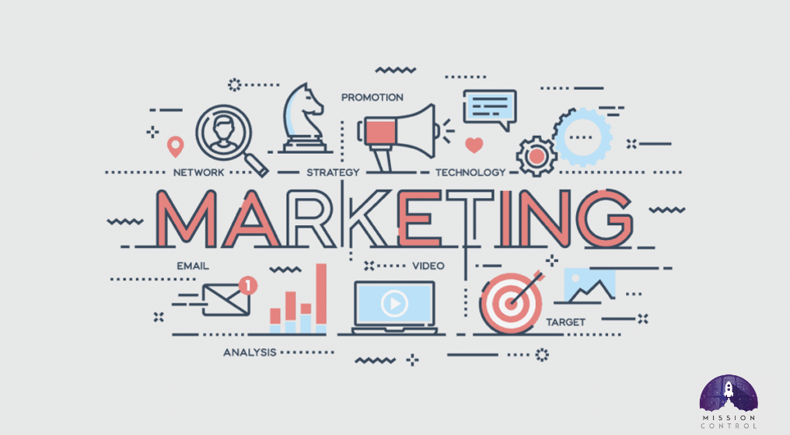

Assignment 2
Subject Name: Marketing Management
Subject Code: LCMB7024
Company Name: Nike
Lecturer: Dr Laila Maazouz
Course: MBA
Term: 1

Student Name: Vraj Dineshbhai Khadela
Student Number: 2423397
Submission Deadline: 28 April 2025
Word Count: 2666

Table of Contents
1. Nike Flow 2
1.1 About Nike 2
1.2 Nike Flow Overview 3
1.3 Unique Value Proposition 3
2. Segmentation, Targeting, and Positioning (STP) 4
2.1 Segmentation 4
2.2 Targeting 5
2.3 Positioning 6
3. Customer Persona 7
3.1 Demographic Profile 7
3.2 Psychographic Profile 8
3.3 Behavioural Characteristics 8
3.4 Customer Pain Points 9
4. Marketing Mix Strategy 10
4.1 Product 10
4.2 Price 11
4.3 Place 12
4.4 Promotion 12
4.5 People 12
4.6 Process 13
4.7 Physical Evidence 13
5. Conclusion 13
6. References 15

1. Nike Flow

1.1 About Nike
Nike, Inc., the world's largest supplier of athletic footwear and apparel, is one of the most iconic brands in the world. Its famous 'Swoosh' logo and the motivational "Just Do It" slogan are instantaneously recognisable (Davies, 2025). Nike, which is headquartered in Beaverton, Oregon, is the owner of several significant sub-brands, such as Converse and Jordan.
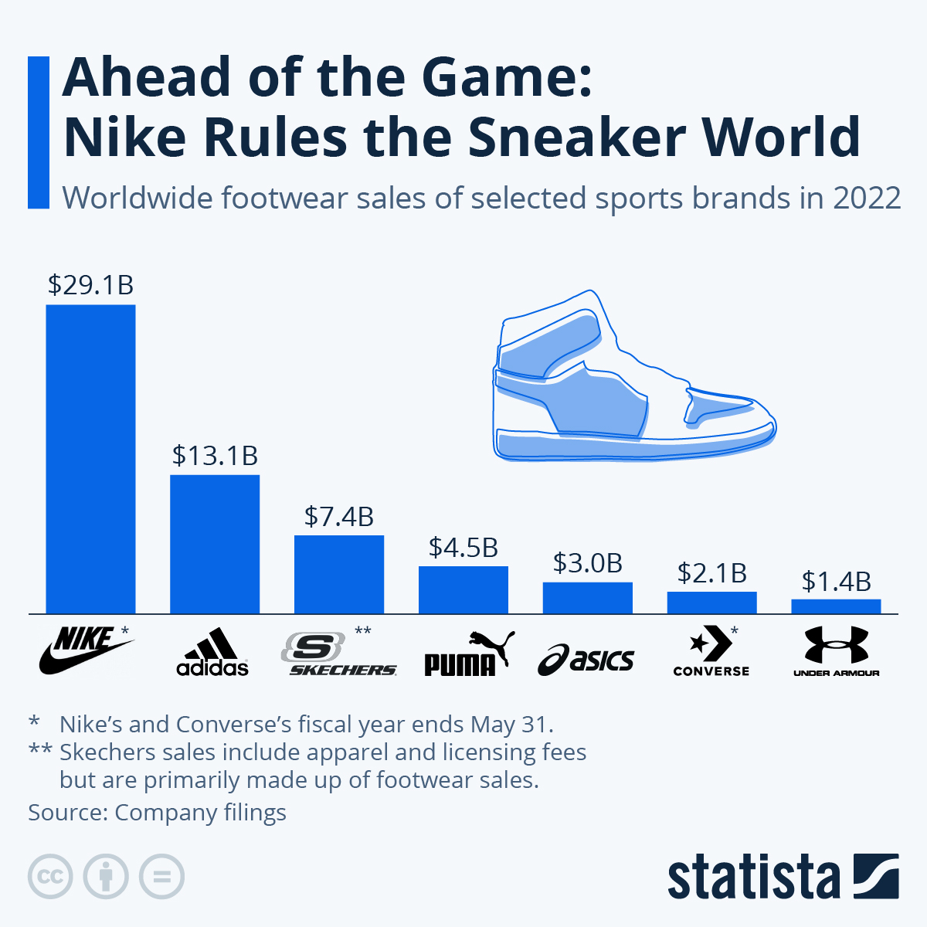
Source: https://www.statista.com/chart/13470/athletic-footwear-sales/
Nike remains a leader in innovation and cultural relevance, as evidenced by its endorsements from prominent athletes including Cristiano Ronaldo, LeBron James, and Serena Williams. Nike generated over $50 billion in revenue during the fiscal year ending May 2024, with footwear accounting for approximately $33 billion (Davies, 2025). Nike's sales growth has been stagnant, and there is a growing pressure to innovate in both the product and direct-to-consumer segments, despite its size.

1.2 Nike Flow Overview
Nike Flow is a new brand extension that is a premium, AI-powered mindfulness and recuperation smartwatch that is specifically designed for active lifestyle consumers and athletes. Nike Flow optimises recuperation and focus by monitoring movement, heart rate variability, breath patterns, and stress levels, thereby bridging the gap between sport, science, and mental wellbeing (Del-Valle-Soto et al., 2024; Jerath, Syam and Ahmed, 2023). It seamlessly integrates with fitness platforms and provides real-time performance feedback, guided respiration, and post-workout wind-downs.

1.3 Unique Value Proposition
Nike Flow is a cutting-edge smartwatch extension that has been specifically engineered to address a critical gap in the wearables market. It is specifically designed to prioritise mental clarity, stress management, and recuperation for athletes and wellness-oriented individuals.
Nike Flow, in contrast to traditional wearables that prioritise physical metrics such as steps and calories, adopts a mindfulness-first approach. This approach is supported by real-time AI analytics and Nike's history of sports performance. With more than 225 million global smartwatch users, the global wearable tech market is anticipated to surmount $50 billion in 2024, and it is currently undergoing exponential growth (Laricchia, 2024).
Nevertheless, the majority of smartwatches fail to capitalise on critical capabilities such as stress monitoring and guided recovery, despite the fact that 84% of current users identify health functionality as a critical determining factor in their purchasing decisions. Despite the fact that 30% of Europeans identify stress as their most significant health concern, only 9% of users are aware that their device has the capability to monitor stress (Huawei, 2023). This unmet need is explicitly addressed by Nike Flow.
Nike's entrance into this market is further bolstered by its robust brand equity, which is valued at over $30 billion, making it the most valuable apparel brand globally, and a demonstrated history of performance-driven innovation. Nike is in an ideal position to spearhead the next phase of health technology, as its equipment segment experienced a 20.3% year-over-year increase to $2.1 billion in FY2024 (MarketLine, 2025).
Nike Flow integrates guided breathwork, sleep recovery scoring, and personalised stress insights with the Nike ecosystem, which includes the Nike Training Club and Nike App. It is not merely a smartwatch; it is a high-performance wellness instrument designed for the next generation of athletes and achievers. The unique value of Nike Flow is delivered by this: assisting users in training more intensely, recovering more intelligently, and living more mindfully.

2. Segmentation, Targeting, and Positioning (STP)
Nike's expansion of its innovation legacy into the swiftly expanding wearables market is presented by the launch of Nike Flow, an AI-powered mindfulness and recovery smartwatch. This presents a unique opportunity for Nike. It is important to establish the market segmentation, target audience, and competitive landscape of Nike Flow in order to guarantee successful brand integration and precise market fit. This landscape has already been influenced by competitors such as Apple, Samsung, and Fitbit (Laricchia, 2024).

2.1 Segmentation
From a demographic standpoint, the product is most appealing to adults between the ages of 25 and 45, who are either already active or seeking to adopt healthier lifestyles. This demographic includes urban professionals and fitness-conscious consumers. This segment is characterised by a middle to high income, which enables them to indulge in premium products priced between £250 and £400 (Huawei, 2023).
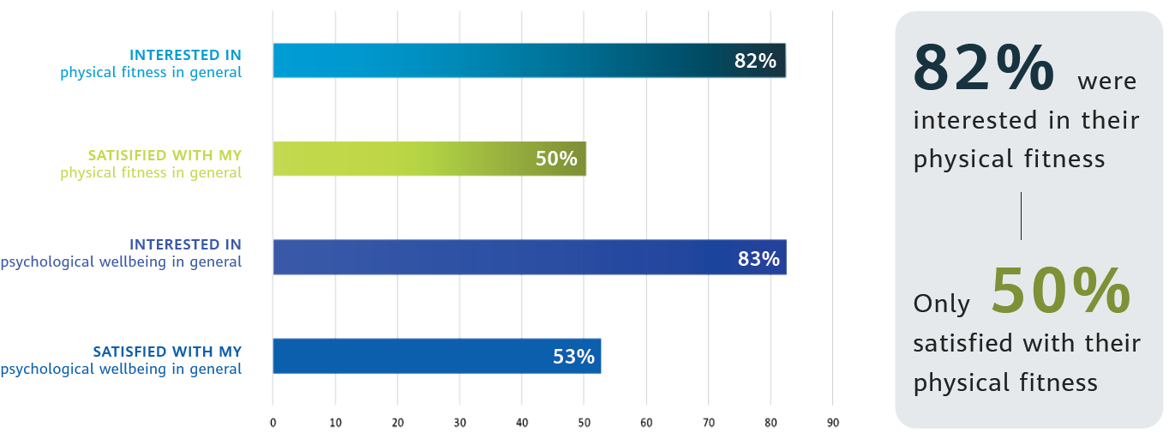
Source: 2023 Huawei European Health Survey
Wellness and performance optimisation serve as significant sources of motivation for these individuals. In Europe, 83% of survey respondents indicated a desire to enhance their psychological well-being, while 82% were equally enthusiastic about enhancing their physical health. Additionally, nearly 91% of Europeans expressed a desire to enhance at least one aspect of their health lifestyle, with tension, sleep, and weight control being the most important (Huawei, 2023).
Behaviourally, Nike Flow resonates with both dedicated fitness enthusiasts and aspirational lifestyle improvers. The CHeSS metrics (Calories, Heart rate, Steps, and Sleep) are among the most frequently monitored; however, advanced features such as stress and recovery monitoring are underutilised (Huawei, 2023). Nike Flow's competitive advantage is derived from its emphasis on recovery, mindfulness, and personalised performance readiness.

2.2 Targeting
Nike Flow's targeting strategy is deliberate and focused as a result of this segmentation. It employs a concentrated targeting approach, focussing on health-conscious urban dwellers who either already engage with smartwatches or health apps or express interest in doing so, rather than appealing to the mass market. Smartwatch adoption is high in countries such as Spain (45%), Italy (41%), and Turkey (40%), indicating a large potential for the European market (Huawei, 2023).

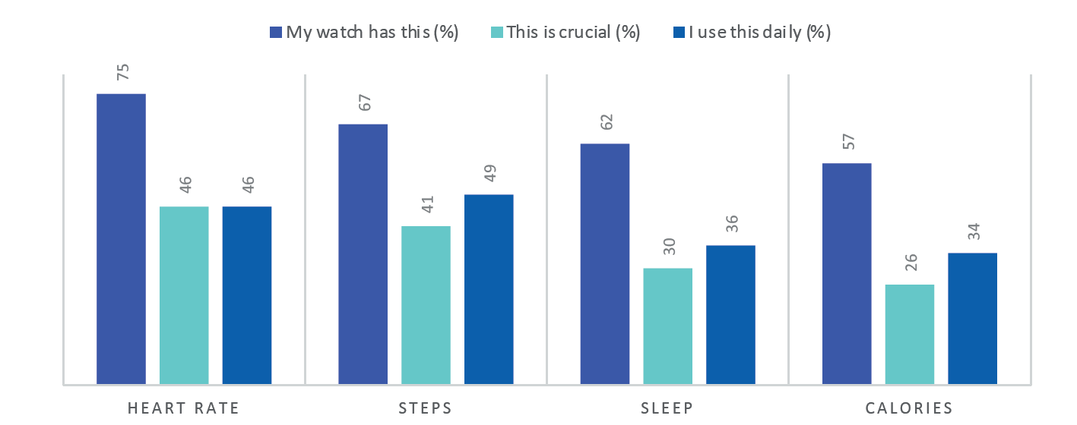
Source: 2023 Huawei European Health Survey
It is crucial to note that 66% of non-smartwatch users in Europe expressed interest in a smartwatch that was specifically designed for health monitoring (Huawei, 2023). Within this demographic, there are two primary user profiles: a newer segment of users who prioritise recovery, self-awareness, and long-term wellness, as opposed to competition, and existing Nike athletes and loyal brand enthusiasts who are seeking the next generation of fitness technology.

2.3 Positioning
In this context, Nike Flow necessitates the identification of its emotional and aspirational advantages, in addition to its functional utility. The Nike Flow is a performance-first recovery aid that combines sport science, mindfulness, and high design, in contrast to general-purpose devices from Apple or Fitbit.
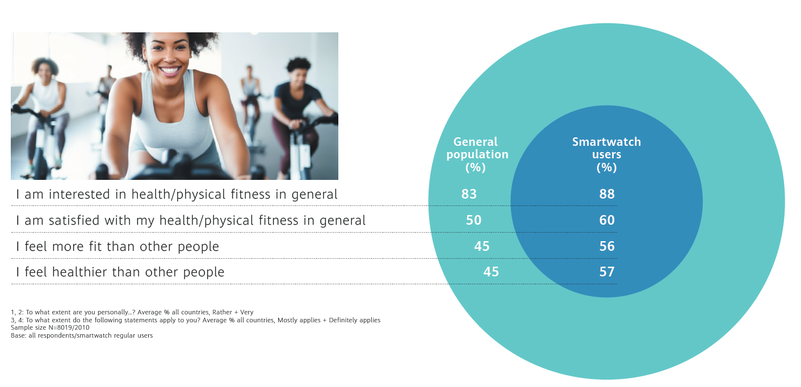
Source: 2023 Huawei European Health Survey
Its unique value is derived from the integration of advanced features, including AI-guided breathing, stress level monitoring, recovery scoring, and personalised suggestions, all of which are framed through the lens of athletic longevity. Despite the fact that 84% of smartwatch users consider health functionality to be a critical determining factor in their purchase, a significant number of them fail to completely capitalise on the device's capabilities (Huawei, 2023).
For example, only 9% of respondents were aware that smartwatches could monitor stress, despite the fact that stress was a top concern. Nike Flow directly addresses this divide by transforming overlooked metrics into key features and enabling users to act on them. In reality, more than 74% of smartwatch users act, frequently consulting with a physician, in response to an anomalous notification (Huawei, 2023). Nike Flow establishes itself as a trusted performance companion, rather than merely another smartwatch, due to the high level of trust and behavioural impact it possesses.

3. Customer Persona
A contemporary, urban individual who views health as a harmonious integration of mind and body, rather than merely fitness, is the ideal consumer for Nike Flow. This individual integrates a desire for proactive wellbeing, self-awareness, and ambition into their lifestyle and is amenable to utilising intelligent tools to accomplish these objectives. In order to investigate this target user, we will examine four main dimensions.

3.1 Demographic Profile
Introducing Lena Müller, a 34-year-old marketing consultant who is situated in Berlin. She resides in a lively neighbourhood of the city, earns an estimated €60,000 annually, and possesses a master's degree in communications. Lena is a representative of a core demographic for Nike Flow: adults aged 25–45 who reside in urban areas, have disposable income, and are already involved in wellness behaviours (Huawei, 2023).
She is a member of a demographic segment that is consistent with the 36% of Europeans who currently possess a smartwatch and the 66% of non-owners who have a significant interest in health-tracking wearables (Huawei, 2023). Her generation prioritises design, functionality, and purpose, rendering her an ideal early adopter of a product that integrates sports science, mindfulness, and premium technology.

3.2 Psychographic Profile
Psychologically, Lena is highly self-motivated and health-conscious; however, she frequently encounters difficulties in consistently adhering to healthy regimens, as do 72% of European respondents. Although she participates in cycling and yoga classes on a regular basis, she also prioritises her mental health. Lena is not an exception to the 83% of Europeans who demonstrate an interest in psychological wellbeing (Huawei, 2023).
She adheres to wellness influencers, utilises meditation applications, and maintains journals. She aspires to live a more fulfilling life, characterised by balance, clarity, and sustainable vitality, rather than merely working harder. She is in search of solutions that are seamlessly integrated into her lifestyle, without evoking a clinical or complex sensation.

3.3 Behavioural Characteristics
Lena, like 67% and 57% of users, already employs fundamental smartwatch features to monitor steps and calories. However, she perceives these tools as inadequate for stress and recovery. She represents a significant portion of users (over 84%) who acquired their smartwatch for health-related purposes. However, she is also one of the 91% of Europeans who are actively seeking to enhance their health behaviours, including stress management, sleep improvement, and more mindful exercise (Huawei, 2023).
Lena has recently initiated the process of monitoring her sleep quality after recognising the detrimental effects of fatigue on her productivity. This sentiment is shared by 35% of survey respondents who report sleep issues, and 30% who identify stress as their greatest challenge (Huawei, 2023).
Lena, a consumer who is well-versed in technology, has confidence in digital tools that offer actionable feedback. She is 75% more likely than a non-user to comprehend her target body fat or calorie intake, and she is among the 81% of smartwatch users who trust the data provided by their device (Huawei, 2023).

3.4 Customer Pain Points
Lena's primary requirement is for clarity and control—a method to comprehend her health in real time without relying solely on physicians or intricate medical devices. She aspires to mitigate tension, optimise recovery, and prevent burnout. However, she believes that the current wearables are either too basic or not sufficiently focused on advanced health indicators such as emotional equilibrium, stress scores, or recovery time. She is among the 31% of individuals who assert that features such as stress analysis and blood sugar monitoring are still lacking (Huawei, 2023).
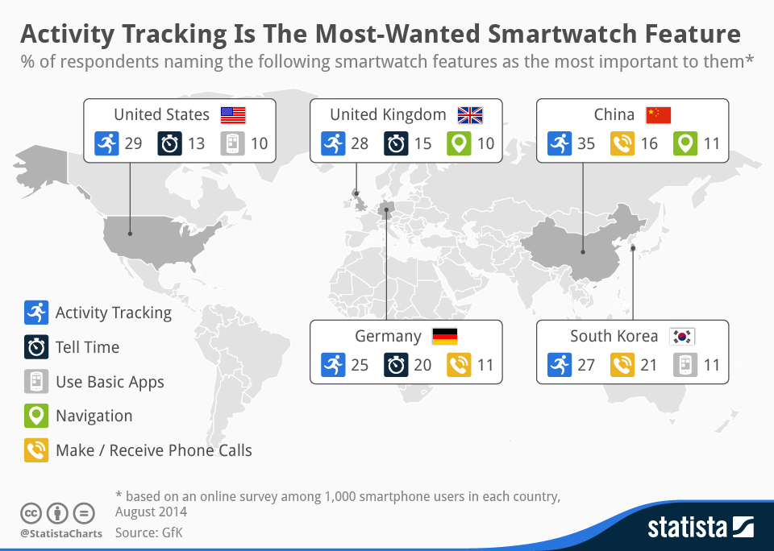
Source: https://www.statista.com/chart/2682/most-wanted-smartwatch-features/
Nike Flow addresses these deficiencies by providing personalised AI-based health coaching, guided breathing sessions, and recuperation optimisation tools in a sleek, athlete-inspired design. For Lena, it is not merely an additional device; it is a daily ritual that facilitates her ability to remain focused, centred, and proficient.

4. Marketing Mix Strategy

4.1 Product
Nike Flow is a premium smartwatch that has been specifically engineered to provide an advanced recuperation and mindfulness experience to athletes and wellness-focused consumers. It combines Nike's sports science heritage with AI-powered features, such as real-time stress monitoring, sleep optimisation, guided breathing, and recovery scoring. It builds upon Nike's equipment segment, which experienced a 20.3% year-over-year increase in revenue in FY2024, reaching $2.1 billion, and its expertise in wearable innovation, which was previously demonstrated through partnerships such as Nike + Apple (MarketLine, 2025).
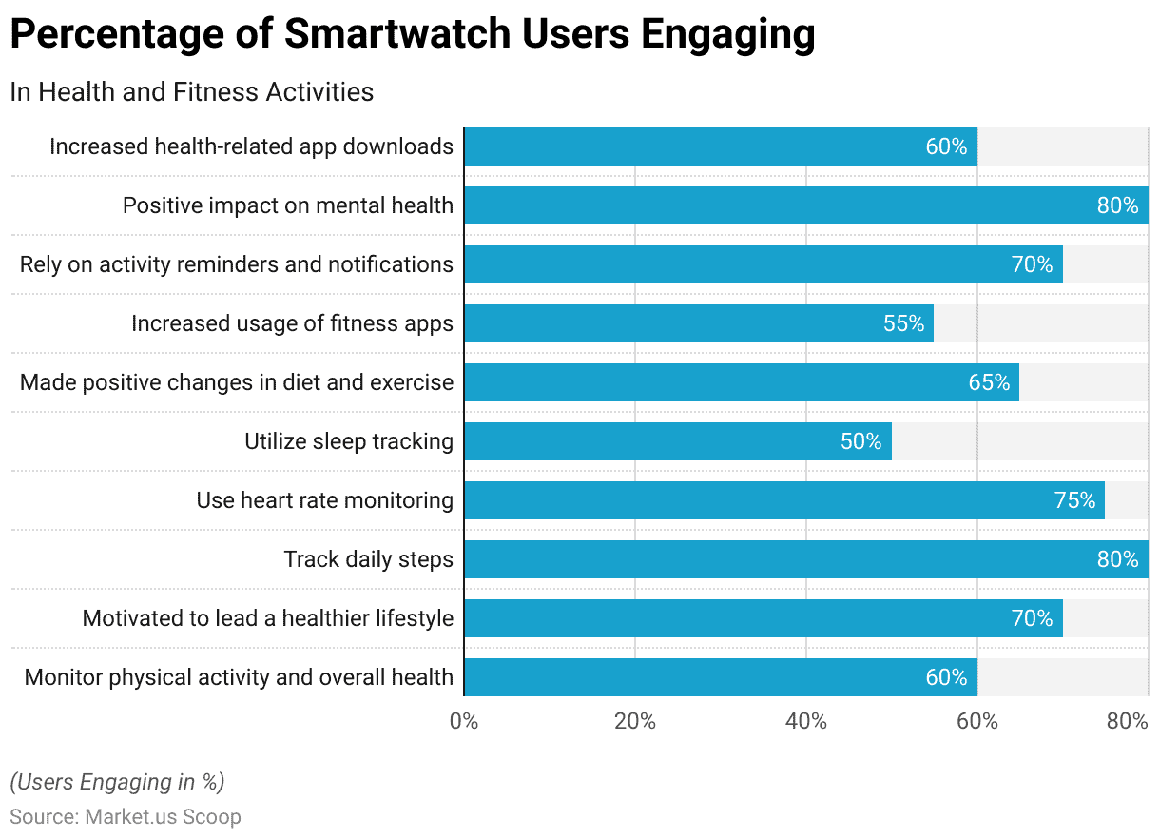
Source: https://scoop.market.us/smartwatch-statistics/
Nike Flow addresses a critical product void in the wearables market, where stress, recovery, and mental performance features are still underdeveloped, despite the fact that 84% of smartwatch users prioritise health features (Huawei, 2023). It also enhances Nike's expanding digital services, including the Nike Training Club and Nike Run Club applications, by providing seamless cross-platform integration.

4.2 Price
The Nike Flow will be priced between £299 and £399, placing it as a premium device that is slightly below Apple's premier smartwatch but above both Fitbit and Xiaomi devices. This pricing strategy enhances Nike's brand equity while maintaining its competitiveness. This value-based pricing approach (Liozu et al., 2012) is reinforced by Nike's consistent emphasis on high-quality, high-performance products (MarketLine, 2025).
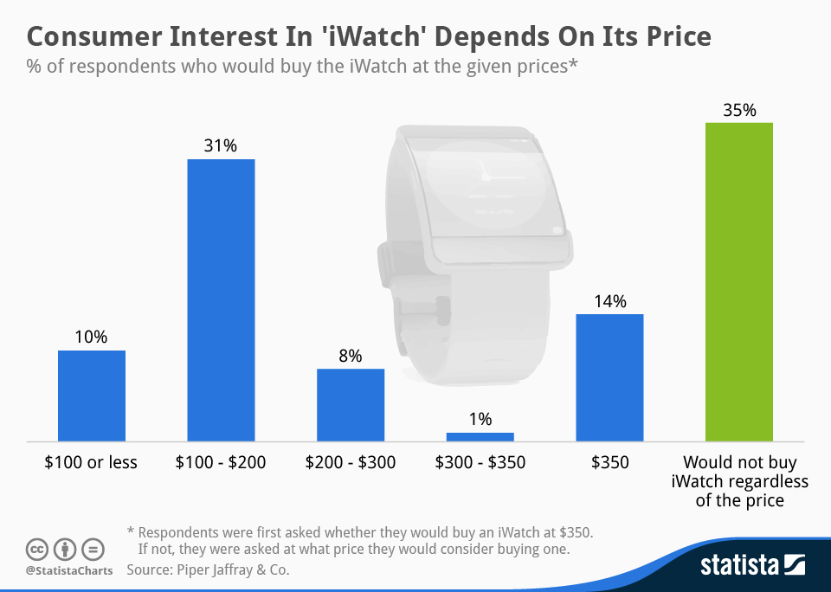
Source: https://www.statista.com/chart/2396/iwatch-willingness-to-pay/
Nike Flow will incorporate exclusive online and member-only offers to promote adoption through its own ecosystem, in light of the company's robust Direct-to-Consumer (DTC) segment, which accounted for 43.5% of FY2024 revenue.

4.3 Place
Nike Flow will capitalise on Nike's global, multi-channel distribution strategy. Nike had 1,032 stores worldwide as of 2024, with 369 of them located in the United States and 663 in other countries. Additionally, the company maintained digital platforms in 40 countries. The launch will concentrate on critical urban markets in Europe, including Spain, Italy, and Germany, where there is a high level of interest in mental wellbeing and the penetration of smartwatches (Huawei, 2023).
The integration of Nike Rise concept stores and flagship stores will provide immersive in-person experiences, while online sales through nike.com, SNKRS, and partner platforms (e.g., Zalando, JD Sports) will assure broad availability (MarketLine, 2025).

4.4 Promotion
Digital-first storytelling and experience marketing will be the primary focus of promotional efforts. Top Nike athletes, such as Simone Biles and Rafael Nadal, who are known for their performance and mindfulness, will be featured in campaigns that prioritise mental clarity and athletic recuperation (Rooney, 2022).
The Nike App, Instagram, YouTube, and TikTok will be utilised to capitalise on Nike's robust digital and social presence. European smartwatch users—66% of whom are interested in health-tracking wearables—will be targeted by paid promotions (Huawei, 2023). Furthermore, consumer trust and relevance will be enhanced through partnerships with fitness creators and mindfulness platforms (e.g., Headspace) (Headspace, 2025).

4.5 People
In addition to product features, Nike Flow's customer-facing staff—both in-store and online—will receive training as "Performance Guides." This training will enable them to discuss the benefits of the products, including mental energy, recovery strategies, and sleep enhancement.
Nike's global service will be consistent due to its history of strong operational excellence and customer experience (MarketLine, 2025). Influencers and athlete ambassadors will also be instrumental in humanising the brand by sharing personal tales of stress, recovery, and the use of Nike Flow to balance performance and peace.

4.6 Process
The customer journey is intended to be frictionless, digital, and personalised. The Nike Flow configuration will be integrated with existing Nike accounts, allowing for the synchronisation of user data from the Nike Training Club, Apple Health, or Google Fit applications.
The Nike App will provide a personalised onboarding experience that includes real-time coaching based on stress levels or sleep recovery. This is consistent with Nike's digital innovation strategy, which includes their investments in performance technology partners such as Hyperice, AI, and Web3 (via.SWOOSH) (MarketLine, 2025).

4.7 Physical Evidence
The sleek, minimalist, high-performance aesthetic that is characteristic of Nike's premium products will be reflected in the physical branding of Nike Flow (MarketLine, 2025). The packaging will be sustainable, leveraging Nike's Living Ink partnership for algae-based materials.
The product will also include characteristic design elements such as the Swoosh, matte finishes, and athletic straps. Nike Rise stores will feature guided recovery zones and display pods during retail installations. Nike Flow's fundamental message is reinforced by each interaction, from the visuals of the app to the packaging: perform better by recuperating more intelligently.

5. Conclusion
A bold and strategic expansion into the swiftly expanding health and wellness technology market is represented by Nike Flow. Nike's premium smartwatch addresses a distinct consumer need for intelligent recovery, mindfulness, and performance optimisation by utilising the iconic brand equity, digital innovation, and sports science expertise of the company. Nike Flow provides a unique solution in a crowded wearable market, as evidenced by the fact that over 90% of Europeans are pursuing lifestyle improvements, which is indicative of the increasing awareness of stress, sleep, and mental wellbeing.
The marketing mix prioritises premium design, seamless integration, and purpose-driven storytelling, while the focused segmentation and targeting strategy guarantees alignment with health-conscious, tech-savvy urban consumers. Nike Flow is not merely a device; it is a lifestyle companion that enhances both the mind and body. This brand extension not only strengthens Nike's position in influencing the future of athletic performance and holistic wellbeing across global markets, but also reflects the company's ongoing commitment to innovation.

6. References
Davies, K. (2025) Topic: Nike. https://www.statista.com/topics/1243/nike/ (Accessed: April 18, 2025).
Del-Valle-Soto, C. et al. (2024) 'A comprehensive review of Behavior change techniques in Wearables and IoT: Implications for Health and Well-Being,' Sensors, 24(8), p. 2429. https://doi.org/10.3390/s24082429.
Headspace (2025) About us. https://www.headspace.com/about-us (Accessed: April 18, 2025).
Huawei (2023) 2023 Huawei European Health Survey.
Jerath, R., Syam, M. and Ahmed, S. (2023) 'The Future of Stress Management: Integration of smartwatches and HRV technology,' Sensors, 23(17), p. 7314. https://doi.org/10.3390/s23177314.
Laricchia, F. (2024) Topic: Smartwatches. https://www.statista.com/topics/4762/smartwatches/ (Accessed: April 18, 2025).
Liozu, S.M. et al. (2012) 'Mindful pricing: transforming organizations through value-based pricing,' Journal of Strategic Marketing, 20(3), pp. 197–209. https://doi.org/10.1080/0965254x.2011.643916.
MarketLine (2025) NIKE Inc, MarketLine. MarketLine, pp. 1–6.
Rooney, K. (2022) 'Nike unveils new “Unlimited Greatness” commercial featuring Serena Williams,' Copyright © HotNewHipHop 2025, 22 November. https://www.hotnewhiphop.com/513186-nike-unveils-new-unlimited-greatness-commercial-featuring-serena-williams-new-video.

